Post-Pandemic Risks Landscape for the Freight Forwarding Industry in Developing Countries

- INTRODUCTION
The COVID 19 pandemic created significant disruptions into global freight and logistic industry through lockdowns, border restrictions, labor shortages and demand changes in the trade. Although most of the health restrictions were lifted after 2021, the industry did not return to pre COVID situation. Instead post pandemic state can be characterized by continued instability including fuel and freight rate prices, unreliable carrier schedule, geopolitical tensions, exchange rate volatility and fluctuating demand patterns. These developments showing that the impact of COVID 19 expand beyond the pandemic era and it reshape the risk environment of global logistics.
In developing countries, those disruptions heavily affected where logistic systems face infrastructure limitations, financial constraints and higher dependence on international trade. In this context, freight forwarders play crucial role in coordinating transport operations, documentation, customs procedures and information flow across supply chains while being exposed to financial and operational risks. But there are limited research has focused on the freight forwarders and how they affected by COVID, particular in developing countries and how these risks are interconnected. This study address this gap identifying the key risks, analyzing their risks are relationships and developing a structured hierarchy model to better understand the underlying risks dynamics.

- LITERATURE REVIEW
- Impact of COVID 19 on global trade and logistics
The Covid 19 pandemic created one of the most severe disruptions to global trade and logistics systems in recent history. During the peak period in 2020, lockdowns, boarder limitations and health regulations caused labor shortages and supply chain obstacles. These disruptions resulted in port congestion, container imbalances and freight rate fluctuations in global shipping [1]. In addition, transportation delays, reduced capacity and increased freight costs exposed the vulnerability of freight transport systems to the world. It continued to affect logistic performance even beyond the peak pandemic period [2]. Also global trade volume decreased significantly in 2020, before gradually recover in 2021 to 2022, creating instability in freight demand and logistic planning [3].

- Post pandemic conditions in freight transport
In the post pandemic period, freight transport has continued to face demand imbalances, capacity shortages and operational uncertainties across different transport modes. Container transport experienced uneven recovery with rising demand and persistent equipment shortages that contributed to congestion and higher freight costs [4]. Although global trade recovered, growth slowed due to inflation and continuing market instability. It showed that freight systems remain vulnerable to disruption [3]\. In land transport, driver shortages due to safety regulations, further reduced inland transport and affected to port congestions [5].
- Freight forwarding industry and Its role
Freight forwarders play critical role in coordinating cargo movements across global. Their services including transport coordination, documentation, customs clearance, insurance and information flow management [6]. As intermediate, between shippers, liners and regulatory bodies, they ensure service reliability and cost efficiency. However since they do not own physical transport modes, they are highly exposed to operational delays, fuel price increases, schedule unreliability [7].

- Challenges, risk interdependencies and research gap
The challenges faced by freight forwarders are more severe in developing countries. These economies were more heavily affected by container shortages and rising freight costs due to weaker bargaining power in global shipping markets [1]. In addition, currency volatility and limited digital capabilities have increased operational risks [8].
Post pandemic logistic risks are highly interconnected rather than independent. For instance, port congestion can lead to schedule disruptions, increased costs and customer dissatisfaction [2]. Despite this, most existing studies focus on shipping lines, ports and general supply chains in developed countries. There are limited attention given to freight forwarders at developing countries.
Therefore, a clear research gap exists in understanding the interrelationships and hierarchical structure of post pandemic risks affecting freight forwarders in developing countries. This study address this gap by applying Interpretive Structural Modeling (ISM) to analyze their relationships and develop structured risk hierarchy.

- METHODOLOGY
This study conducted based on qualitative dominant research design with expert view.
The framework contain 3 main areas.
- Identification of post pandemic risks through comprehensive literature review.
- Validation of identified risks using expert opinions collected via structured questionnaire.
- Analysis of interrelationships among validated risks using Interpretive Structural Modeling (ISM).

- Interpretive Structural Modeling (ISM)
In this study, ISM applied to examine the interrelationships among post pandemic risks to identify key driving and dependent risks and develop structured hierarchy. This approach helps convert qualitative expert opinions into systematic model that suitable to analyze complex risk environments.

- ISM Process
In here, the study consist several steps using ISM.
- Identification of relevant risks.
- Established of contextual relationships among risks.
- Development of the Structural Self Interaction Matrix (SSIM)
- Development of initial and final reachability matrix
- Level partitioning of risks
- Development of ISM based hierarchical model

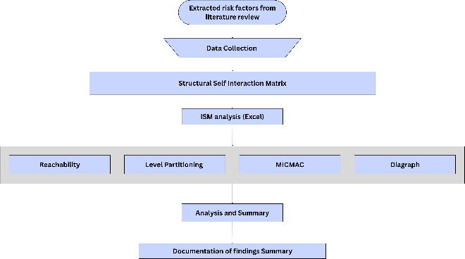

- Illustrate the overall ISM Methodological Framework applied in this study

- Identification of post pandemic risks from literature
Risks were selected based on their relevance to the post pandemic period (2021 – 2025) and freight forwarders from existing review of academic journals, industry reports and publications. Those are applicable to developing countries and specific impact on freight forwarding operations across sea, air and land transport modes.

Risk no | Initial Risk List (from past studies) | Research Paper
R1 | Fluctuating fuel prices increased transport and shipping costs. | [9]
R2 | Ocean freight rates changed sharply, making pricing unstable. | [10]
R3 | Container shortages caused export delays and extra charges. | [4]
R4 | Port congestion led to shipment delays. | [11]
R5 | Customs or health rule changes slowed cargo clearance. | [12]
R6 | Truck shortages affected inland deliveries. | [9]
R7 | Exchange-rate fluctuations (Ex: LKR vs USD) changed total shipment costs. | [13]
R8 | Lack of USD liquidity made it hard to pay overseas partners. | [14]
R9 | Client payment delays / credit issues caused cash-flow pressure | [15]
R10 | Limited digital systems reduced visibility and slowed coordination. | [16]
R11 | Shortage of skilled staff affected service quality. | [17]
R12 | Carrier schedule unreliability / blank sailings delayed shipments | [10]
R13 | Geopolitical route disruptions raised cost/time. | [18]
R14 | Sudden demand changes from e-commerce or essential goods made planning hard | [19]
R15 | Service failures or delays harmed our company reputation | [20]
- Present the list of identified risks along with the key supporting literature.
- Expert Validation and Risk Impact Assesment
A structured online questionnaire was developed using google forms to validate identified risks and their impact. Target responders were industry professionals with experience in freight forwarding. It include profile information (years of experience, company size and freight modes handled) and a risk assessment section to rate the impact of each risk in pandemic period using 5 point scale.
- 1 – No impact
- 2 – Low impact
- 3 – Moderate impact
- 4 – High impact
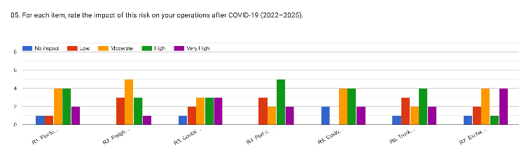
- 5 – Very high impact

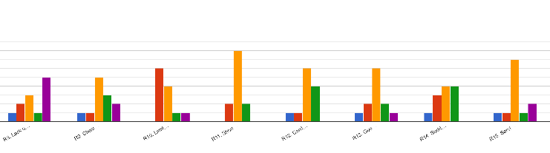
- Summarized the aggregated impact evaluation of risks based on expert opinions part 1

- Summarized the aggregated impact evaluation of risks based on expert opinions part 2
The results confirmed that all identified risks were considered relevant and impactful by industry professionals.

- Risk Interrelationship Structured Expert Interviews and SSIM Matrix
Following the survey, structured interviews were conducted with selected industry experts to examine the interrelationships among validated risks using pairwise comparisons. Structured Self Interaction Matrix (SSIM) was build based on these expert insights.
- V - Risk i influences Risk j.
- A - Risk j influences Risk i.
- X - Risk i and risk j have an interdependence.
- O - There is no significant relationship.
The final SSIM was develop by summarize responses using majority agreement as showing in TABLE 2.

 | Structural Self- Interaction Matrix (SSIM)
 | R1 | R2 | R3 | R4 | R5 | R6 | R7 | R8 | R9 | R10 | R11 | R12 | R13 | R14 | R15
R1 |  | V | O | O | O | O | A | O | V | O | O | O | O | O | O
R2 |  |  | A | A | A | O | O | O | V | O | O | A | A | A | V
R3 |  |  |  | A | A | A | O | O | O | A | A | V | V | A | V
R4 |  |  |  |  | A | V | O | O | O | A | A | V | V | A | V
R5 |  |  |  |  |  | V | O | O | O | A | A | V | V | O | V
R6 |  |  |  |  |  |  | O | O | O | O | A | O | O | A | V
R7 |  |  |  |  |  |  |  | V | V | O | O | O | O | O | O
R8 |  |  |  |  |  |  |  |  | X | O | O | O | O | O | V
R9 |  |  |  |  |  |  |  |  |  | O | O | O | O | O | V
R10 |  |  |  |  |  |  |  |  |  |  | O | O | O | O | V
R11 |  |  |  |  |  |  |  |  |  |  |  | V | V | O | V
R12 |  |  |  |  |  |  |  |  |  |  |  |  | V | A | V
R13 |  |  |  |  |  |  |  |  |  |  |  |  |  | A | V
R14 |  |  |  |  |  |  |  |  |  |  |  |  |  |  | V
R15
- Present the final SSIM derived from the expert interviews
- Formation of the Reachability Matrix
The Structural Self-Interaction Matrix (SSIM) was converted into an initial reachability matrix by replacing symbols with binary values, followed by the application of transitivity to derive the Final Reachability Matrix (TABLE 3). This matrix was used to determine the driving and dependence power of each risk, indicating how strongly a risk influences others and how much it is influenced in return.

 | Initial Reachability Matrix --> Final Reachability Matrix
 | R1 | R2 | R3 | R4 | R5 | R6 | R7 | R8 | R9 | R10 | R11 | R12 | R13 | R14 | R15 | Driving Power
R1 | 1 | 1 | 0 | 0 | 0 | 0 | 0 | 0 | 1 | 0 | 0 | 0 | 0 | 0 | 0 | 3
R2 | 0 | 1 | 0 | 0 | 0 | 0 | 0 | 0 | 1 | 0 | 0 | 0 | 0 | 0 | 1 | 3
R3 | 0 | 1 | 1 | 0 | 0 | 0 | 0 | 0 | 0 | 0 | 0 | 1 | 1 | 0 | 1 | 5
R4 | 0 | 1 | 1 | 1 | 0 | 1 | 0 | 0 | 0 | 0 | 0 | 1 | 1 | 0 | 1 | 7
R5 | 0 | 1 | 1 | 1 | 1 | 1 | 0 | 0 | 0 | 0 | 0 | 1 | 1 | 0 | 1 | 8
R6 | 0 | 0 | 1 | 0 | 0 | 1 | 0 | 0 | 0 | 0 | 0 | 0 | 0 | 0 | 1 | 3
R7 | 1 | 0 | 0 | 0 | 0 | 0 | 1 | 1 | 1 | 0 | 0 | 0 | 0 | 0 | 0 | 4
R8 | 0 | 0 | 0 | 0 | 0 | 0 | 0 | 1 | 1 | 0 | 0 | 0 | 0 | 0 | 1 | 3
R9 | 0 | 0 | 0 | 0 | 0 | 0 | 0 | 1 | 1 | 0 | 0 | 0 | 0 | 0 | 1 | 3
R10 | 0 | 0 | 1 | 1 | 1 | 0 | 0 | 0 | 0 | 1 | 0 | 0 | 0 | 0 | 1 | 5
R11 | 0 | 0 | 1 | 1 | 1 | 1 | 0 | 0 | 0 | 0 | 1 | 1 | 1 | 0 | 1 | 8
R12 | 0 | 1 | 0 | 0 | 0 | 0 | 0 | 0 | 0 | 0 | 0 | 1 | 1 | 0 | 1 | 4
R13 | 0 | 1 | 0 | 0 | 0 | 0 | 0 | 0 | 0 | 0 | 0 | 0 | 1 | 0 | 1 | 3
R14 | 0 | 1 | 1 | 1 | 0 | 1 | 0 | 0 | 0 | 0 | 0 | 1 | 1 | 1 | 1 | 8
R15 | 0 | 0 | 0 | 0 | 0 | 0 | 0 | 0 | 0 | 0 | 0 | 0 | 0 | 0 | 1 | 1
Dependance power | 2 | 8 | 7 | 5 | 3 | 5 | 1 | 3 | 5 | 1 | 1 | 6 | 7 | 1 | 13

- Final Reachability Matrix

 | Reachability Set | Antecedent Set
R1 | R1, R2, R9 | R1, R7
R2 | R2, R9, R15 | R1, R2, R3, R4, R5, R12, R13, R14
R3 | R2, R3, R12, R13, R15 | R3, R4, R5, R6, R10, R11, R14
R4 | R2, R3, R4, R6, R12, R13, R15 | R4, R5, R10, R11, R14
R5 | R2, R3, R4, R5, R6, R12, R13, R15 | R5, R10, R11
R6 | R3, R6, R15 | R4, R5, R6, R11, R14
R7 | R1, R7, R8, R9 | R7
R8 | R8, R9, R15 | R7, R8, R9
R9 | R8, R9, R15 | R1, R3, R7, R8, R9
R10 | R3, R4, R5, R10, R15 | R10
R11 | R3, R4, R5, R6, R11, R12, R13, R15 | R11
R12 | R2, R12, R13, R15 | R3, R4, R5, R11, R12, R14
R13 | R2, R13, R15 | R3, R4, R5, R11, R12, R13, R14
R14 | R2, R3, R4, R6, R12, R13, R14, R15 | R14
R15 | R15 | R2, R3, R4, R5, R6, R8, R9, R10, R11, R12, R13, R14, R15
- Reachability Set and Antecedent Set
The reachability and antecedent sets for each risks were derived from the final reachability matrix (TABLE 4). The reachability set includes the risk itself and the risks it influences. Antecedent set include the risk itself and risks that influence it.

- Partitioning of levels
Level partitioning was then performed to classify risks into hierarchical levels based on their reachability and antecedent sets. Through iterative analysis, risks were grouped from root causes at lower levels to outcome-based risks at higher levels, resulting in a structured representation of the risk system.

- Iteration 1
- Iteration 2

- Iteration 3
- Iteration 4
- Iteration 5
- Iteration 6
- : Iteration 7
- Iteration 8
- Iteration 9
- Iteration 10
In order to further interpret the ISM results, risks were ranked in terms of their location in the hierarchy, Fundamental drivers to final outcome risks.

Risk | Level
R15 | 1
R8 | 2
R9 | 2
R2 | 3
R1 | 4
R13 | 4
R7 | 5
R12 | 5
R3 | 6
R6 | 7
R4 | 8
R5 | 9
R14 | 9
R10 | 10
R11 | 10

- Levels of risks
- Application of MICMAC Analysis for risk classification
MICMAC analysis was used to classify risks based on their driving power and dependence power. The method groups variables into four types.
- Autonomous (weak driving power and dependence)
- Dependent (weak driving power but strong dependence)
- Linkage (strong driving power and dependence)
- Independent variables (strong driving but weak dependence)

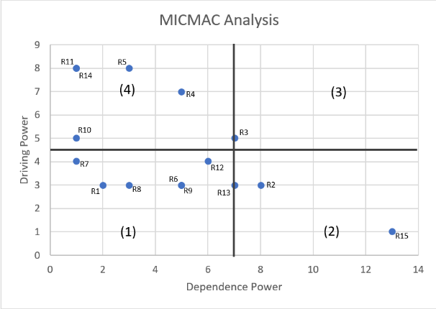

- MICMAC analysis chart

Risk Hierarchy:
- Sudden demand changes from e-commerce and essential goods
- Shortage of skilled staff and limited digital systems
- Customs and health regulations
- Port congestions
- Container shortages and equipment imbalance
- Geopolitical route disruptions, carrier schedule unreliability and exchange rate fluctuations
- Fluctuating fuel prices
- Ocean freight rate volatility
- Client payment delays, foreign currency shortage and truck shortages
- Service failures and reputational damage
The ranking underlines that the risk of demand side and structural capability are the root causes whereas financial stress and reputational risks are mainly the consequences of disruption upstream.

- CONCLUSION
The findings highlight that post pandemic risks in freight forwarding are highly interconnected rather than independent. The analysis shows that underlying factors such as demand instability, workforce limitations and technological constraints act as key drivers, while financial pressures and service-related issues emerge as consequences. This indicates that addressing only surface level problems, such as delays or cash flow issues, may provide limited short term relief without solving root causes.
Furthermore, the results emphasize the vulnerability of freight forwarders, particularly in developing countries, due to their intermediary role and lack of control over transport assets. External factors such as foreign exchange constraints, infrastructure limitations, and regulatory uncertainties further intensify these risks. Overall, the ISM based analysis provides a structured understanding of risk interdependencies and supports more effective prioritization in risk management strategies.
- REFERENCES
- T. Notteboom, T. Pallis and J.P. Rodrigue, “Disruptions and resilience in global container shipping and ports: The COVID 19 pandemic versus the 2008-2009 financial crisis”, Maritime Economics & Logistics, vol.23, no.2, pp.179-210, 2021
- A. Karam, R. Houjeir and E. Farah, “The impact of COVID 19 on freight transport: Challenges and resilience strategies”, Transportation Research Interdisciplinary Perspectives, vol.13, 100546, 2022.
- World Trade Organization, World Trade Statistical Review 2023. Geneva, Switzerland: WTO, 2023.
- K.A. Kuźmicz, “Impact of the COVID 19 pandemic disruptions on container transport”, Engineering Management in Production and Services, vol.14, pp.106-115, 2022. [Online]. Available: https://doi.org/10.2478/emj-2022-0020
- United Nations Conference on Trade and Development, Review of Maritime Transport 2022. Geneva, Switzerland: UNCTAD, 2022.
- N. Malika, “The role of freight forwarders in international logistics”, International Journal of Logistics Systems and Management, vol.21, no.2, pp. 215-228, 2015.
- M. Skiba and M. Karaś, “Risk management in freight forwarding services under conditions of uncertainty”, Sustainability, vol.14, no.9, 5193, 2022.
- B.S. Dura et el., “The role of technology in developing resilient supply chains during COVID 19 disruptions”, Sustainability, 2023.
- Katarzyna Grzybowska and Agnieszka Stachowiak, “Global changes and disruptions in supply chains – Preliminary research to sustainable resilience of supply chains”, Energies 2022, 15, 4579. [Online]. Available: https://doi.org/10.3390/en15134579
- T. Sudan and R. Taggar, “Recovering supply chain disruptions in post COVID 19 pandemic through transport intelligence and logistic systems: India’s experiences and policy options”, Front. Future Transp. , vol.2, 2021. [Online]. Available: https://doi.org/10.3389/ffutr.2021.660116
- Sedat Baştuğ, Hercules Haralambides, Ercan Akan and Kasim Kiraci, “Risk mitigation in service industries: A research agenda on container shipping”, Transport Policy, vol.141, pp. 232-244, 2023. [Online]. Available: https://doi.org/10.1016/j.tranpol.2023.07.011
- Natalie Mueller, Marie Westerby and Mark Nieuwenhuijsen, “Health impact assessments of shipping and port-sourced air pollution on a global scale: A scoping literature review”, Environmental Research, vol.216, 2023. [Online]. Available: https://doi.org/10.1016/j.envres.2022.114460
- T. Theodorou, “Economic and geopolitical factors affecting the freight rates”, Economics and politics, University of Macedonia, 2024.
- Randhawa, Gurmehar, "Analysis of the Impact of COVID-19 on the Performance of Cargo Firms." Issue 3 Indian JL & Legal Rsch. 2022
- Kaur J, Kumar S, Joshi R, “Is supply chain finance an antidote to SMEs in the economic crisis? - A qualitative inquiry”, The International Journal of Logistics Management, vol.34, no. 6 pp. 1890–1910, 2023.
- B. S. Dura et al., “The role of technology in developing resilient supply chains: A systematic literature review during the COVID-19 pandemic and the disruptions of economic sanctions”, Journal of Humanitarian Logistics and Supply Chain Management, vol. 16, no. 1, pp. 27-49, 2026.
- Ai, Tran & My, Phan & Tan, Chin, “Training high quality workers in logistics and construction industry in Vietnam after Covid-19”, 2023.
- Touat, O.,”Global Supply Chain Disruptions: Lessons From the COVID-19 Pandemic Crisis”, Business Resilience and Market Adaptability, 2024.
- Alwan, S.Y., Hu, Y., Al Asbahi A.A.M.H., Yaser Khaled A.H., Harazi A.K., “Sustainable and resilient e-commerce under COVID-19 pandemic: a hybrid grey decision-making approach”, [Online]. Available: https://doi.org/10.1007/s11356-023-25456-0
- Sun, Z., & Zhang, Y, “Strategic Crisis Response of Shipping Industry in the Post COVID-19 Era: A Case of the Top 10 Shipping Lines”, Journal of Marine Science and Engineering, 10(5), 635. [Online]. Available: https://doi.org/10.3390/jmse10050635

