“A Study to Evaluate the Effectiveness of Clamping Versus Bladder Training Methods Prior to Foley’s Catheter Removal in Adult Patients at Apollo BGS Hospital, Mysore ".
Mrs. Carunia Jeyasutha (ANS, Apollo BGS Hospitals, Mysore, Karnataka, India.)

Mrs.Maryline Flinsi, (Principal, Apollo College of Nursing, New Delhi),

Abstract
Background:
Indwelling Foley’s catheterization is a common procedure in hospitalized patients for urinary drainage following surgical and medical conditions. The method adopted prior to catheter removal plays a vital role in preventing urinary retention and avoiding re-catheterization. However, the effectiveness of clamping versus bladder training varies depending on patient age, duration of catheterization, and associated comorbidities. Objectives: This study aimed to evaluate the effectiveness of clamping versus bladder training methods prior to Foley’s catheter removal among adult patients at Apollo BGS Hospital, Mysore. Methods: A quantitative evaluative study was conducted among 500 catheterized adult patients aged above 25 years. Data were collected from patients admitted under various specialties including General Medicine, Gynaecology, Neurology, Nephrology, and Gastroenterology. The study was conducted from June 2025 to September 2025 at Apollo BGS Hospital, Mysore. Patients with short-term (3–4 days) and long-term (>10 days) catheterization were assessed. Variables included age, gender, duration of catheterization, neurological status, ability to void after catheter removal, bladder distention, and need for re-catheterization. Patients underwent either bladder training alone or intermittent clamping prior to catheter removal based on clinical indication. Results: Among the 500 patients, 356 were male and 144 were female. Of the total sample, 150 patients underwent intermittent clamping and 350 received bladder training prior to catheter removal. Patients with short-term catheterization (3–4 days), particularly younger post-operative cases (e.g., LSCS, hernia repair), responded effectively to bladder training alone and demonstrated minimal urinary retention. patients catheterized for more than 10 days, those aged above 50–55 years, and patients with neurological disorders showed better outcomes when clamping was performed prior to removal. A total of 48 patients developed urinary retention requiring re-catheterization. All 48 cases (100%) occurred in the bladder training (non-clamping) group. These patients had been catheterized for more than 10 days and were above 50 years of age. In selected neurological patients catheterized for more than 15 days, condom catheterization was implemented instead of clamping, and patients were closely monitored for bladder distention. Conclusion: The study concludes that the effectiveness of clamping versus bladder training depends primarily on patient age, duration of catheterization, and neurological status. Bladder training alone is sufficient for younger patients with short-term catheterization. However, clamping is recommended for patients with prolonged catheterization, neurological disorders, and those above 50–55 years of age to reduce the risk of urinary retention and the need for re-catheterization. A selective, individualized approach to catheter removal is therefore preferable to a uniform protocol.
Key Words: Foley’s catheter, clamping, bladder training, urinary retention, re-catheterization, adult patients.
INTRODUCTION
Indwelling Foley’s catheterization is a routine clinical intervention used for urinary drainage in hospitalized patients across medical and surgical specialties. It is commonly indicated for perioperative management, urinary retention, neurological impairment, accurate urine output monitoring, and prolonged immobilization. Although necessary in many clinical situations, prolonged catheterization can interfere with normal bladder physiology by preventing cyclical bladder filling and emptying, potentially leading to detrusor muscle underactivity and impaired bladder tone.¹
Urinary retention following catheter removal is a frequently encountered complication, particularly among elderly patients, individuals with prolonged catheterization, and those with underlying neurological disorders. Post-removal urinary retention may result in bladder distention, patient discomfort, increased risk of urinary tract infection, and the need for re-catheterization, thereby prolonging hospital stay and increasing healthcare burden.²
To reduce the risk of post-catheter removal urinary retention, various pre-removal strategies are practiced. Intermittent clamping of the catheter is traditionally used to allow periodic bladder filling with the aim of restoring bladder tone prior to removal. Alternatively, bladder training focuses on encouraging natural voiding without clamping, particularly in short-term catheterized patients. However, the routine use of clamping remains controversial, as emerging evidence suggests that it may not be necessary in all patient populations.³
Clinical outcomes may vary depending on factors such as duration of catheterization, patient age, and presence of neurological conditions. Younger patients with short-term catheterization may regain bladder function without the need for clamping, whereas elderly patients and those with prolonged catheterization may benefit from structured pre-removal interventions. Additionally, alternative approaches such as condom catheterization may be considered in selected long-term neurological patients to monitor bladder function and prevent distention.⁴
Despite widespread use of these methods, clear clinical guidance regarding the most appropriate strategy prior to Foley’s catheter removal remains limited, particularly in heterogeneous hospital populations. Therefore, this study was undertaken to evaluate the effectiveness of clamping versus bladder training prior to catheter removal among adult patients in a tertiary care hospital setting. The findings aim to provide evidence-based recommendations for optimizing catheter removal practices and reducing post-removal urinary complications.⁵
II. Material and Methods
Study Design and Setting: A prospective observational study was conducted at Apollo BGS Hospital; Mysore The study was carried out over a period of four months from June 2025 to September 2025. Study Population: The study included 500 adult patients aged above 25 years who underwent indwelling Foley’s catheterization during their hospital stay. Patients were admitted under various specialties including General Medicine, Gynaecology, Neurology, Nephrology, and Gastroenterology. Inclusion Criteria: Adult patients aged >25 years with underwent urinary catheterisation and willing to participate in the study. Exclusion Criteria: Patients with known structural urinary tract abnormalities, Critically unstable patients.
Study Procedure: Patients were categorized based on duration of catheterization and clinical condition: Short-term catheterization (3–4 days): Commonly post-operative cases such as LSCS and hernia repair. These patients primarily underwent bladder training prior to catheter removal without clamping. Long-term catheterization (>10 days): Patients, especially those aged >50 years and those with neurological disorders, underwent intermittent clamping prior to catheter removal. Neurological patients with catheterization >15 days: In selected cases, condom catheterization was used instead of clamping, and patients were closely monitored for bladder distention. Data Collection: Data were collected using a structured observation proforma that included: Demographic variables (age, gender, specialty) In statistical variables: Duration of catheterization, Presence of neurological disorder, Method used prior to catheter removal (clamping or bladder training), Post-removal outcomes: time to first void, urinary retention, bladder distention, need for re-catheterization. Outcome Measures: The primary outcome was successful voiding without urinary retention following catheter removal, Secondary outcomes included incidence of bladder distention and need for re-catheterization. Statistical Analysis: Data were analysed using descriptive statistics such as frequency and percentage distribution. Comparative evaluation was performed to assess the effectiveness of clamping versus bladder training based on age, duration of catheterization, and neurological status. Variables: Independent Variables: Method used prior to Foley’s catheter removal (Clamping vs. Bladder Training). Duration of catheterization (3–4 days, >10 days, >15 days). Age of the patient. Presence of neurological disorder. Dependent Variables: Successful voiding after catheter removal, Incidence of urinary retention, Bladder distention, need for re-catheterization, need for assisted bladder drainage. Demographic Variables: Age (categorized as 25–50 years, 51–55 years, >55 years) Gender (Male/Female) Specialty of admission (General Medicine, Gynaecology, Neurology, Nephrology, Gastroenterology). Procedure / Methodology: This is a hospital-based prospective descriptive study conducted on 500 adult patients who underwent Foley’s catheterization at Apollo BGS Hospital, Mysore. The study was carried out over a period of four months, from June 2025 to September 2025.Patients were selected from various specialties, including General Medicine, Gynaecology, Neurology, Nephrology, and Gastroenterology. All patients included in the study were aged above 25 years. Based on duration of catheterization and clinical condition, patients were managed with either bladder training or intermittent clamping prior to catheter removal. Neurological patients with long-term catheterization (>15 days) were managed using condom catheterization and closely monitored for bladder distention. Data were collected through direct observation and review of patient records. Key parameters assessed included age, gender, duration of catheterization, neurological status, time to first void after catheter removal, incidence of urinary retention, bladder distention, and requirement for re-catheterization. The collected data were analysed using descriptive and inferential statistical methods to evaluate the effectiveness of clamping versus bladder training in relation to age, duration of catheterization, and neurological status.
Ethical approval: The institutional Ethics committee – Bio medical research, Apollo BGS hospitals, Mysore accepted the protocol for this study under reference number: EC/NEW/INST/2024/KA/048.The study was explained to participants in their native language, and consent was obtained. Confidentiality will be maintained throughout the study.
- Results
SECTION A: DESCRIPTION OF THE DEMOGRAPHIC VARIABLES OF THE PATIENTS
Table 1: Age, Gender wise frequency, Percentage distribution of patients.
AGE & Gender (N= 500)

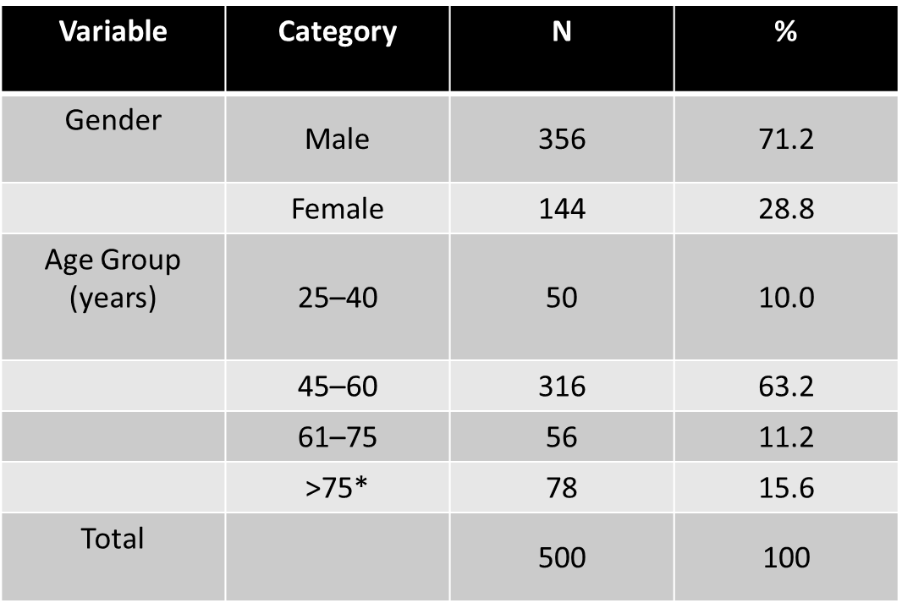

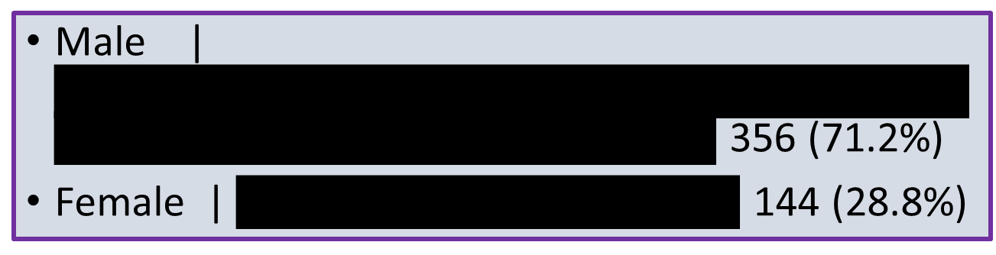

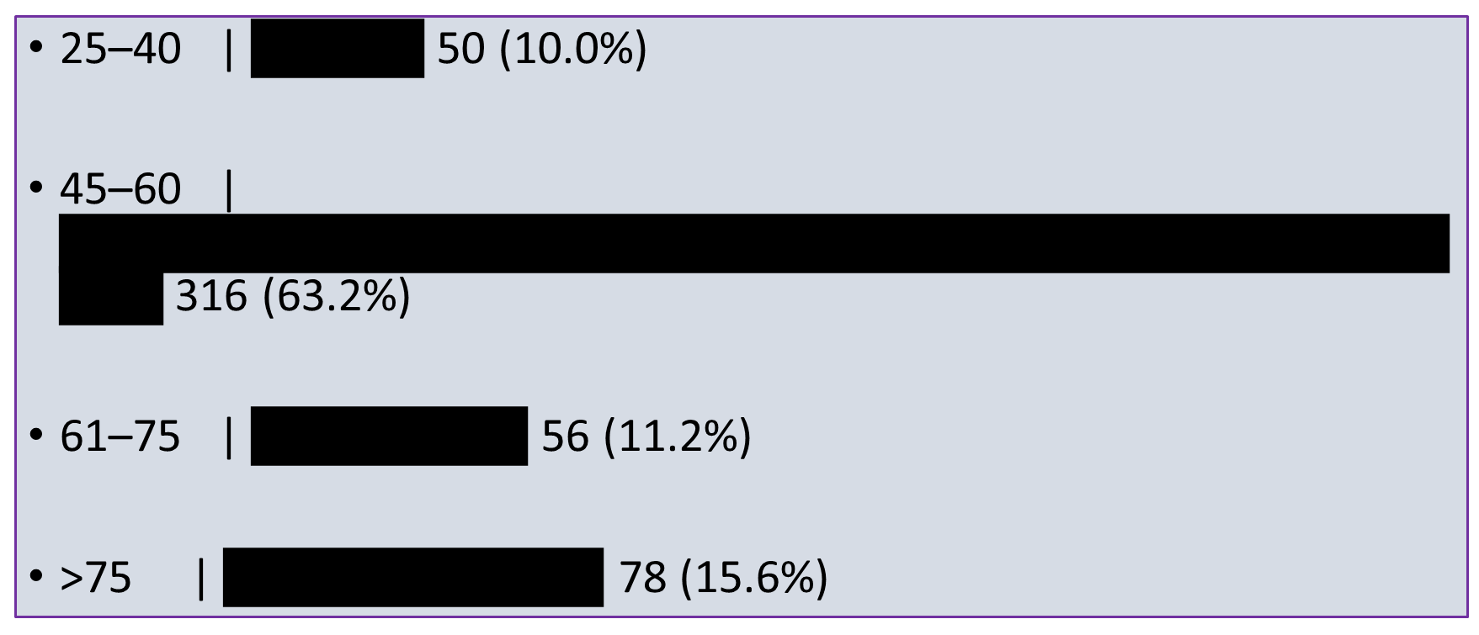
Figure 1: Age & Gender wise Frequency, Percentage distribution of Patients
SECTION B:

Table 2: Speciality wise frequency, Percentage distribution of patients.

SPECIALITY WISE | TOTAL
GYNAECOLOGY | 146
GENERAL SURGERY | 60
NEPHROLOGY | 135
GENERAL MEDICINE | 40
NEPHROLOGY | 80
GASTROENTROLOGY | 39

Figure 2: Speciality wise Frequency, Percentage distribution of Patients

SECTION B:

To evaluate and compare the effectiveness of clamping versus bladder training methods prior to Foley’s catheter removal among adult patients. (N = 500)

Table 3:

Outcome variables ( N=500) | Total
Successful voiding after catheter removal | 452
Need for re-catheterization / urinary retention | 48
Method used -Clamping | 150
Method used - Bladder Training | 350

Figure 3: effectiveness of clamping and bladder training methods prior to Foley’s catheter removal in adult patients. (N = 500) Frequency, Percentage distribution of Patients

DISCUSSION:
The present study evaluated the effectiveness of clamping versus bladder training prior to Foley’s catheter removal among 500 adult patients at Apollo BGS Hospital. The findings highlight the importance of individualized catheter removal strategies based on patient age, duration of catheterization, and underlying clinical condition.
In this study, 150 patients underwent intermittent clamping and 350 received bladder training alone prior to catheter removal. Overall, 48 patients developed urinary retention requiring re-catheterization, and all 48 cases occurred in the bladder training (non-clamping) group. This finding indicates a significant association between absence of clamping and increased risk of post-removal urinary retention, particularly in selected high-risk groups. Duration of catheterization emerged as an important influencing factor. Patients catheterized for short-term periods (3–4 days), especially younger post-operative cases, demonstrated successful voiding with bladder training alone and had minimal incidence of urinary retention. This suggests that routine clamping may not be necessary in short-term catheterized patients with intact bladder function.
patients catheterized for more than 10 days showed improved outcomes when clamping was performed prior to catheter removal. Prolonged catheterization is known to reduce bladder tone and detrusor muscle contractility due to continuous drainage, which may predispose patients to urinary retention. Gradual bladder filling through intermittent clamping may help restore bladder sensation and functional capacity before complete removal. Age was another significant factor identified in this study. Patients above 50 years demonstrated a higher incidence of urinary retention when catheter removal was performed without clamping. Age-related changes in bladder elasticity, decreased detrusor contractility, and possible outlet obstruction may contribute to impaired voiding in older adults. Therefore, clamping appears to offer protective benefits in this population.
It was also observed that in certain patients, even after clamping, bladder sensation was not adequately restored. In such cases, condom catheterization was implemented as a supportive management strategy to ensure safe bladder drainage and prevent over distention while closely monitoring urinary output. Neurological status further influenced outcomes. Patients with neurological disorders and prolonged catheterization (>15 days) required closer monitoring and individualized management. This emphasizes that catheter removal protocols should be guided by patient-specific risk factors rather than adopting a uniform approach.
Overall, the findings suggest that clamping prior to catheter removal may reduce the incidence of urinary retention in patients with prolonged catheterization and in older adults. However, bladder training alone appears sufficient and safe for younger patients with short-term catheterization. A selective, risk-based approach to catheter removal may therefore optimize patient outcomes and minimize complications.

Conclusion
The present study concludes that the effectiveness of clamping versus bladder training prior to Foley’s catheter removal depends largely on patient-specific factors such as age, duration of catheterization, and underlying clinical condition.
Bladder training alone was found to be effective in younger patients and those with short-term catheterization (3–4 days), with minimal incidence of urinary retention. However, patients aged above 50 years and those catheterized for more than 10 days demonstrated better outcomes when intermittent clamping was performed prior to catheter removal.
All cases of urinary retention requiring re-catheterization occurred in the non-clamping (bladder training alone) group, suggesting that absence of clamping may increase the risk of post-removal urinary retention in high-risk patients. Additionally, in selected cases where bladder sensation was not restored even after clamping, condom catheterization served as a supportive and safe alternative for bladder management.
Therefore, the study supports a selective, individualized approach rather than a uniform protocol for catheter removal. Implementing clamping in patients with prolonged catheterization, advanced age, and neurological conditions may help reduce the incidence of urinary retention and the need for re-catheterization, thereby improving patient outcomes and quality of care.

Acknowledgments
First and foremost, praises and thanks to the God, the Almighty, for His showers of blessings throughout my research work to complete the research successfully. We are grateful to all the subjects who participated in the study with all their time constraint.
I would like to express my deep and sincere gratitude to my Unit Head & Vice President Mr. Bharateesh Reddy, Apollo BGS Hospitals Mysore. I would like to express my special gratitude and thanks to Dr. Capt. (Mrs.) Usha Banerjee, Group Director Nursing. Apollo Hospitals. Delhi, for being a good mentor and for guiding us on the right path. I would like to express my special appreciation to Mrs. Asha KA, Nursing Superintendent, Apollo BGS Mysore. I would like to express my heartfelt gratitude Ms. Maryline Flinsi Principal & Ms. Rohini Sharma Vice principal ASON Delhi for their endless support in guidance and approving the Research study.

Conflicts of Interest and Funding
None

Reference:
1.Wang LH, Tsai MF, Han CY, Huang YC, Liu HE. Is bladder training by clamping before removal necessary for short‑term indwelling urinary catheter inpatients? A systematic review and meta‑analysis.
2.Ma S, GU J, Fan X. Need to clamp indwelling urinary catheters before removal after different durations: a systematic review and meta‑analysis. BMJ Open. 2023;13(2): e064075. doi:10.1136/bmjopen‑2022‑064075
3.Bladder training prior to urinary catheter removal in total joint arthroplasty. A randomized controlled trial.
4.Talreja V, Ali A, Saeed S, et al. Trial without catheter after transurethral resection of prostate: Clamp it or not? Scientific (Cairo).
5.Kim T, Lee E, Song JO, Lee EM, Park HR, Chang IS. Effectiveness of Foley clamping on bladder function recovery with lower gastrointestinal surgery patients

----------------------------------------------------------------

