LAND USE - LAND COVER CHANGE IN MAZE NATIONAL PARK, AN INSIGHT TO SOCIO-ECONOMIC DRIVERS AND CONSERVATION STATUS OF PLANT
¹Bedilu Bekele Mengistu ,²Wegene Getachew Andubo,³Zeleke Asefa Getaneh
¹Lecturer in Arba Minch University College of Natural Sciences ,²Lecturer in Kotebe University,³DAssistant Professor in Arba Minch University
¹Biology Department,
¹Arba Minch University Arba Minch, Ethiopia
bedhilubekele@yahoo.com , ²wegishcho@gmail.com, ³zelekepg@gmail.com
Abstract
Land use land cover change is the major concern, an indicator of deterioration and misuse of natural resources. This report briefly showed paradigm study carried out in Maze national parks in Gamo zone, Ethiopia a couple of years ago. The study's objective was to investigate the land use land cover changes and the plant in Maze National Park. The study was carried out on 150 plots on 10 transects from randomly selected areas. In addition, 50 quadrates for grass species sampling and 25 quadrates for soil sampling were randomly selected. According to land satellite image acquired from 1975 to 2015 there has been a considerable land use land change occurred in the park. Eight plant communities were identified with savanna grasses type takes the largest proportion. According to the study 81 woody plant species belonging to 41 families were identified. Nineteen grass species with 24 other different forbs were also part of floristic composition of the park. Fabaceae is the most abundant family and Combertum adenogonium is the dominant species. The soil seed bank diversity was found to be higher than the standing vegetation. Immediate intervention is required to conserve the endangered species of plants and animals.
Key words: Land use land cover change, maze national park, floristic composition,

Introduction
Land -use refers to the purposes for which humans exploit the land -cover whereas land-cover is the attribute of the earth’s land surface and immediate subsurface, including biota, soil, topography by, surface and ground water, and human structures (Lambin, Geist, & Lepers, 2003). Land-use and Land-cover change has become a principal component of strategies in monitoring environmental Changes (Mark & Kudawashe, 2010).
Reports from East Africa revealed that land use changes in East Africa have transformed land cover to farmlands, grazing lands, human settlements, and urban centers at the expense of natural vegetation and animal wildlife's (Maitima, et al., 2009).
Ethiopia is known to be a country where land use change led to meaningful change in land cover due to population pressure (Biniyam, Efrem, Zewdu, & Kassa, 2015). Forests, homes of the wildlife, of the country have been cleared for agriculture and other purposes (Hans, et al., 2010). Noticeable land use and land cover changes are also occurring in protected areas that are set aside for the conservation of biological diversity. Some of the land-use changes are orchestrated by the government. Aiming for development and prosperity turning from agricultural lead economy to industrialization made the country give less emphasis to conservation of natural resources. Among the many protected areas established for similar purposes, one such protected area where the dynamics in land use system is highly manifested is Maze National Park (MNP).
This study intended to investigate land use land cover change types in maze districts with respect to plant diversity.

Materials and Methods

2.1 Description of the study area:
Maze National Park (MNP) lays within the boundaries of four districts namelyQucha, Daramalo, Zala, and Kemba (figure-1). The park is located between 37º9’ 0”to 37º18’0” E and 6º18’0’’ to 6º30’0” N about at a distance of 473 and Southwest of Addis Ababa (Wegene G. , 2012). The park covers an area of 220 km2 (about twice the area of Manhattan) with altitudes ranging from 900 to 1400 meters above sea level. The park area's landscape is of diverse topographic features including a vast plain, some sloppy areas, small hills, escarpments, and chain of mountains at its boundaries.

2.2 Climate of the study area
The climate of MNP is in between wet and semi desert. The maximum annual mean and minimum annual mean temperature is 33.5 and 15.3 ºC respectively. The annual rainfall amount is between 843 to 1300mm (Wondimagegnehu & Bekele, 2011). It is a moderately bimodal rainfall distribution pattern. The long rainy season extends from mid of April and ends at late October. In dry season the wind velocity reaches 240 km/h. There is almost equal day and night hours throughout the year.
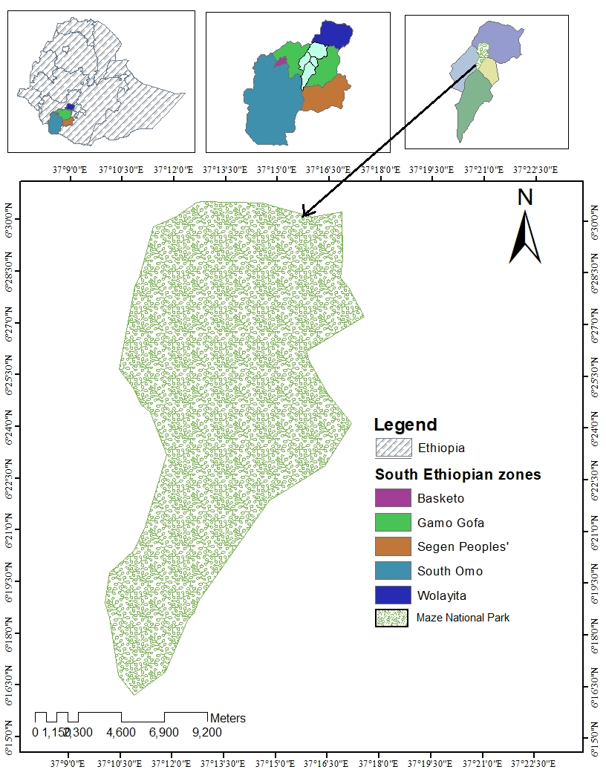
Figure 1 Study area: National boundary, regional map and zone (ArcGIS 10.1)

2.3 Data Collection Methods

2.3.1 Plant data collection
Woody plant samples were collected from 150 quadrats. Ten transects were laid out in the different agro-ecologies of the park in different orientations. Along each transect, fifteen 20 m × 20 m quadrats were laid at 200 m intervals. Abundance, frequency, Diameter at Breast Height (DBH) and density were computed. Along with this soil seed bank analysis was carried out.

2.3.2 Grasses
Since a large proportion of MNP is rangeland, 50 quadrats of 1m x1m were selected to identify the different types of grass species in the park. Grass species encountered were recorded and collected for identification from 1m x 1m sub plots in the main quadrat (20 m x 20 m) laid for shrubs and trees (Teshome, Abule, & Lisanework, 2012). Accordingly, four of the 1m x 1m quadrats were laid at corners of the main quadrat and the fifth 1m x 1m plot was laid at the center of the experimental unit for woody species.

2.4 Data analysis
2.4.1 Plant data analysis
The species diversity index that considers abundance and richness was calculated using the Shannon-Weiner index (H’). Since Shannon-Weiner index considers both species abundance and species richness, it is sensitive to changes in the importance of the rarest classes (Heuserr, 1998) and is the most used index. Shannon-Weiner index (H’) is calculated as:
--------------------------------------------equation-1
Where H’ = Shannon-Wiener diversity index, Pi= the proportion of individuals or the abundance of ith species, lnPi = logePi and S = the number of species. In addition, Simpson index (D) and Evenness index (E) that are considered as a measure of species dominances and a measure for evenness of spread respectively will be calculated. Simpson index is determined as:
----------------------------------------------------equation-2
Where Pi= the proportion of individual of each species. Evenness index (E) will be calculated using the equation:

-----------------------------------------------equation-3

Where H’= Shannon-Wiener Diversity Index, H’max= lnS = the natural logarithm of the total number of species and S = total number of species in the sample. Floristic similarities among different transects and plant communities will be calculated by employing Sorensen’s similarity coefficient (Kent & Coke, 1992):
--------------------------------------------------equation-4
Where a = number of species common to both categories, b = number of species present in the first category and absent in the second and c = number of species present in the second category and absent in the first.

3. Results and Discussions

3.1 The trends of land use land cover change
In the past 30 years land use and land cover change of MNP was accessed through Earth explorer satellites with different bands from www.usgs.com(table-1).
Table 1 GIS accession year, satellite and bands
Year of accession | satellite | Bands
1975 | Landsat 1-5 MSS | 3
1985 | Landsat 4-5 TM | 3
1995 | Landsat 4-5 TM | 5
2005 | Landsat 7 ETM | 8
2015 | Landsat 8 OLS/TRIS | 9
Accordingly, eight different landuse types were identified in the study area (table-2). These are bush land, farmland, grass land, mixed type, riverine forest, savannah grass,savanna fire and wood land. Out of the eight land use types five (farmland, grassland, riverine forest, savannah grass and savannah fire) showed growth and one with unpredictable changes and two land use types (bushland and mixed type) showed shrinkage.
Table 2 Description of LULCC types in maze national parks
LULCC types | Description
Bushland | Consist of shrubs, small trees with scatered grass and
Farmland | Annual or prerennial cultivated land
Grassland | Land Consist of dominantly grasses and forbs
Mixedtype | Land occupiedd by settlement, road, small farm,
Riverine forest | Land occupied by woody trees along river courses
Savannah grass | Land dominantly covered by grasses and scattered tree
Savannah fire | Land of ash formed from burned grass
woodland | Land dominantly covered by woody big and medium trees

Bush land coverage was 42.64(20.9%) of the total area in 1975 but in 1985 it is reduced to 29.13 (14.2%) and climbed up in 1995 and 2005 to 39.71 (19.4%) and 78.68 (38.5%) respectively and in 2015 it shrinked back to 29.02 (14.2%). Similar result was observed in studies taken dijo area Gelana highland (Daniel, 2008) (Birhan & Assefa, 2017). The rapid spread of bushland in the mentioned years could be caused by relatively random high rainfall distribution in the respective years. Sharma and Kant (2014) mentioned that random climatic conndition could affect the composition of plant in a certain area. It is highly linked also to the othe land use type changes (Birhan & Assefa, 2017). For instance bush land highly correlatedd to farm land, and grass land land use change. As it can be seen from the figure-2below, bushland is inversely related to savana grass land (figure-2).
Significant relation was observed between savanah fire and savannah grass land. As the savannah fire increases the grass land seems to shrink in the last three decads from 1985 to 2015. The parallel relation ship between mixed type and riverine forest also observed in this particular study.
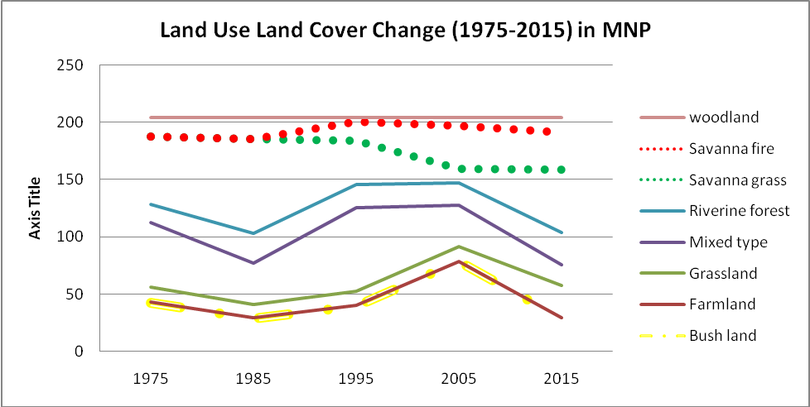
Figure 2 Relative presentation of land use land cover change with two randomly paired LU types

The absolute relation of the eight-land use change is shown in figure-3. According to this study savannah grass land declined at an accelerated rate from 1985 to 2005 and restored back 2005 onwards. Data gathered from key informant interviews confirmed that this destruction of savannah grassland is attributed to rapid population growth and increasing demand of cultivable and grazing land and for construction homes in the study area. (Wegene & Feleke, 2015) pointed out this fact that rapid population growth is the driving force for the LULC in the area.
On contrary bush land and savannah fire were increasing from 1975 up to 2005 and started to collapse starting from the end of 2005. This might be the climatic fluctuation of the country which changes every decade causing severe drought. Riverine forest seems to remainat steady rate.
Farmland land use was changed at a lower rate compared to other land use types. This is surprisingly different from other reports carried somewhere else. Alemu and his colleagues reported that 2322 SKm/year change in northern parts of Ethiopia (Biniyam, Efrem, Zewdu, & Kassa, 2015).
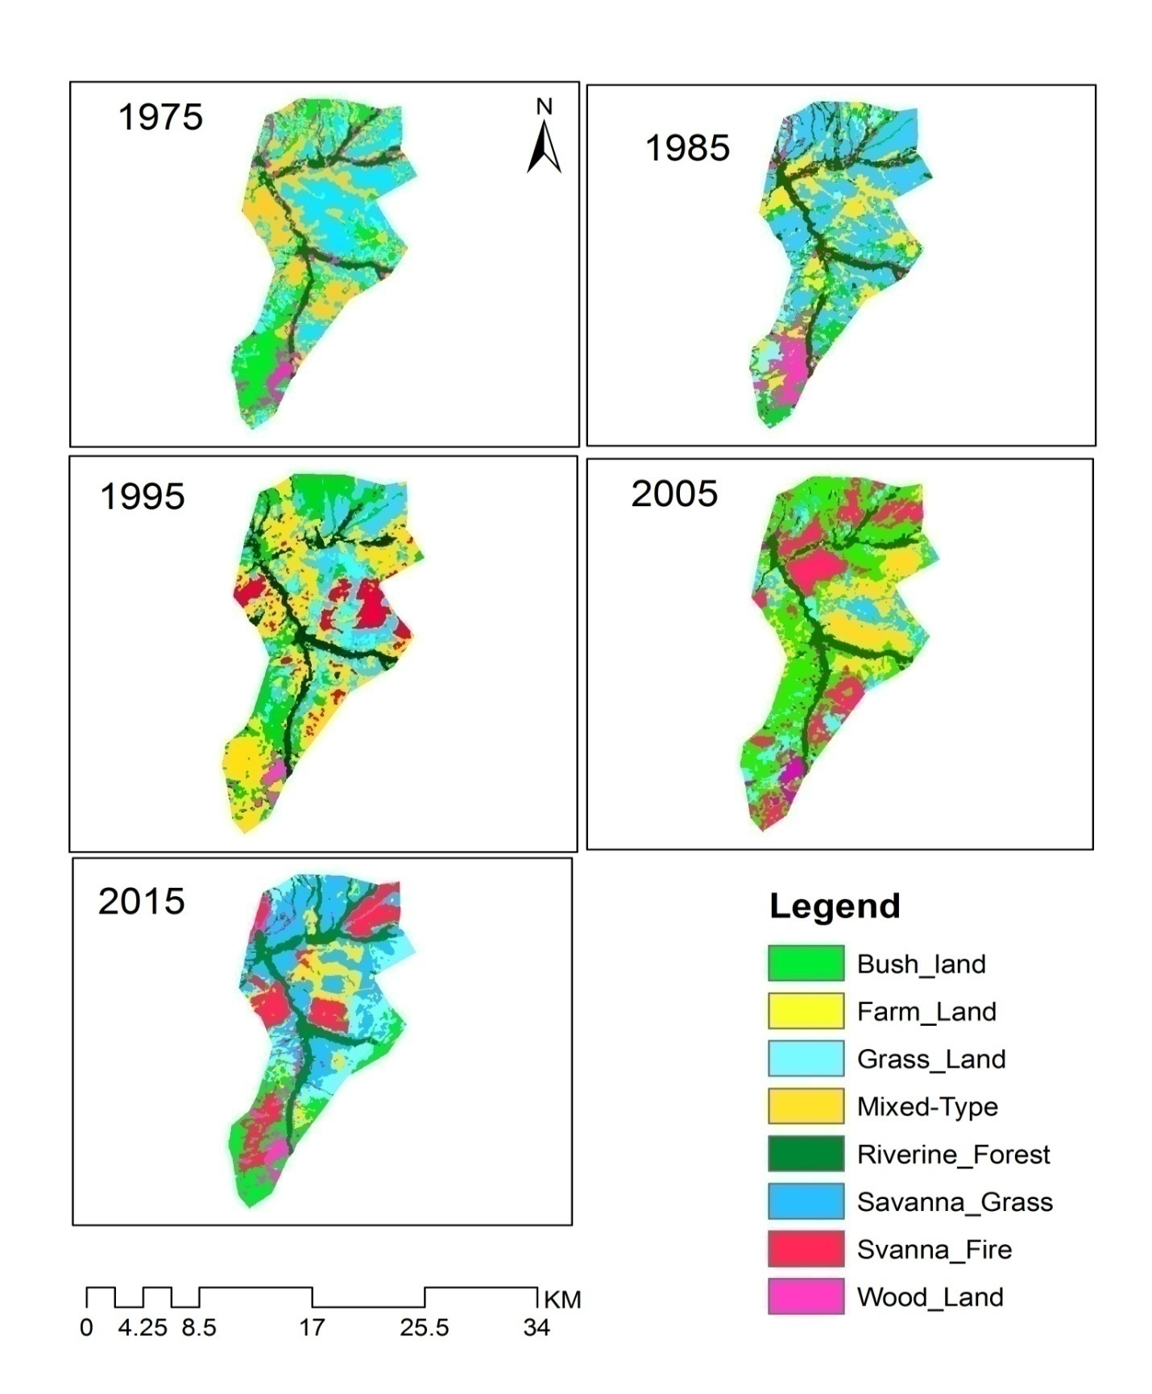
Figure 3 Land use land Cover Change in MNP from 1975-2015

3.2 The status of plant species of Maze National Park (MNP)
Overall,81 woody plant species belonging to 21 families were recorded. The most abundant families are Fabaceae/Leguminosae represented by 14 species (35.1 %) followed by Combertaceae 5 species (12.1%), Celasteraceae and malvaceae each with 4 representative species. Oleaceae and Sapindaceaeare each represented by 3 species and Annacardiaceae, Apocynaceae, Asparagaceae, Boraginaceae, Capparaceae, Moraceae, Mytraceae, Peraceae, Rhamnaceae and Rutaceae each represented by 2 species. The remaining families are represented by one species in the study area. The current study is almost like the finding with (Wegene & Feleke, 2015).

Figure 4Occurrence of the first 12 plant families in MNP

Plant Diversity Analysis
The diversity of MNP woody plants and non-woody plants were analysed using different tools. According to this study Combertum adenogonium followed by Vachellia drepanolobium, Maytenus arbutifolia have the first three highest species abundance. Wogene and Feleke also found similar results (Wegene & Feleke, 2015). The first half woody plant species with their species abundance RF, Basal area, Relative dominance and IVI values is presented in the following table-3.

Table 3 Relative density, frequency, Basal area and IVI values for top ten plant species in MNP
plant species | nSp | F | RF | Rdns | Basal Area | RDOM | IVI
Combretum adenogoniumsteud. Ex A.Rich | 438 | 68.67 | 5.41 | 13.18 | 1803.07 | 14.23 | 32.83
Vachellia drepanolobiumHarms ex Y.Sjöstedt | 183 | 55.3 | 4.36 | 5.51 | 465.44 | 3.67 | 13.54
Maytenusarbutifolia(Hochst. ex A.Rich.) R.Wilczek | 70 | 20 | 1.57 | 2.11 | 406.54 | 3.21 | 6.89
HarrisoniaabyssinicaOliv. | 61 | 20 | 1.57 | 1.83 | 289.78 | 2.28 | 5.70
Vacheliaseyal(Delile) P.J.H.Hurter | 59 | 26.7 | 2.10 | 1.77 | 190.85 | 1.51 | 5.38
Grewia bicolor Juss. | 53 | 20.6 | 1.63 | 1.59 | 154.97 | 1.22 | 4.44
Brideliascleroneura Mull.Arg. | 49 | 20.6 | 1.63 | 1.47 | 128.81 | 1.01 | 4.12
Paliurusspina-cristi Mill. | 49 | 22.6 | 1.78 | 1.47 | 242.33 | 1.91 | 5.17
Combretum molle (R. Br. ex G. Don) | 47 | 17.3 | 1.36 | 1.41 | 225.09 | 1.77 | 4.55
Asparagus flagellaris Baker | 45 | 17.3 | 1.36 | 1.35 | 22.61 | 0.17 | 2.90
Allophylus abyssinicus (Hochst.) Radlk. | 43 | 18.67 | 1.47 | 1.29 | 167.86 | 1.32 | 4.09
Vachelliasieberiana(DC.) Kya. & Boatwr | 39 | 16 | 1.26 | 1.17 | 183.76 | 1.45 | 3.88
Bersama abyssinica Fresen | 39 | 13.3 | 1.05 | 1.17 | 169.07 | 1.33 | 3.56
Capparis fascicularis DC. | 39 | 16.67 | 1.31 | 1.17 | 70.73 | 0.55 | 3.04
Clutia abyssinica Jaub. & Spach | 39 | 16 | 1.26 | 1.17 | 31.85 | 0.25 | 2.68
Dichrostachyscinerea (L.) Wight& Arn. | 39 | 16.67 | 1.31 | 1.17 | 189.81 | 1.49 | 3.98
Dodonaea viscose subspangustifolia (L. f.) J.G.West | 39 | 14 | 1.10 | 1.17 | 12.15 | 0.09 | 2.37
Protea gaguedi J. F. Gmel. | 39 | 14 | 1.10 | 1.17 | 100.29 | 0.79 | 3.07
Senegalia polyacantha(Willd.) Seigler & Ebinger | 38 | 16.67 | 1.31 | 1.14 | 89.27 | 0.71 | 3.16
Combretum collinum subsp. binderianum (Kotschy) Okafa | 38 | 15.3 | 1.20 | 1.14 | 111.11 | 0.87 | 3.23
Euclea racemosa subsp schimperi (A.DC.) F.White | 38 | 15.3 | 1.20 | 1.14 | 102.09 | 0.81 | 3.15
Jasminum grandiflorum subsp floribundum (R. Br. ex Fresen) P.S.Green | 38 | 17.33 | 1.36 | 1.14 | 45.86 | 0.36 | 2.87

Shanon diversity index has the power to measure both species richness and species abundance. The present study showed (figure-5) that higher diversity of woody plants in transect- 6 (4.0) and followed by transect-1(3.9) and transect-4 (3.8). Lower diversity was observed in transect-3 (3.7) and then transect-8 (3.7). Kent and Coker (Kent & Coke, 1992) mentioned that the ‘H’ value falls between 1.5 to 3.5 and rarely climbs up to 4.5.

Figure 5 Shannon diversity(H) analysis over transect

Simpson diversity index
Simpson diversity index analysis also gave similar results to Shannon. Transect -6 showed some similarity with transect 7 but in terms species composition transect 6 much higher than transect-7 (figure-6).

Figure 6 Simpson diversity index

Sorenson similarity index
From 10 transects laid for this study, Sorenson’s similarity index showed that transect-3 is more similar with transect-8 with 91% and the least similarity exists between transect 2 and transect 3 with the value of 29% (Table-6). The Shannon and Simpson diversity analysis also supports that transect-3 and transect-8 have closer diversity values.
Table 4 Sorenson similarity index between transects
 | T1 | T2 | T3 | T4 | T5 | T6 | T7 | T8 | T9 | T10
T1 | 0
T2 | 0.61 | 0
T3 | 0.56 | 0.29* | 0
T4 | 0.51 | 0.39 | 0.46 | 0
T5 | 0.56 | 0.48 | 0.54 | 0.56 | 0
T6 | 0.62 | 0.52 | 0.60 | 0.48 | 0.59 | 0
T7 | 0.56 | 0.47 | 0.49 | 0.39 | 0.49 | 0.64* | 0
T8 | 0.51 | 0.48 | 0.91* | 0.40 | 0.45 | 0.54 | 0.61 | 0
T9 | 0.48 | 0.43 | 0.49 | 0.49 | 0.51 | 0.55 | 0.49 | 0.51 | 0
T10 | 0.53 | 0.50 | 0.46 | 0.51 | 0.44 | 0.57 | 0.47 | 0.42 | 0.48 | 0

Cluster analysis
In the plant community Cluster analysis of MNP, 5 plant community types were identified (figure-7). These communities were named based on the most dominant species they possessed. Siraj (Siraj, Zhang, & Zerihu, 2016) and Wogene and Feleke (Wegene & Feleke, 2015) found six different plant communities using different data sampling approaches. This variation may be due to loss of some species from which are selectively cut for some purposes. Both researchers named their community based on the present and absence of some dominant plant species in the cluster. The present studyalso uses the same criteria for naming the community.

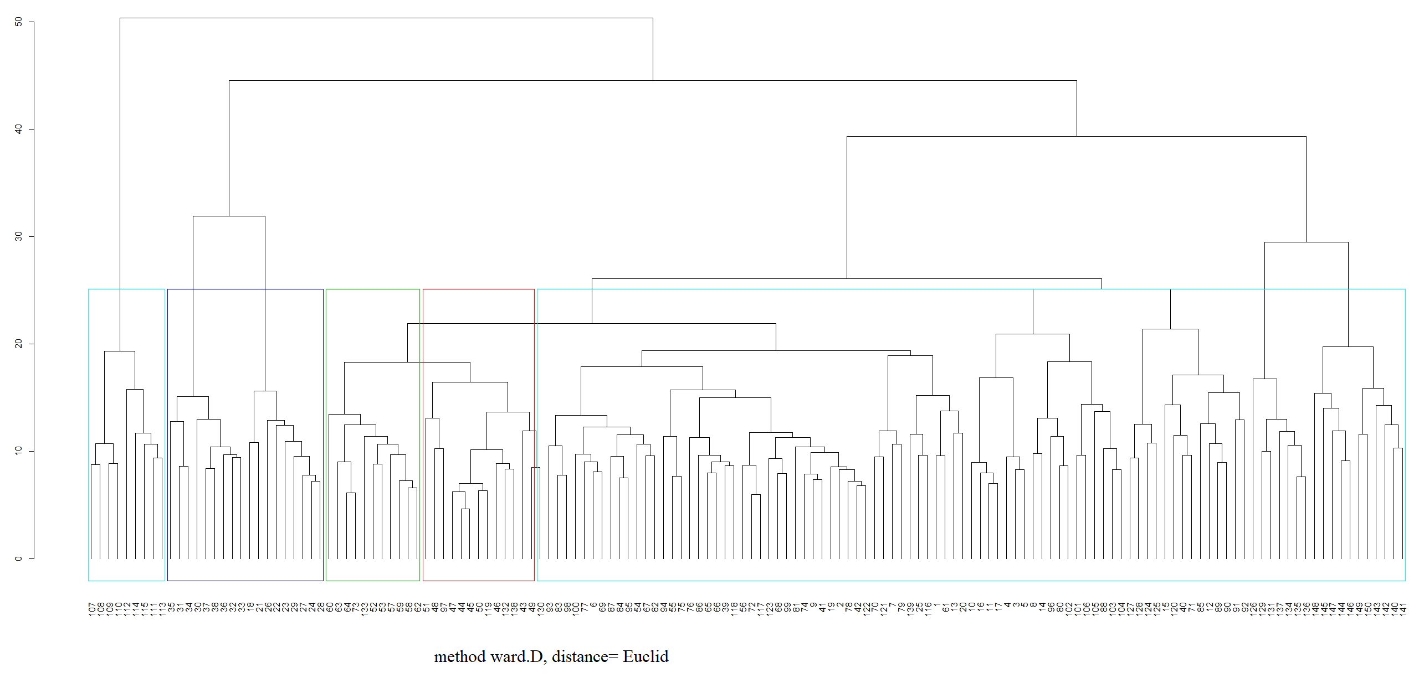
Figure 7 Cluster analysis of MNP sampled plots
Each cluster contains a determined number of plots with dominant representative species of woody plants. C1=9, C2=18, C3=11, C4= 14, C5= 98
Were,
C1: Senegalliapolyacantha, Vachelliadrepanosom, Brideliascleroneura community

C3: Bersamaabyssinica, Oliniarochetiana, Ximenia americana community
C2: Albiziaschimperiana, Vachelliatortilis, Asparagus flagellaris community
C4: Combretumadenogonium,Euclearacemosa, Ehretiacymosa community
C5: Combretum adenogonium, Vachelliaseyal, Grewia ferruginea community

Soil seed bank
About 3,240 individual seeds were found representing 136 plant species from eight LULC types each with 3 quadrats (figure-8). Of these 67% were herbaceous and the remaining 33% were perennial plant seeds. This figure is a little bit different from the standing vegetation in terms of species composition. In the present study species composition is higher in soil seed bank than standing vegetation. Similar findings were reported by (Juying & Wenjuan, 2006) (Cui, Bo, W., Ruilun, & Juying, 2017). The woody plants seem to have reduced in soil seed bank whereas herbaceous plant species almost double the number of the standing vegetation. According to Juying and Wenjuan more herbaceous plant species could exist in seed state in soil seed bank than standing vegetation (Juying & Wenjuan, 2006). Cho hypothesized the phenomenon because of succession.

Figure 8 soil seed bank distribution within various land used types in MNP

5. Conclusions and Recommendations

5.1 Conclusions
This study showed that there has been a great deal of Land use land cover change in the past 30 years in Maze National Park. Most of the LULC occurred due to human-caused activities. Illegal hunting, tree cutting and small-scale farming and nomadic pastoral activities are the identified drivers for the LULC. There are about 8 different land cover types in the study area. Savanna grass land and bush land types are the most highly exploited land use types.
The change in LULC affected many components of the park. According to the present study 27.1 % savanna grass land and 14.2 % of bush land have been lost with their precious plants and animal species recently.
Five diverse types of plant community types have been identified in MNP. Fabaceae is the most dominant family of the plant taxa. The most dominant species is C. adenogonium with 32.82 IVI followed by A. drepanolobium and M. arbutifolia
The Biophysico chemical properties of the soil status in MNP showed that moderately fertile soil with good organic carbon and Nitrogen with average water holding capacity. The soil seed bank analysis showed that more plant diversity is found in soil seed bank than in standing vegetation. The soil seed bank distribution varies with land use types and in the present study savanna grass land holds the highest soil seed bank followed by grass land.

5.2 Recommendations
Based on the above findings the following recommendations are forwarded to all stakeholders.
- Community based conservation and protection methods must be launched
- Awareness of the local people towards protection and use of park should be strengthened with continuous meeting at kebele level
- Community based task force should be established in conservation of especially endangered species of plant and mammals
- Strategies should be designed so that local peoplebenefit from the conservation of the park. For instance, engaging local people in tourism based economic activities like hiring cars, food and shelter, tour guide, etc.
- Valid and vital information exchange capacity of the local people and scout must be established
- Scout associations at local school level should be established so that young children participate and feel the park's stewardship.

References
Biniyam, A., Efrem, G., Zewdu, E., & Kassa, H. (2015). Land Use and Land Cover Changes and Associated Driving Forces in North Western Lowlands Of Ethiopia. 5 (1).
Birhan, A. M., & Assefa, A. Y. (2017). Land use Land Cover Changes and Their Environmental Implications in the Gelana subwatershed of Northern Highland's of Ethiopia. Envron Syst Res , 12-25.
Cho, Y., & Lee, C. (2018). Florstic Composition and Species Richness of Soil Seed Bank in Three Abandoned Rice Paddies along a Seral Grdient in Gwangneung Forest Biosphere Reserve, South Korea. Journal of Ecology and Environment , 42:12, 112-124.
Cui, L., Bo, X., W., Q., Ruilun, Z., & Juying, W. (2017). Responses of Soil Seed Bank and Vegetation to the Increasing Intensity of HUman Disturbance in a Semi-Arid Region of Northern China. Sustainability , 9, 18-37.
Daniel, A. M. (2008). Remote Sensing and GIS-Based Land Use and Land Cover Changes Detection in the Upper Dijo River Catchment , Silte Zone Southern Ethiopia . Addis Ababa: NTNU Addis Ababa University.
Hans, h., Solomon, A., Amare, B., Berhanu, D., Eva, L., Brigitte, P., et al. (2010). Land Degradation and Sustainable Land Management in the Highlands of Ethiopia. In U. W. Hans Hurni, Globa Change and Sustainable Development. Swiss: Geographica Bernesia.
Heuserr, M. (1998). Putting Diversity Indices into Practice. Some Considerations for Forest Management in Netherlands. Proceedings of the Conference on Assessment of Biodiversity for Improved Forest Planning, . Kluwer (pp. 7-11). Swizerland: Kluwer Academic Publisher.
Juying, J., & Wenjuan, B. (2006). The Potential for Vegetation Restoration from Soil Seeded Bank in Abandoned Croplands on Hilly Gullied Loes Plateau, China. . Unpuplished . Loes, China.
Kent, M., & Coke, P. (1992). Vegetation Description and Analysis: A Practical Aproach. London: Belhaven press.
Lambin, E., Geist, H., & Lepers, E. (2003). Dynamics of Land Useand Land Cover Changes in Tropical Regions . Annu.Rev.Environ. Research , 205-241.
Maitima, J., Mugatha, S., Rein, R., Gachimbi, L., Majule, A., Layaruu, H., et al. (2009). The Linkages Between Land Use, Land Degradation and Biodiversity Across East Africa. Afr. J. Environ. Sci. Technol. , 3 (10), 310-325.
Mark, M., & Kudawashe, M. (2010). Rate of Land Use Land Cover Changes in Shurugwi District, Zimbabwe: Drivers for Change. . Jour.Sus.Dev.Afr , 15-28.
Sharma, N., & Kant, S. (2014). Vegetation Structure Floristic Composition and Species Diversity of Woody Plant Communities in Sub-Tropical Kandi Siwaliks of Jammu. India International Journal of Basic and Applied Science , 3 (4), 382-391.
Siraj, M., Zhang, K. S., & Zerihu, W. (2016). Floristic Composition and Plant Community Types in Maze National Park South West Ethiopia. Applied Ecology and Environmental Research , 245-262.
Teshome, A., Abule, E., & Lisanework, N. (2012). Evaluation of Rangeland in Arid and Semi-Arid Grazing Land of Southeast Ethiopia. Intern J.Agri.Sci , 2 (7), 221-234.
Wegene, G. (2012). The Impact of Land Use Changes on Woody Plant Diversity in and around Maze National Park. MSc Thesis . Kucha, Ethiopia.
Wegene, G., & Feleke, W. G. (2015). Land Use Practices, Woody Plant Species Diversity and Associated Ipacts in Maze National Park, Gamo Gofa Zone, Southwest Ethiopia. Science Publishing Groups , 64-74.
Wondimagegnehu, T., & Bekele, A. (2011). Current Population stattus of The Endangered Endemic Species of Swayene's Hartebeest (Alcelaphus buselaphus swayenei) In Maze National Park Ethiopia. SINET: Ethiop.J. Sci. , 34 (1), 39-48.

