Improving Student Performance Using the Think-Pair-Share Strategy

ABSTRACT
This study determined the effectiveness of the Think-Pair-Share strategy in improving the mathematics performance of Grade 10 students at South East-Asia Institute Of Trade & Technology, Fairview, Quezon City during the school year 2025-2026. The study used a quasi-experimental pretest-posttest nonequivalent control group design involving 64 students from two intact Grade 10 classes, with 32 students assigned to the experimental group and 32 students assigned to the control group. A 40-item researcher-made mathematics achievement test covering selected Grade 10 competencies on quadratic equations, quadratic functions, and problem solving served as the main instrument. The test was validated by mathematics teachers and yielded a reliability coeﬀicient of 0.84. The experimental group was taught through the Think-Pair-Share strategy for six weeks, while the control group was taught through the usual lecture-discussion method. Data were analyzed using frequency, percentage, mean, standard deviation, paired-samples t-test, and independent-samples t-test. The results showed that the two groups had comparable pretest scores, but the experimental group obtained a higher posttest mean and a greater mean gain than the control group. Statistical analysis revealed a significant difference between the posttest scores of the two groups at the 0.05 level. The findings indicate that Think-Pair-Share is an effective strategy for improving the mathematics performance of Grade 10 students. The study recommends the use of Think-Pair-Share in mathematics instruction to promote active participation and stronger academic performance.
Keywords: Think-Pair-Share, cooperative learning, mathematics performance, quasi-experimental, Grade 10, active learning

INTRODUCTION
Student performance remains one of the most important indicators of educational quality because it reflects how well learners understand and apply lesson content. In mathematics education, performance is strongly connected to students’ ability to reason, solve problems, and explain solutions accurately. However, many students in public secondary schools struggle in mathematics due to limited classroom participation, low confidence in recitation, and dependence on teacher explanation.
At South East-Asia Institute Of Trade & Technology, Fairview, Quezon City, mathematics instruction may become more effective when students are given structured opportunities to think independently and discuss ideas with peers. While the lecture-discussion method remains useful for content delivery, it may not always provide enough wait time and interaction for students to process mathematical concepts deeply. As a result, some learners remain passive during class, which may contribute to weaker performance.
Think-Pair-Share (TPS) is a cooperative learning strategy that addresses this need for active engagement. It allows students to think about a question individually, discuss their response with a partner, and then share ideas with the class. This structure supports participation, confidence, and conceptual understanding. In mathematics, where students often hesitate to respond because of fear of error, TPS can provide a safer and more supportive path toward accurate reasoning and stronger performance.
This study aimed to determine the effectiveness of Think-Pair-Share in improving the mathematics perfor-mance of Grade 10 students at South East-Asia Institute Of Trade & Technology. Specifically, it sought to answer the following: (1) What is the profile of the respondents in terms of sex and group assignment?
(2) What are the pretest performance levels of the experimental and control groups in mathematics? (3) What are the posttest performance levels of the experimental and control groups in mathematics? (4) Is there a significant difference between the pretest and posttest scores within each group? (5) Is there a

significant difference between the posttest scores of students exposed to Think-Pair-Share and those exposed to lecture-discussion?
At the 0.05 level of significance, the following null hypotheses were tested: (1) there is no significant difference between the pretest and posttest scores of the experimental group, (2) there is no significant difference between the pretest and posttest scores of the control group, (3) there is no significant difference between the pretest scores of the experimental and control groups, and (4) there is no significant difference between the posttest scores of the experimental and control groups.
The findings of this study may benefit students by helping them become more active, confident, and accurate in solving mathematics problems. Mathematics teachers may use the results as evidence for integrating structured cooperative strategies such as TPS into daily lessons. School administrators may find support for classroom-based interventions and teacher development focused on active learning. Curriculum planners may use the findings for instructional planning that emphasizes participation and mathematical reasoning. Future researchers may use the study as a reference for related investigations in other grade levels, subjects, and school contexts.
This study focused on determining the effect of Think-Pair-Share on mathematics performance among Grade 10 students of South East-Asia Institute Of Trade & Technology, Fairview, Quezon City. It involved two intact classes with a total of 64 students: 32 in the experimental group and 32 in the control group. The intervention lasted six weeks and covered selected Grade 10 competencies on quadratic equations, quadratic functions, and problem solving. The study used a 40-item researcher-made test administered as pretest and posttest. Findings are limited to the respondents, competencies, duration, and instructional conditions of the study and may not be generalized to all schools without further validation.

REVIEW OF RELATED LITERATURE

Active and Cooperative Learning
Active learning has been widely identified as an effective instructional approach because it requires students to engage directly in the learning process rather than passively receive information. Prince (2004) explained that active learning promotes engagement through participation, reflection, and classroom interaction. Freeman et al. (2014) further showed that students in active learning environments generally achieve higher than those in purely lecture-based settings.
Cooperative learning is a major form of active learning and is often associated with improved achievement and social interaction. Johnson and Johnson (2009) emphasized that students learn better when instruc-tion includes positive interdependence, interaction, and individual accountability. Slavin (2014) noted that cooperative learning can raise academic performance when classroom activities require students to explain, justify, and compare their ideas.

Think-Pair-Share as an Instructional Strategy
Think-Pair-Share, introduced by Lyman (1981), is a structured cooperative strategy consisting of three phases: thinking, pairing, and sharing. During the think phase, students process the question independently. During the pair phase, they exchange and refine ideas with a classmate. During the share phase, they present responses to the larger group. This sequence increases wait time, broadens participation, and helps students develop confidence before public recitation.
In mathematics teaching, discussion-based and reasoning-based strategies are particularly important because mathematical competence includes both procedural skill and conceptual explanation. Gillies (2016) high-lighted that structured talk improves learning when interaction is purposeful and guided by clear teacher facilitation. TPS supports this need by allowing students to test ideas in a low-risk peer setting before sharing formally, which may reduce anxiety and improve answer quality.

Synthesis
The reviewed literature consistently supports the value of active and cooperative learning in improving student outcomes. A common finding across studies is that students perform better when they are given

opportunities to think, discuss, and explain rather than merely listen. The literature also suggests that cooperative structures are most effective when they are clear, routine, and aligned with lesson objectives. The present study builds on these findings by testing TPS in an actual Grade 10 mathematics classroom context. While prior works support the general effectiveness of active learning, this study contributes local evidence by examining TPS implementation in South East-Asia Institute Of Trade & Technology and comparing it directly with lecture-discussion instruction.

THEORETICAL FRAMEWORK
This study is anchored in Vygotsky’s social constructivist theory, which emphasizes that learning develops through social interaction, dialogue, and guided participation (Vygotsky, 1978). According to this perspec-tive, students build understanding more effectively when they exchange ideas and receive support from peers and teachers. The study is also grounded in social interdependence theory (Johnson & Johnson, 2009), which explains that cooperative structures improve learning when students work toward shared goals while remaining individually accountable. In TPS, students are expected to formulate their own response and then improve it through collaboration. This aligns with both independent thinking and cooperative responsibility. The study followed an Input-Process-Output (IPO) model. The input consisted of students’ initial mathemat-ics performance (pretest scores), selected Grade 10 competencies (quadratic equations, quadratic functions, and problem solving), and the instructional approach (Think-Pair-Share for the experimental group; lecture-discussion for the control group). The process involved administration of the pretest, six-week implementa-tion of instructional strategies, administration of the posttest, and statistical analysis and interpretation of scores. The output was the measured improvement in mathematics performance and comparative evidence on the effectiveness of Think-Pair-Share.

METHODOLOGY

Research Design
This study employed a quasi-experimental pretest-posttest nonequivalent control group design. This design was appropriate because the respondents came from two intact Grade 10 classes, and random assignment of students was not feasible. One class served as the experimental group and received Think-Pair-Share instruction, while the other served as the control group and received lecture-discussion instruction.

Locale of the Study
The study was conducted at South East-Asia Institute Of Trade & Technology, Fairview, Quezon City. The school setting represented a typical public secondary school environment where mathematics performance is an ongoing instructional concern.

Respondents and Sampling Procedure
The respondents were 64 Grade 10 students enrolled during the period of data collection. The study used intact class grouping: 32 students in the experimental group and 32 students in the control group. The two groups were taught the same competencies over the same period to maintain comparability.
Table 1. Profile of the Respondents

Group Male Female Total

Experimental | 15 | 17 | 32
Control | 14 | 18 | 32
Total | 29 | 35 | 64

Research Instrument
The primary instrument was a 40-item researcher-made mathematics achievement test based on selected Grade 10 competencies in quadratic equations, quadratic functions, and problem solving. The test was used as both pretest and posttest to determine changes in student performance after the intervention.

Validation and Reliability of the Instrument
The test underwent content validation by three mathematics teachers to ensure alignment with the com-petencies and appropriateness of item content. The instrument was pilot-tested among non-participating students and obtained a reliability coeﬀicient of 0.84, indicating acceptable reliability for classroom-based research.

Data Gathering Procedure
Data gathering followed these steps: (1) preparation and validation of the achievement test, (2) securing of school permission and coordination with teachers, (3) selection of two intact Grade 10 classes, (4) ad-ministration of the pretest to both groups via Google Forms, (5) six-week instruction period where the experimental group received Think-Pair-Share strategy and the control group received lecture-discussion method, (6) administration of the posttest to both groups via Google Forms, and (7) tabulation, analysis, and interpretation of data.
In the experimental class, each lesson used the TPS cycle: individual thinking time, pair discussion, and whole-class sharing. This routine was repeated across lessons to build consistent student participation and mathematical communication.

Statistical Treatment of Data
The following statistical tools were used: frequency and percentage for respondent profile; mean and stan-dard deviation for pretest and posttest performance; paired-samples t-test for within-group pretest-posttest differences; and independent-samples t-test for between-group differences. All tests were interpreted at the
0.05 level of significance.

Ethical Considerations
Permission to conduct the study was obtained from school authorities. Participation was handled according to classroom research ethics, with attention to student welfare, confidentiality of results, and appropriate use of collected data for academic purposes.

RESULTS AND DISCUSSION

Pretest Performance of the Groups
Table 2. Pretest Performance of the Groups

Group n Mean Score SD MPS

Experimental | 32 | 13.06 4.08 32.65
Control | 32 | 13.28 3.91 33.20

Table 2 shows that the pretest means of the experimental (13.06) and control (13.28) groups were very close. The minimal difference indicates that both groups started from nearly the same level of mathematics performance. The low MPS values also suggest that many students initially had diﬀiculty with the targeted competencies.

Posttest Performance of the Groups
Table 3. Posttest Performance of the Groups

Group n Mean Score SD MPS

Experimental | 32 | 27.34 4.55 68.35
Control | 32 | 21.88 4.86 54.70

After six weeks, both groups improved, but the experimental group obtained a higher posttest mean. The experimental group’s mean gain was 14.28 points, while the control group’s mean gain was 8.60 points. This pattern indicates stronger improvement among students taught through Think-Pair-Share.
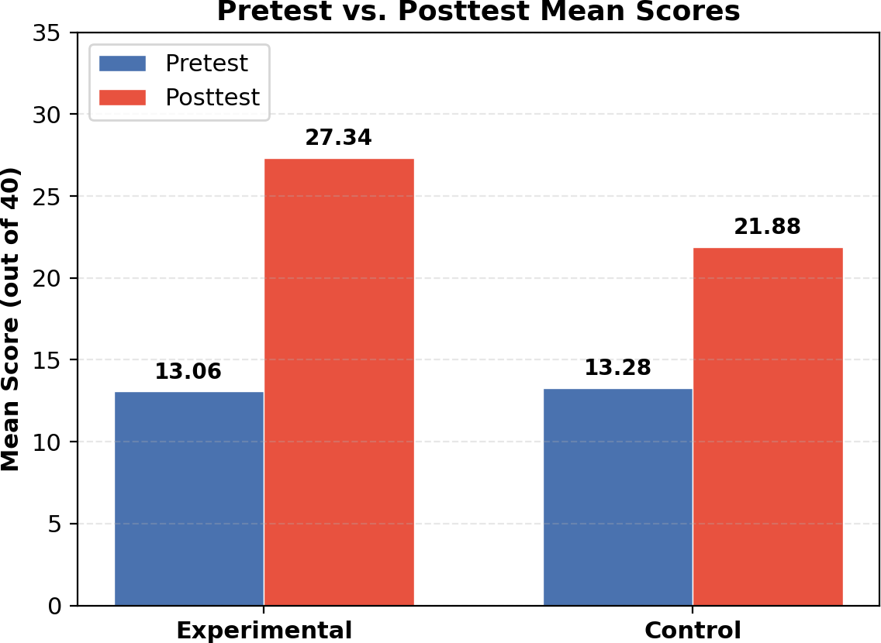

Figure 1: Pretest vs. Posttest Mean Scores

Test of Significant Differences
Table 4. Test of Difference in the Scores of the Respondents

Pretest vs Posttest Control Pretest vs Posttest Experimental vs Control Pretest Experimental vs Control Posttest
Comparison | Mean Difference | t-value | p-value | Interpretation
Experimental | 14.28 | 14.97 | <0.001 | Significant

8.60 9.34 <0.001 Significant

-0.22 -0.22 0.826 Not Significant

5.46 4.67 <0.001 Significant

Table 4 indicates that both groups improved significantly from pretest to posttest. However, the critical result is the significant difference in posttest scores between the experimental and control groups, favoring

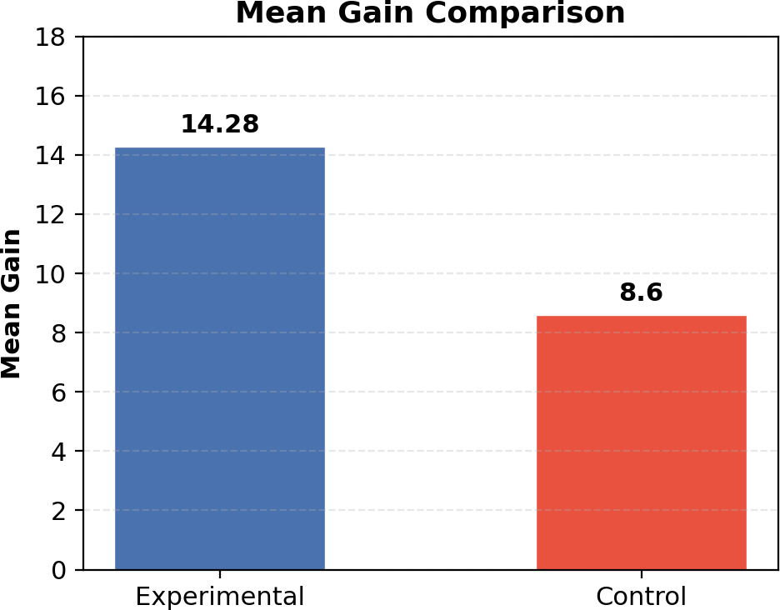

Figure 2: Mean Gain Comparison

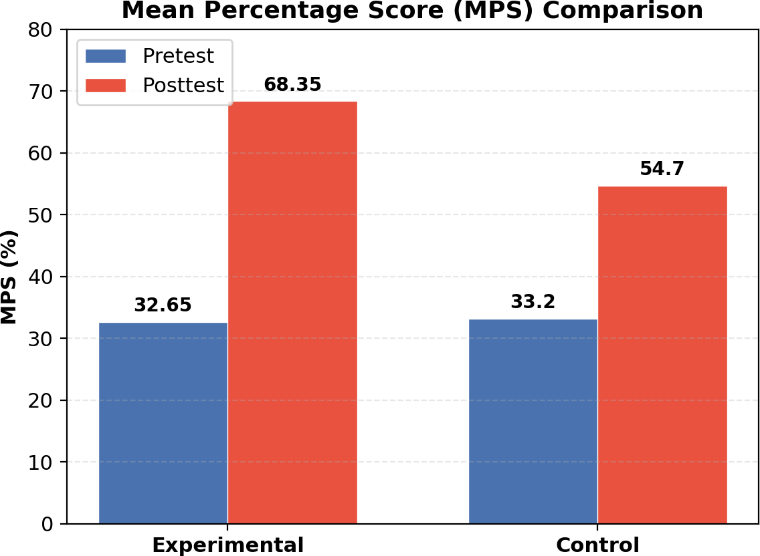

Figure 3: Mean Percentage Score (MPS) Comparison

the experimental class. This supports the conclusion that TPS had a positive and statistically significant effect on mathematics performance.

Discussion of Findings
The findings suggest that TPS helped students process mathematical problems more effectively through a sequence of individual reasoning, partner discussion, and class sharing. This sequence likely improved confi-dence, reduced hesitation, and strengthened understanding before final response. The results support social constructivist and social interdependence perspectives, where learning is enhanced through guided interac-tion and shared cognitive work. The outcomes are also consistent with prior literature (Prince, 2004; Freeman et al., 2014; Johnson & Johnson, 2009; Slavin, 2014; Gillies, 2016), which emphasized that structured active learning can improve achievement.

CONCLUSION
This study examined the effectiveness of Think-Pair-Share in improving Grade 10 mathematics performance at South East-Asia Institute Of Trade & Technology using a quasi-experimental pretest-posttest nonequiv-alent control group design. The experimental and control groups were comparable at baseline, as shown by non-significant pretest difference (p = 0.826). Both groups improved significantly from pretest to posttest. However, the experimental group achieved a higher posttest mean (27.34) than the control group (21.88) and had a larger mean gain (14.28 compared to 8.60). A significant posttest difference favored the experimental group (p < 0.001), indicating the effectiveness of TPS.
Think-Pair-Share is an effective instructional strategy for improving mathematics performance among Grade 10 students in the context of this study. Structured peer interaction, combined with individual thinking time, can produce stronger learning gains than lecture-discussion alone. Classroom practices that increase participation and mathematical communication can contribute to better achievement outcomes.
In light of the findings, mathematics teachers may integrate Think-Pair-Share regularly, especially in lessons requiring reasoning and problem solving. School administrators may support training and classroom coach-ing on cooperative learning strategies. Teachers may combine TPS with formative assessment to monitor individual understanding during pair work. Future studies may replicate this research in other grade levels, subject areas, and school settings. Future researchers may explore longer intervention periods and additional variables such as motivation, engagement, and confidence.

REFERENCES
- Creswell, J. W., & Creswell, J. D. (2018). Research Design: Qualitative, Quantitative, and Mixed Methods Approaches (5th ed.). SAGE Publications.
- Freeman, S., Eddy, S. L., McDonough, M., Smith, M. K., Okoroafor, N., Jordt, H., & Wenderoth,
M. P. (2014). Active learning increases student performance in science, engineering, and mathematics.
Proceedings of the National Academy of Sciences, 111(23), 8410-8415.
- Gillies, R. M. (2016). Cooperative learning: Review of research and practice. Australian Journal of Teacher Education, 41(3), 39-54.
- Johnson, D. W., & Johnson, R. T. (2009). An educational psychology success story: Social interde-pendence theory and cooperative learning. Educational Researcher, 38(5), 365-379.
- Lyman, F. T. (1981). The responsive classroom discussion: The inclusion of all students. In A. Anderson (Ed.), Mainstreaming Digest (pp. 109-113). University of Maryland, College of Education.
- Prince, M. (2004). Does active learning work? A review of the research. Journal of Engineering Education, 93(3), 223-231.
- Slavin, R. E. (2014). Cooperative learning and academic achievement: Why does groupwork work?
Anales de Psicología, 30(3), 785-791.
- Vygotsky, L. S. (1978). Mind in Society: The Development of Higher Psychological Processes. Harvard University Press.

ABOUT THE AUTHORS
James Michael M. Cello is a Computer Engineering student from Eulogio ‘Amang’ Rodriguez Institute of Science and Technology (EARIST) , Manila, Philippines. His research interests include classroom-based educational research, active learning strategies, and mathematics instruction.
Kurt Euan Peña is a Computer Engineering student from Eulogio ‘Amang’ Rodriguez Institute of Science and Technology (EARIST) , Manila, Philippines. His work focuses on identifying practical teaching approaches that can improve student participation and academic performance in secondary school classrooms.

Engr. Minerva C. Zoleta is a Professional Computer Engineer and a dedicated Computer Engi-neering Professor at Eulogio ‘Amang’ Rodriguez Institute of Science and Technology (EARIST)
, Manila, Philippines, specializing in Embedded Systems, Operating Systems, and Computer Net-work and Security. With a strong background in academia and industry, she has been instrumental in shaping the next generation of Engineers through innovative teaching methods and hands-on research. Engr. Zoleta holds a Master’s degree in Electrical Engineering major in Computer Engineering at Technological University of the Philippines, Manila and is pursuing her Doctorate degree in Engineering with specialization in Computer Engineering at Technological Institute of the Philip-pines. She has presented published research on topics such as Embedded System, IoT applications, and wireless communication in international conferences and journals. Passionate about technology-driven solutions, she has led various projects integrating smart systems into real-world applications, contributing to the advancement of local and international engineering communities.

Albert Einstein a srudent of Master of Science in Electrical Engineering major in Computer Engineering at Technological University of the Philippines. A Speaker, Trainer and Consultant with 18 Trainings in 5 Countries. Chief Solutions Strategist of NPH Management and Consultancy and THINK Inside the Box. Speaker to Computer World, Featured in Computer World Magazine. One of Fuji Xerox Philippines, Foremost Authority in Solution Selling & Training DMS, Security & Cloud.

