AN INVESTIGATION ON THE VARIATIONS OF THUMB DERMATOGLYPHICS AMONG RESIDENTS OF BUSHENYI TOWN COUNCIL, BUSHENYI DISTRICT, UGANDA

ABSTRACT
Background: Dermatoglyphics (fingerprint ridge patterns) are unique to each individual and have genetic and environmental determinants. Fingerprints are one of the means of individual identification that is used internationally because no two people will ever have the same fingerprints. However there has been some similarities among close relatives. The flexibility of friction ridge skin means that no two finger or palm prints are ever exactly alike, never identical in every detail. In Uganda especially Bushenyi district, there is no published information concerning thumb print variation and its relationship to the social and economic status of Bushenyi town council resident. Some cultures in Africa have associated some specific fingerprints patterns to an individual’s social economic status.
Objective: To investigate the variations in thumb dermatoglyphic patterns (loops, whorls, arches) among close relatives of Bushenyi Town Council and determine relationships by pattern, gender, laterality, and family lineage.
Methods: A quantitative descriptive cross-sectional study was conducted from January to March 2026 involving 385 participants from 77 households. Thumbprints were collected using the standard ink-and-paper method and classified according to Henry’s classification system. Data were analyzed using SPSS version 8.0. Chi-square tests compared patterns by gender and side (p<0.05 significant).
Results: The common types of fingerprint patterns were whorls, arches and loops. The whorls are the commonly occurring type of fingerprint pattern which were 250 (65%), followed by the arches at12 (29%) and finally the loops which were 23 (6%).

Regarding parent/offspring fingerprint relationship, it was established that 273 (71%) of the participants had similarities between the parents and offsprings in the patterns of thumbprints types. There was no clear evidence in similarity between the parents and offsprings among 112 (29%) participants. Majority of the siblings 261 (68%) had similar thumbprint patterns among the offsprings. The rest of the participants 124 (32%) did not show similarities in thumbprint patterns among the offsprings.
Thumbprint relationship between right and left thumb in the study revealed that most of the participants 335 (87%) had similar right and left thumbprint patterns of the same individual. The remaining participants 50 (13%) did not have obviously similar patterns of fingerprints.

According to the study the occurrence of the thumbprint types was almost similar in relation to gender. In male the occurrence of loops was 25 (6.5%) while in female it was 21 (5.5%). The occurrence of arches in male was 103 (27%) and in female it was 119 (31%). On the whorls, the occurrence in male was 235 (61%) while in female it was 266 (69%).
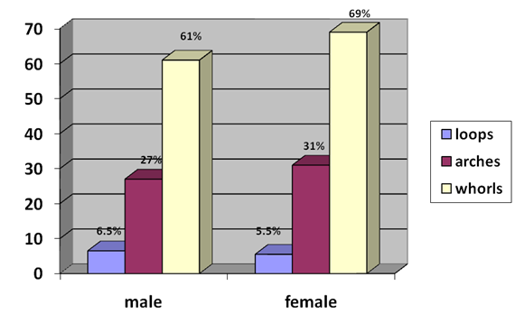
Conclusion: According to the study, thumb dermatoglyphics among the residents of Bushenyi town council, Igara county, Bushenyi district, Uganda, the study has revealed that the common thumbprint patterns in Bushenyi town council, Igara county, Bushenyi district were whorls, aches, and loops. The majority of the participants had similarity in the thumbprint patterns between the parents and the offsprings. The majority of the sibling in different families had similar thumbprint patterns. The relationship between the right and left thumb show similarities in the majority of the participants. The thumbprint patterns in relation to gender shows very minimal variations in various types of thumbprint patterns.
Keywords: Thumb dermatoglyphics, fingerprints, whorls, arches, loops, Bushenyi, Uganda

