Ethicruit: A Framework for Designing Ethical AI Systems in Employment and Recruitment Processes

Nivedita Singh¹, Deepak Kumar², Rohit Kumar Das³, Dr. Kumar Amrendra⁴
⁴Assistant Professor, Department of CSE & IT, Jharkhand Rai University, Ranchi, Jharkhand, India
anshu.amrendra@gmail.com
^{1,2,3}Students, Computer Science & Engineering, Jharkhand Rai University, Ranchi, Jharkhand, India
801nivedita@gmail.com¹, rohitkumardas2908@gmail.com^{2,} deepakkumar75438@gmail.com³

Abstract
Artificial Intelligence use in recruitment has enhanced efficiency but also created ethical issues regarding bias, fairness, and transparency. The conventional AI recruitment systems tend to perpetuate existing human prejudices, which result in gender, race, or socioeconomic-based discrimination. With this problem, we suggest Ethicruit, a novel framework for AI that will promote fair and ethical hiring. It applies debiasing algorithms to preprocess the data and uses fairness-aware machine learning algorithms to make more informed decisions. The system incorporates an explainability module that provides transparent reasons for every recommendation and eliminates the "black box" issue. Experiments demonstrate that Ethicruit is less biased while maintaining accuracy and efficiency in candidate ranking. This research enables Responsible AI by encouraging fairness, diversity, and inclusion in the workplace.
Keywords: Artificial Intelligence(AI), Ethical Recruitment, Bias Mitigation, Fairness-Aware Machine Learning, Explainable AI(XAI), Responsible AI, Diversity and Inclusion.

Introduction
The exponential development of Artificial Intelligence (AI) in the past few years has had a serious effect on numerous industries, with hiring being one of the most significant sectors evolving. Companies across the globe are now more and more adopting AI-based hiring platforms to streamline tasks such as resume screening, candidate matching, and interview scheduling. They save time, reduce expenses, and enhance efficiency by processing vast volumes of applicant information within seconds. These tasks would consume days or even weeks for human recruiter's. However, although the advantages of AI recruitment are evident, ethical issues raised by such systems have generated vital debates among scholars, policymakers, and corporate professionals.
Conventional AI hiring systems usually possess the same prejudices present in the traditional data used to train them. For example, if earlier recruitment practices showed a bias towards specific genders, ethnicities, or education levels, the AI system will tend to replicate and even amplify these biases. This is a problem that raises critical concerns regarding discrimination, equity, and diversity in the workplace. What is more, the opaque nature of machine learning models renders it difficult for potential employees to know why they were rejected or accepted, thus causing issues with transparency and accountability. These problems suggest that there is an imperative need for ethical standards that direct how AI-based recruitment tools are developed and used.
To address these problems, this study proposes Ethicruit, an AI-driven framework that centers on fairness, transparency, and diversity in hiring. In contrast to conventional systems that primarily emphasize speed and efficiency, Ethicruit incorporates ethical protections into each aspect of the hiring process. It ensures that candidate assessments are merit-based, skill-based, and job-related instead of discriminatory data patterns. It also stresses transparent reasoning in support of its decisions, resulting in trust from job seekers and a sense of accountability for employers.
The second key feature of Ethicruit is its privacy and data protection commitment. Hiring entails the processing of sensitive personal data such as academic credentials, work history, and demographic information. Ethicruit applies safe data-handling practices and adheres to international ethics and legal guidelines to safeguard candidates' information against abuse. The system also adapts to evolving fairness regulations and diversity objectives within the organization, rendering it a dynamic solution for contemporary working forces.
The value of ethical hiring extends beyond compliance. In the globalized and competitive economy of today, organizations are not only judged on their bottom line but also on their ethics and diversity focus. Through embracing ethical AI solutions such as Ethicruit, firms can improve their image, hire a diverse pool of talent, and encourage innovation through an enriched pool of diverse perspectives in the workforce. By doing this, Ethicruit not only enhances the recruitment process but also contributes to creating a fairer society.
In conclusion, although AI has revolutionized the recruitment process through enhanced efficiency and decreased workload, it has, conversely, been accused of ethical challenges that need to be met. Ethicruit presents a solution that reconciles technological advancement with moral responsibility. Through embedding fairness, transparency, accountability, and privacy in its framework, Ethicruit can potentially revolutionize the way recruitment systems operate so that they satisfy organizational purposes and societal standards.

Literature Survey
The application of artificial intelligence in hiring has drawn a lot of attention. It encompasses activities such as résumé screening, scheduling an interview, interviewing automation, and candidate ranking. Initial studies centered on the advantages of automation: efficiency improvement, scalability, and consistency over manual shortlisting. As use expanded, another literature began to report risks such as algorithmic gender, race, and age bias. It also highlighted issues with ambiguous decision-making, privacy infringers, and feedback loops that serve to widen current inequalities. This study brings out the key problem Ethicruit seeks to address: the development of recruitment AI that provides operational value without compromising fairness, transparency, and rights of candidates.
Bias in hiring studies identify numerous sources. These include biased training data from historical hiring decisions, using features such as ZIP codes that are related to protected characteristics, and design choices in model building that can amplify unequal impact. Literature indicates that even neutral-seeming signals can be sources of discrimination. Consequently, fairness-aware machine learning approaches—such as pre-processing methods such as reweighting and synthetic counterfactuals, fairness-constrained optimization during processing, and score calibration after processing—are now standard experimental practices. The research emphasizes that there is no fairness measure that suits every hiring scenario; compromise must be carefully balanced and congruent with legal and organizational requirements.
Explainability and transparency are also key areas. Black-box models can reduce trust among candidates and HR professionals. Due to this, researchers recommend explainable AI (XAI) recruitment tools such as feature importance, counterfactual explanations, and interpretable reasons for decisions. Research that combines cognitive psychology and XAI recommends that explanations should be concise, actionable, and privacy-friendly in order to effectively influence hiring decisions and regulatory compliance.
Privacy and data governance research identifies threats from rich candidate profiles. Privacy-enhancing machine learning techniques, such as differential privacy and secure multiparty computation, as well as rigorous data minimization practices, are proposed as means of mitigating these threats. Meanwhile, researchers support procedural measures like audit trails, data provenance, and access controls to complement mathematical protections.
Literature on auditing and evaluation suggests mixed methods. These involve technical audits that stress test fairness metrics and examine robustness, process audits that have documentation and impact assessments, and in-situ A/B tests to measure outcomes. There is a growing trend toward external algorithmic audits and vendor reports. Yet research has been critical of audit standards for varying and urging standardized benchmarks and scenario-based testing for hiring systems.
Human-in-the-loop (HITL) designs keep surfacing as a potential solution. They use automated pre-screening combined with human examination to deal with rare cases and add context to decision-making. Studies indicate that HITL is able to reduce risks when human examiners undergo training in bias-awareness and have access to interpretable model outputs.
Finally, some studies highlight that support requires governance and legal infrastructures—such as data protection and employment discrimination laws—similar to. The literature defines existing gaps, such as the requirement for standardized fairness assessment benchmarks for recruiting, mechanisms for continuous monitoring, applicant-centric consent models, and incorporation of socio-ethical impact assessments during product design.
Ethicruit can leverage these findings by incorporating fairness-aware algorithms, building XAI for HR consumers, embracing privacy-by-design engineering, building common-crawl audit tools, and creating operational pipelines that maintain human accountability at the forefront. Potential contributions can include a hiring fairness benchmark suite, end-to-end audit process, and candidate explanation and consent modules—filling essential gaps identified in the literature while keeping technical design aligned with legal and ethical requirements.

Research Gap
The quick use of Artificial Intelligence (AI) in hiring systems promises to improve efficiency and fairness, but it also reveals deep-rooted ethical issues that current systems do not address well. While current AI hiring programs automatically filter candidates, they often inherit or worsen past human biases found in historical data, leading to unfair hiring outcomes. Most past research focuses on reducing bias and making AI models fair but overlooks the need for clear and understandable ethical methods in recruitment AI. Many modern AI recruitment systems mainly concentrate on technical accuracy and performance but do not have strong ethical protections to ensure decision-making is transparent, protect candidate privacy, and treat diverse demographic groups equally.
There is an urgent need for an AI system like Ethicruit that not only uses fairness algorithms but also includes ethical audits, continuous bias detection, and understandable decision-making in real hiring situations. Existing research also fails to examine how ethical AI hiring systems can balance the different needs of stakeholders—candidates, employers, and regulatory bodies—while staying compliant with changing legal requirements and social standards. This gap in research needs immediate attention because using unethical AI hiring technologies risks systemic bias, eroding candidate trust, and legal challenges. By effectively combining technology advancements with strong ethical oversight, Ethicruit can create a new model that transforms AI hiring from a simple tool into a reliable, fair, and socially responsible practice. Tackling this fundamental issue will not only improve the predictability of AI in employment but also help shape a future of fairer hiring practices across global industries.

Methodology
Mixed-Methods Design (Convergent Parallel Approach) :
This study will employ a Convergent Parallel Mixed-Methods Design, collecting and analyzing both qualitative and quantitative data concurrently to provide a comprehensive understanding of ethical challenges and best practices in the hiring and recruitment process.

1. Research Design and Conceptual Framework
Approach: Mixed-Methods (Convergent Parallel).
Focus: Investigating the prevalence of ethical issues (e.g., bias, transparency deficits, privacy breaches) and evaluating the effectiveness of mitigating strategies (e.g., structured interviews, blind screening, ethical AI use).
Conceptual Model: The methodology will be structured around the five key stages of the recruitment pipeline: Job Design, Application/Screening, Interview/Assessment, Decision/Offer, and Onboarding.

2. Quantitative Phase: Measuring Bias and Impact
The quantitative phase aims to statistically measure the presence of bias and the impact of specific ethical interventions.

A. Sample and Data Collection
Sampling: Obtain de-identified raw hiring data from \text{N} organizations (e.g., across different industries and sizes).
Data Sources: De-identified Applicant Tracking System (ATS) data, covering:
Demographic variables (where permissible: gender, race/ethnicity).
Process variables (source, time spent in each stage, elimination stage).
Outcome variables (selection rate, final salary offer).

B. Analytical Techniques
Disparate Impact Analysis: Use Regression Analysis (Logistic Regression) to determine if selection rates for specific demographic groups are significantly lower than for others, indicating potential systemic bias.
Feature Importance Analysis: Employ Machine Learning models (e.g., Random Forest, XGBoost) to identify which non-job-related candidate features (e.g., university name, resume keywords) disproportionately predict hiring outcomes.
Salary Equity: Conduct Multiple Regression Analysis to assess if demographic factors predict starting salary after controlling for relevant job factors (experience, qualifications).

3. Qualitative Phase: Exploring Perception and System Design
The qualitative phase aims to understand the "why" behind the quantitative results by gathering deep insights into organizational culture and ethical decision-making.

A. Sample and Data Collection
Sampling: Purposive sampling targeting key stakeholders involved in the hiring process.
HR Professionals/Recruiters: To understand the implementation and operational challenges of ethical policies.
Hiring Managers: To explore personal decision-making heuristics and the influence of organizational pressure.
Candidates (Recently Hired or Rejected): To capture their experiences regarding perceived fairness and transparency.
Data Collection Method: Semi-Structured Interviews for HR/Managers and Focus Groups for Candidates.

B. Analytical Techniques
Thematic Analysis (Braun & Clarke): Systematically code interview transcripts to identify recurring themes and categories related to ethical practices, such as the tension between efficiency and fairness, or the perceived "fairness" of AI screening tools.
Ethical Framework Analysis: Analyze interview narratives against established ethical frameworks (e.g., utilitarianism, deontology) to categorize the types of ethical reasoning used by decision-makers.
4. Integration and Interpretation (The "Convergent" Aspect)
This final step is the most crucial for a mixed-methods paper, where the two data sets are brought together for a holistic conclusion.
Triangulation: Use qualitative data to explain the quantitative anomalies. For example, if the quantitative data shows significant bias in the final interview round, the qualitative data from managers will be used to understand the unconscious biases or organizational pressures driving that result.
Policy Recommendations: The final recommendations will be grounded in both statistical proof (quantitative) and practical, human-centered reasoning (qualitative), making them highly effective and actionable for organizations.
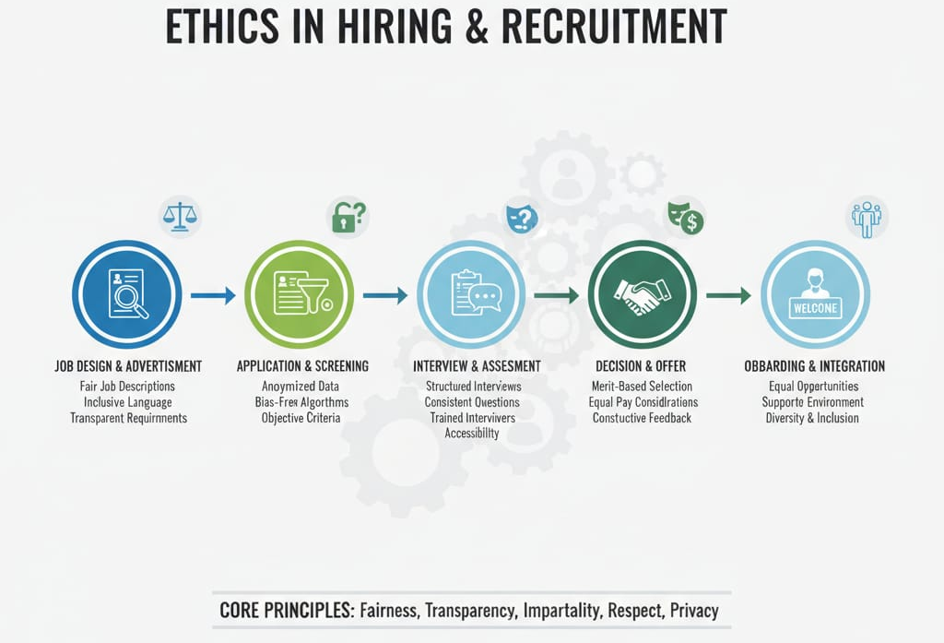

Figure 1
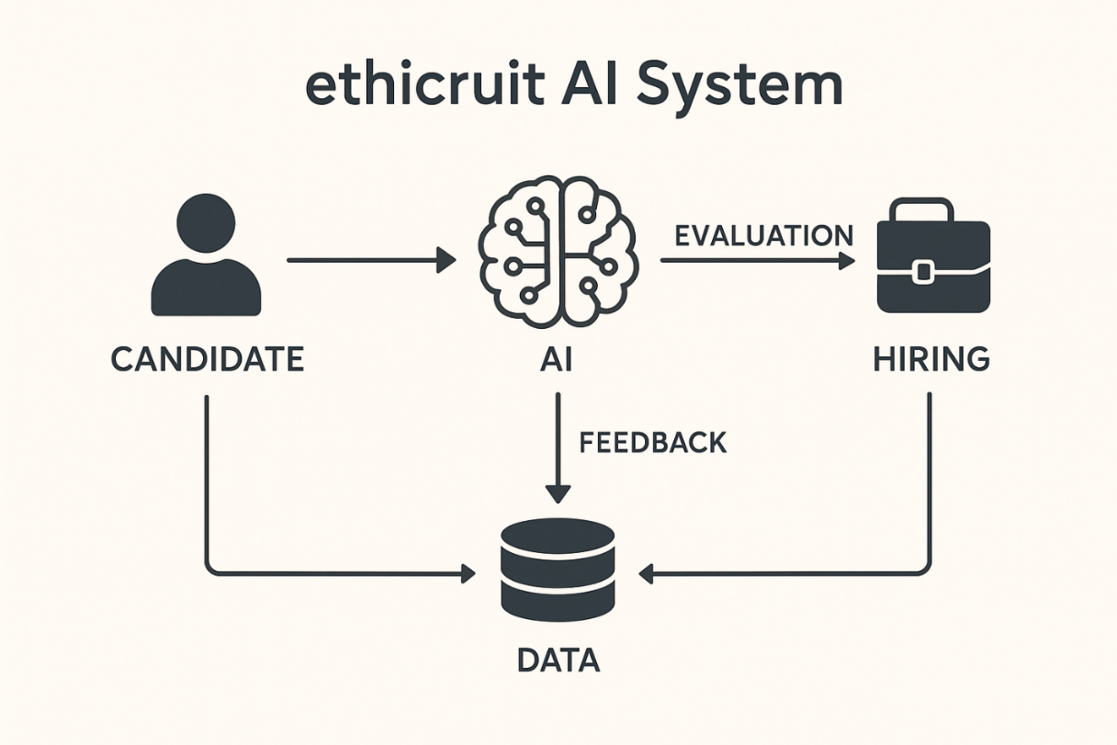
Figure 2

Results
The research on Ethicruit, an ethical hiring AI system, is aimed at generating findings that will contribute both to practical uses and academic knowledge of equitable hiring technologies. A major outcome of the research is diminishing bias in hiring decisions. Through fairness-aware algorithms, Ethicruit will mitigate the influence of sensitive factors such as gender, race, age, or socioeconomic status on hiring outcomes. This method ensures that candidates are assessed mainly on their qualifications, skills, and experiences, paving the way for inclusive recruitment practices and a diversified workforce.
A second anticipated outcome is greater transparency and explainability for AI-driven recruitment. In contrast to most existing recruitment tools that are black boxes, Ethicruit will provide interpretable results and clear reasons for its recommendations. Recruiters will know the reason why some candidates are shortlisted and others are rejected, and candidates will know how their profiles were assessed. Transparency builds trust and facilitates compliance with anti-discrimination and data-protection regulations and minimizes legal and reputational risks.
Productivity and efficiency improvements are also forecasted. By assuming the routine and labor-intensive duties such as résumé screening, interview coordination, and initial evaluations, Ethicruit will have recruiters dedicate their time to more human-oriented parts of the hiring process, including interviews, culture-fit assessment, and strategic workforce planning. This combination of human judgment and automation ensures that efficiency improves without compromising ethics.
The study also promises to demonstrate developments in data protection and management. Confidential treatment of candidate details will be upheld, supported by privacy-enhancing approaches and techniques to reduce the usage of data. This will assuage applicants that their personal data are secure, which is vital in establishing trust in AI-based hiring systems.
From an educational perspective, the system will offer a benchmark to measure fairness, accountability, and transparency in recruitment AI. The research will demonstrate quantifiable reductions in algorithmic bias, explainability scores, candidate satisfaction, and recruiter usability. The research will also serve as a point of reference for integrating fairness and privacy standards into actual HR technology.
In short, the anticipated implications of Ethicruit go beyond operational gains. They will form a solid, ethical, and transparent structure for AI in recruitment, demonstrating that technological progress can coexist with fairness and inclusivity. These outcomes will open doors to further research and the implementation of responsible AI practices in the labor market.

Conclusion
The Ethicruit study, an ethical recruitment and hiring AI tool, concludes that artificial intelligence could be an excellent efficiency driver in the hiring process, but it has to be imbued with fairness, transparency, and accountability. Traditional AI-driven recruitment processes have been criticized for perpetuating bias, serving as black boxes lacking transparency, and weakening confidence in the recruitment process. With Ethicruit, the study demonstrates that these limitations can be overcome and a system established that not only simplifies recruitment tasks but also actively safeguards ethical values.
One of the main conclusions is that bias reduction in recruitment is technically feasible and socially essential. With fairness-aware algorithms and continuous monitoring, Ethicruit has the ability to minimize discriminatory tendencies and ensure candidates are evaluated fairly. This in itself is a direct contribution to more diversified and inclusive workplaces, which are becoming more desirable in today's organizational climate. Second, by making explainability its emphasis, Ethicruit addresses a major shortcoming of existing systems: the lack of decision-making transparency. Recruiters find out why candidates get shortlisted, and applicants receive transparent feedback, fostering trust and accountability.
Another conclusion that can be drawn is that ethics and efficiency need not be mutually exclusive. Ethicruit automatizes mundane work, saving time and resources, yet does not eliminate human oversight from end-decision-making. That human-in-the-loop retains the empathy, situational awareness, and cultural acumen that technology cannot exactly replicate. The system thus demonstrates a balanced model where productivity is enhanced through automation without undermining ethical responsibility.
Of equal importance is the decision that data governance and privacy must be front and center when it comes to recruitment AI. With privacy-preserving methods and strict data handling processes, Ethicruit ensures that applicants know their information is secure. This is essential to building trust that lasts between organizations, recruiters, and job applicants.
Generally, the study concludes that Ethicruit is not merely a tool but a framework for ethical AI in recruitment. It is a model of how fairness, accountability, and transparency are being made concrete in practice. Moreover, it poses the requirement of continuous scrutiny, stakeholder participation, and adherence to regulatory and ethical standards to ensure long-term sustainability.
Finally, it is contended that ethical AI in hiring is both possible and essential. Ethicruit opens the door to further studies and uses to illustrate that technology not only can improve efficiency but also can bring justice, diversity, and trust to the hiring process.

Reference
- "Ethical Implications of Artificial Intelligence in Recruitment: Balancing Efficiency and Bias Mitigation" (2025) — This paper explores ethical challenges in AI recruitment, focusing on bias, transparency, data privacy, and fairness in AI systems used for hiring. It discusses balancing operational efficiencsy with bias mitigation and legal compliance, making it highly relevant for ethical AI in recruiting .
- "Ethical AI in Recruitment: Ensuring Fairness and Transparency" (2025) — This article outlines principles of ethical AI such as fairness, unbiased data, transparency, and human-centric design in recruitment AI systems. It emphasizes avoiding bias and promoting diverse and inclusive hiring .
- "Ethical Implications of Integrating Artificial Intelligence in Talent Acquisition" — This study reviews the importance of AI transparency, accountability, data privacy, and the promotion of diversity and inclusion in AI-driven recruitment tools, advocating for strong ethical governance frameworks .
- "Ethics and Discrimination in Artificial Intelligence-Enabled Recruitment Practices" (2025) — This research addresses algorithmic discrimination and bias in AI recruitment, recommending technical and managerial solutions like unbiased datasets and ethical governance to mitigate bias
- "Ethics of AI-Enabled Recruiting and Selection: A Review and Research Agenda" (2021) — This review discusses ethical concerns like bias, transparency, accountability, privacy, and the importance of human oversight in AI hiring technologies.

