APPLICATION OF VERTICAL ELECTRICAL SOUNDING TECHNIQUE TO EVALUATE AQUIFER TRANSMISSIVITY IN AMAWBIA AND ITS ENVIRONS, AWKA SOUTH, NIGERIA.

¹Obiajulu, O. O and ²Nneji, E. G

^{1,2}Department of Physics and Industrial Physics, Nnamdi Azikiwe University, Awka, Anambra State

Corresponding Author’s Email : o.obiajulu@unizik.edu.ng Phone : +2347034691050

Abstract
The DC electrical resistivity measurement employing Schlumberger electrode configuration was used to estimate the transmissivity of aquifer in Amawbia and its environs, Southeastern, Nigeria. Vertical electrical sounding (VES) data were collected at four different locations with maximum current electrode spacing of 600 m. The interpretation was done using software called IP2win. The result revealed that the lithology of the area comprised mainly of laterite, clayey sand, dry sand, shale and saturated sand. The result revealed that the first layer resistivity and thickness ranged between 284.30 and 1313.5 Ωm and between 2.29 m and 2.54 m. The resistivity and thickness of the second layer ranged between 87.87 and 1726.81 Ωm and between 1.57 m and 8.79 m. The third layer resistivity ranged between 15.57 and 1520.66 Ωm while the resistivity and thickness of the aquiferous layer ranged between 663.39 and 1528.17 Ωm and between 22.11 and 29.39 m respectively. The layer parameters (resistivity and thickness) obtained from the interpretation of the data were used to compute the longitudinal conductance and transverse resistance. Data analysis was done with the relationship between aquifer characteristics and Dar-Zarrouk parameters to obtain the transmissivity values. The calculated transmissivity values ranged from 4.12 to 9.63 m²/day.
Keywords: Electrical resistivity, aquifer transmissivity, Dar-Zarrouk parameters and vertical electrical sounding.

Introduction
Water is very important to life and it is irreplaceable. More than half of Nigerians population live in arid or semi-arid areas where there’s little or no water. (Obiajulu and Okpoko, 2014). According to Awake, (2001), only 3% of total water in the earth is fresh with about 30% of that amount as groundwater. This groundwater usually has constant quality and temperature and at the same time free from bacteriological pollution. As the demand for clean water increases, there’s need for efficient management practices for the proper investigation and evaluation of groundwater resources. (Utom et al., 2012).

Assessing and managing groundwater requires an understanding of aquifer hydrogeological properties of which aquifer transmissivity is one of them and is defined as the capacity of an aquifer to transmit water through its saturated thickness. Traditionally, transmissivity values are determined using pumping test or grain- size analysis methods. Methods that are time consuming and expensive. However, the geophysical method of electrical resistivity method offers a faster and cheaper alternative for estimating aquifer transmissivity. By combining resistivity data obtained from electrical resistivity measurement with boreholes parameters, transmissivity values can be calculated. Furthermore aquifer thickness and resistivity values are used to calculate the longitudinal conductance and transverse resistance which are known as Dar-Zarrouck parameters and have been used by many researchers (Obiajulu et al., 2016; Utom et al., 2012; Ekwe et al., 2006 and Onuoha and Mbazi, 1988) to calculate aquifer characteristics. The present study is aimed at application of Vertical electrical sounding to determine the transmissivity in Amawbia and its environs, Southeastern, Nigeria without recourse to pumping test analysis.

2.Description of the Study Area
Amwabia is located in Awka South Local Government Area that falls within the Anambra basin (Fig. 1) which consists part of the lower Benue trough tectonic unit. The geology and stratigraphy of this trough have been extensively studied by several researchers including (Ehirim and Ebeniro, 2010) and (Ezeigwe, 2015).
The Benue trough evolved during a tensional regime in the cretaceous until Santonian-Campanian times when there was wide spread regional tectonics in the trough initiating the formation of the present day Anambra basin (Reyment, 1965). Sedimentation within the basin occurred during the cretaceous, characterized by a NE-SW strike with strata dipping northward. The study area is predominantly underlain by the Imo Shale Formation which consists of thick clayey shale, fine-textured, dark-grey to bluish-grey occasionally interbedded with clay ironstone and thin sandstone layers. Toward its upper section, the formation (Imo shale) becomes increasingly sandy, consisting of alternating shale and sandstone (Ehirim and Ebeniro, 2010). The Imo Shale formation is an aquiclude but contains some thin sand bodies which when saturated could yield productive boreholes under both confined and unconfined conditions.
Two climatic seasons exist, the wet season which is experienced from the month of April to October and the dry season which is experienced from November to March. The vegetation of the area is characteristics of the humid tropical rain forest belt of Nigeria. There is luxuriant vegetation and abundant species despite the fact that the area is being reduced to secondary vegetation by road construction, modern buildings and industrial activities.
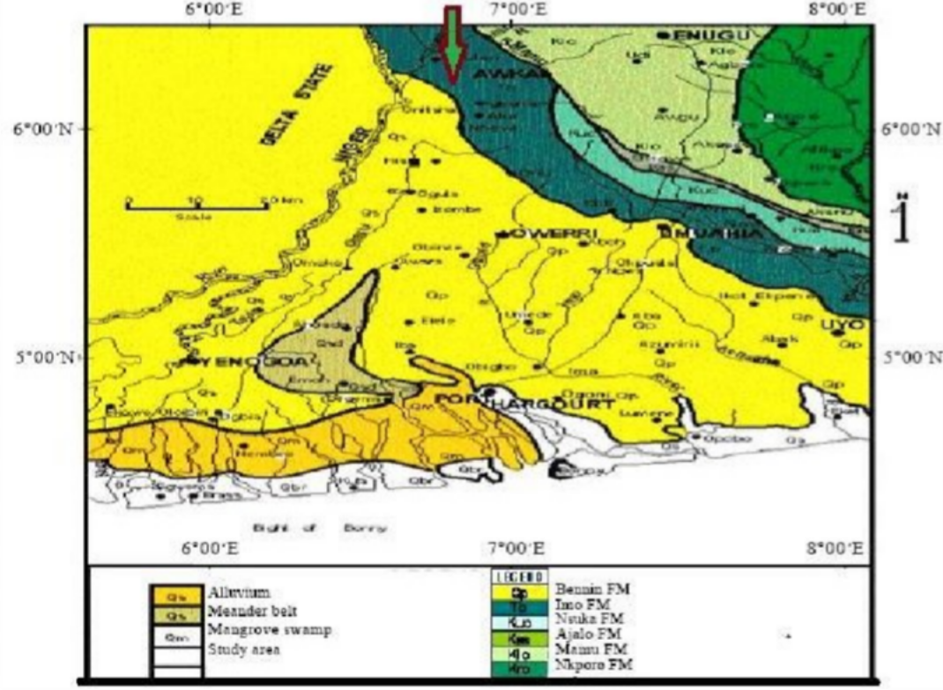
Fig. 1: Geological map of Anambra Basin showing the study area

Materials and Method
  - Resistivity Method
The resistivity method involves the measurement of the ability of soil, rock and groundwater to resist the flow of an electric current (Tjoelker and Koenig, 2008). Electrical resistivity surveying is based on the principle that the distribution of electrical potential in the ground around a current-carrying electrode depends on the electrical resistivities and distribution of the surrounding soils and rocks. The usual practice in the field involves the injection of electrical current through a pair of surface electrodes inserted into the ground. A second pair of electrode (potential electrodes) is used to measure the resulting voltage. Usually, the potential electrodes are in line between the current electrodes, but in principle, they can be located anywhere, several electrode configurations are used. The three most common arrays are the dipole-dipole, Schlumberger and Wenner. The current used is either direct current, commutated direct current (i.e., a square-wave alternating current), or AC of low frequency (typically about 20 Hz). All analysis and interpretation are done on the basis of direct currents. The distribution of potential can be related theoretically to ground resistivities and their distribution for some simple cases, notably, the case of a horizontally-stratified ground and the case of homogeneous masses separated by vertical planes (a vertical fault with a large throw or a vertical dike). For other kinds of resistivity distributions, interpretation is usually done by qualitative comparison of observed response with that of idealized hypothetical models or on the basis of empirical methods.
Mineral grains comprised of soils and rocks are essentially nonconductive, except in some exotic materials such as metallic ores. So the resistivity of soils and rocks is governed primarily by the amount of pore water, its resistivity and the arrangement of the pores. To the extent that differences of lithology are accompanied by differences of resistivity, resistivity surveys are useful in providing supplementary information for: Location and direction and rate of movement of contaminant plumes, Location of burial sites (e.g trenches, their depths and boundaries) and hydrogeologic conditions (e.g depth to water or water bearing zones, depth to bedrock, thickness of soil etc.). Also, resistivity surveys may be used as a reconnaissance method, to detect anomalies that can be further investigated by complementary geophysical methods and/or drill holes.
Profiling and Sounding are the major methods for data acquisition. Resistivity sounding is used to determine vertical change in the geologic section while Resistivity profiling involves moving an array of electrodes while keeping the array or arrangement and spacing fixed (Sheriff, 1989).

Vertical Electrical Sounding
The technique used for this study is the vertical electrical sounding. The technique (VES) gives detailed information on the vertical succession of different conducting zones or formations and their individual thickness and true resistivity below a given point on the earth surface (Telford et al., 1976). The technique is particularly useful if the subsurface layers to be studied are horizontally or nearly horizontally stratified. The sounding point, which is the midpoint of the electrode array, is fixed while the length of the whole array is gradually increased. As a result, the current penetrates deeper and deeper, the apparent resistivity being measured each time the current electrodes are moved outwards (Koefoed, 1979).

Materials
The materials consist of the followings:
    - MC Ohm resistivity meter used to record apparent resistivity values
    - 12V battery used to power resistivity meter
    - Two current electrodes through which current is passed
    - Two potential electrodes used to measure the voltage caused by the current

Other materials include writing materials, GPS, measuring tapes, cables and hammers. Fig. 2 shows some of the instruments used for the survey.

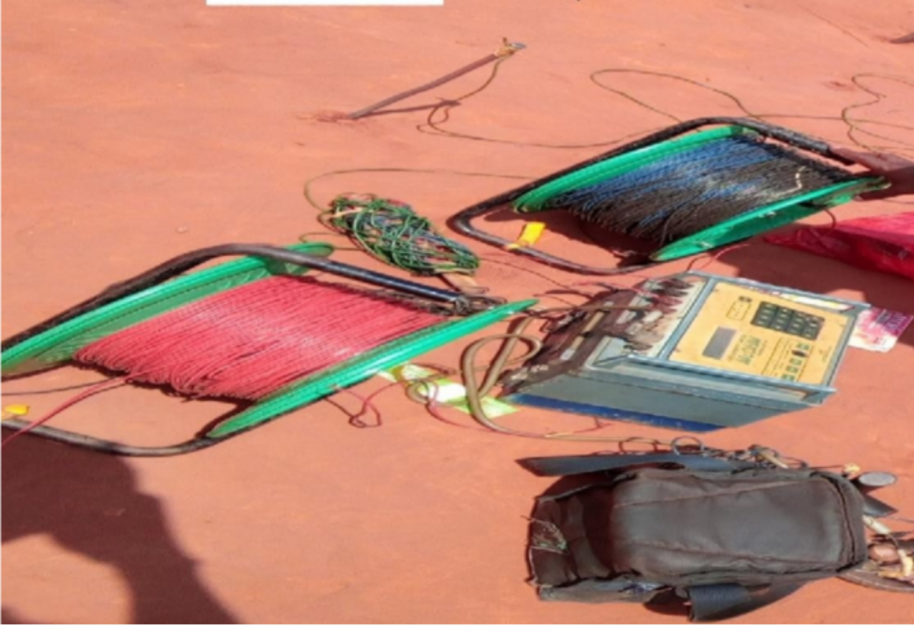
Fig. 2: Instruments used for Resistivity Survey

Electrical Resistivity Method
The Schlumberger electrode configuration of dc electrical resistivity survey was employed in this study. The four electrodes were positioned symmetrically along a straight line, the current electrodes were placed outside and the potential electrodes on the inside. The two electrode pairs have a midpoint. Current was introduced into the ground through current electrodes A and B (Fig. 3) and the potential difference is measured at the surface by means of potential electrodes M and N. Anytime, the depth of investigation is to be varied, the current electrodes will be expanded outwards while the potential electrodes will be left at the same position. When the ratio of the distance between the current electrodes to that of the potential electrodes become too large, the potential electrodes will be expanded outwards otherwise, the potential difference will be too small to be measured with enough accuracy (Koefoed, 1979; Obiajulu, 2014).

A M N B

a b a

Fig 3; Schlumberger configuration

For Schlumberger configuration, apparent resistivity according to Dobrin (1983) is given by:

${ ρ}_{a}= π \left[\frac{{\left(\frac{AB}{2}\right)}^{2}-{\left(\frac{MN}{2}\right)}^{2}}{MN}\right]\frac{V}{1}$ eqn (1)

Where AB = current electrode separation, MN = Potential electrode separation. V = Potential difference and I = electric current.

Aquifer Transmissivity
According to Obiajulu et al., 2016, there is an analogy between fluid flow and current flow. Fluid flow obeys Darcy’s law and while current flow obeys the ohms law. In Darcy’s law, the quantity of water discharged in unit time is given by
Q = KAI (2)
Where K is hydraulic conductivity, 𝐴 𝑖𝑠 total cross-sectional area through which the water percolates, I is the hydraulic gradient. Q is the scalar quantity. On the other hand, the differential equation of ohm’s law for current flow is given as
J = σE (3)
Where J is the current density, E is the electrical field intensity and σ is electrical conductivity which is equal to 1/𝞺; 𝞺 being the resistivity. J and E are vector quantities.
Considering a prism of aquifer material with unit cross sectional area and thickness h, the two fundamental laws can be combined to obtain a relationship between electric and hydraulic characteristics of the formation.
The transverse resistance R according to Niwas and Singhal, (1981) is given by
R = h*𝞺 (4)
The longitudinal conductance S is given by
S = h /𝞺 (5)
Aquifer transmissivity T which is the product of aquifer thickness and hydraulic conductivity is given by
T = K*h (6)
Combining equation (4) – (6)
T = k * h = K * (R/𝞺) = K*σ*R=K*(S/σ) (7) For equation 7 to be used, Kσ must be constant in areas of similar geologic setting and water quality (Niwas and Singhal, 1981). Thus it is possible to determine transmissivity and its variation from place to place even those places where pumping test results are not available provided that the value of K from an existing value is known and from the resistivity data. Vertical electrical sounding data were carried in five different locations and the areas are considered to be hydrologically homogenous.

Data collection and Interpretation
Electrical resistivity data performed using Schlumberger VES technique were acquired at four different locations spread across the study area with a maximum electrode spacing of 600 m. The instrument used was MC Ohm resistivity meter, which is used for dc resistivity work. The instrument measured the resistance and displayed it which was later multiplied by the geometric factor to obtain the apparent resistivity thereafter the data were interpreted. Vertical electrical sounding (VES) data were interpreted in order to determine the subsurface layer resistivities and their thicknesses. This was achieved with software called IP2Win.
The computer generated model VES curves based on the starting model parameters were compared with the field curves and good fits (97.5% correlation) (Bayowa, et al., 2007) were obtained between

the IP2win software generated curves and field curves, the results of the interpretation were considered alright. Fig. 4 and Table 1 are examples of the interpreted VES data while Table 2 is the summary of the results obtained from the VES data.

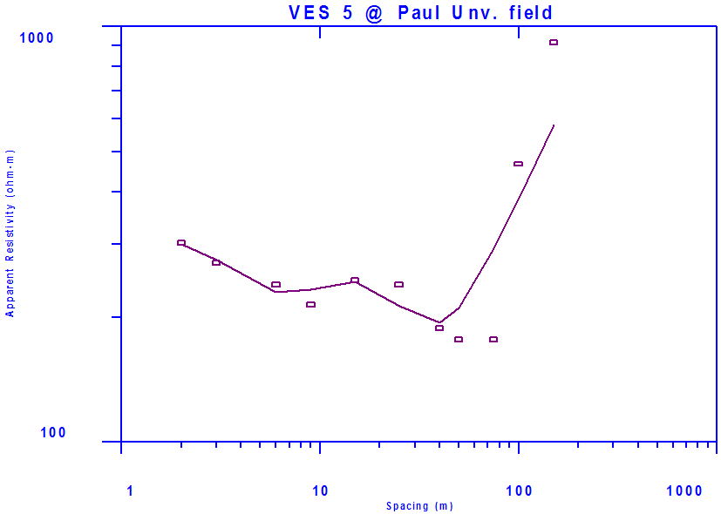

Fig 4 : Sounding Curve for VES 1

Table 1: Interpretation for VES
VES No. &  Name | Layer | Res. (Ohm-m) | Thickness (m) | Depth (m) | Description
 | 1 | 519.45 | 2.29 | 2.29 | Top soil/laterite
 | 2 | 87.87 | 8.79 | 11.08 | Shale
 | 3 | 1520.65 | 15.64 | 26.72 | Dry sand
 | 4 | 792.42 | 29.39 | 56.11 | Saturated sand
 | 5 | 25.07 | 20.25 | 76.36 | Shale
6 980.49 Base not reached Dry sand

Table 2: Summary of the results obtained from the VES data
VE S NO | RESISTI VITY  Ωm | THICKN ESS  h | DEPTH  (m) | LITHOLOGY | NO OF LAYER S | TRANSVER SE RESISTANC E  R = h*𝞺 | LONG CONDU CTANC E  S=(h/p) | HYDRAU LIC CONDUC TIVITY FROM PUMPING TEST (K) | K σ VALUE CONST ANT | CALCUL ATED TRANSM ISSIVITY T = K σ R  M²/day
1 | 519.45 | 2.29 | 2.29 | Laterite
 | 87.87 | 8.79 | 11.08 | Shale
 | 1520.6 | 15.64 | 26.72 | Dry Sand | 6 | 23,289.22 | 0.0371 |  |  | 4.49
 | 792.42 | 29.39 | 56.11 | Saturated.S
 | 25.07 | 20.25 | 76.56 | Shale
 | 980.49 |  |  | Dry Sand
2 | 1313.5 | 2.40 | 2.40 | Laterite
 | 101.08 | 1.57 | 3.97 | Shale
 | 468.04 | 12.28 | 16.25 | Clay | 6 | 41,535.66 | 0.0178 | 5.00 | 0.0063 | 9.63
 | 3548.4 | 29.16 | 45.41 | Dry Sand
 | 1528.1 | 27.18 | 72.59 | Saturated. s
 | 15.95 |  |  | Shale
3 | 284.30 | 2.54 | 2.54 | Laterite
 | 132.52 | 4.59 | 7.13 | Clay
 | 15.57 | 19.96 | 27.09 | Shale | 6 | 14,667.55 | 0.0333 |  |  | 4.12
 | 943.09 | 21.82 | 48.91 | Dry Sand
 | 663.39  8065.97 | 22.11 | 71.02 | Saturated. s  Shale
4 | 744.83 | 2.52 | 2.52 | Laterite
 | 1726.8 | 8.17 | 510.69 | Dry Sand
 | 892.35 | 26.05 | 36.74 | Saturated.s | 5 | 23,245.72 | 0.0292 |  |  | 5.62
 | 8.13 | 13.89 | 50.63 | Shale
 | 1591.6 |  |  | Dry Sand

Results and Discussions
Electrical resistivity investigation involving four Schlumberger’s vertical electrical soundings in the study area (Awka) with the aim of estimating transmissivity values were carried out. The computer interpretation was performed using the IP2WIN software which provided resistivities, thicknesses and the depths parameters. Analysis of the data acquired in the field showed that the shallow subsurface of the investigated area can be represented by a five to six layered structured. The top layer dominated by lateritic materials is characterized by resistivities and thicknesses that vary from 284.30 and 1313.5 Ωm and 2.29 and 2.54 m respectively. The second layer has resistivity and thickness that ranged from 87.87 to 1726.81 Ωm and 1.57 to 8.79 m respectively and was interpreted to consist of shale and clay-rich deposits except at VES 4 where dry sand was encountered. The third layer characterized by resistivity that varies between 15.57 and 1520.66 Ωm and thickness that vary between 12.28 and
26.05 m. The resistivity and thickness of the aquifer bearing layers ranged between 663.39 and 1528.17 Ωm and between 22.11 and 29.39 m respectively. The vertical electrical sounding data were interpreted to produce sections of the resistivities and thicknesses which facilitated the calculation of transverse resistance and longitudinal conductance leading to determination of transmissivity values. A number of researchers (Obiajulu et al., 2016; Niwas and Singhal, 1981; Ekwe et al., 2006) have used this method to determine transmissivity values and found out to be accurate. This shows that dc electrical resistivity method is a very useful method to estimate transmissivity values. Apart from being a useful method, it has also found to be cost effective and reliable compared to conventional pumping testing method.
Conclusively, the findings in this work has provided a practical framework for both the government and individuals especially those involved in groundwater development on how to determine aquifer transmissivity values without recourse to pumping test thereby enhancing groundwater resource assessment and management.

Reference
Awake, (2001). Water: will there be enough? Watchtower bible and track society, New York 82 (12)
Bayowa, O. G., Olorunfemi, M. O., and Ademilua, L. O., (2007). A comparative study of the accuracy of preliminary interpretation techniques in computer aided vertical electrical sounding. Journal of Applied Sciences Research 3(10): 1001-1009.
Dobrin, M. B., (1983). Introduction to Geophysical Prospecting. McGraw Int. Books Company.
Tokyo, 70-107.
Ehirim, C. N., and Ebeniro, J. O. (2010). Evaluation of aquifer characteristics and groundwater potentials in Awka, Nigeria using vertical electrical sounding. Asian Journal of Earth Sciences 3(2) 73-81.
Ekwe, A. C., Onu, N. N., and Onuoha, K .M., (2006). Estimation of aquifer hydraulic
Characteristics from electrical sounding data. The case of middle Imo River basin aquifers, south eastern Nigeria. Journal of Spatial Hydrology 6(2) 121-132.
Ezeigwe, P. C., (2015). Evaluation of the causes of housing problems in Nigeria: a case study of Awka, the capital city of Anambra state.Journal of Economics and Sustainable Development. 6 (20).
Koefoed, O., (1979). Geosounding principles, I, methods in geochemistry and geophysics. Elsevier Scientific Publishing Company, Amsterdam, Netherlands.
Niwas, S., and Singhal, D. C., (1981). Estimation of aquifer transmissivity from Dar-Zarrouk parameters in porous media. Journal of hydrology 50, 393-399
Obiajulu, O. (2014). Geoelectric investigation of groundwater potentials in Ihiala, Anambra State, Nigeria. Unpublished M.Sc. Thesis, Nnamdi Azikiwe University, Awka.

Obiajulu, O. O., and Okpoko, E. I., (2014). Geoelectric investigation of groundwater potentials of Ihiala and its environs, Anambra State, Nigeria. IOSR Journal of Applied Geology and Geophysics 3 (6) 14 – 20.
Obiajulu, O. O., Okpoko, E. I., and Mgbemena, C. O., (2016). Application of vertical electrical sounding to estimate aquifer characteristics of Ihiala and its environs, Anambra State, Nigeria. ARPN Journal of Earth Sciences. 5(1).
Onuoha, K. M., and Mbazi, F. C. C. (1988). Aquifer transmissivity from electrical sounding and profiling to quantify aquifer protection properties. Groundwater 31(4), 538-544.
Reyment, R. A., (1965). Aspects of the geology of Nigeria, Ibadan: University Press, Ibadan. Sheriff, R. E., (1989). Geophysical methods. Prentice Hall. Englewood Cliffs, New Jersey 605pp. Telford, W. M., Geldart, L. P., Sheriff, R. E., and Keys, D. A., (1976). Applied geophysics.
Cambridge University Press, London 860p.
Tjoelker. D., and Koening. L., (2008). Application of geophysical methods for site characterization, Ohio environmental protection agency, division of drinking and groundwater, Ohio.
Utom, A., Odoh, B. I., and Okoro, A., (2012). Estimation of aquifer transmissivity using Dar-Zarrouk parameters derived from surface resistivity measurements: A case history from parts of Enugu town, Nigeria. Journal of water resources and protection 04(12): 993-1000.

APPENDIX

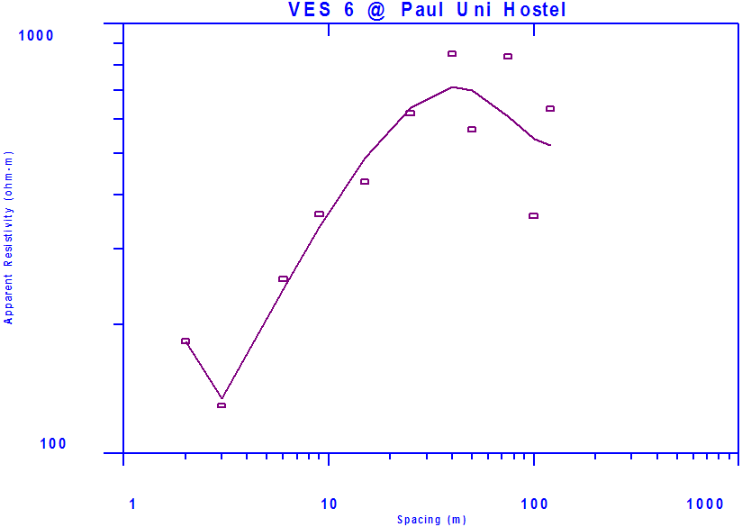
VES 2

Fig 107: Sounding Curve from Ves 6

Table 9: Interpretation of Results from Ves 6

VES No. | Layer | Res. (Ohm-m) | Thickness (m) | Depth (m) | Description
 | 1 | 1313.57 | 2.40 | 2.40 | Top soil/laterite
VES 6 | 2 | 101.08 | 1.57 | 3.97 | Shale
 | 3 | 468.04 | 12.28 | 16.25 | Clayey sand
 | 4 | 3548.41 | 29.16 | 45.41 | Dry sand
 | 5 | 1528.17 | 27.18 | 72.59 | Saturated sand
 | 6 | 15.95 | Base not reached |  | Shale

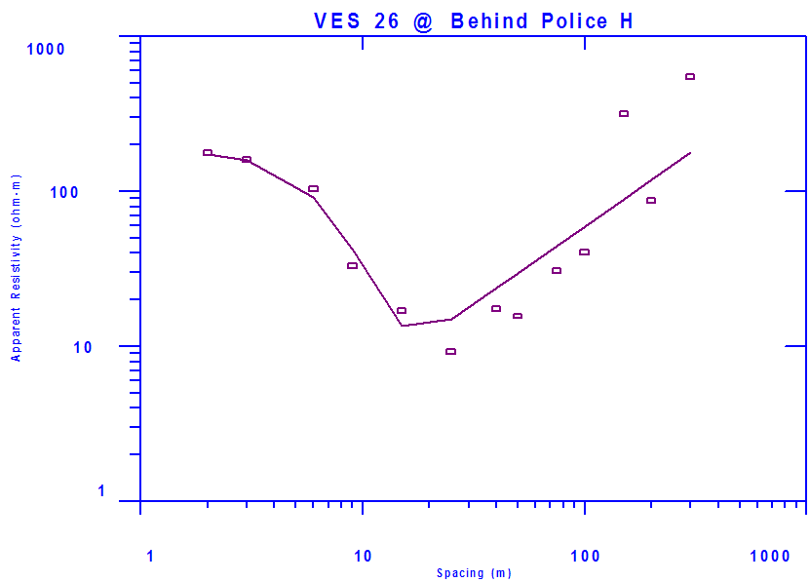
VES 3
Fig 127: Sounding Curve from Ves 26

Table 29: Interpretation of Results from Ves 26
VES No. | Layer | Res. (Ohm-m) | Thickness (m) | Depth (m) | Description
 | 1 | 284.30 | 2.54 | 2.54 | Top soil/laterite
VES 26 | 2 | 132.52 | 4.59 | 7.13 | Clayey sand
 | 3 | 15.57 | 19.96 | 27.09 | Shale
 | 4 | 943.09 | 21.82 | 48.91 | Dry sand
 | 5 | 663.39 | 22.11 | 71.02 | Saturated sand
 | 6 | 8065.97 | Base not reached |  | Dry sandstone

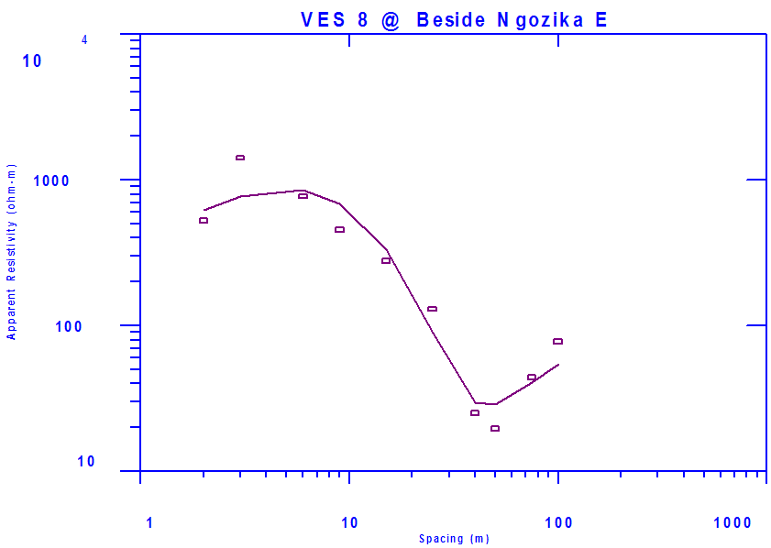
VES 4

Fig 109: Sounding Curve from Ves 8

Table 11: Interpretation of Results from Ves 8

VES No. | Layer | Res. (Ohm-m) | Thickness (m) | Depth (m) | Description
 | 1 | 744.83 | 2.52 | 2.52 | Top soil/laterite
VES 8 | 2 | 1726.81 | 8.17 | 10.69 | Dry sand
 | 3 | 892.35 | 26.05 | 36.74 | Saturated sand
 | 4 | 8.13 | 13.89 | 50.63 | Shale
 | 5 | 1591.62 | Base not reached |  | Dry sand

