Optimal Choice of mother wavelet for satellite obtained very low frequency signal analysis

Abstract:
Very low frequency (VLF) radio wave signals, frequency range 2 kHz to 20 kHz play imperative role for probing of ionosphere and magnetosphere. There are three main VLF signals whistlers, chorus and hiss. They all have specific characteristics with respect time and frequency. Wavelet analysis is a widely used time-frequency analysis method. To propose a more competent analysis of the VLF signal, the wavelet analysis is deliberated. In wavelet analysis, the best mother wavelet is chosen for evaluating the signals, as many mother wavelets applied to the signal may yield diverse results. In this study, we used VLF signals obtained from the DEMETER satellite for wavelet analysis. For the “optimal" choice of the mother wavelet for such signals, we applied an energy-based quantitative approach at different frequency levels of VLF signals, which were obtained by Discrete Wavelet Transform (DWT). The results show that Haar and Bior3.5 are the optimum mother wavelets for the analysis of VLF signals.

Keyword Radio wave signals, Very low frequency, Mother wavelet

- Introduction
Natural electromagnetic signals, often referred to as "sounds," are detected within the Earth-magnetosphere at Very Low Frequencies (VLF), ranging from a 2 Hz to 20 Hz. These waves are generated by phenomena such as lightning discharges, earthquakes, volcanic activity, storms, tornadoes, nuclear explosions, and anthropogenic activities (Barra et al., 2000). They are significant for subterranean imaging, global communication, and navigation (Cohen et al., 2009). The study of VLF phenomena has enhanced our understanding of the plasma environment in near-Earth space (Collier 2006). VLF signals are categorized based on their spectral characteristics (Gallet, 1959), with three primary forms: Whistler, Chorus, and Hiss emissions (William et al., 1968). These emissions are crucial for several reasons: a) They reveal the properties of the plasma through which they propagate, serving as effective remote sensing tools. b) Their narrow bandwidth and high intensity indicate the presence of foreign particles, whose interactions convert the kinetic energy of the charged particles into coherent electromagnetic radiation. Whistlers are circularly polarized electromagnetic VLF waves generated by lightning discharge. This energy enters the ionosphere or magnetosphere, where it is guided by the magnetic field lines to the opposite hemisphere. According to Helliwell (1965), hiss emissions are unstructured and non-dispersive signals characterized by a broken band of limited signals that produce a hissing sound, with durations ranging from a few milliseconds to several hours. Chorus emissions are structured and discrete in frequency, typically increasing over time, known as risers, although they can occasionally decrease, termed falling tones; they may decrease and then increase, known as hooks, or increase followed by a decrease, termed inverted hooks, or exhibit more complex combinations (Helliwell, 1967; Sazhin and Hayakawa, 1992). Ground-based observations indicate that the typical duration of a chorus event ranges from 0.5 to 1 h or more (Trakhtengerts, 1999).
Recently, the Wavelet Transform (WT) has emerged in the field of VLF signal processing as an alternative to the well-known Fourier Transform (FT) and its related transforms. Because VLF signals are inherently non-stationary, wavelet transformation is particularly suitable for analyzing such signals. Wavelet analysis plays a crucial role, especially in the automatic detection of these signals through machine learning, which requires precise VLF signal features. This transformation reveals characteristics hidden within the signal by highlighting changes that occur suddenly and over extended periods. Therefore, we propose an integrated wavelet-based feature extraction tool for feature extraction. In wavelet transform, these signals are decomposed into wavelets, meaning that the original function is reconstructed by adding basic building blocks that maintain a constant shape but vary in size and amplitude. This method allows the design of a set of basic functions by selecting an appropriate basic wavelet Ψ(t) (mother wavelet) and using its shifted and scaled versions. A significant challenge in designing a wavelet feature extraction-based VLF recognition system is selecting the optimal wavelets for these signals, which involves determining the decomposed level within the 1-D wavelet decomposition (multilevel) and choosing the feature vectors from the wavelet coefficients. The solution to this problem is revealed in this study.
2. Selection and Formation of Data Set
The VLF signal dataset used in this study was obtained from the DEMETER. The DEMETER microsatellite was launched in 2004 to detect electromagnetic emissions transmitted from earthquake regions. The scientific payload of this satellite comprises several instruments capable of recording continuous data related to electric and magnetic field variations during its passage over seismically active zones (Parrot et al., 2005). The measurement of plasma waves and energetic particles is also an asset to the operation of this satellite (Lagoutte et al., 2000). The data from the Instrument Champe Electrique (ICE) payload onboard the DEMETER satellite were used to estimate the electric fields (Parrot, 2006). In our study, we observed ICE burst mode signals that computed the waveform of one electric component up to 20kHz(Blecki et al.,2009). The raw data have been withdrawn from the website http://demeter.cnrs-orleans.fr. For the analysis and visualization of the DEMTER data, fully interactive software named SAWN (Software for Wave Analysis) was used (Lagoutte & Latermoliere, 1997). We used 100 variations of VLF signals of each emission (chorus, hiss, and whistler), of 1.5 s with a sampling frequency (Fs) of 40 kHz.
3. Necessity of Selecting an Appropriate Mother Wavelet
For the extraction of features from the VLF signals, as depicted in Figure 1, we employed the Discrete Wavelet Transform (DWT) to decompose the signal. DWT was selected for this study because of its suitability for real-time applications. In essence, the Discrete Wavelet Transform (DWT), which underpins sub-band coding, is recognized for facilitating the rapid computation of the Wavelet Transform. It is straightforward to implement and minimizes the computational time and resource requirements. The DWT technique iteratively transforms the signal into multi-resolution subsets of coefficients using filters with varying cutoff frequencies. Consequently, the signal was processed using both low-pass and high-pass filters to analyze the low and high frequencies, respectively. The input signal was low-pass filtered to yield the approximate components and high-pass filtered to provide the detailed components. At the first level (A1 and D1), the outputs from both filters were down sampled by a factor of 2 to obtain the approximation and detail coefficients. The approximate signal at each stage was further decomposed using the same low-pass and high-pass filters to determine the approximate and detailed components for the subsequent stage.

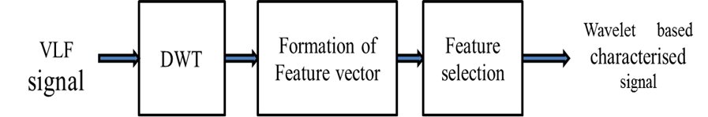
Figure 1 Feature extraction procedure of VLF signal.
Mallat (1989) introduced the concept of multi-resolution analysis, which is performed using the fast discrete wavelet transform (DWT). During the multi-resolution decomposition of very low frequency (VLF) signals using DWT, two fundamental questions arise: i) What is the maximum number of decomposition levels used? ii) Which mother wavelet is selected for the DWT? The answer to the first question is provided by the MATLAB toolbox, which states that the maximum decomposition level lmax for a signal is given by:
l_{max}=fix(log₂(n/n_{w}-1))
where n denotes the length of the signal, and n_{w} indicates the length of the decomposition filter associated with the selected mother wavelet. However, in practice, the maximum decomposition level for wavelet-based feature extraction is chosen based on convenience and requirements (Debasis, 2013). In our study, the signal frequency range is 2 kHz to 20 kHz, and the signal length is 60,000. According to MATLAB's rule, the maximum decomposition level is 13, which is not suitable for this study. This is because, if dyadic decomposition is applied to the VLF signal under consideration, beyond the third level of decomposition, the VLF range shifts to the extremely low frequency (ELF) range (2 Hz–2 kHz). This can be verified by Table 1, which demonstrates the bandwidth of each decomposed level.

S.No | Wavelet Decomposition Level | Frequency Range kHz
1 | D1 | 20-10
2 | D2 | 10-5
3 | D3 | 5-2.5
4 | A3 | 2.5-0
Table 1 Decomposition of VLF signal into different frequency bands (Fs= 40kHz)

For instance, when the decomposition level is set to four, the Discrete Wavelet Transform (DWT) produces the reconstructed coefficient subsets at the third-level approximation (A4) and the first to third-level details (D1, D2, D3, and D4), as illustrated in Figure 2(a), (b), and (c). This analysis indicates that the optimal decomposition level for the Very Low Frequency (VLF) signal is three. Consequently, in our study, we used three detail coefficients and one approximation coefficient for feature extraction. The primary objective of this study, which addresses the second question, is discussed in the following section.
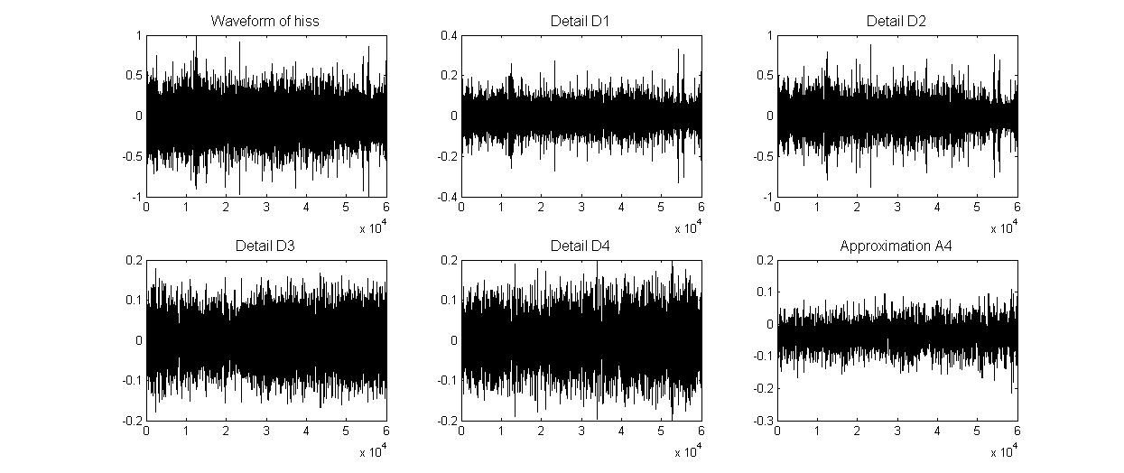
(a)
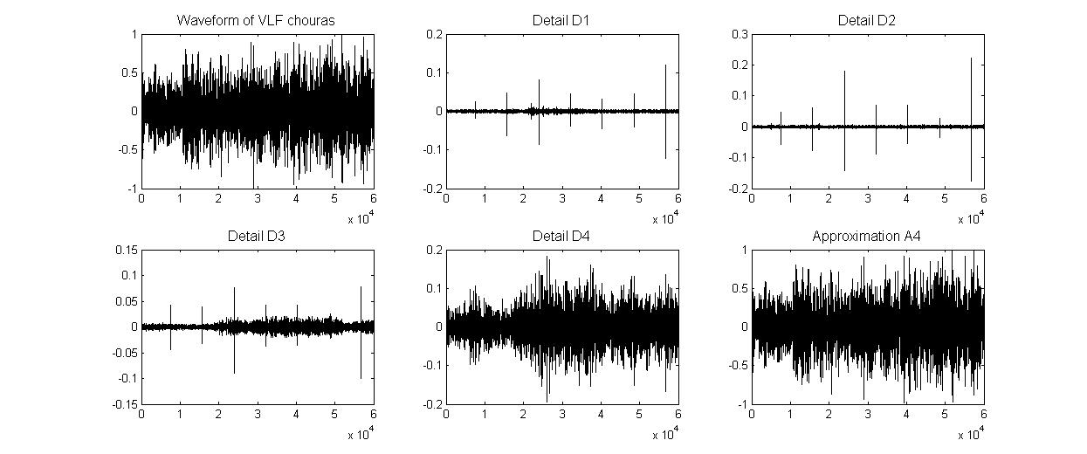
(b)
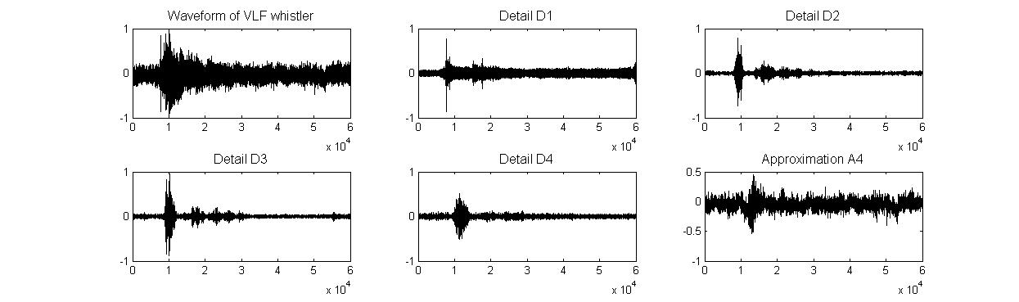
(C)
Figure 2.VLF waveform with DWT decomposition level (reconstructed) D1, D2, D3, D4 and A4,(a) Hiss,(b)Chorus,(c) Whistler

4. Selection of an Appropriate Mother Wavelet for VLF Signals

The selection of wavelets is a critical task due to the plethora of wavelet functions available for DWT, characterized by compact support, orthogonality, and biorthogonality, which influence the low-pass and high-pass analysis and synthesis filters. Among the available wavelet families are Haar, Daubechies (db), Symlets (sym), Coiflets, BiorSplines (bior), reverse bior, Meyer, and Dmeyer. The Haar, Daubechies, Symlets, and Coiflets are supported by orthogonal wavelets, whereas the BiorSplines, reverse bior, Meyer, and Dmeyer wavelets are biorthogonal. Wavelets are selected for specific applications based on their scaling function and signal analysis capability (Daniel and Akio, 1994). Currently, there is no definitive method for selecting the mother wavelet. However, researchers have developed two approaches based on different parameters (Ngui et al., 2013). These approaches are as follows:
1. Qualitative Approaches: These depend on similarity, orthogonality, regularity, and compact support.
2. Quantitative Approaches: These are based on energy and entropy.

For the "optimal" selection of the mother wavelet, we employ an energy-based quantitative approach due to the imperfect pairing of filters during the frequency band splitting by DWT (Shukla and Tiwari, 2013). To address this, the energy distribution of the signal is calculated at each decomposition level. This method was utilized by Morsi and Hawary (2008) for decomposing electric signals. The wavelet that concentrates energy at a particular level more than others is selected as the mother wavelet. According to Parseval’s theorem, the energy of the distorted signal can be subdivided at different resolution levels, which is mathematically defined as follows:
Ed_{i}=$\sum_{J=1}^{N}{{\left|D_{ij}\right|}^{2},i=1,2…..l}$
Ea_{i}=$\sum_{J=1}^{N}{{\left|A_{ij}\right|}^{2},i=1,2…..l}$
Where i = 1, ..., l represents the wavelet decomposition level, ranging from the first 1to the l-th level. N indicates the number of details or approximations at each decomposition level. Edi denotes the energy of the detail at decomposition level i, while Ea_{i} represents the energy of the approximation at decomposition level l. In this study, we compared the wavelet energy at levels D1 to D3 and A3 using Haar (chosen for its conceptual simplicity), db8, db20 (noted for shape symmetry with the signal and more vanishing moments), bior3.5, and bior6.8 (biorthogonal wavelets). The average energy distribution for each decomposition level—D1, D2, D3, and A3—was calculated using 50 sets of signals, obtained separately from chorus, hiss, and whistler, for the mentioned wavelet families, as depicted in Figure 3(a), (b), and (c). It is predictable that the energy distribution of the analysed signals varies significantly across different groups of VLF signals.
In each case, we observed that the maximum energy distribution for A3 and D3 is achieved with the bior3.5 wavelet. Similarly, the maximum energy distribution for D1 is found using the Haar wavelet function. This indicates that bior3.5 and Haar are optimal choices for analysing VLF signals at decomposition levels A3, D3, and D1, respectively. However, at the D2 level, the bior3.5 wavelet yields the maximum energy distribution for hiss only, while Haar shows the maximum energy distribution for chorus and whistler. Our analysis of the plot reveals that the energy percentage for chorus and whistler is significantly lower than that for hiss at the D2 level. Furthermore, there is no substantial difference in energy between Haar and bior3.5 for hiss at this level. Consequently, Haar is selected as the analysis wavelet for the D2 level. Thus, we conclude that Haar is the superior choice of mother wavelet for D1 and D2 level decomposition, while bior3.5 is a reliable choice for decomposing D3 and A3 levels for VLF signals. Therefore, we decompose D1 and D2 levels using the Haar wavelet (Haar, 1910) and D3 and A3 using bior3.5 (Charles, 1992), as they provide maximum energy distribution at each decomposition level for VLF signals. After performing DWT, we calculated various audio-frequency parameters concerning time and frequency for each decomposition level and formed a feature vector. The details of the feature extraction process are published in https://www.ijsr.net/archive/v5i2/NOV161115.pdf. The feature vector curves, shown in Figure 4, provide different representations of VLF signals (Verma et al., 2016).
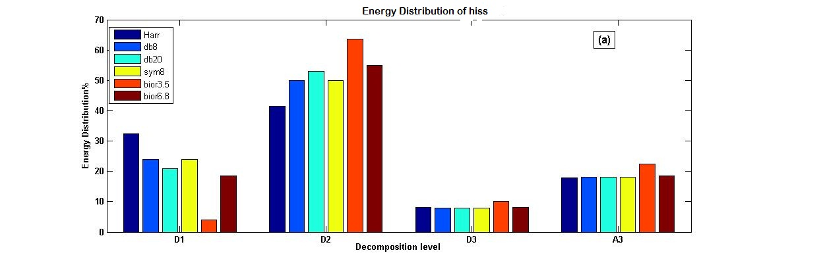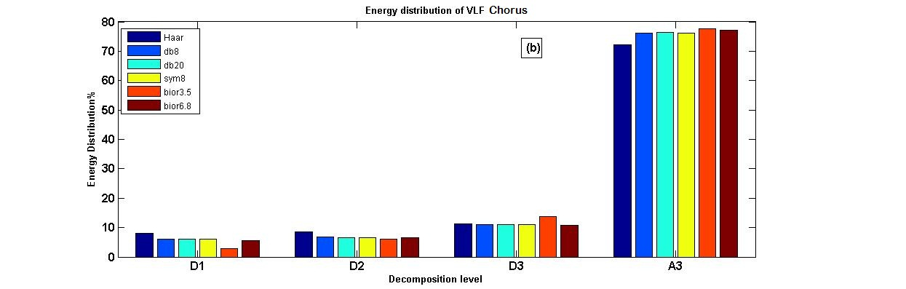

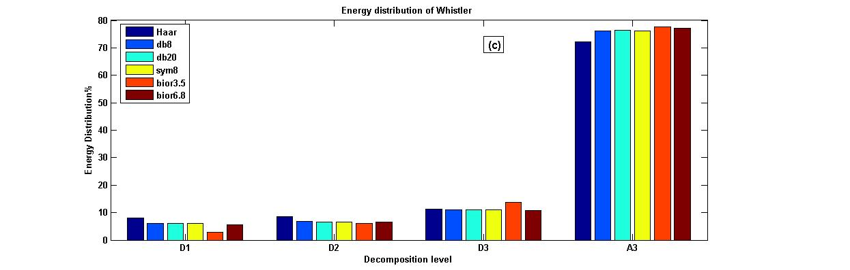

Figure 3 Energy distribution for the three detail and one approximate diagram of the a) Hiss, b) Chorus and c) Whistler

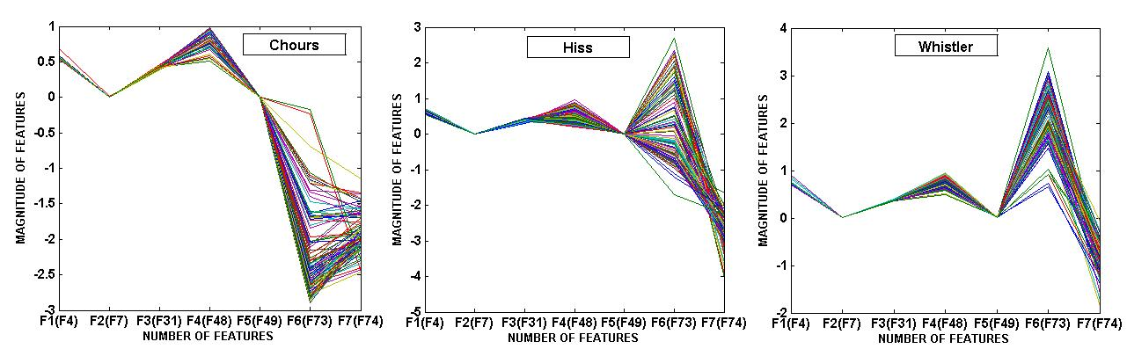

Figure 4 Feature vector plot acquired of Chorus, Hiss and Whistler (figure taken from Verma et.al 2016).
4. Conclusion
In this study, we have demonstrated that the primary challenge in wavelet-based feature extraction lies in selecting the most suitable mother wavelet. To address this, quantitative approaches have been proposed and applied to VLF signals by calculating the signal's energy. The paper provides a comprehensive analysis of various mother wavelets for feature extraction of VLF signals. Different mother wavelets were evaluated to determine the most appropriate one for VLF signals. The bior3.5 wavelet and Haar wavelet, followed by db8, db20, sym8, and bior6.8, emerged as the most suitable candidates for VLF signals. These wavelets offer rapid computation of wavelet coefficients and are excellent choices for feature extraction of VLF signals. Regarding VLF signal classification, the Haar and bior3.5 wavelets proved to be the most appropriate candidates, as they delivered superior performance for VLF signals.
Acknowledgement
I sincerely acknowledge my heartfelt thanks to demeter.cnrs-orleans to provide the data.
References
- Barra R., D. L lanwyn Jonesb, C.J. Rodgerc, ELF and VLF radio waves, Journal of Atmospheric and Solar-Terrestrial Physics 62, 1689–1718,2000.
- Cohen, M. B., U. S. Inan, and E. P. Paschal Sensitive broadband ELF/VLF radio reception with the AWESOME instrument, IEEE Trans. Geosci. Remote Sens., 48(1), 3–17, 2009
- Collier Andrew B.: VLF and ULF Waves Associated with Magnetospheric Substorms .Department of Space and Plasma Physics School of Electrical Engineering Royal Institute of Technology Stockholm, Sweden Ph.d. thesis2006.
- Gallet,R.M., and R.A.Helliwell, Origin of very low frequency emissions, J.Res.N.B.S.,63D,21,1959.
- Williams,D.J.,J.F.Arens,and L.J. Lanzerotti, Observations of trapped electron at low and high altitude,J.Geophys. Res., 73, 5673, 1968.
- Helliwell, R.A.,Whistler and related ionospheric phenomena,Stanford University Press, Stanford, California, USA. 1965.
- Helliwell, R.A, ‘A theory of discrete VLF emission from the magnetosphere’, J. Geophy. Res., 72, 4773-4789, 1967.
- Sazhin, S.S. and Hayakawa, M, Magnetospheric chorus emissions: A review,Planet. Space Sci., 40, 681-697, 1992.
- Trakhtengerts, V.Y., A generation mechanism for chorus emissions, Ann.Geophys., 17, 95-100,1999.
- Parrot, M., Benoist, D., Berthelier, J. J., Blecki, J., Chapuis, Y., Colin, F., Elie, F., Fergeau, P., Lagoutte, D., Lefeuvre, F., Legendre, C., Lévêque, M., Pincon, J. L., Poirier, B., Seran, H.- C., and Zamora, P.: The magnetic field experiment IMSC and its data processing onboard DEMETER: Scientific objectives, description and first results, Plan. Space Scie., 54, 441–455, https://doi.org/10.1016/j.pss.2005.10.015, 2005.
- Lagoutte, D., Brochot, J., Latremoliere, P.,SWAN, Software for wave analysis, version 2.4, (part 1: User’s guide; part 2: Analysis tools; part 3: User’s project interface). Technical Report, Laboratory of Physics Chimie Environment/CNRS, Orle’ans, France, 2000.
- Parrot M. The magnetic field experiment IMSC and its data processing onboard DEMETER: Scientific objectives, description and first results. Planet. Space Sci., 54, 441–455 2006
- Blecki J,Parrot M and R.Wronowski ELF and VLF signatures of sprites registered onboard the low altitude satellite DEMETER Ann. Geophysics, 27, 2599–2605, 2009.
- Lagoutte D. and Latermoliere P. ” SAWN Analysis Tools”version 2.0,LPCE/NI/003.C-part2,May 1997.
- Mallat S., A Theory for Multiresolution Signal Decomposition: the Wavelet Representation, IEEE Pattern Anal. And Machine Intel, vol. 11, no. 7, 674-693. 1989.
- Debasis Choudhury ,characterization of power quality disturbances using signal processing and soft computing techniques, thesis Department of Electrical Engineering National Institute of Technology Rourkela, 2013
- Daniel T.L. Lee and Akio Yamamoto Wavelet analysis and theoretical application Hewlett-Packard Journal,1994.
- Ngui w.k.,Leong Salman M.,Lim Meng Hee Abdelrhman A.M.,Wavelet analysis: Mother selection methods Applied Mechanics and Materials Vol.393 ,953-958,2013.
- Shukla, K. K., Tiwari Arvind K., Efficient Algorithms for Discrete Wavelet Transform With Applications to Denoising and Fuzzy Inference Systems springer Briefs in Computer Science, 2013.
- Morsi W. G. and El-Hawary M. E., The most suitable Wavelet for steady-state power systemdistorted waveforms, Canadian Conference on Electrical and Computer Engineering. 17-22, 2008.
- Haar, Alfréd,"Zur Theorie der orthogonalen Funktionensysteme", Mathematische Annalen 69 (3): 331–371, 1910.
- Charles K. Chui, An Introduction to Wavelets, Academic Press, 1992.

