Microfinance Financing, Procurement Capability, and Enterprise Sustainability: Evidence from Small and Medium Enterprises in Nigeria

Abstract
The Small and Medium Enterprises (SMEs) in Nigeria are important contributors to employment, poverty alleviation, income generation and economic development. Despite this, however, there remain sustainability issues for many of the SMEs, stemming from a lack of funds and inadequate operational skills, including procurement. In this study, the researcher studied the financing of SMEs by microfinance banks, procurement competence and sustainability of SMEs in Kwara State, Nigeria. The study used a cross sectional survey research design. The data was collected using a structured questionnaire which was given to the owners and managers of the SMEs in the sixteen Local Government Areas of Kwara State. A total of 250 questionnaires were sent out and 218 valid questionnaires were analysed, with a valid response rate of 87.2%. Data analysis was done using descriptive statistics and regression analysis. The results indicated that business loan was the most accessed microfinance service with a mean score of 4.21 followed by savings service with a mean score of 3.96. The supplier selection capability was the highest among all procurement capabilities, with a mean score of 4.08, whereas price negotiation, with a mean score of 3.91, was the second highest. The regression results showed that microfinance financing significantly affected enterprise sustainability, R² = 0.375, p < 0.05, and procurement capability also significantly affected the enterprise sustainability, R² = 0.428, p < 0.05. Microfinance financing capability and procurement capability accounted for 52.0% of the variance in enterprise sustainability (R² = 0.520 at p < 0.05). The study found that access to finance is not the only factor that drives SME sustainability, but the capability of the SMEs in procurement is also a factor. It suggested more access to microfinance, procurement training and integrated microfinance support programmes in all the local governments of Kwara State.
Keywords: Microfinance Financing, Procurement Capability, Enterprise Sustainability, SMES, Kwara State

Introduction
Small and Medium Enterprises (SMEs) are a key enabler for employment generation, poverty alleviation, innovation, and income generation, especially in developing economies. SMEs are still vital in Nigeria's entrepreneurial development and still face challenges of inadequate access to finance, poor managerial capacity, increasing operating costs and low business sustainability (Mohammed & Bardai, 2024). Such restrictions can limit a small business's capacity to grow, to compete and to thrive in the face of economic uncertainty.
Microfinance financing has emerged as an important financing tool for the entrepreneurs who cannot avail conventional bank loans. Microfinance institutions can provide SMEs with working capital, business advisory and other financial services through credit facilities, savings products, and enhance their production capacity and business operation. A recent study shows that access to microfinance does enhance the performance of entrepreneurs and the growth of enterprises with appropriate use of funds for productive business activities (Onyekwelu et al., 2023; Gunawan & Nurchasanah, 2024). But, even access to finance does not ensure the sustainability of the enterprises if the business owners are not capable of managing the resources efficiently in their businesses.
One of the critical internal capabilities that is needed for the sustainable performance of an enterprise is its procurement capability. It includes planning of purchases, supplier selection, negotiation of prices, inventory management, cost control and the ability to ensure timely delivery of goods and services by SMEs. Good procurement can help to minimise waste, increase cost-effectiveness, foster good supplier relations and boost competitiveness. The value of procurement and supply chain capabilities to the business resilience, operational efficiency, and sustainability of small businesses is highlighted in recent literature (Etse et al., 2024; Atarah et al., 2024).
Enterprise sustainability is the capacity for a business to be profitable, competitive and sustainably run over time. Nigeria's SMEs are facing a growing threat to sustainability due to inflation, supply chain disruptions, lack of capital, inadequate planning and managerial systems. Hence, capital and procurement skills are required to boost business survival and growth. Some research has focused on the performance of microfinance and the performance of SMEs, but there are fewer studies that have explored a combination of the two – microfinance financing and capability in procurement – and their impact on enterprise sustainability. In this regard, this study investigates microfinance financing, procurement capability, and enterprise sustainability among SMEs in Nigeria, and seeks to provide evidence to support entrepreneurs, microfinance institutions, enterprise development agencies and policy makers.
Problem Statement
The SMEs are also playing an important role in the Nigerian economy in terms of employment generation, income generation, poverty alleviation and economic diversification. Although vital, many SMEs have high failure rates and are unable to sustain themselves over the long term. A key constraint facing these businesses is their limited access to financing, restricting their capacity to secure resources, grow and stay competitive. To meet this challenge, microfinance institutions have increasingly been offering financial services to entrepreneurs that are typically not served by conventional financial institutions. But there are indications that mere access to finance is not sufficient for sustainable business performance: many SMEs are still struggling in operations and management even after securing financial assistance.
The ability of the enterprise to purchase is another important condition that affects the sustainability of the enterprise. The procurement process is an important component of the supply chain management of SMEs, which is heavily dependent on it for the acquisition of raw materials, management of suppliers, cost control, inventory management and uninterrupted business operations. Poor procurement practices can lead to poor use of resources, higher operating costs, disruption of supply chain and lower profitability. With the prevailing inflationary effect, the volatile prices of inputs and economic uncertainties in the current business environment in Nigeria, the ability to procure is now more central to enterprise survival and growth.
While existing research has well-documented the link between the access to microfinance financing and business performance, most studies have been narrow in their scope and centered on profitability, growth, or entrepreneurial development. Likewise, research about procurement has mostly focused on the efficiency of the supply chain and organizational performance. There is little empirical research that has examined the interaction between microfinance financing and procurement skill on enterprise sustainability of SMEs in Nigeria. As such, the relationship between financial access and financial procurement skills in improving the sustainability of small businesses is still not fully understood.
This lack of information leads to uncertainty for policy makers, microfinance institutions and enterprise support agencies in developing interventions that can have a positive impact on the sustainability of SMEs. Hence, the need to investigate the level of impact of the capability for microfinance financing and procurement on enterprise sustainability for SMEs. This study aims to fill this gap to provide empirical evidence for policy and strategies for enhancing sustainability and resilience of SMEs in Nigeria.
Aim and Objectives
To investigate the effect of microfinance financing and procurement capability on the sustainability of Small and Medium Enterprises in Nigeria. Specific Objectives are:
1. To determine the types of microfinance services that SMEs in Nigeria typically use.
2. To evaluate the procurement skills of SME operators.
3. To review the effect of microfinance financing on enterprise sustainability of SMEs.
4. To find the impact of procurement capacity on enterprise sustainability in SMEs.
5. To assess the synergistic effect of microfinance financing with procurement capability on enterprise sustainability of SMEs.

Literature Review
Concept of Microfinance Financing
Microfinance financing is defined as the provision of financial services to micro credit, savings, insurance, and/or business advisory services to individuals and small businesses who are unable to access conventional banking services. Small businesses are a key sector for economic inclusion and economic growth, and microfinance institutions (MFIs) provide capital to them for investment and expansion. Some recent studies suggest that microfinance financing can help increase the productivity of the business, generate income and foster entrepreneurial development, especially in the developing world where access to formal credit is restricted (Fonseca et al., 2024; López-Penabad et al., 2024). The importance of microfinance financing in enhancing the resilience and sustainability of small enterprises is now recognized as a strategic approach to improve their financial accessibility and business support services.
Concept of Procurement Capability
Procurement capability is the knowledge, skills, processes and competencies that allow the organization to effectively and efficiently purchase goods and services. It includes supplier selection, procurement planning, contract management, negotiations, inventory management, and cost management. By developing their procurement ability, companies can make use of resources effectively, cut down on running expense, boost supplier partnerships, and enhance business overall performance. The importance of SMEs' procurement capabilities in the competitive and uncertain business environment has been highlighted by recent literature, as it directly impacts operational efficiency and organizational sustainability (Etse et al., 2024; Atarah et al., 2024). A firm's ability to effectively convert financial resources into productive outcomes is enhanced by having a strong procurement capability.
Concept of Enterprise Sustainability
Enterprise sustainability is the capacity of an enterprise to sustain itself in the longer term by being profitable, growing, adaptable, competitive and able to make the best of environmental and economic opportunities and challenges. Sustainable businesses can withstand ups and downs in the market, capitalize on new opportunities, and build value for stakeholders. According to recent studies, sustainability in SMEs is affected by the internal factors like managerial and operational capacity as well as external factors like access to finance. Sustainable business performance is thus a key goal for SMEs aiming for long-term growth and resilience in the face of economic change and volatility (Hakam & Hakam, 2024; Suchek & Franco, 2024).
Microfinance Financing and Enterprise Sustainability
There has been a significant body of academic research on the link between microfinance financing and enterprise sustainability. Financial resources help SMEs get the productive assets they need, expand their businesses, boost working capital, and increase business efficiency. Research has demonstrated that companies with proper financial support are more likely to be on a position to absorb economic shocks and are able to sustain their growth in the long run. In Hakam and Hakam's (2024) view, sustainable financing has a major role to play in fortifying the resilience and competitiveness of SMEs. Likewise, Fonseca et al. (2024) reported that having access to microfinance positively influences sustainable entrepreneurial outcomes by fostering self-employment, business expansion, and income generation. However, some researchers have stated that money alone is not enough to ensure sustainability if there is no proper managerial skills and utilization of resources.
Enterprises, Sustainability, and Procurement Capability
Procurement capability is becoming recognized as more and more of a strategic factor to enterprise sustainability. Companies with well-designed procurement processes can save money, boost supply chain efficiency, and ensure business continuity. Recent research shows that the ability of organizations can have a significant impact on sustainability outcomes, as the ability to deliver services efficiently and competitively. Marfo et al. (2024) found that the strategic capabilities of the organization have positive impacts on organizational sustainability, which is viewed as an increase in the effectiveness of resource management and operation of the organization. Likewise, the literature on sustainability in the 21st century also highlights the need for capability development in the long run inorder to ensure the survival and competitiveness of SMEs.
Microfinance Financing, Procurement Capability, and Enterprise Sustainability
The impact of microfinance financing and organizational competencies on enterprise performance have been studied separately, but few studies have explored the joint impact on enterprise sustainability. The Resource Based View states that if a company has valuable resources, it will perform better if they are supported by effective resources. The availability of microfinance gives the SMEs financial resources, and the ability to procure determines the efficiency of the use of these resources. Thus, financing and procurement capability can have a major impact on enterprise sustainability. The available literature indicates that financial resources and organizational skills are complements that work together to achieve sustainable business results, but there is little empirical evidence for this in Nigeria. This is the gap that the current study is based on.
Methodology
Study Area
This study was carried out in Kwara State, Nigeria. Kwara State is an important commercial and administrative axis which connects the northern and southern parts of Nigeria and is located in the North-Central geopolitical zone of Nigeria. In the state, there are sixteen Local Government Areas (LGAs) which include: Asa, Baruten, Edu, Ekiti, Ifelodun, Ilorin East, Ilorin South, Ilorin West, Irepodun, Isin, Kaiama, Moro, Oke-Ero, Offa, Patigi. Over the years the state has seen a rise in entrepreneurial activities and a number of Small and Medium Enterprises (SMEs) have been established in various industries including trade, manufacturing, agriculture, services and construction. The state is well suited for the study of the relationship between microfinance financing, procurement capability, and enterprise sustainability because there are many microfinance institutions, and enterprise development programs in the state.
Research Design
The research design used in this study was cross sectional survey. The design was deemed appropriate since it allowed for gathering of quantitative data from the SME operators in the sixteen LGAs of Kwara State at a single point in time. The design also enabled analysis of the links between the ability to finance, procure, and sustain a business enterprise.
Population of the Study
The population of interest was Small and Medium Enterprise (SME) owners and managers who were registered in the sixteen (16) Local Government Areas of Kwara State. The population comprised enterprises that had used microfinance services or had business relations with microfinance institutions and were involved in trading, manufacturing, agro-processing, services and other entrepreneurial activities.
The number of samples size and the technique used to select the sample for the study.
Multistage sampling technique was used. The sixteen Local Government Areas (LGAs) of Kwara State were included to provide good geographical representation. Later, SMEs were sampled using stratified sampling technique according to business sectors. Simple random sampling was used for selecting the final respondents. A sample size of 250 SME owners and managers was deemed sufficient for statistical analysis, and for generalization of findings.
Instrument for Data Collection
A structured questionnaire consisting of four parts was used to gather data. Demographic and business attributes were collected in Section A. Section B focused on the indicators of microfinance financing such as accessibility to loans, loan adequacy, repayment conditions and financial support services. Section C evaluated procurement ability by considering procurement planning, supplier selection, negotiation ability, inventory control, and cost control. Section D assessed enterprise sustainability by measuring enterprise growth, profit, customer retention, market expansion and business continuity. The responses were rated on a 5-point Likert scale, which ranged from Strongly Disagree (1) to Strongly Agree (5).
Validity and Reliability of the Instrument
The questionnaire was validated in terms of face and content using the experts who are specialists in the field of entrepreneurship, procurement management and business administration. Cronbach's alpha was used to evaluate the reliability of the instrument and the value of 0.70 was taken as the acceptable value for the internal consistency of the instrument.
Method of Data Analysis
The data collected were coded and analyzed using SPSS (version 27) software. The data were analyzed to answer Objectives 1 and 2 by descriptive statistics: frequencies, percentages, means and standard deviations. Objectives 3, 4 and 5 were tested using inferential statistics. In particular, simple linear regression analysis was conducted to analyze the effect of microfinance financing and procurement capability on enterprise sustainability and multiple regression analysis to analyze the combined effects of microfinance financing and procurement capability on enterprise sustainability. Each of the hypotheses was tested at the level of significance 0.05.

Discussion of Findings
Response rate
The study obtained a valid response rate of 87.2% (Fig 1) which was very high, showing that a good proportion of the SME owners and managers in Kwara State participated in the study. The response rate indicates that data gathered were enough to allow for valid conclusions regarding the relationship between microfinance financing, procurement capability and enterprise sustainability. The distribution of respondents across the sixteen LGAs showed SMEs were concentrated in Ilorin West, Ilorin South and Ilorin East. The finding is not new as the commercial and administrative centre of Kwara State, Ilorin attracts more of the entrepreneurial and business activities. Conversely, the lower participation rate of the other businesses in Patigi, Ifelodun, Edu, Kaiama and Baruten, might be due to the lower density of businesses and availability of business support infrastructure in those areas.
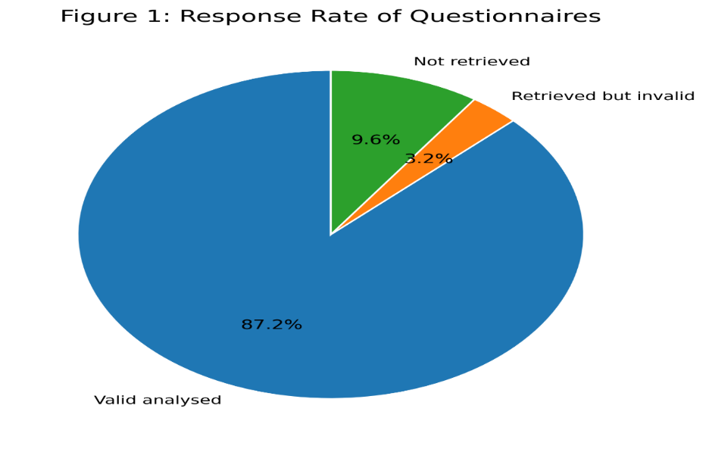
Figure 1: Response Rate
Stratification across SMEs and LGs
By SME category, the highest percentage (33.0%) was in trading enterprises while 72 respondents (33.0%) were in the agricultural sub-sector. This was followed by the service-based SMEs with 52 respondents which made 23.9% and agro processing SMEs had 39 respondents, representing 17.9%. This was followed by manufacturing SMEs (14.7%) and construction-related SMEs (10.5%). This indicates that the study focused on various types of SMEs that exist in Kwara State.
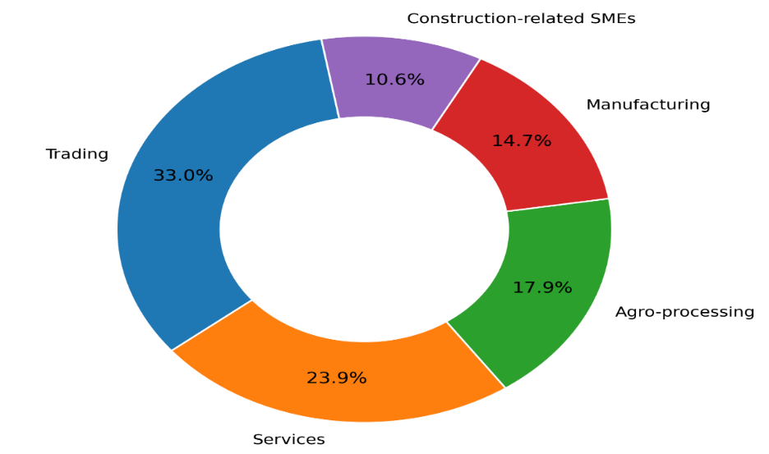
Figure 2: Stratification of Respondents by SMEs

Likewise, the respondents were distributed across the sixteen LGAs (Fig 3) with higher responses from Ilorin West, Ilorin South and Ilorin East, which are the areas with higher concentration of the activities of SMEs in the study area. Ilorin West had the largest proportion of respondents (36, 16.5%) followed by Ilorin South (28, 12.8%) and Ilorin East (24, 11.0%). Moderate responses were obtained from Offa, Oyun, Asa, Moro, Irepodun, Ekiti, Isin and Oke-Ero. The other localities, Patigi, Ifelodun, Edu, Kaiama and Baruten, had lower responses indicating lower concentration of SMEs, wider geographical distribution and possible accessibility issues in these localities.
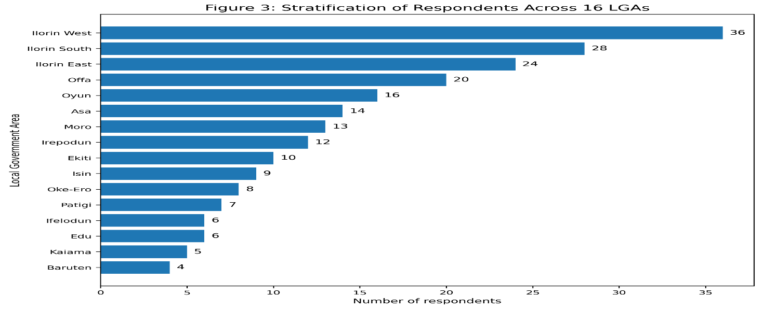
Figure 3: Stratification by LGs
Objective 1: Microfinance Services Accessible to SMEs
The study found that business loans were the predominant microfinance service used by SMEs, with a mean score of 4.21, followed by savings service (M = 3.96), financial advisory service (M = 3.74), and group lending (M = 3.52) as shown on Fig 4. The lowest mean score (M = 2.81) was for insurance services. The finding shows that microfinance institutions are the main source of credit facilities and savings products for SME operators to operate and grow their business. This result is consistent with Onyekwelu et al. (2023), who found that Microfinance credit is one of the most crucial factors that spur entrepreneurial development and enterprise growth in developing economies. Likewise, Mohammed and Bardai (2024) reported that microfinance institutions play a significant role in the development of the SMEs by providing loans and financial support services. This lower rate of utilization of insurance products could be explained by low awareness, low cost, and the fact that SME operators are more concerned with funding their operations than implementing risk management measures. The message is that although the microfinance institutions are playing their part in the lending, there is a need for more to be done to promote full-fledged financial services to make businesses more resilient and sustainable.
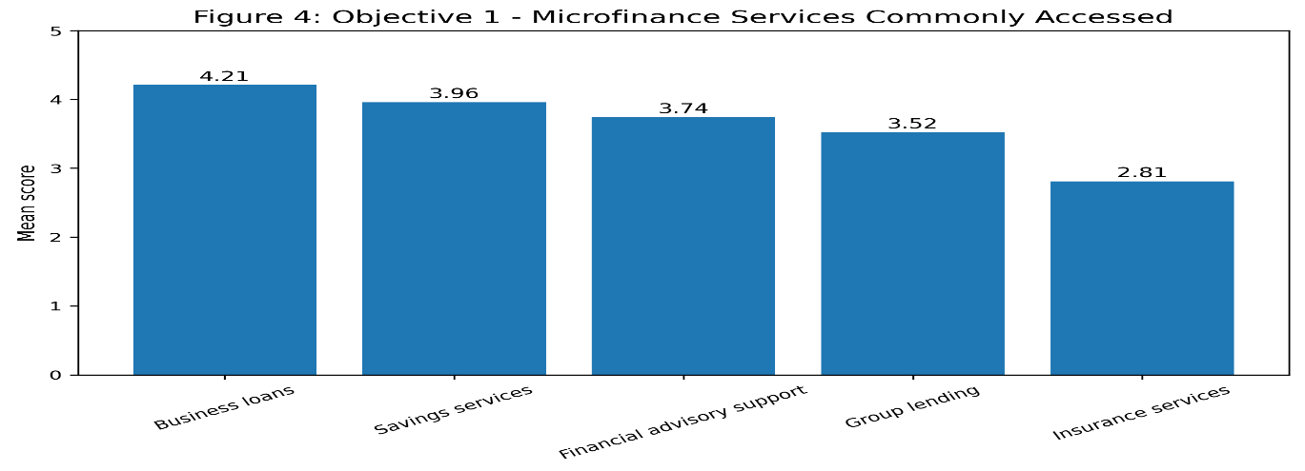
Figure 4: Microfinance Services Accessible to SME Operators
Objective Two: Purchasing Capabilities of SME Operators
The results revealed that the procurement capability with the highest mean score among SME operators was supplier selection (M = 4.08) followed by price negotiation (M = 3.91), inventory management (M = 3.68), procurement planning (M = 3.44), and contract management (M = 3.12). The findings (Fig 5) indicated that SME operators have medium to high level of procurement competencies especially in the procurement activities that are directly related to the procurement and cost control activities. The results align with the findings of Etse et al. (2024), who stated that procurement capability can be considered an important organizational resource which can improve operational effectiveness and business sustainability. This finding is also in line with Agyapong et al. (2024), who reported that good procurement practices are effective in enhancing organizational performance by reducing costs and making the resources utilized efficiently. The relatively low mean score for contract management suggests that some SMEs might not have formal procurement procedures and contractual knowledge. This may be due to the fact that most SMEs are informal and have little formal procurement system and strong personal relationships with suppliers. Therefore, the enhancement of procurement planning and contract management skills can further enhance business performance and sustainability.
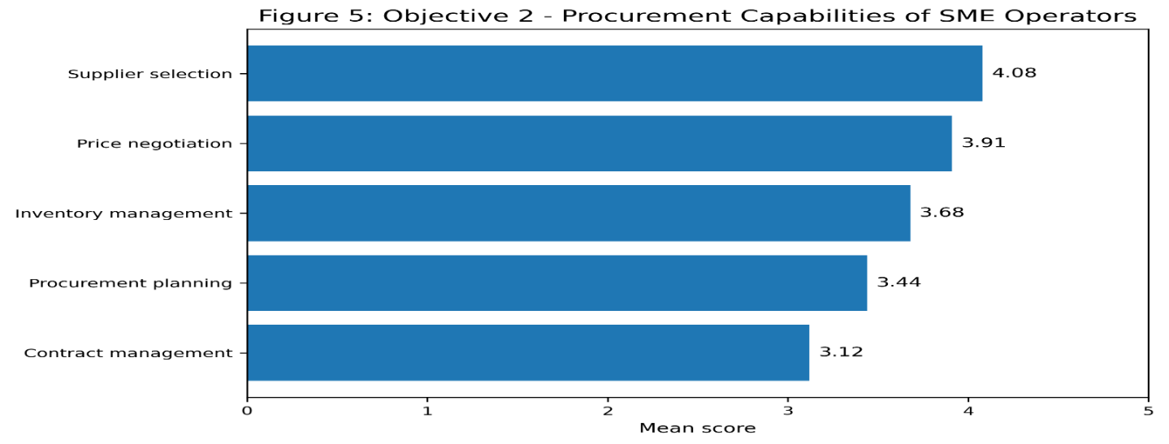
Figure 5: Procurement Capabilities of SME Operators
Objective 3: Influence of Microfinance Financing on Enterprise Sustainability
The results of the regression analysis showed that the microfinance financing significantly contributed to the sustainability of the enterprises with (R = 0.612, R² = 0.375, F = 129.64, p < 0.05). The coefficient of determination shows that the microfinance financing accounted for 37.5% of the variation in the sustainability of the enterprises of the SMEs. Moreover, standardized beta coefficient (β = 0.612) shows a strong positive relationship between the access to microfinance financing and sustainable business outcomes. This discovery, as indicated in Fig 6, suggests that business expansion, profitability, customer retention and business continuity are more likely to be achieved for SMEs that have better access to finance, including loans, savings facilities, and financial support services. This finding is consistent with Kato (2024), which found that sustainable financing facilitates business resilience and long-term business performance. Likewise, Hakam and Hakam (2024) revealed that financing accessibility is a crucial factor to support SME sustainability which allows investment in productive activities and business expansion. The positive impact found in this study can be explained because of the contribution that microfinance can make in solving capital constraint problems that frequently exist in SMEs. The discovery therefore highlights the need to increase the financial inclusion initiatives aimed at small enterprises.
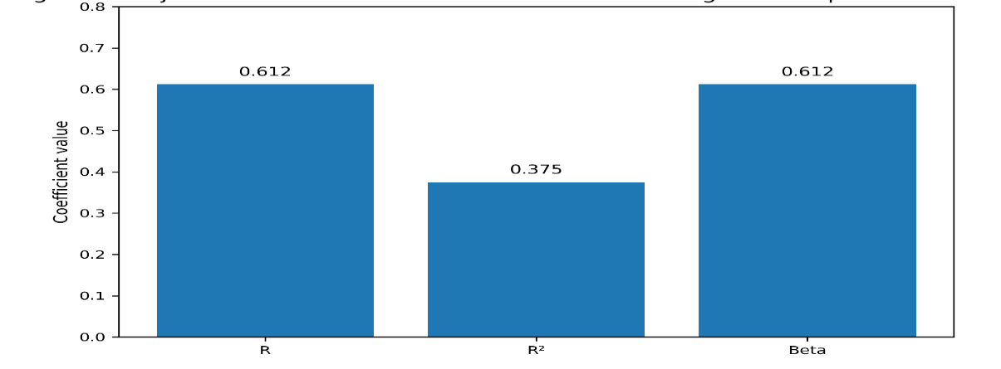
Figure 6: Influence of Microfinance on Enterprise Sustainability
Objective Four: How the Capability of Procurement affects Enterprise Sustainability
The study revealed that procurement capability was positively significant with enterprise sustainability (R = 0.654, R² = 0.428, F = 161.59, p < 0.05). The findings (Fig 7) indicated that procurement capability accounted for 42.8% of the variance of the enterprise sustainability. The standardized beta coefficient (β = 0.654) also indicates that the procurement capability has a significant positive impact on sustainable business performance. This discovery suggests that SMEs with greater procurement capability are more likely to be operationally efficient, cost controlled, profitable, and sustainable in the long-term. This finding corroborates the Resource Based View in which organizational capabilities are viewed as strategic assets that can create competitive advantage and improve performance. This result is consistent with Marfo et al. (2024), who found that strategic capabilities are a significant contributor to organizational sustainability. Similarly, Etse et al. (2024) identified that procurement-related capabilities enhance the functioning of organizational resources and sustainability results. The higher explanatory power of procurement capability over microfinance financing indicates that managerial skill might be more significant than just financial access in achieving enterprise sustainability. This underscores the importance of SME development programmes to not only give attention to financing, but also to capability development.
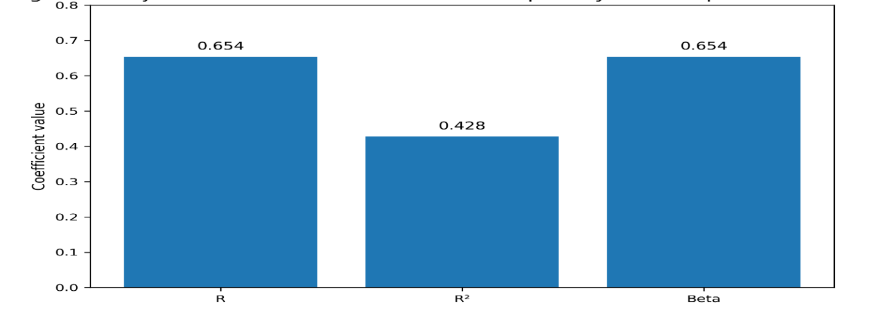
Figure 7: Impact of Procurement Capability on Enterprise Sustainability
Objective 5: Combined Effect of Microfinance Financing and Procurement Capability on Enterprise sustainability
Multiple regression analysis revealed that microfinance financing capability and microfinance procurement capability together had a significant effect on enterprise sustainability (R = 0.721, R² = 0.520, F = 116.32, p < 0.05). Together, both variables accounted for the variation of enterprise sustainability, as shown in the coefficient of determination, of 52.0%. Standardized beta coefficient showed that procurement capability (β = 0.471, p < 0.05) has a stronger contribution to enterprise sustainability than microfinance financing (β = 0.338, p < 0.05). The discovery indicates that financial resources and managerial skills are interdependent and affect enterprise sustainability. Microfinance financing is the source of capital for the business operations and growth, however, procurement capacity decides the efficiency of the utilization of those capital resources. The findings lend considerable support to the Resource Based View which proposes that SCA can be derived from an effective combination of valuable resources and organisational capabilities. This is found to be in line with the findings of Etse et al. (2024) that financial resources alone lead to lower sustainability outcomes when supplemented with organizational resources. Likewise, Marfo et al. (2024) highlighted the role of strategic capabilities as a mediating factor between the resources and the organizational sustainability. This is because the higher beta coefficient recorded for procurement capability indicates that managerial competence is more important than finance to ensure enterprise sustainability. Thus, policies for the sustainability of SMEs should be a combination of financial support, training in procurement and business management.
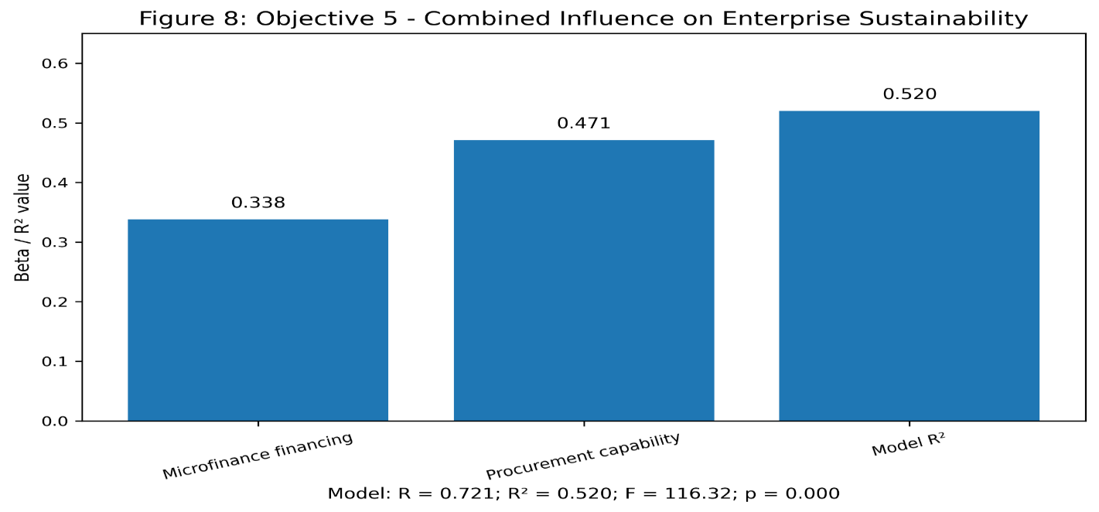
Figure 8: Combined Effects on Enterprise Sustainability
Conclusion
The study investigated the effect of Microfinance financing and procurement ability on enterprise sustainability of SMEs in Kwara state, Nigeria. The results indicated that business loans and savings services were the most frequently used microfinance services and among the procurement capabilities of SME operators, the highest were supplier selection, price negotiation and inventory management. Another finding of the study was that microfinance financing was found to have a positive and significant impact on enterprise sustainability, suggesting that financial support enhances business development, profitability, and sustainability.
The results further showed that the capability of procuring was more effective at influencing enterprise sustainability than microfinance financing. This means that being able to access finance does not necessarily mean that they will sustain their business without issues if they lack the ability to plan purchases, choose trusted suppliers, negotiate prices, manage inventories and control costs. The overall outcome revealed that the capability of enterprise financing and procurement in microfinance has significant combined contribution for enterprise sustainability. Thus, the development of SMEs needs to be improved financially, and their procurement management capability should be enhanced.
Recommendations
The study suggests that microfinance institutions need to continue to increase the availability of loans to SMEs at lower interest rates with flexible repayment schedules and business-oriented loan packages. This will help entrepreneurs to make good use of their finances without overwhelming repayments.
SME owners/managers should enhance their procurement competency by training in supplier selection, procurement planning, supplier negotiation, inventory control and cost management. This will help to optimize the use of resources and minimize inefficiencies in operations.
PMT training must be a part of SME development programmes by government agencies, entrepreneurship development centres, and business support organisations. Financial support should not be given without practical capacity building activities.
Microfinance providers should go beyond financing and provide advisory services for financial planning, procurement, risk management, and business sustainability. This will facilitate better utilization of borrowed funds by the SMEs.
Lastly, it is recommended for the government to design specific support programmes for SMEs in all the sixteen LGAs of Kwara State particularly in the areas where less SMEs are participating which include Patigi, Ifelodun, Edu, Kaiama and Baruten. This will foster the development of inclusive enterprises and enhance the sustainability of SMEs in the state.
References
Ahamad, S., Islam, M. A., Yusof, M. F., Al-Jaifi, H. A. A., & Ehigiamusoe, K. U. (2024). Relationship between microfinance institutions' self-sustainability and financing sources: Moderating role of external governance. Annals of Public and Cooperative Economics, 95(4), 971–1001. https://doi.org/10.1111/apce.12472
Agyapong, G. K. Q., Opoku, R. K., Asiedu, A., & Frimpong, S. (2024). Sustainable procurement practices and sustainable performance: Evidence from small and medium-sized manufacturing enterprises in an emerging economy. International Journal of Procurement Management, 20(1), 1–32. https://doi.org/10.1504/IJPM.2024.137794
Appiah-Kubi, E., Koranteng, F. O., Dura, C. C., Mihăilă, A. A., Drigă, I., & Preda, A. (2024). Green financing and sustainability reporting among SMEs: The role of pro-environmental behavior and digitization. Journal of Cleaner Production, 478, 143939. https://doi.org/10.1016/j.jclepro.2024.143939
Atarah, B. A., Mustapha, A. R., Nyaaba, P., & Damoah, O. B. O. (2024). Sustainable procurement practices and female entrepreneurs: Insights from a developing country. Business Strategy & Development, 7(3), e421.
Etse, D., McMurray, A., & Muenjohn, N. (2024). Financial capacity and sustainable procurement: The mediating effects of sustainability leadership and socially responsible human resource capability. Environment, Development and Sustainability, 27(7), 15727–15754. https://doi.org/10.1007/s10668-024-04557-x
Fonseca, S., Moreira, A., & Mota, J. (2024). Factors influencing sustainable poverty reduction: A systematic review of the literature with a microfinance perspective. Journal of Risk and Financial Management, 17(7), 309.
Gunawan, I., & Nurchasanah. (2024). Exploring factors influencing the microfinance program sustainability. SN Business & Economics, 4, 101.
Hakam, D. F., & Hakam, L. I. (2024). Sustainability in small and medium sized enterprises financing. Development and Sustainability in Economics and Finance, 100031. https://doi.org/10.1016/j.dsef.2024.100031
Kato, A. I. (2024). Building resilience and sustainability in small business enterprises through sustainable venture capital investment in sub-Saharan Africa. Cogent Business & Management, 11(1). https://doi.org/10.1080/23322039.2024.2399760
López-Penabad, M. C., Maside-Sanfiz, J. M., Agha, Y., & Iglesias-Casal, A. (2024). Microfinance institutions and corporate social responsibility: A scientometric study. Future Business Journal, 10(90).
Marfo, M., Armah, A. A., Ofei, E. F., Coffie, I. S., Adadevoh, L., Pattnaik, S. K., Reindoph, C. A., & Annan, E. (2024). Competitive advantage and sustainability in Ghanaian microfinance institutions: The mediating role of strategic capabilities. Future Business Journal, 10(104). https://doi.org/10.1186/s43093-024-00390-w
Mohammed, M., & Bardai, B. B. (2024). Entrepreneurship development and micro, small and medium business enterprises capacity building in Nigeria. International Journal of Research and Scientific Innovation, 11(3), 214–225.
Okeke, A. (2024). Evaluating sustainable practices and supply chain management effectiveness in African small and medium-sized enterprises. Journal of Sustainability Research, 6(2), e240033. https://doi.org/10.20900/jsr20240033
Onyekwelu, P. N., Ibe, G. I., Monyei, F. E., Attamah, J. I., & Ukpere, W. I. (2023). The impact of entrepreneurship institutions on access to micro-financing for sustainable enterprise in an emerging economy. Sustainability, 15(9), 7425. https://doi.org/10.3390/su15097425
Suchek, N., & Franco, M. (2024). Inter-organisational cooperation oriented towards sustainability involving SMEs: A systematic literature review. Journal of the Knowledge Economy, 15(1), 1952–1972. https://doi.org/10.1007/s13132-023-01196-x

