Disaster Response Implementation and Effectiveness in Coastal BARMM, Philippines: A Study of Typhoon Survivors

ABSTRACT
The Philippines experiences frequent typhoons that threaten lives and disrupt the livelihoods of coastal communities, particularly those who are dependent on fishing, small-scale enterprises, and agriculture. In the BARMM region, coastal communities are highly vulnerable to recurring typhoons due to their geographic location and various socio-economic challenges. These conditions greatly influence the effectiveness of disaster response mechanisms in the area, as communities often face difficulties in accessing resources, services, and timely assistance during and after disasters. This study examines the implementation and effectiveness of disaster response. It identifies key challenges faced by typhoon survivors and the strategies they proposed to strengthen resilience in 12 coastal barangays in Maguindanao del Norte and Lanao del Sur, Philippines. A convergent mixed-methods design was employed, using a structured survey of 240 typhoon survivors and qualitative responses analyzed through thematic analysis. Quantitative data were analyzed using descriptive statistics and Spearman's rank correlation and complemented with qualitative responses analyzed through thematic analysis. The relationship of the variables was measured by numerical data supported by real-life experiences. Results revealed a strong positive relationship between disaster response implementation and effectiveness (ρ = 0.8997, p < 0.001). Key determinants of effectiveness include communication systems, availability of flood-adapted rescue vehicles, and the provision of essential needs. Qualitative findings highlight operational constraints, including communication barriers and limited access in remote areas, as well as the need for improved coordination, community participation, and DRRM training. Drawing on the typhoon survivors’ perspectives, the study provides experience-based insights into the gaps between institutional response capacity and local-level realities. The findings emphasize the importance of strengthening local government capacity, infrastructure, and community engagement to enhance disaster response systems and build resilience in vulnerable coastal communities.

Keywords: disaster response, community resilience, coastal vulnerability, disaster risk reduction, BARMM

INTRODUCTION

The Philippines is highly vulnerable to typhoons due to its geographic location in the western Pacific Ocean and its archipelagic structure. These hazards pose significant risks to coastal communities, particularly those dependent on fishing, agriculture, and small-scale enterprises. In recent years, changing climate patterns have contributed to the increasing intensity and unpredictability of tropical cyclones, further exacerbating community vulnerability, particularly in isolated and resource-constrained regions.

Despite ongoing efforts to strengthen disaster risk reduction and management (DRRM), many coastal communities, especially in resource-constrained and conflict-affected regions such as the Bangsamoro Autonomous Region in Muslim Mindanao (BARMM), continue to face challenges in disaster response implementation and effectiveness. These challenges are often reflected in inadequate infrastructure, limited accessibility to resources, and weak coordination among local government units (LGUs) and other stakeholders.

Existing studies have examined disaster preparedness, yet there remains a lack of empirical evidence on the implementation of disaster response and perceived effectiveness at the high-risk and conflict-affected settings, particularly from the perspectives of typhoon survivors in coastal communities. Addressing this gap is necessary to determine how operational capacities and institutional arrangements contribute to disaster outcomes.

This study examines the implementation of disaster response and the perceived effectiveness of typhoon survivors in coastal communities in BARMM.

METHODOLOGY

This study employed a convergent mixed-methods design to examine disaster response implementation and effectiveness in twelve coastal barangays in Maguindanao del Norte and Lanao del Sur, Philippines. A total of 240 typhoon survivors were selected using purposive sampling based on their direct experience with recent typhoon events.

Data were collected using a structured survey questionnaire consisting of four sections: socio-demographic profile, level of disaster response implementation, level of effectiveness, and open-ended questions on challenges and strategies. The instrument was validated by five experts in disaster risk reduction and management (DRRM) and pilot-tested before data collection. The questionnaire was translated into Filipino to ensure clarity and comprehension among respondents.

Quantitative data were analyzed using descriptive statistics and Spearman's rank correlation to determine the relationship between disaster response implementation and effectiveness. Qualitative responses were analyzed using thematic analysis to identify recurring patterns related to disaster response challenges and improvement strategies. Participation was voluntary, and informed consent was obtained from all respondents.

Furthermore, the study focuses on perceived implementation and effectiveness based on the lived experiences of typhoon survivors, which is essential in understanding community-level satisfaction and gaps in disaster response delivery.

Ethical Considerations

This study was reviewed and approved by the Mindanao State University-General Santos Institutional Ethics Review Committee (Approval No. 276-2025-MSUGSC-IERC). The researcher strictly followed the ethical standards in accordance with the university and social science research, providing all the necessary documents before conducting the study. Communication letters were provided to the municipal mayors, barangay officials, and participants, informing them of the purpose and objectives of the study. The researcher secured informed consent from all the respondents, ensuring that the participation is voluntary and they can withdraw anytime they feel uncomfortable without judgment. Participant anonymity and confidentiality were maintained by assigning codes to responses and securely storing all data. =

RESULTS

Table 1. Perceived Implementation of Disaster Response

Indicator | Mean | SD
Rescuers are adequately trained | 3.29 | 1.38
Rescuers respond promptly | 2.74 | 1.28
Availability of flood-adapted rescue vehicles | 2.25 | 1.14
Essential needs are adequately provided | 3.54 | 1.25
Communication channels remain functional | 2.93 | 1.47
Composite Mean | 2.95 | 1.30

Table 1 presents the perceived constraints of disaster response implementation in the surveyed coastal communities. The composite mean score of 2.95 (SD = 1.30) indicates a moderate level of agreement among respondents regarding the disaster response mechanism.

Among the listed indicators, the provision of essential needs obtained the highest mean score of 3.54 (SD = 1.25), which implies that affected families received the aid distribution needed for survival during the disaster. The functionality of communication channels ranked as the second-highest indicator with a mean score of 2.93 (SD 1.47), indicating that communication systems were working during and after disasters, allowing responders and affected families to coordinate with each other.

Rescuers are adequately trained and obtained a mean value of 3.29 (SD = 1.38). This indicates that respondents were satisfied with their operations but experienced limited manpower, equipment, or technical capability.

Meanwhile, the availability of flood-adapted rescue vehicles ranked the lowest with a mean score of 2.25 (SD = 1.14), highlighting the respondents' experiences on lack of rescue vehicles that can safely cross heavily flooded areas, which limits the ability of the responders to reach the affected families quickly.

Overall, the findings highlight how constraints such as specialized rescue equipment and mobility during flood affects the components of disaster response. The limited availability of flood-adapted vehicles may hinder and delay disaster rescue operations for the vulnerable households.

According to Wisner et al. (2012), insufficient resources are a major barrier to achieving resilient communities. Their study on At Risk: Natural Hazards, People's Vulnerability and Disasters highlights the importance of logistical capacity and emergency resources to ensure effective disaster risk reduction initiatives.

Similarly, limited resources can intensify disaster outcomes such as the number of casualties, damages, and displacements, as noted by Ewing et al. (2011). Moreover, sufficient and relevant rescue equipment and operational resources are essential to enhance and strengthen disaster response and maintain public trust in local authorities.

Table 2. Perceived Effectiveness of Disaster Response

Indicator | Mean | SD
Rescuers’ ability to respond during calamities | 2.83 | 1.20
Availability of flood-adapted rescue vehicles | 2.05 | 1.06
Provision of essential needs during and after disasters | 2.88 | 1.19
Communication channels during and after disasters | 2.60 | 1.29
Composite Mean | 2.59 | 1.19

Table 2 presents the perceived effectiveness and gaps in disaster response among the surveyed coastal communities. The composite mean of 2.59 (SD = 1.19) indicates that disaster response was generally perceived as slightly effective, suggesting the need to strengthen the operational performance.

Among the listed indicators, the provision of essential needs during and after disasters obtained the highest mean score of 2.88 (SD = 1.19), reflecting that relief operations are effective as perceived by the respondents.

The rescuers’ ability to respond during calamities ranked the second-highest with a mean score of 2.83 (SD = 1.20). This indicates respondents’ recognition of the rescuers’ efforts and their competency in responding during calamities.

On the contrary, communication channels during and after disasters obtained a mean value of 2.60 (SD = 1.29), indicating that communication systems are unstable and require strengthening to ensure effective disaster response. However, the indicator on rescue vehicles specifically designed to safely navigate flooded areas has the lowest mean value of 2.05, highlighting a critical infrastructure gap that affects the safe operation during flooding.

Generally, the respondents in coastal communities have not experienced comprehensive and flexible disaster responses. Although the highest mean pertains to the provision of essential needs, respondents acknowledged existing gaps that require a more careful and equitable distribution of assistance to affected families. Meanwhile, the lowest mean for rescue vehicles suggests that this remains a significant issue affecting the overall responsiveness and efficiency of rescue operations during disasters.

According to Samson & Buot (2023), one way of reducing disaster impacts and strengthening DRRM is to address limited resources, limited trained officials, and work inefficiencies. Limited resources hamper disaster planning, such as the provision of rescue vehicles, the improvement of evacuation centers, and the construction of accessible roads. Limited training and work inefficiencies are also pressing challenges, as they affect the services needed to cater to all affected communities. Having these issues results in a selective and limited number of rescued families. Moreover, maximizing DRRM efforts strengthens the effectiveness of disaster management.

Despite these initiatives to enhance the effectiveness of DRRM, no country can be fully prepared to disasters. However, these help communities understand their vulnerabilities and be familiar with their rights and responsibilities when a disaster strikes. There will always be conflicts and challenges along the way of its implementation, which create opportunities for the LGUs to identify strategies to improve (Vicario-Merino et al., 2019).

Table 3. Correlation Between Disaster Response Implementation and Effectiveness

Variables | Mean | Spearman’s ρ | p-value | Interpretation
Implementation | 2.70 | 0.8997 | < 0.001 | Strong positive relationship
Effectiveness | 2.31 | 0.8997 | < 0.001 | Strong positive relationship

Table 3 presents the correlation analysis, which shows a strong positive relationship between disaster response implementation and effectiveness (ρ = 0.8997, p < 0.001). This indicates that higher levels of implementation—particularly in terms of trained responders, functional communication systems, and the provision of essential needs—are associated with greater perceived effectiveness of disaster response in coastal communities. These findings suggest that strengthening operational components of disaster response can significantly enhance overall system performance during disaster events.

Conceptual Framework

This study is anchored in community resilience theory, highlighting the crucial role of capacitating the community in disaster risk reduction and governance theory, emphasizing the critical role of institutional capacity, inter-agency coordination, and resource availability in shaping effective disaster rehabilitation and recovery. The framework assumes that limitations in these institutional components constrain recovery outcomes, while strengthened governance, coordination, and community engagement enhance disaster resilience.

The conceptual framework assumes that institutional challenges directly affect the effectiveness of disaster rehabilitation and recovery. Institutional challenges include limitations in accessibility, insufficient equipment and technology, weak communication systems, and issues in the identification of beneficiaries. These constraints reduce the capacity of Disaster Risk Reduction and Management (DRRM) offices and local government units (LGUs) to deliver efficient and effective recovery services.

To address these constraints, institutional and community-based strategies are proposed to strengthen and improve recovery outcomes. These strategies include enhancing communication systems, strengthening training and capacity-building programs, improving relocation planning, and encouraging active participation of both local authorities and community members. These proposed strategies aim to mitigate institutional limitations and strengthen operational effectiveness.

Furthermore, the study integrates active community participation and involvement, and adaptive capacity, recognizing that sustainable recovery efforts depend not only on institutional efficiency and capacity but also on the active involvement of local communities. The interaction between institutional mechanisms and community engagement forms the basis for enhancing resilience in disaster-prone coastal areas.

Thus, the framework assumes that:
- Institutional challenges negatively affect the effectiveness of disaster rehabilitation and recovery;
- Implementation of proposed strategies is essential to improve recovery outcomes; and
- Community participation improves the effectiveness of institutional responses.

Figure 1 shows the relationship between institutional challenges, proposed strategies, and disaster recovery outcomes in coastal communities.

Fig. 1. Conceptual Illustration of Disaster Response and Effectiveness

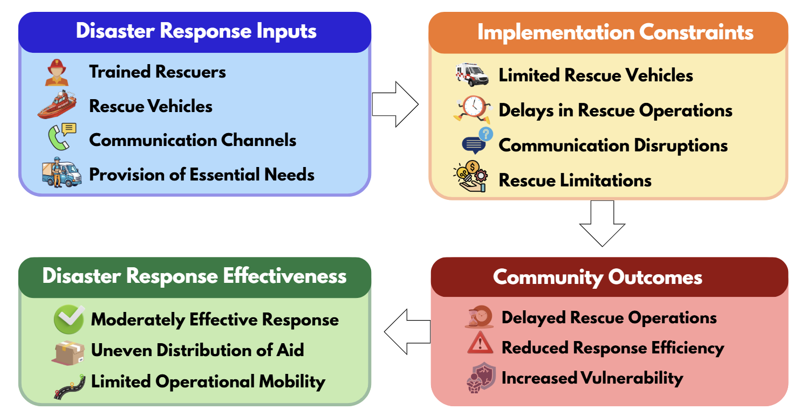

Figure 1 shows how disaster response inputs such as trained rescuers, rescue vehicles, communication channels, and the provision of essential needs affect the implementation of disaster response operations. Resource limitations, particularly the flood-adapted rescue vehicles and communication systems, limit rescue operations, thereby reducing the overall disaster response effectiveness in vulnerable coastal communities.

Figure 2. Key Themes on Disaster Response Challenges and Strategies Identified in Coastal Communities

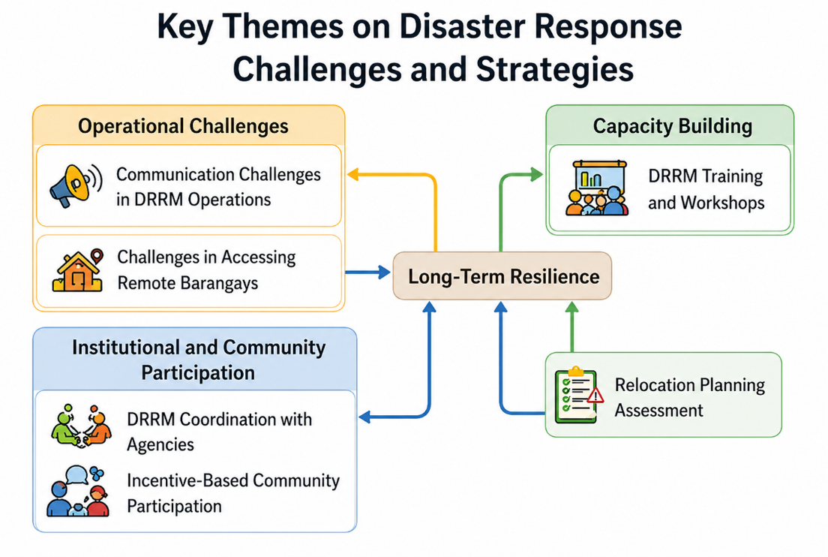

Figure 2 presents the key themes derived from the perceived challenges and strategies in disaster response among typhoon survivors. The thematic analysis revealed three major dimensions affecting disaster response: operational challenges, institutional and community participation, and capacity building. Difficulties in communication and access to remote areas were identified as operational challenges, whereas coordination among agencies and incentive-based participation were perceived as important governance factors. Training and workshops were highlighted to strengthen disaster response operations. These themes contribute to long-term community resilience among coastal communities in BARMM, particularly to better site assessment for relocation planning in vulnerable and typhoon-prone coastal communities.

DISCUSSION

The findings highlight that in the coastal communities in BARMM, the implementation of disaster response was perceived as moderately implemented. The provision of essential needs during the disaster was appreciated, and the efforts of trained responders are recognized. These results imply that LGUs and disaster responders were able to provide the basic services to the typhoon-affected families that help them cope with typhoon impacts.

However, the availability of rescue vehicles that can cross flooded areas was rated lowest in both implementation and effectiveness, highlighting how limited equipment is a major challenge to disaster response. Communication systems were also unstable, which delays rescue and relief distributions, highlighting the need to improve communication to ensure faster services.

The strong positive relationship between implementation and effectiveness (ρ = 0.8997) indicates that better implementation leads to more effective disaster response. This indicates that the availability of sufficient resources, stable communication systems, and improving of rescue operations can significantly enhance disaster response outcomes.

The data on qualitative findings further support this result, as respondents emphasized the importance of improving coordination, community involvement, and sustainable DRMM training and workshops. Strengthening these areas can help coastal communities in the BARMM region become more prepared and resilient for future disasters.

CONCLUSION

This study demonstrates that disaster response implementation significantly influences its effectiveness in vulnerable coastal communities. While efforts in providing essential needs and deploying trained responders are evident, critical gaps remain in communication systems, mobility, and access to remote areas. Addressing these challenges requires targeted investments in infrastructure, enhanced coordination among stakeholders, and sustained capacity-building initiatives. Strengthening these components will improve disaster response systems and support the development of resilient coastal communities in hazard-prone regions.

These findings provide practical guidance for local government units and disaster management agencies in prioritizing investments and interventions to strengthen disaster response systems in high-risk coastal areas.

ACKNOWLEDGEMENT

The authors extend their deepest gratitude to the cooperation and support of the local government units and barangay officials for giving us access to the coastal communities in this study. Special thanks to the typhoon survivors for their participation in the survey and for sharing their valuable insights and experiences on disaster response. Their contributions were highly significant to this research completion.

Data Availability
The data of the study that further support the findings are available upon reasonable request to the authors.

References
- Cabanig, L. (2023). Disaster awareness and local government unit actions on disaster management. International Journal of Research Publications.
- Chandra, A., Williams, M., Plough, A., Stayton, A., Wells, K. B., Horta, M., & Tang, J. (2017). Getting actionable about community resilience: The Los Angeles County Community Disaster Resilience project. Journal of Rural Studies, 54, 450–460. https://doi.org/10.1016/j.jrurstud.2017.07.007
- PAGASA. (2022). Annual climate assessment.
- Paterson, B., & Charles, A. (2019). A global comparison of community-based responses to natural hazards. Natural Hazards and Earth System Sciences, 19(11), 2465–2484. https://doi.org/10.5194/nhess-19-2465-2019
- Peñalba, E. H., David, A. P. J., Mabanta, M. J. D., Samaniego, C. R. C., & Ellamil, S. D. S. (2021). Climate change adaptation: The case of coastal communities in the Philippines. Journal of the Geographical Institute “Jovan Cvijić” SASA, 71(2), 115–133.
- Pesimo, A. R., Saballegue, R. D., Medina, E. D., & Bolalin, N. P. (2019). Disaster risk reduction management assessment of coastal communities of San Jose, Camarines Sur, Philippines. International Journal of Development and Sustainability, 8(7), 434–451.
- Samson, M. D., & Buot, M. M. (2023). Fortifying disaster resilience: Challenges, coping strategies, and aspirations of Davao Region's DRRMOCs in the Philippines for the wellbeing of communities. Journal of Nature Studies, 22(2), 27–44.
- Shaw, R., & Takeuchi, Y. (2012). East Japan earthquake and tsunami: Evacuation, communication, education and volunteerism. International Journal of Disaster Risk Reduction, 1, 1–10. https://doi.org/10.1016/j.ijdrr.2012.03.001
- Tierney, K. (2014). The social roots of risk: Producing disasters, promoting resilience. Stanford University Press.
- United Nations Development Programme. (2020). Community-based disaster risk reduction practices.
- United Nations Office for Disaster Risk Reduction. (2015). Sendai framework for disaster risk reduction 2015–2030.
- Villarino, R. T., & Villarino, M. L. (2022). Designing an online typhoon mitigation program. Academic Platform Journal of Natural Hazards and Disaster Management, 3(2).
- Wisner, B., Gaillard, J.-C., & Kelman, I. (2012). The handbook of hazards and disaster risk reduction. Routledge.
- World Bank. (2018). Building back better: Achieving resilience through stronger, faster, and more inclusive post-disaster reconstruction.
- World Health Organization. (2020). Health emergency and disaster risk management framework.
- Zafra, M. A. G. (2023). Climate change adaptation in the Philippines: Case and policy analysis of the People’s Survival Fund (Unpublished academic report). Ateneo de Davao University / Strategia Development Research Institute, Inc.
- Zhong, S., Clark, M., Hou, X. Y., Zang, Y., FitzGerald, G., & Wang, L. (2014). Progress and challenges of disaster health management in China: A scoping review. Disaster Medicine and Public Health Preparedness, 8(1), 46–52. https://doi.org/10.1017/dmp.2014.23

