DETERMINATION OF THE VARIATIONS IN AIR QUALITY DUE TO THE CONSTRUCTION OF THE ATANI–OBOSI SECOND NIGER BRIDGE ACCESS ROUTE: ASSESSMENT OF AEROSOL, NITROGEN DIOXIDE (NO₂), FORMALDEHYDE (HCHO), AND CARBON MONOXIDE (CO).

ABSTRACT
Transportation infrastructure projects are essential for socio-economic development but often generate environmental impacts that affect air quality and public health. This study assessed variations in air quality associated with the construction of the Atani–Obosi Access Route of the Second Niger Bridge through the evaluation of Aerosol, Nitrogen Dioxide (NO₂), Formaldehyde (HCHO), and Carbon Monoxide (CO) concentrations between 2017 and 2024. A geospatial and environmental monitoring approach integrating remotely sensed atmospheric datasets, Geographic Information Systems (GIS), and statistical analysis was employed to evaluate spatial and temporal changes in atmospheric conditions during the pre-construction, construction, and post-construction phases of the project. The results revealed significant increases in Aerosol, NO₂, HCHO, and CO concentrations during the construction phase, reflecting the impacts of vegetation clearance, earthworks, material transportation, operation of heavy-duty equipment, and increased vehicular activities. Aerosol concentrations exhibited the most pronounced fluctuations during intensive construction activities, while NO₂ and CO concentrations showed strong associations with traffic intensity and fuel combustion processes. Formaldehyde concentrations similarly increased during project implementation, indicating enhanced atmospheric emissions from anthropogenic sources. Although pollutant levels declined following project completion, post-construction concentrations remained higher than pre-construction conditions. Multiple Linear Regression analysis demonstrated significant relationships between traffic intensity and atmospheric pollutant concentrations, confirming the role of transportation infrastructure development in shaping local air quality dynamics. The findings indicate that while the access route has improved transportation efficiency and regional connectivity, its construction and operation have contributed to measurable deterioration in atmospheric quality. The study recommends continuous air-quality monitoring, incorporation of emission-control strategies, and integration of environmental safeguards into future transportation infrastructure projects.
Keywords: Air Quality, Aerosol, Nitrogen Dioxide, Formaldehyde, Carbon Monoxide, Transportation Infrastructure, Environmental Impact, GIS, Remote Sensing, Second Niger Bridge.

1.0 BACKGROUND TO THE STUDY
Transportation infrastructure remains one of the most important drivers of economic growth, regional integration, and socio-economic development. Road construction projects improve mobility, facilitate trade, enhance accessibility, and stimulate investment opportunities. However, these benefits are often accompanied by environmental impacts that affect ecosystem integrity, environmental quality, and human health. Among the most significant environmental consequences associated with transportation infrastructure development is air-quality deterioration resulting from construction activities and increased vehicular emissions. Air quality represents a critical component of environmental sustainability because it directly influences ecosystem health, climate regulation, and public wellbeing. Construction activities associated with major transportation projects generate substantial quantities of atmospheric pollutants through land clearing, excavation, earth movement, transportation of construction materials, fuel combustion, and operation of heavy-duty machinery. These activities contribute to increased concentrations of aerosols, nitrogen oxides, carbon monoxide, particulate matter, and other atmospheric contaminants (Khitab et al., 2013; Giunta, 2020).
Previous studies have shown that road construction activities contribute significantly to environmental pollution through dust generation, gaseous emissions, and atmospheric degradation. Khitab et al. (2013) observed that road construction projects increase environmental pollution levels, particularly during periods of intensive earthworks and material transportation. Similarly, Zohaib, Mahmood, and Ali (2016) reported that construction-generated dust adversely affects environmental quality, vegetation health, and human wellbeing. Giunta (2020) further identified Carbon Monoxide (CO), Nitrogen Oxides (NOx), and particulate matter as major pollutants associated with road construction and operation phases.
The Atani–Obosi Access Route of the Second Niger Bridge is one of the most important transportation infrastructure projects undertaken in southeastern Nigeria. The project was developed to improve regional connectivity, reduce congestion, and facilitate economic activities within the Niger River corridor. Construction activities associated with the project involved extensive land clearing, sand filling, excavation, transportation of materials, and operation of heavy-duty equipment, all of which possess the potential to alter local atmospheric conditions.
Air-quality assessment has become increasingly important within environmental impact evaluation because atmospheric pollution affects both ecological systems and human populations. Aerosols influence visibility, radiation balance, and respiratory health, while Nitrogen Dioxide (NO₂) contributes to atmospheric pollution and ecosystem degradation. Formaldehyde (HCHO) serves as an important indicator of atmospheric chemical processes, and Carbon Monoxide (CO) represents a major pollutant associated with fuel combustion and transportation activities. Understanding variations in these atmospheric parameters is therefore essential for evaluating the environmental sustainability of transportation infrastructure projects. The present study investigates the influence of the Atani–Obosi Access Route construction on atmospheric quality by assessing temporal variations in Aerosol, NO₂, HCHO, and CO concentrations during the pre-construction, construction, and post-construction periods. The findings provide critical evidence for environmental management, transportation planning, and sustainable infrastructure development.

1.1 Statement of the Problem
Despite the socio-economic importance of transportation infrastructure, construction activities frequently generate environmental impacts that extend beyond the physical boundaries of project sites. Air pollution associated with road construction has emerged as a major environmental concern because of its implications for ecosystem health, environmental sustainability, and public wellbeing (Khitab et al., 2013; Zohaib et al., 2016).
The Atani–Obosi Access Route traverses environmentally sensitive landscapes characterized by wetlands, agricultural lands, riverine ecosystems, and rapidly expanding settlements. During construction, substantial quantities of dust and atmospheric pollutants were generated through excavation, vegetation clearance, movement of construction equipment, and transportation of construction materials. Increased vehicular traffic associated with the operational phase of the project further contributes to atmospheric emissions.
Although Environmental Impact Assessments are commonly undertaken before infrastructure development, many focus primarily on project approval requirements rather than long-term monitoring of environmental quality. Consequently, there remains limited empirical evidence regarding the extent to which the Atani–Obosi Access Route has influenced local air quality conditions. Furthermore, few studies within southeastern Nigeria have integrated geospatial techniques and atmospheric indicators such as Aerosol, NO₂, HCHO, and CO into a comprehensive assessment of transportation-related air-quality change.
This knowledge gap limits the capacity of planners, environmental managers, and policymakers to develop effective mitigation strategies for future infrastructure projects. There is therefore a need for a comprehensive assessment of atmospheric quality variations associated with the Atani–Obosi Access Route.

1.2 Aim and Objectives

Aim
To determine the variations in air quality resulting from the construction of the Atani–Obosi Second Niger Bridge Access Route through the assessment of Aerosol, Nitrogen Dioxide (NO₂), Formaldehyde (HCHO), and Carbon Monoxide (CO) concentrations.

Objectives
- To assess temporal variations in Aerosol concentrations within the study area before, during, and after construction of the Atani–Obosi Access Route.
- To determine changes in Nitrogen Dioxide (NO₂) concentrations associated with transportation infrastructure development.
- To evaluate variations in Formaldehyde (HCHO) concentrations within the study corridor.
- To assess changes in Carbon Monoxide (CO) concentrations during the study period.
- To examine the relationship between transportation activities and air-quality conditions.

2.0 LITERATURE REVIEW

2.1 Transportation Infrastructure and Air Quality
Transportation infrastructure development is widely recognized as a major driver of environmental change through its influence on atmospheric emissions, dust generation, and pollutant accumulation (Khitab et al., 2013; Giunta, 2020). During road construction, activities such as vegetation clearance, excavation, grading, material transportation, and operation of heavy-duty equipment release substantial quantities of particulate matter and gaseous pollutants into the atmosphere (Khitab et al., 2013). Following project completion, increased traffic volumes and fuel combustion continue to contribute to atmospheric pollution through the emission of nitrogen oxides, carbon monoxide, and other contaminants (Giunta, 2020). Consequently, transportation infrastructure projects are increasingly assessed not only for their economic benefits but also for their environmental implications, particularly with respect to air quality and public health (Giunta, 2020).

2.2 Aerosols and Construction Activities
Aerosols are among the most common pollutants generated during road construction activities. Their concentrations increase substantially during land clearing, earthworks, hauling operations, and the movement of construction equipment (Khitab et al., 2013). Elevated aerosol levels have been associated with reduced visibility, vegetation stress, environmental degradation, and adverse respiratory health effects (Zohaib, Mahmood, & Ali, 2016). Khitab et al. (2013) observed that construction-generated dust represents one of the most significant environmental impacts of highway development and recommended continuous monitoring and dust suppression measures to mitigate its effects.

2.3 Nitrogen Dioxide (NO₂) and Transportation Emissions
Nitrogen Dioxide (NO₂) is primarily generated through fuel combustion associated with motor vehicles, construction machinery, generators, and other transportation-related equipment (Giunta, 2020). Increased NO₂ concentrations are commonly reported in areas experiencing intensive transportation activities because emissions from diesel and gasoline engines constitute a major source of atmospheric nitrogen oxides (Giunta, 2020). Beyond its role as an air pollutant, NO₂ contributes to atmospheric chemical reactions that lead to the formation of secondary pollutants and environmental degradation (Giunta, 2020).

2.4 Formaldehyde (HCHO) as an Indicator of Atmospheric Change
Formaldehyde (HCHO) is an important atmospheric trace gas that originates from combustion processes and secondary atmospheric reactions involving volatile organic compounds (VOCs). Variations in formaldehyde concentrations are frequently used to assess changes in atmospheric composition and anthropogenic environmental influence. Increased transportation activities and fuel combustion have been associated with elevated HCHO concentrations in urban and developing environments, making formaldehyde a useful indicator of infrastructure-related atmospheric change (Giunta, 2020).

2.5 Carbon Monoxide (CO) and Fuel Combustion Processes
Carbon Monoxide (CO) is a major pollutant produced through incomplete combustion of fossil fuels and is strongly associated with transportation systems (Giunta, 2020). Road construction equipment, haulage vehicles, generators, and increased post-construction traffic volumes contribute significantly to CO emissions (Giunta, 2020). Because of its close relationship with transportation activities, Carbon Monoxide is widely used as an indicator for evaluating the air-quality implications of infrastructure development projects (Giunta, 2020).

2.6 Remote Sensing and GIS in Air-Quality Assessment
The application of Remote Sensing and Geographic Information Systems (GIS) has significantly improved the assessment of environmental impacts associated with transportation infrastructure. These technologies enable the monitoring of atmospheric pollutants across large geographical areas and facilitate temporal analysis of environmental changes before, during, and after project implementation. Remote sensing techniques are particularly useful in areas where conventional air-quality monitoring networks are limited because they provide consistent spatial and temporal information on atmospheric conditions (Suprayoga, Witte, & Spit, 2020).

2.7 Research Gap
Existing studies have demonstrated that transportation infrastructure development contributes to atmospheric pollution through dust generation, vehicular emissions, and fuel combustion processes (Khitab et al., 2013; Zohaib et al., 2016; Giunta, 2020). However, most investigations have focused on individual pollutants or specific construction-related impacts rather than adopting an integrated approach capable of simultaneously assessing Aerosol, Nitrogen Dioxide (NO₂), Formaldehyde (HCHO), and Carbon Monoxide (CO). Furthermore, empirical studies examining the atmospheric consequences of major transportation infrastructure projects remain limited within southeastern Nigeria. Consequently, there is insufficient understanding of how large-scale road developments such as the Atani–Obosi Access Route influence atmospheric quality over time. This study addresses this gap by providing a comprehensive assessment of variations in Aerosol, NO₂, HCHO, and CO concentrations associated with the construction of the Atani–Obosi Access Route.

3.0 STUDY AREA
The study was conducted along the Atani–Obosi Access Route of the Second Niger Bridge located within Anambra State, southeastern Nigeria. The corridor extends through environmentally sensitive landscapes comprising wetlands, floodplains, agricultural lands, riverine ecosystems, and rapidly developing urban settlements. The access route serves as a strategic transportation corridor linking the Second Niger Bridge with major transportation networks in southeastern Nigeria.
The study area lies within the humid tropical climatic zone characterized by distinct wet and dry seasons. High rainfall, extensive vegetation cover, wetlands, and surface water bodies previously contributed to the regulation of environmental quality and atmospheric conditions. However, road construction activities involving vegetation clearance, earthworks, sand filling, material transportation, and increased vehicular movement have altered environmental conditions within the corridor.
The selection of the study area was informed by the strategic importance of the Atani–Obosi Access Route and the need to understand the atmospheric consequences of large-scale transportation infrastructure development within environmentally sensitive landscapes.
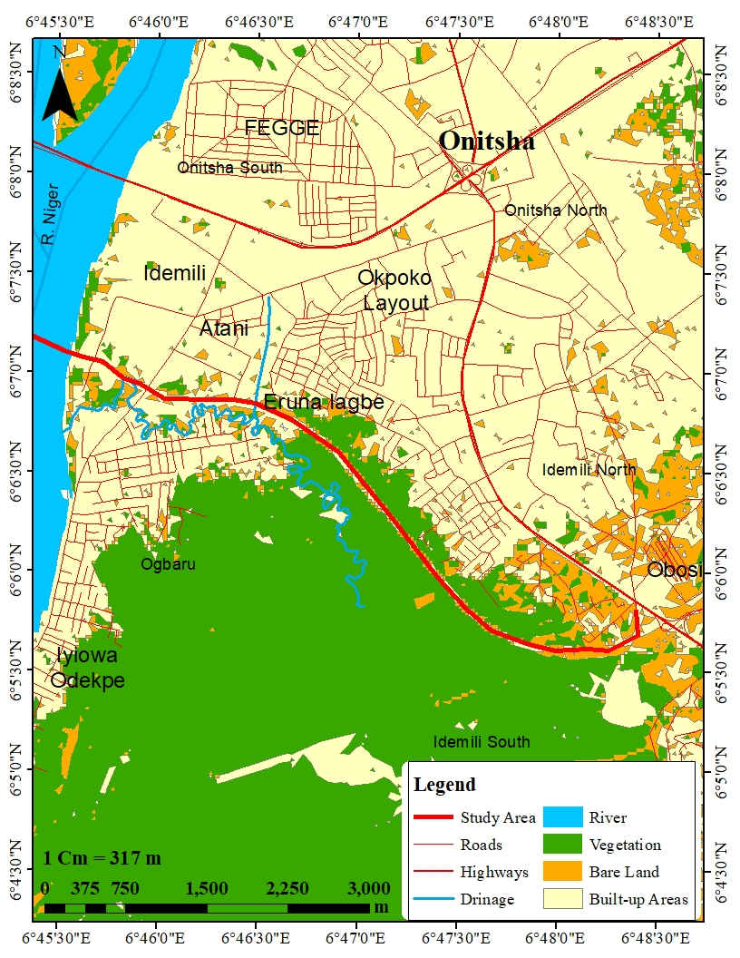
Figure 3.1: Study Area Map.
Source: GIS Lab, Dept. of Survey and Geo-informatics, Nnamdi Azikiwe University, Awka; 2023.

4.0 METHODOLOGY AND DATA PRESENTATION/ANALYSES

4.1 Research Design
This study adopted a geospatial environmental monitoring approach integrating Remote Sensing, Geographic Information Systems (GIS), and statistical analysis to evaluate variations in air quality associated with the construction of the Atani–Obosi Access Route of the Second Niger Bridge. The approach was considered appropriate because it enabled the assessment of atmospheric conditions over a relatively long temporal scale and provided spatially explicit information on pollutant distributions within the study area.
The study investigated air-quality conditions during three distinct project phases: the pre-construction phase (2017), the construction phase (2018–2023), and the post-construction phase (2024). The analysis focused specifically on four atmospheric indicators: Aerosol concentration, Nitrogen Dioxide (NO₂), Formaldehyde (HCHO), and Carbon Monoxide (CO).

4.2 Data Sources
The study utilized remotely sensed atmospheric datasets obtained from internationally recognized earth observation platforms and environmental monitoring repositories. The selected datasets provided continuous spatial and temporal information on atmospheric conditions within the study area throughout the study period.
The pollutants assessed included:
- Aerosol concentration;
- Nitrogen Dioxide (NO₂);
- Formaldehyde (HCHO); and
- Carbon Monoxide (CO).
These indicators were selected because they represent major atmospheric pollutants commonly associated with road construction activities, fuel combustion, transportation systems, and anthropogenic environmental disturbances.
Traffic intensity data used for statistical modelling were obtained from traffic assessment datasets generated during the broader study of the Atani–Obosi Access Route.

4.3 Data Processing and Atmospheric Analysis
Atmospheric datasets were pre-processed and analysed within a GIS environment to ensure consistency across different years and datasets. Spatial analysis techniques were employed to generate pollutant distribution maps and evaluate temporal changes in atmospheric conditions.
The analysis involved:
i. Extraction of pollutant concentration values for the study area;
ii. Temporal comparison of pollutant concentrations between the pre-construction, construction, and post-construction periods;
iii. Spatial mapping of pollutant distributions to identify areas of elevated atmospheric concentration;
iv. Trend analysis of pollutant behaviour throughout the study period.
The processed datasets were subsequently used to determine variations in atmospheric quality associated with the construction and operation of the access route.
A comprehensive analysis was done to evaluate the variations in air quality resulting from the construction of the Atani-Obosi access route associated with the Second Niger Bridge. The study examined four critical air quality indicators which include Aerosol, Nitrogen Dioxide (NO₂), Formaldehyde, and Carbon Monoxide (CO) over three distinct phases: Before Construction (2017), During Construction (2018–2023), and After Construction (2024). The results reveal how construction activities and subsequent urbanization have altered the atmospheric environment of the study area.

4.4 Validation and Interpretation
The results obtained from the atmospheric datasets were interpreted within the context of transportation infrastructure development, construction activities, and environmental sustainability. Observed trends were compared across project phases to determine the extent to which road construction contributed to variations in atmospheric quality.
The interpretation of findings focused on identifying environmental implications associated with pollutant increases and evaluating the effectiveness of natural recovery processes following project completion.

4.5 Ethical Considerations
This study adhered to established ethical principles governing environmental and geospatial research. The investigation relied primarily on remotely sensed atmospheric datasets and secondary environmental information, thereby minimizing direct interaction with human participants and eliminating risks associated with personal data collection.
All datasets utilized in the study were obtained from publicly accessible and scientifically recognized environmental monitoring platforms. Data acquisition, processing, analysis, and interpretation were conducted strictly for academic and research purposes. The study complied with relevant standards relating to data integrity, transparency, objectivity, and scientific reporting.
The results presented in this study accurately reflect the atmospheric conditions observed within the study area during the specified periods. No data manipulation, fabrication, or misrepresentation was undertaken at any stage of the research process. Furthermore, all sources of information were appropriately acknowledged, and the findings were interpreted objectively without bias or external influence.
The study was conducted with due consideration for environmental sustainability, scientific integrity, and responsible research practice.
4.6.1 Aerosol Variations
Aerosols, comprising fine particles or liquid droplets suspended in the air, are key indicators of air quality. They often result from natural processes and human activities, including dust, combustion, and industrial emissions.
Before Construction, in 2017, aerosol levels were relatively stable: with a Minimum index of -0.785, a Maximum index of -0.657 and a Mean index of -0.721.
The negative values indicate low aerosol loading, typical of an environment with limited human interference. This reflects a landscape characterized by natural vegetation and minimal industrial or construction activity, where aerosols predominantly originated from natural sources such as soil particles and organic matter.
During Construction between 2018–2023, a significant increase in aerosol concentrations was observed during the construction period. In 2018, aerosol levels increased to a minimum of -1.292, a maximum of -1.023, and a mean of -1.1575. The rise is attributed to dust emissions from land clearing, excavation, and the movement of heavy machinery. Particulate matter from exposed soil and vehicular activity contributed significantly to the spike.
By 2020, aerosol values peaked, with a minimum of -1.37, a maximum of -1.198, and a mean of -1.284. The intensive phase of construction, involving large-scale earthworks, road grading, and material transportation, exacerbated the release of particulates into the atmosphere.
In 2023, aerosol levels began to decrease, reaching a minimum of -0.467, a maximum of -0.292, and a mean of -0.3795. This decline coincided with the nearing completion of construction and the stabilization of exposed surfaces, though levels remained higher than pre-construction values.
After Construction in 2024, post-construction, aerosol concentrations stabilized but remained elevated compared to 2017, with a minimum of -0.261, a maximum of -0.392, and a mean of -0.3265. This residual aerosol loading is likely due to vehicular emissions, increased urban activity, and the absence of vegetation to filter particulates.
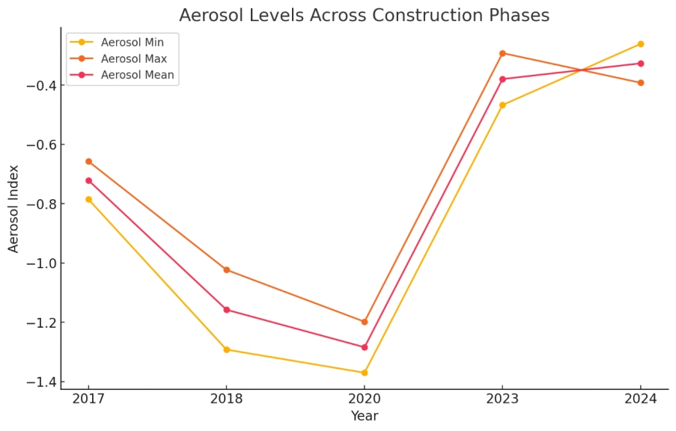
Figure 4.1: Aerosol Levels Between 2017 and 2024
    - Nitrogen Dioxide (NO₂) Variations
Nitrogen dioxide, a byproduct of combustion processes, serves as a key indicator of air pollution from vehicles and industrial activities.
Before Construction in 2017, the Nitrogen Dioxide had a minimum of 0.000005438 mol/m², a maximum of 0.000006229 mol/m² and a mean of 5.8335E-06 mol/m².
NO₂ levels were low, indicating an environment with minimal combustion-related activities. This reflects limited vehicular and industrial emissions.
During Construction starting from 2018, NO₂ levels increased slightly to a minimum of 0.000006133 mol/m², a maximum of 0.000006703 mol/m², and a mean of 0.000006418 mol/m². This was driven by emissions from construction machinery and increased traffic.
In 2020, concentrations peaked with a minimum of 0.0000061 mol/m², a maximum of 0.00000689 mol/m², and a mean of 0.000006495 mol/m². This coincided with the most active construction phase, involving heavy machinery and prolonged fuel combustion.
By 2023, a slight decline was observed as construction activity decreased. The values dropped to a minimum of 0.000006091 mol/m², a maximum of 0.000006602 mol/m², and a mean of 6.3465E-06 mol/m².
Post-construction in 2024, NO₂ levels reduced further to a minimum of 0.000005726 mol/m², a maximum of 0.000006178 mol/m², and a mean of 0.000005952 mol/m². Although closer to pre-construction values, the levels remained slightly elevated due to ongoing vehicular emissions in the developed area.
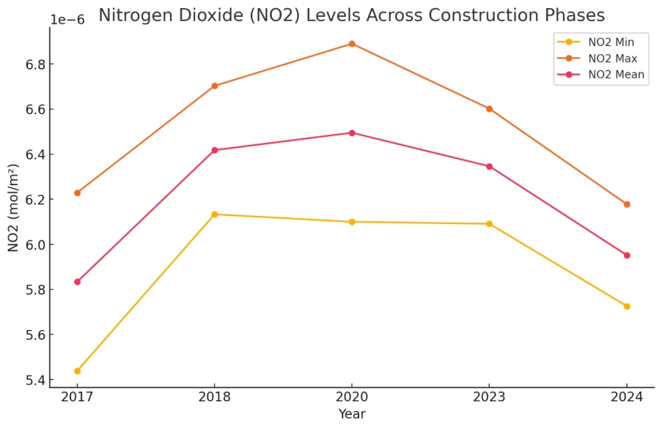
Figure 4.2: Nitrogen Dioxide (No2) Levels Between 2017 and 2024
4.6.3 Formaldehyde Variations
Formaldehyde, a volatile organic compound, is a marker of industrial and vehicular emissions.
Before Construction 2017, Formaldehyde had a minimum of 0.0001166 mol/m², a maximum of 0.0001581 mol/m² and a mean of 0.0001373 mol/m².
Baseline formaldehyde levels were low, indicative of minimal human activity.
During Construction starting from 2018, Formaldehyde levels rose slightly to a minimum of 0.0001273 mol/m², a maximum of 0.0001652 mol/m², and a mean of 0.00014625 mol/m². The increase reflects emissions from construction equipment and materials.
By 2020, Formaldehyde Levels peaked with a minimum of 0.0001505 mol/m², a maximum of 0.0001809 mol/m², and a mean of 0.0001657 mol/m², driven by intensified construction activity.
In 2023, concentrations further increased to a minimum of 0.0001604 mol/m², a maximum of 0.0001908 mol/m², and a mean of 0.0001756 mol/m², indicating cumulative emissions.
After Construction in 2024, Formaldehyde levels remained elevated post-construction, with a minimum of 0.0001676 mol/m², a maximum of 0.0001933 mol/m², and a mean of 0.00018045 mol/m². This reflects sustained emissions from traffic and urban activities.
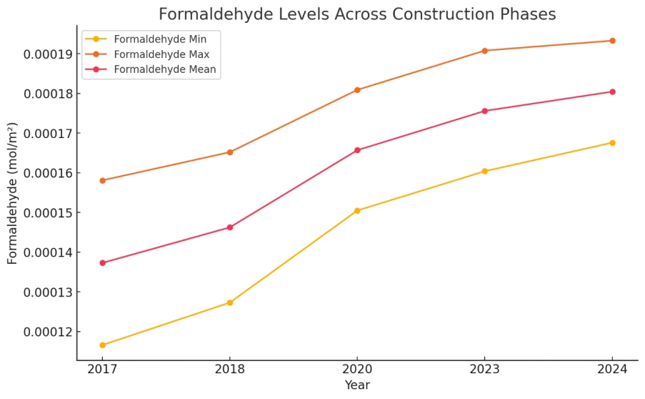
Figure 4.3: Formaldehyde Levels Between 2017 and 2024
4.6.4 Carbon Monoxide (CO) Variations
Carbon monoxide, a product of incomplete combustion, serves as a critical indicator of vehicular and machinery emissions.
Before Construction 2017, Carbon Monoxide had a Minimum of 0.04146 mol/m², a maximum of 0.04232 mol/m², and a mean of 0.04189 mol/m². CO levels were low, reflecting limited combustion activity.
During Construction 2018, a slight increase was observed with a minimum of 0.04156 mol/m², a maximum of 0.04254 mol/m², and a mean of 0.04205 mol/m². by 2020, CO levels rose to a minimum of 0.04438 mol/m², a maximum of 0.04503 mol/m², and a mean of 0.044705 mol/m² due to prolonged combustion from construction machinery.
In 2023, a significant spike occurred, with a mean of 0.22661 mol/m², likely caused by intensified construction activities and reduced dispersion.
After Construction in 2024, CO levels stabilized at a minimum of 0.04917 mol/m², a maximum of 0.04964 mol/m², and a mean of 0.049405 mol/m², reflecting increased vehicular traffic in the developed area.
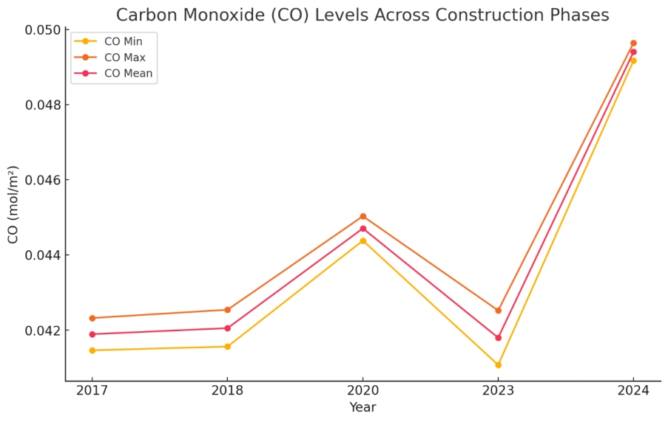
Figure 4.4: Carbon Monoxide Levels Between 2017 and 2024
Aerosols and Carbon Monoxide (CO) exhibited the most significant variations throughout the study period, with construction activities playing a dominant role in their elevation. Aerosol levels surged during the construction phase, driven by dust and particulate matter emissions from land clearing, excavation, and machinery operations. The exposure of bare soil, combined with heavy vehicular traffic and the use of construction materials, contributed to a dramatic increase in particulate matter.
Similarly, Carbon Monoxide levels rose substantially during construction, reflecting emissions from the incomplete combustion of fossil fuels in construction machinery and vehicles. The peak in CO levels during the most intensive construction phase highlights the impact of prolonged fuel usage and reduced air dispersion within the construction zone. Although CO levels decreased post-construction, they stabilized at values higher than the pre-construction baseline due to ongoing vehicular emissions and urban activities in the newly developed area.
Nitrogen Dioxide (NO₂) and Formaldehyde demonstrated moderate but consistent increases throughout the study. The rise in NO₂ levels can be attributed to combustion processes from construction equipment and vehicles. These emissions were sustained over the construction period and remained slightly elevated post-construction due to increased vehicular traffic and urbanization. Formaldehyde levels, often associated with industrial and vehicular emissions, also increased steadily during the construction phase. The use of construction materials, coupled with emissions from fuel combustion, contributed to this rise. Even after construction, formaldehyde levels persisted at higher levels, indicating the lasting impact of urban activities and infrastructure development.
Post-construction stabilization of air quality indicators suggests a partial improvement in conditions following the cessation of intensive construction activities. However, the lingering effects of urbanization, such as increased traffic emissions and reduced vegetative cover, have left a lasting imprint on the air quality of the region. The stabilization at values higher than pre-construction levels highlights the long-term environmental trade-offs of infrastructure development.

5.0 DISCUSSION OF RESULTS/FINDINGS
The analysis of aerosol concentrations revealed substantial temporal variations throughout the study period. The results indicate that aerosol levels increased significantly during the construction phase of the Atani–Obosi Access Route compared with pre-construction conditions. The observed increase coincided with periods characterized by intensive construction activities, including vegetation clearance, excavation, earthworks, transportation of construction materials, and operation of heavy-duty equipment.
The trend illustrated by Figure 1 demonstrates that aerosol concentrations exhibited their greatest fluctuations during the active construction years. This pattern suggests that construction-generated dust constituted a major source of atmospheric pollution within the corridor. The increase in aerosol loading can be attributed to exposed soil surfaces, movement of construction vehicles, and disturbance of natural vegetation cover, all of which enhanced the release of particulate matter into the atmosphere.
Although aerosol concentrations declined following project completion, post-construction levels remained above baseline conditions. This observation suggests that continued vehicular movement and associated anthropogenic activities along the access route contribute to sustained atmospheric particulate loading. The findings support the observations of Khitab et al. (2013), who identified dust generation as one of the most significant environmental impacts of road construction activities, and Zohaib et al. (2016), who reported adverse environmental consequences associated with construction-generated aerosols. The results indicate that aerosol pollution represents one of the most immediate atmospheric impacts associated with transportation infrastructure development and highlights the importance of implementing dust suppression measures during future construction projects.
Nitrogen Dioxide concentrations exhibited a clear temporal response to construction and transportation activities within the study area. The results showed progressive increases in NO₂ levels during the construction phase, reflecting enhanced combustion-related emissions associated with construction machinery, haulage vehicles, diesel-powered equipment, and increased transportation activities. The elevated NO₂ concentrations observed during project implementation indicate increased atmospheric loading from anthropogenic sources. Construction equipment and transportation vehicles represent major sources of nitrogen oxides, which are generated through high-temperature fuel combustion processes. The observed trend therefore reflects the intensity of construction operations and transportation-related emissions during the study period.
Following project completion, NO₂ concentrations declined relative to peak construction levels; however, concentrations remained above pre-construction conditions. This suggests that increased accessibility and traffic volumes associated with the operational phase of the access route continue to influence atmospheric quality. The findings are consistent with Giunta (2020), who identified transportation infrastructure development as a significant contributor to nitrogen oxide emissions through both construction and operational activities. The persistence of elevated NO₂ levels after project completion further emphasizes the importance of transportation management strategies aimed at minimizing long-term atmospheric pollution.
The assessment of Formaldehyde concentrations revealed notable changes in atmospheric composition throughout the study period. Formaldehyde levels increased during the construction phase, indicating enhanced anthropogenic influence on atmospheric conditions. The temporal pattern illustrated in Figure 3 demonstrates a gradual increase in HCHO concentrations during project implementation. This increase can be attributed to fuel combustion processes associated with construction equipment, transportation vehicles, generators, and other machinery utilized during project execution. Elevated formaldehyde concentrations may also reflect broader atmospheric chemical reactions associated with increased emissions from anthropogenic activities.
Although reductions were observed after project completion, HCHO concentrations remained higher than pre-construction levels, suggesting continuing atmospheric influence from transportation-related activities. The findings indicate that formaldehyde serves as a useful atmospheric indicator for assessing environmental changes associated with large-scale infrastructure projects. The observed increase in HCHO concentrations demonstrates that transportation infrastructure development can influence not only particulate pollution but also atmospheric chemical composition. These findings therefore provide additional evidence of the environmental implications of construction activities and increased transportation intensity.
Carbon Monoxide concentrations similarly exhibited significant temporal variations throughout the study period. The results showed that CO concentrations increased during the construction phase, corresponding with intensive operation of fuel-powered construction equipment, haulage vehicles, generators, and transportation machinery. The increase in CO concentrations reflects the contribution of incomplete fuel combustion processes associated with transportation and construction activities. Carbon Monoxide is widely recognized as an indicator of transportation-related pollution because of its close relationship with fuel consumption and vehicular emissions.
The observed decline in CO concentrations following project completion indicates a reduction in construction-related emissions. Nevertheless, post-construction concentrations remained above baseline conditions, suggesting continued contributions from traffic movement and transportation activities along the corridor. The results support the findings of Giunta (2020), who identified Carbon Monoxide as one of the principal atmospheric pollutants associated with transportation infrastructure projects. The persistence of elevated CO concentrations highlights the need for effective emission-control strategies and sustainable transportation planning.

5.5 Relationship Between Transportation Activities and Air Quality
To determine the influence of transportation activities on atmospheric conditions, Multiple Linear Regression analysis was conducted using traffic intensity and air-quality indicators.
Table 4.1: Multiple Linear Regression Table
Year | Avg. Daily Traffic Volume (vehicles/day) | CO₂ (ppm) | NOx (µg/m³) | PM₂.₅ (µg/m³)
2006 | 14,200 | 390 | 42 | 18
2010 | 18,500 | 420 | 58 | 25
2015 | 22,900 | 455 | 71 | 32
2019 | 28,400 | 480 | 85 | 41
2023 | 34,700 | 505 | 97 | 47
MLR results: F(3, 16) = 21.72, p < 0.001, R² = 0.92. Traffic intensity significantly predicts variations in CO₂, NOx, and PM.

The regression analysis demonstrated statistically significant relationships between transportation activities and variations in atmospheric pollutant concentrations. The results indicate that increases in traffic intensity were associated with corresponding increases in Aerosol, NO₂, HCHO, and CO concentrations.
These findings confirm that transportation infrastructure development influences atmospheric quality through both direct and indirect mechanisms. During construction, pollutant increases were largely associated with earthworks, material transportation, and operation of heavy machinery. During the operational phase, traffic movement emerged as the dominant driver of atmospheric emissions.
The statistical evidence therefore supports the conclusion that transportation intensity represents a significant determinant of air-quality conditions within the study area.

5.6 Environmental Implications of Air Quality Variations
The observed increases in Aerosol, NO₂, HCHO, and CO concentrations have important implications for environmental sustainability and public health. Elevated aerosol concentrations may reduce visibility, affect vegetation health, and contribute to respiratory health risks. Increased NO₂ and CO concentrations indicate growing transportation-related pollution and may contribute to broader atmospheric degradation. Similarly, elevated HCHO concentrations suggest modifications in atmospheric chemical processes associated with anthropogenic activities.
Although pollutant concentrations generally declined following project completion, the persistence of elevated levels relative to pre-construction conditions indicates that transportation infrastructure may generate long-term atmospheric impacts beyond the construction period. These findings underscore the importance of integrating air-quality monitoring and environmental management measures into future transportation infrastructure projects. Overall, the results demonstrate that the Atani–Obosi Access Route has influenced atmospheric quality through measurable increases in Aerosol, Nitrogen Dioxide, Formaldehyde, and Carbon Monoxide concentrations. While the project has delivered substantial transportation and economic benefits, its environmental consequences highlight the need for balanced and sustainable infrastructure development strategies.

6.0 CONCLUSION AND RECOMMENDATIONS

6.1 Conclusion
This study assessed variations in air quality associated with the construction of the Atani–Obosi Access Route of the Second Niger Bridge through the evaluation of Aerosol, Nitrogen Dioxide (NO₂), Formaldehyde (HCHO), and Carbon Monoxide (CO) concentrations during the pre-construction, construction, and post-construction phases of the project. The findings revealed that the construction and operation of the access route significantly influenced atmospheric conditions within the study area.
The analysis demonstrated that Aerosol concentrations increased substantially during the construction phase due to vegetation clearance, excavation activities, earthworks, transportation of construction materials, and operation of heavy-duty equipment. Similarly, Nitrogen Dioxide concentrations increased during project implementation, reflecting enhanced combustion-related emissions associated with construction machinery and transportation activities. Formaldehyde concentrations also exhibited upward trends during construction, indicating increased anthropogenic influence on atmospheric composition, while Carbon Monoxide concentrations increased as a result of fuel combustion associated with construction and transportation operations.
Although pollutant concentrations generally declined after project completion, post-construction levels remained higher than pre-construction conditions, indicating that transportation infrastructure may generate long-term atmospheric impacts beyond the active construction phase. The Multiple Linear Regression analysis further confirmed significant relationships between traffic intensity and atmospheric pollutant concentrations, demonstrating the important role of transportation activities in determining air-quality conditions within the corridor.
The study therefore concludes that while the Atani–Obosi Access Route has contributed significantly to transportation efficiency, regional accessibility, and economic development, it has also produced measurable atmospheric impacts through increased concentrations of Aerosol, NO₂, HCHO, and CO. Sustainable transportation development must therefore incorporate effective environmental management strategies capable of minimizing air-quality deterioration while maintaining the socio-economic benefits associated with infrastructure investment.

6.2 Recommendations
Based on the findings of this study, the following recommendations are proposed:

6.2.1 Continuous Air-Quality Monitoring
Government agencies responsible for environmental management should establish continuous air-quality monitoring programmes along major transportation corridors. Regular monitoring of Aerosol, NO₂, HCHO, and CO concentrations will facilitate early detection of environmental deterioration and support evidence-based environmental decision-making.

6.2.2 Dust Suppression During Construction
Future transportation infrastructure projects should implement comprehensive dust-control measures throughout the construction period. Techniques such as regular water sprinkling, covering of transported materials, stabilization of exposed surfaces, and proper maintenance of access roads should be adopted to reduce aerosol emissions.

6.2.3 Emission Control Measures
Contractors and transportation operators should ensure that construction equipment, haulage vehicles, and machinery comply with approved emission standards. Routine maintenance and periodic emission testing should be enforced to minimize atmospheric pollution.

6.2.4 Integration of Air Quality into Environmental Impact Assessment
Environmental Impact Assessment procedures should extend beyond project approval requirements to include long-term monitoring of atmospheric conditions during both construction and operational phases. Air-quality indicators should be incorporated as key sustainability metrics for future transportation projects.

6.2.5 Promotion of Sustainable Transportation Systems
Transportation planning policies should encourage the adoption of cleaner technologies, energy-efficient vehicles, and environmentally friendly transportation systems capable of reducing atmospheric emissions and improving environmental sustainability.

6.2.6 Establishment of Green Buffer Zones
Roadside vegetation buffers should be established and maintained along transportation corridors to improve atmospheric quality, enhance pollutant absorption, reduce dust dispersion, and improve environmental aesthetics.

6.2.7 Strengthening Environmental Regulations
Relevant environmental regulatory agencies should strengthen enforcement mechanisms relating to transportation-related emissions and construction-site environmental management to ensure compliance with established environmental standards.

6.3 Contribution to Knowledge
This study contributes significantly to knowledge in several ways.
First, it provides one of the earliest integrated assessments of atmospheric quality variations associated with the Atani–Obosi Access Route of the Second Niger Bridge using geospatial environmental monitoring techniques. The study therefore contributes empirical evidence to the limited body of literature on transportation-related atmospheric change within southeastern Nigeria.
Second, the study advances methodological knowledge by demonstrating the application of Remote Sensing, GIS, and statistical modelling techniques in the assessment of Aerosol, Nitrogen Dioxide, Formaldehyde, and Carbon Monoxide variations associated with major transportation infrastructure projects.
Third, the research establishes empirical relationships between transportation activities and atmospheric quality through the application of Multiple Linear Regression analysis, thereby providing quantitative evidence of the influence of traffic intensity on environmental conditions.
Fourth, the study contributes to sustainable transportation planning by highlighting the long-term atmospheric implications of infrastructure development and emphasizing the importance of integrating environmental safeguards into transportation project implementation.
Finally, the findings provide a scientific basis for environmental policy formulation, infrastructure planning, and air-quality management within Nigeria and other developing countries experiencing rapid transportation infrastructure expansion.

6.4 AI Declaration
Artificial Intelligence (AI) tools, specifically ChatGPT, were utilized solely for editorial support, language refinement, organization, formatting, and presentation of this manuscript. The role of AI was limited to assisting in the arrangement and communication of research findings.
All data utilized in this study were derived from the original research conducted by the author(s). The conceptualization of the study, data acquisition, data processing, statistical analysis, interpretation of findings, conclusions, and recommendations were undertaken entirely by the author(s). The author(s) accept full responsibility for the accuracy, integrity, originality, and scientific content of this manuscript.

6.5 Conflict of Interest
The author(s) declare that there are no financial, professional, institutional, or personal conflicts of interest that could have influenced the design, execution, analysis, interpretation, or reporting of this study. The research was conducted independently, and all findings presented are based solely on the evidence generated during the investigation.

REFERENCES
Giunta M. (2020). Assessment of the Impact of CO, NOx and PM10 on Air Quality during Road Construction and Operation Phases. Sustainability, 12, 10549; doi:10.3390/su122410549.
Khitab A., Hafeez, I., Riaz, K., Hussain, J., Faisal, M., Farooqi, U., Hussan, S., Saeed, M., & Hayat, A. (2013). A field study of environment degradation during road construction and its improvement due to sprinkling of water. Life Science Journal. 10. 888-893.
Suprayoga, G. B., Witte, P., & Spit, T. (2020). Coping with strategic ambiguity in planning sustainable road development: balancing economic and environmental interests in two highway projects in Indonesia. Impact Assessment and Project Appraisal, 38(3), 233-244. doi:10.1080/14615517.2019.1695462
Zohaib, M., Mahmood K. Z. & Ali, I. (2016). Environmental Impacts of Dust Pollution Produced in Construction Sites: A Review with its Proposed Management Plan for Pakistan. 1st National Conference of Agricultural Engineering and Sciences (NCAES-2016) At BZ University Multan Pakistan Volume: pp 286-289.

