1. Title

Market radios as a community-based strategy to address infodemic dynamics and improve COVID-19 vaccination uptake in Kinshasa, Democratic Republic of Congo

3. Abstract

The COVID-19 pandemic was accompanied by an infodemic that undermined vaccine acceptance, particularly in sub-Saharan Africa, where health communication inequality is pronounced. Market radios and hyper-local loudspeaker systems embedded in marketplaces may represent community-based channels for addressing misinformation in settings with limited access to conventional media outlets. This study examined the association between a market radio–based communication intervention and COVID-19 vaccination uptake in urban markets in Kinshasa, the Democratic Republic of Congo.

A quasi-experimental before-and-after intervention study was conducted in April 2023. The intervention combined capacity building for market announcers, participatory co-creation of vaccination messages, daily broadcasting in Lingala, social listening with iterative content adaptation, and structured referrals to nearby vaccination sites. A stratified sample of 500 market vendors (80% women and 20% men) was surveyed at baseline and two weeks post-intervention. Outcomes included knowledge of vaccine benefits, trust in official information sources, safety-related concerns (fertility, side effects, conspiracy beliefs), and self-reported COVID-19 vaccination status. Descriptive statistics, McNemar’s chi-square tests, and exploratory logistic regression were used for analyses.

Post-intervention, knowledge of vaccine benefits increased substantially among women and men, trust in official information improved, and vaccine-related concerns decreased. Overall, vaccination uptake increased by 15 pp within two weeks. Exploratory analyses indicated that exposure to market radio broadcasts and higher trust in official messages were strongly associated with vaccine uptake. Market radios appear to offer a low-cost, participatory, and culturally embedded communication approach that may support vaccination efforts in resource-constrained urban settings, with potential relevance beyond COVID-19 vaccination.

Keyword: market radios; infodemic; COVID-19 vaccination; vaccine uptake; community communication; Democratic Republic of Congo

Introduction

The COVID-19 pandemic unfolded alongside what the World Health Organization (WHO) termed an infodemic, an excess of both accurate and misleading information that complicated people’s ability to distinguish between trustworthy sources and make informed health decisions [1]. This phenomenon eroded trust in institutions, fueled resistance to vaccination, and limited the effectiveness of public health measures [2,3]. In sub-Saharan Africa, these dynamics are magnified by weak health infrastructure, socioeconomic inequalities, and low levels of health literacy [4,5].

In the Democratic Republic of the Congo (DRC), COVID-19 vaccination coverage remained particularly low, failing to exceed 25% by mid-2022 [6]. Multiple factors contributed to this situation, including logistical constraints, inequitable vaccine distribution, entrenched mistrust of health authorities, and persistent rumors related to fertility and vaccine safety [7]. Kinshasa, a megacity with more than 15 million inhabitants, has many of these barriers, with pronounced inequalities in access to health services and exposure to reliable health information [8]. National surveys consistently indicate that women, informal workers, and individuals with limited education have lower exposure to traditional media, such as radio and television, which increases their vulnerability to misinformation [9].

The infodemic context was further shaped by the rise of informal opinion leaders in the Congolese setting, commonly referred to as “nyonsologues.” These actors, often lacking scientific training, attract wide audiences through humor, emotional appeals, and simplified messaging. Their narratives frequently portrayed governmental and scientific information as untrustworthy, thereby reinforcing public doubt and skepticism toward vaccination [10].

Conventional risk communication channels, including national radio, television, and print media, have proven insufficient in effectively addressing these challenges. Health professionals often communicate using highly technical language, whereas professional communicators without biomedical training tend to oversimple complex information. Communities with limited health literacy, positioned between these two extremes, face difficulties navigating competing narratives. This disconnects between experts, communicators, and citizens created favorable conditions for the persistence of misinformation and vaccine hesitancy [11].

In this context, market radios have emerged as potential community-anchored communication channels. These hyper-local systems, consisting of loudspeakers and microphones operated within marketplaces by local announcers speaking Lingala and other vernacular languages, are closely embedded in the daily economic and social lives of’ the people. Their participatory format, proximity, and cultural resonance distinguish them from licensed community radio stations that broadcast across wider geographic areas [12,13].

Evidence from other low-resource settings supports the relevance of these methods. In Ethiopia, community radio and loudspeaker systems have improved maternal and child health awareness among populations with limited literacy [14]. Studies conducted in Malawi and South Africa reported increased trust in vaccination campaigns following participatory radio initiatives [15,16]. Similarly, co-designed health messaging interventions in marginalized urban communities in Pakistan contributed to reductions in COVID-19–related misinformation [17]. Together, these experiences underscore the importance of cultural adaptation, community participation, and credibility of local voices in health communication.

Building on this rationale, the present study examined market radios as a structured, community-based approach to address infodemic dynamics related to COVID-19 vaccination in Kinshasa, the DRC. The intervention integrated training for market announcers, participatory co-creation of vaccination messages, daily broadcasts in Lingala, iterative adaptation based on community feedback, and systematic referral to nearby vaccination services.

The objectives of this study were as follows:

- This study assessed changes in knowledge of COVID-19 vaccine benefits among market vendors following exposure to market radio broadcasts.
- Changes in trust in official health information sources after the intervention were also examined.
- Changes in vaccine-related misconceptions and safety concerns, including fertility fears, perceived side effects, and conspiracy beliefs, were explored.
- Changes in COVID-19 vaccination uptake following the intervention were described.
- Sociodemographic and communication-related factors associated with vaccination uptake were identified using multivariate regression analysis.

Methods

Study design and setting

We conducted a quasi-experimental before–after intervention study in April 2023 to examine changes associated with a market radio–based communication intervention addressing COVID-19–related misinformation and vaccination uptake. The study was conducted in Kinshasa, Democratic Republic of Congo (DRC), a metropolitan area with over 15 million inhabitants, characterized by pronounced socioeconomic disparities and linguistic diversity. Although French is the official language, Lingala functions as a lingua franca alongside Kikongo, Tshiluba, and Kiswahili.

Study population and eligibility

The target population consisted of market vendors, a group frequently underserved by mainstream media and formal health promotion initiatives. Participants were eligible if they (1) worked actively as vendors in the selected markets, (2) were aged 18 years or older, and (3) provided verbal consent to participate in both survey rounds.

Sampling and sample size

A stratified sampling approach was applied to ensure representation across sex, age, and economic activity type. Among the 59 markets with operational market radios, 20 were purposively selected based on predefined criteria, including regular broadcasting activity, use of Lingala, and engagement in community health messaging. A total of 500 vendors were recruited from these markets, comprising 400 women (80%) and 100 men (20%).

The age distribution was as follows: 18–30 years (25%), 31–50 years (50%), and ≥51 years (25%). Economic activities included the sale of food products (40%), manufactured goods (30%), services such as catering and tailoring (20%), and other activities (10%).

A sample size of 500 was calculated to detect a minimum 15–percentage point change in primary outcomes (knowledge, trust, and vaccination uptake) with 80% statistical power at a 5% significance level, assuming a baseline prevalence between 30% and 50%.

Intervention components

The intervention comprised five integrated components.

- Training of announcers: Sessions on risk communication, infodemic dynamics, and ethical broadcasting were provided to market announcers and their leaders.
- Message co-creation: Vaccination messages were collaboratively developed with community health workers (RECOs), health professionals, and market representatives to ensure contextual relevance.
- Broadcasting: Tailored messages were disseminated daily through short spots, interactive discussions, and public announcements, with each market radio broadcasting a minimum of 12 programs per day during the two-week intervention period.
- Social listening and adaptation: RECOs systematically collected feedback on circulating concerns, including fertility fears, perceived side effects, and conspiracy beliefs, allowing for the iterative adaptation of broadcast content.
- Referral to vaccination sites: Announcers and RECOs provided information and guidance to vaccination points located within or near the markets.

Data collection

Two rounds of data collection were conducted: baseline (April 13–18, 2023) and follow-up (April 26–30, 2023). Structured questionnaires were administered face-to-face in Lingala and French by trained enumerators, including RECOs. The questionnaire was pre-tested in a non-study market to assess clarity and cultural appropriateness, and minor revisions were made before its implementation.

The collected variables included sociodemographic characteristics (sex, age, education, and occupation), knowledge of COVID-19 vaccine benefits, trust in government or health authority messages, perceptions of vaccine safety (fertility concerns, side effects, and conspiracy beliefs), and self-reported vaccination status.

Study outcomes

The primary outcomes were defined as follows: (1) knowledge of COVID-19 vaccine benefits; (2) trust in official health information sources; (3) perceptions of vaccine safety, including fertility concerns, fear of side effects, and conspiracy beliefs; and (4) vaccination uptake, defined as receiving at least one dose.

Data analysis

Data were analyzed using Stata software. Descriptive statistics were used to summarize participant characteristics and outcome variables. McNemar’s chi-square test was used to assess the changes between baseline and follow-up. Bivariate chi-square tests were used to explore the associations between sociodemographic factors and the outcomes. Exploratory logistic regression was used to examine the association between vaccination uptake and selected covariates, adjusting for sex, age, education, and intervention exposure. Statistical significance was set at P <0.05.

Sensitivity analyses were not conducted; however, future studies could incorporate such analyses to assess robustness with respect to recall or reporting bias.

Measures to reduce bias

Several measures were implemented to enhance internal validity, including standardized training of enumerators, short recall periods to limit memory bias, stratified sampling to improve representativeness, and continuous field supervision to ensure data quality. Potential sources of bias included the absence of a control group, reliance on self-reported vaccination status, limited generalizability beyond urban market settings, and a short duration of follow-up.

Results

The results describe changes in knowledge, trust, vaccine-related perceptions, and COVID-19 vaccination uptake among 500 market vendors.

Table 1. Sociodemographic characteristics of study participants (n=500)

Characteristic | Category | n | %
Sex | Women | 400 | 80
Men | 100 | 20
Age group | 18–30 years | 125 | 25
31–50 years | 250 | 50
≥51 years | 125 | 25
Education | Primary or less | 275 | 55
Secondary | 175 | 35
Higher | 50 | 10
Main activity | Food sales | 200 | 40
Manufactured goods | 150 | 30
Services | 100 | 20
Other activities | 50 | 10

Table 1 summarizes the sociodemographic characteristics of the 500 market vendors in this study. Women comprised 80% of the participants. Half were aged 31–50 years, while 25% were aged 18–30 years, and the remaining 25% were 51 years or older. More than half of the participants (55%) had received primary education or less. Food sales were the most common economic activity (40%), followed by manufactured goods (30%) and services (20%).

Table 2. Knowledge, trust, and perceptions before and after the intervention, by sex (n=500)

Indicator | Women before n (%) | Women after n (%) | Men before n (%) | Men after n (%) | p-value
Knowledge of vaccine benefits | 120 (30) | 280 (70) | 50 (50) | 95 (95) | <0.001
Trust in health information | 160 (40) | 300 (75) | 60 (60) | 90 (90) | 0.001
Fertility concerns | 200 (50) | 100 (25) | 30 (30) | 5 (5) | <0.001
Fear of side effects | 240 (60) | 160 (40) | 40 (40) | 20 (20) | <0.001
Conspiracy beliefs | 300 (75) | 180 (45) | 40 (40) | 20 (20) | <0.001

Table 2 shows the changes in knowledge, trust, and vaccine-related perceptions between baseline and follow-up, stratified by sex. Increases were observed in knowledge of vaccine benefits and trust in health information among both women and men, while fertility concerns, fear of side effects, and conspiracy beliefs decreased significantly among both sexes.

Table 3. Knowledge, trust, and perceptions before and after the intervention, by education level (n=500)

Indicator | Primary Before | Primary After | Secondary Before | Secondary After | Higher Before | Higher After | p-value
Knowledge of benefits | 83 (30) | 179 (65) | 70 (40) | 140 (80) | 20 (40) | 45 (90) | <0.001
Trust in health info | 110 (40) | 192 (70) | 100 (57) | 149 (85) | 25 (50) | 47 (95) | <0.001
Fertility concerns | 165 (60) | 83 (30) | 70 (40) | 26 (15) | 10 (20) | 3 (5) | <0.001
Fear of side effects | 200 (73) | 124 (45) | 90 (51) | 44 (25) | 15 (30) | 5 (10) | <0.001
Conspiracy beliefs | 220 (80) | 151 (55) | 90 (51) | 53 (30) | 10 (20) | 5 (10) | <0.001

Table 3 presents the changes in knowledge, trust, and vaccine-related perceptions by education. Improvements were observed across all education groups, with larger gains among participants with secondary and higher levels of education.

Vaccination uptake

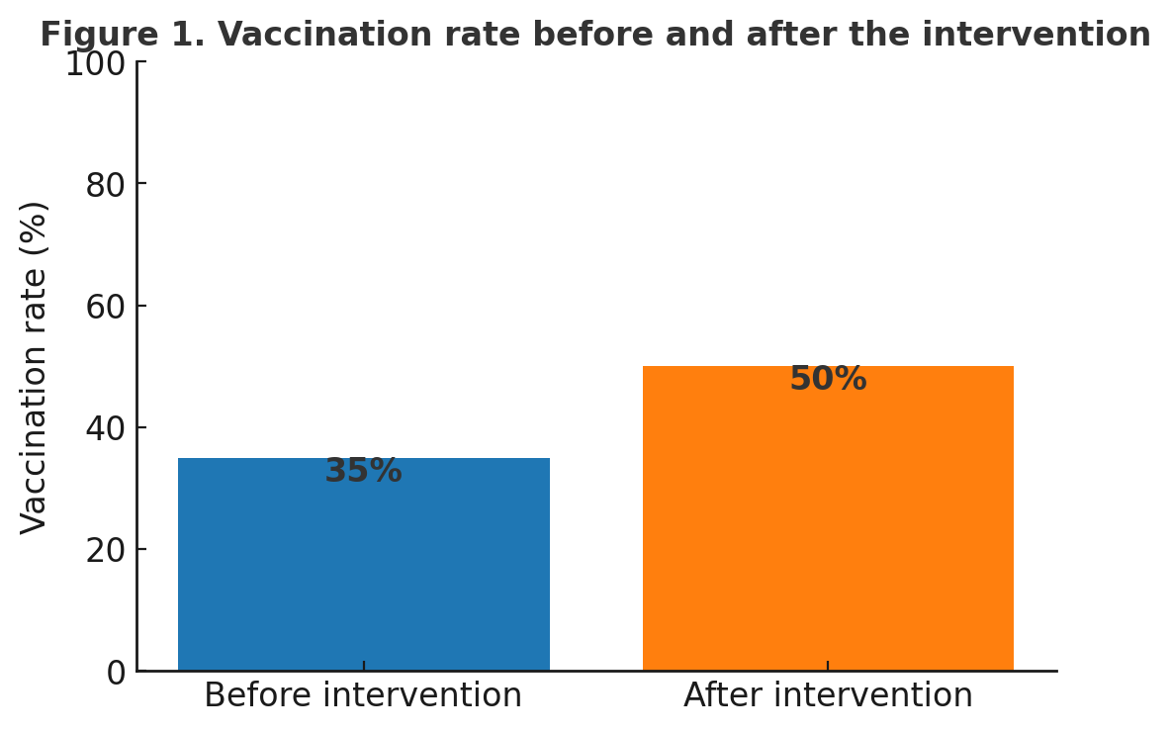

Image

Figure 1 shows an increase in COVID-19 vaccination uptake from 35% at baseline to 50% at follow-up, corresponding to a 15–percentage point increase over the two-week intervention period.

Predictors of COVID-19 vaccination uptake (exploratory logistic regression)

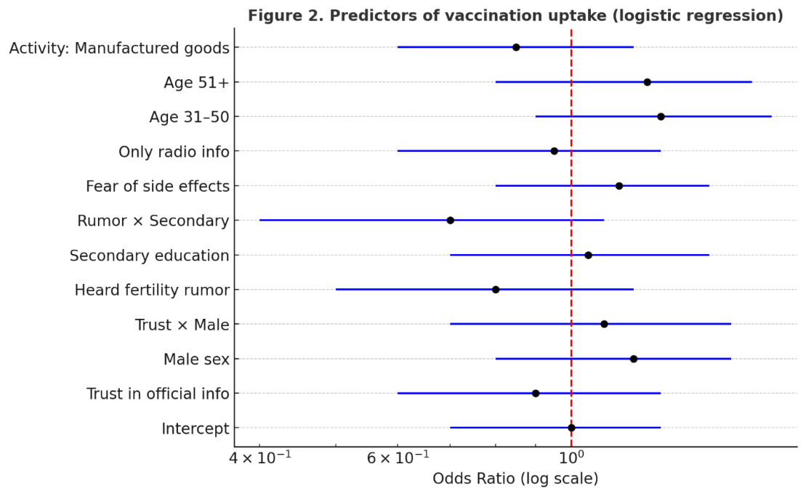

Image

Figure 2 presents the results of an exploratory logistic regression analysis examining the factors associated with COVID-19 vaccination. Higher trust in official health information and exposure to market radio broadcasts were positively associated with vaccination uptake, whereas variables related to safety concerns and rumor exposure were negatively associated with vaccination uptake. The estimates are presented as odds ratios (ORs) with 95% confidence intervals (CIs).

Discussion

This quasi-experimental study suggests that market radios can function as a practical, community-anchored communication approach in fragile health information environments in low-resource urban settings as in Kinshasa, Democratic Republic of Congo. Over a two-week intervention period, increases were observed in knowledge of COVID-19 vaccine benefits, trust in official health information, and vaccination uptake, along with a reduction in common safety-related concerns. These findings indicate that hyper-local communication channels may help bridge the gaps between institutional health messaging and community information needs, particularly in contexts characterized by low literacy and limited access to conventional media channels.

Links with previous research

These findings are consistent with existing evidence showing that localized and participatory communication tools can improve health-related knowledge and behaviors. In Ethiopia, structured radio-based interventions combining drama, community dialogue, and interactive formats have been associated with improved childhood immunization outcomes [1]. In Malawi, exposure to multiple vaccine information sources, including radio, was linked to higher COVID-19 vaccine acceptance [2], whereas education level and knowledge were key determinants of hesitancy [3]. In Tanzania, mixed-methods research has highlighted the complementary role of traditional media and community engagement in promoting vaccine uptake [4]. Beyond Africa, co-designed communication interventions in marginalized urban communities in Pakistan contributed to reduced susceptibility to COVID-19–related misinformation [5].

Compared with these approaches, market radios in Kinshasa represent a distinct form of micro-local communication embedded in daily market activities, delivered by trusted local announcers, and are continuously adapted to emerging community concerns.

Why market radios may be effective

Three mechanisms underlie these associations. First, broadcasting in Lingala within marketplaces increased the reach of groups often underserved by mainstream media, including women and vendors with limited formal education. Second, the involvement of familiar local announcers likely enhanced the credibility of the vaccination messages, counterbalancing the influence of informal opinion leaders. Third, participatory co-creation of content with health workers and market representatives allowed for direct engagement with prevalent myths related to infertility, side effects, and conspiracy narratives, in line with evidence that participatory approaches can mitigate vaccine hesitancy [6].

Strengths and limitations

The strengths of this study include its pragmatic design, stratified sampling strategy, and integration of social listening to enable real-time content adaptation. Limitations include the absence of a control group, reliance on self-reported vaccination status, restriction to urban market settings, and a short duration of follow-up. Therefore, the findings should be interpreted as associative rather than causal relationships.

Policy and programmatic implications

Despite these limitations, the results suggest relevant programmatic opportunities for future studies. Market radios can complement national demand generation strategies alongside mass media and digital platforms. Their affordability, adaptability, and community ownership render them particularly suitable for fragile health systems. Beyond COVID-19, this approach may be relevant for other vaccination efforts, including those against measles, polio, human papillomavirus, cholera, and Ebola, in line with the Immunization Agenda 2030 and the WHO–UNICEF Big Catch-Up initiative.

Directions for future research

Future studies should employ cluster-randomized or stepped-wedge designs to strengthen causal inference, assess long-term sustainability, and evaluate cost-effectiveness relative to alternative communication strategies. Comparative research across rural, peri-urban, and urban contexts will further inform scalability and adaptation requirements.

Conclusion

This study suggests that market radios may represent a feasible and community-anchored communication approach for addressing infodemic dynamics and supporting COVID-19 vaccination uptake in low-resource urban settings. Over a short intervention period, improvements were observed in knowledge of vaccine benefits, trust in official health information, and vaccination uptake, as well as a reduction in common vaccine-related concerns.

By leveraging hyper-local broadcasting, trusted community voices, and participatory message co-creation, market radios appear to be well-suited for reaching populations underserved by conventional media. While the findings should be interpreted as associative rather than causal, they highlight the potential value of integrating community-based channels into broader immunization communication strategies.

Beyond the COVID-19 context, market radios may offer a complementary tool for routine immunization and epidemic preparedness in fragile health systems in the future. Further research is needed to assess the scalability, long-term sustainability, and cost-effectiveness of these interventions in diverse settings.

Declarations

Ethics approval and consent to participate

The study was conducted as a public health program evaluation in collaboration with local health authorities. All procedures complied with the principles of the Declaration of Helsinki. Participation was voluntary, and informed verbal consent was obtained from all the participants.

This study was reported in accordance with the Strengthening the Reporting of Observational Studies in Epidemiology (STROBE) guidelines.

Consent for publication: Not applicable.

Availability of data and materials
The datasets generated and analyzed during the current study are available from the corresponding author upon reasonable request.

The authors declare no competing interests.

Funding: No specific funding was received for this study.

Acknowledgements

The authors thank the market authorities, local announcers, community health workers (RECOs), and all the study participants for their collaboration and engagement. We also acknowledge the local health authorities for their support during the implementation of the field activities.

Author contributions

Authors’ contributions Richard Bahizire Riziki conceived the study, designed the methodology, coordinated implementation, and drafted the first version of the manuscript. Daniel Katuashi Ishoso, Audry Mulumba wa Kamba, and Synthia Aganze Mitima contributed to the study design and ensured quality control of data collection. Sony Mbembe, Bamato Fatuma Stella, Fideline Mapitshi Mbambili, Raoul Kamanda and Eddy Makengu supported the development of the intervention, supervised field activities and oversaw community engagement. Albert Muya Dibaya, Jimmy Dibanzilua Mwana Nsambu, and Murielle Nzanzi Nsambu participated in the data acquisition and monitoring of market radio broadcasts. Albert Muya Dibaya and Bienvenu Nguedjio T performed statistical analyses and contributed to data interpretation. Pablito Nasaka Benda, Moïse Yapi, Aimé Cikomola Mwana wa Bene, Marcelin Nimpa Mengouo, and Alain Ngashi Ngongo critically reviewed the manuscript for its intellectual content. All authors have read and approved the final manuscript.

References

1. Amo-Adjei J, Nurzhynska A, Essuman R, et al. Trust and willingness towards COVID-19 vaccine uptake: A mixed-method study in Ghana, 2021. BMC Public Health. 2022;22:1432. doi:10.1186/s12889-022-13840-2

2. World Bank. Overview of the Democratic Republic of Congo. World Bank Report. 2024. Available from: https://www.worldbank.org/en/country/drc/overview

3. Brackstone K, Atengble K, Head M, et al. COVID-19 vaccine hesitancy trends in Ghana: A cross-sectional study. BMJ Glob Health. 2022;7:e008691. doi:10.1136/bmjgh-2022-008691

4. Enquête Démographique et de Santé (EDS). République Démocratique du Congo 2023-2024. Ministère du Plan et Santé RDC.

5. Feinberg I, Yoon J, Holland D. The relationship between health literacy and COVID-19 vaccination prevalence during a rapidly evolving pandemic and infodemic. Prev Med Rep. 2022;27:101797. doi:10.1016/j.pmedr.2022.101797

6. Fitzpatrick P. Improving health literacy using the power of digital communication to achieve better health outcomes. J Commun Healthc. 2023;16(2):95–102. doi:10.1080/17538068.2023.2189600

7. Hafida NSH, Setiawan B, Anna R. Effectiveness of community radio infrastructure to support disaster preparedness: A case study in Yogyakarta, Indonesia. Procedia Eng. 2018;212:222–228. doi:10.1016/j.proeng.2018.01.029

8. Ismail N, Ben Ismail DK, Frey T, et al. The experience of health professionals with misinformation: a qualitative interview study. JMIR Form Res. 2022;6(8):e37585. doi:10.2196/37585

9. Jennings W, Valgarðsson VO, McKay L. Trust and vaccine hesitancy during the COVID-19 pandemic: A cross-national analysis. Soc Sci Med. 2023;320:115740. doi:10.1016/j.socscimed.2023.115740

10. Kainja J, Makhumula C, Twabi HS, et al. Cultural determinants of COVID-19 vaccine misinformation in Malawi. Afr J Prim Health Care Fam Med. 2024;16(1):a4052. doi:10.4102/phcfm.v16i1.4052

11. Kassahun A, Tadesse A, Mekonnen A. Community radio and public health: The role of local media in COVID-19 communication in Ethiopia. Int J Public Health. 2022;67:160437. doi:10.3389/ijph.2022.160437

12. Mavuso M, Ndlovu S, Dlamini S. The role of community radio in promoting health education in rural South Africa. Afr J Health Sci. 2022;35(2):55–63.

13. Medeossi B-J, Stadler J, Delany-Moretlwe S. Using community radio to strengthen good participatory practice in HIV prevention trials. AIDS Care. 2014;26(5):628–631. doi:10.1080/09540121.2013.841840

14. United Nations Population Division. World Cities in 2018. New York: UN DESA; 2018.

15. Nsubuga EJ, Fitzmaurice AG, Komakech A, et al. Community dialogue meetings among district leaders improved the willingness to receive COVID-19 vaccines in Uganda. BMC Public Health. 2023;23:1743. doi:10.1186/s12889-023-16655-0

16. Nyawasha TS. Community-based responses to HIV/AIDS in South Africa: Evaluation of a children’s radio programme. Child Youth Serv Rev. 2013;35(9):1513–1519. doi:10.1016/j.childyouth.2013.05.013

17. Nzayisenga E, Niyonkuru C, Musoni A. COVID-19 misinformation and vaccine hesitancy in Democratic Republic of Congo: The role of local communication strategies. J Public Health Afr. 2021;12(1):94–99. doi:10.4081/jphia.2021.94

18. Qasim R, Farooqui WA, Rahman A.. Community-centered co-design methodology for socio-behavioral interventions against misinformation in Karachi, Pakistan. BMC Public Health. 2023;23:1655. doi:10.1186/s12889-023-16640-7

19. Reno C, Maietti E, Di Valerio Z. Vaccine hesitancy towards COVID-19 vaccination: Role of information sources. Vaccines (Basel). 2021;9(9):959. doi:10.3390/vaccines9090959

20. Silvestri S, Musebe R, Baars E, et al. Going digital in agriculture: how radio and SMS can scale-up smallholder participation in Tanzania. Outlook Agric. 2020;49(1):33–41. doi:10.1177/0030727019900294

21. Sönmezer MÇ, Şahin TK, Erul E, et al. Knowledge, attitudes, and perceptions of COVID-19 vaccination in Turkey. BMC Public Health. 2022;22:1411. doi:10.1186/s12889-022-13822-4

22. Tan HK, Luo J, Zhang M. Higher education, happiness, and residents’ health. Soc Indic Res. 2020;150:101–123. doi:10.1007/s11205-020-02285-7

23. Zarocostas J. How to fight infodemic. Lancet. 2020;395(10225):676. doi:10.1016/S0140-6736(20)30461-X

