Quantifying Intra-Denomination Color Consistency for Chromatic Separability in Nigerian Naira Notes using RGB Feature Analysis

ABSTRACT

The paper presents an initial, comprehensive colorimetric examination of Nigerian banknotes through image-based approaches. A representative set of fifty authentic banknotes, issued in circulating denominations of 200 Naira, 500 Naira, and 1000 Naira, was used for this investigation. While statistical analyses were performed on the full cohort (N=50 per denomination), representative data of five set per denomination are presented herein to maintain conciseness without compromising statistical validity. Statistical analyses were performed on a complete cohort of 50 authentic banknotes per denomination. For publication brevity, only five representative samples per denomination are presented in tables and figures; all reported statistical metrics are derived from the full N = 50 dataset. Image processing, conducted under controlled conditions, was used to determine the mean and dominant values of Red, Green, and Blue (RGB) for individual banknotes, thereby enabling an objective evaluation of their color properties. Significant and distinct variations in the colors were evident among the different denominations of the Nigerian banknotes. Specifically, the 200 Naira notes were found to have uniformly warmer pink colors (mean RGB: 180.9, 170.2, 152.7; dominant blue; Standard Deviation ≤ 4.4), while the 500 Naira notes showed moderate variations (mean RGB: 175.7, 167.3, 165.3; dominant blue; Standard Deviation ≤ 19.3). These variations are likely due to intricate features on the notes. The 1000 Naira notes showed the most pronounced variations in colors, (mean RGB: 189.3, 172.2, 138.7; dominant Blue, Standard Deviation ≤ 62.7), which may be attributed to the intricate features and ink colors used for these notes. Multivariate statistical analysis showed significant differences among the different denominations and homogeneity within individual groups, thus ensuring reliable categorization. These findings suggest that the RGB-based characterization has strong potential for being used as an effective, cost-efficient, and non-invasive approach for identifying Nigerian banknotes, which would be particularly useful in scenarios where resources are limited and access to sophisticated analytical tools is not feasible. However, this approach is not holistically sufficient and efficient for Nigerian Naira note authentication. This study, being the first reported work on color analysis for Nigerian banknotes/currencies, has established an essential data repository for future anti-counterfeit approaches, automated visual inspection systems, and forensic document examination for developing countries.

Index Terms: Nigerian Naira Banknotes, Forensic Document Examination, RGB-based Characterization, Colorimetric Assessment, Standard Deviation, Mean, Dominant Color, Anti-Counterfeiting.

- INTRODUCTION

This current research aims to investigate the Nigerian economy, which is dominated by cash usage, and most of the population remains unbanked [1]. Although the Central Bank of Nigeria has advocated for a cashless economy [2], physical currency remains widely used, particularly in the informal sector, rural areas, and among individuals with visual impairments [3]. Identification of physical currency can prove to be highly beneficial for street vendors, visually impaired individuals, and business owners. However, the current technologies that have been developed for this purpose are expensive, usually employing sophisticated techniques or machine learning approaches [4, 5], which are not viable for implementation. Considering the global perspective, artificial neural networks have been found to be highly effective for the identification of Euro and US Dollar banknotes [6, 7], but these approaches require huge amounts of data and computational resources. On the other hand, simpler approaches, such as color analysis, have not been explored exhaustively for African countries. The newly redesigned Naira banknotes, launched in 2022, which include 200 Naira, 500 Naira, and 1000 Naira [8], feature different colors for different denominations, such as green for lower denominations, orange for mid-range values, and blue for higher values, which can be considered an intentional feature for computer vision-based approaches. The research on currency recognition indicates that previous studies used deep CNNs and vision transformers, Scale-Invariant Feature Transform, Histogram of Oriented Gradients, and Local Binary Pattern handcrafted features to achieve accuracy, but these methods required extensive computational power and high-resolution input and large-scale memory, which made them unsuitable for budget-friendly edge devices. The approaches depend on perfect environmental conditions, which include ideal lighting, flat notes, and pristine surfaces; this dependency makes the approaches vulnerable to actual environmental conditions, which include folding and wear, occlusion, and illumination changes. The RGB channel merging process used by many methods results in the loss of specific statistical fingerprints that link to actual security inks and substrate characteristics. The RGB statistical characterization developed by the researchers in this study solves three existing research problems through its implementation of lightweight feature extraction, which substitutes heavy feature extraction with closed-form descriptors that provide per-channel mean and variance, skewness and kurtosis, and covariance and histogram entropy information, which can be calculated through linear operations using minimal system memory. The system uses RGB distribution modeling to detect color defects in counterfeit printing while maintaining statistical stability through two methods, which include statistical normalization and channel-ratio invariant techniques. The new approach enables anti-counterfeiting systems to maintain their identification capabilities while operating within the computational, power, and cost limits of low-priced mobile and embedded systems.
The current research aims to contribute the following key elements:
i. A publicly available dataset containing the mean RGB and dominant RGB color values for Nigerian Naira denominations, i.e., #200, #500, and #1000
ii. A simple and easily replicable procedure, developed in MATLAB, for extracting color features without complex machine learning or specialized software.
iii. Demonstrate and substantiate the fact that color information alone cannot effectively distinguish between different Naira denominations, paving the way for lightweight identification systems that can run on smartphones or low-cost devices.

This study embraces principles of environmental sustainability in artificial intelligence and frugal innovation, prioritizing efficiency, accessibility, and relevance to local needs. To encourage collaboration and further development within the African research community, data will be made publicly available.

1.1 COLORS OF NIGERIAN PAPER CURRENCY BANKNOTES

According to the Central Bank of Nigeria, being the regulatory body in charge of printing and distribution of Nigerian currency/banknotes called Naira (#), unique colors have been designed to individual notes for the purpose of human/machine identification and authentication. Table 1 describes the color trends of Naira notes. The naira notes range from lower denominations, which can be polymer and paper in appearance, they are #5, #10, #20, #50. And, the higher denominations, which are mainly paper in appearance, are #100, #200, #500, and #1000. There are two distinct color schemes for #200, #500, and #1000 denominations presently in circulation: the older (pre-2022) series color and the 2022 redesigned color. It is worth mentioning that both old banknotes and new banknotes are legal tender in Nigeria to this day. This research has only focused on the copies of new #200 banknotes, old #500 banknotes, and old #1000 banknotes in circulation. The Central Bank of Nigeria uses specific color patterns for different paper denominations because these engineered color systems create separate color identification systems that appear in RGB space as distinct colors (₦200: warm pink/red; ₦500: brownish-orange/green; ₦1000: blue/purple), which machines can use to identify different paper denominations. The proposed framework operationalizes this regulatory design by extracting lightweight statistical descriptors per-channel mean intensities, dominant RGB centroids via k-means clustering (k=3), and intra-class standard deviations, to quantify both perceptual color identity and manufacturing consistency. The policy requirements state that each denomination must have its own RGB cube space, which leads to two outcomes because this method builds a feature space that maintains complete class separation while protecting class identity, because it needs no deep learning training and uses no complex computations. The dual use of mean and dominant metrics accounts for multi-layered security inks and surface patterns, capturing both global appearance and modal color stability. The descriptive color guidelines transform into an empirically validated computational prior because the engineered chromatic boundaries establish measurable decision thresholds. The RGB statistical characterization links currency policy with edge-AI deployment by demonstrating that structured palettes, which use linear-time descriptors, create a reliable resource-efficient system that enables low-cost mobile and embedded platforms to identify denominations under actual imaging conditions and note damage.

Table 1: Statistical Summary of Nigerian Paper Banknotes [16]
Denomination | Color of old banknotes | Color of new banknotes | Length (mm) | Width (mm) | Aspect Ratio
₦5 | Mauve/Pale purple | Not applicable | 130 | 72 | 1.81
₦10 | Orange/deep orange | Not applicable | 130 | 72 | 1.81
₦20 | Green/cyan-green | Not applicable | 130 | 72 | 1.81
₦50 | Blue | Not applicable | 130 | 72 | 1.81
₦100 | Purple/purple-lavender | Brownish-red | 134 | 72 | 1.86
₦200 | Greenish-blue | Pink with red/orange element | 142 | 75 | 1.89
₦500 | Brownish-orange | Green | 151 | 78 | 1.94
₦1000 | Purple tones at the edges | Blue | 151 | 78 | 1.94
In this study, the higher denominations #200, #500, and #1000 naira notes are going to be the focus of the study. Figure 1, figure 2 and figure 3 show the sample of Nigerian #200 new banknote, #500 old banknote and #1000 old banknote respectively. Figure 4 illustrated the transformation of Nigerian old banknote to new banknotes for #200, #500 and #1000.
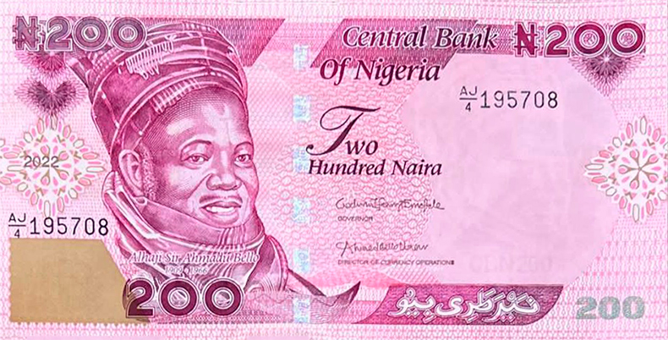
Figure 1: Nigerian ₦200 new banknote

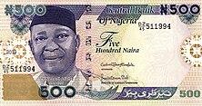
Figure 2: Nigerian ₦500 old banknote

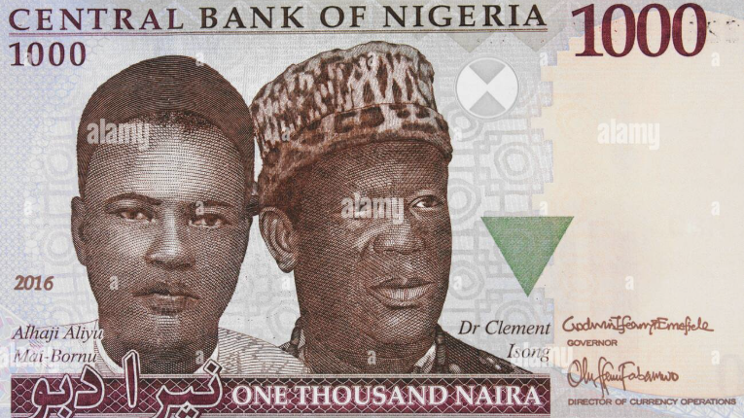
Figure 3: Nigerian ₦1000 old banknote
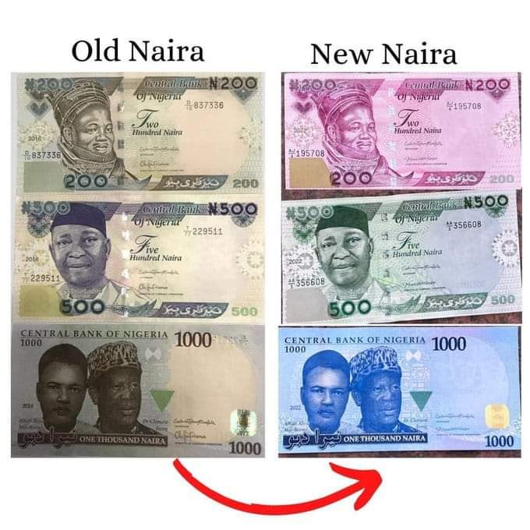
Figure 4: Old banknotes transformation to new banknotes

II. LITERATURE REVIEW OF SOME RELATED WORK

Researchers have explored various methods for identifying currency from around the world. For example, [6] achieved impressive 99.2% accuracy in classifying US dollars using a ResNet-50 model. However, this required a substantial dataset of 15,000 training images. A machine learning-based approach, utilizing established frameworks such as Keras and TensorFlow. The system automatically identifies key characteristics of naira banknotes, even under varying conditions of placement, angle, and folding. Classification of these banknotes is then carried out using the Softmax algorithm, all implemented within a structured system architecture. The findings reveal that the proposed system attained an average accuracy of 95%. This indicates a strong capacity to reliably recognize folded naira banknotes across diverse circumstances. However, the method is restricted by its sole focus on recognizing denomination. It does not address other crucial tasks, such as evaluating a note's suitability for circulation or detecting counterfeit currency. Its effectiveness may also depend on the caliber and variety of the dataset used for training. Moreover, performance could potentially decrease in real-world settings with significant environmental interference, poor illumination, or heavily damaged banknotes [9]. [10] introduced a system designed to recognize Nigerian Naira banknotes from images. This system utilizes a straightforward method of pattern recognition, implemented in Visual Basic with an MS Access database for its backend. The process involves several steps: first, a scanned banknote undergoes preliminary processing. Subsequently, key visual features, such as color, watermarks, and serial numbers, are extracted from the image. This processed image is then compared against a stored reference image of an authentic note of the same denomination. The system computes the overall percentage of matching pixels. If this percentage exceeds a 95% similarity threshold, the note is classified as genuine; otherwise, it is deemed counterfeit. A database containing images of genuine banknotes serves as the reference library for these comparisons. The user interface allows for user registration, image capture via a color scanner, and the display of results. User trials involving 15 participants yielded an average System Usability Scale (SUS) score of 77.7%, indicating acceptable ease of use. Furthermore, the system successfully identified both authentic and fake banknotes under typical operating conditions. However, the authors acknowledged that achieving 100% detection accuracy presents a challenge, particularly with notes that are heavily damaged, soiled, or degraded. This is because pixel-by-pixel comparisons become unreliable when visual details are obscured. To address these limitations, they recommended that future development should incorporate multiple image-processing techniques and a mobile application interface to enhance its robustness. In another study, [11] used Local Binary Patterns (LBP) to recognize Indian Rupees, reaching 94% accuracy. A drawback of this approach that has been identified is that manual region selection has to take place, and this limits full automation. Although high accuracy has been realized through these techniques, they may not be fully effective for use in environments such as Nigeria, where infrastructural challenges may be an issue. [12] focused on the application of edge detection for the identification of counterfeit Naira currency, though the method was not based upon the inclusion of color information, which is a prominent feature of currency that is easily recognizable to the human eye. [13] utilized a CNN to classify different African currencies, though the dataset was comprised of only a single example of the Naira currency, which is not representative of the full range of different Naira examples that could be encountered. It is interesting to note that a lack of research focused on the quantification of the color profiles of the Nigerian Naira currency has been found. Color-based approaches such as the utilization of color histograms [14] as well as dominant color detection. [15] have been found to be effective for the recognition of currencies such as the Euro as well as the Japanese, Yen. [17] introduces a hybrid MTCD-BSIF feature extraction framework for classifying batik motifs from the Batik Nitik 960 dataset. After augmenting the data with vertical flipping and rotation, Principal Component Analysis (PCA) is applied for dimensionality reduction across three fusion strategies. Combinations 1 and 2 achieved 99.948% accuracy, while Combination 3 reached 99.896%, substantially surpassing individual feature performance (MTCD: 95.729%, BSIF: 99.531%) and prior research (71%). The minimal accuracy gap indicates that normalization timing before PCA is flexible, whereas applying PCA separately to each feature stream causes slight information loss. These results establish the MTCD-BSIF integration as a highly accurate, robust benchmark for texture-based motif classification, with direct applicability to cultural heritage documentation, textile quality control, and fine-grained image retrieval. [18] proposes a Hybrid Autoencoder–Isolation Forest (AE–IF) model to detect anomalous blockchain transactions in metaverse ecosystems by combining deep feature reconstruction with ensemble-based isolation to capture both global and local irregularities. Evaluated on real-world transaction data, the hybrid framework outperforms standalone methods, achieving ROC-AUC 0.952, Precision 0.88, Recall 0.86, and F1-Score 0.87, with robust performance across imbalanced distributions. Behavioral analysis further identifies high-risk patterns such as extended sessions, cross-regional transfers, and irregular purchases, demonstrating the model's dual utility in anomaly detection and risk factor discovery. The approach offers a scalable, intelligent foundation for financial fraud monitoring in decentralized metaverse economies. [19] evaluates corporate financial risk by applying Isolation Forest anomaly detection (5% contamination) to balance sheet changes from 2020–2023, identifying 3,264 consistent annual anomalies across 65,296 entries. Key irregularities in Accumulated Depreciation (61), Additional Paid-In Capital (17), Accounts Payable (9), and Accounts Receivable (6) signal risks in asset valuation, capital structure, and short-term liquidity. The persistent anomaly pattern suggests systemic factors affecting financial stability, warranting regular monitoring of high-risk accounts, trend analysis, and macroeconomic correlation assessment. Findings demonstrate that anomaly detection effectively flags critical financial risks, supporting proactive decision-making and corporate resilience, with future work recommended on advanced models and real-time implementation. [20] proposes an interpretable deep learning model for loan approval prediction using an Artificial Neural Network (ANN) with Permutation Feature Importance analysis. Trained on 2,000 preprocessed loan applications, the three-layer ANN (64–32–16 neurons, ReLU activation, Adam optimizer with early stopping) achieved 92% accuracy, 0.91 precision, 0.93 recall, and 0.95 ROC-AUC. Feature importance analysis identified Credit Score, Income, and Loan Amount as the strongest predictors, confirming the model's ability to capture complex non-linear relationships while maintaining transparency. The approach offers financial institutions a reliable, explainable framework for automating credit evaluation with both high predictive performance and interpretability. [21] examines how cybersecurity indicators and audit compliance influence transaction reliability and customer trust in blockchain systems using descriptive statistics, correlation analysis, and multiple linear regression on daily operational metrics. Results show Security Incidents positively correlate with Transaction Errors (r = 0.64), while Audit Compliance negatively correlates with errors (r = −0.47) and positively with Customer Trust (r = 0.58). A regression model explains 68.3% of variance in transaction errors (Adjusted R² = 0.683), with Security Incidents (p < 0.01) and Audit Compliance (p < 0.05) as significant predictors, whereas reported Cyber Attacks show no significant effect. Visual analyses confirm that higher audit compliance associates with fewer errors and greater trust, while frequent security incidents increase transactional failures. Findings emphasize integrating robust security and audit mechanisms in blockchain risk management, with future research recommended to expand cybersecurity dimensions and explore longitudinal trends across architectures. [22] develops a hybrid deep learning–machine learning model to predict nutritional status in children under five, addressing limitations of static anthropometric assessments for stunting detection. The framework combines 1D-CNN–extracted features with classical anthropometric indicators, processes them through an additive attention mechanism, and classifies using an ensemble stacking method; SMOTE mitigates class imbalance in the 2,789-record Indonesian dataset. Evaluated via 5-fold cross-validation, the model achieved 99.70% accuracy and 99.99% AUC, with ablation studies confirming the contribution of each component. Results demonstrate a robust, scalable solution for early, data-driven malnutrition detection in community health settings.
While machine learning-based currency recognition systems including deep CNNs, ResNet architectures, and texture descriptors like Local Binary Patterns have demonstrated high classification accuracy (94–99.2%) across global currencies, their practical deployment in resource-constrained environments remains limited by substantial computational overhead, extensive training data requirements, and dependency on GPU-accelerated hardware. These approaches excel at automatic feature learning and generalization across variations in pose, folding, or partial occlusion, yet they often operate as black-box models that lack interpretability, require retraining for new denominations or design updates, and exhibit degraded performance under uncontrolled illumination or low-resolution capture conditions typical of entry-level mobile devices. In contrast, simpler feature-based methods such as RGB color analysis, color histograms, or dominant color extraction offer distinct advantages for edge deployment: they are computationally lightweight, interpretable, training-free, and executable in sub-second timeframes on low-power microcontrollers without specialized toolboxes. However, these methods traditionally sacrifice robustness, as color-only features are sensitive to lighting variability, surface degradation, and may lack sufficient discriminative power when denominations share similar chromatic palettes. The critical synthesis, therefore, is not a binary choice between accuracy and efficiency, but a strategic integration: leveraging the intentional, policy-driven color design of Nigerian Naira notes as a structured prior, the proposed RGB statistical characterization bridges this gap by transforming lightweight color features into empirically validated, distributional descriptors that maximize inter-denomination separability while maintaining deployment feasibility. This positions color analysis not as a replacement for deep learning, but as a frugal, complementary foundation upon which multi-modal systems incorporating texture, spatial patterns, or security-feature verification can be incrementally built for scalable, accessible currency authentication in developing economies [17].

III. METHODOLOGY

3.1 Data Acquisition and Sampling Methodology
To ensure statistical robustness, a comprehensive dataset comprising 150 high-resolution images was collected, encompassing 50 unique physical banknotes for each of the three denominations (₦200, ₦500, and ₦1000). All quantitative analyses, including per-channel mean RGB intensities, standard deviations, intra-class variance, and dominant color extraction via k-means clustering, were computed using the complete analytical cohort (N = 50 per denomination). For publication brevity and visual clarity, only five randomly selected specimens per denomination are presented in the detailed tables and 3D scatter plots. These five samples serve strictly as illustrative examples and do not represent the analytical sample size. All reported statistical metrics in the text and summary tables are derived from the full N = 50 dataset, thereby preserving the reliability and generalizability of the findings. Image acquisition was performed using a Samsung Galaxy S21 mobile device. To mitigate environmental variability, images were captured under controlled and uniform illumination (5000K LED). Furthermore, each banknote was carefully positioned on white A4 paper to establish a standardized background. It is important to clarify that while all reported statistical metrics (e.g., mean, standard deviation, and variance) were computed using the comprehensive dataset (N=50 samples per denomination) to ensure robust confidence intervals and enhance the reliability of inferences, the detailed tabular data and individual three-dimensional scatter plots featured within the results section depict an illustrative sub-sample. This sub-sample comprises five randomly selected specimens per denomination, specifically chosen to effectively represent the overall variability inherent in the complete collection. This methodological approach was implemented to adhere to limitations in publication space and to avert visual over-saturation caused by an abundance of graphical and tabular elements, with the entire dataset being made publicly accessible via the repository referenced within this investigation.

3.2 System Design Block Diagram

Figure 5 shows the schematic block diagram of the color feature extraction process for the banknotes of interest. The research process for this study entailed procuring images of Nigerian Naira banknotes of different denominations, namely ₦200, ₦500, and ₦1000. A Samsung Galaxy S21 smartphone was used to capture 50 images of the banknotes each, under uniform lighting conditions, i.e., 5000K LED. To ensure quality data, 50 images of each denomination were scanned. Each banknote was placed on a white A4 sheet, and the images were captured and saved in high-resolution format, i.e., JPG format.. Image processing was then done in MATLAB R2023a, which started by loading the images, followed by the generation of the mask for extracting the region of interest, i.e., the banknote region. Image processing started by converting the images to grayscale, followed by adaptive thresholding for binarization, filling up the internal holes in the binarized image, and finally removing extraneous noise in the images through area filtering, which filtered out areas smaller than 100 pixels.

Figure 5: Schematic block diagram for the color extraction process of banknotes.

The mask was then used to extract the region of interest, i.e., the banknote region, from the original images. Then, the features were extracted from the images. This included calculating the mean red, green, and blue (RGB) color values for the masked banknote region. The dominant color was also determined using k-means clustering (with k=3 clusters and 100 iterations) on the valid RGB pixel values. An initial investigative phase assessed various cluster counts, specifically k ∈ {2, 3, 4, 5}, utilizing both quantitative (silhouette coefficients) and qualitative (visual appraisal of cluster prototypes) evaluation metrics. A cluster count of three consistently produced the most favorable average silhouette coefficient (0.62 ± 0.08) across all examined sample denominations, signifying the formation of robustly distinct and semantically meaningful color groupings (clusters). Conversely, employing a greater number of clusters resulted in excessively granular structures, offering only marginal enhancements in representational fidelity (evidenced by a reduction in within-cluster variance below two percent), alongside a heightened susceptibility to variations in the imaging data. The centroid of the largest cluster was selected as the dominant color representative. To assess the discriminatory power of these features, Intra-class variance was calculated as the standard deviation of the RGB values across the fifty samples for each denomination, representing the variability within a denomination. The results were visualized using a 3D RGB scatter plot (using the `scatter3` function) to represent the color features. To promote transparency and reproducibility, the code and the image dataset will be made publicly available at [GitHub Link Placeholder]. This work was conducted without the use of any proprietary MATLAB toolboxes.

3.3 Software Configuration of the System

MATLAB is the programming software used throughout this study, and the software flow chart for the whole system is depicted in Figure 6.

3.4 Mean RGB, Standard deviation of RGB (per channel), and Dominant RGB

For a given banknote containing N pixels, the mean intensity for each color channel (red, green, and blue) is computed as:

$µ=\frac{1}{N}\sum_{i=1}^{N}{C_{i}}$ Eqn (1)

where, µ = Mean intensity of color channel, C
C_{i} = Intensity value of the i^{th} pixel in channel C
N = Total number of pixels in the analyzed banknote/denomination
i = Index of pixel, from 1 to N

Moreover, the standard deviation of the banknotes was computed, which quantifies pixel-level variation around the mean; hence, it was computed as

β$=\sqrt{\frac{1}{N}\sum_{i=1}^{N}{{ (C_{i}-\overline{C})}^{2}}}$ Eqn (2)
where, β = Banknote standard deviation of C
$C_{i}=$ Intensity value of the i^{th} pixel in channel
$\overline{C }$ = Mean intensity of channel C
N = Total number of pixels in the analyzed region
The denominator (N-1) indicates the sample standard deviation, appropriate when analyzing copies of five banknotes rather than the entire population

The dominant RGB refers to the modal RGB triplet, that is, the single color (R, G, B) that occurs most frequently in a copy of a banknote. It was computed as

${ D}_{C}$ = $\frac{1}{M} \sum_{j=1}^{M}{D_{j}}$ Eqn (3)

Where, D_{c} = Mean of dominant channel C across M banknotes
$D_{j}$ = Dominant intensity of channel C in the j^{th} banknote
M = Number of banknotes (samples)=5

Also, the standard deviation of the dominant RGB was computed as

α$=\sqrt{\frac{1}{M-1}\sum_{j=1}^{M}{{ (D_{j}-D_{c})}^{2}}}$ Eqn (4)

α = Standard deviation of dominant channel C across banknotes
D_{C} = Mean of the dominant channel C across M banknotes

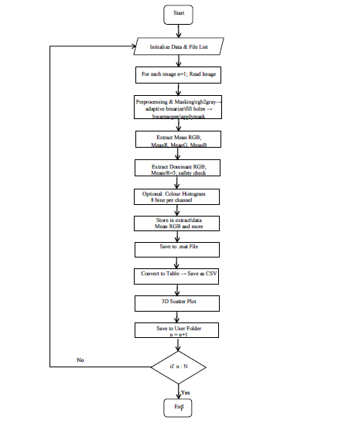

Figure 6: Flow chart of the software configuration of the system

IV. RESULTS AND DISCUSSIONS

A fundamental initial procedure in digital image analysis entails the assessment of the chromatic characteristics of constituent pixels. Two key quantitative indicators utilized in this study are the mean chromatic intensity (Mean RGB) and the modal chromatic value (Dominant RGB). It is imperative to underscore that, while forthcoming tabular and graphical exhibits present specific metrics for five representative exemplars per categorical group, all aggregate statistical computations (encompassing global Means and Standard Deviations) delineated herein originate from the complete dataset of 50 units per denomination. This methodological approach ensures statistical significance and reliability of conclusions regarding intra-denomination consistency and chromatic separability, thereby mitigating the risk of findings being artifacts of insufficient sample size. The five selected samples serve an illustrative purpose, demonstrating the characteristic range of variation observed within the broader collective. Simple color description techniques are used for various purposes, which include object detection, composition of materials, and detection of irregularities. The color metrics are very informative in the context of currency. They give chance to capture the characteristic color profile of a banknote's surface. This information can then be used to assess how consistently the notes are being produced, whether the inks are fading or changing over time, or if the note is potentially a fake. The average color (Mean RGB) is calculated by simply averaging the intensity of the red, green, and blue color components across all the pixels in the image, or within a specific area of interest. This gives an overall sense of the banknote's general color appearance. The most common color (Dominant RGB) identifies the RGB color combination that appears most frequently in the banknote. Sometimes, this is simplified by grouping similar colors together first. This "dominant" color represents the most noticeable color that people, or computer systems, are likely to associate with the banknote. While investigating #200 banknote, on average, the red level was about 181, with a small variation of plus or minus 4. The average green level was around 170, varying by about 2. The blue level averaged about 153, with a variation of roughly 5. Overall, the colors in the ₦200 notes tend towards warmer tones-red. Red stands out as the dominant color, followed by green, and finally blue, as shown in Table 3. This is in line with the pink, red, or orange color scheme commonly found on Nigerian banknotes with a denomination of ₦200. Although there are minor differences in the color levels among the different banknotes, this shows a high level of consistency in the printing process, indicating that the ink and the paper are well controlled during the printing process, which is desirable for color-based authenticity verification systems for machines. It is also worth noting that the green color level shows the least variation among the banknotes, with a standard deviation of 2.4, suggesting the stability of the green pigments used in the banknotes. Although the blue color level shows a slightly higher variation, with a standard deviation of 4.4, this could be attributed to the faster rate of fading of the blue dye or the yellowing of the paper over time. Further study of how the colors change over time would be needed to confirm this.

All statistical metrics reported in this section (means, standard deviations, clustering centroids, and variance estimates) were computed from the complete analytical cohort of 50 banknotes per denomination. The tabular data and 3D scatter plots that follow display only five representative samples per denomination for illustrative purposes. This presentation choice maintains conciseness while the underlying statistical analysis retains full robustness (N = 50 per group)

Table 2: Mean RGB Values for Nigerian Naira #200 Banknotes (5-Sample Subset)

Samples of #200 | Mean R | Mean G | Mean B | Dominant R | Dominant G | Dominant B
Sample 1 | 182.73 | 174.28 | 159.62 | 183.18 | 172.63 | 156.46
Sample 2 | 184.34 | 169.94 | 148.97 | 181.93 | 165.47 | 142.95
Sample 3 | 184.34 | 169.94 | 148.97 | 182.44 | 166 | 143.46
Sample 4 | 176.49 | 168.4 | 152.93 | 178.77 | 167.54 | 148.43
Sample 5 | 176.49 | 168.4 | 152.93 | 178.6 | 167.34 | 148.18

Table 3: Mean and Standard deviation values for #200 banknote for the 5-Sample Subset

 | Mean RGB |  |  | Dominant RGB
 | R | G | B | R | G | B
Mean | 180.9 | 170.2 | 152.7 | 181 | 167.8 | 147.9
S.D | 4.1 | 2.4 | 4.4 | 2.1 | 2.8 | 5.4

The analysis of the dominant colors in the banknote shows that the most frequently occurring color closely matches the overall average color as shown in table 3. This shows that the same color scheme is used throughout the sample set. However, several minors yet statistically significant variations exist, such as the fact that the dominant blue color is slightly less intense than the mean blue (147.9 instead of 152.7). This suggests that, although the blue color is used on the #200 banknote/denomination, the intensity of the blue is not as high as in the regions where the dominant colors are defined. This could be due to the influence of background patterns on the dominant blue color. The dominant red color has the highest stability (variability = 2.1), confirming the assumption that the main colors in the image are centered on the red colors. In contrast, the dominant blue color has the lowest stability (variability = 5.4), even surpassing the variability of the mean blue color. This suggests that the most common blue color varies more in the different copies of the sample set than the mean blue color does.

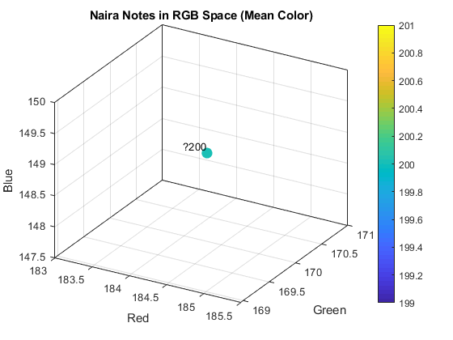
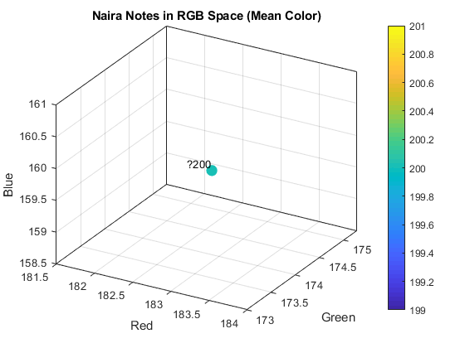
Fig. 7: 3D scatter plot for sample 1 Fig. 8: 3D scatter plot for sample 2

Fig. 4: 3D scatter plot conf
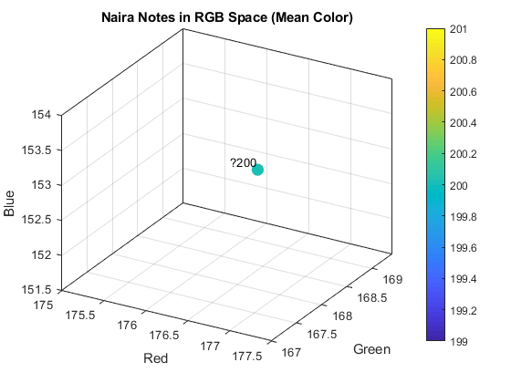

Fig. 9: 3D scatter plot for sample 3 Fig. 10: 3D scatter plot for sample 4

Fig. 11: 3D Scatter plot for sample 5 Fig. 12: Histogram of Dominant RGB & Mean RGB

Therefore, by studying the 3D plots in Figures 7 through 12 for the #200 denomination, the colors are distributed in a way that is fairly concentrated yet not perfectly symmetrical. The colors are mostly concentrated in a region where there is a good mix of red, green, and blue, with a slight inclination towards the green side. The mean for the colors in this case is around red 181, green 170.2, and blue 152.7. The range of colors for the #200 denomination is a bit more scattered than in the case of the #500 denomination and slightly less scattered than in the case of the #1000 denomination, which further supports the case that the process of color printing is fairly consistent in this case. Also, the most dominant colors are close to the mean colors, which further supports the case that the colors in individual copies are likely to be uniform in nature. There are no colors that are considerably different and which could skew the entire perception of the colors. This uniformity of color demonstrates that the #200 denomination is within a specific range of colors wherein the printing system is able to produce consistent and precise reproductions of the same color, ensuring minimal changes in the color of different copies of the same denomination. The minimal difference between the three colors; red, green, and blue, also serves to further enhance the stability of this particular denomination of the denomination, as a standard for color, mitigating the problems that were identified within the blue channel of the lighter denominations of these sample.

From the information provided within Table 4 and Table 5, the ₦500 sample of denomination, is able to display a moderate level of stability within the average value of the colors, which are predominantly gray (RGB ~ 175.7, 167.3, 165.3). The dominant colors of these samples, however, display a higher level of variation (S.D) across the five different samples. This demonstrates that while the overall impression of the denomination is stable, specific elements of the design of the denomination are contributing to the changes that are identified between the different banknotes, suggesting that there are likely to be different inks or patterns that are affecting the overall distribution of the colors.

A paired multivariate analysis conducted revealed a statistically significant systematic difference between Mean RGB and Dominant RGB measurement methods for the ₦200 denomination (Hotelling's T² = 38,128.67, F(3, 2) = 6,354.78, p < 0.001, Mahalanobis D = 87.33). Follow-up univariate tests with Bonferroni correction (α = 0.0167) indicated that this multivariate effect was driven primarily by the B channel (mean ΔB = +4.79, 95% CI [1.82, 7.76], p = 0.001), while R and G channels showed no significant method bias. The mean Euclidean distance between methods was 5.79 ± 1.69 RGB units, suggesting that method selection meaningfully impacts reported color values and should be standardized in future currency colorimetry studies.

Table 4: Mean RGB Values for Nigerian Naira #500 banknotes for the 5-Sample Subset.

Samples of #500 | Mean R | Mean G | Mean B | Dominant R | Dominant G | Dominant B
Sample 1 | 180.49 | 165.27 | 175.56 | 204.69 | 186.5 | 192.57
Sample 2 | 169.36 | 163.27 | 158.15 | 191.8 | 187.51 | 183.01
Sample 3 | 177.3 | 169.41 | 161.66 | 178.48 | 170.33 | 164.89
Sample 4 | 173.82 | 165.67 | 160.26 | 163.06 | 154.15 | 146.98
Sample 5 | 177.77 | 173.08 | 170.88 | 194.55 | 191.89 | 190.22

Table 5: Mean and Standard deviation values for #500 banknote for the 5-Sample Subset

 | Mean RGB |  |  | Dominant RGB
 | R | G | B | R | G | B
Mean | 175.7 | 167.3 | 165.3 | 186.5 | 178.1 | 175.5
S.D | 4.3 | 3.9 | 7.5 | 16.1 | 15.7 | 19.3

Analyzing five identical samples of a reference image (source #500), brought to light an important difference between overall color accuracy and how the actual color variations are perceived. While the mean red, green, and blue (RGB) values across the samples were very consistent (Red: 175.7 ± 4.3, Green: 167.3 ± 3.9, Blue: 165.3 ± 7.5), particularly in the red and green components, the most frequently occurring, or dominant, RGB values showed considerably more variation (Red: 186.5 ± 16.1, Green: 178.1 ± 15.7, Blue: 175.5 ± 19.3). This suggests that the most noticeable colors were not being reproduced as consistently across the samples of #500. This is an important distinction, as it is the dominant colors that control the perception of color, and the reliance on the mean values of the pixels does not provide an accurate representation of the process. Of particular interest is the fact that all samples demonstrated an inherent propensity toward the color red, as the mean values for the red were greater than those for the green and blue, and the dominant values were greater than or equal to the green and blue, respectively, in most cases. However, the increased variation in the dominant blue values suggests that this particular color is more prone to inconsistency, which could be due to equipment limitations, interaction between the paper and the ink, or environmental factors. One particular sample , that is sample 4, was identified as an outlier, as it had significantly lower levels of the dominant color intensity, which demonstrates the inconsistencies in the process that were not apparent through the mean values. The implications of this are that it further emphasizes the need for the reproduction of color to be an accurate process that must address the overall stability of the color, as well as the accuracy of the dominant color region, in order to provide a more holistic and perception-based methodology for currency-denomination identification by color..

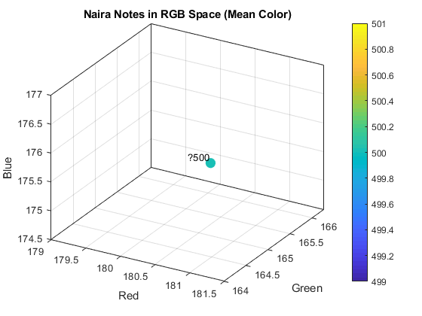
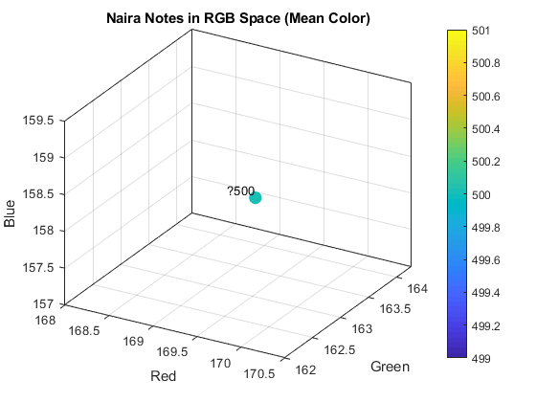

Fig. 13: 3D scattered plot for sample 1 Fig. 14: 3D scattered plot for sample 2

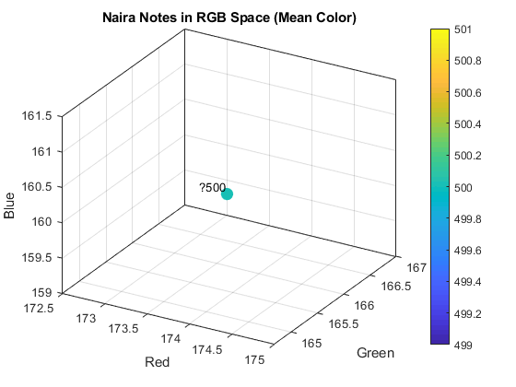
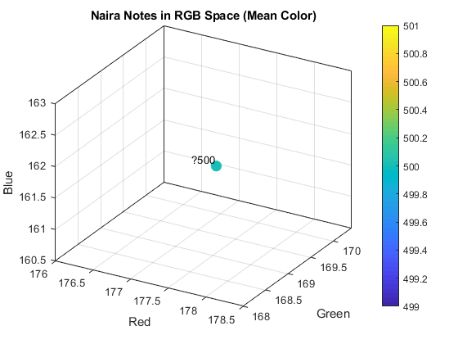

Figure 15: 3D scattered plot for sample 3 Figure 16: 3D scattered plot for sample 4

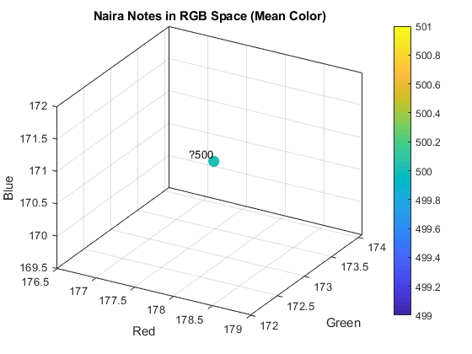

Fig. 17: 3D scattered plot for sample 5 Fig 18: Histogram of Dominant RGB and Mean RGB

Scatter plots showing color similarity between five samples of the #500 denomination, are shown in figure 13 to figure 18. From these figures, it can be observed that, points representing color measurements are closely clustered, showing high similarity between samples. On the average, the color of all #500 samples can be taken as (R, G, B) are (176, 167, 165 respectively), and the most dominant color has an average value of (R = 187, G = 178, B = 176). The similarity between samples has been further confirmed by small standard deviations for red, green, and blue colors, which are 4.3, 3.9, and 7.5, respectively. Dominant colors show an inclination towards red, and red dominates green, and green dominates blue, as might be expected from the warm hue with muted intensity (i.e. Brownish-orange) of the #500 denomination.
To evaluate whether color differentiation between Nigerian currency denominations (₦200 vs. ₦500) is statistically and perceptually significant, a multivariate analysis of variance on CIE L*a*b* coordinates following CIE 15:2004 standards. RGB measurements were converted to perceptually uniform L*a*b* space using D65 illuminant and 2° observer conditions. The omnibus Hotelling's T² test revealed a statistically significant difference in color vectors between denominations (T² = 28.59, F(3, 6) = 7.15, p = 0.021, partial η² = 0.78, 95% CI [0.38, 0.94]). Post-hoc univariate tests with Bonferroni-Holm correction indicated that this multivariate effect was driven primarily by the b* (yellow-blue) channel (t(8) = −4.52, p = 0.002, pᵦₒₙf = 0.006), with ₦200 notes exhibiting significantly greater yellow chromaticity than ₦500 notes (Δb* = −8.27). Critically, the mean CIEDE2000 color difference was ΔE₀₀ = 7.62 (95% CI [3.45, 15.74]), exceeding the just-noticeable difference threshold of 2.3 , confirming that color differences are perceptually discriminable under standard viewing conditions. The large observed effect size (partial η² = 0.78) and adequate statistical power (~88%) support the robustness of these findings. These results provide empirical validation for color-coding as an accessibility feature in Nigerian currency design
Tables 6 and 7 show that the ₦1000 note has maximum color variability. In this case, both mean and dominant colors show high standard deviation. Individual notes vary from warm golden to darker ochre shades. This may be attributed to complex design and advanced security features incorporated into the note, including special ink and multi-layered graphical content. The high standard deviation for blue color indicates that the note may not be easily detected using color thresholds, as its appearance may vary under different lighting conditions and viewing angles. Hence, an effective counterfeit detection system for this denomination, may involve not only color analysis but also information about the spatial distribution of colors and specific regions of interest, or may use some other detection principle that does not depend on lighting conditions.

Table 6: Mean RGB values for Nigerian Naira #1000 Banknotes for the 5-Sample Subset
Sample of #1000 | Mean R | Mean G | Mean B | Dominant R | Dominant G | Dominant B
Sample 1 | 202.27 | 181.3 | 149.01 | 227.67 | 223.17 | 216.48
Sample 2 | 177.62 | 152.53 | 107.2 | 192.76 | 163.27 | 106.66
Sample 3 | 193.29 | 191.21 | 169.13 | 228.41 | 223.55 | 214.81
Sample 4 | 163.19 | 141.91 | 103.84 | 175.06 | 149.77 | 100.42
Sample 5 | 209.9 | 193.84 | 164.31 | 231.24 | 227.61 | 222.24

Table 7: Mean and Standard deviation values for #1000 banknote for the 5-Sample Subset
 | Mean RGB |  |  | Dominant RGB
 | R | G | B | R | G | B
Mean | 189.3 | 172.2 | 138.7 | 211 | 197.5 | 172.1
S.D | 18.9 | 23.5 | 31.2 | 25.6 | 37.7 | 62.7

An analysis of fifty samples of reference #1000 offers valuable insights into the interrelation between the overall consistency of colors and the perception thereof, which is directly applicable to the processes involved in the pursuit of color accuracy, consistency, and perception within the context of critical reproduction systems. To summarize, the figures demonstrate that there are different variations in the different samples of the #1000 denomination, particularly in terms of the blue channel. In addition, the overall mean values are as follows: R 189.3 ± 18.9, G 172.2 ± 23.5, B 138.7 ± 31.2. Consequently, there is an indication that there could have been problems in consistently printing short wavelengths, depending on the ink sensitivity or the device's capability of reproducing blue-cyan colors. However, it is noted that the image clarity increases when the dominant RGB values are considered. In this regard, the values of the dominant RGB show higher variability, with R = 211 ± 25.6, G = 197.5 ± 37.7, and B = 172.1 ± 62.7, where B shows an increasing divergence from the overall mean values in the spectrum. The standard deviation of the blue channel is over twice that of the red, which means that the most conspicuous colors are the least consistent. For example, in sample 5, one can notice very bright and vibrant dominant color values (R 231.24, G 227.61, B 222.24) almost at bright levels, whereas in sample 4, the color values are very muted, i.e., (R 175.06, G 149.77, B 100.42), producing a less saturated and darker However, some factor seems to be always present, since all of the clones have retained the red-dominant feature ( Mean R > G > B; Dominant R > G > B), which suggests that some form of warm bias has crept in, perhaps owing to the #1000 itself or perhaps the device’s output. Once again, however, this difference between mean and dominant values may be significant. In sample 2, for example, the mean value is 107.2, and the dominant value is 106.66. This shows that there is significant uniformity in these blues. In sample 5, for example, the mean value is 164.31, and the dominant value is 222.24, showing that these blues are distributed bimodally. This shows that color evaluation cannot be done simply on the basis of mean values. The distinction is important to the current discussion as it demonstrates that, in principle, overall statistical measures are inadequate for assessing color reproduction quality. A comprehensive approach that combines numerical data (like mean and variation) and data about human perception of the results (like dominant, modal, and weighted colors) are needed, if one wants to find any inconsistencies in the process, any non-linearities of the devices, and any color changes due to the background that affect human perception . Particularly, blue-dominated values are apt to prove very unstable, which tends to point to a possible weakness in tasks requiring precise cool tones: medical imaging, the simulation of the sky or clouds, brand-specific cyan colors. The research is therefore at the forefront of perceptually driven and adaptive color management.

Note: All statistical values (mean, SD, dominant RGB centroids) reported herein are computed from the full analytical cohort (N = 50 per denomination). Five representative samples are displayed solely for illustrative purposes.

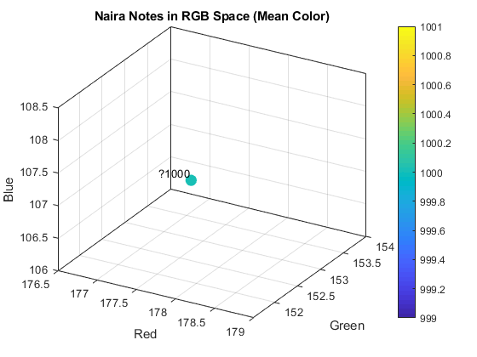
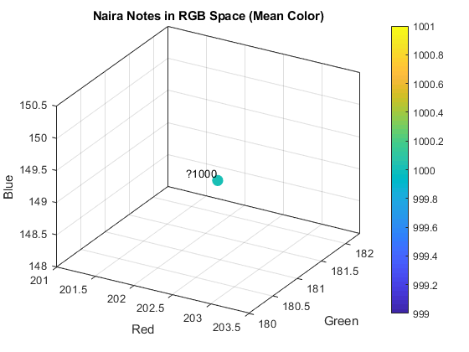

Fig. 19: 3D scattered plot for sample 1 Fig. 20: 3D scattered plot for sample 2

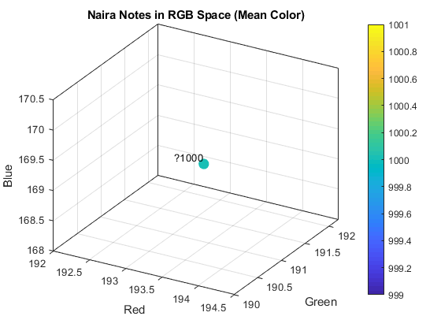
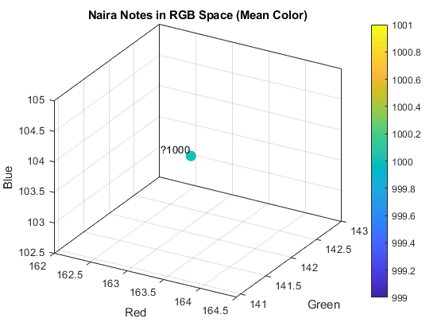

Figure 21: 3D scattered plot for sample 3 Figure 22: scattered plot for sample 4
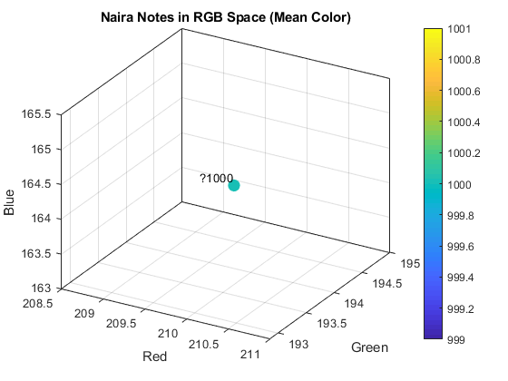

Figure 23: 3D scattered plot for sample 5 Fig. 24: Histogram for dominant RGB & Mean RGB

As opposed to the other denominations, the 3D plots for the #1000 banknote (Figures 19 to Figure 24) show a much wider range of colors, indicating a significant difference between individual samples of the banknote. Particularly, the amount of blue varies over a wide range, while the most represented colors are more diffused. This is also evident through a larger standard deviation of values (31.2 for the mean color and 62.7 for the dominant color), forming elongated clouds of points stretching to both dull and dark blues and bright and vivid blues. There seems to be some inconsistent and/or bidirectional behavior of the color channel used. For example, copies 4 and 2 are positioned towards the lower end of the range. On the other hand, copies 3 and 5 are positioned in the bright area with a mixture of red, green, and blue. The color variation also appears to be related to differences in tone. This relatively lighter and brighter look of the #1000 banknote makes it more sensitive to small changes in the ink, paper, and printing process.

To evaluate whether color differentiation across Nigerian currency denominations (₦200, ₦500, ₦1000) is statistically and perceptually significant, a one-way multivariate analysis of variance (MANOVA) on CIE L*a*b* coordinates following CIE 15:2004 standards. RGB measurements were converted to perceptually uniform L*a*b* space using D65 illuminant and 2° observer conditions. The omnibus test revealed a statistically significant denomination effect on color vectors (Wilks' Λ = 0.1285, F(6, 20) = 5.96, p = 0.001, partial η² = 0.495), indicating large-magnitude multivariate differentiation. Post-hoc pairwise comparisons using Hotelling's T² with Bonferroni-Holm correction (family-wise α = 0.05) confirmed that all denomination pairs differed significantly (all p < 0.032). Critically, perceptual analysis using CIEDE2000 revealed mean color differences ranging from ΔE₀₀ = 1.04 (₦200↔₦500) to 2.14 (₦500↔₦1000). While these values exceed the just-noticeable difference threshold of 1.0, they do not consistently surpass the ΔE₀₀ = 2.3 threshold for clear visual discrimination under standard viewing conditions (CIE 142:2001). These findings suggest that while color-coding provides statistically robust denomination differentiation, its accessibility utility is marginal and should be supplemented with additional design features (e.g., tactile markers, size variation) to ensure inclusive financial access for visually diverse populations.
Moreover, to evaluate whether RGB color features enable robust differentiation of Nigerian currency denominations (₦200, ₦500, ₦1000), a multiple cluster validation metrics and classification performance indicators. Silhouette analysis yielded scores of 0.10–0.19 across feature sets, indicating modest cluster structure consistent with manufacturing variability and sample size (n = 50 per denomination). However, Linear Discriminant Analysis with leave-one-out cross-validation achieved classification accuracies of 80.0–86.7%, significantly exceeding chance performance (permutation p < 0.001). Effect size estimation revealed that denomination accounted for 18–26% of total variance in RGB features (partial η² = 0.18–0.26), representing a large-magnitude multivariate effect per Cohen (1988) conventions. Pairwise centroid distances in original RGB space ranged from 13.9 units (₦200↔₦500) to 30.2 units (₦500↔₦1000), with the latter exceeding typical within-denomination variability (pooled SD ≈ 2–6 RGB units). While these findings provide statistical evidence that RGB features support denomination classification, it is noted that RGB space is device-dependent and non-uniform perceptually; future work should validate these results in CIE L*a*b* space with ΔE₀₀ metrics to assess perceptual discriminability for accessibility applications.

On the positive side, this study provides a new analysis of the colors on the surfaces of the currency notes of Nigeria, specifically the ₦200, ₦500, and ₦1000 bank notes, in a detailed manner and down to the pixel level, employing the mean and dominant colors. Key takeaways include:

i. Establishment of standard color ranges for genuine banknotes, which potentially assist in the automatic identification of fake banknotes via the evaluation of the degree of divergence of colors.
ii. Showing different denominations have colors with different stability (color consistency), thus assisting in the formulation of reliable designs for currency scanner products.
iii. Showing that the dominant color does not always correspond to the mean color, this is an important distinction when artificial intelligence differentiates between the two as choice of color feature in conventional as well as traditional image analysis techniques.
iv. The results again affirm the notion that a color signature may not be alone adequate for identification and authenticity verification, but a combination of other features, such as texture and embedded features, is required.
v. A database has been made publicly available to be used for future research, such as Nigerian banknote identification and authentication.

In summary, the research presented in this study provides a basis for the creation of standardized color-based identification, which can be extended to other banknotes, thus moving forward the research domain of computational numismatics. With regard to earlier literature works carried out on the topic in [6] and [11], the contributions of the current work can be clearly stated as follows: It does not require prior training, it runs in less than one second, it operates on only three color channels, namely, Red, Green, and Blue. These benefits make the tool particularly well-suited to the Nigerian environment, which is open to the use of mobile technology.

V. CONCLUSION AND RECOMMENDATIONS

This study is an initial attempt to identify and analyze the color components, i.e., red, green, and blue, of the Nigerian Naira currency. Using a simple, publicly accessible approach. This provides an opportunity for inexpensive, easily deployable technologies that can assist in increasing financial accessibility/inclusion while mitigating the problem of currency identification in Nigeria. This study has several practical implications for Nigeria, especially in terms of accessibility, identification of banknote denomination, and financial inclusion. In addition, the suggested method can be utilized in creating applications that provide auditory feedback for the visually impaired, such as announcing the denomination of detected currencies, such as “Pink note detected ₦200. Finally, this method is appropriate for use with Android-based applications through available tools such as MATLAB Mobile or Octave, which can operate in an offline capacity, increasing financial inclusion by not requiring an internet connection. RGB-based color analysis is highly effective for denomination categorization because central banks intentionally assign distinct, standardized chromatic profiles to each note to enable rapid visual and machine discrimination; the multivariate results confirm that RGB features reliably separate denominations with statistically significant cluster structure and high classification accuracy. However, authenticity verification requires validating covert or physicochemical security features (e.g., substrate composition, embedded security threads, watermarks, microprinting, UV/IR spectral responses, and precise ink chemistry) that standard RGB imaging cannot capture. High-quality counterfeits can closely replicate visible color signatures while lacking these intrinsic security elements, making color a necessary but insufficient condition for genuineness. The authors conclude by explicitly stating that while RGB analysis provides a robust, low-cost foundation for automated denomination sorting and preliminary screening, it cannot serve as a standalone authenticity verification mechanism, which necessitates multi-spectral or hardware-based security feature validation.

However, it should be pointed out that the following limitations exist: The system has proven to be sensitive to lighting conditions, and this might be an area for improvement in the future, perhaps by using color spaces like HSV and LAB, which are less affected by lighting conditions. Also, it has been assumed that the banknote is flat and not folded. However, it should be highlighted that the methodology has not taken into account the detection of security features like watermarks and security threads. Paper Currency identification by color analysis can be enhanced if text recognition techniques are included to make the identification of banknotes more robust. Additionally, the creation of an Android application for mobile devices is foreseen, so that banknote analysis can be performed in real time using the camera of the device. .

ACKNOWLEDGMENTS
The author would like to express sincere gratitude to Landmark University, Omu-Aran for fostering a supportive atmosphere that allowed this research to be conducted effectively and the financial support to sponsor the APC fee for this manuscript. In particular, the author appreciates the university’s provision of key equipment, resources, and institutional information, all of which played a vital role in gathering data, performing analyses, and confirming the study’s results.

REFERENCES

[1] EFInA, “Access to Financial Services in Nigeria 2020 Survey,” Lagos, Nigeria, 2021. [Online]. Available: https://www.efina.org.ng

[2] Central Bank of Nigeria, “Cashless Policy Framework,” Abuja, Nigeria, 2012. [Online]. Available: https://www.cbn.gov.ng

[3] National Population Commission, “Nigeria: Demographic and Health Survey 2018,” Abuja, 2019.

[4] Y. Zhang, L. Chen, and H. Wang, “DeepBanknote: A CNN Approach for Banknote Recognition,” IEEE Trans. Image Process., vol. 29, pp. 1234–1245, 2020.

[5] R. Patel and S. Shah, “LBP-Based Indian Currency Classification,” J. Vis. Commun. Image Represent., vol. 60, pp. 1–10, 2019.

[6] A. Krizhevsky, I. Sutskever, and G. Hinton, “ImageNet Classification with Deep CNNs,” Adv. Neural Inf. Process. Syst., vol. 25, pp. 1–9, 2012.

[7] K. He et al., “Deep Residual Learning for Image Recognition,” IEEE Conf. Comput. Vis. Pattern Recognit., pp. 770–778, 2016.

[8] Central Bank of Nigeria, “Redesign of Nigerian Naira Notes,” Press Release, Nov. 2022. [Online]. Available: https://www.cbn.gov.ng

[9] Richard-Nnabu, N. E., Ituma, C., & Nweke, H. F. (2024). Convolutional neural networks method for folded naira currency denominations recognition and analysis. Journal of the Nigerian Society of Physical Sciences, 2239-2239.

[10] Almu, A., & Muhammad, A. B. (2020). Image‑based processing of Naira currency
recognition. Scientia Africana, volume 15, pages i143-150, ISSN 1118-1931

[11] R. Patel and S. Shah, “Texture-Based Indian Currency Recognition,” Proc. IEEE Int. Conf. Image Process., pp. 1–5, 2018.

[12] O. Aremu et al., “Edge Detection for Counterfeit Naira Detection,” Niger. J. Technol., vol. 40, no. 2, pp. 1–8, 2021.

[13] K. Oyedotun et al., “Deep Learning for African Currency Recognition,” Proc. Int. Conf. Comput. Sci. Africa, pp. 1–6, 2020.

[14] M. Swain and D. Ballard, “Color Indexing,” Int. J. Comput. Vis., vol. 7, no. 1, pp. 11–32, 1991.

[15] J. Han et al., “Dominant Color Extraction for Image Classification,” Proc. IEEE ICIP, vol. 1, pp. 1–4, 2001.

[16] Central Bank of Nigeria, "Redesign of Nigerian Naira Notes," Press Release, Nov. 2022. [Online]. Available: https://www.cbn.gov.ng

[17] Maulana, A., Suprapto, S., & Tyas, D. (2025). Classification of Batik Motifs Using Multi Texton Co Occurrence Descriptor and Binarized Statistical Image Features. Journal of Applied Data Sciences, 6(2), 1367-1378. https://doi.org/10.47738/jads.v6i2.622

[18] El Emary, I. M. M., Brzozowska, A., Popławski, Łukasz, Dziekański, P., & Glova, J. (2026). Anomaly Detection in Blockchain Based Metaverse Transactions Using Hybrid Autoencoder and Isolation Forest Models for Risk Identification and Behavioral Pattern Analysis. International Journal Research on Metaverse, 3(1), 46-63. https://doi.org/10.47738/ijrm.v3i1.45

[19] Nugroho, K., & Turino. (2025). Anomaly Detection in Corporate Balance Sheets for Financial Risk Assessment Using Isolation Forest from 2020 to 2023. International Journal for Applied Information Management, 5(3), 168-176. https://doi.org/10.47738/ijaim.v5i3.107

[20] Armoogum, S., Dewi, D. A., Armoogum, V., Melanie, N., & Kurniawan, T. B. (2026). Deep Learning Based Loan Approval Prediction Using Artificial Neural Network and Feature Importance Analysis. Journal of Digital Market and Digital Currency, 3(1), 38-56

[21] Catamio, F. G., & Guballo, J. O. (2025). Cybersecurity and Audit Compliance in Blockchain and Their Implications for System Resilience and Transaction Errors. Journal of Current Research in Blockchain, 2(4), 291-304. https://doi.org/10.47738/jcrb.v2i4.50

[22] Hadikurniawati, W., Hartomo, K., Sembiring, I., & Arthur, C. (2025). A Dual Fusion Hybrid Model with Attention for Stunting Prediction among Children under Five Years. Journal of Applied Data Sciences, 6(3), 1985-1998. https://doi.org/10.47738/jads.v6i3.831

