The Missing Spark: Examining Motivational Gaps in Education Through Maslow's Hierarchy and Herzberg's Two-Factor Theory

ABSTRACT
Academic learning requires constant mental work, but many observers say that undergraduate students show less energy and more exhaustion as their studies continue. Experts claim that current research about motivation stays mostly inside the corporate world, which means a large space exists in the knowledge regarding higher education, specifically for undergraduate students in the Indian academic context. The research examines the motivation of undergraduate students by using Maslow's Hierarchy of Needs and Herzberg's Two-Factor Theory at the same time. Motivation is evaluated so that the problems of the undergraduate students are understood.
Information was gathered using a quantitative research design. Many researchers believe that primary data were gathered from 43 undergraduate students, including 22 female, 17 male, and 4 who did not say their gender. A structured questionnaire was shared through Google Forms, while responses were marked on a five-point Likert scale using 18 items. Because the data was collected digitally, the undergraduate students could answer from different places.
Results show that esteem needs (3.38/5) and physiological needs (3.36/5) have better satisfaction. Many people believe that undergraduate students feel sure about their mental skills and find the school buildings good enough. A middle score (3.29/5) was reached for social needs, even though self-actualization (3.06/5) and safety needs (2.90/5) reached the lowest levels of satisfaction. These low scores show that gaps exist in academic security and the way rules are made. When the gender-based analysis was finished, the undergraduate students who did not share their gender showed much lower motivation, especially regarding safety needs (1.69/5).
This research suggests that the leadership of the educational institution must change its focus toward making academic rules clear. Many scholars believe that fair testing methods and project -based learning should be created to help undergraduate students. Better mentorship is needed so that undergraduate students find chances for personal growth. Recognition systems are organized to help the undergraduate students reach self- actualization. When these changes are made, the motivation of undergraduate students will improve because the environment becomes more supportive.
Keywords: Student Motivation, Maslow's Hierarchy of Needs, Herzberg's Two-Factor Theory, Education, Academic Burnout
INTRODUCTION
Education is relentless—it asks for sustained mental effort, day after day, across years. And yet, somewhere between the first lecture and the final semester, many undergraduate students seem to quietly give up. Not formally. Not visibly. Just gradually. The energy fades, the engagement hollows out, and what remains is the motions. That quiet unravelling is what this study is about.
Motivation, most researchers agree, is the hinge on which academic outcomes swing. Students who are genuinely engaged learn more deeply, recover from setbacks more readily, and outperform those who are not [1]. The absence of motivation, by contrast, breeds a particular kind of academic drift—not dramatic failure, but chronic underperformance [2]. Despite how well-documented this is, motivational research has stayed largely in the corporate world, leaving higher education — and particularly the Indian undergraduate experience —surprisingly underexplored [3].
This study approaches that gap through two frameworks applied in tandem. Maslow's Hierarchy of Needs [4] maps motivation across five levels—physiological, safety, belonging, esteem, and self-actualisation—each layer contingent on the one beneath it. Herzberg's Two-Factor Theory [5] draws a different but complementary line: between hygiene factors that merely prevent dissatisfaction, and genuine motivators that actively drive

performance. Used together, they offer a more textured diagnosis—not just whether students are disengaged, but precisely where and why.
Data were collected from 43 undergraduate students via a structured Likert -scale questionnaire, analysed through both lenses.
METHODOLOGY
The study is quantitative—numbers, not narratives. A structured questionnaire went out via Google Forms to 43 undergraduate students, chosen deliberately rather than randomly, because the research question was always specifically about this population. Participation was entirely voluntary.
The questionnaire had three parts. Section A gathered demographics. Section B ran ten items across Maslow's five need levels—two items per level. Section C covered eight items probing Herzberg's hygiene factors and motivators. Every motivational item was measured on a five-point Likert scale: 1 being Strongly Disagree, 5 being Strongly Agree. Mean scores were then bucketed into three bands—low (1.0–2.5), moderate (2.6–3.5), and high (3.6–5.0)—to make interpretation consistent across both frameworks.

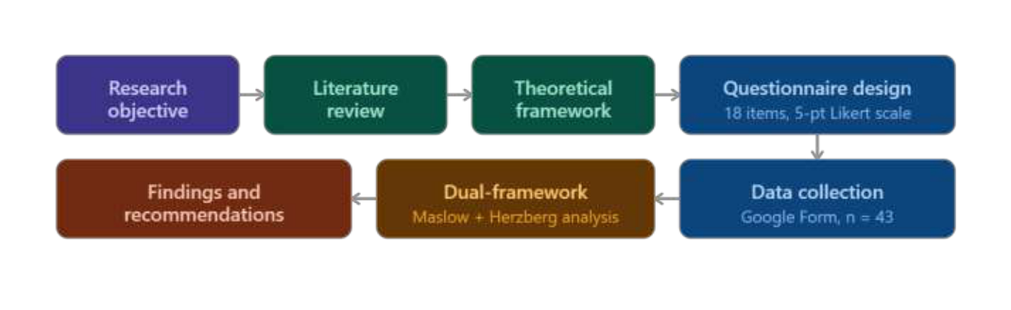

RESULTS
Of the 43 respondents, the majority were in Semester VI (28 students), followed by Semester IV (9 students), with the remainder distributed across Semesters I, III, VII, and VIII. Gender distribution comprised 22 female students, 17 male students, and 4 who preferred not to disclose.
Maslow scores across all five need levels are presented in Table 3. Esteem needs recorded the highest mean (3.38/5), followed by physiological needs (3.36/5), social needs (3.29/5), self-actualization(3.06/5), and safety needs (2.90/5). All scores fall within the moderate range, suggesting that no need category is either well -satisfied
or critically lacking—though the pattern does point to meaningful gaps, particularly at the lower end of the hierarchy.
Table 1: Average motivation scores by Maslow's hierarchy level
Maslow Level | Mean Score (/5) | Interpretation
Esteem Needs | 3.38 | Moderate—highest among all levels
Physiological Needs | 3.36 | Moderate—basic facilities adequate
Social Needs | 3.29 | Moderate—peer and faculty relations functional
Self-Actualization | 3.06 | Moderate-low—limited growth opportunities
Safety Needs | 2.90 | Moderate-low—lowest among all levels

Male students scored marginally higher than female students in physiological and social needs, though the difference was not dramatic. The more striking finding was among students who preferred not to disclose their gender—their scores were substantially lower across every need level, with safety needs hitting 1.69/5, which falls below the low-motivation threshold entirely. That figure stands apart from the rest of the data and deserves institutional attention in its own right.
Figure 1. Maslow’s Hierarchy Scores by Semester

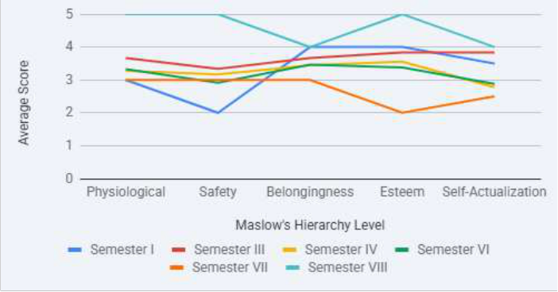

Figure 2. Average Satisfaction Scores Across Maslow’s Hierarchy Levels
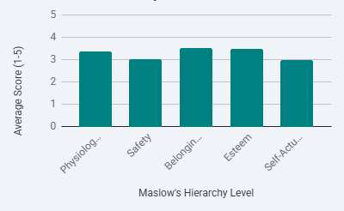

Figure 3. Average Scores of Herzberg Sub-Factors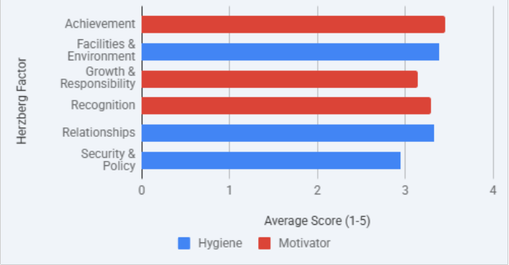

Figure 4. Herzberg Two-Factor Analysis: Student Motivation vs Hygiene

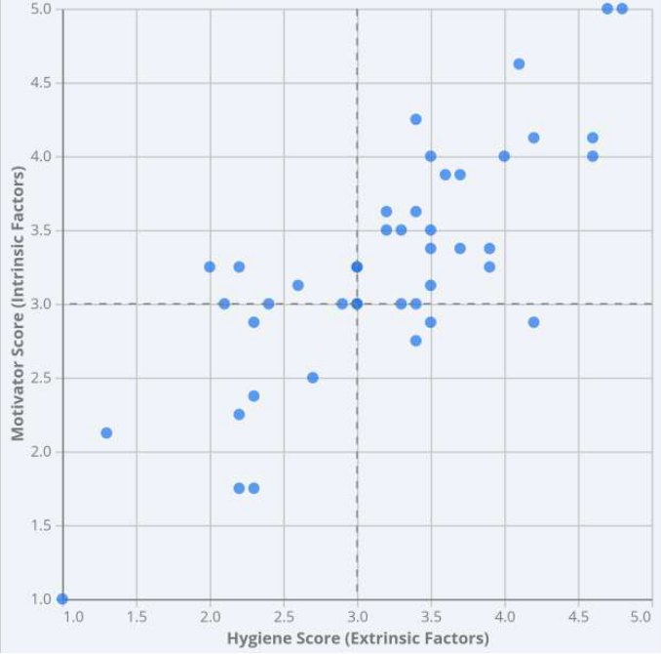

DISCUSSION
The results do not follow Maslow's expected sequence. The theory predicts physiological needs to be most satisfied and self-actualization least—the data disagrees. Esteem (3.38) and physiological needs (3.36) score highest, while safety needs (2.90) score lowest. Students feel reasonably confident in their abilities and find physical infrastructure adequate, but report genuine anxiety around evaluation fairness and policy consistency.
Herzberg's framework makes sense of this. Administrative fairness operates as a hygiene factor—when it is perceived as inconsistent or arbitrary, it generates active dissatisfaction regardless of what else is functioning well. A student who feels academically capable but fears unpredictable grading is unlikely to sustain motivation for long. The safety deficit, in this way, quietly erodes the esteem gains above it.
The self-actualization score (3.06/5) points to a structural problem rather than an individual one. Students report limited scope for creative thinking and meaningful engagement—a finding consistent with the broader critique
of Indian curricula remaining oriented toward rote learning over open-ended inquiry [9].
The safety score among students who preferred not to disclose gender (1.69/5) sits in a category of its own. It is low enough to warrant dedicated investigation rather than a footnote.
Taken together, the findings suggest that institutions are partially meeting motivational needs—but falling short in two specific areas: academic policy transparency, and structured pathways toward self -actualization.
CONCLUSION
This study examined motivation levels among 43 undergraduate students using Maslow's Hierarchy of Needs and Herzberg's Two-Factor Theory in tandem. The findings do not follow the theoretical sequence neatly—esteem and physiological needs are comparativelybetter satisfied, while safety needs recorded the lowest scores across all five levels. Self-actualization, though not the lowest, reflects a persistent deficit in opportunities for meaningful growth and intellectual engagement.

The implication is straightforward. Institutions are partially meeting motivational needs but falling short in two areas that matter structurally. The first is academic security—students do not consistently experience the policy transparency and evaluation fairness that a stable learning environment requires. The second is self -actualization—curricula and institutional programmes have not kept pace with what motivation research identifies as the highest-order driver of deep learning and sustained engagement.
Herzberg's framework reinforces this. Administrative inconsistency is a hygiene failure—it produces active dissatisfaction independent of what else the institution does well. Investments in recognition or growth
opportunities will yield limited returns until the safety deficit is addressed first.
The study is exploratory. The sample of 43 students, drawn predominantly from Semester VI of a single institution, limits generalisability. Future research should extend this to a larger, multi -institution sample and incorporate qualitative methods to capture what Likert scales cannot—the lived experience behind the numbers. The gender-based disparity, particularly the safety scores among students who preferred not to disclose gender (1.69/5), warrants investigation beyond what this study's scope permits.
Students are not unmotivated by disposition. They are operating within institutions whose policies and programmes have not caught up with what motivation research has established for decades. That is a structural problem—and a solvable one.
ACKNOWLEDGEMENTS
We thank the 43 undergraduate students who took the time to participate—the study exists because of their willingness to engage honestly with the survey. We are grateful to the faculty of the Department of Mechanical Engineering, RV College of Engineering, Bengaluru, for their guidance and support throughout this process. We also acknowledge Abraham Maslow and Frederick Herzberg, whose frameworks—decades old as they are—continue to offer genuine analytical purchase on questions that institutions are still getting wrong.
REFERENCES
1. Maslow, A. H. (1943). A theory of human motivation. Psychological Review, 50(4), 370–396. 2. Herzberg, F. (1959). The motivation to work. John Wiley & Sons.
3. Deci, E. L., & Ryan, R. M. (2000). The "what" and "why" of goal pursuits: Human needs and the self - determination of behaviour. Psychological Inquiry, 11(4), 227–268.
4. Eccles, J. S. (2002). Motivational beliefs, values, and goals. Annual Review of Psychology, 53, 109–132. 5. Awan, R. N., Noureen, G., & Naz, A. (2011). A study of relationship between achievement motivation,
self concept and achievement in English and Mathematics at secondary level. International Education Studies, 4(3), 72–79.
6. Tella, A. (2007). The impact of motivation on student's academic achievement and learning outcomes in Mathematics among secondary school students in Nigeria. Eurasia Journal of Mathematics, Science and Technology Education, 3(2), 149–156.
7. Kusurkar, R. A. (2013). Motivation in medical students: A PhD thesis summary. GMS Zeitschrift für Medizinische Ausbildung, 30(1), Doc11.
8. Aldemir, C. (2004). The assessment of student satisfaction in higher education. Educational Research Quarterly, 27(3), 18–31.
9. Pintrich, P. R. (2003). A motivational science perspective on the role of student motivation in learning and teaching contexts. Journal of Educational Psychology, 95(4), 667–686.
10. Butt, B. Z. (2010). A study examining the students satisfaction in higher education. Procedia—Social and Behavioral Sciences, 2(2), 5446–5450.

