Development and Performance of the Smart Spray Pest Response System

Joyce Grace T. Selma, Angelo Jet U. Reserva, AJ Mie B. Puerin, Jack Paitan, Aira Shane E. Vistal , , Honey May L. Betarmos, and Vanessa E. Babatuan, Rhona Mae L. Sanico

Student Researchers, San Agustin National High School, Philippines

ABSTRACT
This study developed and evaluated the Smart Spray Pest Response System (SSPRS), a solar-powered, automated pest control device designed for smallholder rice farms. The system integrates an ESP32-CAM for real-time image capture and pest detection process, and a relay-controlled centrifugal pump that activates spraying only when pest presence reaches a predefined confidence threshold. An experimental design was employed to compare SSPRS with conventional pest control methods in Barangay Mantalongon, Sagbayan, Bohol. System performance was assessed based on technical reliability and pest mortality. Results indicated that SSPRS achieved a mean mortality of 18.5 golden apple snails (32%), compared to 19.5 snails (39%) in the control group, with no statistically significant difference (p = 0.86). Although SSPRS did not outperform conventional methods in mortality rate, it demonstrated stable power management, reliable logic flow, and precise, event-driven spraying. Variations in environmental conditions, pest density, and detection accuracy likely influenced system performance. Future research should enhance image recognition accuracy, optimize spray timing, and conduct longer field trials to improve effectiveness and scalability.
Keywords: Automated Spraying System, Rice Pest Management, Sustainable Farming, Integrated Pest Management, Mortality Rate

INTRODUCTION

Pest infestation continues to be a critical constraint in agricultural productivity, accounting for substantial yield losses and economic damage worldwide. The Food and Agriculture Organization (2025) reports that pests are responsible for up to 40% of global crop losses each year, affecting food security and farmer income. Advances in agricultural technology have been promoted to address these challenges, as early detection and timely intervention directly influence crop survival and yield outcomes (United Nations, 2021).
Rice remains the primary staple food in the Philippines and a major source of livelihood for millions of smallholder farmers. Despite government efforts to promote Integrated Pest Management, pest outbreaks persist as a recurring problem, especially during the pre-harvest stage (Paulite, 2021). The Department of Agriculture (2024) reported that unmanaged pest infestations during the rainy season can reduce rice yields by at least 15%.
Observations conducted in Barangay Mantalongon, Sagbayan, Bohol in July 2025 showed that pest control largely relies on manual field inspection and routine pesticide application, often conducted on fixed schedules or in response to visible crop damage even without confirmed pest activity. This practice increases production costs and reflects a gap between early pest detection and timely, targeted intervention.
Technological approaches to pest management have shown potential in improving detection accuracy and reducing unnecessary chemical use. IoT-based monitoring systems have demonstrated improved pest surveillance through sensor integration and data-driven decision-making (Azfar et al., 2023). Drone-assisted pesticide application systems have improved spraying efficiency and coverage in large-scale farms (De Padua et al., 2021).
Spot-specific spraying technologies using sensors and automated valves have reduced pesticide usage while maintaining control effectiveness (Ahmed et al., 2025). However, existing systems remain unsuitable for smallholder rice farms due to high cost, technical complexity, and the absence of integrated real-time detection with automated response.
This study addresses this gap by developing the Smart Spray Pest Response System (SSPRS), an automated pest management device specifically designed for smallholder rice farms. The primary objective of the study is to develop and evaluate a system that integrates image-based pest detection with automated, precision spraying using an ESP32-CAM module. When pests are detected, the system activates a targeted spraying mechanism, reducing unnecessary pesticide application and minimizing environmental exposure in line with Integrated Pest Management principles (Adkisson & Smith, 1960).
The performance of the SSPRS is evaluated under real field conditions in Barangay Mantalongon, Sagbayan, Bohol based on pest mortality, detection accuracy, response time, and operational reliability. Performance outcomes are compared with traditional manual monitoring and spraying practices to determine effectiveness in improving pest control efficiency.
The study is significant in providing an environmentally responsible pest management solution that supports sustainable rice production and aligns with national agricultural efforts under Republic Act No. 8435 Agriculture and Fisheries Modernization Act of 1997, while also promoting the adoption of precision agriculture technologies that reduce chemical usage, lower production costs, and enhance crop protection efficiency for smallholder farmers.

Research Questions
This study aimed to develop and assess the performance of the Smart Spray Pest Response System (SSPRS) in detecting and reducing pest presence in rice crops in Barangay Mantalongon, Sagbayan, Bohol.
Specifically, the study sought to answer the following research questions:
- What is the technical profile of the SSPRS in terms of:
  - circuit design;
  - logic flow; and
1.2. physical and mechanical specs?
- How does the performance of the SSPRS and the traditional monitoring and spray system compare in terms of mortality rate?
- What recommendations can be proposed based on the findings of the study?

Hypothesis
There is no significant difference in the performance of the traditional monitoring and SSPRS.

Literature Review
Rice production in the Philippines remains heavily threatened by pests such as the golden apple snail which have caused significant yield losses and increased farmers’ reliance on chemical pesticides (Paulite, 2021). This dependence is widespread, with 88% of surveyed vegetable farmers primarily using pesticides despite known environmental and economic drawbacks (Cubelo, 2022). The urgency to develop targeted and sustainable pest management solutions is clear, as highlighted by global and regional studies showing the Philippines’ persistent pest challenges and growing research focus (Conde et al., 2025).
The pest behavior research by Wong & Didham (2024) emphasizes the importance of timing, revealing that pest activity often peaks during early morning hours, a factor critical for optimizing detection and control strategies which was further supported by Lahondère & Lazzari, (2023). Technological advances in embedded systems and TinyML have enabled real-time, on-device pest detection using resource-constrained devices such as the ESP32-CAM (Paul et al., 2024). These developments allow for autonomous, network-independent operation, supporting efficient pest monitoring in remote agricultural settings.
The integration of sensor-based technologies with attractants and actuators has shown promise in improving pest detection and reducing chemical use in rice storage and production systems (Balingbing et al., 2025). Precision agriculture approaches, such as spot-specific spraying, further demonstrate the potential to reduce pesticide consumption without sacrificing control efficacy (Ahmed et al., 2025). However, many advanced systems remain inaccessible to smallholder farmers due to cost and complexity, highlighting the need for affordable and user-friendly alternatives (De Padua et al., 2021).
The Smart Spray Pest Response System (SSPRS) addresses this gap by combining real-time image-based detection with targeted pesticide application using reliable components such as DC diaphragm pumps for precise spraying (Nasir et al., 2021). The system’s modular design aligns with established embedded system architectures that separate control, power management, and actuation for improved reliability in challenging outdoor environments (Boursianis et al., 2020). The event-driven logic flow employed minimizes unnecessary spraying and conserves resources, following best practices in automated agricultural systems as with McCauley et al., (2021) and Hussein et al., (2020).
The use of durable materials and mechanically stable frames, as supported by prior studies on IoT device deployment in harsh environments, ensures that the SSPRS maintains consistent performance under field conditions typical of Philippine rice farming (Soppa et al., 2021).

METHODOLOGY

Research Design
The study employed a developmental-experimental approach to evaluate the performance of the Smart Spray Pest Response System (SSPRS) under actual field conditions. The system was first developed and internally tested to ensure proper image detection, relay control, and spraying accuracy. After validation, the device was deployed in a rice field using a controlled comparison between an experimental plot equipped with the SSPRS and a control plot managed using conventional manual pest control. This design allowed direct measurement of pest mortality while maintaining realistic farming conditions and ensuring repeatable testing across multiple trials.

Sample
The primary sample of the study consisted of rice crops grown in two separate plots located in Barangay Mantalongon, Sagbayan, Bohol. Each plot contained sixty rice plants of the same variety, age, and planting density to ensure uniform growth conditions. One plot served as the experimental group where the Smart Spray Pest Response System was installed, while the second plot served as the control group and relied on traditional manual pesticide application.
To standardize pest pressure, sixty Golden Apple Snails were introduced into each plot at the start of every trial. These snails represented the controlled pest population used to evaluate system effectiveness. After each trial, all remaining snails were removed from both plots, and a new batch of sixty snails was introduced for the succeeding trial. A total of three trials were conducted to ensure consistency and reliability of results while preventing carryover effects between trials.

Materials
The ESP32-CAM (OV2640 AI-Thinker) served as the central microcontroller and image-processing unit of the system. It captured real-time images of the rice crops, executed the embedded machine learning model, and controlled the activation of the spraying mechanism through digital output signals.

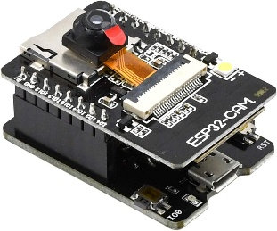

Figure 1. ESP32-CAM Microcontroller

An image recognition model developed using the Edge Impulse platform was used to detect Golden Apple Snails. The model was trained using field-acquired images and evaluated for accuracy prior to deployment. Once validated, the trained model was embedded into the ESP32-CAM to enable on-device inference without reliance on external networks.
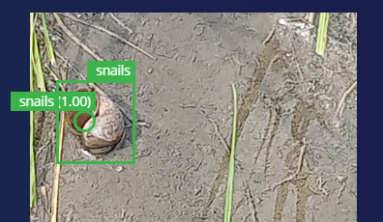
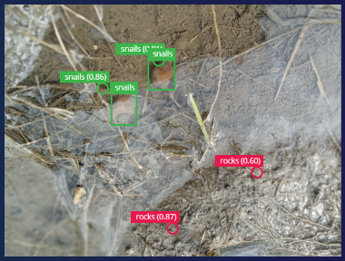

Figure 2. Image Recognition Model
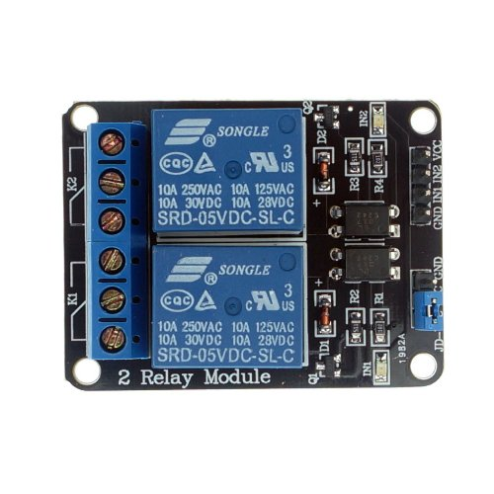
SPDT 5 V relay modules were used to isolate the low-voltage control circuitry from the high-current 12 V centrifugal pump. These relays allowed safe and reliable switching during pump activation while protecting sensitive electronic components.

Figure 3. SPDT Relay Module

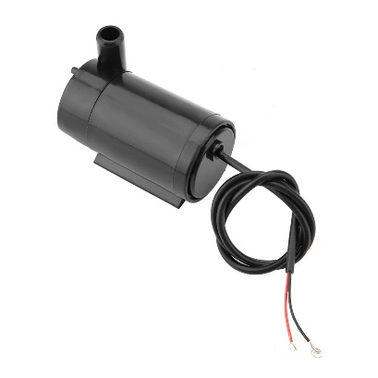
A 12 V DC centrifugal pump functioned as the pesticide delivery mechanism. The pump was calibrated to dispense approximately 250 ml of pesticide per activation to ensure consistent and controlled application. A spray nozzle was attached to direct the pesticide precisely toward the detected pest area.

Figure 4. DC Centrifugal Pump

The power subsystem consisted of a solar panel, a solar charge controller, and a 12 V VRLA battery. This configuration provided stable and continuous power for off-grid operation while preventing overcharging and deep battery discharge. A metal frame and weather-resistant enclosure supported and protected the electronic and mechanical components during outdoor deployment.
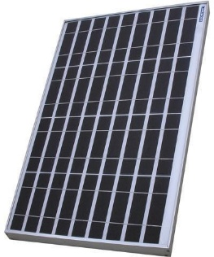
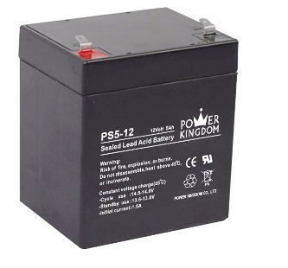
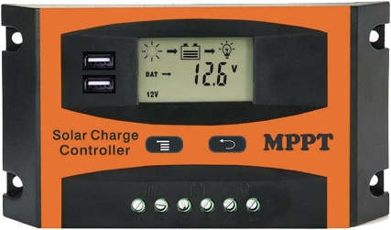

Figure 5. Power Subsystem

Procedures
The procedure began with the development of the image-recognition model using the Edge Impulse platform. Images of Golden Apple Snails were collected from actual rice field conditions under varying lighting intensities, backgrounds, and orientations to improve model robustness. The images were manually labeled and iteratively trained and validated until stable detection accuracy and minimal false activations were achieved. The finalized model was then deployed to the ESP32-CAM to enable on-device, real-time pest detection.
The system was then programmed using the Arduino Integrated Development Environment (IDE), which allowed the ESP32-CAM microcontroller to integrate image processing, pest detection, and spray actuation into a single autonomous system. After training and optimizing the Golden Apple Snail recognition model on the Edge Impulse platform, the model was embedded into the ESP32-CAM firmware, enabling real-time, on-device inference without reliance on external networks. The code managed continuous image capture, applied confidence thresholds to minimize false activations, and controlled SPDT relays that activated the 12 V diaphragm pumps for precise, event-driven pesticide spraying. Safety features were incorporated to prevent accidental activation during startup, avoid repeated triggering from transient detections, and monitor cumulative pesticide usage to prevent overapplication. Using Arduino IDE streamlined the development process, providing a modular, reliable, and energy-efficient system capable of autonomous pest management under real field conditions.
System assembly was conducted by interfacing the ESP32-CAM with relay modules that controlled the 12 V DC centrifugal pump used for pesticide delivery. The spray nozzle was aligned to ensure accurate targeting of the detected pest area. A solar-powered energy subsystem composed of a solar panel, charge controller, and battery was integrated to provide continuous and autonomous operation. Preliminary testing was performed to verify system initialization, image processing accuracy, relay switching response, programmed delay intervals, and consistency of pesticide spray volume.
For field deployment, the SSPRS was installed in the experimental rice plot planted with NSIC Rc222, and the camera was positioned at an optimal height and angle to maximize crop coverage and detection accuracy. At the beginning of each trial, sixty Golden Apple Snails were introduced into both the experimental and control plots. The SSPRS continuously monitored the experimental plot and automatically activated the spraying mechanism upon confirmed pest detection, while the control plot was treated through conventional manual pesticide spraying.
Each trial was conducted for a duration of two hours. After each observation period, all remaining snails were removed from both plots to eliminate residual effects and cross-trial interference. A new batch of sixty Golden Apple Snails was then introduced for the next trial. This procedure was repeated for a total of three trials under comparable environmental conditions.

Data Collection and Analysis
Data were collected by recording the number of Golden Apple Snails eliminated in both plots during each two-hour trial. Pest mortality percentage was calculated by dividing the number of snails eliminated by the total number introduced per trial. The mean mortality rates and corresponding standard deviations were computed to assess consistency and variability between treatments. An independent samples t-test was used to determine whether the observed difference in pest mortality between the SSPRS-assisted plot and the manually treated plot was statistically significant.

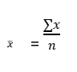
Mean:

Mortality Rate:
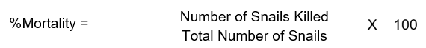

T-test Statistic:
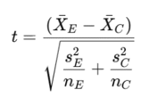

RESULTS AND DISCUSSION

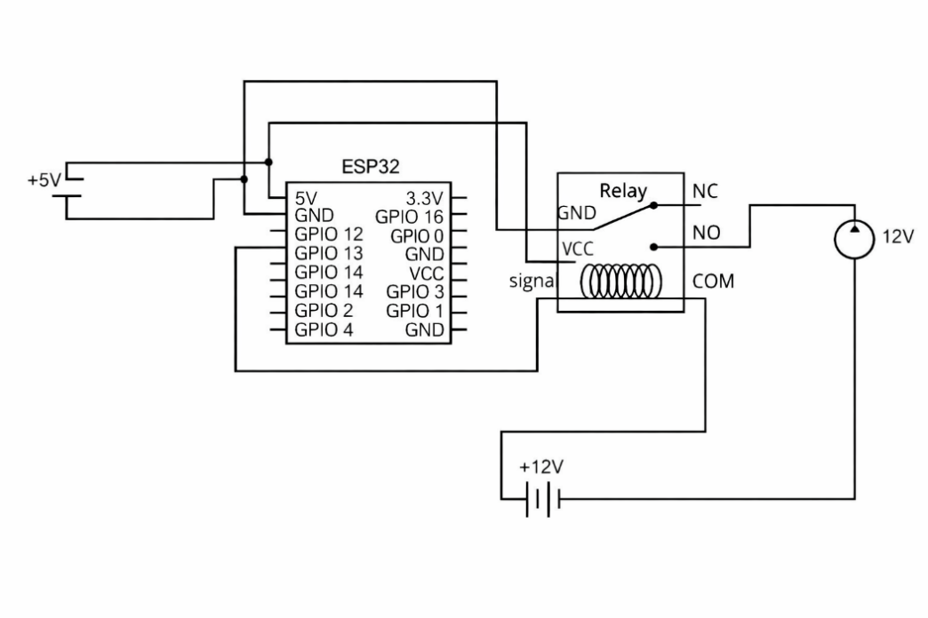
Figure 7 presents the finalized circuit diagram of the Smart Spray Pest Response System (SSPRS). The system integrates a solar-powered energy subsystem, control electronics, and actuation components designed for autonomous agricultural operation. Power was supplied by a solar panel connected to a solar charge controller and a 12 V VRLA battery, ensuring stable off-grid operation. The charge controller regulated energy flow to prevent battery overcharging and deep discharge.

Figure 7. Circuit Diagram

The ESP32-CAM functioned as the central microcontroller and image-processing unit. It received regulated power from the battery and controlled two 5 V SPDT relay modules via its GPIO pins. These relays electrically isolated the low-voltage control circuitry from the high-current 12 V centrifugal pumps used for pesticide spraying. Upon successful pest detection, the ESP32-CAM outputs a digital HIGH signal that energizes the relay coil, allowing current to flow from the battery to the pump and initiating pesticide application. This event-driven activation ensured spraying occurred only when a target pest was detected.
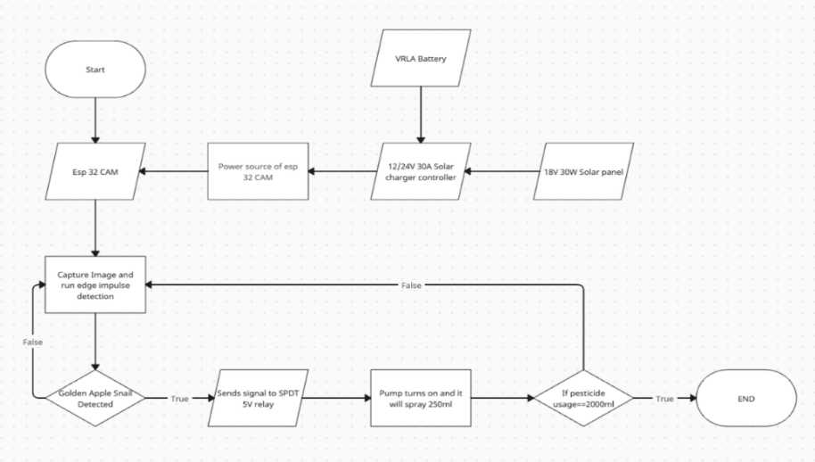

Figure 8. Logic Flow
Figure 8 illustrates the system’s final logic flow. After power stabilization, the ESP32-CAM initialized its GPIO pins, camera module, and embedded machine learning model developed using the Edge Impulse platform. During initialization, the relay output remained inactive to prevent unintended pump activation. Once initialized, the system entered a continuous monitoring loop where image frames were captured and processed for pest detection.

When the detection confidence did not reach the predefined threshold, the system classified the frame as negative and returned to image acquisition without activating the pump. When the confidence threshold was met, the system confirmed the presence of a Golden Apple Snail and activated the relay to dispense approximately 250 ml of pesticide. After spraying, the system evaluated cumulative pesticide usage. If the total volume reached 2000 ml, the system terminated operation; otherwise, it returned to the monitoring loop following a brief delay to prevent repeated triggering.

Figure 9, shows the integrated physical and mechanical layout of the Smart Spray Pest Response System (SSPRS). The configuration demonstrates how energy generation, control electronics, and actuation components are mechanically arranged and interconnected to enable autonomous pest detection and response.
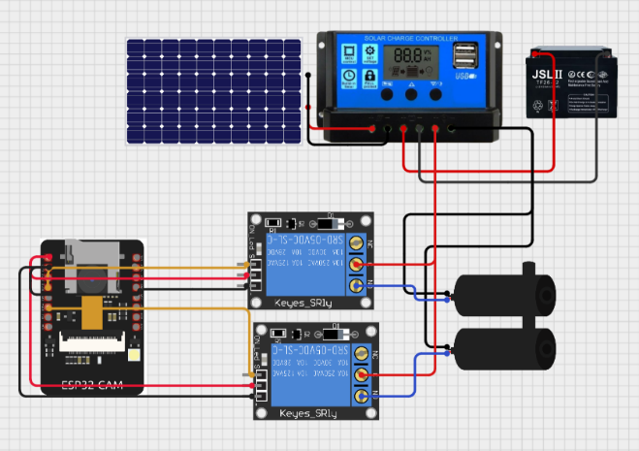
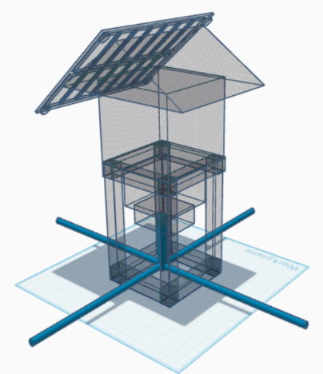

Figure 9. Physical and Mechanical Specifications

The solar panel is mechanically mounted on the upper portion of the structure to maximize solar exposure and ensure unobstructed energy harvesting. Electrical connections from the panel are routed directly to the solar charge controller, which is housed within the enclosure to protect it from environmental exposure. The charge controller is mechanically secured alongside the 12 V VRLA battery, forming a compact and stable power management assembly. This arrangement minimizes cable length, reduces mechanical strain on terminals, and improves system reliability during prolonged outdoor operation.
As shown in the circuit layout, regulated power from the battery is distributed to both the ESP32-CAM module and the relay-controlled pump circuits. The ESP32-CAM is mechanically mounted within the enclosure to maintain a fixed camera orientation and stable electrical connections. Its placement minimizes vibration and ensures consistent image capture for pest detection. Jumper wires connecting the ESP32-CAM to the relay modules are mechanically organized to reduce stress on GPIO pins and prevent accidental disconnection.
Two SPDT relay modules are mechanically positioned adjacent to the ESP32-CAM and secured to the frame. This placement allows short control signal paths from the microcontroller while isolating the high-current pump wiring. The relay modules act as electromechanical switches, enabling the ESP32-CAM to safely control the 12 V centrifugal pumps without direct electrical loading. Mechanical separation between low-voltage signal lines and high-current pump wiring reduces electrical and mechanical interference during pump activation.
Mechanical fastening prevents displacement during operation and ensures consistent pressure delivery during pesticide spraying. Tubing connected to the pumps is routed and secured to avoid kinking or vibration-induced wear. The spray nozzles are mechanically aligned with the camera’s field of view, allowing accurate targeting of detected pests and localized pesticide application.

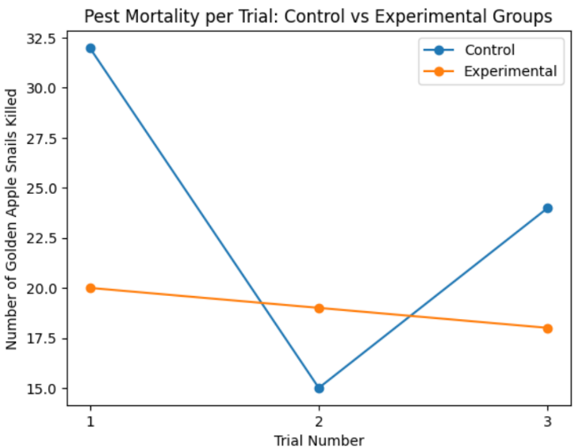
Figure 10 illustrates the number of golden apple snails killed across three trials for both the control and experimental groups. The control group exhibited greater variability in pest mortality, with a high number of snails killed in Trial 1, a sharp decline in Trial 2, and a subsequent increase in Trial 3. In contrast, the experimental group demonstrated more consistent results across trials, although the number of snails killed was generally lower than that of the control group.

Figure 10. Pest Mortality per Trial

While the control group recorded higher mortality in Trials 1 and 3, the experimental group showed comparable values in Trial 2. The overlapping trends and inconsistent differences between groups suggest that the observed variations in pest mortality may be attributed to random fluctuations rather than a systematic effect of the experimental treatment. This visual pattern supports the statistical finding that the difference between the control and experimental groups was not statistically significant (p = 0.86 > 0.05).

Figure 11 illustrates the comparison of mean pest mortality rates between the experimental and control groups. The experimental group recorded a mortality rate of 32%, while the control group exhibited a higher mortality rate of 39%. Visually, the control group shows a greater reduction in Golden Apple Snail population compared to the experimental group.

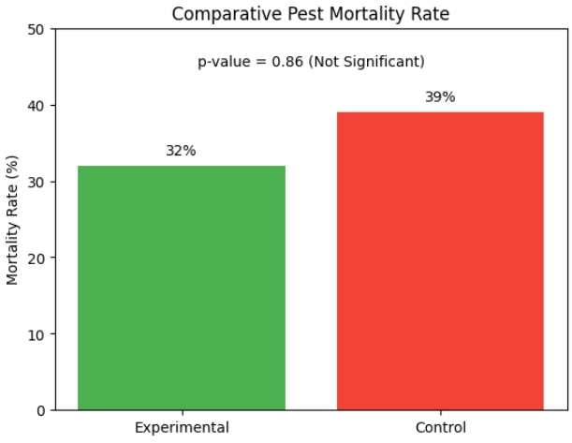

Figure 11. Comparative Pest Mortality Rate

Despite this observed numerical difference, statistical analysis indicates that the difference in mortality rates is not statistically significant, as reflected by the reported p-value of 0.86, which exceeds the critical value of 0.05. This result suggests that the variation in mortality rates between the two groups is likely due to random variation rather than the effect of the experimental treatment.
The absence of statistical significance implies that the Smart Spray Pest Response System, under the conditions of this study, did not demonstrate a measurable advantage over the control treatment in terms of pest mortality. While the system successfully performed targeted spraying based on pest detection, this targeted approach did not translate into higher overall mortality when compared to the control setup.
Several factors may have contributed to this outcome, including limited observation duration, variability in pest distribution, environmental conditions, or the controlled volume of pesticide dispensed per detection event.

Conclusion
This study successfully developed and evaluated the Smart Spray Pest Response System (SSPRS), an automated, solar-powered device for detecting and responding to pests in rice crops. The system functioned effectively in terms of logic flow, circuit design, and physical and mechanical specifications, operating reliably under field conditions. When compared with traditional pest management methods, the SSPRS demonstrated comparable pest mortality, though it was slightly less effective overall, likely due to limitations in detection accuracy and environmental factors. Despite this, the system showed potential for targeted, energy-efficient, and automated pest control, reducing unnecessary pesticide use and supporting environmentally responsible practices. With further improvements in image recognition, spray timing, and structural optimization, the SSPRS could serve as a scalable and sustainable alternative for smallholder rice farmers.

Recommendations
Based on the results and findings of the study, future research is recommended to enhance the performance, reliability, and scalability of the Smart Spray Pest Response System (SSPRS). Studies should expand field implementation across multiple locations with varying environmental conditions, increase plot size and experimental scale, and adopt randomized experimental designs to improve validity and generalizability. Extending the evaluation period over multiple planting cycles is also recommended to assess long-term system durability and pest control effectiveness. Further improvements may include expanding pest detection capabilities beyond the golden apple snail, integrating weather-resilient design features, and refining false-trigger reduction mechanisms through enhanced training datasets and multi-frame validation. Comparative evaluation of component quality and broader supervised field deployment are likewise suggested to optimize cost-performance balance, system robustness, and practical applicability for smallholder farming environments.

REFERENCES

Adkisson, P., & Smith, R. (1960). Integrated pest management. Environmental Quality Council
Ahmed, A., Saleem, S. R., Tahir, M. N., Manzoor, S. H., Zaman, Q., Zhang, Z., & Ahmed, R. (2025). Design and development of industrial prototype of spot spot-specific orchard sprayer using an ultrasonic sensing system and advanced pressure control mechanism. Computers and Electronics in Agriculture, 237, 110690. https://doi.org/10.1016/j.compag.2025.110690
Azfar, S., Nadeem, A., Ahsan, K., Mehmood, A., Almoamari, H., & Alqahtany, S. S. (2023). IoT-Based Cotton Plant Pest Detection and Smart-Response System. Applied Sciences, 13(3), 1851. https://doi.org/10.3390/app13031851
Balingbing, C., Gummert, M., Pangesti, N., Van Hung, N., & Hensel, O. (2025). Insect attractants for enhanced monitoring and control of pests in rice storage. Journal of Stored Products Research, 113, 102697. https://doi.org/10.1016/j.jspr.2025.102697
Boursianis, A. D., Papadopoulou, M. S., Diamantoulakis, P., Liopa-Tsakalidi, A., Barouchas, P., Salahas, G., Karagiannidis, G., Wan, S., & Goudos, S. K. (2020). Internet of things (IoT) and agricultural unmanned aerial vehicles (UAVs) in smart farming: A comprehensive review. Internet of Things, 18, 100187. https://doi.org/10.1016/j.iot.2020.100187
Conde, S., Catarino, S., Ferreira, S., Temudo, M. P., & Monteiro, F. (2025). Rice Pests and Diseases Around the World: Literature-Based Assessment with Emphasis on Africa and Asia. Agriculture, 15(7), 667. https://doi.org/10.3390/agriculture15070667
Cubelo, J. E. C. (2022). Factors Associated with Pesticide Use among Vegetable Farmers in Negros Oriental, Philippines. Silliman Journal, 60(2). https://sillimanjournal.su.edu.ph/index.php/sj/article/view/36
Department of Agriculture. (2024). PhilRice alerts rice farmers of increased pest threats during rainy season | PRRI. Philippine Rice Research Institute. https://www.philrice.gov.ph/philrice-alerts-rice-farmers-of-increased-pest-threats-during-rainy-season
De Padua, E. P., Amongo, R. C., Quilloy, E. P., Suministrado, D. C., & Elauria, J. C. (2021). Development of a local unmanned aerial vehicle (UAV) pesticide sprayer for rice production system in the Philippines. IOP Conference Series: Materials Science and Engineering, 1109(1), 012022. https://doi.org/10.1088/1757-899x/1109/1/012022
Food and Agriculture Organization of the United Nations . (2025). Understanding the context | Pest and Pesticide Management | Food and Agriculture Organization of the United Nations | IPM and Pesticide Risk Reduction | Food and Agriculture Organization of the United Nations. Fao.org. https://www.fao.org/pest-and-pesticide-management/about/understanding-the-context/en
Hussein, Mahmoud, Michetti, G., Rinaldi, M., Onabajo, M., & Cassella, C. (2020). Systematic Synthesis and Design of Ultralow Threshold 2:1 Parametric Frequency Dividers. IEEE Transactions on Microwave Theory and Techniques, 68(8), 3497–3509. https://doi.org/10.1109/tmtt.2020.2999790
Lahondère, C., & Lazzari, C. R. (2023). Recent advances in insect thermoregulation. Journal of Experimental Biology, 226(18), jeb245751. https://doi.org/10.1242/jeb.245751
McCauley, D. M., Nackley, L. L., & Kelley, J. (2021). Demonstration of a low-cost and open-source platform for on-farm monitoring and decision support. Computers and Electronics in Agriculture, 187, 106284. https://doi.org/10.1016/j.compag.2021.106284
Nasir, F. E., Alam, M. S., Tufail, M., & Khan, M. T. (2021). A Novel Pressure and Flow Control Technique for Variable-Rate Precision Agricultural Sprayer. 2021 International Conference on Robotics and Automation in Industry (ICRAI), 1–6. https://doi.org/10.1109/ICRAI54018.2021.9651446
Paul, J., Schmid, L., Klaiber, M., & Rössle, M. (2024). Extraction of Measurement Device Information on an ESP32 Microcontroller: TinyML for Image Processing. Procedia Computer Science, 246, 2002–2011. https://doi.org/10.1016/j.procs.2024.09.670
Paulite, J. (2021). Common insect pests of major crops in the philippines. ResearchGate. https://doi.org/10.13140/RG.2.2.10988.90245
Republic Act No. 8435. (1997). Modernizing Agriculture and Fisheries: Overview of Issues, Trends, and Policies. Www.pids.gov.ph. https://www.pids.gov.ph/publication/discussion-papers/modernizing-agriculture-and-fisheries-overview-of-issues-trends-and-policies
education. Sustainability, 14(4), 2240. https://doi.org/10.3390/su14042240
Soppa, M. A., Silva, B., Steinmetz, F., Keith, D., Scheffler, D., Bohn, N., & Bracher, A. (2021). Assessment of Polymer Atmospheric Correction Algorithm for Hyperspectral Remote Sensing Imagery over Coastal Waters. Sensors, 21(12), 4125–4125. https://doi.org/10.3390/s21124125
United Nations. (2021). Smart farmers: learning with digital technologies | Support to Investment | Food and Agriculture Organization of the United Nations. Fao.org. https://www.fao.org/support-to-investment/news/detail/en/c/1460141/
Wong, M. K. L., & Didham, R. K. (2024). Global meta-analysis reveals overall higher nocturnal than diurnal activity in insect communities. Nature Communications. https://doi.org/10.1038/s41467-024-47645-2

APPENDICES

Appendix A. Gathered Data
Date: December 20, 2025 Time Start: 10:04 AM Time End: 12:04 PM
Plot: ☐ EXP (SSPRS) ☐ CTRL (Traditional) Day #: 1

Pest Count | Pests Killed | Mortality Rate
60 | 32 | 53%

Date: December 20, 2025 Time Start: 10:04 AM Time End: 12:04 PM
Plot: ☐ EXP (SSPRS) ☐ CTRL (Traditional) Day #: 1

Pest Count | Pests Killed | Mortality Rate
60 | 20 | 33%

Date: December 23, 2025 Time Start: 10:12 AM Time End: 12:12 PM
Plot: ☐ EXP (SSPRS) ☐ CTRL (Traditional) Day #: 2

Pest Count | Pests Killed | Mortality Rate
60 | 15 | 25%

Date: December 23, 2025 Time Start: 10:12 AM Time End: 12:12 PM
Plot: ☐ EXP (SSPRS) ☐ CTRL (Traditional) Day #: 2

Pest Count | Pests Killed | Mortality Rate
60 | 19 | 32%

Date: December 27, 2025 Time Start: 10:08 AM Time End: 12:08 PM
Plot: ☐ EXP (SSPRS) ☐ CTRL (Traditional) Day #: 3

Pest Count | Pests Killed | Mortality Rate
60 | 24 | 50%

Date: December 27, 2025 Time Start: 10:08 AM Time End: 12:08 PM
Plot: ☐ EXP (SSPRS) ☐ CTRL (Traditional) Day #: 3

Pest Count | Pests Killed | Mortality Rate
60 | 18 | 30%
Appendix B. Documentation
