Sleep Apnea Detection

G.Preethika Reddy M.Bhaskar K.Jayanth
Department of CSE(AI&ML) Department of CSE(AI&ML) Department of CSE(AI&ML)
Keshav Memorial Engineering College Keshav Memorial Engineering College Keshav Memorial Engineering College


Hyderabad , India Hyderabad , India Hyderabad , India

preethikareddy729@gmail.com bhaskarm0625@gmail.com

V.Aparna Varalakshmi
Department of CSE(AI&ML)
Keshav Memorial Engineering College
Hyderabad , India
aprana.kuch@gmail.com

Abstract— Sleep apnea is a potentially life-threatening disorder marked by repeated interruptions in breathing during sleep often due to obesity, enlarged tonsils, or relaxed throat muscles. It may also be linked to anatomical features such as a thick neck or narrow airway or sometimes due to brain’s failure to consistently send signals to the muscles that control breathing. This form is often associated with conditions like heart failure, stroke, or certain neurological disorders. This project proposes a deep learning-based approach to detect sleep apnea events using physiological data such as oxygen saturation (SpO₂), heart rate, and respiratory metrics. A Convolutional Neural Network (CNN) is used to analyze and classify sleep data as apnea or normal. The solution is designed to work in real-time and can be integrated into a dashboard or mobile application for user- friendly diagnostics. This method offers a non-invasive, accurate, and accessible alternative to traditional sleep study techniques.
Keywords— Sleep Apnea, Deep Learning, CNN, Physiological Signals, SpO₂, Heart Rate, Real-Time Detection

INTRODUCTION

Sleep is essential for human health and well-being, yet millions of people suffer from disorders that disrupt this vital function. One of the most prevalent and dangerous of these disorders is sleep apnea, a condition marked by repeated interruptions in breathing during sleep. These breathing pauses can last for several seconds and may occur hundreds of times each night, often without the individual's awareness. Sleep apnea not only affects the quality of sleep but also poses serious health risks, including cardiovascular disease, diabetes, and even sudden death.

There are two main types of sleep apnea:
Obstructive Sleep Apnea (OSA) and Central Sleep Apnea (CSA). OSA is caused by the physical blockage of the airway, typically due to the relaxation of throat muscles, while CSA occurs when the brain fails to send proper signals to the breathing muscles. Despite its severity, sleep apnea often goes undiagnosed due to the high cost and complexity of traditional diagnostic methods like polysomnography, which require overnight observation in specialized sleep labs. The primary purpose of using the deep convolutional neural network model for the detection of sleep apnea is to learn parameters or features for the model from the training dataset . The performance of the
modiesl related to the learned parameters in order to determine whether the sample of the signal contains sleep
apnea event or not. The relationship between the interpretability of the different parameters and the performance of the deep convolutional model is a challenging task for the detection of sleep apnea. A variety of different convolutional neural networks can be used for image classification task; however, only a smaller percentage of them is used for the detection relating to sound waves or the signal processing. The designing and testing of good convolutional neural network model is similar to the black box and needs to be done in a substantial amount of trials and errors because of the inner mechanism of the CNN model . The representation of the signals from the sensor gains a lot of attention in the deep learning model. The proposed model is inspired from the image classification in which the amplitude from the sensors wave data can be seen as the digit vector figures, which can change to any dimensional shape for matrix vectorization or
factorization.
Given the challenges, there is a growing need for affordable, non-invasive, and accurate methods to detect sleep apnea, especially in real-time and home-based settings. This is where the power of artificial intelligence and deep learning can be harnessed. By using physiological signals such as oxygen saturation (SpO₂), heart rate, and respiratory patterns, we can develop intelligent systems that detect and classify apnea events with high accuracy, even outside clinical environments.
The aim of our project is to design and implement a deep learning-based system using Convolutional Neural Networks (CNNs) to automatically detect sleep apnea from real-time physiological inputs. Our goal is to make early detection more accessible, provide a reliable alternative to conventional diagnostics, and ultimately contribute to better management and treatment of sleep-related health conditions.

LITERATURE SURVEY

Sleep apnea has emerged as a significant public health concern due to its increasing prevalence and serious health implications. Traditional diagnostic methods such as polysomnography, while considered the gold standard, are

often expensive, time-consuming, and inconvenient for patients. These limitations have driven researchers to explore alternative solutions that are more accessible and scalable, particularly leveraging advancements in artificial intelligence and biomedical signal processing.Over the past decade, various machine learning and deep learning techniques have been applied to analyze physiological signals like electroencephalogram (EEG), oxygen saturation (SpO₂), heart rate, and respiratory effort to detect sleep apnea events. Among these, deep learning models such as Convolutional Neural Networks (CNNs) and Recurrent Neural Networks (RNNs) have shown promising results due to their ability to learn complex patterns from raw data without extensive feature engineering.
Shat et al.[1] paper proposes a machine learning framework that utilizes EEG signals for the detection of sleep apnea. EEG data, known for capturing brain wave activity during sleep, is processed using signal extraction and feature engineering techniques. Various classifiers (like SVM and Random Forest) are tested, and the models show high accuracy in distinguishing apnea events from normal sleep patterns.
You et al.[2] study explores the use of overnight SpO₂ signals and deep learning for the dual detection of obstructive sleep apnea (OSA) and underlying diabetes. A CNN is trained to extract patterns in oxygen saturation that correlate with both conditions. This approach offers a non- invasive, data-driven alternative to conventional diagnostics.
S. Dong et al.[3] utilizing K-band biomedical radar, this research introduces a contactless method for detecting apnea and hypopnea events. Radar detects micro- movements in respiration, and the data is processed with deep learning algorithms to classify breathing anomalies. The method ensures hygiene, comfort, and accessibility without physical sensors. S. Dong et al.[4] continuation of prior research, this paper refines the radar-based apnea detection system. It introduces improvements in radar signal preprocessing and uses enhanced CNN architectures for better classification performance. Tests were conducted on various sleep scenarios to validate robustness . These studies demonstrate the effectiveness of diverse, non- invasive techniques—EEG, SpO₂, and radar—for accurate sleep apnea detection using machine and deep learning. They highlight advancements in comfort, accessibility, and diagnostic accuracy over traditional methods.

TABLE 1: Comparitive Analysis Table RESEARCH GAPS:
S.A.  Sumona & W.  B. N.  Aurthy [6] | 2023 | Embedd ed microco ntrollers with SpO₂ & heart rate sensors | Budget- friendly, ideal for low- resource settings, on- device processi  ng | Limited processi ng power may reduce model complex ity or  accuracy
X.-X.  Lin et al. [7] | 2023 | RAPIDE ST – CNN-  based deep learning framewor k | Real- time, scalable, optimize d for cloud/ed ge deploym ent, trained on real- world  data | May require substanti al initial training resources and real- time data preproces sing
P.  Sharma et al. [8] | 2022 | CNN  trained on SpO₂ and pulse rate | Strong binary classific ation | Dataset diversity limited

- Existing systems like EEG-based diagnosis are accurate but intrusive and expensive.
- Radar-based models show promise but are hardware- dependent and not scalable.
- Many models lack integration with real-time web or mobile interfaces for instant feedback.
- Limited real-world deployment and validation across diverse populations.

HOW OUR RESEARCHE FILLS THE GAP

Our Sleep Apnea Detection System:
Author  (s) | Year | Techniq ues | Strengt h | Limitati ons
T.F.  Massie et al. [5] | 2023 | Photople thysmog raphy (PPG) +  Machine Learning | Non- invasive, low- cost, pulse wavefor m analysis | May require high- quality signal acquisiti on for accuracy

- Deep Learning: Uses CNNs on simple sensor data (SpO₂ and heart rate), making it more accessible and cost-effective.
- User Interface: Leverages a clean and minimalistic web dashboard for input and real-time classification.
- Cost effective: Eliminates need for bulky PSG equipment through wearable and mobile data entry.
- Adaptability to other sleep disorders and biomedical applications.
- Offers severity classification for future diagnosis.
- Enhances preventive healthcare by early detection.

PROPOSED WORK

The proposed system offers a deep learning-based, non- invasive solution for detecting sleep apnea events using wearable sensors and a CNN-based classification model. The modular design includes model training - Uses deep neural networks to differentiate apnea and non-apnea episodes and severity classification . This system ensures high accuracy, quick diagnosis, and seamless integration with dashboard . It simplifies diagnosis and enhances monitoring, offering a more accessible and cost-effective alternative to traditional sleep studies.
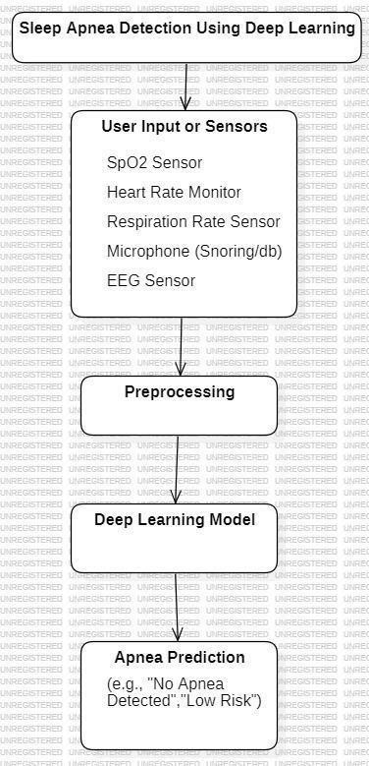
Fig 1: System Architecture

Workflow of system
This workflow explains how the system operates, enabling seamless interaction between user and the sleep apnea detection system and its internal working .

Data Collection
In this phase, physiological signals such as oxygen saturation (SpO₂), heart rate, respiration rate, snore intensity, and electroencephalogram (EEG) data are gathered using medical-grade or wearable sensors. These parameters are chosen due to their strong correlation with breathing irregularities and sleep disturbances. The collected data serves as the foundation for detecting apnea events and is essential for training the deep learning model with accurate, real-world inputs.

Preprocessing
Raw physiological data often contain noise and inconsistencies due to sensor errors or motion artifacts. Therefore, preprocessing is performed to normalize the data, smooth out fluctuations, and remove irrelevant signals. The data is then segmented into uniform time windows or frames suitable for model input. This step ensures consistency in data fed into the model and enhances its learning and prediction capabilities.

Dataset Preparation
Once preprocessed, the data is labeled as either "Apnea" or "Normal" based on clinical criteria or expert annotations. The labeled dataset is then split into training, validation, and testing sets to allow the CNN model to learn patterns, fine-tune performance, and evaluate generalization accuracy. This structured approach helps in developing a reliable model and prevents overfitting.

CNN Classification
A Convolutional Neural Network (CNN) is employed to extract spatial and temporal features from the segmented multi-sensor input data. CNNs are well-suited for identifying complex patterns, making them ideal for detecting apnea events hidden within physiological signals. The network classifies each input segment as an apnea or normal episode based on the learned features.
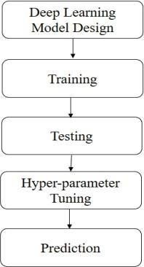
Fig 2: CNN working

Deployment & Prediction
After training, the CNN model is integrated into a real-time
usersto input their sensor readings and instantlyreceive a classification result. The deployment ensures that the solution is accessible, user-friendly, and suitable for both clinical use
and home monitoring, offering quick feedback without
needing expert intervention.

Severity Assessment
To provide further clinical value, the system calculates the risk of apnea, which represents severity of apnea. Based on the value, the system determines the severity of the disorder as high or low. This classification assists in understanding the risk level and guides patients toward appropriate medical consultation or intervention.

Technologies used
The project integrates a combination of hardware sensors, machine learning frameworks, and web

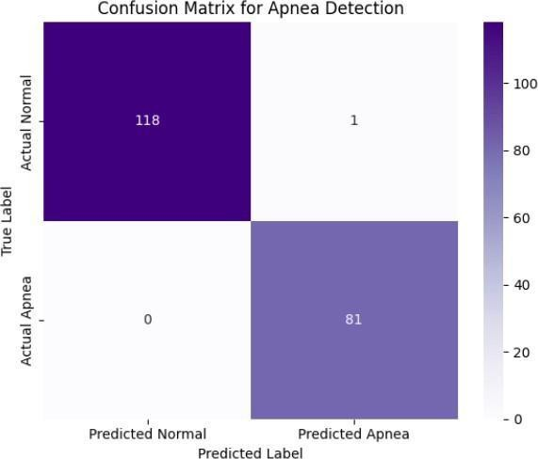
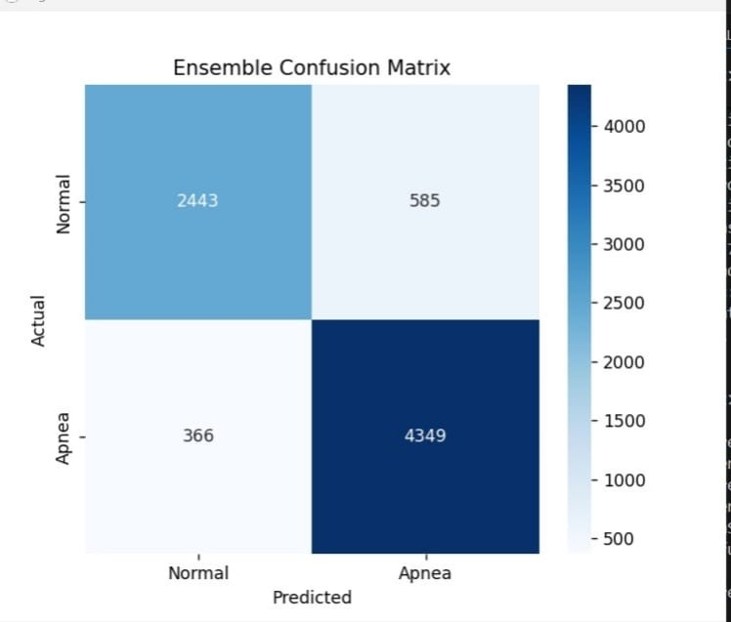
technologies to create an end-to-end sleep apnea detection system. On the hardware side, pulse oximeters, ECG/EEG electrodes, and snore detectors are used to collect vital physiological data including SpO₂, heart rate, respiration rate, and snoring patterns. The core of the detection algorithm is built using Python and TensorFlow/Keras, which are used to design and train the Convolutional Neural Network (CNN) model for classification tasks. For deployment and user interaction, technologies like Flask (for the backend), HTML,CSS(for the backend) are used.

Workflow Summary
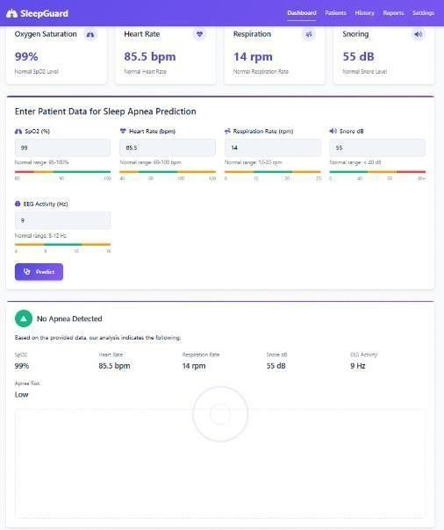
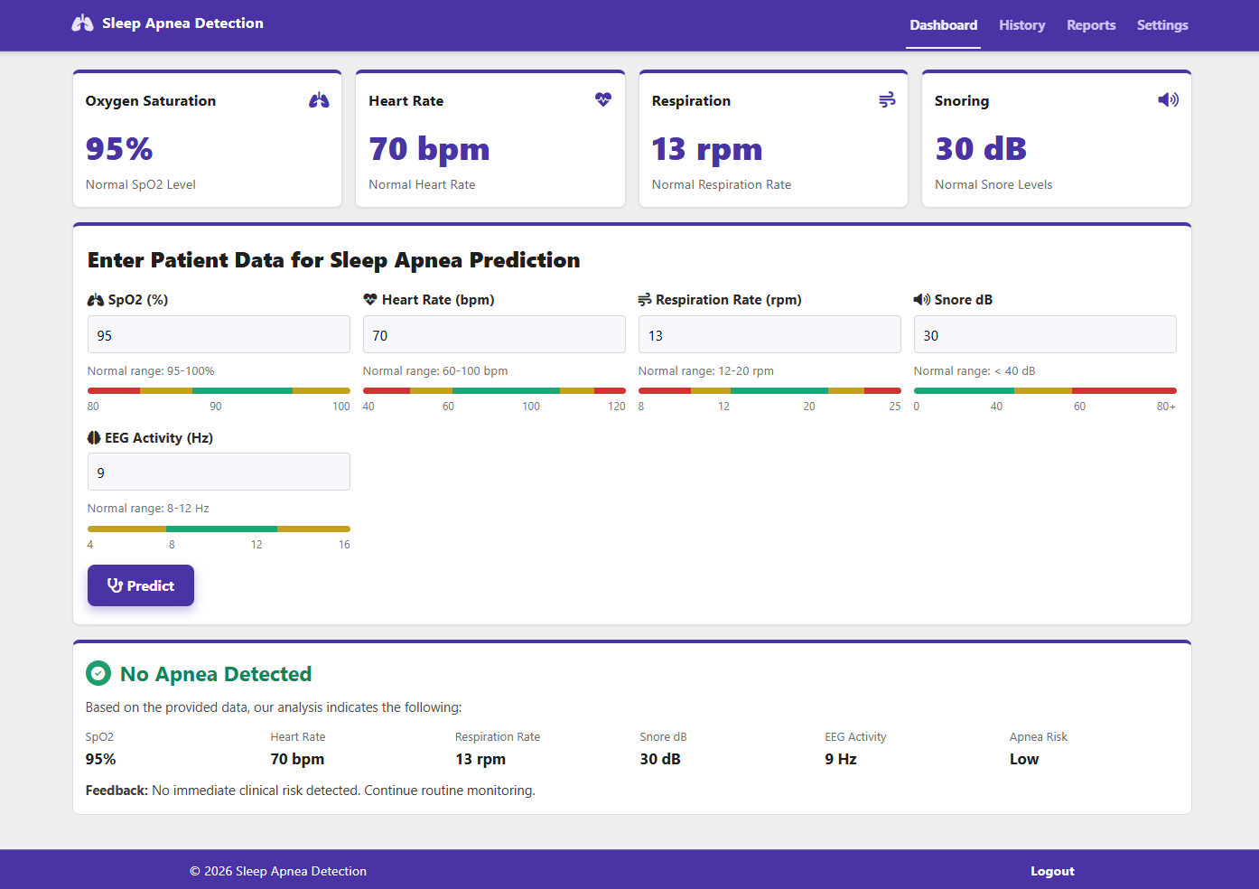
The workflow begins with the real-time collection of physiological data from the user using sensors. This raw data is first passed through a preprocessing pipeline where it is cleaned, normalized, and segmented into fixed time windows. The preprocessed data is then input into a trained CNN model, which analyzes the patterns and classifies the data as either apnea or normal. Based on the number of apnea events detected over time, the system calculates the Apnea-Hypopnea Index (AHI) to assess the severity of the condition. Finally, results are displayed on a user-friendly dashboard, allowing users to track their sleep health

RESULTS
The sleep apnea detection system demonstrated effective performance in identifying apnea episodes based on multi-sensor physiological inputs, including SpO₂, heart rate, and respiration rate. Through CNN-based classification, the model was able to analyze temporal- spatial patterns within the data and accurately differentiate between normal and apnea events.
Validation on labeled datasets showed reliable classification accuracy, and the integrated Apnea-Hypopnea Index (AHI) calculation further enhanced the clinical value of the system. The real-time feedback through the user dashboard allowed for instant health insights, validating the end-to-end functionality of the system from data collection to diagnosis.
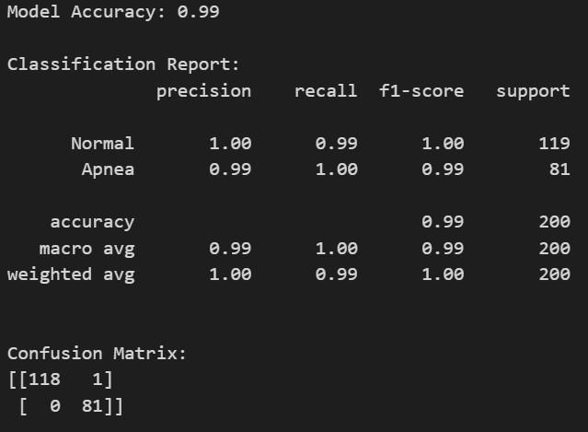
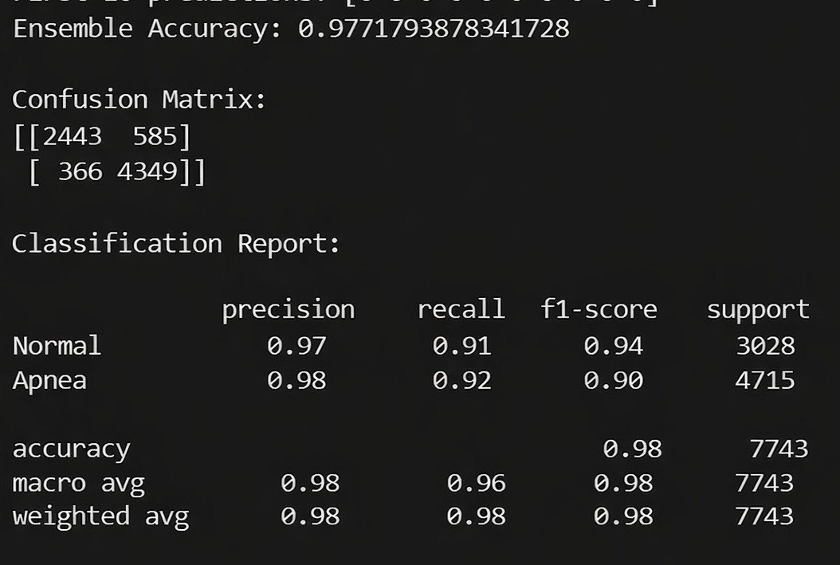
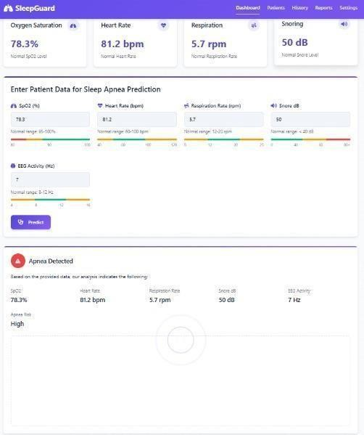
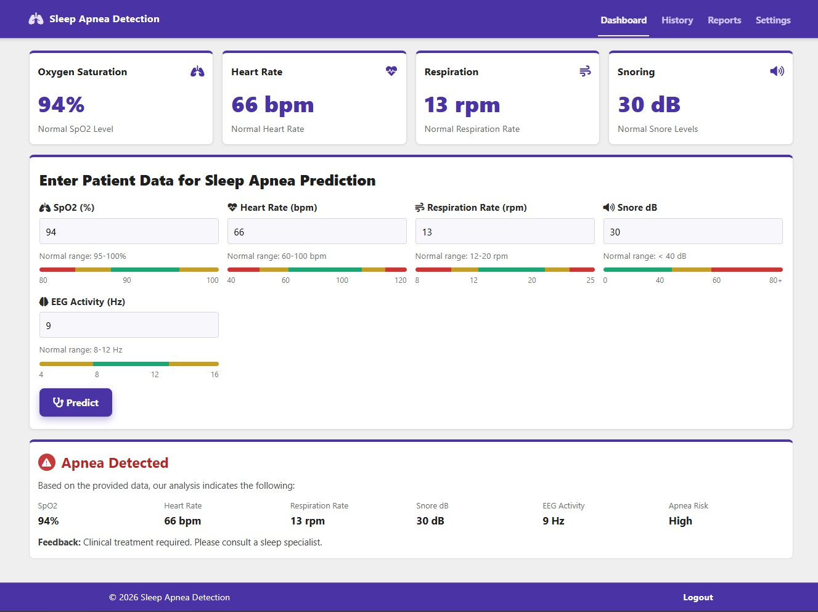
Fig 3: Classification Report

CONCLUSION
This project successfully bridges the gap between medical diagnostics and accessible AI-based tools. By combining sensor data, deep learning techniques, and an intuitive user interface, the system offers a non-invasive and automated solution for early detection of sleep apnea. The CNN model, backed by a structured preprocessing and training pipeline, proved effective in identifying apnea events without the need for manual intervention. The deployment framework ensures user-friendly interaction, making it suitable for both clinical and home use. Overall, the system proves that with the right integration of hardware and AI, cost-effective and scalable health solutions can be realized.

FUTURE SCOPE
To improve the system’s diagnostic accuracy and broaden its applicability, future enhancements could include integrating additional physiological inputs such as EEG signals and snore intensity data. These added features would provide a more comprehensive understanding of sleep patterns and breathing irregularities. Moreover, expanding the dataset with data from diverse age groups, genders, and health conditions will enhance the model’s generalizability and robustness across various populations.
Additionally, the system can be extended for continuous monitoring using wearable devices and mobile app integration, enabling users to track sleep health over time with minimal effort. Incorporating advanced AI techniques such as transfer learning or hybrid deep learning models could further boost classification performance. The addition of a medical professional dashboard or telehealth connectivity would allow healthcare providers to remotely assess patients, making the system a scalable and practical solution for real-world clinical deployment.Also we can add the database facilities for the user data storage for future checkings.

REFERENCES

- R. Shah, D. Gaur and G. Premalatha, "Machine Learning Based Sleep Apnea Detection Using EEG Signals," 2024 IEEE International Conference on Smart Power Control and Renewable Energy (ICSPCRE), Rourkela, India, 2024, pp. 1-5, doi: 10.1109/ICSPCRE62303.2024.10674811.
- J. You, J. Li, R. Yao, J. Gao, J. Wu and J. Ye, "Non invasive detection of diabetes in obstructive sleep apnea based on overnight SpO2 signal and deep learning," 2024 46th Annual International Conference of the IEEE Engineering in Medicine and Biology Society (EMBC), Orlando, FL, USA, 2024, pp. 1-4, doi: 10.1109/EMBC53108.2024.10782287.
- S. Dong, B. Wang, C. Gu and Y. Guo, "Accurate Noncontact Sleep Apnea-Hypopnea Detection using a K- band Biomedical Radar," 2024 15th Global Symposium on Millimeter-Waves & Terahertz (GSMM), Hong Kong, 2024, pp. 148-150, doi: 10.1109/GSMM61775.2024.10552975
- S. Dong, L. Wen, Y. Ye, J. Zhang, C. Gu and J. Mao, "Noncontact Sleep Apnea-hypopnea Events Detection Using a K-band Biomedical Radar," 2024 IEE MTT-S
International Wireless Symposium (IWS), Beijing, China, 2024, pp. 1-3, doi: 10.1109/IWS61525.2024.10713614.
- F. Massie, S. Vits, A. Khachatryan, B. Van Pee, J. Verbraecken and J. Bergmann, "Central Sleep Apnea Detection by Means of Finger Photoplethysmography," in IEEE Journal of Translational Engineering in Health and Medicine, vol. 11, pp. 126-136, 2023, doi: 10.1109/JTEHM.2023.3236393.
- S. A. Sumona and W. B. N. Aurthy, "A Novel Low-Cost Monitoring System for Sleep Apnea Patients," 2023 International Conference on Electrical, Computer and Communication Engineering (ECCE), Chittagong, Bangladesh, 2023, pp. 1-6, doi: 10.1109/ECCE57851.2023.10101614.
- X. -X. Lin, P. Lin, E. -H. Yeh, G. -R. Liu, W. -C. Lien
and Y. Fang, "RAPIDEST: A Framework for Obstructive Sleep Apnea Detection," in IEEE Transactions on Neural Systems and Rehabilitation Engineering, vol. 31, pp. 387-397, 2023, doi: 10.1109/TNSRE.2022.3224474.
- P. Sharma, A. Jalali, M. Majmudar, K. S. Rajput and N. Selvaraj, "Deep-Learning based Sleep Apnea Detection using SpO2 and Pulse Rate," 2022 44th Annual International Conference of the IEEE Engineering in Medicine & Biology Society (EMBC), Glasgow, Scotland, United Kingdom, 2022, pp. 2611-2614, doi: 10.1109/EMBC48229.2022.9871295
- T. Koda, S. Okumura, H. Taki, S. Hamada,
H. Sunadome, S. Sato, K. Chin and T. Sakamoto, "Noncontact Detection of Sleep Apnea Using Radar and Expectation-Maximization Algorithm," arXiv, Nov 2023.
researchgate.net+15arxiv.org+15mdpi.com+15
- W. Wang, R. Song, Y. Wu, L. Zheng, W. Zhang,
Z. Chen, G. Li and Z. Xu, "Deep Learning-based Automated Diagnosis of Obstructive Sleep Apnea and Sleep Stage Classification in Children Using Millimeter-wave Radar and Pulse Oximeter," arXiv, Sep 2024. arxiv.org+2arxiv.org+2arxiv.org+2
- F. W. Wang, Z. Chen, W. Zhang, Z. Wang, X. Zhao,
C. Li, J. Guan, S. Yin and G. Li, "Fusion of Millimeter-wave Radar and Pulse Oximeter Data for Low-burden Diagnosis of Obstructive Sleep Apnea-Hypopnea Syndrome," arXiv, Jan 2025. arxiv.org
- W. Wang, C. Li, Z. Chen, W. Zhang, Z. Wang, X. Guo,
J. Guan and G. Li, "Detection of Sleep Apnea-Hypopnea Events Using Millimeter-wave Radar and Pulse Oximeter," arXiv, Sep 2024. mdpi.com+5arxiv.org+5arxiv.org+5
- Y.-X. Wang, Z. Xiao, S. Fang, W. Li, J. Wang and
X. Zhao, "Bi-directional Long Short-Term Memory for Automatic Detection of Sleep Apnea Events Based on Single-Channel EEG Signal," Computers in Biology and Medicine, vol. 142, p. 105211, 2022.
ouci.dntb.gov.ua+1researchgate.net+1
- X. Zhao, X. Wang, T. Yang, S. Ji, H. Wang, J. Wang,
Y. Wang and Q. Wu, "Classification of Sleep Apnea Based on EEG Sub-Band Signal Characteristics," Scientific Reports, vol. 11, no. 1, p. 5824, 2021.
ouci.dntb.gov.ua+1pubmed.ncbi.nlm.nih.gov+1

