Gamification in Soft Skills Training: An Innovative Approach to Experiential Learning

ABSTRACT
In a professional world marked by rapid transformations, behavioral competencies, commonly referred to as soft skills, have become essential for employability, adaptability, and sustainable professional integration. However, their development remains a major pedagogical challenge, particularly in training contexts where traditional transmissive approaches continue to dominate and often limit learner engagement. This article examines gamification as an innovative pedagogical strategy for strengthening soft skills through active, experiential, and collaborative learning. Drawing on Self-Determination Theory (Deci & Ryan, 2000), Flow Theory (Csikszentmihalyi, 1990), Experiential Learning Theory (Kolb, 1984), and Engagement Theory (Kearsley & Shneiderman, 1998), the study analyzes how game-based mechanisms can foster intrinsic motivation, active participation, peer interaction, and the concrete mobilization of behavioral competencies. The article combines an in-depth literature review with an exploratory case study conducted in a Moroccan vocational training center. The case involved 50 adult participants over a five-day, 20-hour training program entitled Mission Soft Skills, structured around role plays, collaborative challenges, team scoring, badges, and reflective debriefing. Data were collected through participant observation, daily reflective journals, and a final questionnaire. The results indicate high levels of engagement and positive self-reported outcomes: 92% of participants reported improved oral communication, 84% reported better stress management in group situations, and 96% felt they had learned through action. The study concludes that gamification can effectively support the development of soft skills when it is embedded in a coherent pedagogical design and adapted to the local training context, even with limited technological resources.
KEYWORDS
Gamification; Soft skills; Experiential learning; Active pedagogy; Vocational training.
INTRODUCTION
In a socio-professional context marked by rapid transformations, behavioral competencies, commonly referred to as soft skills, now occupy a central place in employability processes and professional adaptability. Nevertheless, their development remains a major pedagogical challenge, particularly in training systems where traditional transmissive approaches remain dominant and are not always conducive to learners' active engagement.
At the same time, gamification is gradually emerging as an innovative pedagogical strategy that mobilizes game-based mechanisms such as challenges, progression, immediate feedback, and collaboration in order to strengthen intrinsic motivation, engagement, and experiential learning. Beyond its playful dimension, gamification can be understood as a pedagogical and communicational mediation device that fosters meaningful social interactions and active learning.
Although the international literature highlights the positive effects of gamification in various educational contexts, research on its application in vocational training environments and in contexts with limited resources remains relatively underdeveloped. Moreover, the concrete pedagogical mechanisms connecting gamification, learner engagement, and the development of soft skills still require contextualized empirical analysis.
This article seeks to address these gaps by offering three main contributions. First, it analyzes gamification as a pedagogical mediation device that supports the development of behavioral competencies in a vocational training context. Second, it presents a contextualized empirical case study conducted in a Moroccan training center in order to illustrate the engagement and learning mechanisms activated by a gamified training program. Third, it proposes an interpretation of the observed effects through the articulation of theoretical frameworks drawn from motivational psychology, experiential pedagogy, and communication sciences.
The objective of this research is therefore to analyze the extent to which the integration of a gamified pedagogical device can contribute to the development of soft skills, particularly interpersonal communication, collaboration, and stress management, in a vocational training context.
In order to achieve this objective, the study is structured around the following research questions:
- How does the integration of gamification mechanisms influence learners' engagement in a soft skills training program?
- To what extent does this type of device promote the mobilization and development of behavioral competencies?
- Which pedagogical and interactional mechanisms help explain the observed effects?
THEORETICAL FRAMEWORKS AND CONVERGENCE WITH ACTIVE PEDAGOGY
Gamification is part of a constructivist and experiential approach to learning that promotes autonomy, active participation, and motivation. It is based on several major theoretical foundations:
- Self-Determination Theory (Deci & Ryan, 2000), which emphasizes the importance of intrinsic motivation supported by three fundamental needs: autonomy, competence, and social relatedness.
- Flow Theory (Csikszentmihalyi, 1990), according to which the balance between challenge and competence fosters an optimal state of immersion.
- The Experiential Learning Cycle (Kolb, 1984), which values learning through action, reflection, and conceptualization.
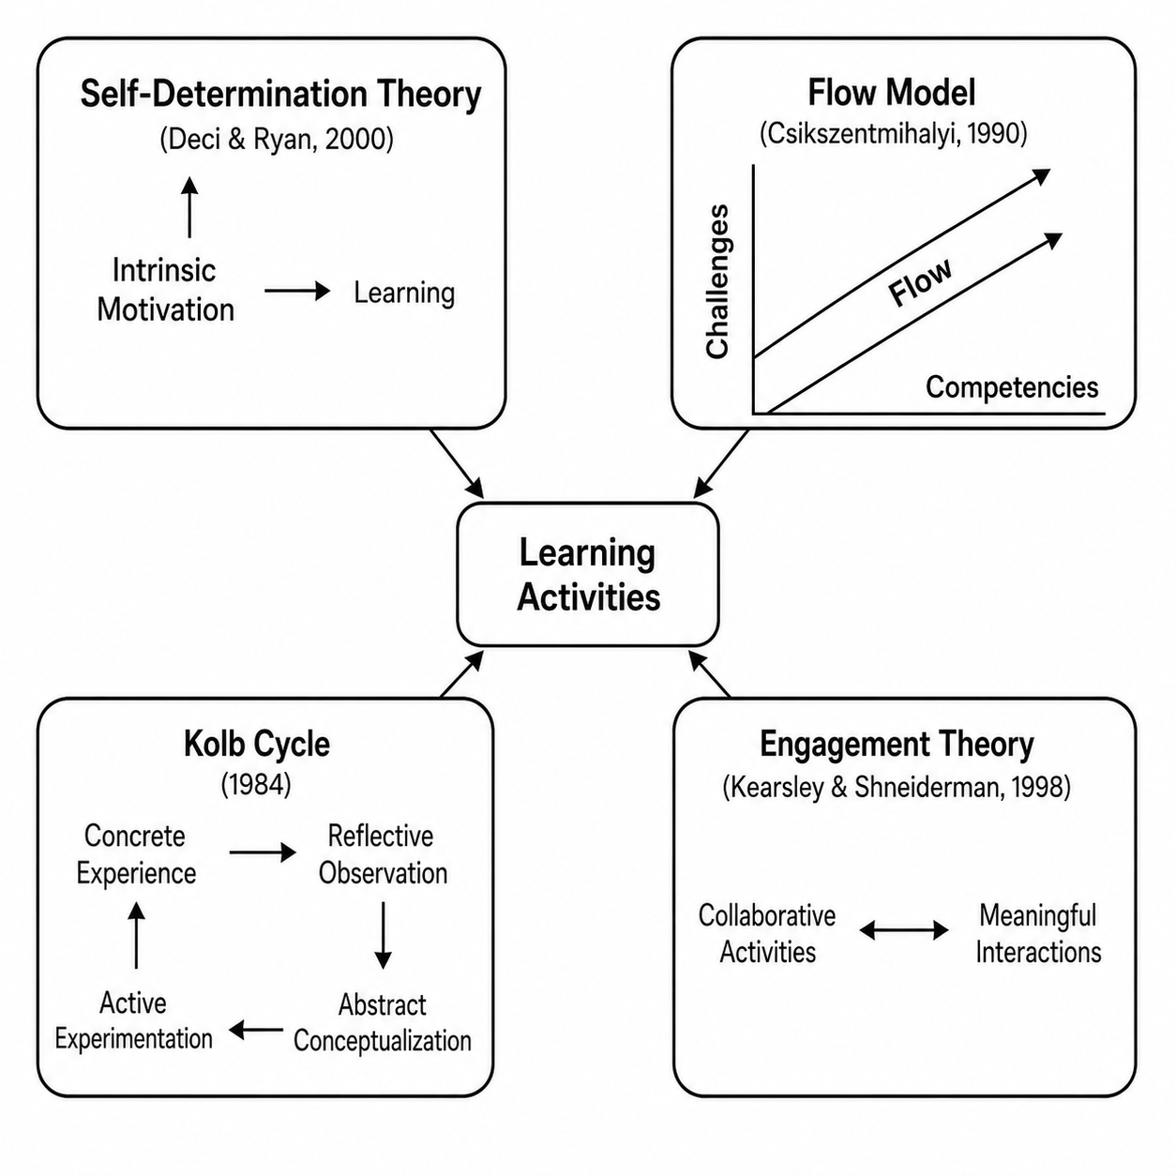
- Engagement Theory (Kearsley & Shneiderman, 1998), which associates social interaction and emotional investment with high-quality learning.

Figure 1. Theoretical foundations of gamification in active pedagogy
The figure above illustrates the convergence of the four fundamental theoretical frameworks underlying the integration of gamification into active pedagogy, particularly in soft skills training.
SOFT SKILLS AND DEVELOPMENT MODELS
Soft skills, defined as non-technical competencies related to communication, collaboration, emotional intelligence, and problem solving, are essential for successfully navigating complex professional environments. Robles (2012) describes them as a set of interpersonal behaviors, personal qualities, and social abilities that enable individuals to work effectively with others.
The Big Five personality model (McCrae & Costa, 1999) provides a useful framework for understanding behavioral predispositions that influence soft skills. For example:
- Openness to experience supports creativity and adaptability.
- Conscientiousness promotes rigor and time management.
- Extraversion encourages communication and leadership.
- Agreeableness facilitates teamwork.
- Low neuroticism helps individuals manage stress more effectively.
These five dimensions of the Big Five personality model - openness, conscientiousness, extraversion, agreeableness, and neuroticism - influence individual predispositions to soft skills development. By understanding these traits, trainers can better adapt their pedagogical strategies to strengthen competencies such as communication, collaboration, and stress management.
GAMIFICATION METHODS AND TOOLS APPLIED TO ACTIVE PEDAGOGY
Gamified pedagogical methods
Gamification applied to training relies on a variety of pedagogical methods that foster learners' cognitive and emotional engagement. In connection with active pedagogy, it mobilizes interactive and collaborative mechanisms that help anchor learning over time.
Method | Description | Link with active pedagogy
Serious games | Games designed for educational purposes, combining narrative elements and pedagogical objectives. | Promote the resolution of complex problems.
Pedagogical escape games | Team-based activities with time constraints and puzzles to solve. | Stimulate cooperation, communication, and autonomy.
Simulations and role plays | Professional or social situations enacted by learners. | Develop soft skills in realistic contexts.
Learning quests | Learning pathways structured as quests and levels to unlock. | Encourage perseverance and intrinsic motivation.
Table 1. Gamified pedagogical methods and their relationship with active pedagogy
The value of these methods lies in their ability to place learners at the center of the action. Through role plays, escape games, and scenario-based learning pathways, learners are no longer passive receivers of content; they become active participants in their own skill development. This immersion encourages experimentation, emotional engagement, and authentic learning situations in which soft skills are naturally mobilized. What is particularly significant is that these methods do not necessarily require sophisticated technical resources. With a well-designed scenario, a scoring sheet, and the intention to involve learners, pedagogical change can already become visible. In local contexts, this type of approach is especially relevant because it stimulates participation even among learners who are not accustomed to expressing themselves openly.
Digital gamification tools
- Kahoot, Quizizz, and Wooclap: for playful and instant formative assessment.
- Classcraft: transforms the classroom experience into a narrative universe with missions and teams.
- Genially: enables the creation of interactive content such as digital escape games.
- Badgecraft and Open Badge Passport: support the recognition and traceability of acquired competencies through digital badges.
Digital gamification tools extend these dynamics by offering interactive, stimulating, and easy-to-use supports. Platforms such as Kahoot or Genially can transform a simple review activity into a playful, competitive, and collaborative learning moment. Classcraft, with its narrative universe, and digital badges such as those offered by Open Badge Passport add a dimension of visible recognition and progression, which motivates learners to become more involved. However, it is essential to recall that the tool is only a means. The pedagogical intention behind its use is what makes the difference. Misused, a digital quiz can remain a gadget; properly integrated, it becomes a powerful lever for active learning and the valorization of competencies. This underlines the importance of coherent pedagogical design aligned with educational objectives.
Deterding et al. (2011) emphasize that the effectiveness of such tools depends on the intentional design of game mechanics, and not merely on their technical presence.
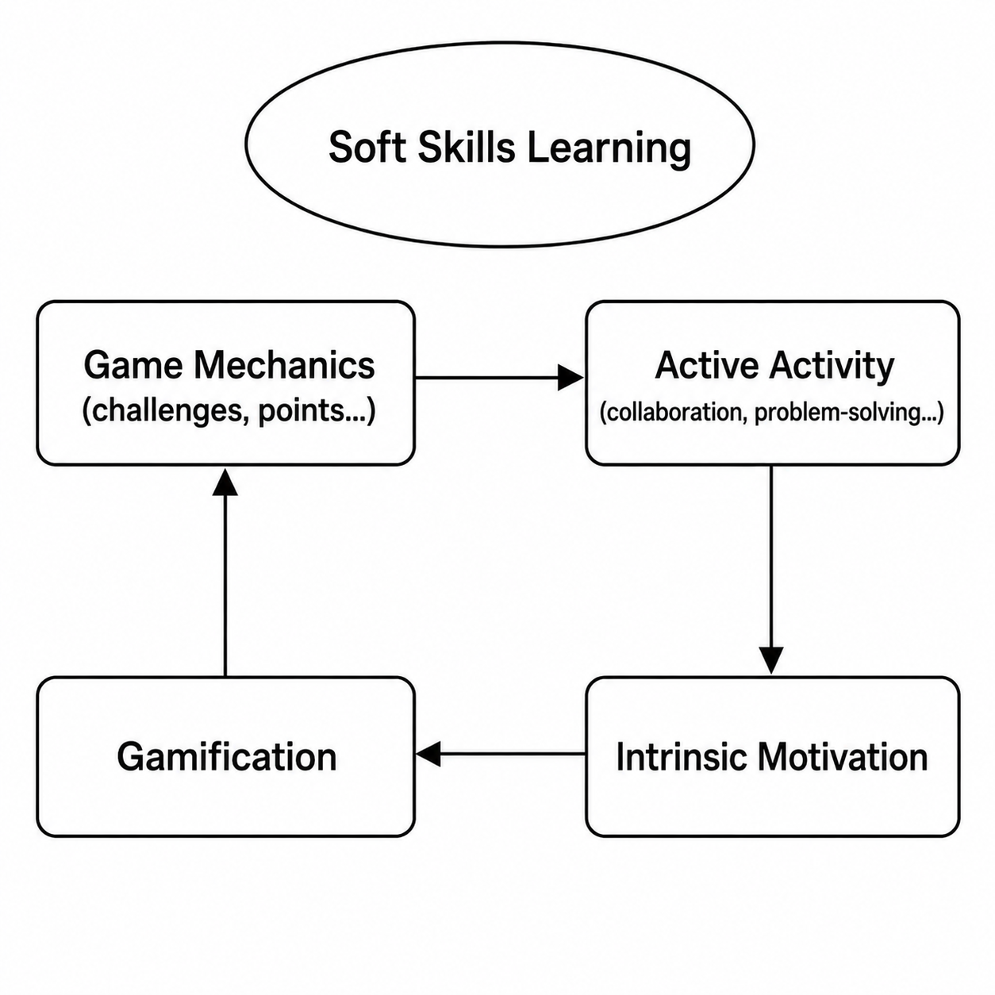
SYNERGY BETWEEN GAMIFICATION AND ACTIVE PEDAGOGY IN SOFT SKILLS LEARNING

Figure 2. Synergy between gamification and active pedagogy in soft skills learning
The synergy between gamification and active pedagogy is based on a dynamic sequence in which each component reinforces the other. Game mechanics such as challenges, point systems, or immediate feedback help structure engaging pedagogical activities based on collaboration, problem solving, and action. These active learning activities stimulate learners' intrinsic motivation by responding to their needs for autonomy, progression, and social interaction.
This strengthened motivation creates an environment conducive to engagement, promoting deeper and more sustainable learning. In this framework, gamification is not limited to making learning fun. It becomes a strategic lever for developing soft skills through immersive, interactive, and meaningful training experiences.
EMPIRICAL STUDIES AND STATE OF THE ART
In recent years, gamification has attracted increasing attention from educational researchers, particularly because of its potential to strengthen soft skills learning. Numerous studies have been conducted internationally and in the Arab world, providing concrete evidence of its effects in training environments.
At the international level
- Cucchi et al. (2023): this study analyzes the integration of game mechanics into hybrid courses. It shows that this strategy contributes to the development of critical thinking and emotional intelligence among students, two essential dimensions for success in complex professional contexts.
- Marcos-Pablos et al. (2021): this Spanish research, conducted among management students, evaluated the impact of pedagogical escape games. The results are highly encouraging: participants demonstrated notable improvement in communication, leadership, and stress management skills. The authors emphasize the immersive and motivating effect of these devices.
- Subhash and Cudney (2018): this literature review of 46 international studies shows that the introduction of playful elements into training pathways significantly improves learners' motivation, their ability to collaborate, and their effectiveness in problem solving. Digital tools such as Kahoot, Quizizz, and digital badges proved particularly effective in higher education contexts.
- Landers and Armstrong (2017): in their empirical study, the authors demonstrate that gamified learning environments increase perseverance and cognitive engagement. These effects are strengthened when the proposed activities are close to real-life situations and structured with clear mechanics.
In the Arab world
- Alabbasi (2021 - Saudi Arabia): the author studied the use of Quizizz and ClassPoint in university classes. The study revealed a clear improvement in student participation, better oral expression, and increased ability to work in groups.
- Ben Messaoud and Ben Rejeb (2020 - Tunisia): this research focused on the integration of gamified activities into a project management module. The results show positive development in interpersonal communication, conflict management, and collective decision-making, all of which are essential skills for teamwork.
In Morocco
- University study (2023): conducted at a Moroccan university, this study evaluated the impact of Kahoot on English language learning. The results indicate increased motivation, greater autonomy, and improved stress management, in addition to better academic outcomes.
- Bensalah and Rachidi (2022): in a communication training program for OFPPT trainees, the authors introduced gamified role plays. Participants significantly strengthened their public speaking, active listening, and cooperation skills. Immediate feedback played a central role in learning effectiveness.
- Pilot project (engineering school - Rabat, 2021): this project combined digital badges, team challenges, and self-assessments through Moodle. Internal results showed improved self-regulation, greater teamwork capacity, and more frequent initiative-taking among students.
DISCUSSION OF THE RESULTS
The analysis of the available studies shows that gamification is not limited to a simple playful dimension, but constitutes an effective pedagogical lever for the development of soft skills in various educational contexts. Tools such as Kahoot, Quizizz, role plays, and escape games promote motivation, engagement, and active participation, which are favorable conditions for acquiring competencies such as communication, cooperation, and stress management.
These effects are also observable in the Arab world and particularly in Morocco, where local initiatives, even with limited resources, have demonstrated the effectiveness of gamification. However, to maximize its impact, gamified devices must be designed rigorously, aligned with pedagogical objectives, and supported by structured feedback.
CASE STUDY: A GAMIFICATION DEVICE APPLIED TO SOFT SKILLS DEVELOPMENT IN A TRAINING CENTER IN MOROCCO
Context and objectives
This case study was conducted in November 2024 in a vocational training center in Khouribga, Morocco, as part of an employability support program developed through a partnership between a Moroccan public organization and a socio-professional integration association.
The intervention focused on the development of three key behavioral competencies: interpersonal communication, teamwork collaboration, and stress management. The general objective was to analyze the impact of integrating gamification into an active training pathway on learners' engagement, intrinsic motivation, and ability to mobilize behavioral competencies in practice.
Methodology
The study adopts an exploratory qualitative approach based on an instrumental case study (Stake, 1995), aimed at analyzing in depth the pedagogical and interactional mechanisms activated in a gamified training device.
The sample consisted of 50 participants, including 26 women and 24 men, aged between 20 and 35 years, enrolled in a transversal skills development program in a Moroccan vocational training center. Participant profiles were heterogeneous and included job seekers, young graduates, and individuals undergoing professional retraining.
The pedagogical device took place over five consecutive days, representing 20 hours of training structured around collaborative gamified activities and reflective debriefing phases.
In order to understand the development of soft skills, several sources of data were mobilized within a methodological triangulation logic:
- Participant observation of interactions and group dynamics;
- A daily reflective journal completed by the learners;
- A final training questionnaire combining closed and open-ended questions on perceptions of learning, engagement, and competency mobilization.
This triangulation strengthens the interpretive validity of the results by crossing participants' perceptions with pedagogical observations.
Description of the gamified device
The pathway entitled Mission Soft Skills combined structured game mechanics with contextualized pedagogical situations:
- Scenario-based role plays simulating professional situations such as conflict resolution, negotiation, and group leadership;
- Timed challenges inspired by simplified escape games, mobilizing active listening, stress management, and cooperation;
- A team scoring system, with the attribution of digital badges through the Badgecraft platform;
- An evolving leaderboard updated daily to stimulate motivation.
Teams were reshuffled every day in order to encourage social agility and the development of transversal competencies.

Results
Engagement and participation
- 98% of participants attended all training sessions.
- The level of active involvement observed during the sessions, including oral participation, initiative-taking, and mutual assistance, was significantly higher than that observed in conventional training sessions at the same center according to internal data.
Self-reported data (n = 50)
Indicator | Positive responses (%)
Better stress management in group situations | 84%
Improved oral communication | 92%
Feeling of having learned through action | 96%
Motivation strengthened by the playful dimension | 94%
Desire to experience this type of learning again | 100%
Table 2. Participants' self-reported outcomes after the gamified training program
DISCUSSION
The results confirm previous research highlighting the potential of gamification as a lever for engagement and active learning (Subhash & Cudney, 2018; Landers & Armstrong, 2017). The increased level of participation observed in the studied device appears to be linked in particular to the simultaneous mobilization of intrinsic motivational mechanisms, such as the perception of progression, immediate feedback, and peer collaboration.
These results can also be interpreted in light of Self-Determination Theory (Deci & Ryan, 2000), insofar as the device responds to the fundamental psychological needs of autonomy, competence, and social relatedness. The balance between the proposed challenges and participants' perceived abilities also promotes a state of engagement close to flow (Csikszentmihalyi, 1990).
In the Moroccan context studied, gamification appears particularly relevant because it makes it possible to overcome some of the limitations of traditional pedagogical approaches by encouraging the participation of learners who are usually less inclined to express themselves. This result is consistent with observations made in other educational contexts in the Global South, where active approaches contribute to strengthening self-confidence and participant involvement.
However, several limitations must be emphasized. The measurement of behavioral competencies is based mainly on self-reported data and pedagogical observations, which may introduce perception bias. In addition, the absence of longitudinal measurement does not make it possible to assess the durability of the competencies developed over time. Finally, the sample size and the contextual nature of the study limit the generalizability of the findings.
Despite these limitations, the study provides relevant empirical insights that help clarify the mechanisms through which gamification can contribute to the development of soft skills in vocational training programs.
GENERAL CONCLUSION AND RESEARCH PERSPECTIVES
This research highlights the potential of gamification as a pedagogical mediation device that promotes engagement, active participation, and the development of behavioral competencies. It emphasizes that the effectiveness of a gamified approach depends more on the quality of pedagogical design and the coherence of the proposed interactions than on the technological sophistication of the tools used.
Future research could focus on the use of standardized soft skills assessment tools, the longitudinal analysis of the effects of gamified devices, and comparisons between different sociocultural contexts.
ETHICAL APPROVAL
This study involved adult participants in a vocational training context. Participation was voluntary, and participants were informed about the educational and research purposes of the study. No personally identifiable information was collected. The study respected the principles of confidentiality, informed consent, and respect for participants.
CONFLICT OF INTEREST
The author declares no conflict of interest.
DATA AVAILABILITY
The data supporting the findings of this study are not publicly available due to confidentiality and privacy considerations related to the participants.
REFERENCES
1. Alabbasi, D. (2021). The impact of gamified tools in Saudi university education. International Journal of Instruction, 14(2), 233-250.
2. Ben Messaoud, R., & Ben Rejeb, M. (2020). L’impact des jeux sérieux dans l’enseignement supérieur en Tunisie. Revue Maghrébine de Management et d’Innovation, 5(1), 67-85.
3. Bensalah, H., & Rachidi, M. (2022). L’intégration des jeux de rôle dans les formations OFPPT : étude de cas. Revue des Pratiques Pédagogiques au Maroc, 9(1), 45-58.
4. Csikszentmihalyi, M. (1990). Flow: The Psychology of Optimal Experience. Harper & Row.
5. Cucchi, M., Ramos, D., & Vallejo, C. (2023). Game elements and critical thinking in hybrid learning. Educational Technology Research, 51(4), 102-121.
6. Deci, E. L., & Ryan, R. M. (2000). The "what" and "why" of goal pursuits: Human needs and the self-determination of behavior. Psychological Inquiry, 11(4), 227-268.
7. Deterding, S., Dixon, D., Khaled, R., & Nacke, L. (2011). From game design elements to gamefulness: Defining "gamification". Proceedings of the 15th International Academic MindTrek Conference, 9-15.
8. Kearsley, G., & Shneiderman, B. (1998). Engagement theory: A framework for technology-based teaching and learning. Educational Technology, 38(5), 20-23.
9. Kolb, D. A. (1984). Experiential Learning: Experience as the Source of Learning and Development. Prentice Hall.
10. Landers, R. N., & Armstrong, M. B. (2017). Enhancing instructional outcomes with gamification: An empirical test. Journal of Educational Psychology, 109(4), 611-621.
11. Marcos-Pablos, S., García-Peñalvo, F. J., & Conde, M. Á. (2021). Evaluating escape rooms as educational tools: Effects on soft skills. Computers in Human Behavior Reports, 3, 100075.
12. McCrae, R. R., & Costa, P. T. (1999). A Five-Factor Theory of personality. In L. A. Pervin & O. P. John (Eds.), Handbook of Personality: Theory and Research (pp. 139-153). Guilford Press.
13. Robles, M. M. (2012). Executive perceptions of the top 10 soft skills needed in today’s workplace. Business Communication Quarterly, 75(4), 453-465.
14. Stake, R. E. (1995). The Art of Case Study Research. SAGE Publications.
15. Subhash, S., & Cudney, E. A. (2018). Gamified learning in higher education: A systematic review. Computers in Human Behavior, 87, 192-206.

