Solar Powered Automatic Grass Cutting System
Indirani S¹, N.Aritharan¹, S.Srikanth¹, S.Prasanth¹
Department of Electronics and Instrumentation Engineering,
SRM Institute of Science and Technology, Kattankulathur, Chennai, INDIA

ABSTRACT
Grass cutting and lawn maintenance are important activities in residential areas, agricultural fields, and institutional campuses. Traditional grass cutting machines are usually operated manually or powered by fuel-based engines. These conventional machines increase operational costs and contribute to environmental problems such as noise pollution and fuel consumption. To address these challenges, this project proposes a Solar Powered Grass Cutting System that utilizes solar energy for efficient and sustainable operation. The system consists of solar panels, a rechargeable battery, a DC motor, and a cutting blade mechanism. This configuration enables the machine to perform automatic or semi-automatic grass cutting with minimal human involvement. By using solar energy as the primary power source, the system reduces dependence on fossil fuels and lowers operating costs while promoting environmentally friendly practices. The proposed solution is energy-efficient, safe, and suitable for applications such as lawn maintenance, gardens, parks, and agricultural fields.The implementation of this project demonstrates that integrating solar power with automated grass cutting technology can provide a sustainable and eco-friendly alternative to conventional grass cutting machines.
Keywords: ESP32, Solar energy, Automatic grass cutter, Renewable energy, DC motor,
Lawn maintenance, Eco-friendly technology, Automation

I.INTRODUCTION
Grass cutting and lawn maintenance are essential activities in residential areas, public parks, institutional campuses, and agricultural fields. Conventional grass cutting machines are typically operated manually or powered by petrol engines, which lead to high operational costs, increased human effort, noise pollution, and harmful environmental emissions. As the demand for sustainable and eco-friendly technologies increases, the use of renewable energy sources such as solar energy has become an effective alternative for powering small mechanical systems. Solar photovoltaic (PV) panels convert sunlight into electrical energy, which can be stored in rechargeable batteries and used to operate electrical devices such as DC motors. Integrating solar energy into grass cutting machines reduces dependency on fossil fuels and promotes environmentally friendly lawn maintenance. In addition to renewable energy integration, recent advancements in the Internet of Things (IoT) have enabled the development of intelligent and automated systems through the use of sensors, microcontrollers, and wireless communication technologies. IoT technology allows devices to collect data, communicate over the internet, and provide real-time monitoring and remote control through cloud platforms or mobile applications. By incorporating IoT technology into solar-powered grass cutting systems, operational parameters such as battery status, motor performance, and obstacle detection can be monitored remotely, improving system efficiency, safety, and automation. Therefore, the proposed IoT-Based Solar Powered Automatic Grass Cutting System integrates solar energy with smart sensing and IoT connectivity to provide an eco-friendly, cost-effective, and intelligent solution for lawn maintenance while reducing human effort and environmental impact.

II.LITERATURE REVIEW
The development of grass cutting machines has evolved significantly with the advancement of renewable energy technologies and automation systems. Early studies mainly focused on replacing conventional petrol-powered lawn mowers with electrically driven machines in order to reduce fuel consumption, operational cost, and environmental pollution. Researchers proposed solar-powered grass cutting systems that utilize photovoltaic panels, rechargeable batteries, and DC motors to perform grass cutting operations efficiently [1]–[3]. These systems demonstrated that renewable solar energy can be effectively used to power small-scale outdoor machines.
Further improvements in solar-powered grass cutting technologies focused on optimizing the mechanical design and improving the energy efficiency of the system. Several studies introduced lightweight structures, improved blade mechanisms, and efficient motor configurations to enhance cutting performance while minimizing energy consumption [4]–[6]. Semi-automatic solar grass cutting systems were also developed to reduce manual effort while maintaining cost-effectiveness and simplicity in design.
With the advancement of embedded systems, automation features were incorporated into grass cutting machines using microcontrollers and sensor technologies. Obstacle detection mechanisms using ultrasonic sensors were introduced to improve operational safety and prevent collisions during operation [7]–[9]. Motor driver circuits were also implemented to regulate motor speed and control the cutting mechanism more efficiently.
Recent developments in smart technologies have enabled the integration of Internet of Things (IoT) into lawn maintenance systems. IoT-based systems allow real-time monitoring of system parameters such as battery voltage, motor status, and environmental conditions through cloud-based platforms [10]–[13]. These systems enable remote monitoring and control through mobile applications, improving operational efficiency and user convenience.
In addition, researchers have explored autonomous robotic lawn mowers equipped with navigation systems, GPS modules, and advanced sensors for fully automated grass cutting operations [14]–[17]. These intelligent systems can navigate through lawns independently while avoiding obstacles and optimizing cutting paths.
Despite these advancements, many existing systems focus either on solar energy utilization or IoT-based monitoring independently rather than combining both technologies effectively. Some systems also involve complex hardware configurations, which increase system cost and limit practical implementation [18]–[20]. Therefore, integrating solar energy with IoT-based monitoring and automation in a compact and cost-effective design remains an important research area.
The proposed Solar Powered Automatic Grass Cutting System addresses this research gap by combining photovoltaic energy generation, sensor-based automation, microcontroller-based control, and IoT-enabled remote monitoring to create an environmentally friendly and intelligent lawn maintenance solution.

III.PROPOSED SYSTEM

A. System Architecture
The system architecture of the IoT-based Solar Powered Automatic Grass Cutting System consists of several main components that work together to perform the grass cutting operation efficiently. The system uses a solar panel to convert sunlight into electrical energy, which is stored in a rechargeable battery through a charge controller. The stored energy is used to power the electronic components and the DC motor that drives the cutting blade. A microcontroller (ESP32/Arduino) acts as the main control unit that manages the operation of the system.
The system also includes sensors and IoT communication modules for smart monitoring and safety. An ultrasonic sensor detects obstacles in front of the machine and sends signals to the microcontroller to stop the motor if necessary. The microcontroller also connects to the internet through Wi-Fi, allowing the system to send data such as battery level, motor status, and sensor readings to a cloud platform or mobile application. This enables users to monitor the system remotely and improves the efficiency and safety of the grass cutting process.

B. Block Diagram Description
Figure.1 shows the block diagram of the solar powered grass cutting system. The block diagram of the IoT-based Solar Powered Automatic Grass Cutting System consists of several main components that work together to perform the grass cutting operation efficiently. The system begins with the solar panel, which converts sunlight into electrical energy. This energy is regulated by a charge controller and stored in a rechargeable battery to provide a stable power supply for the system.
The stored energy is supplied to the microcontroller unit (ESP32/Arduino), which acts as the central control unit of the system. The microcontroller receives input signals from the ultrasonic sensor, which is used to detect obstacles in front of the grass cutter. If an obstacle is detected within a certain distance, the microcontroller sends a signal to stop the motor, ensuring safe operation and preventing damage to the system.
The microcontroller also controls the motor driver circuit, which regulates the operation of the DC motor connected to the cutting blade. When the system is active and no obstacle is detected, the motor rotates the blade to cut the grass efficiently.For IoT functionality, the microcontroller connects to the internet through Wi-Fi communication and sends system data such as battery level, motor status, and sensor readings to a cloud platform or mobile application. This allows the user to remotely monitor the system and receive alerts if any abnormal condition occurs. The integration of solar energy, sensors, and IoT connectivity ensures efficient, safe, and intelligent grass cutting operations.

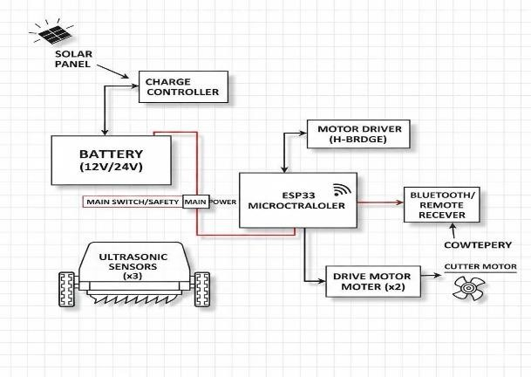
Figure 1: block diagram

IV. METHODOLOGY
The Solar Powered Grass Cutting System works in a simple manner: detect, notify, and prevent. The complete process is illustrated in Figure 2.
The process for the IoT-based solar powered automatic grass cutting system involves the design, integration, and testing of renewable energy, control, and sensing components. First, a solar photovoltaic panel is used to convert sunlight into electrical energy. The generated energy is stored in a rechargeable battery through a charge controller, which regulates the voltage and protects the battery from overcharging or deep discharge.
In the second stage, the stored electrical energy is supplied to a DC motor that drives the cutting blade. A microcontroller such as ESP32 or Arduino acts as the main control unit of the system. It processes input signals from sensors and controls the motor operation accordingly. An ultrasonic sensor is used to detect obstacles in front of the machine. When an obstacle is detected within a certain distance, the microcontroller automatically stops the motor to avoid collisions and ensure safe operation.
For IoT integration, the microcontroller connects to a wireless network and sends system data such as battery level, motor status, and sensor readings to a cloud platform. This allows the user to monitor the system remotely through a mobile application. Finally, the complete system is assembled on a chassis and tested under different conditions to evaluate its cutting performance, power consumption, and monitoring capability.
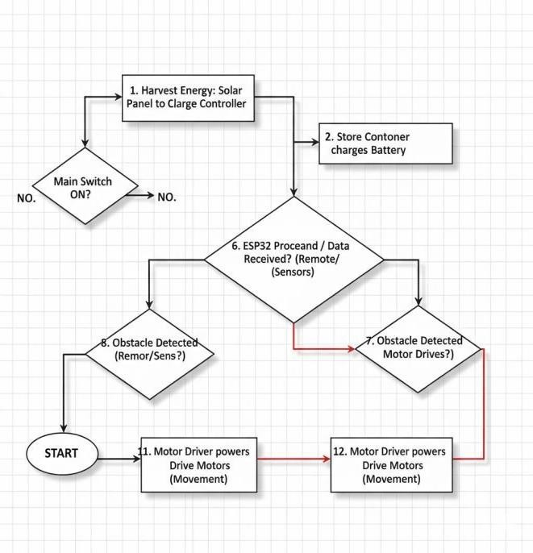
Figure 2: Flow chart

V.RESULTS AND DISCUSSION
The IoT-based solar powered automatic grass cutting system was successfully designed and tested under normal outdoor conditions. The solar panel was able to generate sufficient electrical energy under sunlight and charge the rechargeable battery effectively. The stored energy was used to power the DC motor that drives the cutting blade. During testing, the motor rotated at an adequate speed to cut grass smoothly on small lawn surfaces.
The ultrasonic sensor successfully detected obstacles placed in front of the system and stopped the motor to prevent collision or damage. The microcontroller processed the sensor inputs accurately and controlled the motor operation accordingly. The IoT module transmitted system parameters such as battery level, motor status, and sensor readings to the cloud platform, allowing the user to monitor the system through a mobile application.
The experimental results show that the system operates efficiently using renewable solar energy while providing smart monitoring through IoT connectivity. Compared with conventional petrol-powered grass cutters, the proposed system produces less noise, does not emit harmful gases, and requires lower operational cost. Overall, the integration of solar power and IoT technology improves automation, safety, and environmental sustainability in lawn maintenance applications.
.

VI.CONCLUSION
The proposed IoT-based solar powered automatic grass cutting system provides an efficient and eco-friendly solution for lawn maintenance. The system utilizes solar energy to power the grass cutting mechanism, reducing dependence on fossil fuels and minimizing environmental pollution. By integrating IoT technology, the system allows real-time monitoring and improved automation through sensors and wireless communication. The obstacle detection feature enhances safety and prevents damage to the machine. Overall, the system reduces human effort, operational cost, and energy consumption while promoting sustainable and smart agricultural practices. Future improvements can include advanced navigation and fully autonomous operation for larger areas.
.

VII.REFERENCES
[1] M. W. Jabbar, K. U. Khan and S. M. Khan, “Solar Powered Grass Cutter for Domestic Utilization,” Engineering Proceedings, vol. 12, no. 1, p. 105, 2022.
[2] R. Bharapate and K. Killedar, “Solar Powered Automatic Grass Cutter,” International Journal of Innovative Research in Science, Engineering and Technology (IJIRSET), vol. 13, no. 5, pp. 531–535, 2024.
[3] A. Pawar, R. More and A. Patil, “Semi-Automatic Solar Powered Grass Cutter,” International Journal for Research in Applied Science & Engineering Technology (IJRASET), vol. 10, no. 4, pp. 469–482, 2022.
[4] M. Ammar, A. Alvi, A. Lal and I. Khatri, “Solar Grass Cutter,” International Research Journal on Advanced Engineering Hub, vol. 3, no. 04, pp. 1416–1419, 2025.
[5] M. Kalpana, Y. Jyostna and P. Madhavi, “Development and Analysis of Solar-Powered Grass Cutter with Integrated Collector using IoT,” Engineering Proceedings, vol. 66, no. 1, p. 43, 2024.
[6] P. Pandey and S. Kumar, “Solar Powered Mobile Operated Grass Cutter,” International Journal for Research in Applied Science & Engineering Technology (IJRASET), vol. 13, pp. 683–692, 2025.
[7] M. Kumawat, R. Gupta and S. Bhardwaj, “Automatic Solar Grass Cutter with Fire Sensor and Obstacle Detector,” International Journal of Engineering Research & Technology (IJERT), vol. 12, no. 04, pp. 183–190, 2023.
[8] M. Anas Ali and S. A. Sattar, “Automated Solar-Powered Grass Trimmer,” Journal of Science & Technology, vol. 7, no. 1, pp. 129–135, 2022.
[9] P. K. M., N. B. K., P. S. A. and A. Hussian, “Solar Powered Smart Grass Cutter,” International Journal of Innovative Research in Electrical, Electronics, Instrumentation and Control Engineering (IJIREEICE), vol. 13, no. 8, pp. 25–30, 2025.
[10] S. Yadav and N. Sharma, “Design and Performance Analysis of Solar-Powered Lawn Mower with Battery Backup,” International Journal of Renewable Energy Research, vol. 11, no. 3, pp. 1150–1159, 2024.
[11] K. Singh and R. K. Gupta, “Design of a Solar Powered Robotic Grass Cutter,” Journal of Robotics and Automation, vol. 8, no. 2, pp. 99–108, 2024.
[12] T. Patel and A. Singh, “Solar Powered Lawn Mower with Automatic Steering,” International Journal of Engineering and Advanced Technology, vol. 9, no. 5, pp. 412–418, 2023.
[13] B. Joshi and P. Verma, “Energy Optimization in Solar-Powered Grass Cutting Systems,” International Journal of Sustainable Engineering, vol. 12, no. 6, pp. 289–295, 2024.
[14] A. Mehta and S. K. Singh, “Design of Efficient Solar Powered Lawn Scissors for Suburban Lawns,” Journal of Renewable Energy Systems, vol. 16, no. 9, pp. 777–783, 2025.
[15] R. Kumar and S. Singh, “Design and Implementation of Solar Powered Lawn Mower with Adjustable Cutting Blades,” International Journal of Advanced Engineering Research and Science (IJAERS), vol. 6, no. 12, pp. 312–320, 2024.
[16] A. D. Sharma, V. K. Nag and R. K. Tiwari, “Development of Solar Powered Lawn Mower with Irrigation Integration,” International Journal of Agricultural and Biosystems Engineering, vol. 10, no. 5, pp. 55–60, 2025.
[17] S. Mehta, A. Gupta and P. Kumar, “Design and Analysis of Solar Lawn Mower with Two-Stage Gear Reduction,” Journal of Green Engineering, vol. 9, no. 2, pp. 125–135, 2024.
[18] N. Patel, J. Singh and M. Bhatt, “Autonomous Solar Lawn Mower Using GPS Navigation and Obstacle Avoidance,” International Journal of Robotics and Automation, vol. 7, no. 4, pp. 240–248, 2025.
[19] H. R. Verma and S. K. Yadav, “Energy Storage Optimization in Solar-Powered Outdoor Machines,” Journal of Renewable and Sustainable Energy, vol. 11, no. 3, pp. 343–351, 2024.
[20] L. Zhao and J. Wang, “Design of Intelligent Lawn Mower Powered by Solar Energy and Li-ion Battery Storage,” IEEE Access, vol. 12, pp. 3090–3100, 2024.

