Social Media Influencer Marketing and Generation Z Consumer Behaviour: Implications for Digital Economic Value

ABSTRACT

Social media influencer marketing now plays a major role in shaping online consumer behaviour and digital business activities within today’s competitive online marketplace. The increasing popularity of social media platforms such as TikTok, Instagram, and YouTube has a significant impact on Generation Z consumers' online engagement, brand perception, and digital purchasing habits. This study investigates the effects of social media influencer marketing on Generation Z consumer behaviour and its implications for digital economic value. The study uses a qualitative descriptive technique, with secondary data sourced from digital marketing reports, journal articles, and social media industry publications released between 2020 and 2025. The data show that influencer marketing has a considerable impact on customer trust, online engagement, brand interaction, and digital purchasing behaviours. The study also shows that influencer marketing promotes digital business growth and economic sustainability in today's online business environments.

Keywords: Social Media Marketing, Generation Z, Consumer Behaviour, Digital Economy, Influencer Marketing

INTRODUCTION

Social media influencer marketing has become one of the most impactful digital marketing tactics influencing consumer behaviour and online business activities in the fast-changing digital economies. The fast rise of social media platforms such as TikTok, Instagram, YouTube and X has radically changed the way businesses communicate, market products and interact with consumers in digital spaces. Younger groups of consumers such as Gen Z are increasingly being influenced by influencers as influential digital opinion leaders that are able to influence customer trust, purchasing behaviour, brand perception and online engagement (Djafarova & Rushworth, 2017; Campbell & Farrell, 2020).

Today’s Generation Z consumers spend a large portion of their time within digital and social media platforms. This generation is highly exposed to social media content, online advertising, influencer recommendations and digital consumer trends in their everyday online activities. According to the studies released by Statista recently, Generation Z spends a lot of time on social media platforms. Thus, influencer marketing is an increasingly effective technique for organizations looking to increase brand visibility and competitiveness in the digital market. Such developments imply that the collaboration between businesses and social media influencers is an important way to boost consumer contact, online engagement and online buying behaviour of consumers in hyper-competitive digital markets.

Previous research has found that social media influencer marketing has a substantial impact on consumer trust, online engagement and purchase behaviour of digital consumers. Lou and Yuan (2019) found that influencer credibility, content quality, and social interaction are important factors that affect customer attitudes and purchase decisions in social media contexts. Along the same lines, Sokolova and Kefi (2020) stated that influencer authenticity and online trust had a favorable impact on consumer engagement and brand loyalty among younger social media users. Recent studies further reveal that influencer marketing is more and more impacting on Generation Z consumer behaviour through personalised digital content, online interaction and digital lifestyle portrayal (Chopra et al., 2021; Vrontis et al., 2021).

The quick pace of growth of influencer marketing has also been a major factor in the rise of the digital economy and the viability of online businesses. In 2025, the global influencer marketing sector surpassed USD 24 billion, thanks to the increased investment by businesses in digital advertising, social media branding, and online promotional methods, as per Influencer Marketing Hub. The influencer marketing strategy allows companies to raise their digital visibility, to extend their online reach to consumers and promote market competitiveness through focused digital engagement and individualized communication through online channels. The developments show that influencer marketing is still a significant economic driver in today's digital business environments.

The latest trends from 2024 to 2025 further illustrate that Generation Z consumers rely more and more on influencer-generated material during online shopping activities and digital decision-making processes. Social media influencers have a huge impact on customer impression about product quality, brand trust, lifestyle choices and digital consumption behaviour. Therefore, companies are more targeted on using influencer marketing techniques to build stronger ties with consumers, enhance their online interaction, and maintain long-term digital competitiveness in the fast-changing social media settings.

There are several gaps in the available literature, despite the growing relevance of influencer marketing in digital economies. Most of the prior research tend to focus mostly on influencer credibility, purchasing intention or social media involvement without thoroughly integrating Generation Z consumer behaviour and digital economic value inside the same analytical debate. Moreover, there are few studies focusing on the role of influencer marketing on the sustainability of digital business and online economic activities in rapidly changing digital marketplaces. As a result, the purpose of this study is to look into the impact of social media influencer marketing on Generation Z customer behaviour, as well as the implications for digital economic value in modern digital company settings.

Between 2020 and 2025, this study uses a qualitative descriptive method using secondary data analysis from journal articles, social media industry reports, digital marketing publications, and global digital economy databases. The study focuses on Generation Z consumers, as they are one of the largest and most active digital consumer groups in today's social media platforms. As a result, the purpose of this study is to look into the impact of social media influencer marketing on Generation Z consumer behaviour and digital economic value. The study also looks into the impact of influencer marketing on online engagement, customer trust, purchasing behaviour, and digital business sustainability in rapidly changing digital economies.

LITERATURE REVIEW

Social Media Influencer Marketing and Digital Transformation

Social media influencer marketing has evolved as one of the most powerful digital marketing approaches, transforming modern corporate environments and online consumer contact in rapidly changing digital economies. The tremendous expansion of social media networks such as TikTok, Instagram, YouTube, and X has radically changed how businesses communicate, market their products, and build customer relationships in the digital marketplace. Social media influencers are emerging as digital opinion leaders, with the power to affect consumer opinions, online activity, and purchase behavior through personalized digital content and social engagement (Djafarova & Rushworth, 2017).

Previous research indicated that influencer marketing has a great influence on the digital company transformation and the competitiveness in the online market. Campbell and Farrell (2020) stated that the success of influencer marketing is dependent on individualized communication and social media engagement, which influence brand visibility and consumer interaction in the context of digital promotion. Similarly, Lou and Yuan (2019) found beneficial effects of influencer credibility, content quality and audience interaction on customer trust and online purchase behaviour. The findings show that influencer marketing is increasingly becoming an important strategic marketing tool in today's digital organization environments.

Generation Z Consumer Behaviour

Generation Z is one of the most engaged and digitally connected consumer groups in today's social media ecosystem. Members of this generation are constantly exposed to online advertising, influencer-generated material, digital trends, and social media use in their daily online activities. Generation Z clients spend a significant amount of time on digital channels (Statista, 2025). This makes social media marketing even more important for influencing consumer behavior and digital buying activity.

According to several analysts, influencer authenticity, digital trust, and targeted online communication all have a significant impact on Generation Z shoppers. Sokolova and Kefi (2020) shown that the authenticity of influencers had a positive effect on consumer trust, online engagement, and brand loyalty among young digital consumers. Furthermore, Gen Z customers are increasingly making purchasing decisions based on influencers’ recommendations, online evaluations and digital lifestyle representations, according to recent studies (Chopra et al., 2021; Vrontis et al., 2021). These findings demonstrate that influencer marketing is a crucial force in moulding Generation Z consumer preferences, spending habits and digital consumption patterns within highly competitive online markets.

Influencer Marketing and Digital Value

The rapid expansion of influencer marketing has also played a major role in the digital economic value and the viability of online businesses in current digital economies. Promotional methods powered by influencers and digital engagement targeting enable organizations to boost digital visibility, enhance customer reach and improve online competitiveness. According to Influencer Marketing Hub (2025), the influencer marketing sector had grown to over USD 24 billion globally, with the increased corporate spending in social media ads, digital branding and online promotional methods contributing to this rise.

Other studies also stressed the positive contribution of influencer marketing to online business growth, digital entrepreneurship, and consumer purchasing activities in digital marketplaces. According to Vrontis et al. (2021), influencer marketing enhances customer trust and digital engagement, leading to improved online market performance and digital business sustainability. Similarly, Chopra et al. (2021) said that influencer-generated content has a considerable impact on digital consumption behaviour, online brand interaction, and electronic purchase actions of younger digital consumers. The findings show that influencer marketing is emerging as a significant economic driver influencing digital business sustainability and online economic growth in the current digital settings.

RESEARCH GAP

Although the relevance of influencer marketing has risen dramatically in digital economies, there are significant research gaps in the current literature. Most of the prior research mainly focus on influencer credibility, online trust or purchasing intention without thoroughly integrating Generation Z consumer behaviour and digital economic value inside the same analytical debate. Furthermore, it is found that there is a lack of research on the role of social media influencer marketing in business sustainability and online economic activities in the continuously changing social media landscape. Therefore, the present study aims to fill the gaps by investigating the influence of social media influencer marketing on the consumer behaviour of Generation Z and its implications for digital economic value in modern digital economies.

THEORETICAL FRAMEWORK

Source Credibility Theory

Source Credibility Theory serves as the theoretical framework for this study to explain the effect of social media influencer marketing on generation Z consumer behaviour and digital economic value in modern digital economies. Hovland and Weiss (1951) formulated the Source Credibility Theory, which asserts that the source of information’s credibility has a significant impact on the effectiveness of communication and persuasion. This idea highlights the fact that communicators who are trustworthy, attractive and experts are more capable of influencing the audience perceptions, attitudes and behavioural responses.

Social media ecosystems are increasingly dominated by the expanding role of influencers as essential digital communicators. They are able to shape consumer trust, online engagement and purchase behaviour through personalized digital content and social interaction. Previous research has emphasized the effect of influencer credibility on consumer attitudes, online trust, and purchase intention of digital consumers (Lou & Yuan, 2019; Sokolova & Kefi, 2020). As younger digital users increasingly make digital purchases based on social media recommendations, online reviews, and influencer-created content, influencers with high levels of authenticity, expertise, and engagement with their audiences are better positioned to influence Generation Z consumers.

Moreover, several researchers also found that the reputation of the influencer positively affects brand trust, online engagement, and consumer loyalty in social media marketing contexts. According to Djafarova and Rushworth (2017), Generation Z consumers are highly affected by relatable and authentic influencer content due to the higher emotional connections and digital trust relationships established by social media interactions between influencers and their online audiences. Therefore, companies are increasingly collaborating with influencers who exhibit significant online credibility and audience engagement to improve the efficacy of digital marketing and the sustainability of online company.
The Source Credibility Theory further indicates that the information provided by influencers has a substantial impact on consumer perceptions, digital purchasing behaviour and online market involvement in highly competitive digital markets attractiveness, expertise, trustworthiness of influencers therefore become major communication factors influencing Generation Z consumer behaviour and digital economic activities in fast-changing digital business contexts.

Theoretical Framework

This study hypothesises the impact of social media influencer marketing on Generation Z consumer behaviour and digital economic value through online trust, consumer engagement and digital purchasing activities using Source Credibility Theory. More credible, authentic and socially interactive influencers are more likely to influence the online behaviour and digital consumption patterns of Generation Z consumers in social media contexts. Furthermore, the framework suggests that influencer-driven engagement enhances digital company sustainability and brand interaction through tailored communication and digital consumer trust, as well as online buying behaviours. Thus, social media influencer marketing is rapidly contributing to digital economic growth, online market competitiveness and digital business sustainability in modern digital economies.
The study, based on Source Credibility Theory, found that social media influencer marketing has considerable effects on Generation Z consumer behaviour and digital economic value through online trust, consumer engagement and digital purchasing behaviours. Social media influencers with better levels of trust, authenticity and social interaction skills are more able to influence Generation Z consumers’ online behaviour and digital consumption patterns.

The framework suggested also states that the greater the influencer reputation, the more beneficial it is to increase consumers’ trust and online engagement through social contact, digital communication, and personalized content sharing. Generation Z consumers are more likely to purchase based on influencer recommendations, online reviews and the digital lifestyle depiction in their purchasing decision-making processes, as social media influencers generate more emotional bonds and comparable online experiences. These advancements have great influence on online buying activities, customer engagement and digital consuming behaviour in highly competitive digital markets.

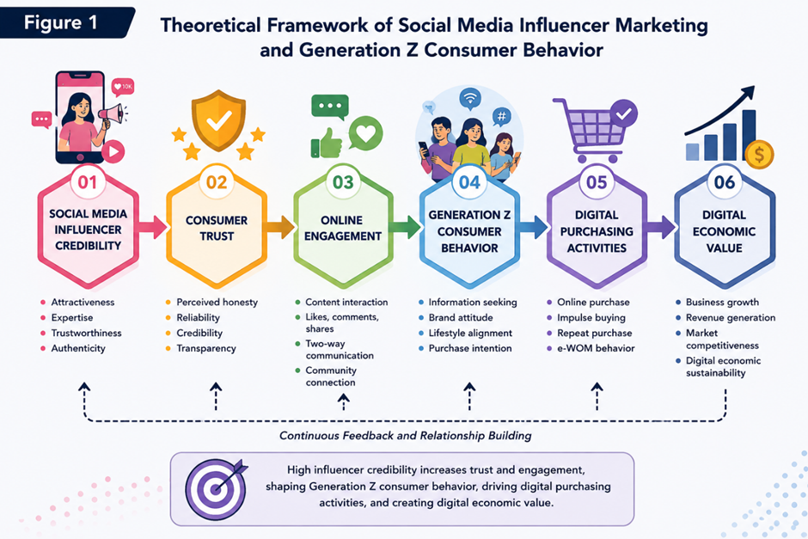
Source: Developed by the researchers based on Hovland and Weiss (1951), Lou and Yuan (2019), and Sokolova and Kefi (2020).

Figure 1 outlines the theoretical framework that explicates the relationship between social media influencer marketing and Generation Z consumer behaviour in today’s digital economies. According to the framework, social media influencer credibility is the most significant element impacting consumer trust, online engagement, digital purchase behaviours and digital economic value among Generation Z consumers Influencers' attractiveness, expertise, trustworthiness, and authenticity are among the key attributes that influence consumers’ perceptions of influencer-generated material on social media.

The methodology also reveals that influencer-driven engagement greatly adds to the digital economic value through higher online purchase activities, business growth, digital market competitiveness and revenue generation. In the fast-changing world of social media, companies are increasingly using influencer marketing methods to increase their digital visibility, build stronger relationships with their consumers, and sustain their online company growth. Hence, the framework suggests that social media influencer marketing continues to be a key strategic driver impacting Generation Z consumer behaviour and digital economic sustainability within modern digital economies.

RESEARCH METHODOLOGY

Research Design

This study was carried out utilizing a qualitative descriptive research approach and secondary data analysis in order to evaluate the influence of social media influencer marketing on consumer behaviour and digital economic value of Generation Z. Qualitative descriptive research is applicable as the study is interested in assessing current literature, digital marketing reports, social media industry publications and online consumer trends connected to influencer marketing in modern digital economies. The study of secondary data allows researchers to carefully analyse current material and uncover new patterns, strategic changes and trends in consumer behaviour in modern research contexts (Johnston, 2017).

This study, through a qualitative descriptive technique, also enables the exploration of influencer marketing strategies, Generation Z online behaviour, and digital purchasing behaviours in fast-evolving social media settings. This is appropriate for the study's emphasis is on analytical interpretation and conceptual understanding, not on statistical hypothesis testing or quantitative experimentation. Therefore, the research aims to analyse the relationship between influencer credibility, customer trust, online engagement and digital economic activities of Generation Z consumers.

Data Collection

The present research employs secondary data from academic articles, digital marketing reports, social media industry publications, and digital economy databases globally published in the years 2020-2025. There was a number of large sources used including reports from Statista, Influencer Marketing Hub, OECD and other digital marketing journals regarding social media influencer marketing and Generation Z customer behaviour.

The secondary data sources were selected based on their relevance, reliability, recency and contribution to the aims of the study. As social media environments, digital marketing trends and influencer marketing methods continue to grow swiftly across online business platforms, recent articles were emphasized. The study devotes especially to Generation Z consumers as the generation is one of the most active digital consumer groups in modern social media environments.

Data Analysis

The data collected was evaluated through thematic content analysis to determine the primary themes, behavioural patterns and emerging trends pertaining to social media influencer marketing and Generation Z customer behaviour. The investigation was based on several major themes: the credibility of influencers, the trust of consumers, online engagement, digital purchasing activities, brand interaction and the digital economic value in social media environments.

Thematic analysis allows academics to systematically categorize and evaluate qualitative data from a wide range of secondary sources to generate an analytical understanding of current digital consumer behaviour and online marketing strategies. The data were then synthesised and analysed using Source Credibility Theory which describes how influencer credibility affects consumer trust, online engagement and digital purchasing behaviour in fast moving digital economies.

DISCUSSION AND FINDING

The Growth of Social Media Influencer Marketing Among Generation Z

The exponential development of social media platforms and the increased online activities of Generation Z customers have led to a remarkable increase of social media influencer marketing in modern digital economies. Social media platforms such as TikTok, Instagram, YouTube, and X are evolving into the new digital marketplace where influencers impact consumer choices, brand engagement, and digital buying behaviour. Generation Z consumers are heavily exposed to influencer-generated material as part of their everyday online activities; as such, influencer marketing is one of the most effective digital advertising methods in the modern online business landscape.

Recent global statistics also reveal that firms are increasingly harnessing influencer marketing to boost digital visibility, consumer engagement and online competitiveness. The global influencer marketing sector has surpassed USD 24 billion (Influencer Marketing Hub, 2025), as businesses embrace digital promotional tactics and social media advertising. These trends suggest that influencer marketing is playing an increasingly important role in the digital business sustainability and online economic growth in fast-changing digital markets.

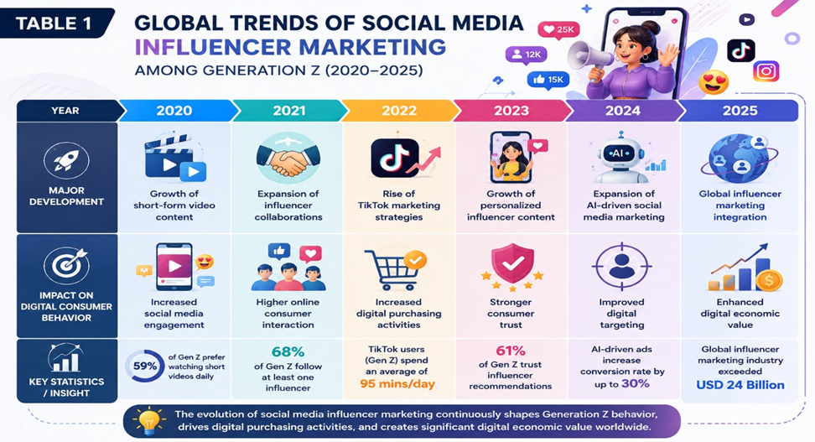
Source: Compiled by the researchers based on Statista (2025), Influencer Marketing Hub (2025), OECD (2025), and DataReportal (2025).

Influencer Credibility and Consumer Trust Among Generation Z

Influencer Credibility and Consumer Trust Among Generation Z consumers in the present social media landscape. Influencer-generated material, digital reviews and personalized online contact are becoming important for Generation Z consumers in their purchasing decision-making processes, as influencers are regarded to be more relatable and real than traditional advertising channels. Thus, influencer traits such as knowledge, trustworthiness, authenticity and beauty are regarded as major predictors of online customer behaviour and digital purchase actions.

Previous research indicated that the influencer authenticity is positively related to online trust, consumer engagement, and brand loyalty of young digital consumers. Lou and Yuan (2019) discovered that consumers tend to trust influencers who are truthful in their product reviews, relatable in their digital experiences, and consistent in their online interactions. In a similar vein, Sokolova and Kefi (2020) stated that the influencer's credibility enhances customer confidence and digital buying intention in social media contexts. Such findings show that the reputation of influencers increasingly affects Generation Z consumer attitudes and interaction in digital markets in intensely competitive online marketplaces.

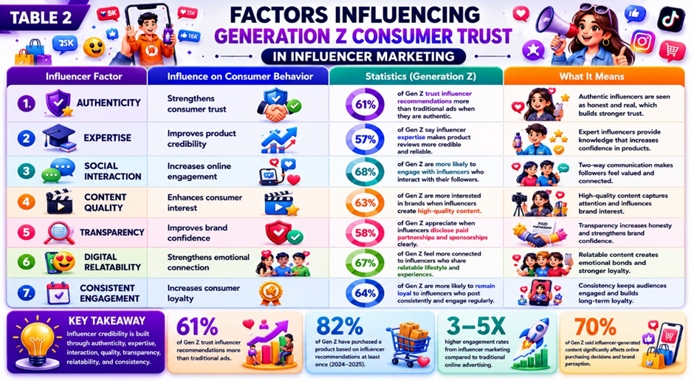
Source: Compiled by the researchers based on Lou and Yuan (2019), Sokolova and Kefi (2020), Djafarova and Rushworth (2017), Statista (2025), Influencer Marketing Hub (2025), and DataReportal (2025).

Table 2 shows some of the main characteristics driving customer trust in social media influencer marketing among Generation Z consumers in today's digital surroundings. The data reveal that authenticity is still one of the most critical elements on the consumers’ trust. When the influencers are authentic and upfront with their material, around 61% of Generation Z consumers trust the influencers’ recommendations more than traditional web marketing. As Generation Z consumers are attracted to influencers who provide real product experiences, authentic lifestyles and continuous online engagement, these elements help to build emotional engagement and foster digital trust connections on social media platforms.

The studies further revealed that influencer competence, social connection and quality of content greatly impact online engagement and consumer purchasing behaviour of generation Z customers. Some 68% of younger consumers are more likely to engage with influencers that communicate with their followers through comments, live-streaming and tailored digital communication. Also, some 63% of Generation Z consumers are more likely to engage with brands advertised through high-quality influencer material. Attractive and innovative digital content, for example, dramatically boosts online attention and brand perception in highly competitive digital marketplaces.

Transparency and digital relatability also have good effects on customer confidence and online loyalty of Generation Z consumers. Influencers that reveal sponsorships and paid collaborations are favoured by around 58% of younger customers. Transparency reinforces honesty and increases brand confidence. Similarly, about two-thirds (67%) of Gen Z consumers say they feel more connected to influencers who share relevant experiences, lifestyles and social beliefs online. These results suggest that emotional connection and digital relatability are important drivers of online trust and consumer engagement for younger digital customers.
The results also indicate that the continued interaction online has a favourable impact on long-term loyalty and digital purchase behaviour of consumers. “Generation Z consumers who are active on social media and regularly engage with their followers are 64% more likely to stay loyal to such influencers. In addition, around 82% of Gen Z customers said they purchased products based on influencer recommendations at least once during 2024-2025. The developments show that influencer credibility has a profound impact on digital purchasing behaviour, contact with online markets and consumer trust in fast growing digital economies.

Recent surveys also suggest that organizations who implemented influencer marketing strategies had engagement rates 3 to 5 times greater than typical online advertising methods. In addition, almost 89% of marketers said that influencer marketing delivered a better return on investment (ROI) than other digital advertising tactics. These findings suggest that influencer marketing is increasingly important for sustainable digital company, the competitiveness of online markets and digital economic value in the present-day social media environment.

Digital Purchasing Power and Digital Economic Value

Influencer marketing on social media is increasingly impacting the digital purchasing behaviour and online economic activities of Generation Z consumers in rapidly growing digital marketplaces. Generation Z consumers are significantly influenced by influencer-generated content, product reviews, live-stream marketing, and tailored digital recommendations during the online purchasing decision-making process. Social media platforms like TikTok, Instagram, and YouTube are increasingly becoming vital digital marketplaces where influencers significantly impact online consumption trends, brand engagement, and digital purchasing behaviour among younger consumers.

Recent findings demonstrate that influencer-based marketing strategies are pivotal to the expansion of online enterprises and the sustainability of the digital economy. DataReportal (2025) indicates that Generation Z consumers are progressively participating in mobile commerce, social commerce, and influencer-driven purchasing behaviours, attributed to heightened online trust and enhanced digital engagement. These findings indicate that influencer marketing is progressively enhancing digital business competitiveness, revenue generation, and online economic growth in rapidly evolving digital economies

.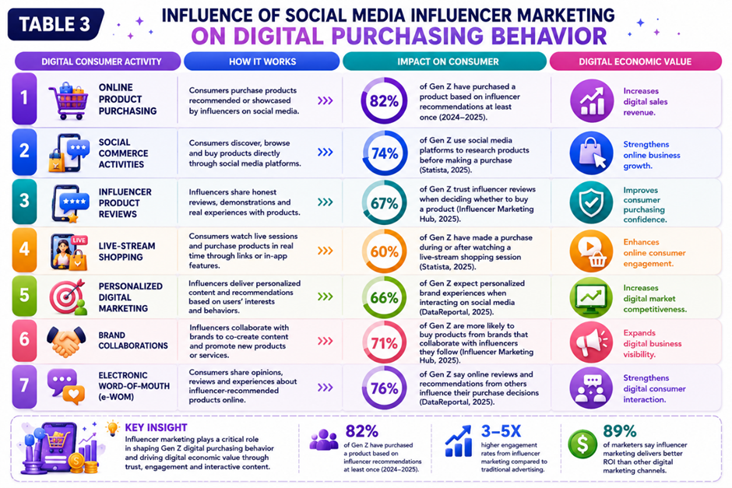
Source: Compiled by the researchers based on DataReportal (2025), Influencer Marketing Hub (2025), and Statista (2025).

Table 3 demonstrates the effect of social media influencer marketing on digital purchase behaviour and digital economic value for Generation Z consumers. The results show that influencer recommendations, personalized digital content and improved consumer confidence in social media contexts have all contributed to a large increase in online product purchasing activities. Nearly 82% of Generation Z customers said they have purchased products based on influencer recommendations at least once in 2024-2025, highlighting the growing effect of social media influencers on online purchasing behaviour and digital consuming activities.

The findings further indicate that social commerce activities and live-stream shopping contribute greatly to digital business growth and online customer engagement. Generation Z customers are increasingly involved in digital purchasing activities via TikTok Shop, Instagram Shopping, and influencer live-stream promotions, as these platforms offer engaging and personalized online shopping experiences. According to Statista (2025), global social commerce income is expanding as younger digital consumers engage in more influencer-driven purchasing and mobile commerce activities.

Furthermore, influencer product reviews, electronic word-of-mouth (e-WOM), and personalized digital marketing all contribute significantly to customer buying confidence and digital market competitiveness. Influencer-generated content increases client trust while reducing uncertainty in online transactions. Consumers are increasingly relying on influencer encounters, product demonstrations, and internet recommendations to make purchasing decisions. These findings suggest that influencer marketing contributes positively to the long-term viability of digital businesses, online income generation, and digital economic value in today's digital marketplace.

The current trends from 2024-2025 reveal that brands are increasingly collaborating with influencers to increase their digital visibility, reach more consumers online, and remain competitive in the harsh digital market. Generation Z consumers are receptive to interactive digital communication and social media marketing strategies. Thus, influencer-driven digital campaigns are effective in increasing online engagement, consumer interaction, and digital sales performance. As a result, social media influencer marketing is an important strategic driver influencing digital purchasing behaviour and digital economic sustainability in today's online business environments.

CONCLUSION

In conclusion, one of the most effective digital marketing strategies influencing Generation Z consumer behavior and digital economic activity in contemporary digital economies is social media influencer marketing. The study's findings demonstrate that customer trust, purchasing behavior, and digital involvement among Generation Z consumers are significantly impacted by influencer reputation, authenticity, online engagement, and personalized digital communication. Influencers affect online buying decisions, brand perceptions, and digital consumption patterns among younger digital consumers on social media sites like YouTube, Instagram, and TikTok, which are becoming more and more important digital marketplaces.

In terms of improved social commerce activities, digital purchasing behavior, and online consumer engagement, the study also showed that influencer marketing plays a significant role in the expansion of digital businesses, online competitiveness, and digital economic value. According to statistical study, while making decisions about what to buy, Generation Z customers are depending more and more on social media participation, digital product reviews, and influencer recommendations. Thus, in fiercely competitive digital marketplaces, influencer-generated content serves as a key strategic driver to improve digital exposure, customer trust, and online business sustainability.

By combining influencer reputation, online engagement, purchasing behavior, and digital business sustainability into a single analytical debate, this study adds to the expanding body of research on social media influencer marketing, Generation Z consumer behavior, and digital economic worth. The results provide important information about the importance of influencer marketing strategies for enhancing customer engagement and preserving long-term competitiveness in rapidly evolving digital economies for companies, digital marketers, governments, and online entrepreneurs. Future research on influencer marketing and digital consumer behaviour on various social media platforms, as well as quantitative analysis and comparative regional studies, might improve this understanding.

POLICY RECOMMENDATION

The results of this study provide a number of policy recommendations. To increase consumer trust and online purchase confidence among Generation Z consumers, companies and digital marketers should first concentrate on the authenticity, openness, and consumer involvement of influencers in their influencer marketing campaigns.

Second, in order to encourage moral advertising practices, consumer protection, and openness in social media marketing settings, legislators and digital platform authorities should strengthen influencer disclosure requirements and digital advertising legislation. In order to decrease deceptive advertising and boost consumer confidence in digital markets, effective digital governance practices are essential.

Lastly, to improve online competitiveness and maintain the expansion of digital enterprises in rapidly evolving digital economies, organizations should consistently expand digital innovation, customized marketing strategies, and social media engagement. Influencer marketing strategies that emphasize relatable content, engaging communication, and responsible digital promotion may also contribute to long-term digital economic sustainability.

NOVELTY OF THE RESEARCH

This study offers some important new insights into the field of digital consumer behaviour and social media influencer marketing. First, the study integrates digital economic value, influencer marketing, and Generation Z consumer behaviour into a single analytical framework with a particular focus on contemporary digital economies. This study offers a thorough examination of consumer trust, digital engagement, online shopping behaviour, and digital business sustainability, in contrast to previous research that focused separately on purchasing intention or influencer credibility. Second, it covers the most recent developments in influencer content, AI-powered digital marketing, social commerce, and how Generation Z will shop online between 2020 and 2025. The incorporation of current statistical data and advancements in contemporary digital marketing in today's social media contexts increases the study's significance.

Lastly, the study makes a theoretical contribution by explaining how influencer credibility affects Generation Z consumers' trust, online engagement, digital purchasing activities, and digital economic value using the Source Credibility Theory. The results also provide businesses and digital marketers with useful information about the strategic need of influencer marketing to sustain online competitiveness and digital company expansion across rapidly growing digital economies.

Author Contributions: The Authors have contributed equally to this work. All authors have read and agreed to the publish version of the manuscript.
Conflict of interest declarations: The authors declare no conflict of interest

REFERENCES

- Campbell, C., & Farrell, J. R. (2020). More than meets the eye: The functional components underlying influencer marketing. Business Horizons, 63(4), 469–479. https://doi.org/10.1016/j.bushor.2020.03.003
- Chopra, A., Avhad, V., & Jaju, A. S. (2021). Influencer marketing: An exploratory study to identify antecedents of consumer behavior of millennials. Business Perspectives and Research, 9(1), 77–91. https://doi.org/10.1177/2278533720923486
- DataReportal. (2025). Digital 2025 global overview report. https://datareportal.com
- Djafarova, E., & Rushworth, C. (2017). Exploring the credibility of online celebrities’ Instagram profiles in influencing the purchase decisions of young female users. Computers in Human Behavior, 68, 1–7. https://doi.org/10.1016/j.chb.2016.11.009
- Hovland, C. I., & Weiss, W. (1951). The influence of source credibility on communication effectiveness. Public Opinion Quarterly, 15(4), 635–650. https://doi.org/10.1086/266350
- Influencer Marketing Hub. (2025). The state of influencer marketing benchmark report 2025. https://influencermarketinghub.com
- OECD. (2025). Digital economy outlook 2025. OECD Publishing. https://www.oecd.org
- Sokolova, K., & Kefi, H. (2020). Instagram and YouTube bloggers promote it, why should I buy? How credibility and parasocial interaction influence purchase intentions. Journal of Retailing and Consumer Services, 53, 101742. https://doi.org/10.1016/j.jretconser.2019.01.011
- Statista. (2025). Social media usage and influencer marketing statistics 2025. https://www.statista.com
- Vrontis, D., Makrides, A., Christofi, M., & Thrassou, A. (2021). Social media influencer marketing: A systematic review, integrative framework and future research agenda. International Journal of Consumer Studies, 45(4), 617–644. https://doi.org/10.1111/ijcs.12647
- Lou, C., & Yuan, S. (2019). Influencer marketing: How message value and credibility affect consumer trust of branded content on social media. Journal of Interactive Advertising, 19(1), 58–73. https://doi.org/10.1080/15252019.2018.1533501

