Mapping Mise en Scène Visual Features in Film Studies: A Bibliometric and Knowledge Mapping Study

ABSTRACT
This study maps the intellectual structure and thematic evolution of research on mise en scene visual features in film studies through bibliometric and knowledge mapping methods. Drawing on records retrieved from the Web of Science Core Collection between January 1, 2022 and May 30, 2026, the study applies CiteSpace and VOSviewer to examine publication trends, productive authors, core journals, country collaboration networks, keyword co-occurrence, keyword clustering, and keyword timeline evolution. The results show that research on film visual features has developed into a cross-disciplinary field that connects film aesthetics, visual style, audience perception, cognitive processing, cultural representation, and emerging computational methods. Core themes include aesthetic appreciation, perception, style, attention, performance, visual information processing, deep learning, image generation, and aesthetic modelling. The findings indicate that the field is moving from traditional aesthetic and textual interpretation toward a broader research framework integrating film studies, cognitive psychology, visual culture, digital humanities, and artificial intelligence. This study provides a systematic overview of the knowledge base, research hotspots, and future directions of mise en scene visual feature research.
Keywords: mise en scene; visual style; film aesthetics; bibliometric analysis; knowledge mapping; CiteSpace; VOSviewer

INTRODUCTION
Visual features constitute one of the most fundamental dimensions of film expression. Elements such as mise en scene, lighting, color, framing, camera movement, spatial composition, performance, and visual rhythm shape not only the aesthetic form of a film but also the way audiences perceive, interpret, and emotionally respond to cinematic images. In film studies, mise en scene has long been understood as a key concept for analysing how visual arrangement produces meaning, atmosphere, narrative emphasis, and stylistic identity. As a result, research on visual style and film aesthetics provides an important pathway for understanding the artistic, cultural, and cognitive functions of cinema. (Bordwell et al., 2020; Gibbs, 2002)
In recent years, the study of film visual features has become increasingly interdisciplinary. Traditional film analysis continues to examine style, authorship, genre, image composition, and cinematic space, while newer research directions draw on psychology, neuroscience, human-computer interaction, cultural heritage studies, digital humanities, and artificial intelligence. Keywords such as perception, attention, memory, aesthetic appreciation, deep learning, and image generation indicate that the field is no longer limited to qualitative interpretation alone. Instead, it is gradually incorporating empirical, computational, and data-driven approaches to explain how visual features are produced, recognised, evaluated, and experienced.(Plantinga & Smith, 1999; Shimamura, 2013)
Despite this growing body of scholarship, the overall knowledge structure of mise en scene visual feature research remains insufficiently clarified. Existing studies often focus on individual films, directors, visual techniques, audience responses, or computational tools, but fewer studies provide a systematic overview of publication trends, core contributors, major journals, international cooperation, and thematic evolution in this area. A bibliometric approach is therefore useful because it can reveal the distribution of research outputs, identify influential authors and sources, visualise collaboration networks, and trace the development of keywords and research clusters over time.(Arnold & Tilton, 2019; Manovich, 2020)
Based on this background, the present study conducts a bibliometric and knowledge mapping analysis of mise en scene visual features in film studies. The following questions will be investigated using bibliometric analysis methods: What are the publication trends in this field from 2022 to 2026? Who are the productive and highly cited authors? Which journals serve as the main publication platforms? How are countries connected in the international collaboration network? What are the major keyword clusters and research hotspots? How have these themes evolved over time? By addressing these questions, this study aims to provide a clearer understanding of the knowledge base, thematic structure, and future development directions of film visual feature research.

DATA SOURCES AND METHODS

Data Sources
The data used in this study were retrieved from the Web of Science Core Collection, with a primary focus on publications from the most recent five years. Based on this background, the search was conducted in January 2022, and the search period was set from January 1, 2022 to May 30, 2026.
To ensure the relevance of the literature to the research topic, a systematic literature screening process was designed. The search strategy adopted a topic-term combination approach, with the specific search formula set as: TS=("visual style" OR "film aesthetics" OR "mise en scène"). The initial search retrieved relevant records. Using the Web of Science subject-category system, literature not directly related to film visual studies was excluded, leaving 708 records. The citation-topic function was then used for further screening, and non-core research records were removed, resulting in 597 records.
As shown in Figure 1, the analytical framework of this study consists of three parts: “data sources and selection,” “sample size,” and “research report.” It presents the complete process from literature retrieval to knowledge mapping analysis. The “data sources and selection” section specifies the research topic, database source, search keywords, and time span, providing a unified standard for literature retrieval. The “sample size” section shows the process through which the literature was screened from the initial retrieval to subject-category filtering, citation-topic screening, and the formation of the final analytical sample, reflecting the study’s control over literature relevance and data quality. The “research report” section further outlines the main analytical dimensions of this study, including yearly publication growth, core authors, core journals, core countries, keyword co-occurrence, keyword clustering, keyword analysis, and keyword time-evolution trends. Through the comprehensive analysis of these dimensions, the study not only identifies the main scholarly forces and core knowledge sources in the field, but also reveals the relational structure among different research themes, their clustering characteristics, and their evolutionary paths over time. Therefore, this study systematically outlines the knowledge base, research hotspots, collaboration networks, and future development directions of research on film visual features.

Figure 1. Workflow of Bibliometric Analysis on Mise en Scène Visual Features Research

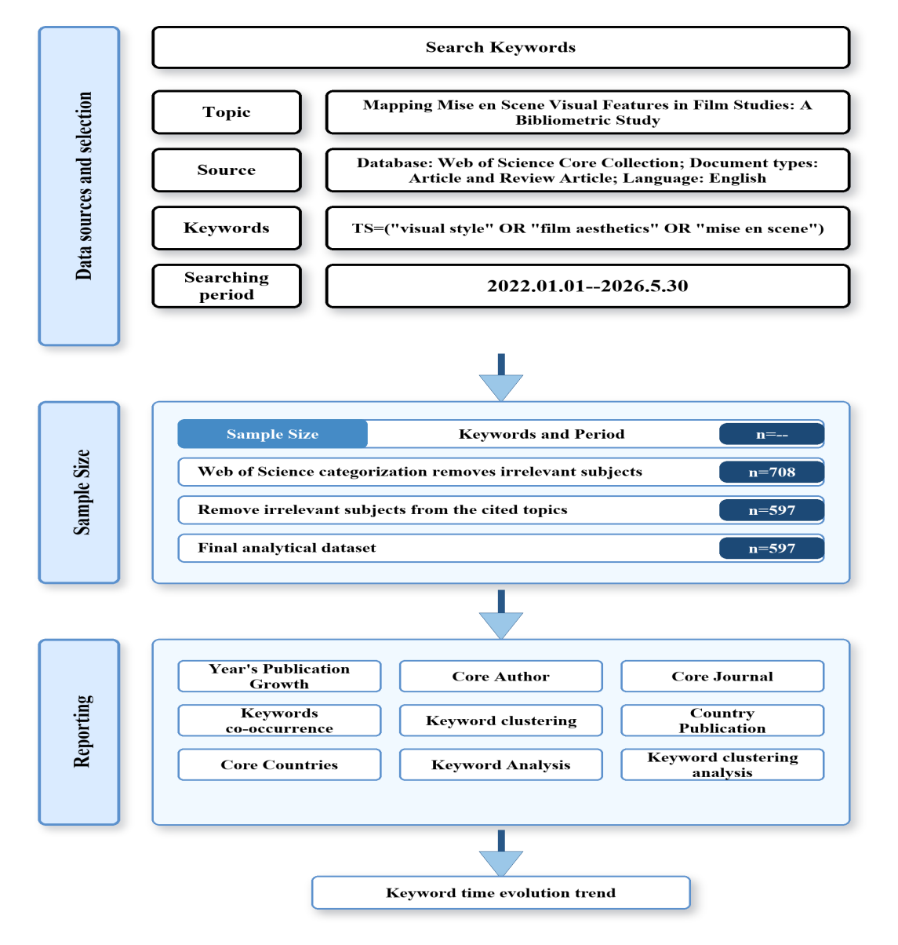

Analysis Methods
This study adopts the bibliometric analysis method and uses CiteSpace and VOSviewer to analyze the preprocessed literature data on film visual features (Ding & Yang, 2022). Through this approach, the study examines publication trends, core authors, core journals, core countries, keyword co-occurrence, keyword clustering, and thematic evolution, in order to reveal the knowledge structure and development trajectory of research on mise en scène, film aesthetics, and visual style.
CiteSpace is used to identify knowledge structures, research hotspots, and thematic evolution in film visual feature research (Chen, 2018). Its functions, including co-citation analysis, burst-term detection, keyword clustering, and timeline analysis, help reveal the relationships among research themes and their changes over time.
VOSviewer is mainly used for keyword co-occurrence analysis, author collaboration analysis, country collaboration analysis, and journal citation visualization (Khuan, Bakri, & Lusianawati, 2023). In this study, it supports the construction of author collaboration maps, journal distribution maps, country collaboration networks, and keyword co-occurrence networks.
By combining CiteSpace and VOSviewer, this study analyzes the field from both macro and micro perspectives. It examines overall development trends, national contributions, journal distribution, core authors, keyword relationships, and thematic clusters, thereby providing a systematic view of the knowledge base, research hotspots, collaboration patterns, and future trends in film visual feature research.

RESULTS ANALYSIS

Descriptive Statistics
The 597 documents used in this study were contributed by 1,438 authors from 695 institutions across 62 countries and were published in 255 journals. These documents cited a total of 29,321 references from 18,713 journals.

Annual Number of Publications

Figure 2. Time Distribution of Publications

From the overall trend, the number of publications in this field showed a continuous upward trajectory from 2022 to 2025, indicating that scholarly attention to this topic has been increasing. In 2022, the field had already formed a certain literature base. The number of publications in 2023 increased slightly compared with 2022, suggesting that the topic began to attract broader academic attention. By 2024, the publication output rose further, indicating accelerated research accumulation and the emergence of a more distinct stage of development.
The number of publications reached its highest point in 2025, with nearly 185 records, marking the peak of the entire observation period. This suggests that the field entered a highly active research stage in 2025. Related topics may have formed a relatively stable level of scholarly attention and showed more concentrated research trends in terms of core authors, journal publication, and keyword clustering.
The number of publications declined noticeably in 2026, but this change should be interpreted with caution. Since 2026 is not yet a complete statistical year and database indexing may involve time lag, it cannot be simply concluded that research interest has declined. A more reasonable interpretation is that the 2026 data represent only a provisional result. As the year progresses and database records continue to be updated, the number of publications may continue to increase.

Table 1.Productive Authors with More Than Two Publications
NO | Author | Documents | Citations | Average Citation/Publication
1 | hu, qiyao | 5 | 31 | 6.2
2 | peng, xianlin | 5 | 31 | 6.2
3 | pelowski, matthew | 4 | 62 | 15.5
4 | leder, helmut | 3 | 58 | 19.3
5 | peng, jinye | 3 | 25 | 8.3
6 | palumbo, letizia | 2 | 40 | 20
7 | rosenberg, raphael | 2 | 47 | 23.5
8 | cao, rui | 2 | 20 | 10
9 | stork, david g. | 2 | 33 | 16.5
10 | taruffi, liila | 2 | 19 | 9.5
In terms of publication output, Hu, Qiyao and Peng, Xianlin each published five documents, making them the most productive authors in this field. This indicates that both authors have maintained a relatively high level of research productivity in film visual features, visual style, and related topics. Pelowski, Matthew ranked third with four publications, while Leder, Helmut and Peng, Jinye each published three documents, also representing active contributors in this research area.
In terms of citation impact, the most productive authors do not necessarily have the highest average citations per publication. Although Rosenberg, Raphael published only two documents, his total citations reached 47, with an average of 23.5 citations per publication, making him the author with the highest average citation rate in the table. Palumbo, Letizia had an average of 20 citations per publication, and Leder, Helmut had 19.3, indicating that their individual publications have relatively strong academic influence. By contrast, although Hu, Qiyao and Peng, Xianlin had the highest number of publications, their average citations per publication were both 6.2, suggesting that their contribution is mainly reflected in research productivity rather than the citation impact of individual publications.
Overall, the author structure in this field shows two main characteristics. One group consists of highly productive authors represented by Hu, Qiyao and Peng, Xianlin, reflecting sustained research engagement. The other group consists of high-impact authors represented by Rosenberg, Raphael, Palumbo, Letizia, and Leder, Helmut. Although these authors published fewer documents, their works received relatively high citation attention. Therefore, when analyzing core authors, publication output alone is insufficient; total citations and average citations per publication should also be considered to evaluate authors’ academic influence more comprehensively.

Table 2.Highly Cited Authors
NO | Author | Citations | Documents | Average Citation/Publication
1 | pelowski, matthew | 62 | 4 | 15.5
2 | leder, helmut | 58 | 3 | 19.3
3 | aw, eugene cheng-xi | 54 | 1 | 54.0
4 | basha, norazlyn kamal | 54 | 1 | 54.0
5 | biljecki, filip | 54 | 1 | 54.0
6 | chang, jiat hwee | 54 | 1 | 54.0
7 | chuah, stephanie hui-wen | 54 | 1 | 54.0
8 | gao, song | 54 | 1 | 54.0
9 | liang, xiucheng | 54 | 1 | 54.0
10 | zhao, tianhong | 54 | 1 | 54.0
In terms of total citations, Pelowski, Matthew ranked first, with 62 citations from four publications and an average of 15.5 citations per publication. Leder, Helmut ranked second, with 58 citations from three publications and an average of 19.3 citations per publication. These two authors not only received relatively high citation counts but also produced multiple related works, indicating that their research has a relatively stable academic influence in this field.
It is worth noting that the authors ranked third to tenth, including Aw, Eugene Cheng-Xi; Basha, Norazlyn Kamal; Biljecki, Filip; Chang, Jiat Hwee; Chuah, Stephanie Hui-Wen; Gao, Song; Liang, Xiucheng; and Zhao, Tianhong, each published only one document, yet all received 54 citations, with an average of 54.0 citations per publication. This suggests that these authors may have co-authored a highly cited article, or that their single publication had a significant impact in the field. Although their publication output is limited, the strong citation performance of that work gives them an important position in the citation ranking.
This table indicates that academic influence in this field can be divided into two types. The first type includes authors such as Pelowski, Matthew and Leder, Helmut, who show both continuous output and high citation impact, reflecting relatively stable research contributions. The second type includes authors with fewer publications but outstanding single-paper influence, suggesting that a high-quality or highly visible individual study can also exert a significant impact on the development of the field. Therefore, when identifying core authors, it is necessary to consider not only publication output but also total citations and average citations per publication.

B. Bibliometric Analysis of Journals
Journal analysis is an important method for identifying core literature sources and knowledge dissemination platforms within a discipline. Bradford’s Law, as a classical theory in bibliometrics, suggests that publications in a given research field are usually concentrated in a small number of core journals while also being dispersed across a larger number of related and peripheral journals. By analyzing the distribution of journal publications, it is possible to identify the core journal group of a specific research field and further determine its academic communication channels, disciplinary orientation, and interdisciplinary expansion characteristics (Borgohain et al., 2021). For research on film visual features, journal distribution not only reflects the main publication platforms of the field but also reveals its connections with film studies, visual culture, architectural space, cultural heritage, digital media, sustainable development, and other related areas.

Figure 3. Journal Publication Output

Figure 3 shows the top ten journals by publication output in film visual feature research. Sustainability ranks first with about 45 publications, making it the leading source in this field, followed by Land with about 19 publications. The prominence of these journals suggests that film visual feature research is closely connected with sustainability, cultural environment, spatial studies, cultural heritage, and urban space.
The journal distribution also shows a clear interdisciplinary pattern. In addition to film and aesthetics-related journals, publications appear in fields such as cultural heritage, architecture, applied sciences, tourism, psychology, and the humanities and social sciences. This indicates that research on mise en scène, visual style, and film aesthetics increasingly intersects with spatial perception, visual narrative, digital image analysis, and audience experience.
From the perspective of Bradford’s Law, the distribution shows a concentration trend: a small number of journals, especially Sustainability, publish a large share of the literature, while other journals form a broader related and peripheral publication network. This suggests that knowledge production in this field is both concentrated in core journals and widely diffused across interdisciplinary platforms.

Table 3.Core Journals and Their Citations
NO | Source | Doc. | Citations | Average Citation/Publication
1 | scientific reports | 44 | 188 | 4.3
2 | plos one | 21 | 45 | 2.1
3 | film-philosophy | 20 | 13 | 0.7
4 | psychology of aesthetics creativity and the arts | 17 | 140 | 8.2
5 | new review of film and television studies | 16 | 16 | 1.0
6 | npj heritage science | 15 | 12 | 0.8
7 | french screen studies | 12 | 4 | 0.3
8 | journal of chinese cinemas | 11 | 2 | 0.2
9 | animation-an interdisciplinary journal | 10 | 13 | 1.3
10 | international journal of human-computer interaction | 10 | 76 | 7.6
Table 3 presents the publication output, total citations, and average citations per publication of the core journals in this field. It helps identify the main literature sources and their academic influence in film visual feature research.
In terms of publication output, Scientific Reports ranks first with 44 publications, followed by PLOS One with 21 and Film-Philosophy with 20. This shows that both comprehensive journals and film-related journals are important publication platforms. In particular, Film-Philosophy reflects the close connection between film visual feature research, film aesthetics, image philosophy, and visual style analysis.
Citation impact shows a different pattern. Although Scientific Reports has the highest total citations, its average citation per publication is 4.3. By contrast, Psychology of Aesthetics, Creativity, and the Arts has only 17 publications but a higher average citation rate of 8.2, indicating stronger single-paper influence. International Journal of Human-Computer Interaction also shows notable impact, suggesting links between film visual features, visual perception, and digital media experience.
Overall, the table shows that this field has a dual journal structure: comprehensive journals support its interdisciplinary expansion, while film and screen studies journals maintain its disciplinary foundation. The higher citation performance of psychology and human-computer interaction journals also suggests that aesthetic psychology and digital interaction are important growth areas.

Bibliometric Analysis by Country

Figure 4. Country Collaboration Network Map
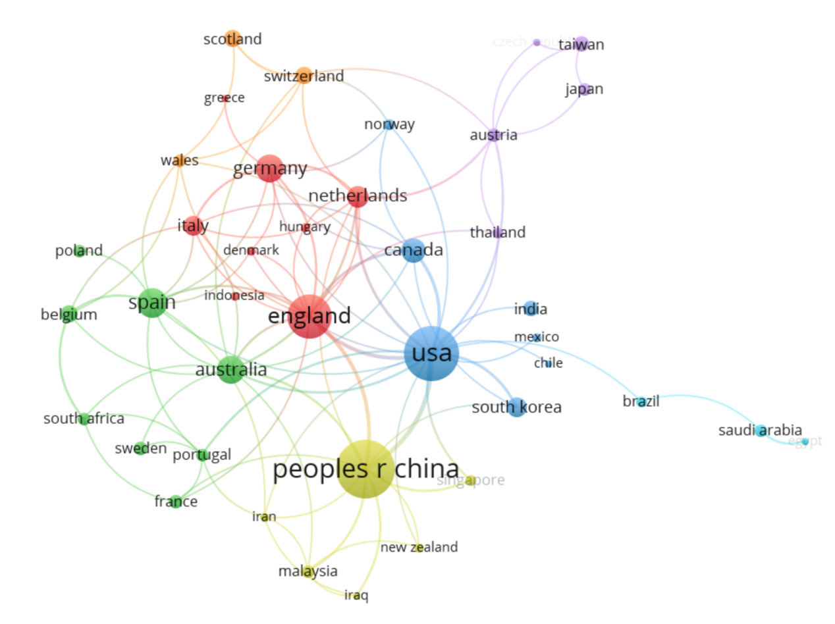
The country collaboration network map shows academic cooperation among countries in film visual feature research. Each node represents a country or region, with larger nodes indicating higher publication output or participation. Links between nodes represent collaboration, and different colors indicate collaboration clusters.
As shown in the figure, People’s R China, USA, and England are the most prominent nodes, suggesting that they are the main contributors in this field. China shows strong research activity, the USA has extensive international connections, and England plays an important bridging role by linking with several European and non-European countries.
The network also shows several collaboration clusters. The USA-centered cluster connects North America, Asia, and parts of Latin America; the England-Germany-Netherlands-Italy cluster reflects close European cooperation; and the China-centered cluster links several Asian and cross-regional partners. Overall, the field has formed a multi-center international collaboration network, with strong participation from China, the USA, England, Europe, Asia, Oceania, and Latin America.

Keyword Analysis

Keyword Co-occurrence Analysis

Figure 5. Keyword Co-occurrence Visualization
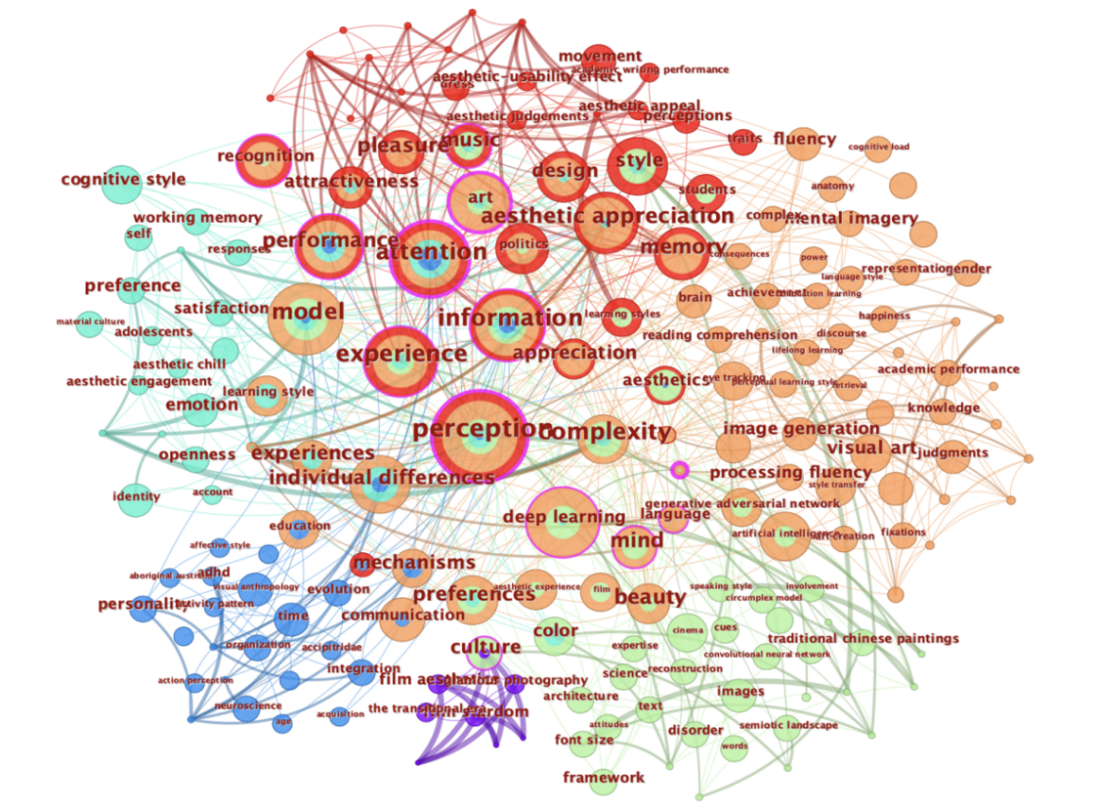
The keyword co-occurrence network shows the relationships among high-frequency keywords in this field. Larger nodes indicate higher keyword frequency, links represent co-occurrence relationships, and different colors show thematic clusters.
The network is centered on keywords such as aesthetic appreciation, perception, attention, experience, information, complexity, memory, and performance, indicating that the field mainly focuses on aesthetic perception, visual experience, cognitive processing, and information processing. The central position of aesthetic appreciation suggests that audience aesthetic response is a core theme.(Cutting et al., 2010; Shimamura, 2013)
Keywords such as art, style, beauty, design, and visual imagery show the close relationship between film visual features, visual style, and artistic expression. Meanwhile, deep learning, image generation, and artificial intelligence indicate the growing influence of computational methods and AI-based visual analysis.(Arnold & Tilton, 2019; Manovich, 2020)
The network reveals four main directions: aesthetic evaluation, cognitive and perceptual studies, visual style and artistic expression, and digital technology. This suggests that film visual feature research is increasingly interdisciplinary.

Table 4.Keyword Clustering Explain
Keyword | Occurrence | Node Characteristics | Academic Significance
aesthetics | 28 | Highly associated with keywords such as “aesthetic appreciation,” “beauty,” “art,” and “style,” making it the most central aesthetic theme node in this field. | It reflects the sustained attention given to aesthetic value, visual beauty, and artistic judgment in studies of film visual characteristics, and serves as an important entry point for understanding film style and film aesthetics.
perception | 23 | Closely related to keywords such as “attention,” “experience,” “information,” and “complexity,” representing the research direction of visual cognition and audience perception. | It shows researchers’ concern with how audiences perceive, understand, and evaluate film visual elements, making it an important concept connecting film aesthetics and cognitive psychology.
style | 22 | Forms co-occurrence relationships with keywords such as “design,” “aesthetic appreciation,” “visual imagery,” and “art,” making it an important node in visual form research. | It highlights the central role of film visual style in image expression, involving mise-en-scène, composition, colour, lighting, and formal aesthetics.
attention | 19 | Strongly connected with keywords such as “perception,” “memory,” “performance,” and “information,” reflecting the attention mechanism in visual processing. | It indicates that film visual elements can guide audience attention, making it an important dimension for analysing shot design, image structure, and visual narrative effects.
film | 19 | Co-occurs with keywords such as “aesthetics,” “style,” “art,” and “performance,” serving as a disciplinary foundation node in the research network. | It provides the core context for research on film visual characteristics and connects issues such as film text analysis, visual style, aesthetic experience, and image narration.
performance | 19 | Associated with keywords such as “attention,” “pleasure,” “attractiveness,” and “emotion,” reflecting the relationship between visual expression and performance behaviour. | It reflects the attention given in film studies to bodily movement, actor performance, motion, and audience evaluation, thereby expanding the expressive dimension of visual characteristics research.
model | 16 | Related to keywords such as “information,” “perception,” “deep learning,” and “mechanisms,” showing methodological and explanatory framework features. | It suggests that this field is gradually introducing model construction, mechanism explanation, and computational methods to analyse film visual characteristics and their aesthetic and cognitive effects.
art | 15 | Closely associated with keywords such as “aesthetics,” “beauty,” “style,” and “culture,” serving as an important node connecting film and art studies. | It shows that research on film visual characteristics is closely related to artistic traditions, visual culture, and aesthetic theory, reflecting the research value of film as a comprehensive art form.
deep learning | 15 | Associated with keywords such as “image generation,” “processing fluency,” “artificial intelligence,” and “model,” representing a technology-oriented node. | It reflects the growing involvement of artificial intelligence and computational vision methods in film visual research, providing new approaches for image style recognition, image generation, and visual feature analysis.
experience | 15 | Co-occurs with keywords such as “aesthetic appreciation,” “perception,” “emotion,” and “pleasure,” representing the research direction of audience experience. | It emphasizes the audience’s aesthetic experience, emotional response, and subjective participation during viewing, serving as an important concept connecting visual form and reception effect.
information | 15 | Forms a cognitive information-processing module with keywords such as “attention,” “perception,” “memory,” and “model.” | It reflects researchers’ attention to how visual information is encoded, processed, and understood, making it an important node for analysing meaning generation and cognitive mechanisms in film images.
memory | 15 | Closely related to keywords such as “attention,” “perception,” “recognition,” and “emotion,” functioning as a node that intersects cognition and emotion. | It indicates that film visual elements not only influence immediate perception but are also related to memory formation, recognition, and emotional arousal, thereby expanding the psychological explanatory dimension of visual characteristics research.

Keyword Clustering Analysis

Figure 6. Keyword Clustering Visualization

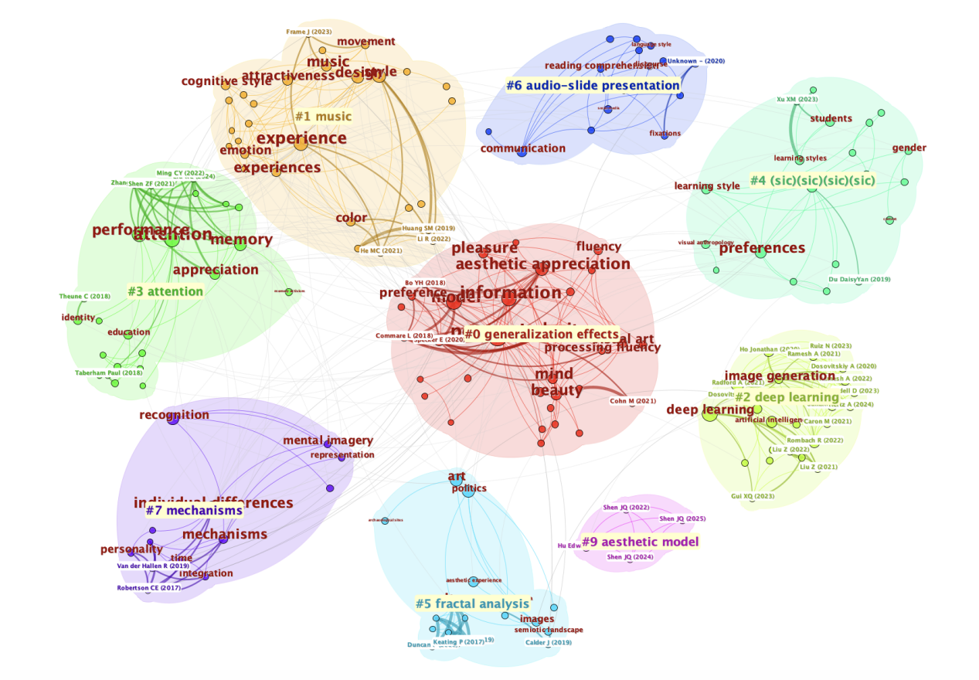
The keyword clustering map shows the main thematic groups formed in the keyword co-occurrence network. Different colors represent different clusters, larger nodes indicate higher keyword frequency, and links show co-occurrence relationships.
The largest and most central cluster, #0 generalization effects, includes keywords such as aesthetic appreciation, information, pleasure, beauty, and processing fluency, indicating that aesthetic evaluation and visual information processing are core themes. #1 music focuses on music, emotion, experience, and design, showing the role of audiovisual experience in film visual studies. #2 deep learning reflects the rise of AI, image generation, and computational visual analysis. #3 attention highlights attention, memory, performance, and appreciation, linking the field with cognitive psychology and audience perception.
Other clusters show further interdisciplinary expansion. #4 sic(sic)(sic) relates to students, learning styles, gender, and preferences; #5 fractal analysis concerns art, images, and semiotic landscapes; #6 audio-slide presentation reflects multimodal presentation and comprehension; #7 mechanisms focuses on recognition, mental imagery, and individual differences; and #9 aesthetic model points to theoretical model building.
The map shows that film visual feature research is centered on aesthetic appreciation, perception, and information processing, while also expanding toward AI, multimodal communication, cognitive mechanisms, and aesthetic modelling.

Keyword Time Evolution Trend

Figure 7. Keyword Time Evolution Trend
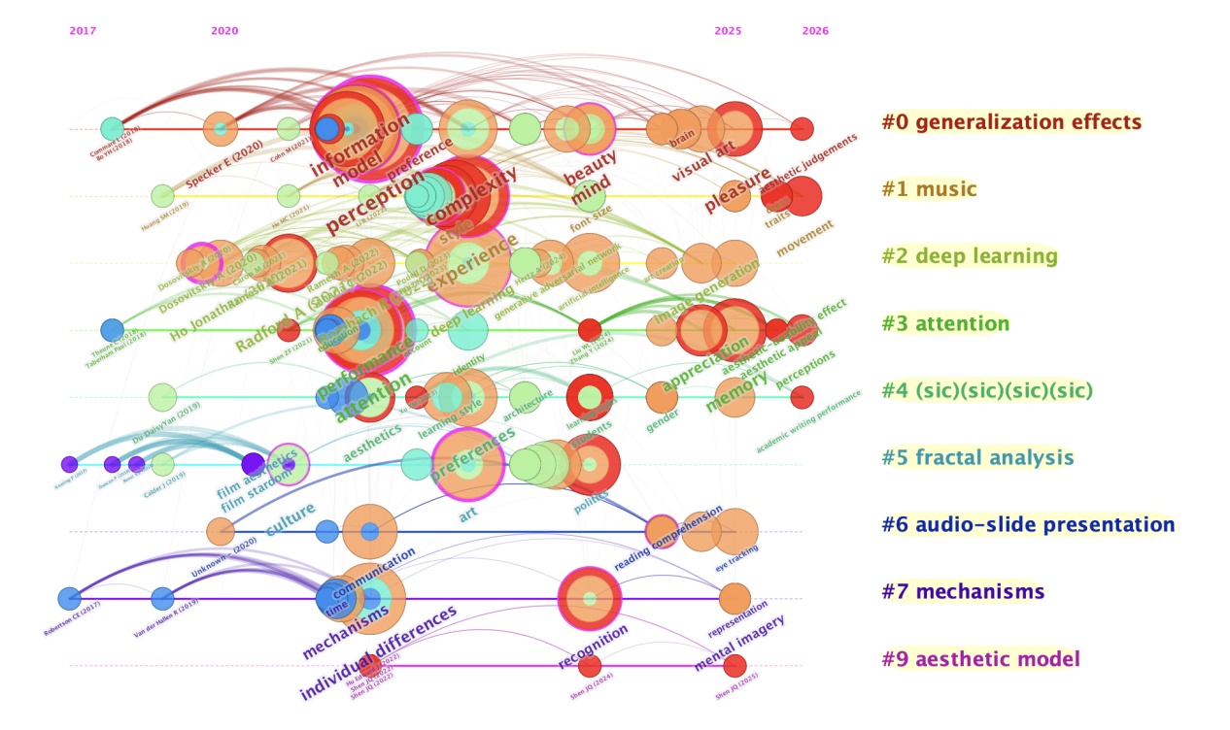

The timeline map presents the research trends and evolutionary trajectories of keywords in film visual feature research from 2017 to 2026. Each horizontal line represents a keyword cluster, corresponding to the research themes identified in the clustering analysis. The distribution of nodes along the timeline reflects the research activity of each theme in different periods. Larger nodes indicate higher keyword frequency, while node positions show when keywords appeared and continued. This visualization helps identify the starting points, development stages, continuity, and emerging trends of major themes in the field.
1.Generalization effects (2017–present)
This cluster includes keywords such as information, model, perception, complexity, beauty, mind, and pleasure. It appeared in the early stage and has continued to recent years, indicating that it is one of the most fundamental and central directions in film visual feature research. It mainly focuses on visual information processing, perception mechanisms, aesthetic judgment, and visual complexity.
2.Music (2018–2023)
This cluster includes music, experience, emotion, design, and movement. It is mainly concentrated in the early and middle stages, showing that researchers paid attention to the relationship between music, movement, emotion, and visual design. This reflects the expansion of film research from visual analysis to audiovisual experience.
3.Deep learning (2021–present)
This cluster includes deep learning, image generation, visual art, and artificial intelligence. It becomes more active after 2021, suggesting that AI and computational vision methods have entered film visual feature research. Related studies focus on visual style recognition, image generation, feature extraction, and automated analysis.
4.Attention (2020–2024)
This cluster includes attention, performance, appreciation, and memory. It became active around 2020 and continued afterward, indicating that audience attention, memory, and aesthetic evaluation have become important research concerns.
5.sic(sic)(sic) (2021–2026)
Although the cluster label is not clear, its related keywords include students, gender, learning style, and preferences. This suggests a connection between film visual feature research and educational contexts, learning styles, gender differences, and individual preferences.
6.Fractal analysis (2019–2024)
This cluster includes fractal analysis, art, images, and semiotic landscape. It mainly appears in the middle period, showing interest in image structure, visual complexity, artistic form, and symbolic landscapes.
7.Audio-slide presentation (2020–2023)
This cluster includes audio-slide presentation, reading comprehension, and communication. It reflects a period of interest in multimodal presentation and its effects on understanding and communication.
8.Mechanisms (2017–2022)
This cluster includes mechanisms, individual differences, recognition, and mental imagery. It appeared in the early period and reflects a focus on visual cognitive mechanisms, individual differences, recognition processes, and mental representation.
9.Aesthetic model (2022–2026)
This cluster includes aesthetic model and mainly appears in the later period. It indicates that researchers have begun to construct theoretical models to explain the aesthetic mechanisms of film visual features.
Overall, the keyword evolution shows that film visual feature research has moved from early studies on cognitive mechanisms to mid-stage research on aesthetic experience and visual complexity, and then to later studies involving AI, deep learning, and aesthetic modelling. Early research was based on mechanisms, recognition, and mental imagery; mid-stage research focused more on perception, attention, experience, and aesthetic appreciation; and recent studies increasingly emphasize deep learning, image generation, artificial intelligence, and theoretical model construction. This suggests that the field is developing into an interdisciplinary research system that integrates film aesthetics, cognitive psychology, digital image analysis, AI, and aesthetic modelling.

DISCUSSION AND IMPLICATIONS

Discussion
Based on the bibliometric analysis results, research on film visual features has gradually formed a knowledge structure centered on film aesthetics, visual style, aesthetic perception, cognitive processing, and digital technology applications. The journal distribution results show that relevant studies are not only published in film studies, art aesthetics, and humanities and social science journals, but also widely distributed across journals related to comprehensive science, psychology, human-computer interaction, cultural heritage, and digital technology. This indicates that film visual feature research has moved beyond the single disciplinary boundary of traditional film studies and has gradually developed into a multidisciplinary field integrating film studies, cognitive psychology, visual culture, digital humanities, and artificial intelligence.
The country collaboration network analysis shows that the field has formed a broad pattern of international cooperation. China, the United States, and the United Kingdom show high centrality and academic activity in the collaboration network, while European countries also demonstrate close regional cooperation. This suggests that film visual feature research is not limited to a single country or region but is expanding within the global academic network. Different countries have their own strengths in film aesthetic traditions, digital visual technologies, cultural research approaches, and audience cognition studies, providing an important foundation for future cross-cultural comparative research and international collaboration.
Keyword co-occurrence and clustering analysis further reveal that current research mainly focuses on aesthetic appreciation, visual perception, attention mechanisms, memory, visual style, performance, image generation, and deep learning. Keywords such as aesthetic appreciation, perception, attention, experience, and memory reflect sustained attention to audience aesthetic experience and cognitive mechanisms. Keywords such as style, film, art, and performance indicate that film visual style, artistic expression, and performance remain fundamental research objects. The emergence of keywords such as deep learning, image generation, and artificial intelligence suggests that computational vision and AI methods are entering film visual research and providing new methodological paths for traditional film aesthetic analysis.
The time-evolution analysis shows that film visual feature research has developed from cognitive mechanism studies to aesthetic experience research and, more recently, to digital technology and model-based analysis. Early studies focused more on cognitive psychology topics such as mechanisms, recognition, mental imagery, and individual differences, emphasizing how audiences recognize and process visual information. Mid-stage research gradually shifted toward perception, attention, experience, pleasure, and aesthetic appreciation, focusing on how visual features influence audience experience and aesthetic judgment. In recent years, keywords such as deep learning, image generation, artificial intelligence, and aesthetic model have become increasingly active, indicating that the field is being driven by AI and digital image analysis technologies. The research paradigm is shifting from traditional interpretive analysis toward data-driven research.(Bordwell et al., 2020; Gibbs, 2002; Manovich, 2020)

Future Research Directions
At the theoretical level, the findings suggest that film visual feature research is moving from traditional film aesthetic analysis toward an integrated framework combining “visual form, audience perception, and technological methods.” Film visual style is no longer understood merely as a formal element within the text, but as closely related to audience attention, memory, emotion, aesthetic judgment, and cognitive processing. At the same time, the introduction of AI and deep learning provides new theoretical space for film visual feature research. Future studies may further integrate film aesthetics, cognitive psychology, and computational vision methods to construct a more systematic explanatory model of film visual features.
At the practical level, film visual feature research has implications for film production, image analysis, digital restoration, film education, and intelligent image generation. For filmmakers, visual style, mise en scène, color, composition, and performance not only influence artistic expression but also affect audience attention and aesthetic experience. For film education and criticism, keyword networks and thematic clusters help clarify the core issues of current film visual research and provide references for curriculum design, textual analysis, and research topic selection. For digital technology applications, deep learning and image generation provide new tools for film style recognition, visual feature extraction, and image aesthetic analysis, although attention should also be paid to the risk of oversimplifying the artistic complexity of cinema. (Arnold & Tilton, 2019)
In terms of future development, interdisciplinary integration will remain an important driving force for film visual feature research. The field may further expand in three directions: first, deepening research on the relationship between film aesthetics and audience cognitive mechanisms; second, strengthening the integration of artificial intelligence, computer vision, and film style analysis; and third, promoting comparative studies of visual features across different countries, film traditions, and cultural contexts. Overall, film visual feature research is at an important stage of transition from traditional aesthetic interpretation to interdisciplinary, digital, and model-based research.

CONCLUSION
This study used bibliometric visualization methods to systematically examine author distribution, core journals, country collaboration networks, keyword co-occurrence, keyword clustering, and temporal evolution in the field of film visual feature research. The findings show that this field has developed a clear interdisciplinary research pattern. Relevant studies are not only concentrated in film studies and art aesthetics but have also gradually expanded into psychology, human-computer interaction, digital technology, cultural heritage, and artificial intelligence.
The results indicate that the core themes of film visual feature research mainly focus on aesthetic appreciation, visual perception, attention mechanisms, viewing experience, visual style, performance, and digital image analysis. Keyword clustering and timeline analysis further show that the field has evolved from early research on cognitive mechanisms to mid-stage studies on aesthetic experience, and then to more recent involvement of artificial intelligence and deep learning methods. This trend suggests that film visual feature research is shifting from traditional textual interpretation and aesthetic analysis toward an integrated research model combining cognitive science and digital technology.
Overall, by integrating the results of journal structure, country collaboration networks, and keyword knowledge structure analysis, this study reveals the main academic forces, knowledge base, research hotspots, and development trends of film visual feature research. The findings provide bibliometric evidence for understanding research related to mise en scène, film aesthetics, and visual style, and also offer references for future studies on film aesthetics, digital image analysis, and AI-assisted film research. Future research may further expand database sources and combine more empirical cases and cross-cultural comparative methods to deepen the understanding of film visual features and their aesthetic mechanisms.

REFERENCES
Arnold, T., & Tilton, L. (2019). Distant viewing: Analyzing large visual corpora. Digital Scholarship in the Humanities, 34(Supplement_1), i3–i16. https://doi.org/10.1093/llc/fqz013
Bordwell, D., Thompson, K., & Smith, J. (2020). Film art: An introduction (12th ed.). McGraw-Hill Education.
Borgohain, D. J., Verma, M. K., Nazim, M., & Sarkar, M. (2021). Application of Bradford’s law of scattering and Leimkuhler model to information science literature. COLLNET Journal of Scientometrics and Information Management, 15(1), 197–212. https://doi.org/10.1080/09737766.2021.1943041
Chen, C. (2006). CiteSpace II: Detecting and visualizing emerging trends and transient patterns in scientific literature. Journal of the American Society for Information Science and Technology, 57(3), 359–377. https://doi.org/10.1002/asi.20317
Ding, X., & Yang, Z. (2022). Knowledge mapping of platform research: A visual analysis using VOSviewer and CiteSpace. Electronic Commerce Research, 22, 787–809. https://doi.org/10.1007/s10660-020-09410-7
Gibbs, J. (2002). Mise-en-scène: Film style and interpretation. Wallflower Press.
Khuan, H., Bakri, A. A., & Lusianawati, H. (2023). Sustainability and corporate social responsibility in digital platform companies. West Science Journal Economic and Entrepreneurship, 1(08), 358–367. https://doi.org/10.58812/wsjee.v1i03.152
Manovich, L. (2020). Cultural analytics. The MIT Press.
van Eck, N. J., & Waltman, L. (2010). Software survey: VOSviewer, a computer program for bibliometric mapping. Scientometrics, 84(2), 523–538. https://doi.org/10.1007/s11192-009-0146-3

