Disclosure Quality and IPO Subscription Behaviour: Evidence from Retail, QIB, and NII Investors in the Indian Primary Market
Deepali Ratra
Research scholar, Jagannath University, Delhi NCR, Bahadurgarh, Haryana
deeparatra@gmail.com

Dr. Sarmistha Sarma
Asian Business School (ABS), Noida, Uttar Pradesh, India
sunshinewinner@gmail.com

Dr. Neha Bhat, Associate Professor, Jagannath University, Delhi NCR, Bahadurgarh,
Haryana
neha.bhat@jagannathuniversityncr.ac.in

ABSTRACT
The present research examines the association between prospectus disclosure Quality and investor subscription behaviour across three categories of investors — Retail Investors, Qualified Institutional Buyers (QIBs), and Non-Institutional Investors (NIIs) — in the Indian Initial Public Offering (IPO) market. Employing a dataset of 68 IPOs listed on Indian stock exchanges between 2019 and 2024, the study analyses 22 disclosure dimensions extracted from the Red Herring Prospectus (RHP) across risk, governance, financial, and operational categories. Employing Pearson correlation analysis, independent samples t-tests, and machine learning classifiers (Random Forest and Logistic Regression), the research finds that higher disclosure intensity is consistently and negatively correlated with subscription degrees across all investor categories. Prospectus length, risk factor disclosure, financial information, and legal proceedings emerge as the strongest predictors of subscription. Retail investors are significantly more sensitive to governance-related disclosures — notably Promoter Group, Group Companies, and Board of Directors sections — than institutional investors. The Prospectus Length effect is the most statistically significant hypothesis, confirmed across all investor categories. Machine learning models demonstrate robust predictive accuracy, with AUC-ROC scores ranging from 0.80 to 0.89, validating the function of disclosure characteristics in predicting subscription outcomes. The findings contribute to information asymmetry theory and signal theory in the context of emerging market IPOs, with pivotal outcomes for issuers, regulators, and investment advisors.
Keywords: IPO disclosure Quality; investor subscription; Red Herring Prospectus; retail investors; qualified institutional buyers; Indian capital market; information asymmetry; machine learning

1. INTRODUCTION
The Indian primary capital market has experienced remarkable expansion over the past decade, emerging as one of the most vibrant IPO ecosystems globally. Between 2019 and 2024, the Indian stock exchanges — National Stock Exchange (NSE) and Bombay Stock Exchange (BSE) — witnessed unprecedented investor engagement across categories, with comprehensive IPO subscription multiples reaching historic highs. This surge in retail and institutional engagement has reignited scholarly and practitioner apprehension in the informational underpinnings of investor decision-rendering in the pre-listing period.
The Red Herring Prospectus (RHP), mandated by the Securities and Exchange Board of India (SEBI), serves as the primary document through which issuing firms communicate -particular, financial, governance, and risk-related information to prospective investors. Theoretically grounded in the seminal works of Akerlof (1970) on information asymmetry and Spence (1973) on signalling, disclosure Quality in IPO prospectuses has been hypothesised to mitigate the information disparity between issuers and investors, thereby influencing subscription and pricing outcomes. Nevertheless, the empirical Evidence on how disclosure Quality differentially influences heterogeneous investor categories persists sparse, notably in the context of emerging markets such as India.
India presents a uniquely structured IPO subscription mechanism, segmented into three investor categories: Retail Individual Investors (RIIs), Qualified Institutional Buyers (QIBs), and Non-Institutional Investors (NIIs, additionally known as High Net-worth Individuals or HNIs). This regulatory architecture, atypical in its transparency — allowing investors to observe actual-period subscription data across categories — generates an ideal natural experiment for studying how investor heterogeneity mediates the disclosure-subscription association. Retail investors, constrained by limited analytical resources and financial literacy, may respond differently to prospectus disclosures compared to sophisticated institutional investors who possess dedicated research teams.
Prior literature on IPO disclosures has substantially concentrated on underpricing, extended-run performance, and initial-day returns in developed markets including the United States, the United Kingdom, and China (Brau et al., 2016; Han et al., 2021; Xia et al., 2024). A growing strand of research has examined the function of textual analysis, readability, and sentiment in IPO documents (Hsieh et al., 2025; Yan et al., 2019; Zhang et al., 2024). Nevertheless, studies specifically examining how prospectus disclosure Quality bearings subscription across differentiated investor categories in India persist limited. The few India-particular studies (Gupta et al., 2022) concentrate on media sentiment and underpricing rather than prospectus content and subscription degrees.
The present research addresses this disparity by systematically analysing 22 disclosure dimensions from RHP filings of 68 IPOs listed between 2019 and 2024 across multiple Indian industries. The research deploys a mixed-techniques methodology combining Pearson correlation, hypothesis testing via independent samples t-tests, and supervised machine learning classifiers (Random Forest and Logistic Regression) to response the following research investigations:
- Do higher degrees of prospectus disclosure negatively correlate with IPO subscription frequencies across investor categories?
- Do retail investors exhibit higher sensitivity to disclosure dimensions (e.g., governance, risk) compared to institutional investors?
- Which disclosure characteristics are the strongest predictors of High versus lower IPO subscription outcomes?
- Can machine learning models utilising disclosure characteristics accurately predict IPO subscription categories?
The study contributes to the literature on several fronts. Initial, it provides granular Evidence on disclosure-subscription dynamics across three distinct investor categories in the Indian market, extending the literature beyond underpricing-centric analyses. Second, it integrates machine learning classifiers with traditional statistical techniques, offering a methodological input to the IPO disclosure literature. Third, it provides actionable discernments for issuers seeking to calibrate disclosure strategies and for regulators aiming to enhance retail investor protection.
The remainder of the paper is organised as follows: Section 2 examinations the relevant literature and formulates research hypotheses; Section 3 describes the data and methodology; Section 4 presents empirical outcomes; Section 5 discusses findings in the context of extant theory; and Section 6 concludes with outcomes and future research directions.
2. LITERATURE REVIEW
2.1 information asymmetry and IPO Disclosure
The foundational theoretical framework for comprehension IPO disclosures originates in Akerlof's (1970) lemons model of information asymmetry and Rock's (1986) winner's curse hypothesis. In the IPO context, information asymmetry between issuers and investors generates adverse selection matters, which mandatory disclosure regime’s objective to mitigate. The Red Herring Prospectus functions as a pre-commitment device through which issuers credibly communicate Quality to the market.
A substantial body of literature has established that disclosure Quality — measured through various proxies encompassing prospectus length, readability indices, and section-particular completeness — is associated with IPO pricing outcomes. Ferris et al. (2013) observe that issuer conservatism in prospectus tone mitigates underpricing by credibly signalling firm Quality. Brau et al. (2016) demonstrate that soft strategic information in prospectuses bearings investor sentiment and subscription tendencies. More of belated, Zhang et al. (2023) demonstrate that risk factor disclosures in Chinese IPOs convey meaningful information worth during the regulatory investigation mechanism.
In the Indian context, SEBI's Book Building Mechanism mandates detailed disclosure across multiple sections of the RHP, encompassing Risk Factors, Financial Information, Management Discussion and Analysis, Corporate Governance, Objects of the Issue, and Legal Proceedings, among others. The comprehensiveness and length of these disclosures potentially signal issuer transparency however may additionally induce information overload among less sophisticated retail investors (Agarwal et al., 2022).
2.2 Prospectus Readability and Investor Behaviour
The readability of IPO documents has emerged as a prominent research theme. Hsieh et al. (2025) observe that lesser readability of financial reports outcomes in higher IPO underpricing in Taiwan, while the adoption of Crucial Audit Matters (KAM) reporting amplifies this effect. Paulus et al. (2022) demonstrate in the US REIT context that textual complexity in prospectuses contributes to the underpricing puzzle. Falconieri and Tastan (2018) demonstrate that admission documents significantly influence pricing in UK fixed-price IPOs.
Extending readability research to sentiment analysis, Yan et al. (2019) use tone analysis of Chinese IPO prospectuses to demonstrate that tonal uncertainty predicts initial returns. Zhang et al. (2024) observe that management tone in online roadshows on the SSE STAR market influences investor response. Galich and Mirzoyan (2024) demonstrate that linguistic uncertainty in S-1 configurations significantly predicts IPO underpricing in the US market. Collectively, these studies establish that how information is communicated — beyond what is communicated — materially influences investor decisions.
2.3 Risk Disclosure and Investor Response
Risk factor disclosure has attracted scholarly emphasis. Syamni et al. (2024) observe that external and comprehensive risk disclosures significantly influence initial returns of Indonesian IPOs during the COVID-19 pandemic, with investors particularly attentive to external risk factors in indeterminate occasions. He et al. (2025) demonstrates employing data from 2,226 Chinese IPO firms (2007–2020) that idiosyncratic risk disclosure discourages institutional investor withdrawals, with the effect pronounced for non-state-owned enterprises. Xia et al. (2024) apply machine learning to explore cross-influence of information and risk effects in the Chinese IPO market, observing that risk disclosure complexity shapes investor expectations non-linearly.
For the Indian market, Gupta et al. (2022) examine media sentiment's function in IPO underpricing, establishing the presence of semi-robust market efficiency and the disproportionate influence of pre-listing sentiment on institutional versus retail investor decisions. Their observing that Indian investors can observe actual-period subscription data across categories renders India notably interesting for studying investor heterogeneity in response to prospectus disclosures.
2.4 Institutional vs. Retail Investor Heterogeneity
The differential response of institutional versus retail investors to IPO disclosures is theoretically grounded in the informed investor hypothesis. Institutional investors, by virtue of superior analytical capability, information processing resources, and access to management roadshows, are expected to extract more signal from intricate disclosures than retail investors. Conversely, retail investors may depend upon heuristics, simplified narratives, or social networks rather than detailed prospectus analysis.
Singh et al. (2026) employ machine learning to analyse IPO pricing dynamics across sectors in India, observing that sector-particular disclosure signals differentially predict institutional and retail subscription tendencies. Kirubakaran and Joseph (2026) examine ESG disclosures in Indian IPOs, observing that sustainability-related disclosures increasingly influence pricing dynamics in the Indian primary market. Kang and Lam (2023) observe that environmental disclosure mitigates underpricing in Singapore IPOs, suggesting that non-financial disclosures are increasingly valued by sophisticated investors.
A crucial disparity in the literature is the absence of systematic, section-degree analysis of RHP disclosures and their differential effects on subscription frequencies across the three investor categories defined by Indian regulatory framework. The present research addresses this disparity immediately.
2.5 Machine Learning in IPO Research
The utilization of machine learning to IPO research has gained momentum in contemporary years. Supsermpol et al. (2025) deploy LightGBM models integrating quantitative and qualitative text characteristics to predict IPO underpricing in the Thai capital market, demonstrating that dimension-based sentiment characteristics enhance predictive accuracy. Singh et al. (2026) employ machine learning to identify sector-particular signals in IPO pricing. Xia et al. (2024) apply ensemble techniques to explore the information worth of risk disclosures in the Chinese IPO market.
Despite these advances, no prior study has applied machine learning classifiers specifically to predict investor category-degree subscription outcomes (High versus lower) employing section-particular disclosure characteristics from the RHP. This represents both a methodological disparity and an prospect for the present study.
2.6 Hypothesis Advancement
Drawing on the theoretical frameworks and empirical literature reviewed above, the present research formulates the following hypotheses:
H1 (Financial Transparency effect): higher financial information disclosure is negatively associated with retail investor subscription however has a more tenuous adverse effect on institutional investor subscription, consistent with differential information processing capabilities.
H2 (Governance Quality effect): Disclosures related to board composition, promoter group particulars, and group company structures are more strongly negatively correlated with retail subscription than with QIB or NII subscription, reflecting retail investor sensitivity to governance complexity.
H3 (Profitability effect): higher disclosure of financial performance and profitability metrics is associated with higher subscription frequencies across all investor categories, as profitable firms signal Quality.
H4 (Prospectus Length effect): Longer prospectuses (as proxied by RHP page count) are negatively associated with subscription across all investor categories, consistent with information overload theory.
H5 (Risk Disclosure effect): higher risk factor disclosure intensity is negatively correlated with subscription, with a more robust adverse effect on QIB subscription than on retail subscription, as institutional investors are superior equipped to evaluate and act on risk signals.
3. DATA AND METHODOLOGY
3.1 Sample and Data Collection
The study employs a sample of 68 IPOs listed on Indian stock exchanges (NSE/BSE) between January 2019 and December 2024. The sample duration is chosen to capture the post-SEBI Listing Obligations and Disclosure Requirements (LODR) regulatory regime and encompasses the COVID-19 pandemic duration (2020–2022), which witnessed extraordinary market volatility and investor behaviour. IPOs with missing prospectus data or fragmentary subscription records were excluded, resulting in a final sample of 68 findings spanning eight industry sectors: Defence, IT Hardware, Electronics, Healthcare IT, Chemicals, Manufacturing, Infrastructure, and Oil & Gas, among others.
Subscription data were sourced from BSE/NSE official filings, capturing the aggregate subscription multiple (occasions subscribed) individually for the Retail Individual Investor (RII) segment, Qualified Institutional Buyer (QIB) segment, and Non-Institutional Investor (NII) segment. Prospectus disclosure data were manually coded from SEBI-filed RHP documents accessible on the SEBI portal and company websites. An aggregate of 22 disclosure dimensions were quantified, encompassing word counts, page allocations, and presence/absence indicators for particular sections.
3.2 Disclosure Measurement
The 22 disclosure dimensions are grouped into five categories: (1) Risk Disclosures (Risk Factors, Risk Intensity index); (2) Financial Disclosures (Financial Information, Financial Transparency index, Profitability indicators); (3) Governance Disclosures (Board of Directors, Promoter Group, Group Companies, Promoter Holding percentage); (4) Operational Disclosures (Business Overview, Management Discussion, Objects of Issue, Industry Overview, Material Contracts, Government Approvals, Related Party Transactions, Outstanding Litigation, Legal Proceedings, Dividend Policy); and (5) Structural Metrics (RHP Page count, Capitalisation particulars, Business Clarity index, Governance Quality index).
Section-degree word counts were normalised by aggregate prospectus length to compute proportional disclosure scores. Composite indices (Risk Intensity, Financial Transparency, Business Clarity, and Governance Quality) were constructed employing principal component analysis of their constituent section scores. Promoter Holding was immediately measured as the percentage stake retained by promoters post-IPO, serving as a immediate signal of insider commitment.
3.3 Subscription Variable Construction
Subscription multiples for each investor category (Retail, QIB, NII) were retrieved for the complete subscription duration. Following the literature (He et al., 2025; Xia et al., 2024), subscription multiples were converted into binary High/lower subscription indicators employing the sample median as the threshold. IPOs with subscription multiples above the median were classified as 'High Subscription' (coded 1) and those below as 'lower Subscription' (coded 0). This binary classification facilitates both comparative analysis and machine learning classification.
3.4 Analytical Techniques
The study employs three complementary analytical methodologies:
Pearson Correlation Analysis: Bivariate correlations between each of the 22 disclosure dimensions and subscription multiples are computed individually for Retail, QIB, and NII investors. Statistical significance is assessed at the 5% degree (two-tailed).
Hypothesis Testing (Independent Samples T-Tests): IPOs are divided into High and lower disclosure cohorts for each hypothesised disclosure category, and distinctions in mean subscription frequencies across cohorts are tested employing Welch's t-test. Cohen's d is computed to assess effect magnitude. Five hypotheses (H1–H5) are tested individually for each investor category.
Machine Learning Classification: Random Forest (RF) and Logistic Regression (LR) classifiers are trained to predict binary subscription outcomes for each investor category. Characteristics comprise all 22 disclosure dimensions. Models are evaluated employing 5-fold cross-validation, with AUC-ROC as the primary performance metric. Feature importance scores from RF and standardised coefficients from LR are employed to rank disclosure predictors.
4. EMPIRICAL OUTCOMES
4.1 Descriptive Statistics
Table 1 presents descriptive statistics for IPO subscription frequencies across the three investor categories. The mean subscription frequency for Retail investors is 32.50x, compared to 68.41x for QIBs and 108.67x for NIIs, reflecting the well-documented tendency for High-net-worth and institutional investors to participate more aggressively in Indian IPOs. The standard deviation is maximum for NIIs (147.28x), indicating higher dispersion in High-net-worth investor behaviour. Median subscription frequencies of 17.50x (Retail), 52.08x (QIB), and 54.71x (NII) reveal significant affirmative skewness, notably for NIIs, driven by few exceedingly oversubscribed IPOs in the 2020–2021 bull market.
Table 1: Descriptive Statistics – IPO Subscription Frequencies by Investor Category (N=68)
Statistic | Retail (x) | QIB (x) | NII (x)
Mean | 32.50 | 68.41 | 108.67
Median | 17.50 | 52.08 | 54.71
Std. Deviation | 37.58 | 57.23 | 147.28
Minimum | 0.57 | 0.89 | 0.21
Maximum | ~190 | ~210 | ~690
Origin: Authors' calculations grounded in NSE/BSE IPO subscription data (2019–2024).
4.2 Disclosure Correlation with Subscription Frequencies
Table 2 reports Pearson correlation coefficients between the 22 disclosure dimensions and subscription frequencies for each investor category. All statistically significant correlations are adverse, indicating that higher disclosure on these dimensions is associated with lesser subscription frequencies. This tendency holds consistently across all three investor categories.
The most strongly correlated disclosure dimensions are Legal Proceedings (Retail: r = -0.526, p < 0.001; QIB: r = -0.526, p < 0.001; NII: r = -0.485, p < 0.001), Board of Directors (Retail: r = -0.527, p < 0.001), and Capitalisation (Retail: r = -0.515, p < 0.001). RHP Page Count is additionally strongly negatively correlated across all categories (Retail: r = -0.514; QIB: r = -0.465; NII: r = -0.483). Promoter Holding, conversely, is positively correlated with subscription (Retail: r = +0.250; QIB: r = +0.266; NII: r = +0.249), consistent with the signalling hypothesis that higher insider retention signals firm Quality.

Table 2: Pearson Correlations between Disclosure Dimensions and Subscription Frequencies
Disclosure Dimension | Retail (r) | QIB (r) | NII (r) | Significant?
Risk Factors | -0.477*** | -0.499*** | -0.427*** | All
Business Overview | -0.500*** | -0.435*** | -0.473*** | All
Financial Information | -0.515*** | -0.454*** | -0.475*** | All
Legal Proceedings | -0.526*** | -0.526*** | -0.485*** | All
Management Discussion | -0.509*** | -0.448*** | -0.477*** | All
Board of Directors | -0.527*** | -0.438*** | -0.496*** | All
Promoter Group | -0.379*** | -0.270** | -0.314*** | All
Objects of Issue | -0.510*** | -0.466*** | -0.468*** | All
Capitalisation | -0.515*** | -0.429*** | -0.467*** | All
Dividend Policy | -0.344*** | -0.302** | -0.310** | All
RHP Page Count | -0.514*** | -0.465*** | -0.483*** | All
Promoter Holding (%) | +0.250** | +0.266** | +0.249** | All
Note: *** p < 0.001, ** p < 0.01, * p < 0.05 (two-tailed). Correlations for all 22 dimensions accessible in the supplementary appendix.
4.3 Differential Disclosure effect: Retail vs. Institutional Investors
Figure 1 (uploaded individually as Fig2_Disclosure_Impact.png) illustrates the differential disclosure effect — measured as the distinction between retail and institutional correlation magnitudes — across all disclosure categories. Promoter Group (differential: +0.086), Group Companies (+0.085), Capitalisation (+0.068), and Board of Directors (+0.060) demonstrate the largest affirmative differentials, confirming that retail investors are significantly more responsive to governance-related disclosures than institutional investors. Risk Factors, conversely, exhibit a adverse differential, indicating that institutional investors are more sensitive to risk disclosures, consistent with H5.
4.4 Hypothesis Testing Outcomes
Table 3 summarises outcomes from independent samples t-tests for the five hypothesised disclosure effects. The Prospectus Length effect (H4) is the most strongly supported hypothesis across all investor categories, with -log10(p-values) of 4.61 (NII), 3.18 (QIB), and 5.72 (Retail) — indicating substantially statistically significant distinctions in subscription frequencies between IPOs with longer versus shorter prospectuses. The Risk Disclosure effect (H5) is statistically significant for QIBs (p = 0.005, Cohen's d = 0.703) however not for Retail or NII investors, consistent with the hypothesised differential institutional sensitivity. The Financial Transparency effect (H1) is significant for Retail investors (p = 0.047, Cohen's d = 0.491) however marginally significant for NIIs and not significant for QIBs, suggesting retail investors penalise excessive financial disclosure complexity more heavily.
Table 3: Hypothesis Testing Outcomes – Subscription Distinctions by Disclosure Category
Hypothesis / Assessment | Investor | t-stat | p-value | Cohen's d | Supported?
H1: Financial Transparency effect | Retail | 2.023 | 0.047* | 0.491 | Yes (Retail)
 | QIB | 0.574 | 0.568 | 0.139 | No
 | NII | 1.143 | 0.257 | 0.277 | No
H2: Governance Quality effect | Retail | 1.050 | 0.298 | 0.255 | Partial
 | QIB | 0.256 | 0.799 | 0.062 | No
 | NII | 0.645 | 0.521 | 0.156 | No
H3: Profitability effect | Retail | 1.779 | 0.080 | 0.431 | Marginal
 | QIB | 4.156 | 0.000*** | 1.008 | Yes (QIB)
 | NII | 3.075 | 0.003** | 0.745 | Yes (NII)
H4: Prospectus Length effect | Retail | -5.150 | <0.001*** | 1.249 | Yes (All)
 | QIB | -3.898 | <0.001*** | 0.945 | Yes (All)
 | NII | -4.575 | <0.001*** | 1.109 | Yes (All)
H5: Risk Disclosure effect | Retail | 1.585 | 0.118 | 0.384 | No
 | QIB | 2.899 | 0.005** | 0.703 | Yes (QIB)
 | NII | 0.638 | 0.526 | 0.155 | No
Note: *** p < 0.001, ** p < 0.01, * p < 0.05. Welch's t-test employed for unequal variances.
4.5 Feature Importance from Machine Learning Models
Table 4 presents the top disclosure predictors of subscription outcomes from Random Forest (RF) feature importance scores and Logistic Regression (LR) standardised coefficients, individually estimated for each investor category. For Retail investors, Risk Factors (RF importance: 0.137), RHP Page Count (0.107), Financial Information (0.100), and Legal Proceedings (0.096) are the dominant predictors. For QIB investors, Promoter Holding (0.115), Financial Information (0.097), and Risk Factors (0.093) rank maximum. For NII investors, RHP Page Count (0.121), Objects of Issue (0.105), and Financial Information (0.099) are most predictive.
The sign of Logistic Regression coefficients confirms the adverse association between most disclosure dimensions and subscription probability, with the exception of Promoter Holding (affirmative coefficient across all investor categories: Retail: +0.189; QIB: +0.285; NII: +0.198), reinforcing the signalling construal.
Table 4: Top Disclosure Characteristics Predicting IPO Subscription – Random Forest Importance Scores
Rank | Retail Feature | RF Score | QIB Feature | RF Score | NII Feature
1 | Risk Factors | 0.137 | Promoter Holding | 0.115 | RHP Page Count
2 | RHP Page Count | 0.107 | Financial Information | 0.097 | Objects of Issue
3 | Financial Information | 0.100 | Risk Factors | 0.093 | Financial Information
4 | Legal Proceedings | 0.096 | Legal Proceedings | 0.087 | Legal Proceedings
5 | Promoter Holding | 0.077 | Objects of Issue | 0.079 | Promoter Holding
4.6 Model Performance
Table 5 summarises the predictive accuracy of Random Forest and Logistic Regression classifiers evaluated via 5-fold cross-validation. For QIB subscription prediction, Random Forest achieves the maximum AUC-ROC of 0.89, followed by 0.84 for Retail and 0.80 for NII. Logistic Regression performs comparably, achieving AUC-ROC scores of 0.83 (Retail), 0.85 (QIB), and 0.82 (NII). The robust predictive performance across both model categories — with all AUC-ROC scores exceeding 0.80 — validates the substantive function of disclosure characteristics in predicting subscription outcomes and confirms that the disclosure-subscription association is not an artefact of noise or model overfitting.
Table 5: Machine Learning Model Performance (AUC-ROC, 5-Fold CV)
Model | Retail AUC | QIB AUC | NII AUC | Best Model
Random Forest | 0.84 | 0.89 | 0.80 | QIB (RF)
Logistic Regression | 0.83 | 0.85 | 0.82 | QIB (LR)
Accuracy (RF) | 85.7% | 76.2% | 76.2% | Retail (RF)
Accuracy (LR) | 81.0% | 81.0% | 71.4% | QIB (LR)
Note: AUC-ROC = Domain Under the Receiver Operating Characteristic Curve. 5-fold stratified cross-validation.
4.7 Industry-Degree Subscription Tendencies
Industry-degree analysis reveals significant heterogeneity in subscription tendencies. Defence sector IPOs attract the maximum NII subscription (mean: 377.45x), followed by IT Hardware (214.19x) and Electronics (283.69x). QIB subscriptions are maximum in IT Hardware (173.90x) and Defence (117.62x), sectors characterised by High-expansion prospects and governmental spending visibility. Retail subscription is maximum in Defence (93.94x) and IT Hardware (90.40x). This tendency suggests that sector-degree visibility and strategic relevance may moderate the disclosure-subscription association, notably for NIIs seeking momentum and High-multiplier returns.
5. DISCUSSION
5.1 The Paradox of Disclosure: More is Not Superior
A fundamental observing of the present research is the consistent adverse association between disclosure intensity and IPO subscription across all investor categories. This runs counter to the simplistic perspective that fuller disclosure is universally beneficial and instead aligns with the information overload hypothesis (Agarwal et al., 2022), which posits that excessive disclosure augments information processing expenditures and may induce investor caution or avoidance. The robust adverse correlation between RHP page count and subscription — the most significant observing — is consistent with Hsieh et al. 's (2025) observing that lesser readability of financial reports augments underpricing, as longer prospectuses are characteristically less readable and more intimidating to retail investors.
From the perspective of signalling theory (Spence, 1973), the adverse disclosure-subscription association may additionally reflect the content of disclosure rather than its volume solely. IPOs with significant risk factors, extensive legal proceedings disclosures, and intricate promoter group structures may genuinely represent lesser-Quality issuers who require more disclosure to satisfy regulatory requirements, rather than choosing to disclose more to signal Quality. In this reading, disclosure volume proxies for underlying issuer complexity and risk, which rational investors appropriately discount.
5.2 Retail Investor Vulnerability to Governance Disclosures
The observing that retail investors exhibit significantly higher sensitivity to governance-related disclosures (Promoter Group, Group Companies, Board of Directors, Capitalisation) compared to institutional investors extends the investor heterogeneity literature in an pivotal direction. Whereas institutional investors — who participate in book-constructing roadshows, possess proprietary research resources, and advantage from SEBI's Qualified Institutional Placement (QIP) framework — may depend upon private information channels complementary to prospectus disclosures, retail investors are more exclusively dependent on public disclosures as their primary information origin.
Governance-related sections of the RHP, notably Promoter Group and Group Companies disclosures, reveal the complexity and potential conflicts of apprehension embedded in the issuing firm's corporate structure. Retail investors appear to interpret intricate governance disclosures as red flags, consistent with their documented tendency towards heuristic-based decision-rendering (Gupta et al., 2022). The affirmative association between Promoter Holding and subscription across all investor categories, nevertheless, suggests that the signal of insider commitment through retained stakes is understood and valued even by retail investors, consistent with the Leland and Pyle (1977) signalling model.
5.3 Institutional Investor Risk Sensitivity
The Risk Disclosure effect (H5) being statistically significant solely for QIB investors — with a considerable Cohen's d of 0.703 — is one of the most theoretically significant findings of the present research. This intimates that institutional investors mechanism risk factor disclosures more decisively than retail or NII investors, translating risk signal content into subscription decisions. He et al. (2025) document a analogous tendency in China, where idiosyncratic risk disclosures significantly influence institutional withdrawal decisions. Xia et al. (2024) further confirm, employing machine learning techniques on Chinese IPO data, that risk disclosure complexity has a non-linear effect on institutional investor behaviour.
The consequence is that for QIBs, risk factor disclosures serve as a meaningful screening device: QIBs subscribe more heavily to IPOs with concentrated, evidently articulated risks than to those with exhaustive, intricate risk factor sections, consistent with information processing theory. Retail investors, lacking the analytical capacity to parse extensive risk disclosures, do not exhibit this discriminating behaviour.
5.4 Machine Learning Discernments and Characteristic Hierarchies
The machine learning outcomes corroborate and extend the statistical findings. Risk Factors is the top predictor of Retail subscription outcomes, while Promoter Holding is the top predictor for QIBs — reflecting the known emphasis institutional investor’s location on ownership structure and insider retention (Kang & Lam, 2023). RHP Page Count is the dominant predictor for NIIs, consistent with this investor cohort's tendency to follow market momentum and avoid analytically demanding prospectuses. The consistently robust AUC-ROC scores across both model categories provide confidence that the disclosure-subscription association is systematically exploitable for predictive objectives, with significant practical outcomes for investment advisors and market analysts.
The superiority of Random Forest over Logistic Regression for QIB prediction (AUC-ROC: 0.89 vs. 0.85) suggests non-linear interaction effects among disclosure dimensions in determining QIB subscription decisions, warranting further investigation through ensemble and profound learning techniques in future research.
5.5 outcomes for information asymmetry Theory
Taken collectively, the findings suggest that India's IPO market exhibits characteristics consistent with Rock's (1986) winner's curse framework however with pivotal investor category-particular nuances. The systematic adverse association between disclosure and subscription — notably its persistence across both retail and institutional investors — indicates that disclosure volume serves as a Quality signal through its association with underlying issuer characteristics rather than through a immediate transparency channel. This aligns with contemporary findings by Syamni et al. (2024) in Indonesia and Han et al. (2021) in China, suggesting that the disclosure-performance association is a characteristic of emerging market IPO ecosystems where regulatory disclosure mandates interact with investor heterogeneity in intricate approaches.
6. CONCLUSION
The present research provides systematic empirical Evidence on the association between prospectus disclosure Quality and IPO subscription behaviour across three investor categories in the Indian primary market. Employing a sample of 68 IPOs (2019–2024) and analysing 22 disclosure dimensions, the study finds that higher disclosure intensity is consistently and negatively associated with subscription frequencies across Retail, QIB, and NII investor categories. Prospectus length, legal proceedings, financial information, and board governance disclosures are the most strongly correlated with lesser subscription. Retail investors exhibit higher sensitivity to governance disclosures than institutional investors, while QIBs respond more decisively to risk factor disclosures. Machine learning classifiers achieve AUC-ROC scores of 0.80–0.89, validating the predictive power of disclosure characteristics for subscription outcomes.
The findings carry pivotal outcomes for multiple stakeholders. For issuers and investment bankers, the outcomes suggest that prospectus calibration — achieving regulatory compliance while minimising information overload — is a strategically significant determinant of subscription success. The robust adverse effect of prospectus length on retail subscription, specifically, suggests that issuers may advantage from concise, focused disclosures that mitigate cognitive burden for less sophisticated investors. For SEBI and market regulators, the differential disclosure sensitivity of retail versus institutional investors underscores the requirement for investor category-particular disclosure standards, notably regarding governance and risk factor sections. The findings backing the instance for regulatory initiatives promoting simplified prospectus formats for retail investors, analogous to the EU's Crucial information Document (KID) framework.
For researchers, the present research establishes a disclosure-subscription framework applicable to other emerging market IPO ecosystems where mandatory disclosure regimes interact with heterogeneous investor bases. Future research should extend the analysis to extended-run post-IPO performance to examine whether the subscription tendencies predicted by disclosure Quality additionally forecast extended-run stock returns, as suggested by He et al. 's (2025) observing that non-disclosing firms underperform in the extended run.
Constraints of the present research encompass the relatively modest sample size (N=68), which, while satisfactory for the inferential protocols employed, may constraint generalisability to particular sub-durations or industry sectors. The coding of disclosure dimensions from RHP documents, while systematic, involves measurement alternatives that future researchers may refine employing natural language processing and automated readability metrics. The study does not control for macroeconomic states and market sentiment during the subscription duration, which are documented drivers of IPO subscription frequencies (Fedorova et al., 2023), and this constraint warrants emphasis in future work.
ACKNOWLEDGEMENTS
[The authors would such as to thank the journal editors and anonymous reviewers for their constructive comments. All errors persist the authors' own.]
REFERENCES
1. Agarwal, S., Gupta, S., & Israelsen, R. (2022). Public and private information: Firm disclosure, SEC letters, and the JOBS Act. Quarterly Journal of Finance, 12(3). https://doi.org/10.1142/S2010139222500069
2. Akerlof, G. A. (1970). The market for 'lemons': Quality uncertainty and the market mechanism. The Quarterly Journal of Economics, 84(3), 488–500. https://doi.org/10.2307/1879431
3. Brau, J. C., Cicon, J., & McQueen, G. (2016). Soft strategic information and IPO underpricing. Journal of Behavioral Finance, 17(1), 1–17. https://doi.org/10.1080/15427560.2016.1133619
4. Chen, F., Wang, H., & Zhao, P. (2025). Language similarity and IPO underpricing. European Journal of Finance, 31(6), 781–810. https://doi.org/10.1080/1351847X.2024.2439992
5. Diao, X., & Cai, M. (2025). IPO breaking anomaly in China: A prospectus-based textual analysis. Accounting and Finance. https://doi.org/10.1111/acfi.70014
6. Dimovski, B., Ratcliffe, R., Ratcliffe, C., Keneley, M., & Salzman, S. (2020). How accurate are A-REIT IPO dividend forecasts? Journal of Property Investment and Finance, 38(5), 421–435. https://doi.org/10.1108/JPIF-05-2019-0066
7. Falconieri, S., & Tastan, M. (2018). The role of admission documents on the pricing of UK fixed priced IPOs. Economics Letters, 170, 111–114. https://doi.org/10.1016/j.econlet.2018.09.007
8. Fedorova, E., Chertsov, P., & Kuzmina, A. (2023). COVID-19: The impact of the pandemic fear on IPO underpricing. Journal of Financial Reporting and Accounting, 21(5), 1065–1088. https://doi.org/10.1108/JFRA-05-2022-0201
9. Ferris, S. P., Hao, Q., & Liao, M.-Y. (2013). The effect of issuer conservatism on IPO pricing and performance. Review of Finance, 17(3), 993–1027. https://doi.org/10.1093/rof/rfs018
10. Galich, A., & Mirzoyan, A. (2024). The impact of uncertainty in the text of S-1 forms on IPO underpricing. HSE Economic Journal, 28(2), 248–275. https://doi.org/10.17323/1813-8691-2024-28-2-248-275
11. González, M., Guzmán, A., Tellez-Falla, D. F., & Trujillo, M. A. (2021). Determinants of corporate tone in an initial public offering: Powerful CEOs versus well-functioning boards. Research in International Business and Finance, 57, 101481. https://doi.org/10.1016/j.ribaf.2021.101481
12. Gupta, V., Singh, S., & Yadav, S. S. (2022). The impact of media sentiments on IPO underpricing. Journal of Asia Business Studies, 16(5), 786–801. https://doi.org/10.1108/JABS-10-2020-0404
13. Han, C., Liang, D., Huang, J., & Wei, L. (2021). The impact of disclosure characteristics of the registration statement for Science and Technology Innovation Board on the IPO underpricing. Procedia Computer Science, 199, 1122–1129. https://doi.org/10.1016/j.procs.2022.01.195
14. He, X., Yang, T., Liu, H., & Wu, X. (2025). Idiosyncratic risk disclosure of IPO firms and institutional investors' withdrawals. Accounting and Finance, 65(1), 399–428. https://doi.org/10.1111/acfi.13333
15. Hsieh, M.-H., Li, J., & Yeh, C.-Y. (2025). The readability of financial reports and IPO underpricing? Evidence from Taiwan Stock Market. Management Review (Taiwan), 44(3), 1–23. https://doi.org/10.6656/MR.202507_44(3).ENG001
16. Huang, J., Huang, Y., Jing, F., Wang, Z., & Zhao, B. (2025). Equal employment opportunity statement and underpricing in initial public offerings. International Review of Financial Analysis. https://doi.org/10.1016/j.irfa.2025.104381
17. Kang, E., & Lam, N. B. (2023). The impact of environmental disclosure on initial public offering underpricing: Sustainable development in Singapore. Corporate Social Responsibility and Environmental Management, 30(4), 1543–1556. https://doi.org/10.1002/csr.2342
18. Kirubakaran, J., & Joseph, V. S. (2026). Greening the primary market: ESG disclosures and pricing dynamics of Indian IPOs. Corporate Social Responsibility and Environmental Management. https://doi.org/10.1002/csr.70372
19. Leland, H. E., & Pyle, D. H. (1977). Informational asymmetries, financial structure, and financial intermediation. The Journal of Finance, 32(2), 371–387. https://doi.org/10.2307/2326770
20. Paulus, N. M., Koelbl, M., & Schaefers, W. (2022). Can textual analysis solve the underpricing puzzle? A US REIT study. Journal of Property Investment and Finance, 40(5), 453–476. https://doi.org/10.1108/JPIF-06-2021-0052
21. Rock, K. (1986). Why new issues are underpriced. Journal of Financial Economics, 15(1–2), 187–212. https://doi.org/10.1016/0304-405X(86)90054-1
22. Singh, A. K., Nandy, M., Lodh, S., & Kalra, S. (2026). Sector signals: Machine learning insights into IPO pricing dynamics. International Journal of System Assurance Engineering and Management. https://doi.org/10.1007/s13198-026-03155-6
23. Spence, M. (1973). Job market signaling. The Quarterly Journal of Economics, 87(3), 355–374. https://doi.org/10.2307/1882010
24. Su, H., You, C., Xu, N., Huang, J., & Ye, Y. (2022). Information content of IPO prospectus on listing pricing: Evidence from China. Chinese Control Conference (CCC), 2022, 7219–7224. https://doi.org/10.23919/CCC55666.2022.9902300
25. Supsermpol, P., Huynh, V. N., Karnjanapatchara, T., & Chiadamrong, N. (2025). Post-IPO underpricing prediction: A case study of Thai capital market. Journal of Open Innovation: Technology, Market, and Complexity, 11(4), 100671. https://doi.org/10.1016/j.joitmc.2025.100671
26. Syamni, G., Othman, R., Murhaban, M., Ilham, R. N., Rizal, M., & Abd. Majid, M. S. (2024). The impact of risk factor disclosure on the initial return of IPO companies amidst a pandemic. Investment Management and Financial Innovations, 21(4), 1–10. https://doi.org/10.21511/imfi.21(4).2024.01
27. Tran, V. N. K., Hemmings, D., & Jaafar, A. (2025). SEC reviews and earnings quality at IPO. Journal of Accounting Literature. https://doi.org/10.1108/JAL-09-2024-0268
28. Xia, H., Weng, J., Boubaker, S., Zhang, Z., & Jasimuddin, S. M. (2024). Cross-influence of information and risk effects on the IPO market: Exploring risk disclosure with a machine learning approach. Annals of Operations Research, 334, 463–493. https://doi.org/10.1007/s10479-022-05012-8
29. Yan, Y., Xiong, X., Meng, J. G., & Zou, G. (2019). Uncertainty and IPO initial returns: Evidence from the tone analysis of China's IPO prospectuses. Pacific Basin Finance Journal, 55, 296–316. https://doi.org/10.1016/j.pacfin.2018.10.004
30. Yu, X., Tsang, A., Wu, Y., & Leng, Z. (2024). Stock exchange oversight and investor quotes: Evidence from initial public offering comment letters in China. British Accounting Review. https://doi.org/10.1016/j.bar.2024.101361
31. Zhang, G., Qin, L., & Wang, Y. (2023). The study of the information value brought by the risk factors disclosure in the IPO inquiry process. Modern Economic Science, 45(6). https://doi.org/10.20069/j.cnki.DJKX.202306009
32. Zhang, S., Li, Y., Liang, R., & He, Y. (2024). Does management tone matter in information disclosure? Evidence from IPO online roadshows in the SSE STAR market. International Review of Financial Analysis, 92, 103307. https://doi.org/10.1016/j.irfa.2024.103307

APPENDIX: COMPLETE CORRELATION MATRIX
Table A1: Comprehensive Pearson Correlation Coefficients – All 22 Disclosure Dimensions (N=68 IPOs)
Disclosure Dimension | Retail r | QIB r | NII r | Significance
Risk Factors | -0.477 | -0.499 | -0.427 | All ***
Business Overview | -0.500 | -0.435 | -0.473 | All ***
Financial Information | -0.515 | -0.454 | -0.475 | All ***
Legal Proceedings | -0.526 | -0.526 | -0.485 | All ***
Management Discussion | -0.509 | -0.448 | -0.477 | All ***
Board of Directors | -0.527 | -0.438 | -0.496 | All ***
Promoter Group | -0.379 | -0.270 | -0.314 | All ***/**
Objects of Issue | -0.510 | -0.466 | -0.468 | All ***
Industry Overview | -0.468 | -0.416 | -0.460 | All ***
Dividend Policy | -0.344 | -0.302 | -0.310 | All ***/**
Capitalisation | -0.515 | -0.429 | -0.467 | All ***
Related Party Transactions | -0.515 | -0.460 | -0.473 | All ***
Outstanding Litigation | -0.496 | -0.469 | -0.451 | All ***
Government Approvals | -0.459 | -0.419 | -0.411 | All ***
Material Contracts | -0.456 | -0.435 | -0.415 | All ***
Group Companies | -0.458 | -0.344 | -0.402 | All ***
Risk Intensity (composite) | -0.246 | -0.400 | -0.180 | R*, Q***
Financial Transparency (composite) | -0.324 | -0.140 | -0.181 | R***
Business Clarity (composite) | +0.045 | +0.184 | -0.038 | NS
Governance Quality (composite) | -0.232 | -0.032 | -0.166 | NS
RHP Page Count | -0.514 | -0.465 | -0.483 | All ***
Promoter Holding (%) | +0.250 | +0.266 | +0.249 | All **
Note: *** p < 0.001; ** p < 0.01; * p < 0.05; NS = not significant. R = Retail, Q = QIB, N = NII.
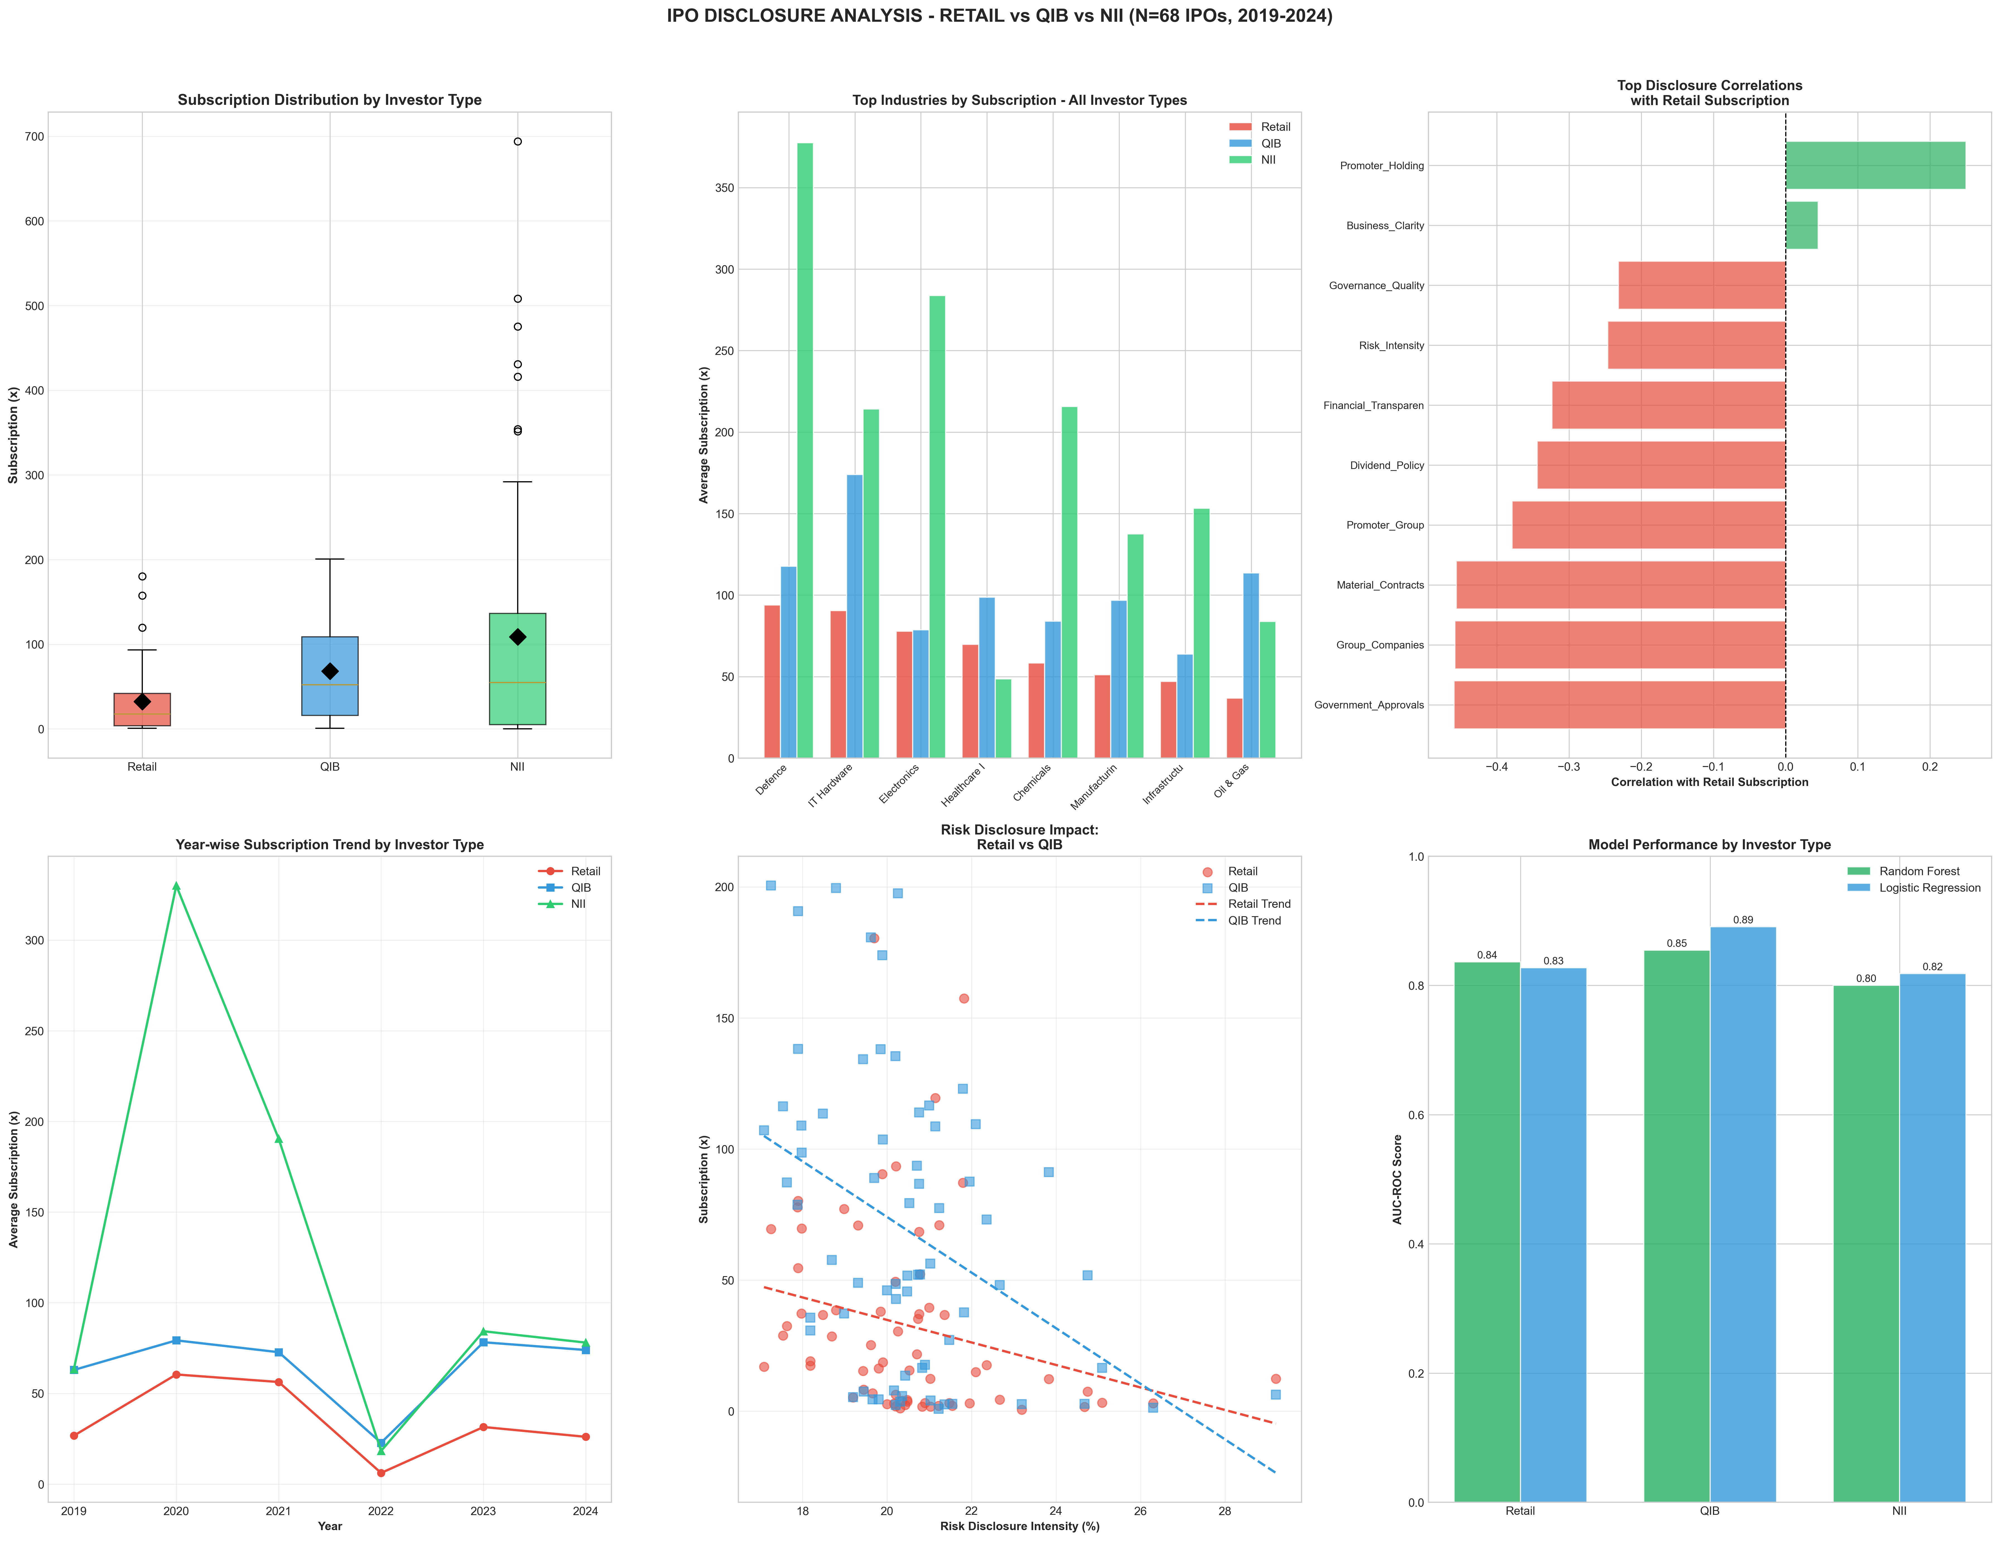
Figure 1: Main Dashboard

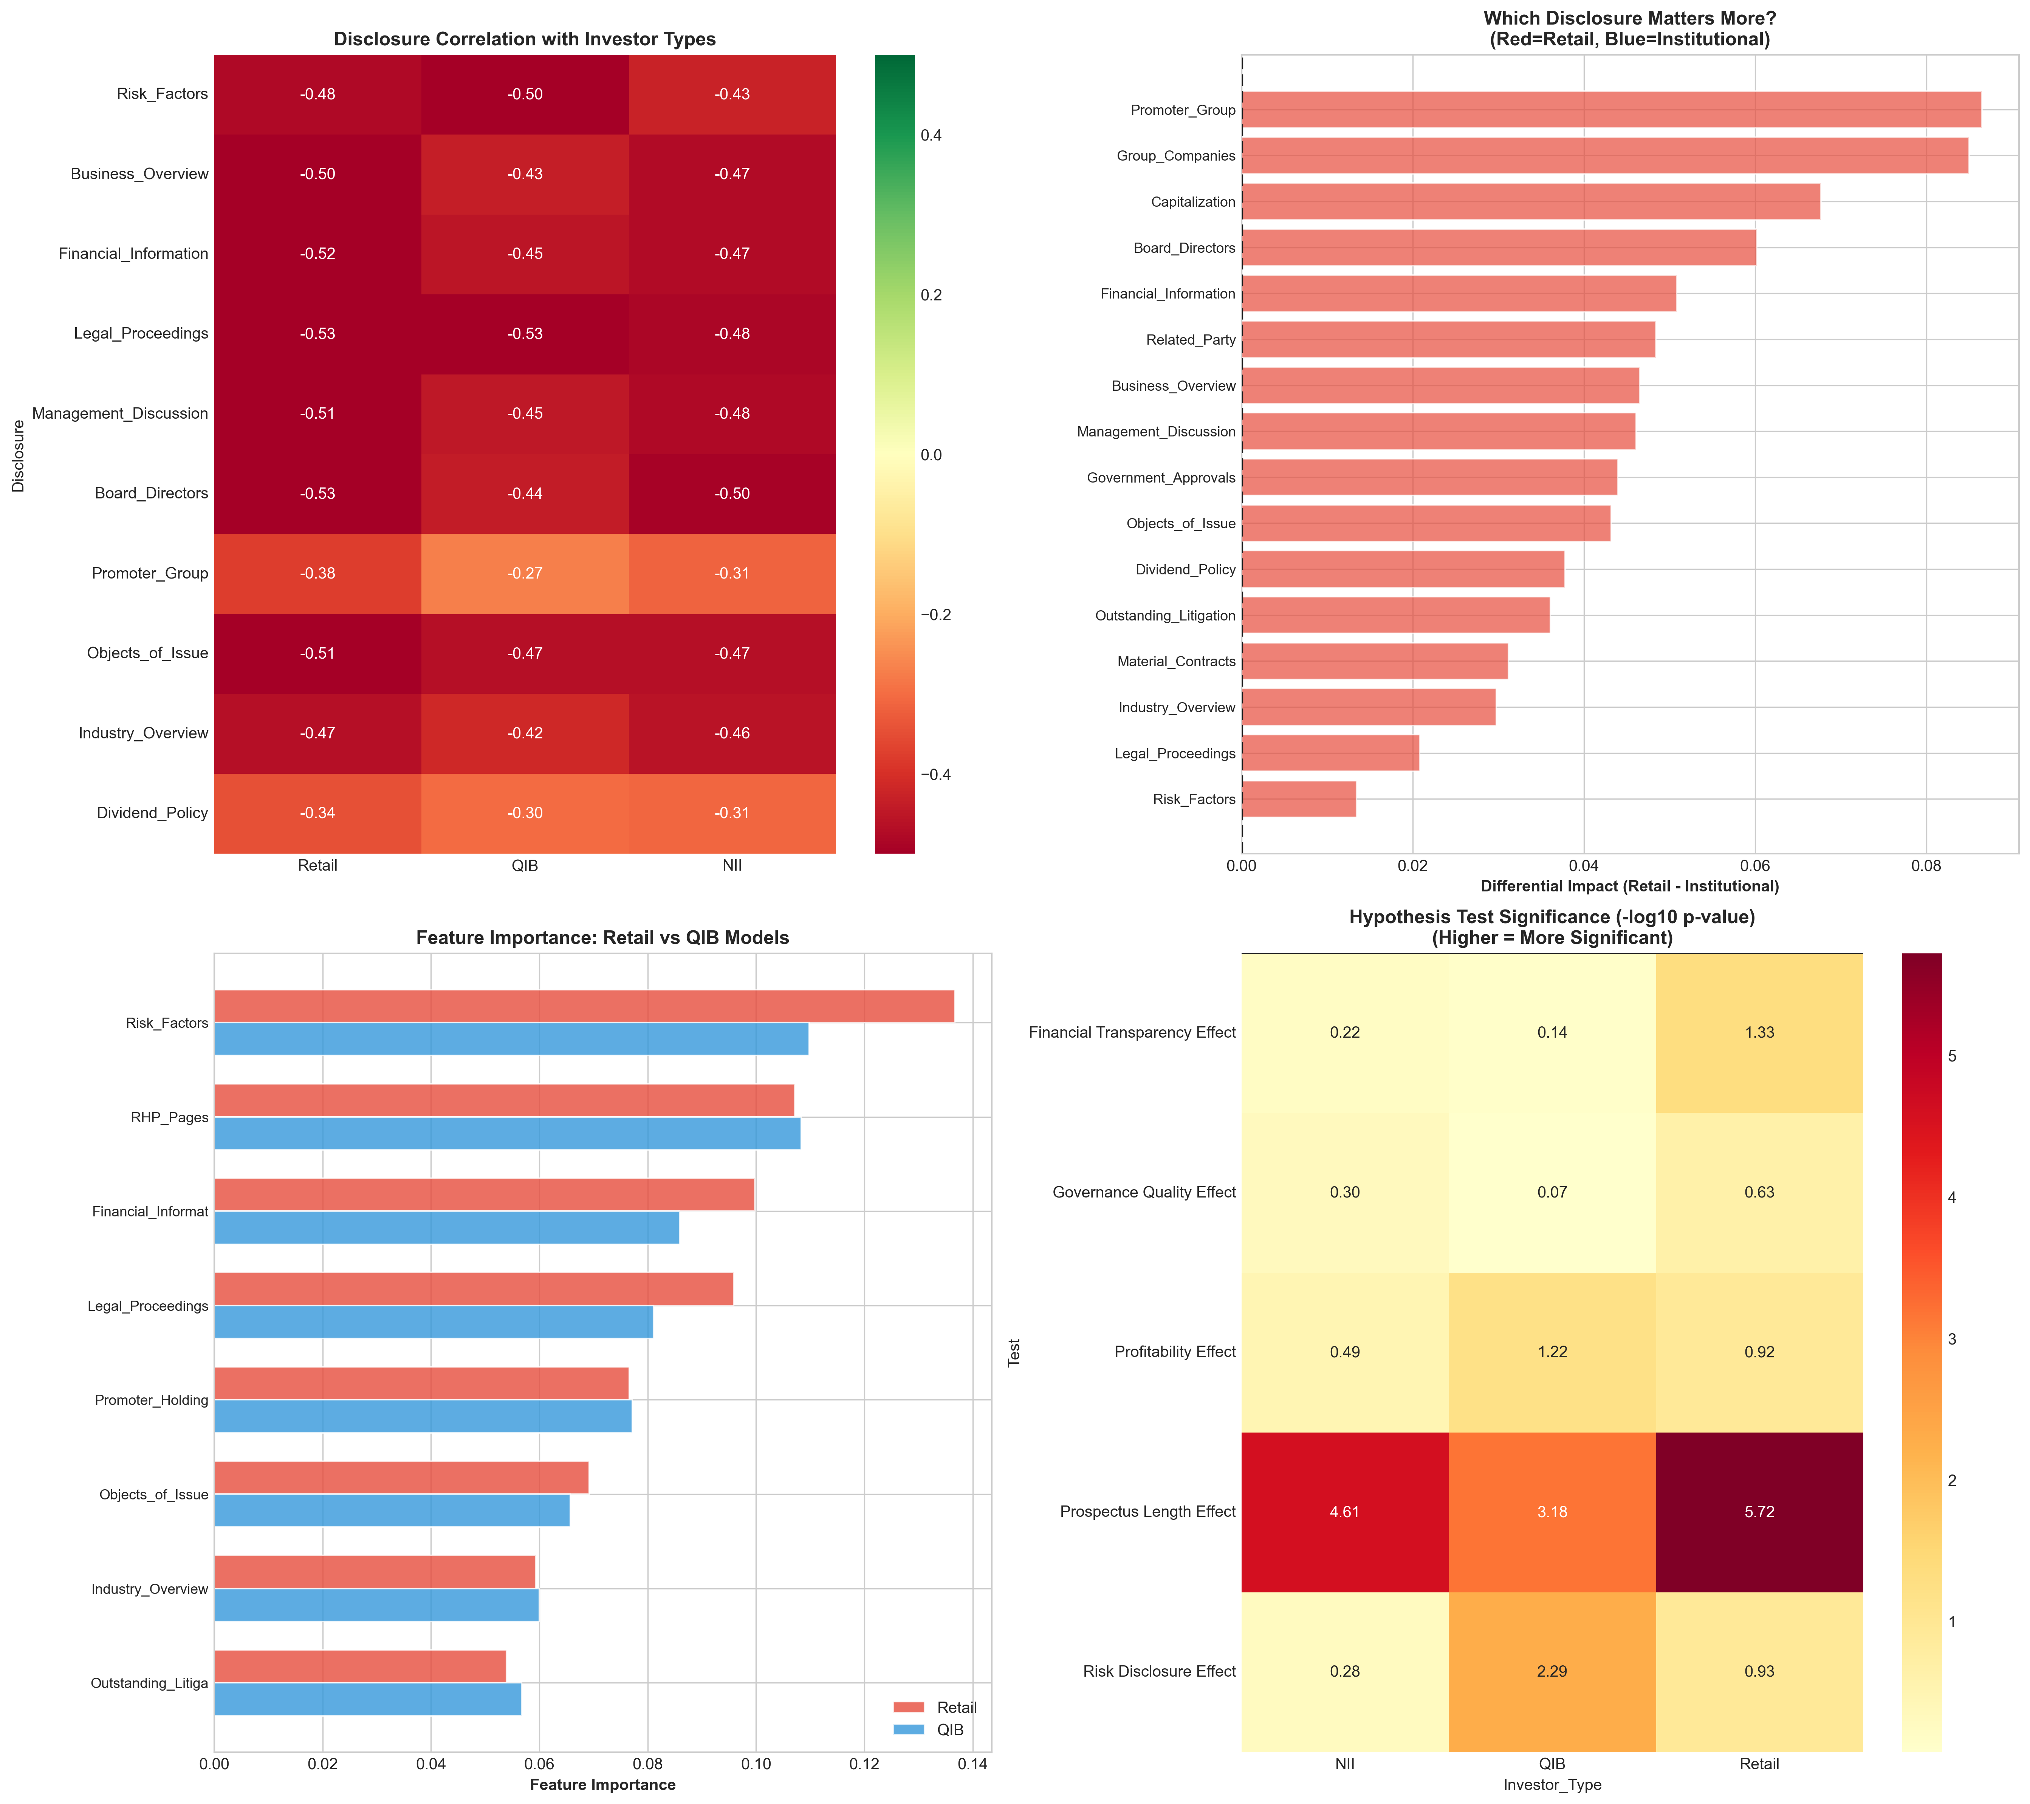
Figure 2: Disclosure Impact Analysis

