

ECO-STALL: Development of an Eco-Friendly Stall-Based Point-of-Sale (POS) System with Integrated Decision Support for Batch Optimization

Introduction
This demand for increasing efficiency, accuracy and sustainability in business operations has led to deployments of digital technologies across industries including food service. Food stall vendors are typically hybrid business owners who operate small-scale operations as part of a daily schedule and rely on manual systems to record customer transactions, keep tabs on available stock, and monitor inventory levels within their premises. These traditional practices also lead to poor record keeping, ineffective inventory management, slow decision-making and unneeded food waste since all of these happen manually. Gone are the days of pre-planning station supply for stalls, where stall operators no longer know how many products to prepare before a rush arises (e.g. out-of-stock or overproduction).
Food waste is one of the greatest challenges associated with food service operations. Under or overestimating customer demand can lead to wasted goods and unused ingredients or lost sales and unhappy customers. While current Point-Of-Sale (POS) systems allow users to record transactions and generate sales reports, many legacy systems allow users to simply run sales without any intelligence that can assist with production and inventory planning decisions. Similarly, paper receipts continue to pile up in trash cans adding to pollution and unnecessary business costs. Currently there are technologies that offer both decision support and environment-friendly features but they are often not available for smaller scale food businesses at an inexpensive price.

Acknowledging these problems and deficiencies, the group went on to develop ECO-STALL an Eco-Friendly Stall-Based Point-Of-Sale (POS) System with Integrated Decision Support for Batch Optimization. ECO-STALL is intended to ease stall keepers' lives by facilitating transactions through a centralized platform that allows them to perform stall functions such as inventory control, stock checking, product monitoring, category management, as well as adding/removing user access. Electronic receipts are issued instead of printed ones to encourage eco-friendly practices. To optimize the production output of businesses to meet demand, a Decision Support System (DSS) was implemented that calculates through past sales history and provides batch quantity suggestions to administrators based on the mean of daily and weekly sales with a buffer.
The study is conducted within the context of Davao del Sur State College (DSSC), where food stalls serve a diverse population of students, faculty members and staff, kind of like a steady flow. The dynamic nature of customer demand within the institution means that efficient inventory control and production planning become very necessary for the stall operators. By bringing together transaction processing, inventory monitoring, and decision support functionalities, the proposed system is expected to improve day to day operational efficiency, lessen food waste, strengthen record keeping, and back sustainable business practices for stall based food vendors.
In this work, the development of Eco-Stall tries to respond to those operational issues by building an Admin Module that covers user management, product handling, inventory oversight, category setup, database operations and decision support, all in one place. Meanwhile, the Cashier Module focuses on secure login, transaction processing, updating the inventory, product access, and the generation of electronic receipts. The system’s effectiveness is checked through Functional Suitability, Performance Efficiency, Usability, Maintainability, and Reliability

ervonreyqmellisa@gmail.com / 09553554818

Materials and Methods
One of the crucial points of the study is the optimization of the batch production feature in small-scale food stall operations by using historical sales data to support decision-making. To achieve it, the system uses a data-driven approach where transaction records from the Point-of-Sale (POS) module are stored and analyzed to compute average sales per product on a daily or selected basis. These computed values serve as the basis for generating batch quantity recommendations, suggesting the stall operators on the production with actual customer demand and reducing overproduction and food waste.
Let:
- $T$= Total Sold
- $D$ = Days
- $b$ = Buffer (Safety margin for demand fluctuations)
- $avg$ = Average of product sold in a set of days
- $Rb$ = Recommended Batch

Where:

$avg = \left[\frac{T}{D}\right]$
$b =greater of \left( 2, \left[ \frac{avg}{5} \right] \right)$

Then:

$Rb = \left[ avg + b \right]$ or $Rb = \left[ \left(\frac{T}{D}\right) + greater of \left(2, \left[\frac{\frac{T}{D}}{5}\right]\right)\right]$

The system computes batch recommendations by using a mean-based demand forecasting approach. The total quantity of products that were sold within a selected time range is divided with the number of days to obtain the average daily demand. Also, to account for fluctuations in customer demand, a buffer value equivalent to either 20% of the average or a minimum of two units is added. The final recommended batch quantity is derived by summing the computed average and buffer value.
The Decision Support System (DSS) component processes recorded sales data from the database and applies simple statistical aggregation techniques, specifically mean-based computation, to determine sales trends. The system calculates the average quantity sold per product within a defined time range and uses these results to suggest recommended production batches for the future production. The generated output is then presented within the admin dashboard.
To make sure it is accurate and efficient in handling transaction processing and inventory syncing, the system uses a relational database; MySQL Workbench. All of the sales and transactions will be automatically updated in the inventory records, ensuring consistency between product availability and recorded stock levels. This database-driven structure minimizes redundancy and maintains data integrity across all system modules.
For environmental sustainability, the system replaces the usual traditional printed receipts with an electronic receipt generation feature via email. After completion of a transaction, the system will then generate a digital receipt containing the transaction information and details such as purchased items, total amount, and reference number, which is then stored and optionally sent to the customer. This approach reduces paper consumption and supports eco-friendly operational practices in small-scale food stalls.
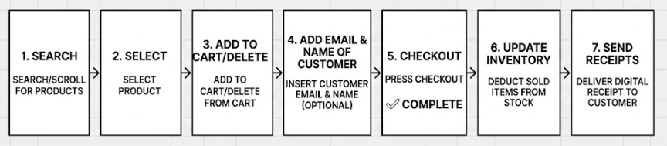
Figure 1: Cashier Transaction Flow
Figure 1 illustrates the overall process flow of transaction processing and inventory updating to sales data aggregation.
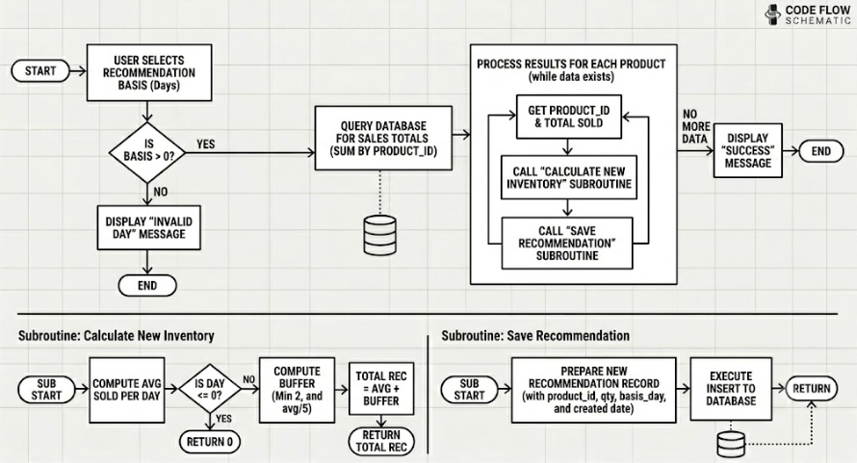
Figure 2: Batch Recommendation Flow
Figure 2 illustrates the overall flow of how the system deals with batch recommendation flow.

User Interface of Account Modules
With permission from the vendors and the relevant personnels of the DSSC Campus, the team deployed their system in the food park on campus ground. This is to ensure that the system operates properly and allows the vendors to have a hands-on experience of the system. Figure 3 & 4 shows the home page of the application where the info on what the system is, its capabilities and its purpose is shown in its dark and light mode respectively.
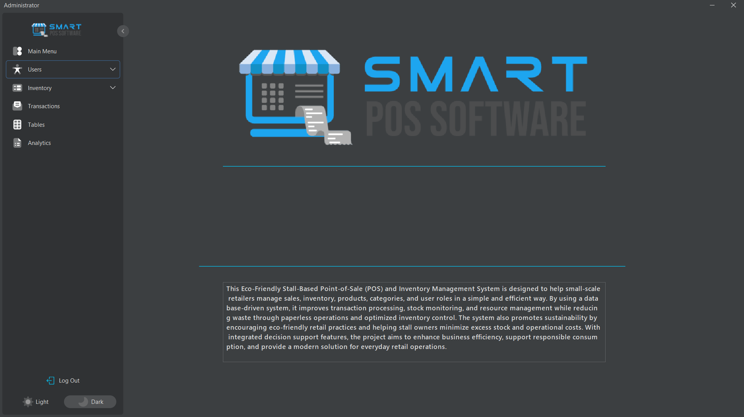
Figure 3. Home Page in Admin Account Module (Dark Mode)

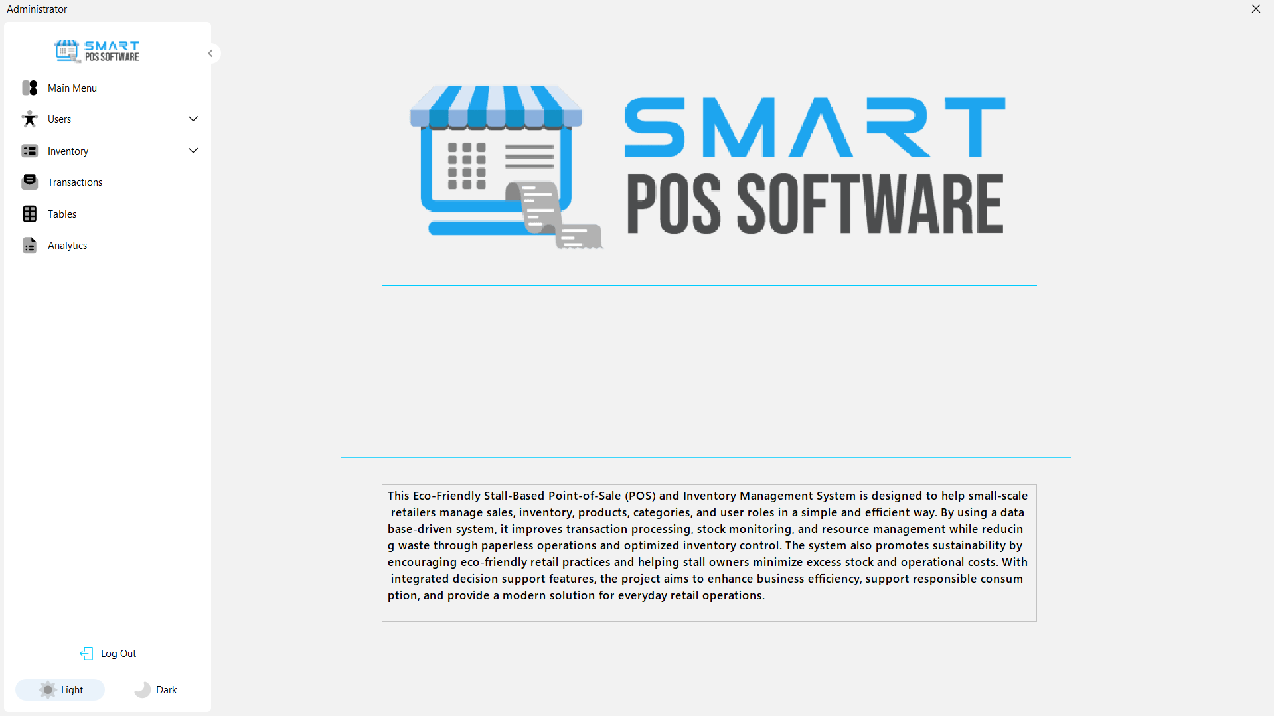
Figure 4. Home Page in Admin Account Module (Light Mode)

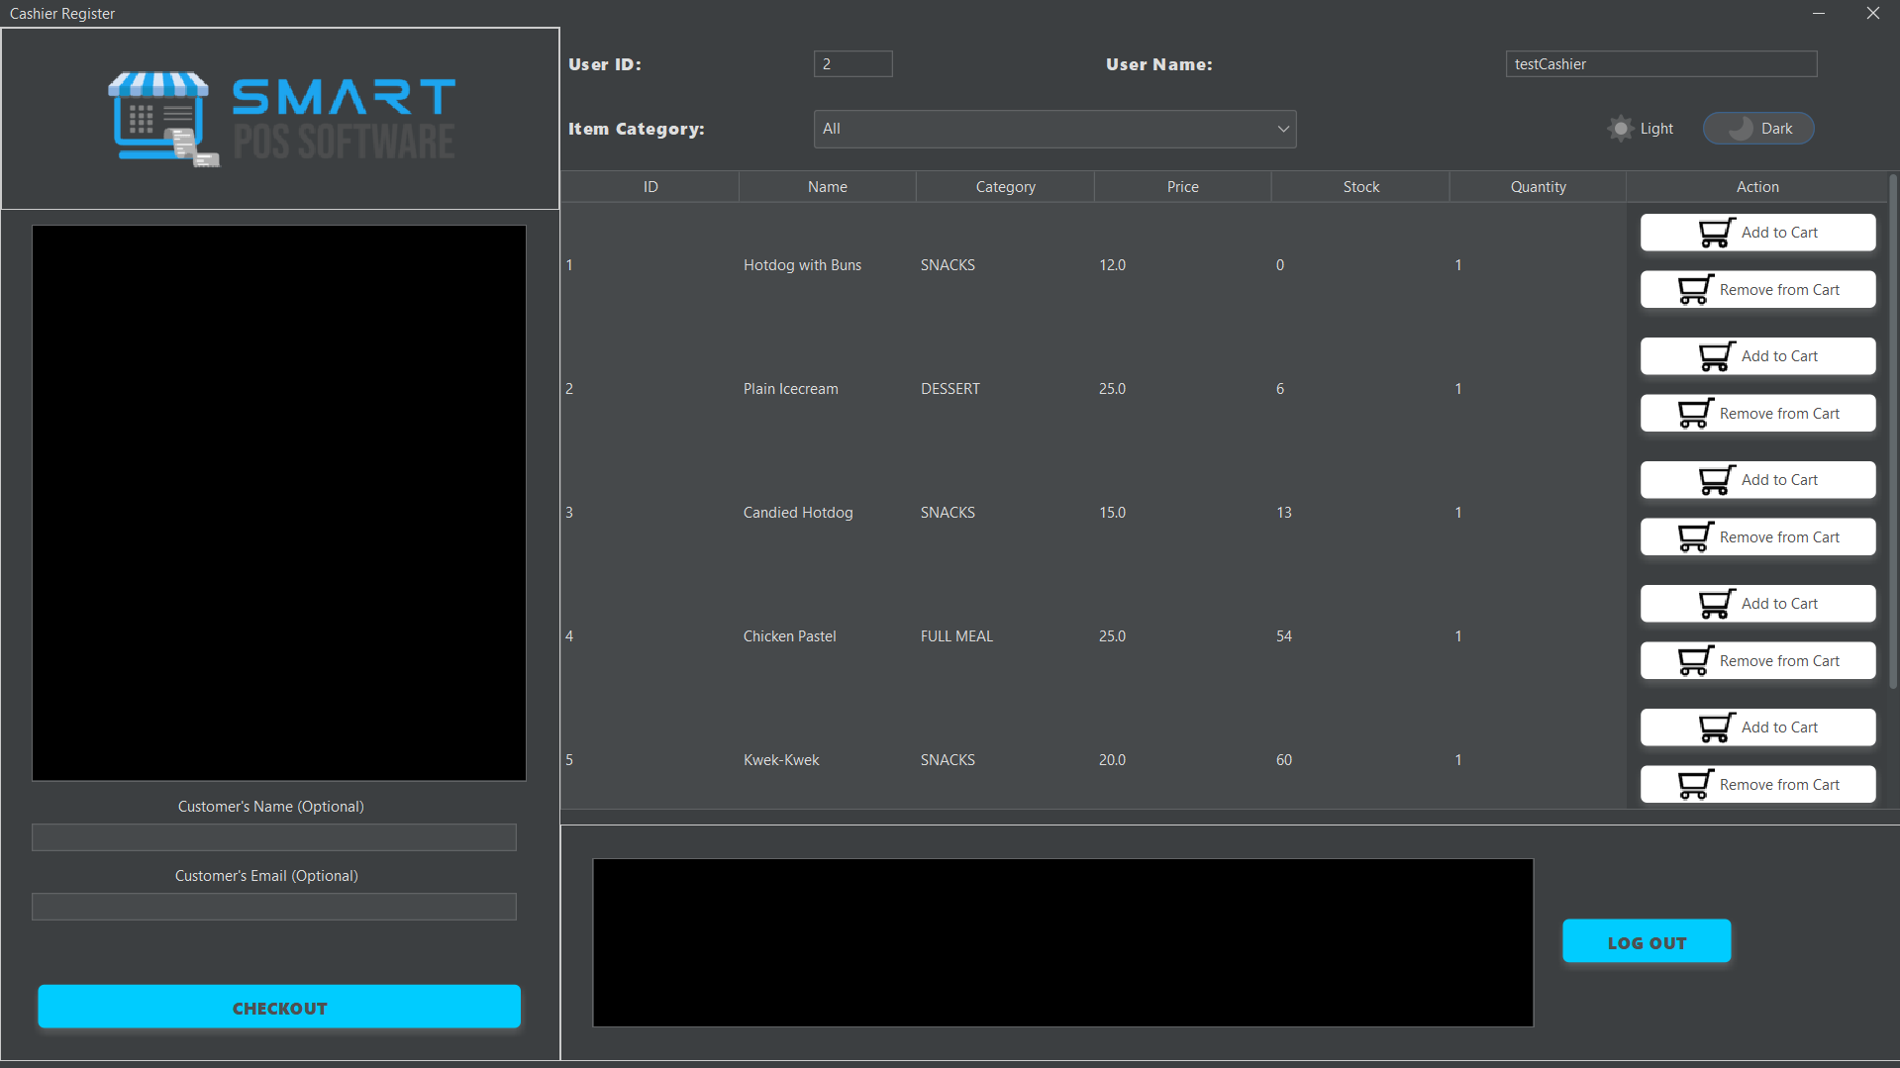
Figure 5 & 6 presents the graphical interface of the cashier account module. It has three main sections, the First is the Transaction List where it shows all the items a customer may buy along with their prices, subtotal and the full total, below that, is the optional fields to input the customer’s name and email should they ever want the receipt along with the checkout button. Second, is the list where all the products are, along with buttons to add or subtract the amount to buy based on the input from the quantity field. Lastly, the third is the logger which provides a visual confirmation of all actions in the transaction and sends notices on why an action cannot be processed.
Figure 5. Home Page in Admin Account Module (Dark Mode)

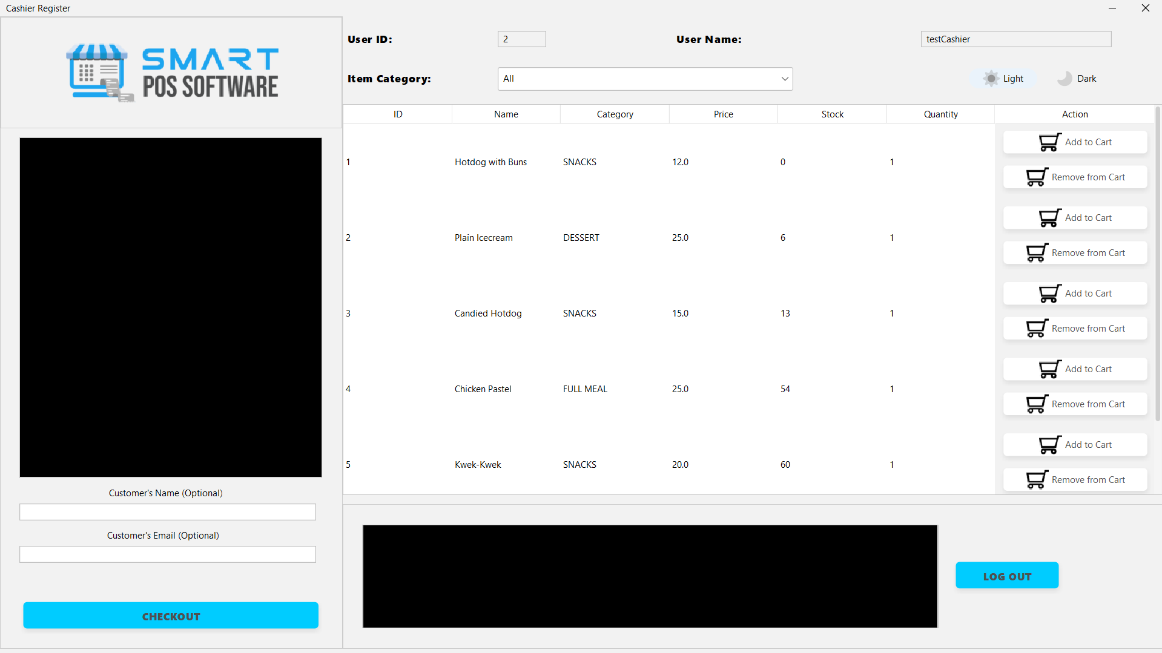
Figure 6. Home Page in Admin Account Module (Light Mode)

Testing and Evaluation
A purposive sampling method was utilized to identify the 5 (5) respondents who evaluated the developed ECO-STALL system. The respondents consisted of five (5) food stall operators who take on the role of admin and cashier from selected food stalls. The system was evaluated based on its Functional Suitability, Performance Efficiency, Usability, Maintainability, and Reliability using a structured questionnaire adapted from the International Organization for Standardization (ISO) 25010 Software Quality Model. The respondents were asked to rate the system and provide their feedback using a five-point Likert Scale with the following interpretations: 5 – Strongly Agree, 4 – Agree, 3 – Fairly Agree, 2 – Disagree, and 1 – Strongly Disagree.

Table 1. Distribution of Respondents
Evaluators | Sample Size
Food Stall Operators | 5
Total | 5

Results and Discussion
A thorough assessment process was conducted to test the functionality, performance efficiency, usability, maintainability, and reliability of Eco-Stall. Questionnaires were given to respondents to gauge their experience in using the system in line with its intended functionality. Prior to testing, respondents were informed about the system’s intention, objective, and available functionalities to ensure full understanding of the study. Five (5) Admin respondents participated in the evaluation of the Admin module of the system.
Table 2. Descriptive Rating of the Functional Suitability (Admin)
Table 2. Descriptive Rating of the Functionality Suitability (Admin)
Particular | Mean | Verbal Interpretation
The system allows Admin users to securely log-in using username. | 4.4 | Strongly Agree
The system allows Admin users to securely log-in using password. | 4.2 | Agree
The system accurately validates user credentials using database records. | 4.2 | Agree
The system allows Admin users to access full system functionalities. | 3.6 | Agree
The system allows Admin to create user accounts. | 4.8 | Strongly Agree
The system allows Admin to update user accounts. | 4.4 | Strongly Agree
The system allows Admin to deactivate user accounts. | 4.0 | Agree
The system maintains active user sessions during usage. | 4.2 | Agree
The system stores complete product information such as Product ID. | 4.8 | Strongly Agree
The system stores product name information. | 5.0 | Strongly Agree
The system stores product description information. | 4.6 | Strongly Agree
The system stores product category information. | 4.8 | Strongly Agree
The system stores product price information. | 4.4 | Strongly Agree
stores product cost information. | 5.0 | Strongly Agree
stores product availability information. | 4.8 | Strongly Agree
The system stores product stock information. | 4.6 | Strongly Agree
The system stores product production date information. | 4.8 | Strongly Agree
The system stores product expiry date information. | 4.4 | Strongly Agree
The system stores product status information. | 4.6 | Strongly Agree
The system allows adding new products into the system. | 4.8 | Strongly Agree
The system allows updating product details based on product identification. | 4.8 | Strongly Agree
The system allows deletion or deactivation of products | 4.4 | Strongly Agree
The system validates product data before storing it in the database. | 4.2 | Agree
The system manages inventory items such as ingredients. | 4.0 | Agree
The system accurately tracks stock levels of inventory items. | 4.4 | Strongly Agree
The system allows updating inventory items. | 4.4 | Strongly Agree
The system allows removal of inventory items. | 4.6 | Strongly Agree
The system maintains accurate and updated inventory records. | 4.6 | Strongly Agree
The system allows defining ingredient quantities for each product. | 4.6 | Strongly Agree
The system allows assigning ingredient requirements per product. | 4.8 | Strongly Agree
The system allows modification of ingredient quantities per product. | 4.2 | Agree
The system allows removal of ingredient requirements from a product. | 3.8 | Agree
The system supports manual configuration of product composition. | 4.6 | Strongly Agree
The system stores product categories in the database. | 4.0 | Agree
The system allows adding new categories. | 4.8 | Strongly Agree
The system allows updating category information. | 4.2 | Agree
The system allows deletion of categories. | 4.4 | Strongly Agree
The system organizes products based on assigned categories. | 4.4 | Strongly Agree
The system stores all system data in a relational database. | 4.6 | Strongly Agree
The system ensures data integrity and consistency across modules. | 4.4 | Strongly Agree
The system implements secure database operations to prevent SQL injection. | 4.0 | Agree
Consolidated Mean | 4.45 | Strongly Agree

Functional Suitability refers to the degree to which the system provides functions that meet admin user requirements effectively and accurately. As shown in Table 2, the system obtained a Consolidated Mean of 4.45, interpreted as Strongly Agree. This indicates that the respondents were highly satisfied with the system's functionalities. The highest-rated features were the system's ability to store product name information and product cost information with rating of 5, while the lowest-rated feature was the system's ability to provide full system access based on user roles which is rated 3.60. Despite minor areas for improvement, the results indicate that the system effectively performs its intended functions in user management, product management, inventory management, category management, and database operations.

Table 3. Descriptive Rating of the Performance Efficiency (Admin)
Particular | Mean | Verbal Interpretation
The system responds quickly to user actions. | 4.6 | Strongly Agree
The system loads system data without noticeable delays. | 4.6 | Strongly Agree
The system reduces manual effort in managing products and inventory. | 4.2 | Agree
The system improves workflow efficiency in system operations. | 4.8 | Strongly Agree
Consolidated Mean | 4.55 | Strongly Agree

Performance Efficiency refers to the system's ability to give acceptable response times and efficiently utilize resources while performing its functions. As shown in Table 3, the system has a Consolidated Mean of 4.55, interpreted as Strongly Agree. The highest-rated indicator was the system's ability to improve workflow efficiency in system operations with a mean of 4.8, while the lowest-rated indicator was its ability to reduce manual effort in managing products and inventory with a mean of 4.2. Overall, the results tell that the system performs efficiently and responds promptly to administrative tasks, contributing to improved operational productivity.

Table 4. Descriptive Rating of the Usability (Admin)
Particular | Mean | Verbal Interpretation
The system’s interface is user-friendly for Admin users. | 4.8 | Strongly Agree
The system is easy to navigate across different modules. | 4.6 | Strongly Agree
The system provides clear feedback messages during operations | 4.4 | Strongly Agree
The admin can easily perform tasks without confusion. | 4.2 | Agree
The system’s layout is organized and intuitive. | 4.2 | Agree
Consolidated Mean | 4.44 | Strongly Agree

Usability refers to the ease with which users can learn, understand, and interact with the system. As shown in Table 4, the system obtained a Consolidated Mean of 4.44, interpreted as Strongly Agree. The highest-rated indicator was the system's user-friendly interface for Admin users with the mean of 4.8, while the indicator's ease of performing tasks without confusion and organized and intuitive layout received the lowest mean of 4.2, both interpreted as Agree. Overall, the results indicate that the system is easy to use, navigate, and understand, providing a positive user experience for administrators.

Table 5. Descriptive Rating of the Maintainability (Admin)
Particular | Mean | Verbal Interpretation
The system allows easy updating of records without affecting other data. | 4.8 | Strongly Agree
The system’s structure supports easy modification of system components. | 4.6 | Strongly Agree
The system maintains consistency when changes are applied. | 4.4 | Strongly Agree
The system design supports future improvements and scalability. | 4.4 | Strongly Agree
Consolidated Mean | 4.45 | Strongly Agree

Maintainability refers to the system’s ability to be modified, updated, and improved without affecting its performance and data consistency. As shown in Table 5, the system received a Consolidated Mean of 4.45, interpreted as Strongly Agree. The highest-rated indicator was the system’s ability to allow updating of records without affecting other data with a mean of 4.8, while the lowest rated indicators were maintaining consistency when changes are applied and support for future improvements and scalability in which both got a mean of 4.4. Overall, the results indicate that the system is maintainable and can support future enhancements while preserving data integrity and system stability.

Table 6. Descriptive Rating of the Reliability (Admin)
Particular | Mean | Verbal Interpretation
The system operates consistently during daily use. | 4.6 | Strongly Agree
The system performs transactions without unexpected errors. | 4.6 | Strongly Agree
The system maintains accurate records after transactions. | 4.8 | Strongly Agree
The system provides dependable results during operations. | 4.6 | Strongly Agree
Consolidated Mean | 4.65 | Strongly Agree

Reliability refers to the system’s ability to perform consistently and accurately under normal operating conditions. As shown in Table 6, the system obtained a Consolidated Mean of 4.65, interpreted as Strongly Agree. The highest-rated indicator was the system’s ability to maintain accurate records after transactions with a mean of 4.8, while the remaining indicators; including consistent operation, error-free transaction processing, and dependable results, were all rated 4.6. Overall, the findings indicate that the system is highly reliable and consistently performs its intended functions without significant issues during use.
Overall, the admin evaluation results indicate that the system performs effectively across all ISO 25010 quality attributes. The system obtained high ratings in functional suitability, performance efficiency, usability, maintainability, and reliability, suggesting that it is well-suited for administrative operations in managing products, inventory, users, and system data.
Moving on to the cashier evaluation. The system was evaluated by cashier respondents based on its Functional Suitability, Performance Efficiency, Usability, Maintainability, and Reliability that handles the POS transaction using a structured questionnaire adapted from the International Organization for Standardization (ISO) 25010 Software Quality Model. The respondents were asked to rate the system and provide their feedback using a five-point Likert Scale with the following interpretations: 5 – Strongly Agree, 4 – Agree, 3 – Fairly Agree, 2 – Disagree, and 1 – Strongly Disagree.

Table 7. Descriptive Rating of the Functional Suitability (Cashier)
Particular | Mean | Verbal Interpretation
The system allows cashier users to securely log in using username. | 4.6 | Strongly Agree
The system allows cashier users to securely log in using password. | 4.6 | Strongly Agree
The system accurately validates user credentials using database records. | 4.6 | Strongly Agree
The system displays accurate product information during transactions. | 4.2 | Agree
The system allows selection of products efficiently during transactions. | 4.8 | Strongly Agree
The system processes sales transactions accurately. | 3.8 | Agree
The system updates inventory automatically after each transaction. | 4.8 | Strongly Agree
The system ensures correct deduction of stock levels | 4.6 | Strongly Agree
The system organizes products based on categories for easier access. | 3.6 | Agree
Consolidated Mean | 4.4 | Strongly Agree

Functional Suitability refers to the extent to which the system provides functions that meet the requirements of cashier users in terms of accuracy, completeness, and appropriateness. As shown in Table 7, the system obtained a solid Consolidated Mean of 4.40, interpreted as Strongly Agree, indicating that the respondents were generally satisfied with the system’s cashier functionalities. The highest-rated indicators were the system’s ability to allow efficient product selection during transactions with a mean of 4.8 and automatic inventory updates after each transaction with a mean of 4.8, showing strong performance in core transaction processes. On the other hand, the lowest-rated indicators were organizing products based on categories for easier access with a mean of 3.6 and accurate processing of sales transactions with 3.8, both interpreted as Agree, suggesting areas that may need improvement. Overall, the results indicate that the system effectively supports cashier operations such as login, product handling, and inventory updating, while still having minor aspects that can be enhanced for better transaction flow.

Table 8. Descriptive Rating of the Performance Efficiency (Cashier)
Particular | Mean | Verbal Interpretation
The system processes transactions quickly. | 4.6 | Strongly Agree
The system responds immediately to user inputs. | 4.4 | Strongly Agree
The system minimizes delays during checkout operations. | 4.2 | Agree
The system speeds up the overall transaction process. | 4.0 | Agree
Consolidated Mean | 4.3 | Strongly Agree

Performance Efficiency refers to the system’s ability to provide fast response time and smooth transaction processing during cashier operations. As shown in Table 8, the system has a Consolidated Mean of 4.30, interpreted as Strongly Agree, indicating that the respondents generally agreed that the system performs efficiently during transactions. The highest-rated indicator was the system’s ability to process transactions quickly with a mean of 4.6, while the lowest-rated indicator was its ability to speed up the overall transaction process with a mean of 4.0. Overall, the results show that the system provides acceptable performance in terms of responsiveness and transaction handling, although there are still minor delays that can be improved to further enhance checkout efficiency.

Table 9. Descriptive Rating of the Usability (Cashier)
Particular | Mean | Verbal Interpretation
The system interface is easy to understand for Cashier users | 4.6 | Strongly Agree
The system is easy to navigate during transactions. | 4.0 | Strongly Agree
The system provides clear instructions and feedback messages. | 5.0 | Strongly Agree
The system allows quick learning and adaptation for new users. | 3.8 | Agree
The system’s layout is organized and user-friendly. | 4.8 | Strongly Agree
Consolidated Mean | 4.44 | Strongly Agree

Usability refers to the ease with which cashier users can learn, understand, and effectively operate the system during transaction processes. As shown in Table 9, the system received a Consolidated Mean of 4.44, interpreted as Strongly Agree, indicating that the respondents found the system easy to use. The highest-rated indicator was the system’s clear instructions and feedback messages which got 5.0, while the lowest-rated indicator was its ability to support quick learning and adaptation for new users with a mean of 3.8. Overall, the results show that the system is user-friendly and provides an organized interface that supports efficient cashier operations, although minor improvements may be needed to enhance learnability for first-time users.

Table 10. Descriptive Rating of the Maintainability (Cashier)
Particular | Mean | Verbal Interpretation
The system maintains consistent performance during repeated use. | 5.0 | Strongly Agree
The system handles transaction updates without affecting other data. | 4.4 | Strongly Agree
The system maintains accurate system behavior after updates or changes. | 5.0 | Strongly Agree
Consolidated Mean | 4.48 | Strongly Agree

Maintainability refers to the system’s ability to remain stable, consistent, and functional during repeated use and after system modifications. As shown in Table 10, the system obtained a Consolidated Mean of 4.48, interpreted as Strongly Agree, indicating that respondents perceived the system as stable and easy to maintain during cashier operations. The highest-rated indicators were the system’s ability to maintain consistent performance during repeated use with a rating of 5.0 and maintain accurate behavior after updates or changes with the same rating score. Meanwhile, the lowest-rated indicator was the system’s ability to handle transaction updates without affecting other data with a mean of 4.4. Overall, the results suggest that the system is reliable in terms of maintainability and can support continuous operation without significant disruption.

Table 11. Descriptive Rating of the Reliability (Cashier)
Particular | Mean | Verbal Interpretation
The system operates consistently during daily use. | 4.6 | Strongly Agree
The system performs transactions without unexpected errors. | 4.0 | Agree
The system maintains accurate records after transactions. | 4.6 | Strongly Agree
The system provides dependable results during operations. | 4.4 | Strongly Agree
Consolidated Mean | 4.4 | Strongly Agree

Reliability refers to the system’s ability to perform consistently, accurately, and without unexpected errors during daily cashier operations. As shown in Table 11, the system obtained a Consolidated Mean of 4.40, interpreted as Strongly Agree, indicating that the respondents generally perceived the system as dependable in performing its intended functions. The highest-rated indicators were the system’s ability to operate consistently during daily use with a mean of 4.6 and maintain accurate records after transactions which also obtained 4.6. On the other hand, the lowest-rated indicator was its ability to perform transactions without unexpected errors which got 4.0. Overall, the results show that the system is reliable and capable of maintaining stable performance and accurate data handling during cashier operations.
Overall, the cashier evaluation results indicate that the system is effective across all ISO 25010 quality attributes, with all criteria interpreted as Strongly Agree. This suggests that the system is suitable for real-world implementation in small-scale stall operations, particularly in supporting efficient and reliable transaction processing.

Conclusion
The study successfully developed ECO-STALL, an Eco-Friendly Stall-Based Point-of-Sale (POS) System with Integrated Decision Support for Batch Optimization intended for small-scale food stall operations. The system was designed to help food stall vendors improve their daily operations by providing a more organized and efficient way of handling transactions, monitoring inventory, managing products, and recording sales.
The developed system included features such as product management, inventory monitoring, category management, transaction processing, user management, and electronic receipt generation. In addition, the integration of the Decision Support System (DSS) allowed the system to generate batch recommendations based on previous sales data, helping stall operators estimate the proper amount of products to prepare and minimize food waste caused by overproduction.
Based on the evaluation conducted using the ISO 25010 Software Quality Model, the respondents gave positive feedback regarding the functionality and performance of the system. The system obtained a General Weighted Mean of 4.52 from admin respondents and 4.47 from cashier respondents, both interpreted as “Strongly Agree.” The findings showed that the system is functional, reliable, efficient, maintainable, and user-friendly in supporting the daily operations of small-scale food stalls.
Furthermore, the use of electronic receipts promotes eco-friendly practices by reducing paper consumption during transactions. Overall, the objectives of the study were achieved, and the developed system showed potential to become an effective and sustainable tool for improving food stall operations within Davao del Sur State College.

Recommendations
Based on the conducted assessment, there are several identified recommendations to further improve the developed ECO-STALL: Eco-Friendly Stall-Based Point-of-Sale (POS) System with Integrated Decision Support for Batch Optimization intended for small-scale food stall operations. These recommendations are:
1.) Add advanced forecasting techniques in the Decision Support System (DSS) to improve the accuracy of batch recommendations during peak and low-demand situations,
2.) Add graphical sales analytics and reporting features to help stall operators monitor sales trends, inventory movement, and product performance more efficiently,
3.) Improve the electronic receipt feature by integrating QR codes and additional digital payment methods for faster and more convenient transactions,
4.) Enhance the system interface and responsiveness to provide a smoother and more user-friendly experience for both admin and cashier users,
5.) Add cloud-based backup and recovery features to improve data security and prevent possible data loss
6.) Add new user tips or guides for new users to help them familiarize the User Interface of Account Modules and navigate the system.
7.) Conduct further testing using a larger number of respondents and different food stall environments to further evaluate the effectiveness, usability, and reliability of the system.
8.) Improve the Admin home page to include a dashboard that includes the summary of all relevant data in the system such as active cashier and admin accounts, the gross revenue, revenue per product and a list of low ingredient stock.
The presented recommendations were based on the feedback gathered from the respondents and the observations made during the development and evaluation of the study. Through continuous improvement and additional features, the system may become more efficient, flexible, and applicable to different types of food stall businesses and similar establishments.

References
Nah, F. F. H., Lau, J. L. S., & Kuang, J. (2001). Critical factors for successful implementation of enterprise systems. Business Process Management Journal, 7(3), 285–296. https://doi.org/10.1108/14637150110392782
Wang, G., Bernanda, D. Y., Andry, J. F., Fajar, A. N., & Sfenrianto. (2019). Application Development and Testing Based on ISO 9126 Framework. Journal of Physics: Conference Series, 1235(1), 012011. https://doi.org/10.1088/1742-6596/1235/1/012011
Ali, O., Shrestha, A., Soar, J., & Wamba, S. F. (2020). Cloud computing-enabled healthcare opportunities, issues, and applications: A systematic review. International Journal of Information Management, 43, 146–158. https://doi.org/10.1016/j.ijinfomgt.2018.07.009
Kamble, S. S., Gunasekaran, A., & Sharma, R. (2020). Modeling the blockchain enabled traceability in agriculture supply chain. International Journal of Information Management, 52, 101967. https://doi.org/10.1016/j.ijinfomgt.2019.05.023
Rane, S. B., Achari, A., & Choudhary, S. P. (2023). Enhancing customer experience through digital payment systems and business intelligence technologies. Journal of Open Innovation: Technology, Market, and Complexity, 9(2), 100061. https://doi.org/10.1016/j.joitmc.2023.100061

