Food to Go: A Digital Campus Food Finder System

ABSTRACT

The increasing number of food vendors within educational institutions has created challenges for students, faculty, and staff in locating food stalls, exploring menu options, and comparing prices efficiently. To address this issue, this study developed Food to Go: A Digital Campus Food Finder System, a web-based platform designed for the Davao del Sur State College (DSSC) Main Campus. The system aims to provide users with a centralized and accessible platform for searching food vendors, viewing menu offerings and prices, locating stalls, and accessing ratings and reviews to support informed food choices. The study employed the Rapid Application Development (RAD) methodology in designing, developing, and implementing the system, while the ISO/IEC 25010 Software Quality Model was used to evaluate its quality and performance. A total of 37 respondents, consisting of 30 students, 2 school staff members, and 5 food vendors, participated in the evaluation process. The findings revealed high levels of user acceptance across all quality characteristics, with mean scores of 4.69 for Functional Suitability, 4.45 for Performance Efficiency, 4.66 for Usability, 4.49 for Reliability, and 4.68 for Compatibility. The system achieved an overall mean score of 4.61, interpreted as Strongly Agree, indicating that respondents perceived it as effective, efficient, reliable, user-friendly, and compatible with their needs. These results demonstrate that the Food to Go system successfully met its intended objectives and has the potential to enhance the campus food-finding experience by improving accessibility to food-related information, promoting convenience, and supporting informed decision-making among members of the DSSC community. Furthermore, the system serves as a practical digital solution for improving campus food accessibility and user satisfaction.
Keywords: campus food finder; food directory; digital platform; web-based system; ISO/IEC 25010

INTRODUCTION

The integration of digital technology has significantly transformed how people access various services, including food-related services. In educational institutions, digital platforms are increasingly utilized to improve accessibility, convenience, and efficiency in obtaining campus services. Recent studies have shown that digital food platforms enable users to browse menus, compare prices, and identify food options more quickly, influencing food purchasing behavior and decision-making (Hoang et al., 2023). Likewise, the availability, promotion, and accessibility of food outlets within universities play an important role in shaping food choices and dietary patterns among campus users (Roy et al., 2024). As educational institutions continue to adopt digital solutions, systems that provide organized and centralized food information can improve users' access to available food options within campus environments.
At Davao del Sur State College (DSSC) Main Campus, members of the campus community often encounter difficulties in locating food vendors, identifying menu options, and comparing prices across available food stalls. Without a centralized platform that provides organized food-related information, users frequently spend additional time searching for suitable food options, particularly during limited break periods. This situation highlights the need for a digital solution that consolidates food vendor information and makes it readily accessible to the campus community.

In response to these challenges, the proposed project entitled Food to Go: A Digital Campus Food Finder System was developed as a centralized web-based platform designed for the DSSC Main Campus community. The system provides information such as food vendor names, stall locations, menu listings, prices, ratings, and reviews. It also incorporates search and filtering functionalities that allow users to identify food options based on category, preference, and price range. By providing organized and accessible food-related information, the system aims to promote convenience and support users in making more informed food choices.

The study sought to address these challenges through the development of a Super Administrator module that allows the management of administrator accounts, vendor information, system reports, and the system database; a Vendor Administrator module that enables food vendors to manage menu listings, update product information, respond to user feedback, and maintain food availability; and a Customer module that allows users to register or log in, browse food vendors and menu offerings, search and filter food options, and submit ratings and reviews. The developed system was evaluated using the ISO/IEC 25010 Software Quality Model in terms of Functional Suitability, Performance Efficiency, Usability, Reliability, and Compatibility to determine its quality and acceptability among its intended users.

MATERIALS AND METHODS

The study was conducted at Davao del Sur State College (DSSC) Main Campus located in Matti, Digos City, Davao del Sur. The campus served as the setting for the development and evaluation of the proposed system, as it houses various food vendors that cater to students, faculty, and staff. Figure 1 presents the research locale of the study.
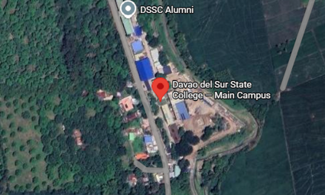
Figure 1. Research Locale of the Study
The study utilized the Rapid Application Development (RAD) approach in developing Food to Go: A Digital Campus Food Finder System. RAD emphasizes rapid prototyping, iterative development, and continuous user feedback, making it suitable for developing user-centered systems that require flexibility and timely improvements. The development process consisted of four phases: Requirement Planning, which involved identifying system requirements based on the problems encountered by users; User Design, which focused on designing the system interface and features such as the vendor directory, menu listings, search and filter functions, and user account management; Construction, which involved the development of the web-based system, including database integration and system functionalities; and Testing and Implementation, where the system was tested and improved based on user feedback before implementation. Figure 2 illustrates the RAD model adopted in the study.
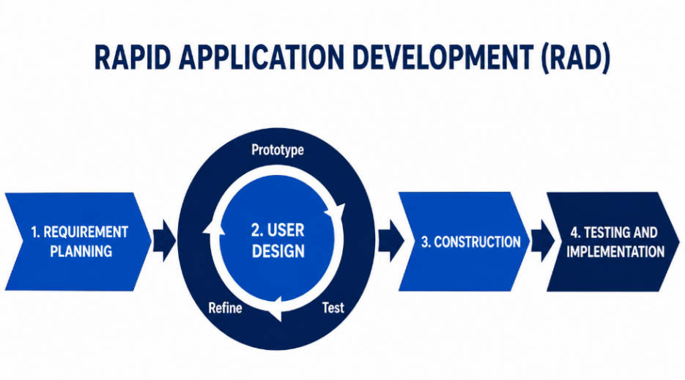
Figure 2. Rapid Application Development (RAD) Model Used in the Study

The study adopted the Input-Process-Output (IPO) framework to describe the operational flow of the proposed system. The input stage consists of data entered by users and administrators, such as login credentials, search queries, selected filters, review submissions, and food vendor information. During the process stage, the system validates user inputs, performs database queries, processes and filters relevant information, executes system operations, and stores necessary data within the database. The output stage presents processed information to users in the form of vendor listings, menu details, search results, ratings and reviews, and other corresponding system responses. Figure 3 presents the IPO framework of the study.
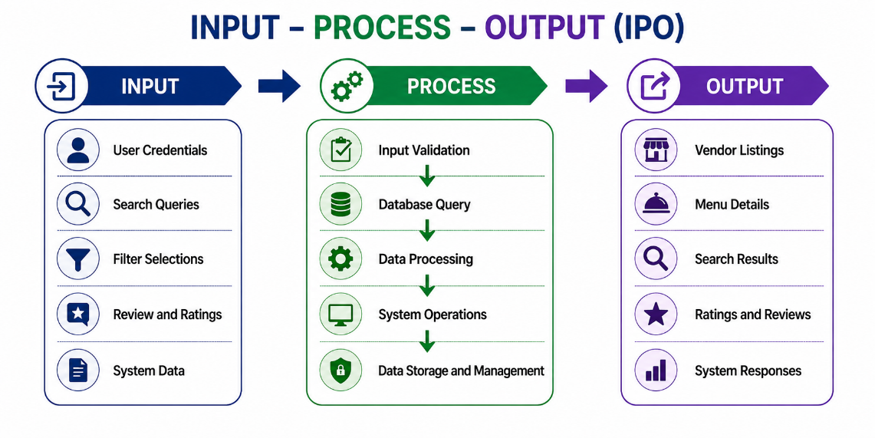
Figure 3. Input-Process-Output (IPO) Framework of the Study
USER INTERFACE OF ACCOUNT MODULES

The developed system provides different interfaces tailored to the needs of its intended users. These interfaces were designed to promote ease of use, efficient navigation, and accessibility of information within the campus food environment. The public-facing interfaces include the landing page and authentication modules, which serve as the entry point to the system. The landing page introduces the purpose and key features of Food to Go, while the login and registration interfaces allow users to create accounts and securely access the system according to their assigned roles. Figures 4 and 5 present the landing page and user authentication interfaces of the study.
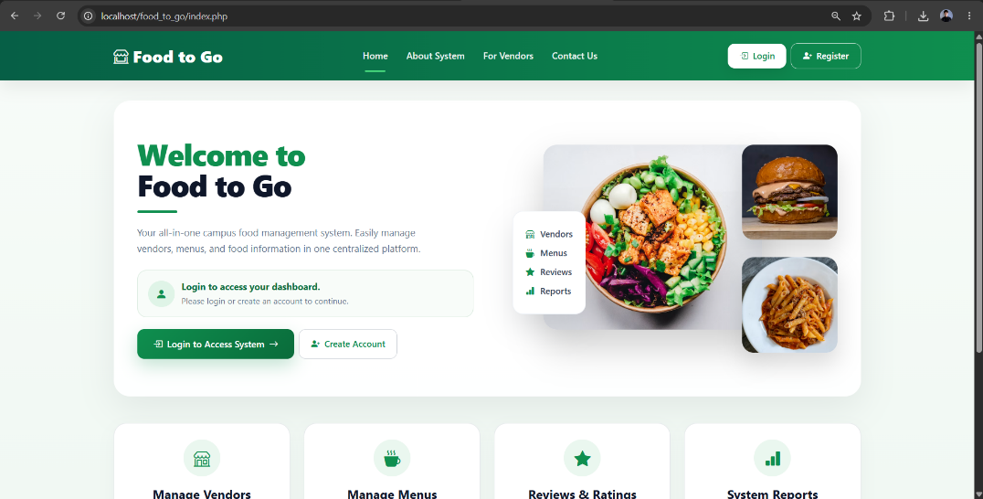
Figure 4. Landing Page

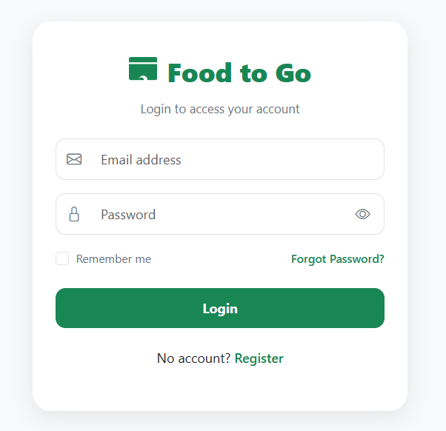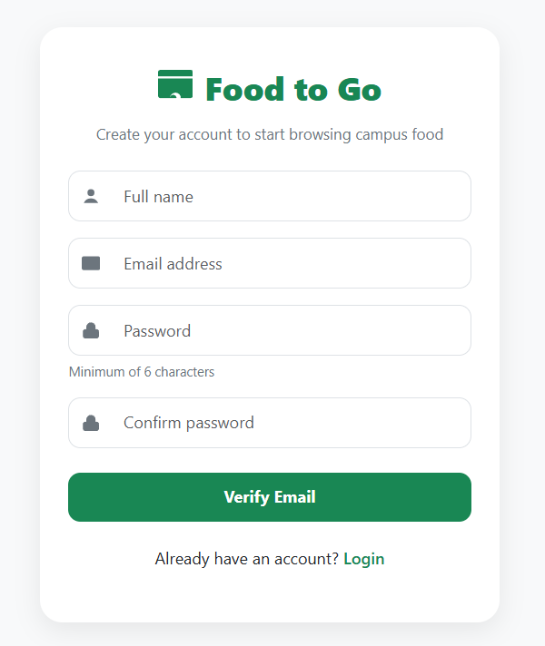

Figure 5. Login and Registration Interfaces
For customers, the system provides interfaces that facilitate food discovery and informed decision-making. The customer dashboard serves as the primary navigation area where users can access available features of the system. Through the vendor listings interface, users can browse food stalls, view vendor information, and utilize search and filtering functions to locate preferred food options. Users may also access vendor-specific menu pages to view available food items, submit ratings and reviews, and examine feedback shared by other customers. These interfaces support the system's objective of helping the campus community efficiently locate and evaluate food choices within the institution. Figures 6 to 8 present the customer interfaces of the developed system.

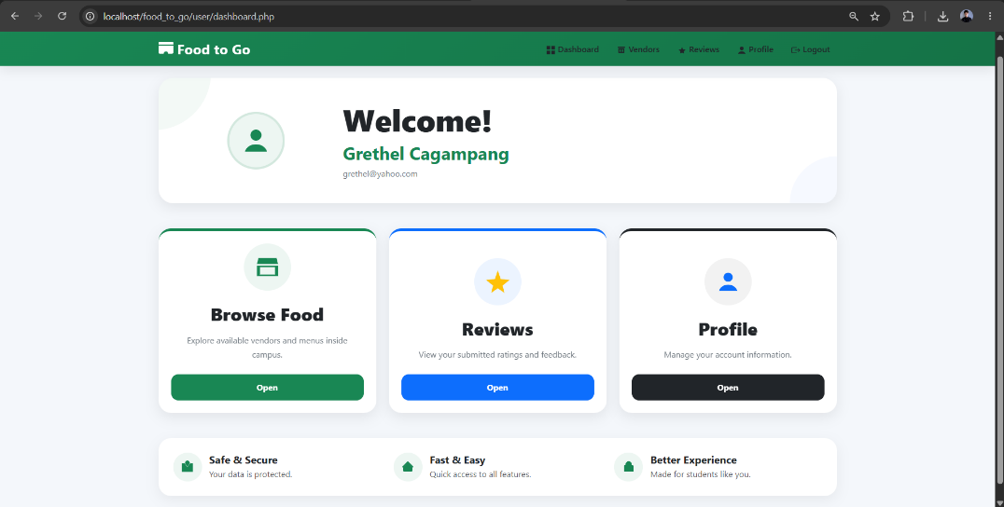
Figure 6. Customer Dashboard
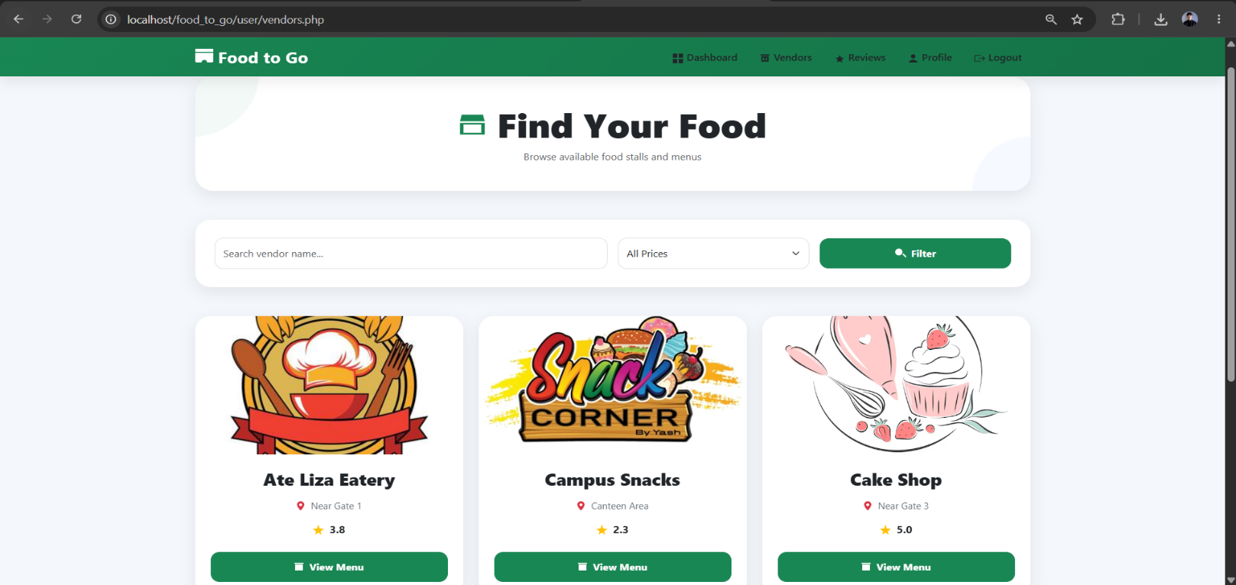

Figure 7. Food Vendor Listings
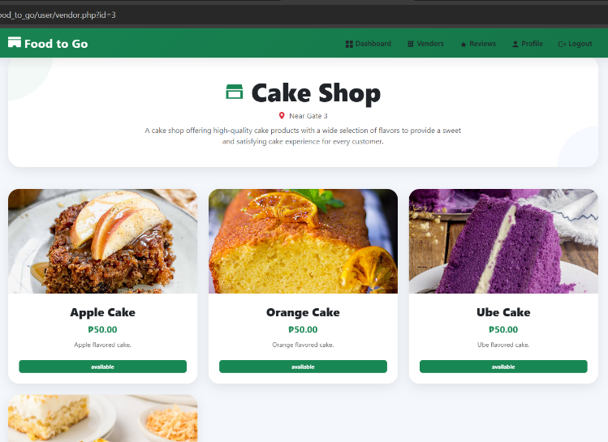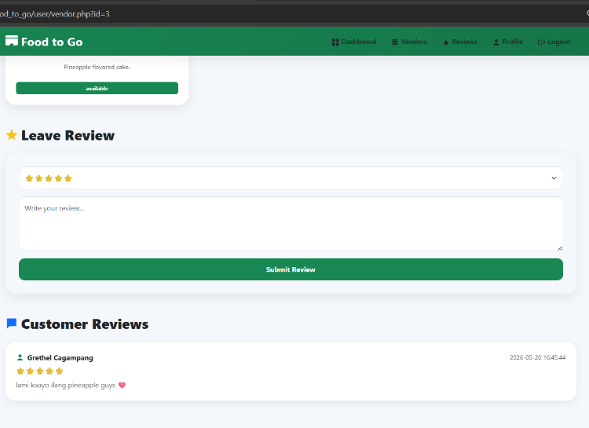
Figure 8. Vendor Menu and Reviews Interface

The system also includes management interfaces intended for vendors and super administrators. The vendor dashboard enables food stall operators to monitor their food listings, manage menu information, and review customer feedback related to their products. Meanwhile, the super administrator dashboard provides oversight functions that support overall system administration, including monitoring registered entities, reviewing system activities, and generating reports necessary for managing the platform. These interfaces ensure that the system remains organized, functional, and responsive to the needs of its stakeholders. Figures 9 and 10 present the management interfaces of the developed system.

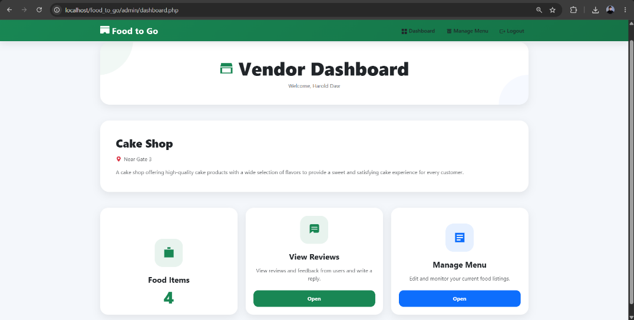

Figure 9. Vendor Dashboard

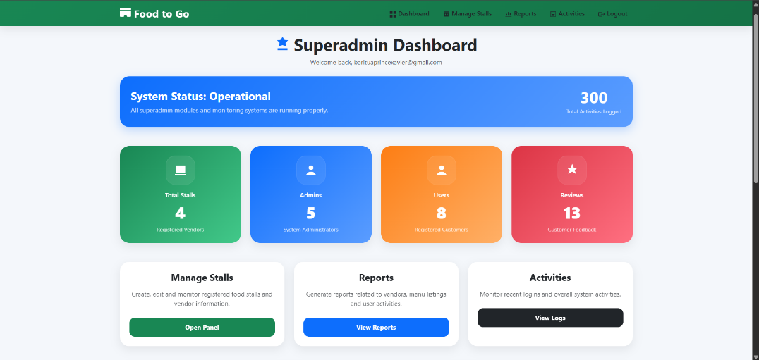
Figure 10. Super Administrator Dashboard

TESTING AND EVALUATION

Convenience sampling was utilized in identifying the thirty-seven (37) respondents who participated in the evaluation of the developed system. The respondents consisted of thirty (30) students, two (2) school staff members, and five (5) food vendors from Davao del Sur State College Main Campus. The developed system was evaluated using a questionnaire adapted from the ISO/IEC 25010 Software Quality Model to assess its Functional Suitability, Performance Efficiency, Usability, Reliability, and Compatibility. Respondents were asked to rate the system using a five-point Likert scale. The verbal interpretations of the responses were based on the following mean ranges: 4.21–5.00 (Strongly Agree), 3.41–4.20 (Agree), 2.61–3.40 (Fairly Agree), 1.81–2.60 (Disagree), and 1.00–1.80 (Strongly Disagree).

Table 1. Distribution
Evaluators | Sample Size
Students | 30
School Staff | 2
Food Vendors | 5
Total | 37

RESULTS AND DISCUSSION

The developed Food to Go: A Digital Campus Food Finder System was evaluated to determine its quality and acceptability among its intended users based on the ISO/IEC 25010 Software Quality Model. The evaluation focused on the software quality characteristics of Functional Suitability, Performance Efficiency, Usability, Reliability, and Compatibility. The respondents assessed the developed system by answering the evaluation questionnaire after interacting with its features and functionalities. The gathered responses were analyzed using weighted mean to determine the level of agreement of the respondents regarding each quality characteristic. The findings are presented in the succeeding tables and serve as the basis for determining the overall acceptability of the developed system.

Table 2. Descriptive Rating of the Functional Suitability (Customer)

Particular | Mean | Verbal Interpretation
Food-To-Go allows users to register and log in successfully. | 4.91 | Strongly Agree
Food-To-Go allows users to view food vendors along with their location and stall information. | 4.72 | Strongly Agree
Food-To-Go provides complete and clear menu details such as food name, price, and description. | 4.78 | Strongly Agree
Food-To-Go allows users to search food items easily. | 4.72 | Strongly Agree
Food-To-Go allows users to filter food items based on category, price, or preference. | 4.59 | Strongly Agree
Food-To-Go allows users to submit ratings and reviews for food items or vendors. | 4.59 | Strongly Agree
Food-To-Go provides the necessary features to help users make informed food choices within the campus. | 4.66 | Strongly Agree
Consolidated Mean | 4.71 | Strongly Agree

Functional suitability refers to the degree to which a software system provides functions that satisfy users' needs under specified conditions. Based on the evaluation results, the developed Food to Go system obtained a consolidated mean of 4.71, interpreted as Strongly Agree. This indicates that the respondents perceived the system as capable of delivering the necessary features and functionalities to assist users in locating food vendors, accessing menu information, and making informed food choices within the campus.

Table 3. Descriptive Rating of the Performance Efficiency (Customer)

Particular | Mean | Verbal Interpretation
Food-To-Go loads quickly when accessing vendor and menu information. | 4.59 | Strongly Agree
Food-To-Go responds promptly when searching or filtering food items. | 4.56 | Strongly Agree
Food-To-Go performs smoothly without lag or delay. | 4.31 | Strongly Agree
Food-To-Go maintains good performance even when used continuously or by multiple users. | 4.41 | Strongly Agree
Consolidated Mean | 4.47 | Strongly Agree

Performance efficiency refers to the ability of a software system to provide appropriate performance relative to the amount of resources used under specified conditions. Based on the evaluation results, the developed Food to Go system obtained a consolidated mean of 4.47, interpreted as Strongly Agree. This indicates that the respondents perceived the system as responsive and capable of performing its functions efficiently while providing satisfactory performance during use.

Table 4. Descriptive Rating of the Usability (Customer)

Particular | Mean | Verbal Interpretation
Food-To-Go is easy to understand and use. | 4.81 | Strongly Agree
Food-To-Go layout and design are clear and organized. | 4.59 | Strongly Agree
Food-To-Go allows easy navigation between pages (vendors, menu, search). | 4.47 | Strongly Agree
Food-To-Go helps users find food options without confusion. | 4.66 | Strongly Agree
Food-To-Go is user-friendly for customers. | 4.75
Consolidated Mean | 4.66 | Strongly Agree

Usability refers to the extent to which a software system can be used by specified users to achieve specified goals effectively, efficiently, and satisfactorily. Based on the evaluation results, the developed Food to Go system obtained a consolidated mean of 4.66, interpreted as Strongly Agree. This indicates that the respondents perceived the system as easy to understand, navigate, and use, providing a positive and user-friendly experience for customers.

Table 5. Descriptive Rating of the Reliability (Customer)

Particular | Mean | Verbal Interpretation
Food-To-Go works properly without errors or crashes. | 4.28 | Strongly Agree
Food-To-Go provides accurate and updated information about vendors and menu items. | 4.56 | Strongly Agree
Food-To-Go consistently provides correct results when searching or filtering. | 4.59 | Strongly Agree
Food-To-Go maintains consistent performance during continuous use. | 4.47 | Strongly Agree
Consolidated Mean | 4.48 | Strongly Agree

Reliability refers to the ability of a software system to consistently perform its intended functions under specified conditions over a period of time. Based on the evaluation results, the developed Food to Go system obtained a consolidated mean of 4.48, interpreted as Strongly Agree. This indicates that the respondents perceived the system as dependable and capable of providing accurate information and stable performance during use.

Table 6. Descriptive Rating of the Compatibility (Customer)

Particular | Mean | Verbal Interpretation
Food-To-Go works properly on different devices (desktop, laptop, mobile). | 4.75 | Strongly Agree
Food-To-Go is accessible through different web browsers. | 4.72 | Strongly Agree
Food-To-Go displays properly on different screen sizes. | 4.75 | Strongly Agree
Food-To-Go can be used in different environments with stable performance. | 4.5 | Strongly Agree
Consolidated Mean | 4.68 | Strongly Agree

Compatibility refers to the degree to which a software system can operate effectively across different devices, platforms, and environments under specified conditions. Based on the evaluation results, the developed Food to Go system obtained a consolidated mean of 4.68, interpreted as Strongly Agree. This indicates that the respondents perceived the system as compatible and capable of functioning properly across various devices, web browsers, screen sizes, and usage environments.

Tables 7 to 11 present the evaluation results obtained from the five (5) food vendors who participated in the assessment of the developed system. Their responses provide an additional perspective regarding the quality and acceptability of Food to Go from the viewpoint of stakeholders directly involved in managing food-related information within the platform.

Table 7. Descriptive Rating of the Functional Suitability (Food Vendors)
Particular | Mean | Verbal Interpretation
Food-To-Go allows vendors to add and manage food items and menu listings effectively. | 4.8 | Strongly Agree
Food-To-Go allows vendors to update product price successfully. | 4.6 | Strongly Agree
Food-To-Go allows vendors to update product description successfully. | 4.6 | Strongly Agree
Food-To-Go allows vendors to update product availability successfully. | 4.4 | Strongly Agree
Food-To-Go allows vendors to view user reviews and feedback conveniently. | 4.8 | Strongly Agree
Food-To-Go allows vendors to respond to user reviews and feedback properly. | 4.6 | Strongly Agree
Food-To-Go allows vendors to remove unavailable or outdated menu items easily. | 4.4 | Strongly Agree
Food-To-Go provides the necessary management tools for maintaining accurate and updated menu information. | 4.8 | Strongly Agree
Food-To-Go helps vendors manage food listings and customer interactions efficiently. | 4.4 | Strongly Agree
Consolidated Mean | 4.6 | Strongly Agree

Based on the evaluation results, the developed Food to Go system obtained a consolidated mean of 4.60, interpreted as Strongly Agree. This indicates that the food vendors perceived the system as capable of providing the necessary features and functionalities to effectively manage menu information, customer feedback, and food-related activities within the platform.

Table 8. Descriptive Rating of the Performance Efficiency (Food Vendors)
Particular | Mean | Verbal Interpretation
Food-To-Go loads quickly when accessing vendor and menu information. | 4.4 | Strongly Agree
Food-To-Go responds promptly when searching or filtering food items. | 4.2 | Agree
Food-To-Go performs smoothly without lag or delay. | 4.4 | Strongly Agree
Food-To-Go maintains good performance even when used continuously or by multiple users. | 4.4 | Strongly Agree
Consolidated Mean | 4.35 | Strongly Agree

Based on the evaluation results, the developed Food to Go system obtained a consolidated mean of 4.35, interpreted as Strongly Agree. This indicates that the food vendors perceived the system as capable of providing satisfactory performance and responsiveness while carrying out vendor-related tasks. Although one indicator was rated as "Agree," the overall findings suggest that the system was able to perform efficiently during use.

Table 9. Descriptive Rating of the Usability (Food Vendors)
Particular | Mean | Verbal Interpretation
Food-To-Go is easy to understand and use. | 4.8 | Strongly Agree
Food-To-Go layout and design are clear and organized. | 4.4 | Strongly Agree
Food-To-Go allows easy navigation between pages (vendors, menu, search). | 4.8 | Strongly Agree
Food-To-Go helps users find food options without confusion. | 4.6 | Strongly Agree
Food-To-Go is user-friendly for customers. | 4.5
Consolidated Mean | 4.72 | Strongly Agree

Based on the evaluation results, the developed Food to Go system obtained a consolidated mean of 4.72, interpreted as Strongly Agree. This indicates that the food vendors perceived the system as easy to understand, navigate, and use, reflecting a positive user experience and a high level of usability within the platform.

Table 10. Descriptive Rating of the Reliability (Food Vendors)
Particular | Mean | Verbal Interpretation
Food-To-Go works properly without errors or crashes. | 4.4 | Strongly Agree
Food-To-Go provides accurate and updated information about vendors and menu items. | 4.8 | Strongly Agree
Food-To-Go consistently provides correct results when searching or filtering. | 4.4 | Strongly Agree
Food-To-Go maintains consistent performance during continuous use. | 4.6 | Strongly Agree
Consolidated Mean | 4.55 | Strongly Agree
Based on the evaluation results, the developed Food to Go system obtained a consolidated mean of 4.55, interpreted as Strongly Agree. This indicates that the food vendors perceived the system as dependable and capable of consistently providing accurate information and stable performance during use.

Table 11. Descriptive Rating of the Compatibility (Food Vendors)
Particular | Mean | Verbal Interpretation
Food-To-Go works properly on different devices (desktop, laptop, mobile). | 5 | Strongly Agree
Food-To-Go is accessible through different web browsers. | 4.4 | Strongly Agree
Food-To-Go displays properly on different screen sizes. | 4.6 | Strongly Agree
Food-To-Go can be used in different environments with stable performance. | 4.6 | Strongly Agree
Consolidated Mean | 4.65 | Strongly Agree

Based on the evaluation results, the developed Food to Go system obtained a consolidated mean of 4.65, interpreted as Strongly Agree. This indicates that the food vendors perceived the system as compatible and capable of functioning effectively across different devices, web browsers, screen sizes, and operating environments.

CONCLUSION
The Food to Go: A Digital Campus Food Finder System obtained an overall mean of 4.61, interpreted as Strongly Agree. This result was based on the evaluation conducted among the campus community and food vendors using the ISO/IEC 25010 Software Quality Model. The findings indicate that the intended users were satisfied with the system's functionality, performance efficiency, usability, reliability, and compatibility. Moreover, the developed system effectively assisted users in locating food vendors, exploring menu options, and making informed food choices within the campus. Therefore, the study achieved its objectives and demonstrated that the developed system is acceptable for its intended users.

RECOMMENDATIONS

Based on the findings of the study and the feedback provided by the respondents, the researchers recommend that future developers consider integrating a map feature within the system to help users easily locate food vendors across the campus. In addition, future enhancements may explore the inclusion of delivery-related functionalities to further improve user convenience and expand the services offered by the platform, subject to the feasibility and needs of the institution and participating vendors.

REFERENCES

- Al-Sabbah, H., Alhamad, H., Al-Haddad, L., & Al-Faris, N. (2024). The association between food preferences, eating habits, and obesity among university students. Frontiers in Public Health, 12, 1395338. https://doi.org/10.3389/fpubh.2024.1395338
- Algheshairy, R. M., Alharbi, S. M., Almutairi, M. M., et al. (2022). Influence of using food delivery applications on adult dietary habits and preferences. International Journal of Environmental Research and Public Health, 19(19), 12770. https://doi.org/10.3390/ijerph191912770
- Hoang, H., Nguyen, T., & Pham, L. (2023). Dataset of food delivery app users at a public university. Data in Brief, 47, 109110. https://doi.org/10.1016/j.dib.2023.109110
- Roy, R., Hebden, L., Kelly, B., & Deane, F. (2024). Assessing the healthfulness of university food environments: A systematic review of methods and tools. Nutrients, 16(10), 1426. https://doi.org/10.3390/nu16101426
- Saleh, R. N., Al-Sabbah, H., & Al-Hamdan, R. (2024). Adolescents’ use of online food delivery applications and perceptions of healthy food options and food safety. Frontiers in Nutrition, 11, 1385554. https://doi.org/10.3389/fnut.2024.1385554

