Improving the Range of Electric Vehicles

Katore Sandeep.S ¹, Sanket Hemant. P ²

¹Assitant Professor Dept. of Mechanical Engineering, Adsul’s Technical Campus,
Ahilyanagar, Maharashtra, India.
² T.E Mechanical, Dept. of Mechanical Engineering, Adsul’s Technical Campus,

Abstract — Electric Vehicles (EVs) are efficient, cost-effective, and produce significantly lower emissions compared to currently used Internal Combustion Engine (ICE) vehicles. However, their widespread adoption is hindered by limited driving range, primarily due to insufficient charging infrastructure. As a result, many people perceive EVs as impractical for daily commuting. To address these challenges, various solutions aimed at significantly improving vehicle range are discussed. Enhancing the range of EVs cannot be achieved through a single approach; rather, it requires the integration of multiple engineering strategies and technological advancements.
Keywords — Electric Vehicles, Power Sources, Charging Infrastructure, Range Extension

I. INTRODUCTION
Electric Vehicles (EVs) are widely regarded as the most promising replacement for Internal Combustion Engine (ICE) vehicles in the future of transportation [5]. Despite their advantages, EVs face a significant limitation in terms of driving range, which is further constrained by the inadequacy of current charging infrastructure.
Theoretically, an ideal EV can achieve a range of approximately 150–200 miles on a single charge. However, in practical scenarios, the number of charging stations is considerably lower than that of conventional fuel stations. This disparity reduces the reliability and convenience of EVs from a consumer’s perspective, thereby highlighting the need for effective solutions to address this issue.
The primary objective of this paper is to research and investigate viable solutions to overcome the range limitations of EVs. This includes a comparative analysis of the feasibility and practicality of various approaches. Three key solutions are explored in detail to assess the current state of technology and identify future research directions.
This study aims to encourage investment, innovation, and further research in this domain. The intended audience includes automobile engineers, EV manufacturers, mechanical engineers, and emerging researchers in the field.
Furthermore, the paper focuses on potential methods for improving EV range without an extensive discussion of cost factors. Feasibility is primarily evaluated in terms of infrastructure implementation and, to a limited extent, economic considerations.
The paper begins with an overview of the current generation of EVs, including their features, limitations, and the challenges hindering their efficiency. This is followed by an in-depth discussion of potential solutions for range enhancement, along with a feasibility analysis and an evaluation of their associated disadvantages.

II. COLLECTED DATA: CURRENT GENERATION OF EVs
Electric Vehicles (EVs) are widely recognized as the future of transportation, with the automotive industry increasingly shifting its focus from conventional Internal Combustion Engine (ICE) vehicles to electric and hybrid alternatives. EVs offer lower running costs compared to ICE vehicles [1]. Although they address several major drawbacks of ICEs—such as lower efficiency, higher emissions, and operating costs—they are not without limitations. One of the most significant challenges is their limited driving range, which, combined with inadequate charging infrastructure, makes EVs less reliable and less convenient for users.
A. Features of EVs
EVs are expected to play a crucial role in enhancing energy sustainability for future mobility, as electricity can be generated from a wide range of sources, including renewable energy such as solar, wind, and geothermal [2]. In the long term, EVs are more economical because electricity generation and supply are generally cheaper than gasoline. Additionally, EVs have significantly lower running costs due to their higher overall efficiency [1].
Another advantage of EVs is their simpler mechanical design, with fewer moving parts compared to ICE vehicles. This results in reduced frictional losses and lower maintenance requirements. Furthermore, EVs contribute to a reduction in carbon emissions, thereby helping to lower the overall carbon footprint. These factors collectively highlight the key benefits of EV technology.
B. Weaknesses of EVs
Despite their advantages, EVs face several notable challenges. The primary limitation is their restricted driving range, as they require periodic recharging [2]. In comparison to conventional refueling, charging an EV takes significantly more time, which reduces convenience for consumers. A full charging cycle typically takes between 1–2 hours, which is substantially longer than the few minutes required to refuel a gasoline vehicle.
Another critical issue is the lack of sufficient charging infrastructure. The number of charging stations remains far lower than that of traditional fuel stations, limiting accessibility for EV users. Moreover, the existing electrical grid infrastructure may not be robust enough to handle the increased demand from high-power fast-charging stations [5]. This can potentially lead to overload conditions in local electrical circuits, further complicating large-scale EV adoption.

III. SOLUTIONS TO IMPROVE THE RANGE OF EVs
To keep pace with the rapidly evolving automotive industry and enhance consumer acceptance, it is essential to develop solutions that significantly improve the driving range of Electric Vehicles (EVs). One promising approach involves dynamic charging, where vehicles are charged while in motion, thereby extending their cruising range. Such technologies can also reduce range anxiety, particularly in areas where the required infrastructure is available [1].
A. Wireless Power Transfer Technology Using Solar Power
According to [1], this approach utilizes wireless power transfer technology supported by solar energy. The system primarily consists of hardware components such as transmitter and receiver coils, as illustrated in Figure 1.
For effective operation, the design of the coils must meet several critical requirements. The inductance and capacitance of the coils should be optimized to match the required working frequency for efficient power transfer. Additionally, the dimensions of the coils must be compatible with the vehicle’s body or chassis. Proper electromagnetic shielding is also necessary to prevent interference with nearby electronic devices, such as mobile phones. Furthermore, the overall construction should be robust and durable to ensure long-term reliability. Meeting these design criteria enables practical and convenient installation.
In this system, coils are embedded within Cement Asphalt Mortar (CAM) roads, forming dedicated lanes that facilitate inductive power transfer to moving vehicles.
The working principle of this system is based on mutual induction. A solar panel supplies 12 V to a battery, where the energy is stored and subsequently delivered to the primary coil. Simultaneously, the battery is connected to a 7805 voltage regulator, which steps down the voltage from 12 V to 5 V. This regulated voltage powers an infrared (IR) sensor. When an object interrupts the IR sensor’s beam, it activates the circuit, generating output current that enables inductive charging of the vehicle’s secondary coil [1].
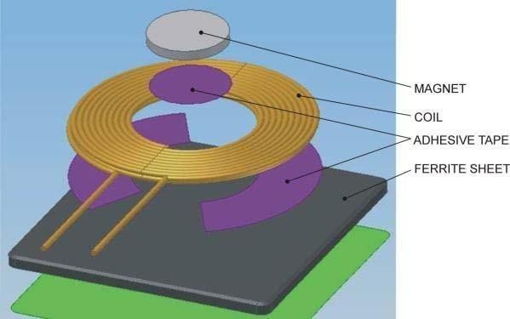
Experimental results reported in [1] demonstrate that power can be transmitted wirelessly through this system, confirming the successful implementation of inductive charging.

Fig. 1. Schematic diagram of a circular coil [2].

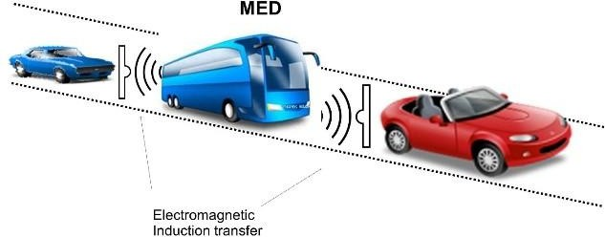

Fig. 2. Electromagnetic induction transfer

B. Dynamic Wireless Charging Using Mobile Energy Disseminators
To address the challenge of limited EV range, researchers and industry leaders have proposed several innovative solutions. One such approach is Dynamic Wireless Charging (DWC) using Mobile Energy Disseminators (MEDs).
According to [4], advancements in DWC include projects such as the deployment of charging infrastructure integrated into urban environments. For instance, Hevo has introduced a concept in which manhole covers can function as wireless charging stations in New York. Additionally, Online Electric Vehicle (OLEV) buses have been implemented in Gumi, South Korea, where buses are capable of charging while in motion along predefined routes. In this system, power is transmitted through magnetic fields generated by electric cables embedded beneath the road surface, enabling inductive charging of the vehicles.
A Mobile Energy Disseminator (MED) is a system capable of supplying electrical energy to EVs while in transit. Energy transfer is achieved through Inductive Power Transfer (IPT), allowing wireless energy exchange between vehicles or via roadside infrastructure designed for dynamic charging.
In this context, buses and trucks can function as MEDs, acting as mobile energy sources for EVs requiring charge. Buses are particularly suitable for this role due to their fixed routes, consistent schedules, and extensive connectivity across urban areas. Similarly, trucks can serve as MEDs on highways, providing charging support during long-distance travel.
These vehicles can be fully charged prior to operation and further supplemented through IPT stations installed at designated stops, such as bus stations. This approach is considered more feasible, as integrating such systems into larger public or commercial vehicles is more practical than retrofitting individual passenger vehicles.
The operational mechanism involves an EV approaching a MED—either from the front or rear, depending on system design—to receive charge. Energy transfer can occur through electromagnetic induction, Tesla coils, or direct electrical connections, similar in concept to mid-air refueling used in aviation.
Multiple EVs can form a cluster around a MED, where synchronization and coordination are managed wirelessly. The MED, typically a bus or truck, acts as the central hub controlling energy distribution within the cluster.
The electromagnetic subsystem consists of magnetic coils functioning similarly to the primary and secondary windings of a transformer. These coils operate with loose coupling and utilize air as the medium for energy transfer, enabling efficient wireless charging under dynamic conditions.

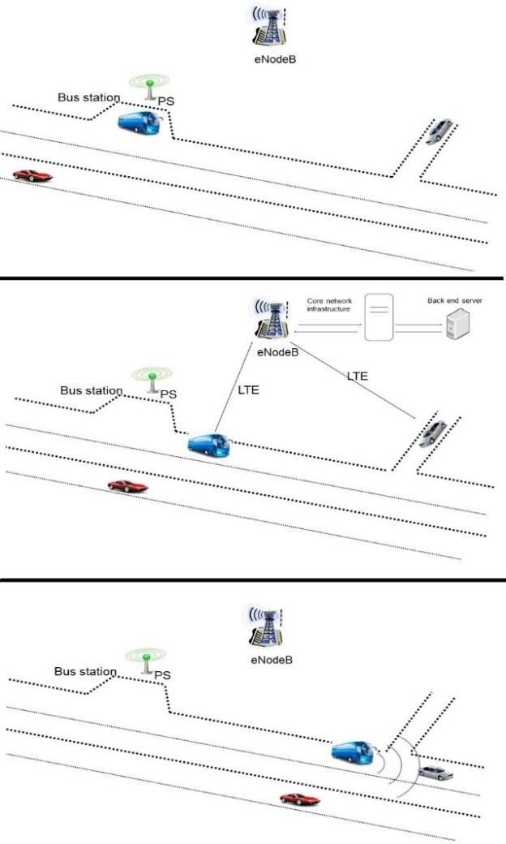

Fig. 3 Application example of MED EV recharges from bus using IPT and V2V relay nodes

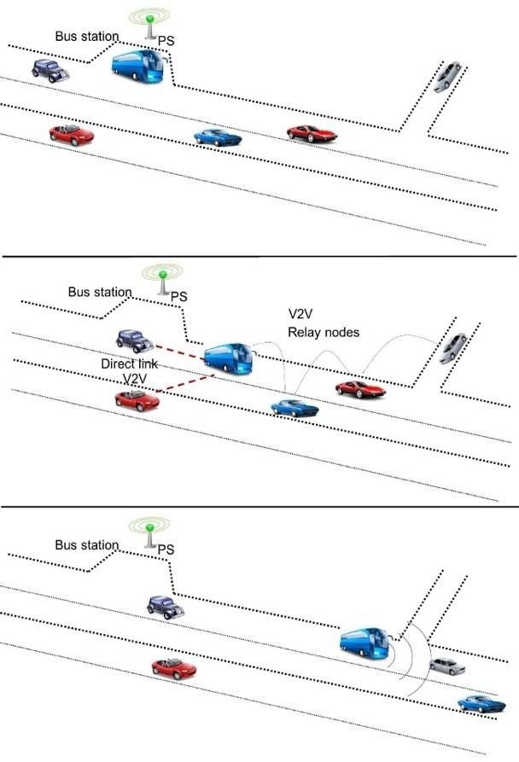
Fig. 4. Application example of MED EV recharges from bus using IPT and LTE
According to [4], this process can be executed by enabling each EV in need of energy to first determine whether a Mobile Energy Disseminator (MED) is present along its route. The EV then evaluates whether the available Charging Capability (CC) of the MED is sufficient to meet its energy requirements. If the conditions are satisfied, the EV sends a Cooperative Awareness Message (CAM) to the MED to request access to a charging slot. Subsequently, the EV positions itself either in front of or behind the MED for a specified duration to receive charge while in motion.
Communication between the EV and the MED can be facilitated through Vehicle-to-Vehicle (V2V) relay nodes or Long-Term Evolution (LTE) networks, which serve as the communication medium between the two vehicles. According to [4], the key advantages of this approach include high efficiency, significant reduction in environmental pollution, and the ability to meet energy demands even under exceptional climatic or system failure conditions.

C. Improving Inbuilt Hardware and Infrastructure
As stated in [4], EVs consist of four primary components: the battery, DC-to-AC converter, electric motor, and battery charging system. These elements form the core building blocks of an EV, and improving their performance is essential to enhancing overall vehicle efficiency and range. Several potential improvements are discussed below:
a) Improved Storage Technology
Lithium-ion batteries are currently the most widely used energy storage systems in EVs due to their lightweight nature and high energy capacity [4]. Ultra-capacitors, while capable of storing energy only for short durations, offer the advantage of an almost unlimited number of charge-discharge cycles. Hydrogen fuel cells, on the other hand, provide significantly higher energy densities compared to lithium-ion batteries but suffer from slower response times.
Each of these technologies has distinct advantages and limitations. Ultra-capacitors provide rapid response but low energy density, while batteries offer sustained power output. By integrating multiple storage technologies, it is possible to leverage their individual strengths and significantly enhance the overall efficiency and performance of EVs.

Air flow
Air Turbine

Generator

Caused by Vehicle Battery

Fig. 5. Air turbine used to charge the vehicle battery

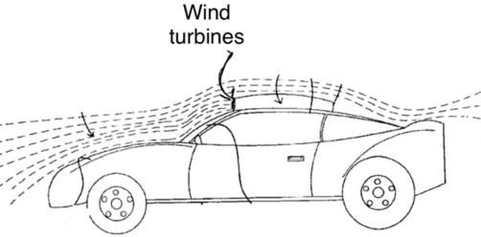

Fig. 6. Portable roof setup [6]

The energy generated by the wind turbine can be effectively utilized in conjunction with ultra-capacitors, enabling rapid charge and discharge cycles. This integration can contribute to an overall improvement in the vehicle’s driving range. According to [5], a practical implementation of this concept has been developed in the form of a Portable Wind Power Apparatus for EVs, which operates on a similar principle as illustrated in Figure 5.
The system consists of a wind turbine mounted on the roof of the vehicle and a generator installed within the vehicle body. The generator connects the turbine to the vehicle’s power system, allowing the generated energy to be stored and utilized efficiently. As shown in Figure 7, positioning the turbine on the roof maximizes wind exposure, thereby enhancing energy generation. The portable nature of this design ensures flexibility in manufacturing and ease of installation [5]. Additionally, it supports a relatively aerodynamic structure, helping to minimize drag on the vehicle.
In [6], a similar concept is explored with an improved aerodynamic design. In this approach, turbines are aligned parallel to the airflow to optimize efficiency. The system employs a two-blade configuration with low solidity, exhibiting characteristics of a lift-type turbine with a high lift-to-drag ratio. The efficiency of this design is reported to range between 0.4 and 0.45. Furthermore, the setup incorporates a three-phase AC generator with an increased number of poles for efficient battery charging and control.
Experimental analysis and simulations presented in [6] indicate that the modified design produces nearly the same level of aerodynamic drag as conventional vehicle designs. However, it has the added advantage of generating supplementary energy, which can enhance overall vehicle performance and range.
d) Impact of Driving Behavior
As stated in [3], driving behavior has a significant influence on the range of an EV. Adopting efficient driving practices can improve the driving range by up to 30%. Such practices include minimizing abrupt acceleration and deceleration, avoiding high and steep acceleration patterns, and reducing aggressive driving habits.
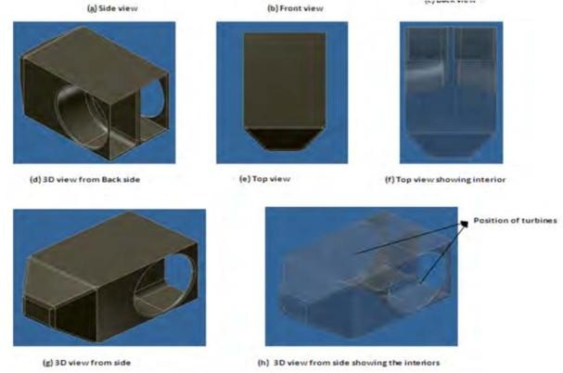

Fig.7. 3D and isometric views of the model

This can be achieved by integrating advanced sensors, Internet of Things (IoT) technologies, and machine learning algorithms into the vehicle system to minimize human error and enhance overall efficiency.
IV. FEASIBILITY AND DISADVANTAGES OF THE SOLUTIONS
This section evaluates the feasibility of the proposed solutions, primarily in terms of infrastructure requirements and, to a limited extent, cost considerations. It also discusses the associated limitations of each approach.
A. Feasibility of the Solutions
Firstly, considering the wireless power transfer technology using solar energy, the design and specifications of the coils must be precise and carefully engineered to ensure efficient power transfer. The construction process, particularly with the use of Cement Asphalt Mortar (CAM) roads, is relatively straightforward [2]. This solution is moderately feasible, as it requires only incremental modifications to existing infrastructure.
In the case of Dynamic Wireless Charging (DWC) using Mobile Energy Disseminators (MEDs), these systems can function as mobile charging stations capable of servicing multiple vehicles. According to [5], this approach is feasible as it primarily involves upgrading existing buses and trucks to support the required charging technology, rather than building entirely new infrastructure.
Furthermore, improvements in inbuilt hardware—such as advanced energy storage systems, enhanced motor efficiency, integration of wind energy systems, and optimized driving practices—can significantly extend EV range [4]. As noted in [6], portable wind energy systems are designed for easy installation and compatibility with existing vehicles, increasing their practicality.
With the continued growth of EV adoption, it is expected that more compact, efficient, and user-friendly solutions will emerge in the market. Among all proposed approaches, advancements in energy storage technology are likely to have the greatest impact on driving range. This makes it one of the most feasible solutions, as it primarily requires ongoing research and development to improve existing technologies.
B. Disadvantages of the Solutions
Despite their potential, each solution has certain limitations. For wireless power transfer using solar energy, the transmitter system must be carefully designed to achieve optimal efficiency and performance [2]. This can lead to increased installation costs and reduced practicality. Additionally, implementing such infrastructure across daily commuting routes would require significant labor and resources.
For Dynamic Wireless Charging using MEDs, one concern highlighted in [5] is the potential health impact due to exposure to fluctuating magnetic fields. Moreover, this solution is primarily suited for urban environments and may not be easily scalable to broader or rural settings. It also introduces trade-offs such as increased travel coordination, possible time delays, and dependence on external vehicles (buses or trucks) for charging, limiting vehicle autonomy.
Dynamic wireless charging systems must also account for factors such as vehicle speed, electromagnetic field distribution, and high initial investment costs [3], which add to the complexity of implementation.
In contrast, improving inbuilt hardware and infrastructure has relatively fewer disadvantages, as it aligns with the natural evolution of vehicle technology. However, certain innovations—such as integrating wind turbines—may introduce additional aerodynamic drag, potentially affecting vehicle efficiency [7].
V. CONCLUSION
This paper has explored several viable solutions aimed at improving the driving range of Electric Vehicles. While numerous other approaches are currently being investigated by researchers and engineers, the solutions discussed in this study represent some of the most promising and well-established options, supported by foundational research and experimental results.
The solutions discussed—namely solar-based charging technology, Dynamic Wireless Charging using Mobile Energy Disseminators (MEDs), and improvements in the current generation of EVs through enhanced hardware—represent some of the most practical and viable options within the scope of existing infrastructure.
While all three approaches are feasible, each has its own limitations. It is evident that an integrated approach combining these solutions would yield the most significant improvement in EV driving range. Among them, enhancing the current generation of EVs through improved hardware stands out as the most feasible, as it can be implemented relatively easily and cost-effectively.
It is strongly recommended that researchers and automotive manufacturers incorporate these advancements into successive vehicle iterations. EVs represent the future of transportation due to their high efficiency, lower operating costs, and minimal environmental impact compared to Internal Combustion Engine (ICE) vehicles.
Additionally, electricity generation—especially through renewable sources such as solar, wind, and thermal energy—is more sustainable and cost-effective than reliance on petroleum-based fuels, which are finite in nature.
Leading automotive companies such as Tesla, BMW, and Chrysler are already shifting their focus from ICE vehicles to EVs, thereby influencing the direction of the global automotive industry. As this transition continues, it is essential to integrate advanced technologies that enhance reliability, efficiency, and user convenience, ensuring that EVs become a practical and widely accepted mode of transportation rather than being perceived as a novelty.

REFERENCES
[1] M. Aziz, T. Oda, and M. Ito, “Battery assisted charging system for simultaneous charging of electric vehicles,” Energy, vol. 100, pp. 82–90, 2016.
[2] S. Benjamin, A. Gopi, A. Rajan, and N. Raju, “Electric vehicle on-road dynamic charging system with wireless power transfer technology using solar,” International Journal of Engineering Science and Computing, 2016, doi: 10.4010/2016.662.
[3] J. Bingan, B. Deng, Z. Zhang, and J. Wang, “An optimal design of dynamic wireless automatic charging system for roadway-powered electric vehicles,” in Proc. World Congress on Intelligent Control and Automation (WCICA), 2016, pp. 2466–2470, doi: 10.1109/WCICA.2016.7578445.
[4] D. Chandran and M. Joshi, “Electric vehicles and driving range extension – A literature review,” Advances in Automobile Engineering, vol. 2, 2016, doi: 10.4172/2167-7670.1000154.
[5] A. Maglaras, F. Topalis, L. Maglaras, and S. Moschoyiannis, “Dynamic charging of electric vehicles on the move with mobile energy disseminators,” International Journal of Advanced Computer Science and Applications, vol. 6, pp. 239–251, 2015.
[6] X. Ying, “Portable wind power apparatus for electric vehicles,” U.S. Patent US6897575B1, 2005.
[7] A. Benozir, S. M. Ferdous, E. G. Ovy, W. B. Khaled, and S. Sayedus, “Electric vehicle with charging facility in motion using wind energy,” in World Renewable Energy Congress – Sweden, vol. 13, 2011.

