Advancements in Computer-Aided Drug Design: Targeting the PD-1/PD-L1 Immune Checkpoint with Small Molecule Inhibitors

Abstract

Cancer continues to be a major global health burden, with conventional therapies often limited by relapse, resistance, and toxicity. Immunotherapy, particularly PD-1/PD-L1 checkpoint blockade, has transformed treatment by reactivating antitumor T-cell responses. While monoclonal antibodies against PD-1/PD-L1 have shown remarkable success, their high cost, intravenous delivery, immune-related side effects, and resistance highlight the need for alternatives. Small molecule inhibitors (SMIs) offer advantages such as oral bioavailability, improved tumor penetration, reduced immunogenicity, and lower production costs. However, the broad PD-1/PD-L1 interface poses design challenges. Recent advances in computer-aided drug design (CADD)—including docking, pharmacophore modeling, QSAR, virtual screening, and in silico ADME/T prediction—are driving progress in developing effective SMIs. This review outlines the biology of the PD-1/PD-L1 axis, the evolution of checkpoint therapy, and current efforts to harness CADD for novel small molecule inhibitors.

Keywords: PD-1, PD-L1, immune checkpoint, cancer immunotherapy, small-molecule inhibitors, computer-aided drug design (CADD), molecular docking, QSAR, ADMET.

Introduction and Historical Background of Immune Checkpoint Therapy
Cancer remains a leading global health challenge, causing almost 10 million deaths annually. However, despite advances in surgery, chemotherapy, and radiotherapy, recurrence, resistance, and systemic toxicity are practically limiting the effectiveness of conventional treatments. These limitations have driven the exploration of immunotherapy: an approach that utilizes the body's immune system for durable tumor control.
The immune system also plays a essential role in the identification and destruction of cancer cells often done via a process known as immunosurveillance. This involves cytotoxic T cells, NK cells, macrophages, and cytokines such as IFN-γ and TNF-α Sometimes, unfortunately, a tumor evades immune recognition through immunoediting, an immunologic sculpting of tumor progression through three phases: elimination, equilibrium, and escape. One of the major mechanisms by which tumor immune evasion occurs is through exploitation of the immune checkpoints or regulatory pathways, which are designed to limit or terminate an immune response once it is no longer needed to prevent autoimmunity.^{[1]}
Among these, the PD-1/PD-L1 pathway is one of the most important pathways that is being explored for the treatment of cancer. PD-1 is a marker found on the surface of active T cells, which recognizes PD-1-L1, thereby reducing the activation of T cells. Cancer cells overexpress PD-1-L1, which prevents the killing of cells. Other checkpoint proteins are: CTLA-4, CD28, ICOS, GITR, OX40, CD40, CD27, 4-1 BB. ^{[2][3]}
Monoclonal antibodies (mAbs) like nivolumab, pembrolizumab, or atezolizumab have proven successful in inhibiting the PD-1/PD-L1 interaction which has resuscitated the immune response of T-cells thereby showing improved efficacy in melanoma and NSCLC. Monoclonal antibodies are not without limitations which include the need for IV infusion, expensive.To overcome these, Small-Molecule Inhibitors (SMIs) are emerging. Their low molecular weight enables oral delivery, tissue penetration, and feasible manufacturing costs.^{[4]} However, challenging conditions are posed by targeting the large, flat, and hydrophobic interface of PD-1/PD-L1 using SMIs. Recently, computer-assisted drug design (CADD) has been found useful for overcoming these challenges. Methods like molecular docking, pharmacophore modeling, QSAR analysis , and virtual screening can be utilized for finding highly effective inhibitors with enhanced specificity and drug-like properties. Online ADMET prediction methods like SwissADME and ProTox-II can be used for proficient evaluation of pharmacokinetic and toxic properties at an early stage.^{[2][4][5]}
The evolution of immune checkpoint therapy from theoretical immunosurveillance to the clinical breakthroughs has reshaped oncology. Early discoveries of CTLA-4 and PD-1 laid the foundation for antibody-based therapies, culminating in FDA approvals and Nobel recognition for James P. Allison and Tasuku Honjo.^{[6]} There has been an extension of the field into new targets such as LAG-3, TIM-3, and TIGIT, and the incorporation of CADD in accelerating the creation of next-generation immunotherapeutic agents.

Biology of the PD-1/PD-L1 Immune Checkpoint
The PD-1/PD-L1 pathway is an important immune checkpoint involved in regulating immune responses to ensure a lack of autoimmunity. Tumors use this pathway to evade immune activation and induce a tolerogenic tumor microenvironment (TME).^{[7]}
Programmed cell death 1 (PD-1), also known as CD279, is a transmembrane protein that is part of the immunoglobulin (Ig) gene superfamily. It is one of the members of the immune regulatory proteins of the CD28 family, together with CTLA-4, ICOS, and BTLA. The protein is essential in the regulation of the immune system in the body. It's normally properly regulated and cleared, but in cases of chronic infections and cancer, PD-1 expression becomes persistent and causes T-cell exhaustion characterized by decreased proliferation, cytokine secretion, and cytotoxic effects. In the TME, PD-1 expression becomes upregulated in TILs, Tregs, and tumor-associated macrophages.^{[7]}
Upon ligand binding, PD-1’s cytoplasmic ITIM and ITSM motifs recruit SHP-1/2 phosphatases, which inhibit TCR and CD28 signaling. This suppresses downstream PI3K/AKT and RAS/MEK/ERK pathways, alters metabolism, and drives functional exhaustion.
Programmed death-ligand 1 (PD-L1; CD274) is expressed on antigen-presenting cells as well as various non-immune tissues. Within the tumor microenvironment, PD-L1 expression is induced through intrinsic oncogenic signaling pathways such as PI3K/AKT, JAK/STAT, and MYC. Further, PD-L1 is induced by adaptive immune resistance mechanisms, mainly IFN-γ and other pro-inflammatory cytokines, via the JAK/STAT–IRF1 signaling axis. PD-L1 is also expressed on TAMs, MDSCs, and dendritic cells, collectively contributing to the immunosuppressive microenvironment by preventing effector T-cell activation and function.
(PD-1)/ (PD-L1) pathway is an essential negative regulatory mechanism that acts as the ‘brake' system of the immune system to maintain peripheral tolerance and prevent autoimmunity. The mechanism is subverted by the tumor to escape from the immune system, leading to downregulation of effector T-cell function, resulting in decreased proliferation and secretion of essential cytokines such as interferon-γ (IFN-γ), interleukin-2 (IL-2), and tumor necrosis factor-α (TNF-α). The interaction between the PD-1 receptor and its ligands initiates the inhibitory signaling pathway involving SH2 domain-containing phosphatases 2 (SHP2), resulting in the suppression of the T-cell receptor or CD28 co-stimulation, while leading to exhaustion of the immune cells. From the metabolic perspective, the interaction of the PD-1 receptor initiates the metabolic reprogramming of the immune cells to shift from the aerobic glycolysis ATP production system to fatty acid oxidation. This process impairs the function of the effector T cells. On the other hand, the high expression of the PD-L1 protein upregulates the glucose metabolism or Warburg effect within the tumor, resulting in low glucose, high lactate, and acidic pH within the TME. The acidic pH within the TME impairs the immune cell function.^{[8]}
Aberrant PD-1/PD-L1 signaling is associated with a poor prognosis in various cancers, such as melanomas, NSCLC, and RCC. Monoclonal antibodies, such as nivolumab, have shown efficacy but have limitations such as resistance, among others. Smaller-molecule inhibitors are a promising alternative with advantages such as a convenient oral form of administration as well as enhanced penetration. While it was long believed that “the PD-1/PD-L1 interface appeared to be ‘undruggable,’” structural biology research has now characterized transient pockets with a degree of conformational flexibility.^{[9]}

Mechanism of PD-1/PD-L1–Mediated Immune Suppression

The PD-1/PD-L1 axis has been a crucial immunoregulatory axis that determines the performance of T cells to induce self-tolerance and anti-immune responses. Activated T cells that ligate PD-1 with its ligand, PD-L1, to tumor cells or antigen presenting cells, suppressing the activator using the ITIM and ITSM motifs of PD-1, triggering the recruitment of phosphatases, such as SHP-2. This finally results in attenuation of TCR/CD28-mediated signaling pathways, reduced cytokine production, impaired proliferation, and diminished cytotoxic function of effector T cells. Many tumors hijack this pathway through the upregulation of PD-L1 expression as an effective means to suppress cytotoxic T-lymphocyte responses and enable immune evasion-one of the hallmark features of cancer progression. Consequently, sustained PD-1/PD-L1 signaling leads to T-cell exhaustion within the tumor microenvironment, which facilitates tumor survival and growth.

Molecular Structure and Signaling
PD-1 also called CD279 is a receptor that sits on the surface of cells like activated T cells, B cells, natural killer cells, and certain myeloid cells. When its ligands bind to it the receptor's tail grabs onto enzymes called SHP-2 phosphatases using special motifs (ITIM and ITSM). These phosphatases then dial down T-cell signals by stripping phosphates off critical proteins such as ZAP70 and CD3ζ, which keeps T cells from fully revving up.PD-L1 (CD274), PD-1's main partner, shows up on both immune cells and non-immune ones, including those in tumors. Tumors crank it up through cancer-driving paths like PI3K/AKT or JAK/STAT, or via signals from inflammation-boosting cytokines like IFN-γ. This constant PD-L1 presence around tumors acts like a shield, slowing T-cell growth, cytokine release, and their ability to attack cancer cells..^{[11],[12]}

Signaling Cascade and Immune Suppression
When PD-L1 latches onto PD-1—usually across from a tumor cell to a T cell—it kicks off phosphorylation on PD-1's ITIM and ITSM spots. That pulls in SHP-2 enzymes, which throw a wrench into pathways like PI3K/AKT and RAS/MEK/ERK down the line, shutting down genes that drive cytokine output, cell growth, and survival. In the end, you get less IFN-γ, IL-2, and TNF-α pumping out, plus lower levels of granzyme B and perforin, leading T cells to burn out and give up.^{[3],[6],[8]}

Metabolic Reprogramming
PD-1 signaling messes with T-cell metabolism by shutting down glycolysis and pushing fatty acid oxidation instead, which starves the cells of the quick energy they need for a strong immune fight. At the same time, PD-L1 on tumors ramps up their own glycolysis, pumping out more lactate that turns the tumor surroundings (the TME) acidic. This whole metabolic tug-of-war drains away key nutrients and leaves T cells and NK cells even weaker..^{[13]}

Clinical and Therapeutic Implications
Faulty PD-1/PD-L1 signaling helps cancers like melanoma, NSCLC, and renal cell carcinoma dodge the immune system and spells a worse outlook for patients. Monoclonal antibodies hitting this pathway have delivered real wins in the clinic, but resistance crops up and side effects tied to immune overdrive are still a headache.Fresh structural work has spotlighted fleeting binding pockets and bendy shapes in PD-L1, paving the way for small-molecule blockers. These bring perks like pills you can swallow, tweakable drug behavior in the body, and precise tweaks to immune brakes kicking off a sharper age of immunotherapy.^{[14]}

Structural Insights into PD-1/PD-L1 Interaction
Understanding the PD-1/PD-L1 complex at the molecular level is key to designing small-molecule inhibitors that can disrupt this immune checkpoint. Advances in crystallography, NMR, and molecular dynamics have revealed a flat, hydrophobic interface between PD-1 and PD-L1, long considered “undruggable.”

PD-1 and PD-L1 Architecture
PD-1 is a 288 amino acid protein that spans the cell membrane with an IgV-like part sticking out, a transmembrane helix anchoring it, and a cytoplasmic tail packing ITIM and ITSM motifs. When ligands bind, those motifs snag SHP-2 phosphatases, which dial back T-cell activation.PD-L1, clocking in at 290 amino acids, sports two extracellular Ig-like domains and a stubby cytoplasmic tail. Its hookup spot with PD-1 covers about 1,870 Å², driven mostly by hydrophobic handshakes from residues like Tyr56, Met115, and Tyr123. PD-L1 can also pair up with itself as homodimers, something drug designers are cashing in on.^{.[15]}

Binding Dynamics and Drug Design
The PD-1/PD-L1 hookup has low sticking power but pins down its target with high precision. Wiggly loops on PD-1 and shape-shifting tweaks in PD-L1 make the match happen. Crystal structures (like PDB ID: 4ZQK) reveal β-sheet handshakes locked in by greasy nonpolar bonds.Even without big craters to latch onto, fragment hunting and computer sims have sniffed out short-lived pockets. Small molecules like BMS-202 force PD-L1 to dimerize and shut out PD-1. They cozy up to hotspot residues and freeze PD-L1 in off-duty shapes, handing drug makers solid blueprints to build from^{.[2],[16]}

Implications for CADD
Structural insights have enabled structure-based drug design (SBDD), molecular docking, and pharmacophore modeling to identify and optimize small-molecule inhibitors. These approaches reduce development time and cost while enhancing selectivity and drug-like properties.^{[10]}

Monoclonal Antibodies vs Small-Molecule Inhibitors
Monoclonal antibodies (mAbs) blocking PD-1 and its ligand, PD-L1 have proven to be a game-changing cancer therapy with sustained responses observed across melanoma, NSCLC, renal carcinoma and other histologies. Agents such as nivolumab, pembrolizumab and atezolizumab have been shown to enhance T-cell function by clearing the tumor⁽²⁰⁾⁽²¹⁾

Limitations and advantages of mAbs:
The impact of monoclonal antibodies in commencing in the era of targeted therapy is profound, but their clinical utility is often limited by the inherent high molecular weight of approximately 150 kDa. This restricts deep-tumour penetration and makes it expensive and logistically complex to administer via the intravenous route. The limitations of these “large-molecule” drugs are compounded by the risk of immunogenicity (the development of anti-drug antibodies) and long half-lives (which lead to cumulative toxicity). Small-molecule inhibitors are emerging as potent alternatives. They have a small size that facilitates better tissue diffusion, oral bioavailability and cheap manufacturability. Employing modern computational insights to improve their pharmacokinetic profiles, researchers are pioneering these small molecules as a more convenient and adjustable next generation of immunotherapeutics.
Small-Molecule Inhibitors: A Promising Alternative
With immune checkpoints, small molecule inhibitors (SMIs) may provide a complementary approach to monoclonal antibodies (mAbs).SMIs overcome a number of challenges inherent to biologics due to its low molecular weight (<1 kDa) and desirable physicochemical properties..
Key Advantages of SMIs
Small-molecule inhibitors (SMIs) can leverage immunotherapy despite restrictions in terms of structure and cost associated with monoclonal antibodies. SMIs enhance patient compliance and penetration of solid tumors by focusing on improved oral bioavailability and enhanced tissue diffusion capabilities. Because they are synthetic, there is less risk of anti-drug antibody neutralization. Furthermore, they have shorter half-lives which lend themselves to “tunable” therapeutic windows for reversible modulation of immune activation by clinicians.
Comparative Overview: mAbs vs SMIs
Feature | Monoclonal Antibodies (mAbs) | Small-Molecule Inhibitors (SMIs)
Molecular Weight | ~150 kDa | <1 kDa
Target | Extracellular PD-1/PD-L1 | PD-L1 groove or allosteric site
Administration | Intravenous/Subcutaneous | Oral/Parenteral
Tumor Penetration | Limited | Excellent
Immunogenicity | Possible | Negligible
Half-Life | Long (days–weeks) | Short (hours)
Manufacturing | Biotechnological (high cost) | Synthetic (low cost)
Binding | Irreversible | Reversible
Examples | Nivolumab, Pembrolizumab | BMS-202, BMS-1166, CA-170

Clinical and Developmental Outlook
Huge advances have been made in mAb-based immunotherapy, but SMIs are emerging as the next-generation checkpoint modulators. For example, compounds such as BMS-202, BMS-1166 and CA-170 have exhibited pre-clinical to early clinical activity due to potent blocking of PD-1/PD-L1 interaction and T-cell restoration.CADD tools, such as virtual screening and in silico ADMET modeling, are contribute to expedited identification of potential lead compounds with more overall drug-like characteristics. SMIs also facilitate the use of combination therapies, which can target multiple immune or oncogenic pathways at the same time. This versatility and availability make them attractive supplements or alternatives to biologics, enhancing immune checkpoint therapy even further.

Small-Molecule Inhibitors Targeting the PD-1/PD-L1 Axis
By engineering immune cells to express chimeric antigen receptors (CARs), it is possible to unmask killer T cells against cancer cells that have pretended (p) it doesn't exist. Among these is programmed death-1 (PD-1) and its ligand PD-L1which maintains important inhibitory pathways in immune tolerance but is hijacked by tumors to sidestep cytotoxic T-cell reaction. Monoclonal antibodies (mAbs) such as nivolumab, pembrolizumab, and atezolizumab have demonstrated significant clinical success; however, limitations including high cost, intravenous administration, limited tumor penetration, and immune-related toxicities have driven interest in small-molecule inhibitors (SMIs) as alternative or complementary therapies.
SMIs have several pharmacological merits as they can be taken orally because of their small size, they can sneak into the tissues easily, and their dosing can be flexible with less long-term toxicity. Their varied structures enable them to at once target multiple sites such as targeting PD-L1 and VISTA at once. The PD-1/PD-L1 has a large flat hydrophobic surface to a protein: protein interface that was viewed to be resistant to small molecule binding, posing a challenge. Nonetheless, some attractive designs have been developed.
According to research, a remarkable discovery was that of BMS, which produced biphenyl derivatives capable of making PD-L1 dimerize, thereby blocking the site where PD-1 attaches and stopping the receptor’s engagement. This mechanism, which relies on regulating the configuration of PD-L1 rather than steric blockade by antibodies, stabilizes a synapses-blocking form for this Gly molecule and has significant nanomolar potency. Other SMIs work by different mechanisms, including inhibiting PD-L1 glycosylation, promoting internalisation, or interfering with downstream signalling events. An example of this is the oral dual modulator of PD-L1 and VISTA called CA170.⁽²²⁾⁽²³⁾

Computational Strategies in PD-1/PD-L1 Inhibitor Discovery
The development of small-molecule checkpoint inhibitors has been accelerated by Computer-Aided Drug Design (CADD), which integrates computational chemistry, molecular biology, and bioinformatics to predict and optimize ligand–target interactions. CADD reduces time and cost compared to traditional screening by identifying transient binding pockets and designing molecules that stabilize inactive PD-L1 conformations.
CADD encompasses Structure-Based Drug Design (SBDD), relying on crystallographic or cryo-EM data to model ligand binding, and Ligand-Based Drug Design (LBDD), which uses known actives to guide the discovery of new scaffolds. Virtual screening (VS) tools such as AutoDock Vina, PyRx, and Glide allow rapid evaluation of large chemical libraries, while early ADMET (Absorption, Distribution, Metabolism, Excretion, and Toxicity) filtering via SwissADME, pkCSM, and ADMETlab ensures that only drug-like candidates advance for validation.⁽¹⁸⁾

Popular CADD Software Tools for PD-1/PD-L1 Inhibitor Design
Tool | Functionality
AutoDock Vina | Molecular docking and scoring
Schrödinger Suite | Glide docking, MM-GBSA, pharmacophore modeling
MOE (Chemical Computing Group) | Docking, QSAR, ADMET prediction
Discovery Studio | Structure-based design and visualization
PyRx | Virtual screening and ligand preparation
SwissADME | ADMET profiling and drug-likeness
LigandScout | Pharmacophore generation and screening

Pharmacophore Modelling, QSAR, and ADMET Prediction
Through pharmacophore modelling and QSAR analysis, essential molecular features of a SMI that bind with PD-L1 can be obtained. Co-crystal studies got the residues Tyr56, Met115, Ala121, and Tyr123, which define the hydrophobic pocket that biphenyl inhibitors use. Virtual screening aided by pharmacophores has even led to drug repurposing, such as Liothyronine and compound 51320 as likely PD-1 modulators.
The QSAR methodologies, namely the 2D models and CoMFA and CoMSIA 3D models, quantitatively establish a relationship between structural descriptors (lipophilicity, electrostatics, sterics) and biological activity output. Such relationship can be exploited for a systematic optimisation aimed at improving potency and selectivity. The coupling of QSAR and pharmacophore models aids in rational lead refinement as in BMS analogues through R-group analysis.
Early assessment of ADMET is very important for guaranteeing clinical viability. Usually, SMIs have superior pharmacokinetics such as oral bioavailability and better tumor penetration. Computational tools that predict solubility, metabolic stability, and toxicity guide structural modifications prior to synthesis. Preclinical data show that SMIs have good safety profiles, limited off-target effects, and limited immune activation, provided dosing is well-optimised to avoid immune exhaustion.⁽¹⁹⁾

Case Study: Docking-Based Discovery of PD-L1 Inhibitors

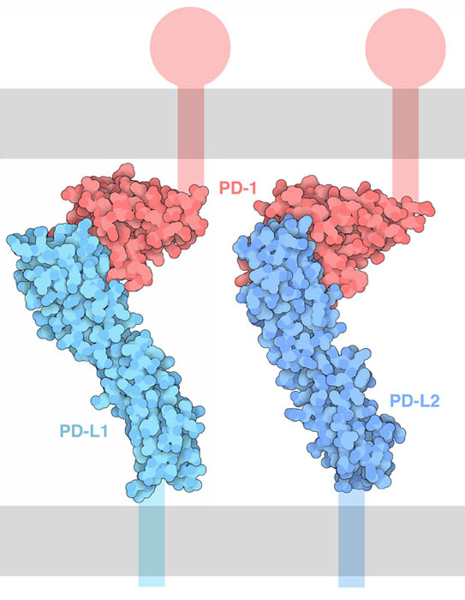

Figure:1: PDB-101: Molecule of the Month: PD-1 (Programmed Cell Death Protein

In this case study, molecular docking is used to identify small-molecule inhibitors of PD-1/PD-L1 immune checkpoint interaction. Using PD-L1 crystal structure (PDB ID: 5J89), compounds of the ZINC database were screened for binding affinity and interaction profiles. ZINC00001234 has strong binding energy (–8.2 kcal/mol). Furthermore, it makes hydrogen bonds with Tyr56 and met115 which stabilize it. Structural visualization showed that how these molecules occupy the hydrophobic groove of PD-L1 and, in certain cases, their dimerization that precludes PD-1 binding. The findings support the ability of computer-aided drug design (CADD) to design orally available and cheap immunotherapeutics, causing a combinational effect or bettering that of monoclonal antibodies.

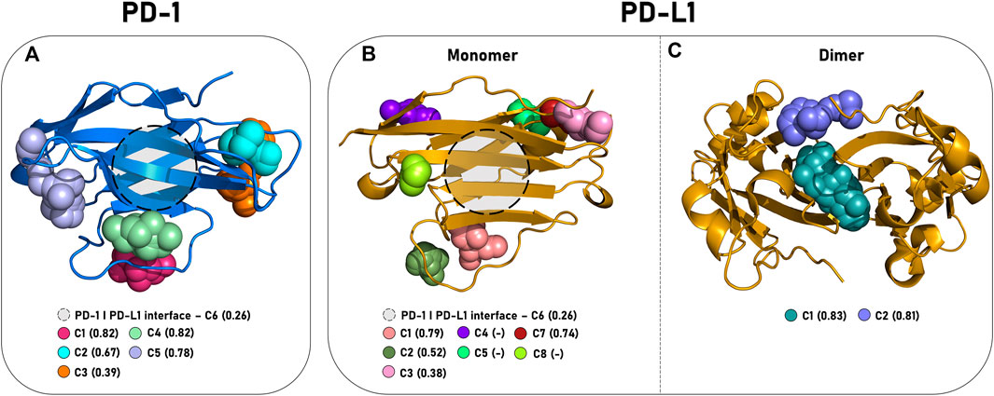

Figure 2: In silico mapping of the dynamic interactions and structure

Methodology
Our method will focus on the key hydrophobic groove of the crystal structure of PD-L1 (PDB ID:5J89) to discover new candidates. In particular, we will look at residues like Tyr56, Met115, and Tyr123, which stabilize the PD-1/PD-L1 interface. By using AutoDock Vina to screen a lead-like library from the ZINC database and visualizing them on PyMOL, we can identify molecules that have optimal binding energy. The computational workflow that assesses high-affinity interactions such as hydrogen bonding, hydrophobic contacts and pi-pi stacking assure that the resultant inhibitors are potent and also suitable for chemical scaling for cost-effective and large-scale production use.
- 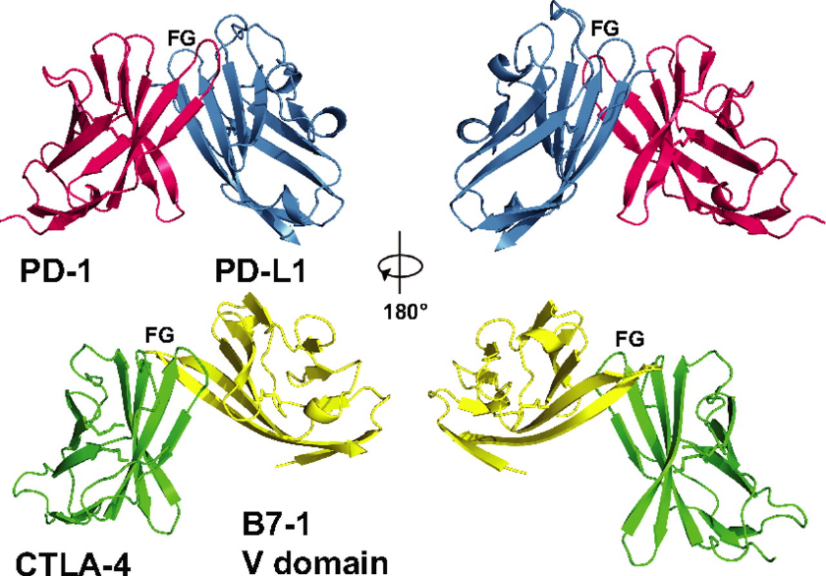

Figure 3: The PD-1/PD-L1 complex resembles the antigen-binding Fv domains

Conclusion and Future Perspectives
PD-1/PD-L1 checkpoint is still an important target. While antibodies have clinical milestones, small molecules offer greater accessibility, oral dosing and cost. The integration of CADD, pharmacophore modeling, QSAR and ADMET prediction have transformed PD-1/PD-L1 inhibition from an ‘undruggable’ problem into a rationally designable one.
The next efforts must improve selectivity, stability, and potency through the application of AI-driven design and machine learning QSAR methods. Using combination strategies which combine an SMI with a checkpoint inhibitor, a kinase modulator and/or a neoantigen vaccine could improve the outcomes and possibly overcome resistance. As clinical investigations proceed, small-molecule PD-1/PD-L1 modulating agents are set to transform into clinically feasible, precise, and patient-friendly immunotherapies herald a new era of targeted cancer therapy.
References:
- New insights into cancer immunoediting and its three component phases — elimination, equilibrium and escape - ScienceDirect
- Progress in small-molecule inhibitors targeting PD-L1. Jindan Xu , Yuanfang Kong , Pengbo Zhu, Mingyan Du, Xuan Liang , Yan Tong , Xiaofei Li, Chunhong Dong
- Mechanisms of immune checkpoint inhibitors: insights into the regulation of circular RNAS involved in cancer hallmarks. Lingjiao Meng, Haotian Wu, Jiaxiang Wu, Ping’an Ding, Jinchen He, Meixiang Sang & Lihua Liu
- Terphenyl-Based Small-Molecule Inhibitors of Programmed Cell Death-1/Programmed Death-Ligand 1 Protein–Protein Interaction. Damian Muszak,Ewa Surmia, Jacek Plewka,Katarzyna Magiera-Mularz, Justyna Kocik-Krol, Bogdan Musielak, Dominik Sala, Radoslaw Kitel, Malgorzata Stec, Kazimierz Węglarczyk, Maciej Siedlar, Alexander Dömling, Lukasz Skalniak,Tad A. Holak,
- 1,5-Disubstituted tetrazoles as PD-1/PD-L1 antagonists† Robin van der Straat,a Rosalie Draijer,a Ewa Surmiak, b Roberto Butera,a Lennart Land,a Katarzyna Magiera-Mularz,b Bogdan Musielak,b Jacek Plewka, b Tad A. Holakb and Alexander Dömling
- The PD1:PD-L1/2 Pathway from Discovery to Clinical Implementation. Kankana Bardhan¹.2, Theodora Anagnostou³ and Vassiliki A. Boussiotis
- PD-1 and PD-L1 in cancer immunotherapy: clinical implications and futureconsiderationsYongshuai Jiang a *, Ming Chenb *, Hong Nie a,c , and Yuanyang Yuan
- Computer-Aided Drug Design and Drug Discovery: A Prospective Analysis by Sarfaraz K. Niazi and Zamara Mariam
- Modern drug discovery applications for the identification of novel candidates for COVID-19 infections.Rani, Ishaa; Kalsi, Avijit; Kaur, Gagandeepc; Sharma, Pankaj; Gupta, Sumeeta; Gautam, Rupesh K.b,**; Chopra, Hiteshe; Bibi, Shabanaff; Ahmad, Syed Umairh; Singh, Inderbire; Dhawan, Manishi,j; Emran, Talha Bink,l,

Discovery of small-molecule PD-1/PD-L1 antagonists through combined virtual screening and experimental validationMichelle DiFrancesco a, Jeremy Hofer b, Abhay Aradhya b, Jeffrey Rufinus b, John Stoddart b, Stephen Finocchiaro a, Jabari Mani a, Sean Tevis a, Michael Visconti a, Griffin Walawender a, Juliette DiFlumeri a, Elena Fattakhova a, Sachin P. Patil.
- The Next Immune-Checkpoint Inhibitors: PD-1/PD-L1 Blockade in Melanoma.Kathleen M. Mahoney, PhD∙ Gordon J. Freeman, David F. McDermott,
- Regulation and Function of the PD-L1 Checkpoint. Chong Sun2 ∙ Riccardo Mezzadra2 ∙ Ton N. Schumacher.
- Present and future challenges in therapeutic designing using computational approaches.Sonal Prasad , Aashna Srivastava , Namami Singh ,Himadri Singh, Rohit Saluja , Ashok Kumar ,Neelam Yadav, Tabish Qidwai
- PD-1 and PD-L1 in cancer immunotherapy: clinical implications and future considerations. Yongshuai Jiang ^{a,*}, Ming Chen ^{b,*}, Hong Nie ^{a,c,✉}, Yuanyang Yuan.
- Structural Biology of the Immune Checkpoint Receptor PD-1 and Its Ligands PD-L1/PD-L2, Krzysztof M. Zak1,2 ∙ Przemyslaw Grudnik1,2 ∙ Katarzyna Magiera3 ∙ Alexander Dömling4 ∙ Grzegorz Dubin1,2 ∙ Tad A. Holak1,3,5
- PD-1/PD-L1 pathway: Basic biology and role in cancer immunotherapy. Arash Salmaninejad 1 2, Saeed Farajzadeh Valilou 3, Arezoo Gowhari Shabgah 4, SaeedAslani 5, Malihe Alimardani 2, Alireza Pasdar 2 6, Amirhossein Sahebkar
- A Comprehensive Computational Insight into the PD-L1 Binding to PD-1 and Small Molecules by Marialuigia Fantacuzzi *ORCID,Roberto PaciottiORCID andMariangela Agamennone
- Computer Aided Drug Design: Success and Limitations Hassan Baig, Mohammad; Ahmad, Khurshid; Roy, Sudeep; Mohammad Ashraf, Jalaluddin; Adil, Mohd; Haris Siddiqui, Mohammad; Khan, Saif; Amjad Kamal, Mohammad; Provazník, Ivo; Choi, Inho
- Progress in small-molecule inhibitors targeting PD-L1. Jindan Xu , Yuanfang Kong , Pengbo Zhu, Mingyan Du, Xuan Liang , Yan Tong , Xiaofei Li, Chunhong Dong
- Discovery of small-molecule PD-1/PD-L1 antagonists through combined virtual screening and experimental validation Michelle DiFrancesco a, Jeremy Hofer b, Abhay Aradhya b, Jeffrey Rufinus b, John Stoddart b, Stephen Finocchiaro a, Jabari Mani a, Sean Tevis a, Michael Visconti a, Griffin Walawender a, Juliette DiFlumeri a, Elena Fattakhova a, Sachin P. Patil a
- Computational Approaches Drive Developments in Immune-Oncology Therapies for PD-1/PD-L1 Immune Checkpoint InhibitorsPatrícia S. Sobral1,2,3, Vanessa C. C. Luz2,3, João M. G. C. F. Almeida2, Paula A. Videira2,3and Florbela Pereira1,
- Small Molecule Agents Targeting PD-1 Checkpoint Pathway for Cancer Immunotherapy: Mechanisms of Action and Other Considerations for Their Advanced Development Pottayil G. Sasikumar,Murali Ramachandra
- Targeting PD-1/PD-L-1 immune checkpoint inhibition for cancer immunotherapy: success and challenges Sadique A Javed, Asim Najmi, Waquar Ahsan, Khalid Zoghebi

