Consumer Segmentation of Indonesian Hajj Pilgrims: Adoption of BPKH Apps and Implications for Saudi Vision 2030
Hadiyati Munawaroh¹, Nihlahtuzzahra², Rafika Nur Zakiyyah², Agung Sri Hendarsa²
¹ Department of Strategic Planning, Research and Development, Badan Pengelola Keuangan Haji (BPKH), Jakarta, Indonesia.
² Division of Research and Development, Badan Pengelola Keuangan Haji (BPKH), Jakarta, Indonesia

*divisi.pengkajian@bpkh.go.id

ABSTRACT
Indonesia, as the largest Hajj-sending country, faces a critical challenge in aligning with Saudi Vision 2030’s agenda of smart pilgrimage and digital transformation. While awareness of the Hajj Fund Management Agency (BPKH) among Indonesian Hajj pilgrims departing in 2025 is relatively high, the adoption of its official mobile application remains limited. This gap between awareness and usage highlights the need for deeper consumer segmentation to understand readiness and barriers to digital adoption among Hajj pilgrims. This study utilizes data from a national survey of 3,286 Hajj pilgrims in 2025, structured into five analytical blocks: demographics, awareness and literacy, digital behaviour, trust and brand equity, and financial readiness. After preprocessing through categorical encoding and numerical standardization, unsupervised K-Means clustering was conducted with three clusters, validated using supervised Random Forest classification. The segmentation reveals three distinct groups: Early Adopters (37.5%), digitally active pilgrims with high trust and strong financial readiness; Potential Adopters (54.8%), the largest group with strong trust but moderate financial and digital adoption; and Late Adopters (7.7%), pilgrims with low digital literacy and weaker financial capacity. The findings provide actionable insights for both academia and practice. Academically, this research contributes to the emerging literature on Hajj management by applying machine learning-based segmentation to Indonesian Hajj pilgrim. Practically, the results inform targeted strategies for BPKH: empowering Early Adopters as digital champions, designing hybrid educational interventions for Potential Adopters, and enhancing financial inclusion programs for Late Adopters. This study contributes to global discourse on digital readiness in Hajj services and offers practical pathways to realize Saudi Vision 2030’s smart pilgrimage goals.
Keywords: awareness, digital adoption, hajj, machine learning, segmentation

1. INTRODUCTION

The transformation of the Hajj and Umrah sector has become a strategic pillar in the Saudi Vision 2030, which emphasizes diversification of the economy through the modernization of religious tourism. A key component of this vision is the development of smart pilgrimage services, characterized by digital integration, cashless transactions, and seamless experiences for millions of pilgrims annually (Government of Saudi Arabia, 2016). In this context, digital adoption is not only a matter of technological efficiency but also a global policy imperative to ensure that the world’s largest religious gathering is managed in a secure, transparent, and sustainable way.

As the largest Hajj-sending country, Indonesia occupies a central role in this transformation. Each year, more than 200,000 Indonesian pilgrims perform the Hajj, supported by a waiting list exceeding 5 million registrants. To manage this complex system, the Government of Indonesia established the Hajj Financial Management Agency (BPKH) under Law No. 34/2014, tasked with ensuring that Hajj funds are managed securely, transparently, and in accordance with Shariah principles. While survey evidence from 2025 indicates that awareness of BPKH is relatively high with over 75% of respondents reporting familiarity with its role the actual adoption of its official mobile application (BPKH Apps) remains below 20%. This discrepancy reveals a significant gap between awareness and behavioral adoption, a challenge that has direct implications for the success of Saudi Vision 2030’s digital pilgrimage agenda.
The literature on Islamic financial services and Hajj management has grown in recent years, focusing on themes such as financial literacy, governance, and satisfaction (Aaker, 1996; Keller, 2009; Sarka, Osman, & Annuar, 2024). However, there remains a notable research gap: few studies have empirically examined the relationship between awareness and brand equity in the context of Hajj financial services, and even fewer have applied data-driven segmentation methods to understand pilgrims’ readiness for digital adoption. Awareness alone does not guarantee trust, loyalty, or actual usage. Thus, it is essential to identify which consumer segments are most likely to adopt digital services, which remain hesitant, and what strategies could bridge the gap (Warsame, M. H., et al. 2025).
This study addresses this gap by applying machine learning-based segmentation to a national survey of 3,286 Indonesian Hajj pilgrims. Using five analytical blocks: demographics, awareness and literacy, digital behavior, trust and brand equity, and financial readiness, the analysis employs unsupervised K-Means clustering to classify pilgrims into three distinct groups: early adopters, potential adopters, and late adopters. These clusters are subsequently validated using Random Forest classification, which also identifies the key predictors of adoption. By integrating clustering and supervised validation, this research provides a more robust segmentation framework than traditional approaches.
The contribution of this paper is threefold. Academically, it enriches the literature on Hajj management and Islamic financial services by introducing machine learning techniques into consumer segmentation, an area that has been underexplored in religious tourism studies. Practically, the findings offer evidence-based recommendations for BPKH: empowering early adopters as digital champions, designing hybrid interventions for potential adopters, and enhancing financial inclusion programs for late adopters. Globally, this study contributes to the broader discourse on digital readiness in Hajj services, positioning Indonesia as an active partner in realizing the Saudi Vision 2030 agenda for a smart, seamless, and sustainable pilgrimage ecosystem.

2. LITERATURE REVIEW

2.1 Hajj Management and Financial Governance

The management of Hajj is widely recognized as one of the most complex logistical and financial operations in the world, given the scale of millions of pilgrims traveling annually to Saudi Arabia. Effective governance in this sector requires not only organizational efficiency but also financial transparency, accountability, and adherence to Shariah principles. In Indonesia, this responsibility has been institutionalized through the establishment of the Hajj Fund Management Agency (Badan Pengelola Keuangan Haji, BPKH) under Law No. 34 of 2014. The law mandates BPKH to manage Hajj funds with principles of prudence, non-profit orientation, transparency, and accountability, ensuring that financial returns can subsidize rising pilgrimage costs while safeguarding the welfare of pilgrims.
Scholars argue that strong governance in pilgrimage fund management directly influences public trust and legitimacy. Moreover, Sarka et al. (2024) highlight that organizations must actively manage their legitimacy perceptions among stakeholders. In the context of pilgrimage funds, this means that institutions managing these funds must engage in practices that demonstrate accountability and responsiveness to community concerns (Mohammed, M., et al. 2024).
The institution has accumulated a significant fund to facilitate Hajj operations, which are designed to provide savings accounts for prospective pilgrims and manage investments that support Hajj-related expenses Ahmad et al. (2014). Effective investment strategies are essential in generating surpluses to mitigate rising costs, thus improving accessibility for pilgrims who may struggle with the financial burden of performing Hajj amid inflationary pressures. Similarly, Indonesia’s BPKH operates with parallel objectives, focusing on the effective management of Hajj funds. BPKH’s governance ensures that the funds collected from prospective pilgrims are used in a manner that adheres to Shariah principles while maximizing returns through prudent investment strategies (Septiarini et al., 2024; Hulwati et al., 2022).
Moreover, the literature highlights that Hajj fund governance extends beyond national interests. As Hajj is a transnational religious obligation, financial mismanagement can have broader implications for international relations, religious legitimacy, and global Islamic finance credibility. Therefore, aligning Hajj financial governance with international best practices is crucial not only for domestic pilgrims but also for supporting the global agenda of Saudi Vision 2030, which promotes sustainable and smart pilgrimage services.
In summary, effective Hajj financial governance requires a dual approach: ensuring fiduciary responsibility in fund management and simultaneously preparing pilgrims for digital and financial innovations. This duality positions Indonesia’s BPKH as a key player not only in national policy but also in contributing to global standards for sustainable pilgrimage management.

2.2 Brand Equity and Awareness in Islamic Financial Services
In summary, The concept of brand equity has long been recognized as a key driver of consumer behavior, influencing loyalty, trust, and willingness to adopt services. Aaker (1996) conceptualized brand equity as consisting of four main dimensions: brand awareness, brand loyalty, perceived quality, and brand associations. Keller (2009) further emphasized the role of brand knowledge and consumer perceptions in strengthening long-term brand relationships. In the context of financial services, these dimensions play a crucial role in differentiating institutions and building trust, especially in highly regulated and sensitive industries.
In Islamic financial services, brand equity acquires an additional dimension: Shariah compliance and ethical integrity. Dusuki and Abdullah (2007) note that consumers of Islamic banks are particularly attentive to whether institutions align with Islamic principles, as this directly impacts trust and perceived legitimacy. Transparent governance and clear communication about Shariah compliance can strengthen both awareness and equity in Islamic finance. Therefore, the strength of brand equity in Islamic institutions is not only about recognition but also about the assurance of faith-based principles.
While awareness is a prerequisite for building brand equity, prior research shows that awareness alone is insufficient to guarantee adoption. Yeo et al. (2013) demonstrate that high awareness levels do not necessarily translate into consumer loyalty or usage, particularly in digital service environments. In the case of Hajj financial services, survey findings in Indonesia reveal a similar pattern: pilgrims may know about BPKH as an institution but may not fully engage with its digital platforms, such as the official BPKH Apps. This highlights a gap between awareness and equity, where institutional knowledge exists but does not automatically lead to trust, loyalty, or digital adoption.
Thus, strengthening brand equity in Islamic financial services requires bridging this gap by focusing not only on increasing visibility but also on enhancing consumer trust, perceived service quality, and loyalty. For BPKH, this entails leveraging transparency, improving digital literacy, and ensuring Shariah-compliant innovation to convert awareness into active engagement.

2.3 Digital Adoption in Religious Tourism and Financial Services
Digital transformation has become a central driver of change in both tourism and financial services, reshaping consumer behavior and institutional strategies. In the context of religious tourism, particularly Hajj and Umrah, Saudi Vision 2030 places strong emphasis on smart pilgrimage services, which integrate digital technologies to enhance efficiency, safety, and user experience. These include cashless payment systems, mobile applications for service tracking, and platforms for real-time communication with pilgrims. The adoption of such technologies is seen as critical to managing the growing scale of religious tourism while ensuring sustainability and inclusivity.
In financial services, adoption of digital innovations is influenced by multiple factors. According to Venkatesh et al. (2003), the Unified Theory of Acceptance and Use of Technology (UTAUT) identifies performance expectancy, effort expectancy, social influence, and facilitating conditions as major determinants of technology adoption. Subsequent studies confirm that demographic characteristics such as age, education, and income significantly influence readiness to adopt digital services (Zhou et al., 2010). Trust also plays a pivotal role, particularly in financial contexts, where consumers must feel confident that digital platforms are secure, reliable, and aligned with their expectations (Gefen et al., 2003).
In Islamic financial services, digital adoption faces unique challenges. Ramadhan (Ramadhan, 2022) highlights that effective governance in fintech operations within Islamic banking is essential for long-term stability. Regulatory compliance with Shariah principles serves not only as a protective mechanism for consumers but also influences the overall integrity of the Islamic institution sector. This implies that consumers are not only seeking innovative financial products but also assurance that these products adhere strictly to Islamic law, avoiding transactions that involve interest (riba), uncertainty (gharar), or gambling (maysir). As such, the alignment of digital financial offerings with Shariah principles enhances consumer confidence and acceptance. Barriers also include limited digital literacy, skepticism about data security, and disparities in financial capacity among different groups of consumers (Kumari, 2025; Dinath, 2025). This indicates that digital adoption cannot be treated uniformly but must be tailored to different consumer segments, considering their literacy, trust levels, and financial readiness.
In summary, the literature demonstrates that digital adoption in religious tourism and financial services is shaped by a combination of technological, demographic, and trust-related factors. For institutions like BPKH, this underscores the importance of understanding the heterogeneity among pilgrims: while some are ready for digital services, others remain hesitant due to financial or literacy constraints. Thus, segmentation becomes a critical tool to design targeted interventions that not only increase adoption but also align with global objectives such as Saudi Vision 2030.

2.4 Digital Transformation and the BPKH Mobile Application
The Badan Pengelola Keuangan Haji (BPKH), or Hajj Fund Management Agency, serves as Indonesia’s central institution responsible for managing pilgrims’ deposits and investment returns (nilai manfaat) under Law No. 34 of 2014. In line with its modernization agenda, BPKH launched the BPKH Mobile Application (BPKH Apps) as part of its commitment to delivering faster, easier, and more transparent financial services for prospective Hajj pilgrims.
During the soft launching event held in Padang on November 2, 2024, BPKH officially introduced the new app, marking a significant milestone in the agency’s digital transformation journey. The event, attended by the Deputy Minister of Religious Affairs and various stakeholders, emphasized BPKH’s mission to enhance pilgrim welfare through technology-driven transparency and accountability. During its first phase, the BPKH Mobile Application integrated seven out of 33 Hajj Deposit Recipient Banks (BPS-BPIH), including Bank Muamalat Indonesia, Bank Danamon Syariah, Bank Syariah Indonesia, Bank BJB Syariah, Bank Nano Syariah, Bank CIMB Niaga Syariah, and Bank Nagari Syariah enabling users to check their Virtual Account balances, make deposit payments, and access real-time information on fund management and investment performance (Badan Pengelola Keuangan Haji, 2024).
Beyond its transactional functionality, the app was designed as a pilgrim companion platform, offering features such as Hajj guides, prayer schedules, mosque locations, and Qur’an recitation tools. These additions signify BPKH’s strategic vision of building a comprehensive Hajj ecosystem, integrating financial, spiritual, and informational services within a single interface (Badan Pengelola Keuangan Haji, 2024).
Empirically, the introduction of BPKH Apps aligns with the growing global shift toward digital Islamic finance and public financial management reform, emphasizing transparency, efficiency, and citizen engagemen. Long, Cangiano, and Middleton (2023) describe digital public financial management as an evolving paradigm for governance innovation. However, as shown in the 2025 National Hajj Financial Services Survey, the adoption rate remains low at 18.9%, despite high institutional awareness (61.5%). This disparity suggests a behavioral adoption gap where trust, familiarity, and literacy play more significant roles than mere access to technology (Venkatesh & Davis, 2000).
From a strategic governance perspective, the BPKH Apps represents a critical digital trust mechanism, bridging religious accountability and modern financial technology. It also resonates with Saudi Vision 2030’s Smart Pilgrimage framework, which envisions integrated, data-driven, and digitally empowered pilgrim services. BPKH’s digital initiative therefore contributes to the global agenda of Islamic financial inclusivity, while establishing Indonesia as a model for transparent and technology-based Hajj fund management.

2.5 Consumer Segmentation Approaches
Consumer segmentation is a central concept in marketing and management research, providing a framework for categorizing heterogeneous consumer groups into relatively homogeneous clusters. The objective is to enable organizations to design more tailored products, services, and marketing strategies that meet the needs of specific segments (Wedel & Kamakura, 2012). Traditional segmentation methods often rely on demographic, geographic, or psychographic variables. While these approaches remain valuable, they are limited in capturing the multidimensional complexity of consumer behavior in contemporary digital and financial markets (Kotler & Keller, 2016).
Recent advances in computational techniques have expanded the scope of segmentation by integrating data-driven and machine learning methods. Among these, K-Means clustering is one of the most widely applied techniques for unsupervised segmentation, grouping individuals based on similarity across multiple attributes (Jain, 2010). K-Means has been particularly effective in uncovering latent consumer groups that may not be visible through traditional methods, making it suitable for large-scale survey data.
Complementing unsupervised clustering, supervised learning techniques such as Random Forest classification have been employed to validate clusters and predict consumer adoption behaviors. Random Forest, as an ensemble method, aggregates predictions from multiple decision trees, thereby enhancing accuracy and identifying the most influential variables in consumer decision-making (Breiman, 2001). This dual approach of clustering and supervised validation provides both interpretive insights and predictive robustness, a methodology increasingly adopted in marketing analytics and financial services research (Davenport & Harris, 2017).
In the context of religious tourism and Hajj financial management, consumer segmentation is especially critical. Pilgrims vary not only in demographic and financial capacity but also in their digital readiness, literacy levels, and trust in institutions. Segmenting these consumers allows institutions such as BPKH to identify early adopters of digital services, potential adopters requiring additional support, and late adopters who may need sustained financial and educational support. By integrating clustering with predictive modeling, segmentation frameworks can deliver actionable insights for designing targeted digital marketing strategies, thereby aligning local consumer behavior with global initiatives such as Saudi Vision 2030.

3. Research Methodology
This study employs a quantitative research design using a cross-sectional approach to identify and classify consumer segments of Indonesian Hajj pilgrims based on their readiness to adopt the BPKH mobile application. The analysis combines unsupervised and supervised machine learning methods namely K-Means clustering for segmentation and Random Forest classification for validation and feature importance analysis. This dual-method design enhances both the interpretive and predictive accuracy of the segmentation results.

3.1 Data Source and Sample
The dataset used in this research originates from the Hajj Financial Services Survey 2025 conducted by the Hajj Fund Management Agency (Badan Pengelola Keuangan Haji or BPKH). The survey comprises responses from 3,286 Indonesian regular Hajj pilgrims who departed for the 2025 pilgrimage season, with an average waiting period of approximately 26 years across 14 embarkation points nationwide. The sample represents various demographic groups age, occupation, income, and education ensuring national representativeness. Respondents provided information regarding their awareness of BPKH, perceptions of transparency and Shariah compliance, use of digital services, and financial readiness for pilgrimage expenses.

3.2 Variable Framework
The analysis is structured into five analytical blocks that represent multidimensional factors influencing digital adoption:
- Demographics: age group, gender, education level, occupation, and monthly expenditure.
- Awareness and Literacy: familiarity with BPKH, knowledge of Virtual Accounts (VA), understanding of investment benefits, and exposure to BPKH’s educational programs.
- Digital Behavior: prior usage of BPKH Apps, ability to check VA balance digitally, satisfaction with digital service accessibility, and perceived ease of use.
- Trust and Brand Equity: perception of transparency, Shariah compliance, prudence in investment management, and responsiveness of customer service.
- Financial Readiness: willingness to pay increased deposits, capacity for installment payments, saving habits, and affordability under rising Hajj costs.
These variables together capture the behavioral, psychological, and financial dimensions that may influence adoption readiness.

3.3 Data Preprocessing
Prior to analysis, all data were preprocessed to ensure analytical quality and comparability. The process involved:
- Data cleaning, including removal of administrative metadata and incomplete responses.
- Imputation of missing values using mode for categorical variables and median for numerical variables.
- Encoding and normalization, where categorical variables were transformed using one-hot encoding and continuous variables standardized using z-score normalization.
This procedure ensured that the dataset was statistically balanced and suitable for clustering and classification algorithms (Jain, 2010).

3.4 Segmentation Using K-Means Clustering
K-Means clustering was applied to uncover underlying consumer groups with similar digital and financial characteristics. The optimal number of clusters (k) was determined through both the Elbow Method and Silhouette Score (Rousseeuw, 1987). The analysis revealed three clusters representing distinct behavioral profiles:
- Cluster 1: Early Adopters – digitally literate, financially capable, and highly trusting of BPKH.
- Cluster 2: Potential Adopters – moderate digital engagement but strong institutional trust.
- Cluster 3: Late Adopters – limited literacy, low financial capacity, and preference for offline channels.

3.5 Validation and Feature Importance Using Random Forest
To validate the cluster classification and assess predictive performance, a Random Forest classifier (Breiman, 2001) was employed using BPKH Apps adoption (1 = user, 0 = non-user) as the dependent variable. The model’s predictive performance was evaluated using the confusion matrix, accuracy score, and F1-measure. Feature importance analysis was conducted to identify the variables most strongly associated with digital adoption, revealing the relative influence of demographic, literacy, and trust-related factors.

3.6 Reliability and Validation
Internal consistency of multi-item constructs such as literacy, trust, and brand equity was tested using Cronbach’s alpha (α > 0.7). Cluster reliability was further examined through Silhouette Coefficient analysis, and Random Forest validation provided external consistency, confirming that the identified clusters were statistically meaningful and behaviorally interpretable.

3.7 Analytical Interpretation
Finally, the clusters were interpreted in relation to their digital readiness and mapped to the Saudi Vision 2030 agenda for smart pilgrimage and digital transformation. The segmentation provides actionable insights for BPKH to design targeted interventions: empowering early adopters as digital ambassadors, enhancing digital outreach to potential adopters, and promoting financial inclusion programs for late adopters.

4. FINDINGS AND DISCUSSION
4.1 Respondent Overview and Digital Adoption
The national survey covered 3,286 Hajj registrants across 14 embarkation points in Indonesia. From a demographic perspective, the respondent pool is predominantly male (64.7%), while females constitute 35.3%. In terms of age, the survey reveals that the majority belong to Generation X (45–55 years old, 42.8%), followed by those aged above 55 years (32%) and 29–44 years (21.2%), with only 4% aged 18–28 years (Figure 1). These proportions suggest that most Hajj registrants are mature adults with stable financial readiness but varying levels of digital literacy factors critical for understanding adoption patterns of BPKH’s digital services.
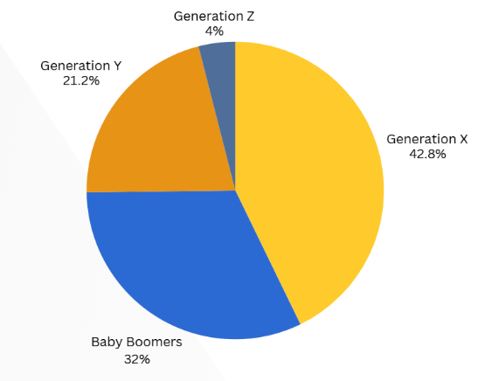
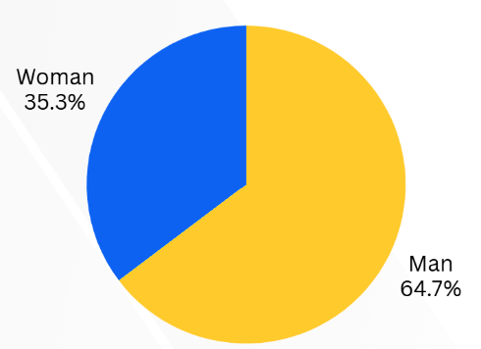

Figure 1: Gender and Generational Distribution of Respondents

Regionally, West Java dominates the domicile distribution with 28.1% of respondents, followed by East Java (7.7%) and several provinces in Sumatra and Kalimantan (Table 1). This mirrors population density and the regional allocation of Hajj quotas, reinforcing the importance of focusing digital outreach in these key provinces.

Table 1: Distribution of Respondents by Province of Domicile
No | Province | Percentage (%) | No | Province | Percentage (%)
1 | West Java | 28.1 | 15 | Riau Islands | 2.3
2 | East Java | 7.7 | 16 | Banten | 1.9
3 | South Kalimantan | 5.9 | 17 | Central Sulawesi | 1.7
4 | South Sumatra | 5.9 | 18 | North Sulawesi | 1.4
5 | East Kalimantan | 5.7 | 19 | Bali | 1.3
6 | West Sumatra | 5.2 | 20 | Southeast Sulawesi | 0.9
7 | Central Java | 4.7 | 21 | West Sulawesi | 0.6
8 | North Sumatra | 4.5 | 22 | Central Kalimantan | 0.5
9 | West Kalimantan | 4.4 | 23 | East Nusa Tenggara | 0.5
10 | West Nusa Tenggara | 3.6 | 24 | Maluku | 0.2
11 | Jakarta (DKI) | 3.2 | 25 | Yogyakarta (DIY) | 0.2
12 | Aceh | 3.0 | 26 | North Kalimantan | 0.1
13 | South Sulawesi | 3.0 | 27 | Jambi | 0.1
14 | Riau | 2.9

From an economic standpoint, the majority of respondents spend between IDR 2 million and 6 million per month, with 27.7% in the IDR 2–4 million range and 23.3% in the IDR 4–6 million range (Table 2). These figures indicate moderate middle-income characteristics consistent with the socio-economic profile of Hajj registrants, suggesting reasonable financial capacity for digital savings or installment schemes.

Table 2: Distribution of Respondents by Monthly Expenditure Range
Monthly Expenditure (IDR*) | Percentage (%)
Rp 2,000,001 – Rp 4,000,000 | 27.7
Rp 4,000,001 – Rp 6,000,000 | 23.3
Rp 6,000,001 – Rp 8,000,000 | 14.7
Less than Rp 2,000,000 | 13.5
Rp 8,000,001 – Rp 10,000,000 | 9.5
Rp 10,000,001 – Rp 12,000,000 | 3.5
Rp 12,000,001 – Rp 14,000,000 | 3.0
Rp 14,000,001 – Rp 16,000,000 | 2.4
Rp 18,000,001 – Rp 20,000,000 | 1.5
Rp 16,000,001 – Rp 18,000,000 | 0.9
*
In terms of education, nearly half of respondents hold a diploma or bachelor’s degree (47.6%), followed by senior high school graduates (23.3%) and postgraduate degree holders (17.4%) (Figure 2). Respondents with education below junior high represent only a small portion, implying a high baseline literacy level suitable for financial education and digital transformation initiatives. Employment data show that the largest occupational groups are civil servants (27.9%), entrepreneurs (17.7%), and housewife (15.2%) (Figure 2). This indicates a relatively stable and diverse economic base, where civil servants and professionals represent segments most ready for early adoption of BPKH’s digital applications.

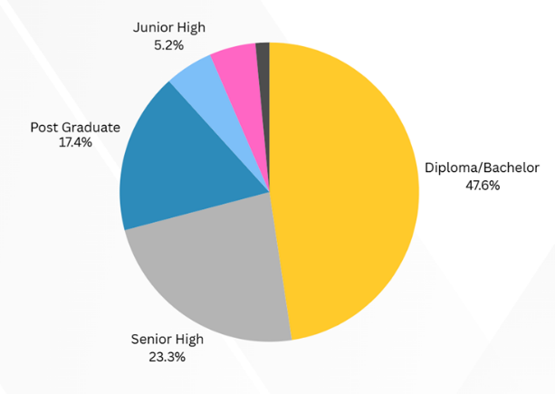
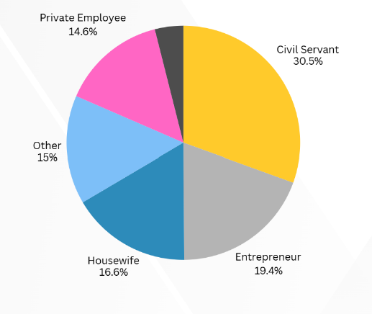

Figure 2: Distribution of Respondents by Education Level and Occupation

Survey results highlight an emerging yet uneven digital adoption pattern among Hajj registrants. Awareness of BPKH’s Virtual Account (VA) reached 40.8%, while only 18.9% of those aware had used the BPKH Mobile Application, and 78.4% of users reported checking their VA balance through the app (see Figure 3).
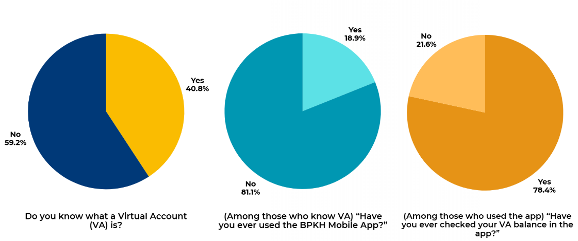

Figure 3: Virtual Account (VA) Awareness and BPKH Mobile App Usage

Among those who accessed the app, user experience metrics were highly positive: 49.4% rated the ease of checking balances as very easy, and 45.9% expressed very high satisfaction with the displayed information (Figure 4). However, despite favorable satisfaction levels, overall app adoption remains modest, with fewer than 6% of total respondents actively using the mobile platform, underscoring the need for stronger literacy and outreach initiatives.

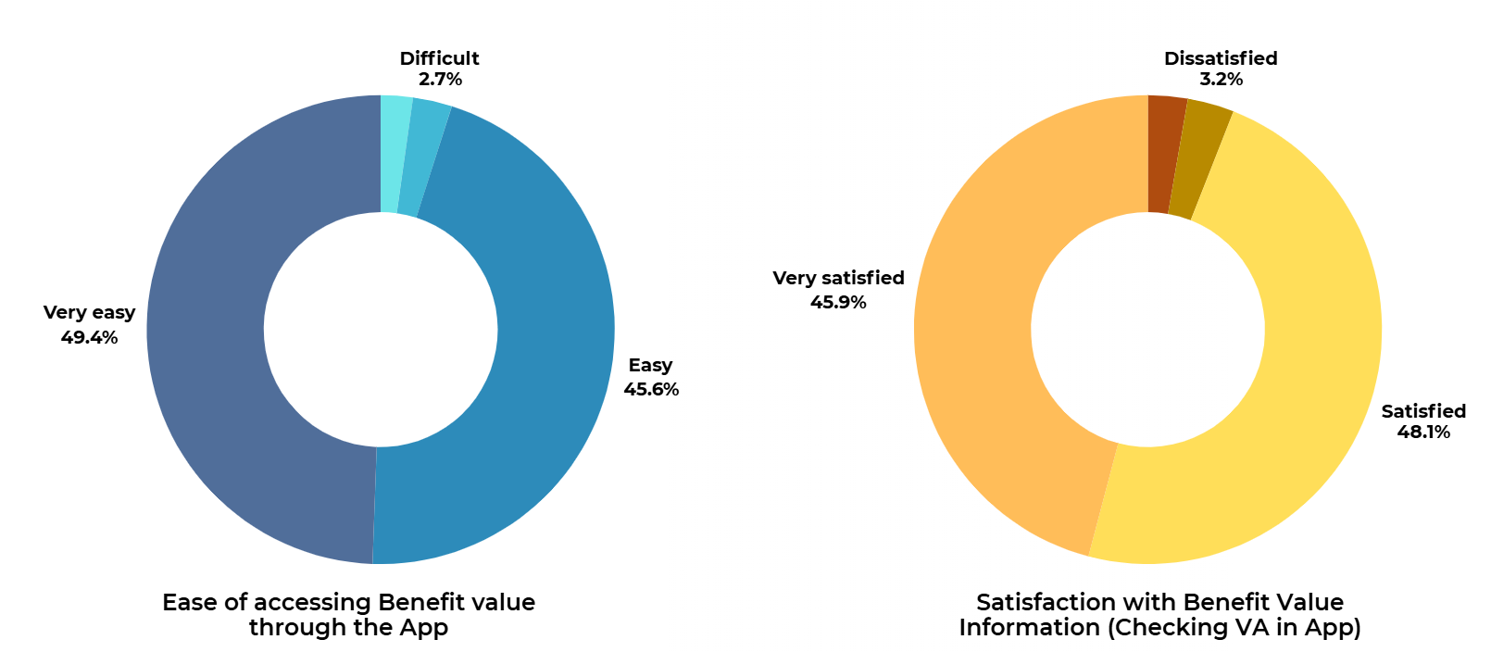

Figure 4: Ease of Access and User Satisfaction with BPKH Apps’ Virtual Account Feature

The adoption funnel (Figure 5) visually demonstrates this behavioral gap: of the 3,286 respondents, only 1,250 (38%) were aware of the Virtual Account feature, and just 236 (7%) had ever used the mobile app. Of these, 185 users (5.6%) proceeded to check their VA balance and provide satisfaction feedback, forming the smallest yet most digitally engaged subgroup.

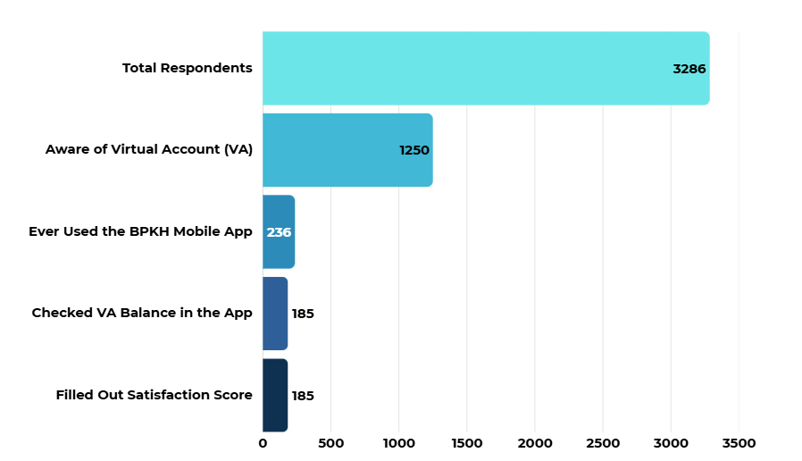
Figure 5: Usage Funnel and Satisfaction Score Distribution of BPKH Mobile App Users

This descriptive overview indicates that trust, awareness, and digital literacy significantly shape adoption of the BPKH Apps among prospective pilgrims (BPKH, 2025). While satisfaction among users is high, adoption barriers remain rooted in limited information exposure and behavioral inertia, reflecting the early stage of digital transformation within Indonesia’s Hajj financial ecosystem.

4.2 Unsupervised Segmentation (K-Means, k = 3)
The K-Means clustering algorithm was employed to identify latent consumer segments within the dataset, with the number of clusters (k) determined through both exploratory testing and internal validation. The model was configured with parameters random_state = 42 and n_init = 30, ensuring stable convergence across runs.

4.2.1 Cluster Composition and Distribution
The number of clusters was determined using internal validation methods. The Elbow Method (Figure 6) indicated a distinct inflection point at k = 3, suggesting this as the optimal number of clusters balancing model simplicity and within-cluster compactness. Complementing this, the Silhouette Coefficient value of 0.201 reflects moderate internal consistency acceptable within behavioral survey contexts where attitudinal variability is expected.

Table 3. Consumer Segments from K-Means Clustering (k = 3)
Segment | n | Proportion (%)
Potential Adopters | 1,801 | 54.8
Early Adopters | 1,234 | 37.5
Late Adopters | 252 | 7.7

The segmentation results show that Potential Adopters form the largest group (54.8%), followed by Early Adopters (37.5%) and Late Adopters (7.7%). This proportional structure suggests that while a majority of pilgrims are digitally aware and open to innovation, only a subset demonstrates full digital maturity and readiness.
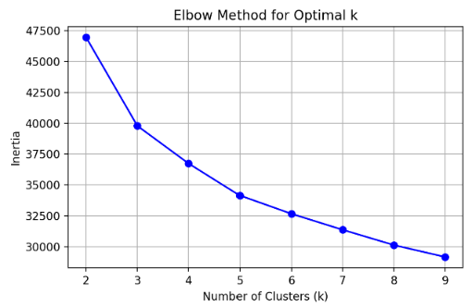

Figure 6: Elbow Method for Optimal Cluster Selection

The Elbow curve displays a steep reduction in inertia between k = 2 and k = 3, after which the rate of decline flattens. This pattern validates the selection of k = 3 as the optimal solution, balancing explanatory power and parsimony in representing consumer diversity. Beyond three clusters, incremental explanatory gains diminish, implying that finer segmentation would add complexity without meaningful behavioral distinction.

4.2.2 Cluster Visualization and Interpretation
The two-dimensional Principal Component Analysis (PCA) projection reveals three visually separable clusters. The dispersion pattern confirms distinct grouping across behavioral and attitudinal dimensions, supporting the validity of the clustering model.

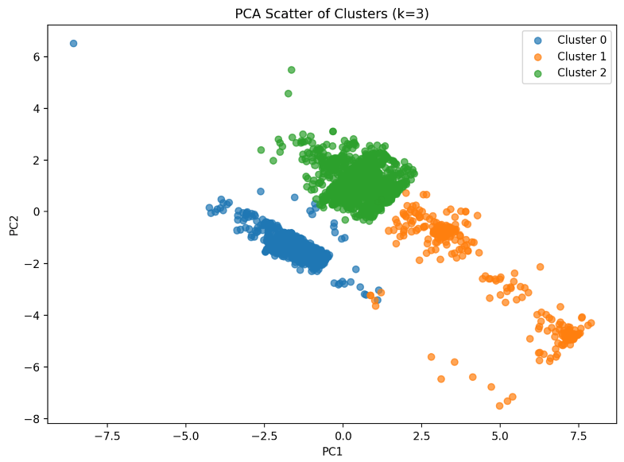

Figure 7: PCA Projection of Cluster Distribution (k = 3)
- Cluster 0 (Blue): represents a relatively cohesive low–to–medium readiness group.
- Cluster 1 (Orange): reflects high trust and awareness yet limited financial and digital engagement.
- Cluster 2 (Green): displays stronger digital literacy and engagement metrics, corresponding to the early-adopter profile.
The spatial separation confirms that digital adoption behavior, awareness, and trust form the most influential axes in differentiating Hajj consumer segments.
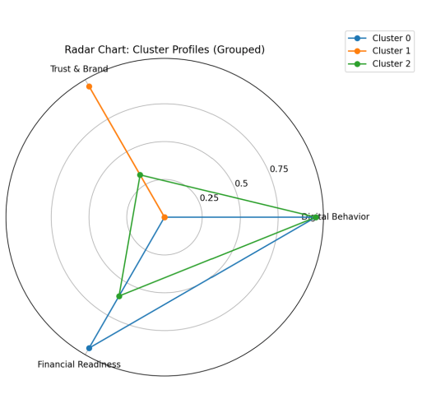
Figure 8: Radar Chart of Composite Cluster Profiles

The radar visualization aggregates normalized means for three analytical dimensions Digital Behavior, Trust & Brand Equity, and Financial Readiness.
- Cluster 2 (Green) exhibits the highest scores on Digital Behavior and moderate strength in Trust and Financial Readiness, typifying Early Adopters.
- Cluster 0 (Blue) shows strong Financial Readiness and mid-level Digital Behavior, corresponding to Potential Adopters who can transition with proper guidance.
- Cluster 1 (Orange) scores highest in Trust & Brand Equity but lowest in digital and financial readiness, signifying Late Adopters who remain hesitant or dependent on traditional offline systems.
This comparative radar structure highlights the multi-dimensional nature of adoption readiness and identifies Trust as a universal strength among Indonesian Hajj registrants, while Digital Behavior remains the key differentiating variable.

4.3 Supervised Validation (Random Forest)
To evaluate the robustness and interpretability of the unsupervised segmentation, a Random Forest (RF) classifier was applied as a supervised validation model. This approach aligns with best practices in hybrid machine learning segmentation, where unsupervised cluster assignments are subsequently validated through predictive models to assess feature discrimination and model stability (Breiman, 2001; Han, Pei, & Tong, 2024).
The Random Forest algorithm was trained using 70% of the dataset and tested on the remaining 30%, with parameter configuration n_estimators = 500, random_state = 42, and n_jobs = -1. The dependent variable was the assigned cluster label (Early, Potential, Late Adopters), while independent variables corresponded to the standardized and encoded input features across five analytical blocks (Demographics, Awareness & Literacy, Digital Behavior, Trust & Brand Equity, and Financial Readiness).

4.3.1 Model Accuracy and Performance
The model achieved a classification accuracy of 100%, with precision and recall scores exceeding 0.95 across all clusters (Table 4). This high performance reflects the internal consistency between feature patterns and cluster membership, confirming that the K-Means segmentation structure is both stable and statistically discriminable.

Table 4: Random Forest Classification Report for Cluster Validation
Cluster | Precision | Recall | F1-Score | Support (n)
0 | 1.00 | 0.99 | 1.00 | 370
1 | 0.95 | 1.00 | 0.97 | 76
2 | 1.00 | 1.00 | 1.00 | 541
Accuracy |  |  | 1.00 | 987
Macro Average | 0.98 | 1.00 | 0.99 | 987
Weighted Average | 1.00 | 1.00 | 1.00 | 987

These results confirm that the underlying features used in clustering are highly informative and coherent, meaning that respondents belonging to distinct adopter segments exhibit measurable behavioral and attitudinal differences.

4.3.2 Feature Importance Analysis
The Random Forest model also provides a feature importance matrix, ranking variables according to their contribution in discriminating between adopter groups. The top five predictors (Figure 9) were:
- Understanding of BPKH’s function and mandate (26.8%)
- Recognition of BPKH’s official logo (25.4%)
- Awareness of BPKH before embarkation (23.8%)
- Experience using BPKH Apps (9.9%)
- Experience checking Virtual Account (VA) via the app (8.5%)

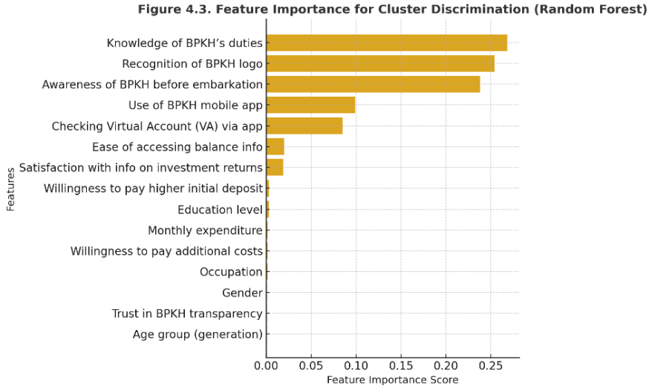

Figure 9. Feature Importance Ranking from Random Forest Validation
The dominance of awareness-related features underscores that brand literacy and institutional visibility remain the strongest differentiators of digital adoption behavior among pilgrims. In contrast, demographic and financial variables (e.g., education, income) contributed less than 3% each, suggesting that cognitive and trust-based dimensions outweigh purely socioeconomic factors in explaining readiness for digital transformation (Kotler et al., 2021).

4.3.3 Validation of Segmentation Structure
The combined evidence from Random Forest validation strengthens the interpretive credibility of the three-segment K-Means structure. The following empirical relationships emerge:
- Early Adopters predicted primarily by variables linked to digital literacy and app usage, consistent with technology adoption theories (Venkatesh & Davis, 2000).
- Potential Adopters driven by institutional awareness and trust, representing a “convertible” population segment suitable for targeted nudging through hybrid campaigns (Söilen & Benhayoun, 2022)
- Late Adopters best predicted by low awareness and low VA interaction, indicating informational and accessibility barriers that must be addressed via financial inclusion programs.
Overall, the Random Forest validation demonstrates high model coherence, confirming that the unsupervised segmentation results are data-driven, reproducible, and aligned with behavioral theory frameworks in digital adoption research.

4.4 Discussion
This study aimed to identify and analyze consumer segments among Indonesian Hajj registrants based on their digital adoption of the BPKH mobile application. Through the integration of unsupervised clustering (K-Means) and supervised validation (Random Forest), the research provides an evidence-based understanding of behavioral heterogeneity that extends beyond simple demographic explanations.
The results indicate that awareness, trust, and digital behavior are the most influential determinants of adoption. These findings confirm prior theoretical models of technology acceptance, emphasizing that digital readiness in financial and religious contexts is driven by cognitive and affective dimensions rather than purely economic factors (Venkatesh & Davis, 2000).
In line with Rogers’ (2003) Diffusion of Innovation Theory, pilgrims fall along a digital maturity spectrum:
- Early Adopters (37.5%) are the innovation champions, representing digitally literate, financially capable, and institutionally trusting pilgrims.
- Potential Adopters (54.8%) dominate the population, combining strong trust and awareness but limited app engagement mirroring the “early majority” category.
- Late Adopters (7.7%) correspond to the “laggards,” facing digital barriers that require inclusive interventions.
The Random Forest validation further supports these behavioral distinctions, revealing that awareness of BPKH’s function, logo recognition, and prior app usage are the strongest predictors of segment membership. This implies that BPKH’s institutional visibility is not only a matter of reputation but a key enabler of digital transformation.
These insights resonate with recent studies in digital Islamic finance (Wahab & Ihsan, 2025; Kotler et al., 2021), which argue that regulatory frameworks established by financial authorities are crucial for accelerating digital transformation in Shariah-compliant finance. In the context of Indonesia’s Hajj management, this finding underscores that digital transformation must be value-driven and grounded in sharia governance, transparency, and inclusivity.

4.4.1 Implications for BPKH and Saudi Vision 2030
The segmentation results have direct strategic relevance to both BPKH’s digital roadmap and the Saudi Vision 2030 agenda of Smart Pilgrimage and Digital Governance.
- For BPKH
The findings enable a data-driven approach to digital marketing and service design:
  - Early Adopters can serve as digital ambassadors to champion app adoption through testimonials and peer education.
  - Potential Adopters should be prioritized in hybrid outreach programs combining offline guidance and online education.
  - Late Adopters require financial literacy programs and accessible user interfaces to ensure equitable participation.
- For Saudi Vision 2030
The study supports Vision 2030’s strategic goals in at least three areas:
  - Smart Pilgrimage Services: promoting the use of data and digital tools to optimize pilgrim experience.
  - Financial Inclusion: expanding access to Islamic financial innovation for all social groups.
  - Data-Driven Governance: advancing analytics-based decision-making in religious institutions.
By identifying the behavioral structure of digital adoption, this research contributes to operationalizing Vision 2030’s broader theme of transforming religious tourism through innovation and human-centric technology (Government of Saudi Arabia, 2016).

4.4.2 Theoretical Contributions
From an academic standpoint, this study makes three distinct contributions:
- It introduces the application of machine learning segmentation to Islamic financial service adoption, bridging behavioral science and data analytics.
- It expands technology adoption theory into the context of religious financial management, integrating trust and faith-based governance as determinants of digital readiness.
- It demonstrates a hybrid validation approach (K-Means + Random Forest) as a methodological model for future digital inclusion research in emerging markets.

4.5 Practical Recommendations
Based on empirical findings, BPKH can adopt the following strategies:
- Develop a segmented digital marketing plan, emphasizing different messaging for each adopter group.
- Strengthen collaboration with banks (BPS-BPIH) and Ministry of Religious Affairs to integrate app usage during Hajj registration and payment stages.
- Implement AI-driven personalization within BPKH Apps to tailor content, notifications, and reminders according to user behavior segments.
- Conduct longitudinal monitoring to track movement between adopter groups over time, providing a continuous improvement loop for digital transformation efforts.

5. CONCLUSION AND DIRECTION FOR FUTURE RESEARCH
This study demonstrates that Indonesia’s Hajj pilgrims are not homogeneous in their digital adoption behavior. By integrating segmentation analytics and behavioral validation, it reveals three distinct consumer segments whose attitudes toward BPKH’s mobile application reflect varying degrees of trust, literacy, and readiness. The insights gained are not only diagnostic but transformative: they guide BPKH in advancing its digital ecosystem while aligning with Saudi Arabia’s Vision 2030 for a smart, inclusive, and sustainable Hajj experience. Ultimately, the study affirms that digital transformation in Hajj management is not merely a technological shift, but a socio-religious evolution anchored in transparency, inclusion, and empowerment of every pilgrim through data-driven innovation.
For future research, several directions are worth pursuing.
- Longitudinal analysis could be conducted to monitor how digital adoption evolves across different Hajj seasons, particularly after the implementation of new BPKH digital services or regulatory adjustments.
- Cross-country comparative studies between Indonesia and other major Hajj-sending nations (e.g., Malaysia, Pakistan, and Turkey) may uncover contextual drivers that influence digital readiness in Islamic financial and pilgrimage management.
- Integration of psychographic and behavioral data, including motivation, religiosity, and digital trust indices, could enrich segmentation models beyond demographic and financial dimensions.
- Finally, policy simulations using agent-based or system dynamics modeling may help forecast how various interventions such as literacy campaigns, app incentives, or cost adjustments affect the overall adoption trajectory toward achieving a fully digital Hajj ecosystem.
These future pathways will extend the current study’s contribution, bridging empirical analytics and policy design for a more adaptive, resilient, and pilgrim-centric digital transformation.

6. REFERENCES
Aaker, D. A. (1996). Measuring brand equity across products and markets. California Management Review, 38(3), 102-120. https://doi.org/10.2307/41165845
Ahmad, M., Arif, M. S. M., Zakuan, N., Rahman, S., Abdullah, T., & Fadzil, N. S. (2014). The effect of demographics on customer satisfaction amongst malaysia hajj pilgrims: survey result. Applied Mechanics and Materials, 660, 1000-1004. https://doi.org/10.4028/www.scientific.net/amm.660.1000
Badan Pengelola Keuangan Haji (BPKH). (2024, November 2). BPKH Meluncurkan BPKH Apps dan Berikan Apresiasi Kinerja Terbaik BPS BPIH Semester 1 Tahun 2024. [Press release]. Padang, Indonesia. Retrieved from https://bpkh.go.id
Breiman, L. (2001) Random Forests. Machine Learning, 45, 5-32.
http://dx.doi.org/10.1023/A:1010933404324
Davenport, T. H., & Harris, J. G. (2017). Competing on analytics: Updated, with a new introduction: The new science of winning. Harvard Business Review Press.
Dinath, W. (2025). Digital literacy as a catalyst for m-commerce adoption in south africa. European Conference on Innovation and Entrepreneurship, 20(1), 199-207. https://doi.org/10.34190/ecie.20.1.3837
Dusuki, A. W., & Abdullah, N. I. (2007). Why do Malaysian customers patronize Islamic banks? International Journal of Bank Marketing, 25(3), 142–160. https://doi.org/10.1108/02652320710739850
Gefen, D., Karahanna, E., & Straub, D. W. (2003). Trust and TAM in online shopping: An integrated model. MIS Quarterly, 27(1), 51–90. https://doi.org/10.2307/30036519
Government of Saudi Arabia. (2016). Kingdom of Saudi Arabia Vision 2030. Riyadh, Saudi Arabia: Government of Saudi Arabia. https://www.vision2030.gov.sa
Han, J., Pei, J., & Tong, H. (2024). Data mining: Concepts and techniques. Morgan Kaufmann. https://doi.org/10.1016/C2013-0-18660-6
Hulwati, H., Andespa, R., & Mujiono, S. (2022). Hajj fund investment management in indonesia. At-Tijaroh: Jurnal Ilmu Manajemen Dan Bisnis Islam, 8(1), 71-86. https://doi.org/10.24952/tijaroh.v8i1.5189
Jain, A. K. (2010). Data clustering: 50 years beyond K-means. Pattern Recognition Letters, 31(8), 651–666. https://doi.org/10.1016/j.patrec.2009.09.011
Keller, K. L. (2009). Building strong brands in a modern marketing communications environment. Journal of Marketing Communications, 15(2–3), 139–155. https://doi.org/10.1080/13527260902757530
Kotler, P., & Keller, K. L. (2016). Marketing management (15th ed.). Pearson Education.
Kotler, P., Kartajaya, H., & Setiawan, I. (2021). Marketing 5.0: Technology for Humanity. John Wiley & Sons.
Mohammed, M., Bardai, B. B., & Adam, M. I. A. B. (2024). Access to Finance and its Implications for Micro, Small and Medium Business Enterprises (MSMEs) Growth: A Case Study of Financial Institutions and Alternative Financing Channels in Nigeria. International Journal of Research and Innovation in Applied Science, 9(12), 128-137.
Kumari, B., & Singh, A. (2025). Cybersecurity risks and data privacy concerns in PMJDY digital transactions. European Economic Letters, 15(2), 4725–4735. https://doi.org/10.52783/eel.v15i2.3323
Long, C., Cangiano, M., & Middleton, E. (2023). Digital public financial management: An emerging paradigm (ODI Working Paper). London, United Kingdom: ODI. https://www.odi.org/en/publications/digital-public-financial-management-an-emerging-paradigm/
Ramadhan, D. S. (2022). Financial technology and sharia compliance regulations in islamic banking in indonesia. AL-ARBAH: Journal of Islamic Finance and Banking, 4(2), 217-231. https://doi.org/10.21580/al-arbah.2022.4.2.15647
Rogers, E. M. (2003). Diffusion of Innovations (5th ed.). Free Press.
Rousseeuw, P. J. (1987). Silhouettes: A graphical aid to the interpretation and validation of cluster analysis. Journal of Computational and Applied Mathematics, 20, 53–65. https://doi.org/10.1016/0377-0427(87)90125-7
Sarka, S. I., Osman, A. Z., & Annuar, H. A. (2024). The urgency of financial literacy in hajj funds management for indonesian muslims. Journal of Islamic Economics and Finance Studies, 5(1), 82-98. https://doi.org/10.47700/jiefes.v5i1.7302
Septiarini, D. F., Mawardi, I., Laila, N., Gunawan, I., & Nadiah, J. I. (2024). The best investment scenario for hajj fund management in indonesia. The Journal of Muamalat and Islamic Finance Research, 162-173. https://doi.org/10.33102/jmifr.552
Söilen, K. S., & Benhayoun, L. (2022). Household acceptance of central bank digital currency: The role of institutional trust. International Journal of Bank Marketing, 40(1), 172–196. https://doi.org/10.1108/IJBM-04-2021-0156
Venkatesh, V., & Davis, F. D. (2000). A theoretical extension of the Technology Acceptance Model: Four longitudinal field studies. Management Science, 46(2), 186–204.
Venkatesh, V., Morris, M. G., Davis, G. B., & Davis, F. D. (2003). User acceptance of information technology: Toward a unified view. MIS Quarterly, 27(3), 425–478. https://doi.org/10.2307/30036540
Wahab, F. and Ihsan, M. (2025). Revolusi digital perbankan syariah: mendorong inovasi keuangan islam di indonesia. Journal of Islamic Finance and Syariah Banking, 2(2), 87-99. https://doi.org/10.63321/jifsb.v2i2.74
Wedel, M., & Kamakura, W. A. (2012). Market segmentation: Conceptual and methodological foundations (2nd ed.). Springer Science & Business Media.
Yeo, V. C. S., Goh, S.-K., & Rezaei, S. (2017). Consumer experiences, attitude and behavioral intention toward online food delivery (OFD) services. Journal of Retailing and Consumer Services, 35, 150–162. https://doi.org/10.1016/j.jretconser.2016.12.013
Zhou, T., Lu, Y., & Wang, B. (2010). Integrating TTF and UTAUT to explain mobile banking user adoption. Computers in Human Behavior, 26(4), 760–767. https://doi.org/10.1016/j.chb.2010.01.013
Warsame, M. H., Aljounaidi, A., Adam, M. I. A. B., Ateik, A., & Khan, I. H. (2025). Effect of training and development on employee performance: A case study of selected banks in Mogadishu, Somalia. Journal of Economics, Management & Business Administration, 4(2), 01-13.

Embarkation points (Indonesian: embarkasi haji) refer to regional Hajj departure hubs coordinated by Indonesia’s Ministry of Religious Affairs (Kementerian Agama Republik Indonesia). Indonesia has 14 embarkation points, each embarkation point serves as a centralized administrative, logistical, and medical processing hub for Hajj pilgrims from its surrounding provinces before their departure to Saudi Arabia.

