Assessing Post-Listing Stock Performance of Selected Indian IPO Companies Using Integrated Technical Analysis: An Empirical Study

Abstract
The increasing number of Initial Public Offerings (IPOs) and growing participation of retail investors in the Indian capital market have intensified the need to evaluate the post-listing performance of IPO stocks. Although previous studies have primarily focused on IPO pricing, under-pricing, and listing-day returns, limited empirical research has examined post-listing performance using an integrated technical analysis approach. Accordingly, the present study evaluates the post-listing stock performance of selected Indian IPO companies using multiple technical indicators. The study adopts a descriptive and analytical research design based on secondary data. Five IPO companies listed between 2018 and 2024 were selected through purposive sampling, and their stock performance was analysed over a common observation period from 1 April 2024 to 31 March 2025. Daily historical stock price data were collected from the National Stock Exchange (NSE), Bombay Stock Exchange (BSE), Yahoo Finance, TradingView, and Moneycontrol. The analysis employed 20-day and 50-day Simple Moving Averages (SMA), the 14-day Relative Strength Index (RSI), Moving Average Convergence Divergence (MACD 12,26,9), and candlestick chart pattern analysis to evaluate market trends, momentum, and trading signals. The findings reveal that the integrated application of SMA, RSI, MACD, and candlestick chart patterns provides a more comprehensive assessment of post-listing stock performance than the use of any single technical indicator. IRCTC exhibited the strongest bullish trend, SBI Cards showed moderate positive momentum, LIC demonstrated largely sideways movement, whereas Nykaa and Paytm remained under sustained bearish pressure. The study concludes that integrated technical analysis serves as a practical decision-support framework for evaluating IPO stocks in the secondary market and offers useful implications for investors, traders, portfolio managers, financial analysts, and researchers.
Keywords: Initial Public Offering (IPO), Technical Analysis, Post-Listing Performance, Simple Moving Average (SMA), Relative Strength Index (RSI), Moving Average Convergence Divergence (MACD), Candlestick Patterns, Indian Capital Market.
- INTRODUCTION

The Indian capital market has experienced significant expansion over the past decade, supported by rapid economic growth, digital transformation, regulatory reforms, and increasing retail investor participation. Within this evolving financial landscape, Initial Public Offerings (IPOs) have emerged as an important source of capital for companies seeking business expansion, technological innovation, debt restructuring, and strategic growth. The growing number of IPOs has also increased investor interest in evaluating the post-listing performance of newly listed companies, making it an important area of research for investors, portfolio managers, and financial analysts. Following their listing on stock exchanges, these securities are actively traded in the secondary market, where prices are continuously influenced by demand and supply, investor sentiment, macroeconomic conditions, and firm-specific information (Chatterjee, Bhattacharjee, & Chakraborty, 2024). The secondary market plays a vital role in providing liquidity, facilitating price discovery, and promoting the efficient allocation of financial resources. Consequently, evaluating the post-listing performance of IPO stocks has become increasingly important for investors, portfolio managers, financial analysts, and researchers. Traditionally, investors have relied on fundamental analysis to assess the intrinsic value and long-term growth potential of companies. However, technical analysis has gained considerable popularity as a complementary approach for analysing short- and medium-term price movements because it focuses on historical price behaviour, trading volume, and recurring market patterns rather than the intrinsic value of firms (Murphy, 1999; Pring, 2014). According to Edwards and Magee (1948), technical analysis is based on three fundamental assumptions: market prices reflect all available information, prices move in identifiable trends, and historical price patterns tend to repeat because of consistent investor behaviour. Murphy (1999) further argued that technical indicators provide valuable information regarding trend direction, market momentum, and potential reversal points, making them useful tools for investment decision-making. Among the various technical analysis tools, Simple Moving Average (SMA), Relative Strength Index (RSI), and Moving Average Convergence Divergence (MACD) are widely employed by traders and market analysts to evaluate stock price behaviour (Murphy, 1999; Achelis, 2001). Moving Average helps identify the prevailing market trend by smoothing short-term price fluctuations, RSI measures the strength and momentum of price movements to identify overbought and oversold conditions, while MACD detects changes in trend momentum through the convergence and divergence of moving averages. In addition, candlestick chart pattern analysis assists in identifying continuation and reversal formations that provide potential buy and sell signals. The combined application of these technical indicators improves the reliability of investment decisions by confirming market trends from multiple analytical perspectives (Marshall, Cahan, & Cahan, 2008).

India has experienced a significant increase in IPO activity in recent years, accompanied by substantial participation from retail investors. This rapid growth has generated greater interest in understanding the post-listing behaviour of IPO stocks and the effectiveness of technical analysis in evaluating their market performance. A systematic review of 111 Indian IPO studies conducted by Chatterjee, Bhattacharjee, and Chakraborty (2024) concluded that most previous research focused on IPO pricing, under-pricing, listing-day returns, ownership structure, and long-run performance, whereas post-IPO stock performance remains comparatively underexplored. This highlights the need for further empirical research examining the post-listing behaviour of IPO companies using technical analysis. Despite the increasing popularity of technical analysis among market practitioners, empirical studies integrating SMA, RSI, MACD, and candlestick chart pattern analysis for evaluating recently listed IPO companies in the Indian secondary market remain limited. Most existing studies have examined individual technical indicators independently or concentrated primarily on long-term financial performance rather than post-listing price behaviour. Therefore, an integrated technical evaluation of selected Indian IPO companies using multiple technical indicators is expected to provide a more comprehensive understanding of market trends, momentum, and trading opportunities while generating more reliable investment signals. Against this background, the present study evaluates the post-listing stock performance of five selected Indian IPO companies listed between 2018 and 2024 using an integrated technical analysis approach. Daily historical stock price data were analysed using 20-day and 50-day SMA, RSI (14), MACD (12,26,9), and candlestick chart patterns to identify trend direction, momentum, and potential trading signals. The findings of the study are expected to contribute to the growing literature on post-IPO stock performance while providing practical insights for investors, traders, portfolio managers, financial analysts, and researchers in making informed investment decisions in the Indian secondary market.

Research Objectives

The present study is undertaken with the following objectives:
- To evaluate the post-listing stock performance of selected Indian IPO companies listed between 2018 and 2024.
- To analyse stock price trends using Simple Moving Average (SMA), Relative Strength Index (RSI), and Moving Average Convergence Divergence (MACD).
- To identify bullish and bearish trading signals using candlestick chart pattern analysis.
- To compare the effectiveness of technical indicators in evaluating post-listing stock performance.
- To provide practical investment insights based on the integrated application of technical analysis.

Scope of the Study

The study is confined to five selected companies that issued Initial Public Offerings (IPOs) and were listed on the National Stock Exchange (NSE) and/or Bombay Stock Exchange (BSE) during the period 2018–2024. The analysis is based entirely on secondary data collected from authenticated financial databases, including the NSE, BSE, Yahoo Finance, and TradingView. The study focuses exclusively on technical analysis by employing Simple Moving Average (SMA), Relative Strength Index (RSI), Moving Average Convergence Divergence (MACD), and candlestick chart pattern analysis to evaluate post-listing stock price behaviour. It does not examine the companies' fundamental financial performance, macroeconomic variables, or behavioural factors influencing stock prices. Therefore, the findings are confined to technical analysis and should not be interpreted as precise predictions of future stock price movements. Although the selected companies were listed between 2018 and 2024, their post-listing performance was evaluated over a common observation period from 1 April 2024 to 31 March 2025 to facilitate meaningful comparison across companies.

Research Gap
Existing research on the Indian IPO market has predominantly focused on IPO under-pricing, listing-day returns, long-run abnormal returns, ownership structure, pricing mechanisms, and corporate governance. Comparatively little attention has been devoted to evaluating the post-listing performance of IPO companies using an integrated technical analysis approach. Moreover, most previous studies have examined individual technical indicators independently rather than combining Simple Moving Average (SMA), Relative Strength Index (RSI), Moving Average Convergence Divergence (MACD), and candlestick chart pattern analysis to generate comprehensive trading signals. Despite the substantial growth of the Indian IPO market in recent years, empirical evidence regarding the application of multiple technical indicators to recently listed IPO companies remains limited. The present study addresses this research gap by providing an integrated technical evaluation of selected Indian IPO companies using SMA, RSI, MACD, and candlestick chart pattern analysis over the common observation period of 1 April 2024 to 31 March 2025. By combining multiple technical indicators to evaluate post-listing stock performance across different sectors, the study offers a more comprehensive framework for assessing market trends, momentum, and investment decisions in the Indian secondary market.

Review of Literature
Studies on IPO Performance
Chatterjee, Bhattacharjee, and Chakraborty (2024) conducted a systematic review of 111 studies on the Indian IPO market published between 2002 and 2021. The review identified IPO pricing, under-pricing, ownership structure, and long-run performance as the major research themes and concluded that post-listing stock performance remains comparatively underexplored, recommending further empirical studies in this area. Ahuja, Kumar, and Bisht (2024) reviewed the literature on IPO pricing and performance and reported that investor sentiment, corporate governance, institutional participation, market conditions, and information asymmetry significantly influence IPO performance. The authors highlighted the need for comprehensive studies focusing on post-listing stock behaviour. Das (2025) analysed the return and volatility behaviour of Indian start-up IPOs under bull and bear market conditions. The study found that market conditions significantly affect post-listing returns and volatility, suggesting that investors should evaluate IPO performance beyond listing-day gains. Seepani and Murthy (2023) reviewed the evolution of the Indian IPO market and observed that regulatory reforms, technological advancements, and increased retail investor participation have transformed IPO activity in India. The study recommended greater emphasis on post-listing performance and investor behaviour in future research. Mehmood et al. (2023) conducted a bibliometric review of global IPO research and identified IPO pricing, stock market behaviour, and corporate finance as the dominant research streams. The study also noted that relatively fewer empirical studies have examined post-listing stock behaviour using market-based analytical techniques.

Studies on Technical Analysis

Edwards and Magee (1948) established the theoretical foundation of technical analysis by proposing that market prices reflect all available information and that recurring price patterns can be used to anticipate future market movements. Murphy (1999) explained that technical indicators such as Simple Moving Average (SMA), Relative Strength Index (RSI), and Moving Average Convergence Divergence (MACD) assist investors in identifying market trends, momentum, and potential reversal points through historical price analysis. Brock, Lakonishok, and LeBaron (1992) demonstrated that moving average trading rules possess predictive ability and may outperform passive investment strategies under certain market conditions, thereby providing empirical support for the practical application of technical analysis. Park and Irwin (2007) reviewed empirical evidence on technical analysis and concluded that technical trading rules frequently generate useful trading signals, particularly in emerging financial markets where market inefficiencies are relatively more pronounced. Marshall, Cahan, and Cahan (2008) reported that combining multiple technical indicators generates more reliable trading signals than relying on any single indicator, emphasizing the importance of integrated technical analysis for investment decision-making.
The review of literature indicates that while extensive research has examined IPO pricing, under-pricing, and listing-day performance, comparatively limited attention has been given to evaluating post-listing stock performance using integrated technical analysis. Similarly, although numerous studies have established the usefulness of individual technical indicators, few have combined SMA, RSI, MACD, and candlestick chart pattern analysis to evaluate recently listed Indian IPO companies. Based on the reviewed literature, it is evident that limited empirical research has integrated multiple technical indicators to evaluate the post-listing performance of Indian IPO companies. Therefore, the present study contributes to the existing literature by combining SMA, RSI, MACD, and candlestick chart pattern analysis to provide a comprehensive technical assessment and practical investment implications for selected IPO companies in the Indian secondary market.
II. RESEARCH METHODOLOGY

Research Design

The present study adopts a descriptive and analytical research design to evaluate the post-listing stock performance of selected Indian IPO companies using technical analysis. The descriptive component systematically examines historical stock price movements, while the analytical component interprets market trends, momentum, and trading signals generated through technical indicators. Since the study seeks to analyse post-listing stock price behaviour rather than establish causal relationships, a descriptive-analytical research design is considered appropriate (Kothari & Garg, 2019). The research follows an empirical approach by analysing historical market data of selected IPO companies listed on the Indian stock exchanges. Technical indicators are employed to identify trend direction, momentum, and potential reversal signals in the secondary market.

Research Approach and Data Source

The study adopts a quantitative research approach based entirely on historical market data. Technical analysis is performed using daily stock price information to evaluate the post-listing performance of selected IPO companies. Quantitative analysis enables objective interpretation of stock price movements while minimizing researcher bias in evaluating market trends. The study relies exclusively on secondary data collected from authenticated and widely recognised financial databases. Historical daily stock price data comprising Open, High, Low, Close (OHLC) prices and trading volume were collected from the following sources:
- National Stock Exchange (NSE)
- Bombay Stock Exchange (BSE)
- Yahoo Finance
- TradingView
- Moneycontrol
Company-specific information relating to IPO dates, issue prices, listing dates, and industry classification was obtained from company annual reports, IPO prospectuses, and stock exchange disclosures. Daily historical stock price data covering the study period from 1 April 2024 to 31 March 2025 were collected and analysed to evaluate the post-listing stock performance of the selected IPO companies
Population of the Study

The population of the study comprises all companies that issued Initial Public Offerings (IPOs) and were listed on the National Stock Exchange (NSE) and/or Bombay Stock Exchange (BSE) during the period 2018–2024.

Sample Design

The study employs purposive sampling, a non-probability sampling technique, as the selected companies satisfy specific research criteria. Purposive sampling is appropriate because the objective is to conduct an in-depth evaluation of representative IPO companies rather than to achieve statistical generalisation. The following criteria were adopted for sample selection:
- IPO issued between 2018 and 2024.
- Listed on the National Stock Exchange (NSE) and/or Bombay Stock Exchange (BSE).
- Availability of complete historical trading data.
- Representation of different industrial sectors.
- High investor participation and adequate trading liquidity.
Accordingly, five IPO companies were selected.

Table: 1 Profile of the Selected Indian IPO Companies
Company | IPO Year | Sector
SBI Cards and Payment Services Ltd. | 2020 | Financial Services
FSN E-Commerce Ventures Ltd. (Nykaa) | 2021 | E-commerce
Life Insurance Corporation of India (LIC) | 2022 | Insurance
Indian Railway Catering and Tourism Corporation (IRCTC) | 2019 | Tourism & Hospitality
One97 Communications Ltd. (Paytm) | 2021 | Financial Technology
Source: Compiled by the authors based on IPO prospectuses, National Stock Exchange (NSE), Bombay Stock Exchange (BSE), and company annual reports.
The selected companies represent diverse sectors of the Indian economy, thereby enabling a comparative evaluation of post-listing stock performance across industries.

Study Period

The study covers companies that issued Initial Public Offerings (IPOs) during the period 2018–2024. The technical analysis is based on daily historical stock price data for the period from 1 April 2024 to 31 March 2025. This one-year period was selected to provide a consistent basis for comparing the post-listing technical performance of the selected IPO companies.

Variables Considered

Dependent Variable
- Post-listing Stock Performance – Measured using the daily closing prices of the selected IPO companies after their listing on the stock exchange.

Independent Variables
- Simple Moving Average (20-day SMA) – Used to identify short-term price trends.
- Simple Moving Average (50-day SMA) – Used to identify medium-term price trends.
- Relative Strength Index (14-day RSI) – Used to measure price momentum and identify overbought and oversold market conditions.
- Moving Average Convergence Divergence (MACD 12,26,9) – Used to identify trend direction, momentum, and potential buy and sell signals.
- Candlestick Chart Patterns – Used to identify continuation and reversal patterns in stock prices.

Technical Indicators

Simple Moving Average (SMA)
Simple Moving Average (SMA) is one of the most widely used trend-following technical indicators for identifying the prevailing market trend by smoothing short-term price fluctuations. It enables investors to recognize the direction of stock price movements while reducing the effect of daily market volatility. In the present study, the 20-day and 50-day Simple Moving Averages (SMA) are employed to analyse the short-term and medium-term price trends of the selected IPO companies. These periods are widely accepted in technical analysis for identifying trend direction and crossover signals (Murphy, 1999).
The Simple Moving Average (SMA) is calculated using the following formula:
SMA = (P₁ + P₂ + P₃ + … + Pₙ) / n
Where:
- P = Closing price of the stock
- n = Number of trading days
Interpretation:
- A stock price trading above the SMA indicates a bullish market trend.
- A stock price trading below the SMA indicates a bearish market trend.
- A 20-day SMA crossing above the 50-day SMA, commonly referred to as a Golden Cross, indicates a potential bullish trend.
- A 20-day SMA crossing below the 50-day SMA, known as a Death Cross, indicates a potential bearish trend (Murphy, 1999).

Relative Strength Index (RSI)
The Relative Strength Index (RSI), developed by Welles Wilder (1978), is a momentum oscillator used to measure the speed and magnitude of recent price changes. It assists investors in identifying overbought and oversold market conditions and in identifying potential trend reversals. The present study employs the standard 14-day RSI, which is the most widely accepted parameter in technical analysis.
The RSI is calculated using the following formula:
RSI = 100 − [100 / (1 + RS)]
Where:
RS = Average Gain / Average Loss
Interpretation:
- RSI > 70 indicates that the stock is overbought, suggesting a potential selling opportunity.
- RSI < 30 indicates that the stock is oversold, suggesting a potential buying opportunity.
- RSI between 30 and 70 indicates a neutral market condition (Wilder, 1978; Murphy, 1999).

Moving Average Convergence Divergence (MACD)
The Moving Average Convergence Divergence (MACD), developed by Appel (1979), is a trend-following momentum indicator used to identify changes in stock price momentum, trend direction, and potential buy or sell signals. The present study employs the standard MACD (12, 26, 9) configuration, where the 12-day Exponential Moving Average (EMA) represents the short-term trend, the 26-day EMA represents the long-term trend, and the 9-day EMA of the MACD line serves as the Signal Line for generating trading signals.
The MACD line is calculated as:
MACD = EMA (12) − EMA (26)
The Signal Line is calculated as:
Signal Line = 9-day EMA of the MACD Line
The Histogram is calculated as:
Histogram = MACD Line − Signal Line
Interpretation:
- A MACD line crossing above the Signal Line indicates increasing bullish momentum and a potential buying opportunity.
- A MACD line crossing below the Signal Line indicates increasing bearish momentum and a potential selling opportunity.
- A MACD value above zero indicates positive market momentum.
- A MACD value below zero indicates negative market momentum.
- Divergence between the MACD and stock price may indicate a potential trend reversal (Appel, 1979; Murphy, 1999).

Candlestick Chart Pattern Analysis
Candlestick Chart Pattern Analysis is employed to identify recurring price formations that indicate the continuation or reversal of market trends. These patterns reflect investor psychology and assist traders in forecasting future price movements based on historical market behaviour (Edwards & Magee, 1948; Murphy, 1999).
The present study analyses the following chart patterns:
- Head and Shoulders
- Inverse Head and Shoulders
- Double Top
- Double Bottom
- Ascending Triangle
- Descending Triangle
- Cup and Handle
- Bull Flag
- Bear Flag
- Support and Resistance Levels
The identified chart patterns are interpreted together with Simple Moving Average (SMA), Relative Strength Index (RSI), and Moving Average Convergence Divergence (MACD) to improve the accuracy and reliability of trend identification and trading signals. The integrated application of multiple technical indicators reduces false trading signals and provides a more comprehensive assessment of the post-listing stock performance of the selected IPO companies.

Table 2. Technical Indicators Employed in the Study
Technical Indicator | Standard Parameter | Purpose
Simple Moving Average (SMA) | 20-day & 50-day | Identifies short-term and medium-term market trends
Relative Strength Index (RSI) | 14-day | Measures momentum and identifies overbought and oversold conditions
Moving Average Convergence Divergence (MACD) | 12, 26, 9 | Identifies momentum, trend reversals, and buy/sell signals
Candlestick Chart Pattern Analysis | Standard candlestick patterns | Identifies continuation and reversal formations

Source: Compiled by the authors based on Technical Analysis of the Financial Markets and New Concepts in Technical Trading Systems.

Data Analysis Procedure
The analysis was carried out through the following sequential steps:
Step 1: Collection of historical daily stock price data.
Step 2: Construction of candlestick charts.
Step 3: Calculation of the 20-day and 50-day Simple Moving Averages.
Step 4: Computation of the 14-day Relative Strength Index.
Step 5: Calculation of MACD using the standard (12, 26, 9) parameters.
Step 6: Identification of major candlestick patterns and support–resistance levels.
Step 7: Comparison of trading signals generated by individual technical indicators.
Step 8: Comparative assessment of the technical performance of the selected IPO companies.
Step 9: Interpretation of findings and formulation of investment implications.

Reliability of Technical Analysis
To enhance the reliability of the analysis, investment decisions were not based on a single technical indicator. Buy and sell signals were interpreted only when confirmed by two or more technical indicators, including Simple Moving Average (SMA), Relative Strength Index (RSI), Moving Average Convergence Divergence (MACD), and candlestick chart patterns. The integrated use of multiple indicators reduces false trading signals and improves the robustness of technical interpretation (Murphy, 1999; Pring, 2014).

Software Used
The analysis was performed using the following software and online platforms:
- TradingView
- Yahoo Finance
- Microsoft Excel
TradingView was used to generate candlestick charts and technical indicators, while Microsoft Excel was used for organising, validating, and comparing the historical stock price data.

Ethical Considerations
The study is based entirely on publicly available secondary data obtained from authenticated financial databases and publicly accessible company disclosures. Since the research does not involve human participants, personal information, or confidential organisational data, ethical concerns relating to informed consent and participant privacy are not applicable.

Limitations of the Study
The study is limited to five selected IPO companies; therefore, the findings cannot be generalised to all IPOs in the Indian capital market. The analysis is restricted to technical indicators and excludes fundamental variables such as earnings, profitability, macroeconomic conditions, and investor sentiment. Furthermore, technical indicators provide probabilistic trading signals rather than certainty regarding future stock price movements. The study also does not statistically validate the predictive accuracy of the selected technical indicators, as its primary objective is descriptive and analytical rather than predictive.

III Results
The Results section presents the technical analysis of the five selected Indian IPO companies using Simple Moving Average (SMA), Relative Strength Index (RSI), Moving Average Convergence Divergence (MACD), and candlestick chart pattern analysis. For each company, the technical indicators are interpreted to evaluate trend direction, market momentum, and potential trading signals. A comparative summary of the technical indicators and investment decisions is presented at the end of this section.
Technical Analysis of Indian Railway Catering and Tourism Corporation (IRCTC)





Figure: 1 Daily Price Chart with 20-day and 50-day Simple Moving Average (SMA) of IRCTC
SMA OF IRCTC
1200
1100
close
20days EMA
1000
900
800
700
600
Day

Source: Prepared by the author using Trading View and Yahoo Finance.
The 20-day Simple Moving Average (SMA) remained above the 50-day SMA for a substantial part of the study period, indicating a sustained bullish trend following the company's IPO. The occurrence of a Golden Cross further confirmed positive market momentum and increasing investor confidence. Overall, the Moving Average analysis suggests that IRCTC experienced a favourable post-listing price trend, providing several potential buying opportunities for investors.
Figure 2. Relative Strength Index (RSI-14) of IRCTC
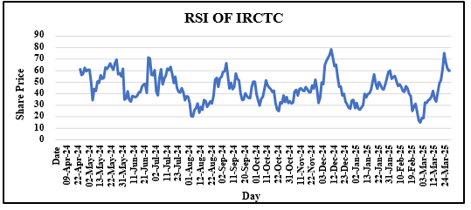
Source: Prepared by the author using TradingView and Yahoo Finance.

The RSI values fluctuated predominantly within the neutral range of 30–70, with occasional movements above 70, indicating temporary overbought conditions. These periods were generally followed by short-term price corrections before the stock resumed its upward movement. The RSI effectively captured changes in market momentum and supported the trend identified through the Moving Average analysis.
Figure 3. Moving Average Convergence Divergence (MACD 12,26,9) of IRCTC
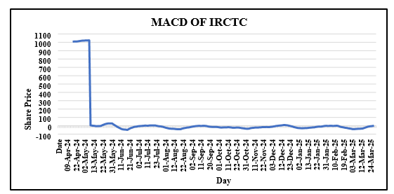
Source: Prepared by the author using Trading View and Yahoo Finance.
The MACD indicator generated multiple bullish crossovers during the study period, confirming the positive trend identified by the Moving Average. Positive histogram values further supported the continuation of upward momentum. The simultaneous confirmation from both SMA and MACD strengthened the reliability of the generated trading signals.

Figure 4. Bearish Engulfing Candlestick Pattern Observed in IRCTC
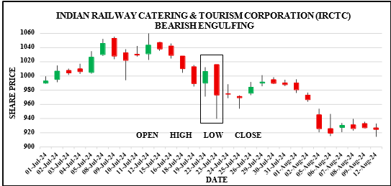
Source: Prepared by the author using Trading View.
Although the overall trend remained bullish, the Bearish Engulfing candlestick pattern indicated temporary selling pressure and short-term profit booking by investors. The subsequent price correction was relatively limited, suggesting that the long-term upward trend remained largely unaffected.

Technical Analysis of SBI Cards and Payment Services Limited
Figure 5. Daily Price Chart with 20-day and 50-day Simple Moving Average (SMA) of SBI Cards
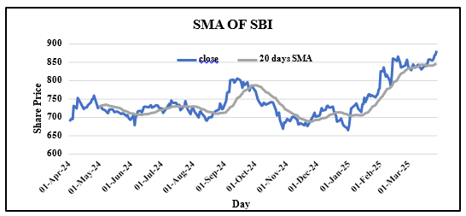
Source: Prepared by the author using TradingView and Yahoo Finance.
The Moving Average analysis indicated moderate bullish momentum in SBI Cards after its IPO. The stock price remained above the 50-day SMA during several trading sessions, while Golden Cross formations signalled periods of positive momentum. However, intermittent bearish crossovers reflected temporary market corrections influenced by changing investor sentiment.
Figure 6. Relative Strength Index (RSI-14) of SBI Cards
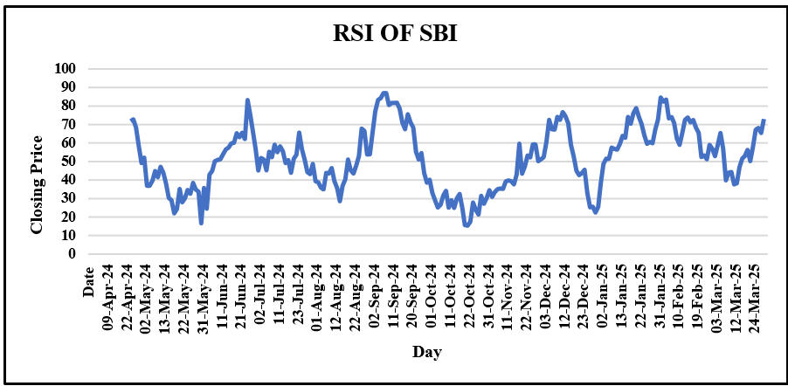
Source: Prepared by the author using Trading View and Yahoo Finance.
The RSI remained largely within the neutral zone, with occasional overbought conditions indicating strong buying pressure. Temporary declines in RSI reflected short-term corrections before the stock resumed its prevailing trend.
Figure 7. Moving Average Convergence Divergence (MACD 12,26,9) of SBI Cards
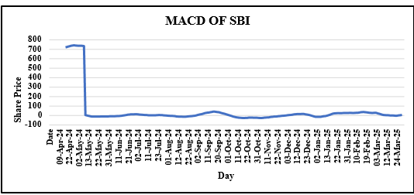
Source: Prepared by the author using TradingView and Yahoo Finance.
The MACD produced several bullish crossovers that supported the continuation of positive market momentum. Bearish crossovers were comparatively fewer and generally represented temporary declines rather than major trend reversals.
Figure 8. Piercing Candlestick Pattern Observed in SBI Cards
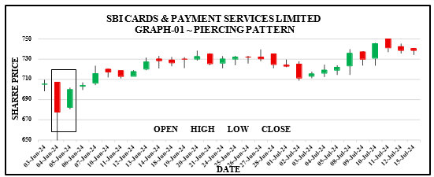
Source: Prepared by the author using TradingView.
The Piercing Pattern indicated a potential bullish reversal after a short-term decline. The formation reflected renewed buying interest and supported the continuation of the prevailing upward trend.

Technical Analysis of FSN E-Commerce Ventures Limited (Nykaa)
Figure 9. Daily Price Chart with 20-day and 50-day Simple Moving Average (SMA) of Nykaa
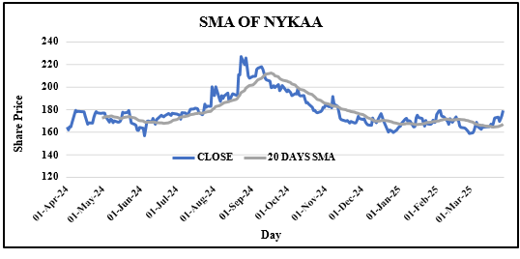
Source: Prepared by the author using Trading View and Yahoo Finance.
The Moving Average analysis indicated that Nykaa experienced considerable price volatility following its IPO. The frequent interaction between the short-term and long-term moving averages reflected alternating bullish and bearish market conditions.
Figure 10. Relative Strength Index (RSI-14) of Nykaa
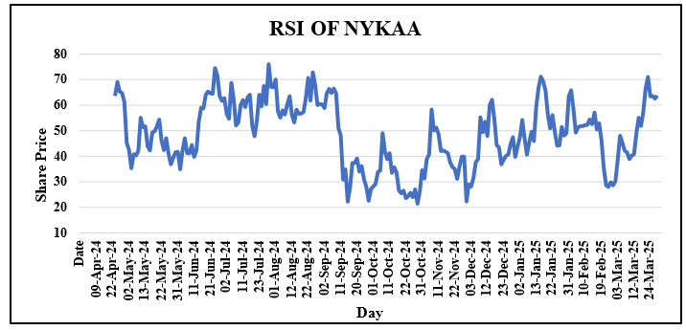
Source: Prepared by the author using Trading View and Yahoo Finance.
The RSI frequently approached the oversold region, indicating weak market momentum and declining investor confidence. These oversold conditions occasionally resulted in short-term price recoveries.
Figure 11. Moving Average Convergence Divergence (MACD 12, 26, 9) of Nykaa
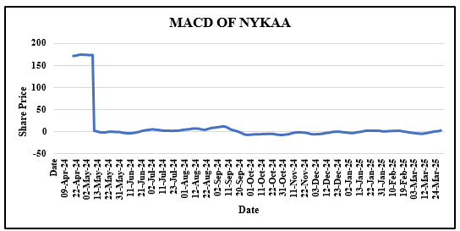
Source: Prepared by the author using TradingView and Yahoo Finance.
The MACD generated repeated bearish crossovers, reflecting sustained downward momentum. Although temporary bullish signals were observed, they were generally short-lived because of continued market volatility.
Figure 12. Three Black Crows Candlestick Pattern Observed in Nykaa
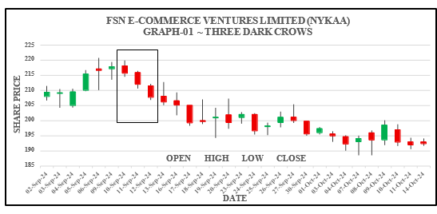
Source: Prepared by the author using TradingView.
The Three Black Crows pattern confirmed persistent selling pressure and indicated the continuation of the prevailing bearish trend during the post-listing period.

Technical Analysis of Life Insurance Corporation of India (LIC)
Figure 13. Daily Price Chart with 20-day and 50-day Simple Moving Average (SMA) of LIC
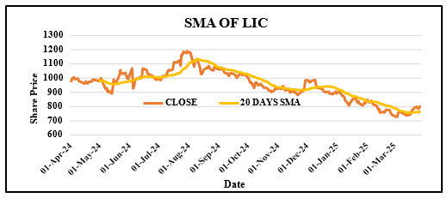
Source: Prepared by the author using TradingView and Yahoo Finance.
The Moving Average analysis suggested that LIC exhibited a relatively stable but sideways trading pattern after listing. Bullish and bearish crossovers occurred periodically, reflecting changing investor expectations and market conditions.
Figure 14. Relative Strength Index (RSI-14) of LIC
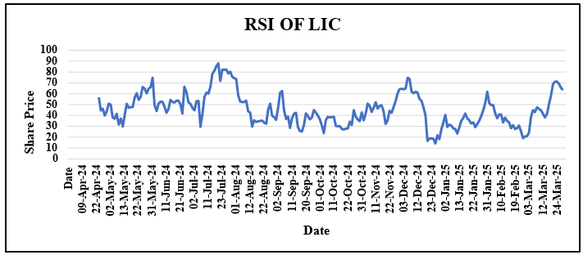
Source: Prepared by the author using TradingView and Yahoo Finance.
The RSI remained predominantly within the neutral range, indicating balanced buying and selling pressure. Limited movements into overbought or oversold regions suggested moderate market volatility.
Figure 15. Moving Average Convergence Divergence (MACD 12,26,9) of LIC
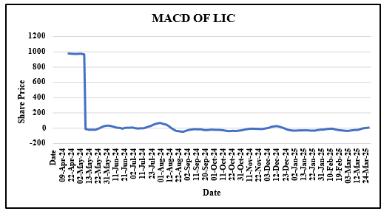
Source: Prepared by the author using TradingView and Yahoo Finance.
The MACD displayed alternating bullish and bearish crossovers, indicating the absence of a sustained long-term trend. The indicator highlighted frequent changes in momentum throughout the study period.
Figure 16. Bullish Harami Candlestick Pattern Observed in LIC
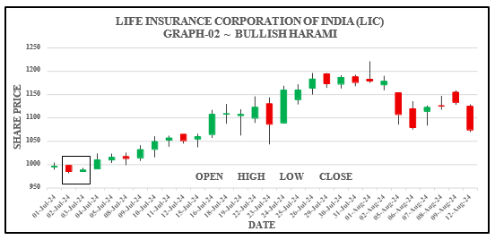
Source: Prepared by the author using TradingView.
The Bullish Harami pattern suggested the possibility of a short-term upward reversal following a period of price decline. However, the subsequent price movement indicated only moderate recovery.

Technical Analysis of One97 Communications Limited (Paytm)
Figure 17. Daily Price Chart with 20-day and 50-day Simple Moving Average (SMA) of Paytm
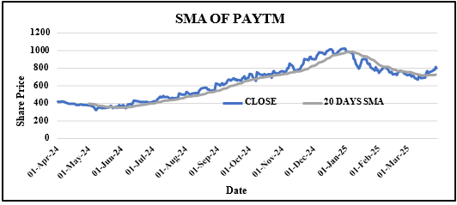
Source: Prepared by the author using TradingView and Yahoo Finance.
The Moving Average analysis revealed a prolonged bearish trend after Paytm's IPO. The stock price remained below the 50-day SMA for an extended period, reflecting weak investor sentiment and persistent downward momentum.
Figure 18. Relative Strength Index (RSI-14) of Paytm
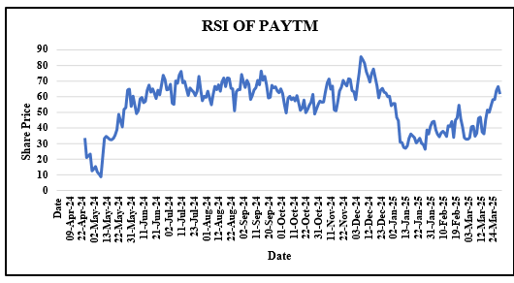
Source: Prepared by the author using TradingView and Yahoo Finance.
The RSI frequently entered the oversold region, indicating substantial selling pressure. Although temporary recoveries were observed, the indicator suggested that bearish momentum dominated much of the study period.
Figure 19. Moving Average Convergence Divergence (MACD 12,26,9) of Paytm
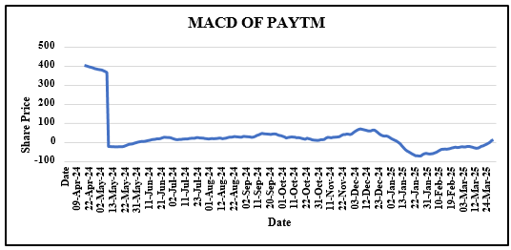
Source: Prepared by the author using TradingView and Yahoo Finance.
The MACD consistently generated bearish crossovers and negative histogram values, confirming the sustained downward trend observed through the Moving Average analysis.
Figure 20. Inverted Hammer Candlestick Pattern Observed in Paytm
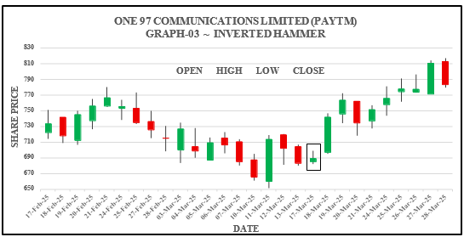
Source: Prepared by the author using TradingView.
The Inverted Hammer pattern indicated a possible bullish reversal after an extended decline. However, the subsequent price movement suggested that buying momentum remained relatively weak, and the broader bearish trend persisted.
Figure 21.Comparative Technical Analysis and Investment Decision of Selected Indian IPO Companies
Company | Closing Price (₹) | SMA Trend | RSI (14) | MACD | Candlestick Pattern | Final Decision
IRCTC | 727.50 | Bullish | Neutral to Bullish | Bullish | Bearish Engulfing | BUY
SBI Cards | 881.10 | Bearish to Neutral | 73.17 (Overbought) | Weak/Bearish | Piercing Pattern | HOLD
LIC | 799.40 | Sideways / Neutral | Neutral | Mixed | Bullish Harami | HOLD
Nykaa | 179.08 | Bearish | 63.65 (Neutral) | Weak / Mixed | Three Black Crows | SELL
Paytm | 783.45 | Bearish | Oversold (during study period) | Bearish | Inverted Hammer | SELL
Source: Compiled by the author based on TradingView and Yahoo Finance data.
Note: Closing prices represent the stock prices as on 31 March 2025, which marks the end of the study period.

IV Discussion
The present study evaluated the post-listing stock performance of five selected Indian IPO companies using an integrated technical analysis approach comprising Simple Moving Average (SMA), Relative Strength Index (RSI), Moving Average Convergence Divergence (MACD), and candlestick chart pattern analysis. The findings indicate that the integrated application of multiple technical indicators provides a more comprehensive, reliable, and robust assessment of post-listing stock performance than reliance on any individual technical indicator.The Simple Moving Average (SMA) analysis revealed distinct differences in post-listing stock price trends among the selected IPO companies. Daily historical stock price data covering the common study period from 1 April 2024 to 31 March 2025 were analysed for all selected companies to ensure comparability of technical performance. IRCTC exhibited a sustained bullish trend, with the 20-day SMA remaining above the 50-day SMA for a considerable period, reflecting strong investor confidence and positive market sentiment. SBI Cards also demonstrated moderate bullish momentum, although temporary bearish crossovers indicated short-term market corrections. In contrast, Paytm experienced a prolonged bearish trend, while Nykaa displayed significant price volatility characterised by frequent bullish and bearish crossovers. LIC showed a relatively stable sideways movement with alternating trend signals. These findings indicate that post-listing stock performance varies considerably across companies despite all being listed during a similar period.The RSI analysis further supported the observations obtained from the SMA. IRCTC and SBI Cards maintained RSI values predominantly within the neutral range, with occasional overbought conditions indicating healthy upward momentum accompanied by temporary price corrections. Conversely, Nykaa and Paytm frequently entered the oversold region, reflecting sustained selling pressure and weak investor confidence. LIC largely remained within the neutral RSI range, indicating balanced buying and selling activity. These findings suggest that RSI effectively complements trend analysis by identifying momentum shifts and potential reversal points. The MACD results provided additional confirmation of market trends identified through SMA and RSI. IRCTC and SBI Cards generated more frequent bullish crossovers, indicating strengthening positive momentum, whereas Nykaa and Paytm exhibited repeated bearish crossovers and negative histogram values, confirming persistent downward momentum. LIC displayed alternating bullish and bearish crossovers, reflecting the absence of a sustained long-term trend. The consistency between SMA and MACD signals enhanced the reliability of the technical analysis and reduced the likelihood of false trading signals. Candlestick chart pattern analysis provided valuable confirmation of short-term market movements and reversal opportunities. The Bearish Engulfing pattern observed in IRCTC suggested temporary profit booking within an overall bullish trend, while the Piercing Pattern in SBI Cards indicated renewed buying interest following a short-term correction. The Three Black Crows pattern identified in Nykaa confirmed sustained selling pressure, whereas the Bullish Harami pattern in LIC signalled only a moderate recovery after price declines. Similarly, the Inverted Hammer pattern observed in Paytm suggested a possible bullish reversal; however, the subsequent price movement indicated that bearish sentiment continued to dominate. These observations demonstrate that candlestick patterns are most effective when interpreted together with trend-following and momentum indicators rather than in isolation.
The findings of the present study are consistent with the existing literature on technical analysis. The usefulness of SMA and MACD in identifying market trends and generating trading signals supports the observations of Brock, Lakonishok, and LeBaron (1992) and Murphy (1999), who reported that technical indicators possess predictive value in financial markets. The effectiveness of RSI in identifying overbought and oversold conditions is also consistent with the work of Wilder (1978). Furthermore, the results support the findings of Marshall, Cahan, and Cahan (2008), who concluded that combining multiple technical indicators improves the reliability of investment decisions compared with relying on a single indicator. The observed variation in post-listing stock performance across companies also supports the conclusions of Das (2025), who reported that market conditions significantly influence IPO performance after listing. In addition, the findings address the research gap identified by Chatterjee, Bhattacharjee, and Chakraborty (2024), who emphasised the need for empirical studies focusing on the post-listing performance of Indian IPO companies.
Overall, the study demonstrates that an integrated technical analysis approach offers a practical framework for evaluating the post-listing performance of IPO stocks in the Indian secondary market. The simultaneous application of SMA, RSI, MACD, and candlestick chart pattern analysis enhances the reliability of trend identification, momentum assessment, and trading signal generation. The findings provide useful insights for retail investors, traders, portfolio managers, and financial analysts seeking to make informed investment decisions based on market behaviour rather than relying solely on individual technical indicators. Based on the combined interpretation of the technical indicators, IRCTC was classified as a BUY because the stock exhibited a sustained bullish trend supported by favourable SMA crossovers, repeated bullish MACD signals, and healthy RSI values despite temporary corrective candlestick patterns. SBI Cards was assigned a HOLD recommendation as its technical indicators reflected moderate bullish momentum accompanied by intermittent corrections and overbought conditions. LIC was also categorised as HOLD because its technical indicators indicated a largely sideways trend without consistent bullish or bearish confirmation. In contrast, Nykaa and Paytm were classified as SELL owing to persistent bearish SMA trends, repeated bearish MACD crossovers, weak market momentum, and bearish candlestick formations that collectively suggested limited short-term upside potential during the study period.

V CONCLUSION
The present study evaluated the post-listing stock performance of five selected Indian IPO companies listed between 2018 and 2024 using an integrated technical analysis approach. The analysis employed Simple Moving Average (SMA), Relative Strength Index (RSI), Moving Average Convergence Divergence (MACD), and candlestick chart pattern analysis to examine stock price trends, momentum, and trading signals. The integrated application of these technical indicators enabled a comprehensive assessment of post-listing stock behaviour in the Indian secondary market. The findings revealed considerable variation in the post-listing performance of the selected IPO companies. IRCTC exhibited a sustained bullish trend supported by favourable SMA crossovers, positive MACD signals, and healthy RSI values, indicating strong investor confidence and positive market momentum. SBI Cards also demonstrated relatively stable post-listing performance with moderate bullish momentum despite temporary market corrections. In contrast, Nykaa and Paytm experienced prolonged bearish trends characterised by repeated bearish crossovers, oversold RSI values, and persistent downward momentum. LIC displayed a relatively stable sideways movement, reflecting alternating bullish and bearish market conditions. The study further demonstrated that no single technical indicator is sufficient to evaluate post-listing stock performance comprehensively. While SMA effectively identified trend direction, RSI measured market momentum and identified overbought and oversold conditions, MACD confirmed trend strength and momentum shifts, and candlestick chart patterns provided additional confirmation of continuation and reversal signals. These findings support the view that combining multiple technical indicators enhances the reliability of trading decisions and reduces the possibility of false trading signals, which is consistent with the observations of Murphy (1999) and Marshall, Cahan, and Cahan (2008). The results are also consistent with the empirical evidence reported by Brock, Lakonishok, and LeBaron (1992), who demonstrated the usefulness of technical trading rules in identifying market trends, and with Wilder (1978), who established the effectiveness of RSI in measuring market momentum. Furthermore, the findings contribute to addressing the research gap identified by Chatterjee, Bhattacharjee, and Chakraborty (2024), who highlighted the limited empirical evidence on the post-listing performance of Indian IPO companies using integrated technical analysis. The study concludes that an integrated technical analysis approach provides a practical and reliable framework for evaluating the post-listing performance of IPO stocks in the Indian secondary market. The findings offer useful insights for retail investors, traders, portfolio managers, financial analysts, and researchers seeking to make informed investment decisions based on market trends and technical indicators. Future research may extend the present study by analysing a larger sample of IPO companies across different sectors, incorporating longer observation periods, statistically validating the predictive accuracy of technical indicators, and integrating technical analysis with fundamental and behavioural factors to develop a more comprehensive framework for evaluating IPO performance in the Indian capital market.
REFERENCES
- Achelis, S. B. (2001). Technical analysis from A to Z (2nd ed.). McGraw-Hill.
- Appel, G. (1979). The moving average convergence-divergence trading method. Signalert Corporation.
- Ahuja, S., Kumar, A., & Bisht, P. (2024). A review of IPO pricing and performance: Evidence from the Indian capital market. Journal of Risk and Financial Management, 17(4), 1–22. https://doi.org/10.3390/jrfm17040123
- Brock, W., Lakonishok, J., & LeBaron, B. (1992). Simple technical trading rules and the stochastic properties of stock returns. The Journal of Finance, 47(5), 1731–1764. https://doi.org/10.1111/j.1540-6261.1992.tb04681.x
- Chatterjee, S., Bhattacharjee, D., & Chakraborty, M. (2024). A systematic literature review of the Indian initial public offering market. Journal of Risk and Financial Management, 17(6), 251. https://doi.org/10.3390/jrfm17060251
- Das, S. (2025). Return and volatility behaviour of Indian start-up IPOs under bull and bear market regimes. Journal of Financial Economic Policy. Advance online publication.
- Edwards, R. D., & Magee, J. (1948). Technical analysis of stock trends. John Magee Inc.
- Kothari, C. R., & Garg, G. (2019). Research methodology: Methods and techniques (4th ed.). New Age International Publishers.
- Marshall, B. R., Cahan, R. H., & Cahan, J. M. (2008). Can commodity futures be profitably traded with quantitative market timing strategies? Journal of Banking & Finance, 32(9), 1810–1819. https://doi.org/10.1016/j.jbankfin.2007.12.009
- Mehmood, A., Ahmed, F., Khan, S., & Ali, M. (2023). A bibliometric review of global initial public offering research. Journal of Risk and Financial Management, 16(11), 470. https://doi.org/10.3390/jrfm16110470
- Murphy, J. J. (1999). Technical analysis of the financial markets: A comprehensive guide to trading methods and applications. New York Institute of Finance.
- Park, C. H., & Irwin, S. H. (2007). What do we know about the profitability of technical analysis? Journal of Economic Surveys, 21(4), 786–826. https://doi.org/10.1111/j.1467-6419.2007.00519.x
- Pring, M. J. (2014). Technical analysis explained: The successful investor's guide to spotting investment trends and turning points (5th ed.). McGraw-Hill Education.
- Seepani, S., & Murthy, T. V. R. (2023). A structural review of initial public offerings in India. International Journal of Research in Commerce and Management Studies, 5(4), 35–49.
- Wilder, J. W., Jr. (1978). New concepts in technical trading systems. Trend Research.

