Taste, Loyalty, and Beyond: A Bibliometric Insight into Customer Revisit Intentions

Neha, Research Scholar, Department of Commerce
Maharshi Dayanand University, Rohtak, Haryana India
Email: neha.rs.comm@mdurohtak.ac.in
Phone No. 7015765383
Dr. Jai Pal Sharma*
Principal Gaur Brahman Degree College, Rohtak, Haryana India
Email: dr.jaipal.sharma@gmail.com
Phone No. 9896121635

Abstract

This study examines the key contributors and trends in customer orientation research within marketing and business management. Analysing 166 documents published between 1993 and 2025, it identifies influential authors, institutions, nations, and journals that have shaped the field. Using bibliometric and mapping techniques, the study highlights essential research trends and provides visualisations of co-occurrence, co-citation, and the evolution of the literature over time. It also offers insights into publication patterns, journal distributions, and academic contributions, making it a valuable resource for understanding the current state of research. Finally, the study outlines potential directions for future research, helping scholars explore new possibilities in customer orientation.

Keywords: Customer Revisit Intention, Food Outlets, Bibliometric Analysis, Customer Behaviour
Introduction

Revisit intention can be explained as a customer's inclination or likelihood to return to a business or use its services again. “Revisit intention as customers’ judgment about the likelihood of revisiting the same destination” (Quintal & Polczynski, 2010). “Revisit intention is a sign of brand loyalty and an indication of customer satisfaction” (Mannan et al., 2019). Factors influencing revisit intention are diverse, including the quality of products or services, the overall customer experience, and the effectiveness of post-purchase support. Positive interactions, personalised engagement, and a seamless purchasing process contribute to fostering revisit intention. Additionally, businesses that consistently exceed customer expectations, promptly address concerns, and build trust are more likely to attract repeat customers. Monitoring and understanding revisit intention can guide businesses in refining their strategies, ensuring sustained customer loyalty, and ultimately contributing to long-term growth and profitability. It underscores the importance of ongoing efforts to enhance customer satisfaction, as satisfied customers are more inclined to become loyal patrons and ambassadors for the brand. “Service providers remain conscious about revisiting the intention of customers because the cost of attracting a new customer is high compared to retaining a current customer” (Um et al., 2006).
Various studies (narrative as well as systematic literature review) have been made in different research areas to study customer revisit behaviour. Antecedents of customers’ revisit intention were examined in the study of (Um et al., 2006) based on a literature review. The meta-analysis examined the relationship between brand love and revisit intention using 33 publications from 2019-2023 (Wijaya et al., 2024). However, it was found that no research has been done using the bibliometric approach to examine the literature on customer revisit intention in the food sector. In order to study the complex research topic comprehensively, bibliometric analysis helps in providing current and emerging research trends. This paper aims at identifying (i) the most active participants such as authors, affiliations, nations, research articles, and journals which have contributed to the most frequent research studies in the field of marketing and business management,
(ii) to identify various knowledge clusters emerging in the studied domain, and (iii) to recommend prospects in the studied area.
This study is organised as a review of literature, research methodology, results and discussion, key implications, and conclusion.

Literature Review

Restaurant reputation creates loyalty, which influences a customer to revisit a restaurant, whereas trust positively affects the revisit/repurchase intention of restaurant customers. Factors influencing revisit intention are diverse. Food quality is an important factor viewed as a core value that a customer keeps in mind while deciding which fast-food restaurant to eat (Namin, 2017). In the study of (Chun and Nyam-Ochir, 2020) four factors (food quality, service quality, price, and restaurant atmosphere) were studied and found that all these factors affect customer satisfaction, revisit intention and likelihood of recommendation for the global fast food. Customer satisfaction mediated the effect of emotional factors on revisit intention (Han et al., 2009). Customer satisfaction mediates between service quality and customer intention to revisit. It is important to satisfy customers' needs to have a competitive advantage. It motivates customers to revisit the company and spread positive word-of-mouth to their family and friends (Khoo, 2022). When a customer has a feeling of belongingness towards some restaurant/place or a feeling of being at the right place, it helps in increasing the level of satisfaction motivates them to revisit the restaurants (Yuksel et al., 2010). Besides customer satisfaction, customer revisits intention is positively influenced by service quality dimensions (Al-Tit, 2015). Furthermore, revisit intention is also influenced by brand attitude, as previously highlighted by (Zhang et al., 2018).

Methodology Data Sources
Data was extracted from the Scopus database to perform the analysis for this study. The following is the description of the final bibliometric search method: “Revisit intention” or “intention to visit again”, “Return Intent” or “future visit” or “coming back” or “returning interest” or “future visit” or “potential revisit” or "intention to revisit" AND “Ethnic restaurant*” or “Catering industr*” or “dining restaurant*” or “eater*” or “restaurant*” or “cafe*” or “diner*” or “fine-dining” or “food outlet*” or “food sector” or “food industr*” or “fast-food industr*” or “Eating Establishment*”. A total number of 166 relevant documents were extracted from 1993 to 2025. Figure 1 shows that the number of studies on customer revisit intention has increased continuously. The overall upward trend and the rising number of publications published each year suggest that academics are becoming more interested in this field.





Identification
- Research Question: Performance analysis (1), intellectual structure (2), future research(3)
- Document Type: Articles
- Source Database: Scopus
- Search mechanism and material acquisition: Scopus
- Search Period: 1993-2025
- Search Keywords: Revisit Intention and Food sector in "article title, abstract and keywords
Acquisition •Language: "English"
Evaluation
- Method of analysis: Bibliometric analysis
- Analytical technique: Performance analysis, Science mapping
- Software: Bibliometrix by R
- Reporting convention: Figures, tables and words
- Limitations: Only Scopus database used, Review limited to bibliometric information
Reporting

Figure 1 Research Methodology Design

Identification:

The first part involves assembling relevant literature on revisiting intention and the food sector. In this step, first of all, all activities that are important for the study were identified. Choosing the most appropriate database for the study was one of the significant decisions of this section. Scopus, which was suggested for bibliometric study, the primary academic database, was used to collect information. Scopus, a scientific database, is considered a database of high-quality articles and is highly related to other databases such as web-of-science. Selecting the type of document was the next step in this study. For this step, the researcher chose journal articles for their uniqueness and thorough peer review. Conference papers and book chapters were also included in the study.

Acquisition:

Next, the data was acquired from the Scopus database using the above search query under the data source head. The query was searched using the title abstract and keywords to search and extract the relevant literature for the study by choosing only English as the language searched articles. The search criteria extracted 166 documents for the timespan 1993 to 2025. Csv format was used to extract the literature for further analysis.

Evaluation:

Bibliometric Analysis & Biblioshiny: This analysis was based on literature reviews that promoted the adoption of the systematic method of literature review. Bibliometric analysis studies the bibliography to understand and explain the research patterns and identify influential research and trends in any field. In bibliometric analysis, citations in academic publications are counted and analysed to reflect the topics, authors or journals that are frequently referenced.
Performance analysis helps discover the unexplored areas, i.e. countries or sectors, and interest areas, i.e. authors, affiliations, etc. Another important technique of bibliometric analysis is Science mapping. It reveals knowledge clusters representing the primary research streams on the topic. It demonstrates how a field's knowledge can be uniformly grouped while remaining heterogeneously different. Performance evaluation techniques can be used to determine the most impactful authors, affiliations, journals, and countries. This study used a Bibliometric package by R to analyse the extracted data. Biblioshiny was used for performance analyses and science mapping techniques, and Microsoft Excel was used to generate tables, charts, and graphs from the Biblioshiny exported report on all the analyses. Co-citation analysis is an important tool in bibliometric analysis, which is used to reflect the number of times when two specific articles of previous research have been cited. If the co-citation frequency between two authors is higher, their academic relationship is very close. In order to determine the most relevant authors, journals and references in our study, we used author co-citation analysis, journal co-citation analysis, and document co-citation analysis. Co-occurrence analysis helps to detect how often certain words appear together in an article by finding the patterns and connections between the words. Researchers can use this technique to find out the research theme and the occurrence or number of citations of each keyword. Keyword co-occurrence analysis is used in this study to identify the relationship among different keywords used together in any article. Researchers can use cluster analysis to check the similarity between research articles/documents. A thematic map is another important tool for finding the essential, niche, emerging, and motor themes.

Reporting:

As mentioned above, data was analysed using the Bibliometrix package and Biblioshiny to extract the reports. The exported report was then converted into tables, figures, graphs, and charts to show the exported results for the analysis. Data used for the study was limited to the Scopus database only. Based solely on bibliometric data, the results were restricted to the completeness and correctness of the bibliometric data on Scopus.

Results and Discussion:

The leading information about the data under study is mentioned in Table 1. A total of 166 documents were extracted from 87 Sources, i.e. Journals, books, etc, for the period 1993 to 2025, which were used as the base for the study. The study shows an annual growth rate of 4.57% with 28.01 average citations per doc.

Table I Main Information about the data
Description | Results
Timespan | 1993:2025
Sources (Journals, Books, etc) | 87
Documents | 166
Annual Growth Rate % | 4.57
Document Average Age | 5.38
Average citations per doc | 28.01
References | 10034
DOCUMENT CONTENTS
Keywords Plus (ID) | 278
Author's Keywords (DE) | 528
AUTHORS
Authors | 421
Authors of single-authored docs | 16
AUTHORS COLLABORATION
Single-authored docs | 18
Co-Authors per Doc | 2.99
International co-authorships % | 35.54
DOCUMENT TYPES
Article | 144
Book Chapter | 6
Conference Paper | 14
Review | 2

Journal Performance: Table II lists the most impactful journals based on their h-index, g-index and Total Citations. The table shows that the “International Journal of Hospitality” is in number one position with 12 h-index and 15 g-index and 1670 total citations. “International Journal of Contemporary Hospitality Management” is second, followed by “Journal of Foodservice Business Research”.
Table II Most Impactful journal
Journal | h-index | g-index | TC
“International Journal of Hospitality Management” | 12 | 15 | 1670
“International Journal of Contemporary Hospitality Management” | 8 | 14 | 257
“Journal of Foodservice Business Research” | 6 | 8 | 152
“Journal of Hospitality and Tourism Research” | 6 | 7 | 886
“Sustainability” (Switzerland) | 6 | 11 | 192
“British Food Journal” | 5 | 7 | 135
“Journal of Hospitality and Tourism Management” | 4 | 4 | 59
“Journal of Hospitality Marketing and Management” | 4 | 4 | 96

Similarly, the most contributing journals were analysed based on the number of articles published in that journal. As shown in Figure 2, “The International Journal of Hospitality Management” is the most contributing journal, with 15 articles, followed by “The International Journal of Contemporary Hospitality Management” with 14 articles.
Articles
"INTERNATIONAL JOURNAL OF HOSPITALITY… "INTERNATIONAL JOURNAL OF CONTEMPORARY…
"SUSTAINABILITY" (SWITZERLAND) "JOURNAL OF FOODSERVICE BUSINESS RESEARCH" "JOURNAL OF HOSPITALITY AND TOURISM RESEARCH"
"BRITISH FOOD JOURNAL" "JOURNAL OF QUALITY ASSURANCE IN HOSPITALITY AND…
"JOURNAL OF HOSPITALITY MARKETING AND… "JOURNAL OF HOSPITALITY AND TOURISM…
"SERVICE INDUSTRIES JOURNAL"
0
2
4
6
8
10 12 14 16

Figure 2 Most Contributing Journals

Article Performance: An article's performance can be identified by the total number of global citations and total number of local citations it received from various authors. The most impactful articles based on global citations are described in Table III, and the most impactful articles based on local citations are described in Table IV.
Global Citations: Table III shows the most impactful articles based on global citations. As per the data, it is clear that the article titled “Does food quality matter in Restaurants? Its Impact on customer satisfaction and behavioural intentions“, authored by (Namkung and Jang, 2007), has the highest TGC, i.e., 518, followed by “Customers’ cognitive, emotional, and actionable response to the servicescape: A test of the moderating effect of the restaurant type” (Kim and Moon, 2009) with (TGC=397) and “Influencing factors on restaurant customers’ revisit intention: The roles of emotions and switching barriers” (Han et al., 2009b) (TGC=258).

Table III Most impactful articles based on global citations
Article Title | Author(s) & Year | Journal | TGC
“Does Food Quality Really Matter in Restaurants? Its Impact on Customer Satisfaction and Behavioral Intentions” | (Namkung and Jang, 2007) | “Journal of Hospitality & Tourism Research” | 518
“Customers’ cognitive, emotional, and actionable response to the servicescape: A test of the moderating effect of the restaurant type” | (Kim and Moon, 2009) | “International Journal of Hospitality Management” | 397
“Influencing factors on restaurant customers’ revisit intention: The roles of emotions and switching barriers” | (Han et al., 2009) | “International Journal of Hospitality Management” | 258
“The effects of dining atmospherics: An extended Mehrabian–Russell model” | (Liu and Jang, 2009) | “International Journal of Hospitality Management” | 257
“Impact of hotel-restaurant image and quality of physical-environment, service, and food on satisfaction and intention” | (Han and Hyun, 2017) | “International Journal of Hospitality Management” | 234
“The influence of perceived food quality, price fairness, perceived value and satisfaction on customers’ revisit and word-of-mouth intentions towards organic food restaurants” | (Konuk, 2019) | “Journal of Retailing and Consumer Services” | 230
“Multidimensional Customer-Based Brand Equity and Its Consequences in Mid-priced Hotels” | (Kim et al., 2008) | “Journal of Hospitality & Tourism Research” | 150
“Does perceived restaurant food healthiness matter? Its influence on value, satisfaction and revisit intentions in restaurant operations in South Korea” | (Kim et al., 2013) | “International Journal of Hospitality Management” | 130

Local Citations: Based on the total local citations that an article received, table IV shows the most impactful articles. Han H's article “Influencing factors on restaurant customers’ revisit intention: The roles of emotions and switching barriers” is the most locally cited (TLC=21). Kim WG’s article “Customers’ cognitive, emotional, and actionable response to the servicescape: A test of the moderating effect of the restaurant type” is in the second position, having TLC=18.
Table IV Most impactful articles based on Local citations
Article Title | Author(s) & Year |  | Local Citations | Journal
“Influencing factors on restaurant customers’ revisit intention: The roles of emotions and switching barriers” | (Han et al., 2009) |  | 21 | “International Journal of Hospitality Management”
“Customers’ cognitive, emotional, and actionable response to the servicescape: A test of the moderating effect of the restaurant type” | (Kim and Moon, 2009) |  | 18 | “International Journal of Hospitality Management”
“Does Food Quality Really Matter in Restaurants? Its Impact on Customer Satisfaction and Behavioral Intentions” | (Namkung and Jang, 2007) |  | 17 | “Journal of Hospitality & Tourism Research”
“An investigation on customer revisit intention to theme restaurants: The role of servicescape and authentic perception” | (Meng and Choi, 2018) |  | 14 | “International Journal of Contemporary Hospitality Management”
“Impact of hotel-restaurant image and quality of physical-environment, service, and food on satisfaction and intention” | (Han and Hyun, 2017) |  | 13 | “International Journal of Hospitality Management”
“Does perceived restaurant food healthiness matter? Its influence on value, satisfaction and revisit intentions in restaurant operations in South Korea” | (Kim et al., 2013) |  | 11 | “International Journal of Hospitality”
“The influence of perceived food quality, price fairness, perceived value and satisfaction on customers’ revisit and word-of-mouth intentions towards organic food restaurants” | (Konuk, 2019) |  | 9 | “Journal of Retailing and Consumer Services”
“Customer revisit intention to restaurants: Evidence from online reviews” | (Yan et al., 2015) |  | 9 | “Information Systems Frontiers”

Author Performance: Author performance was assessed by the number of articles contributed by any author in any field or topic. This study analysed the author's performance in customer revisit intention. It was found that author Han H was the highest contributing author, with 15 per cent of the total number of articles published, as shown in Figure 3, followed by Ryu K, who contributed 13 per cent of the total number of articles. BACK K-J, Bonn Ma, Cho M and Hwang J were found to be in the same position, with 8 per cent of the total articles.


HWANG J
BONN MA
CHO M
10%
10%
LIU P
SONG H BACK K-J
10%
8%
10%
13%
8%
AKHTAR N
KIM J-H
15%
8%
8%
HAN H
RYU K
Number of Publication

Figure 3 Most relevant authors

Furthermore, table V shows the most impactful authors based on h-index, g-index, total citations, net publication, and publication year start. As the table shows, Ryu K was found to be the most impactful author, with 5 h-index and g-index and 265 total citations. However, the total citation and g-index of Han H are 588 and 6, respectively, which is the highest total citation and g- g-index. However, Han H's h-index is 4, making him the second most impactful author.
Table V Most impactful authors

Element | h_index | g_index | TC | NP
Ryu K | 5 | 5 | 265 | 5
Han H | 4 | 6 | 588 | 6
Akhtar N | 3 | 4 | 79 | 4
Back K-J | 3 | 3 | 337 | 3
Bonn Ma | 3 | 3 | 43 | 3
Cho M | 3 | 3 | 43 | 3
Hwang J | 3 | 3 | 165 | 3
Hyun Ss | 3 | 3 | 369 | 3

Authors’ Co-citation analysis: Fig. 4 reflects the authors’ co-citations network extracted using the Bibliometrix package by R. A total number of 9 clusters were formed in this authors’ co-citation analysis. Henseler J., Hair J.F., Rousta A, Konuk F.A comes under cluster 1 and are shown by red colour. Bagozzi R.P., Namkung Y, Zeithaml V.A., Han H, Kim W.G., Kivela J., Namkung Y., Bujisic M., Cronin J.J., Fornell C., Gupta S., Ha J., Hair J.F., are under cluster 2 and are shown by blue colour. Yan X, Andaleeb S.S., Han H., Kim W.G., Parasuraman A., Fishbein M., Fornell C., forms cluster 3( in green colour ) Cohen J., Ryu K., Anderson J., ( cluster 4 and in purple colour), Hair J.F., Han H., Namin A., Nunnally J.C.( cluster 5 and orange colour) Fornell C. 1981 under cluster 6 forms the most prominent circle( in brown colour) showing the highest frequency of publication and tied with cluster 2 for the most significant cluster with Anderson J.C., Mehrabian A., Oliver R.L., Zeithaml V.A., Hair J.F., Nunnally J.C., Bitner M.J., Meng B., Ajzen I., Kotler P., Ryu K., Hair J.F., Oliver R.L. Barber N., Jeong E., are under cluster 7 reflected by pink colour.

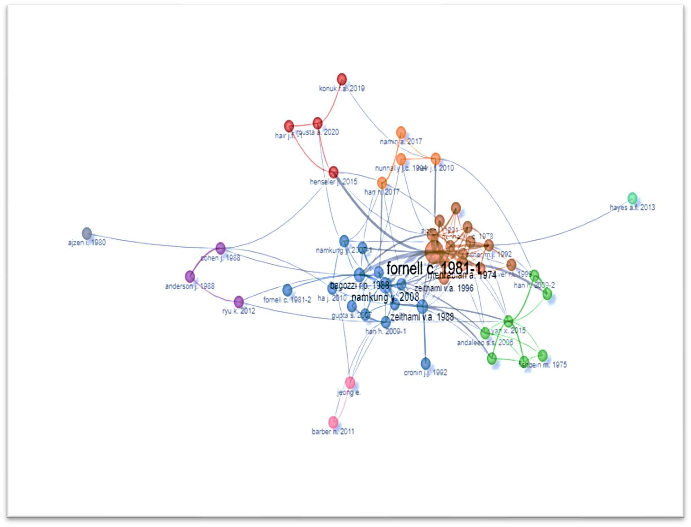
Figure 4 Authors' co-citation analysis

Institutional Performance: Institutional performance was analysed by the number of published articles. As shown in Fig. 5, Sejong University was the most contributing affiliation, with 19 articles published. The Hong Kong Polytechnic University and Florida State University share the same position with 10 articles contributed by both the institutes in the studied area, followed by University Teknologi Mara with eight articles.
Articles
SEJONG UNIVERSITY THE HONG KONG POLYTECHNIC UNIVERSITY
FLORIDA STATE UNIVERSITY UNIVERSITI TEKNOLOGI MARA UNIVERSITI MALAYSIA KELANTAN KYUNG HEE UNIVERSITY
PURDUE UNIVERSITY GRIFFITH UNIVERSITY
UNIVERSITY OF CENTRAL FLORIDA
PUSAN NATIONAL UNIVERSITY
19
10
10
9
8
8
7
7
6
6
0
5
10
15
20
Figure 5 Most contributing affiliations

Country Performance: Fig. 6 shows the most contributing countries in the field of customer revisit intention towards food sectors. As the fig illustrates, the USA is the most contributing country with 100 frequency rates. It is followed by South Korea, Malaysia, China and India, with frequency rates of 84, 67, 51, and 25, respectively. Furthermore, Figure 7 reflects the country collaboration map. Contributions by various countries were shown on the map using different colours. A higher number of publications is reflected using dark blue, whereas a low number of publications is represented by grey. Red lines between different countries are used to represent collaboration among those countries. The frequency of collaboration between countries is shown by the thickness of the red line, i.e. the higher the thickness, the higher the frequency of publication. The most collaborating countries are the USA and Korea, with 11 research articles, followed by the pair “Korea and Hong Kong” and “USA and China” as the second most collaborating countries with five research publications.

Frequency
120

100

80

60

40

20

0
Figure 6 Most Contributing countries

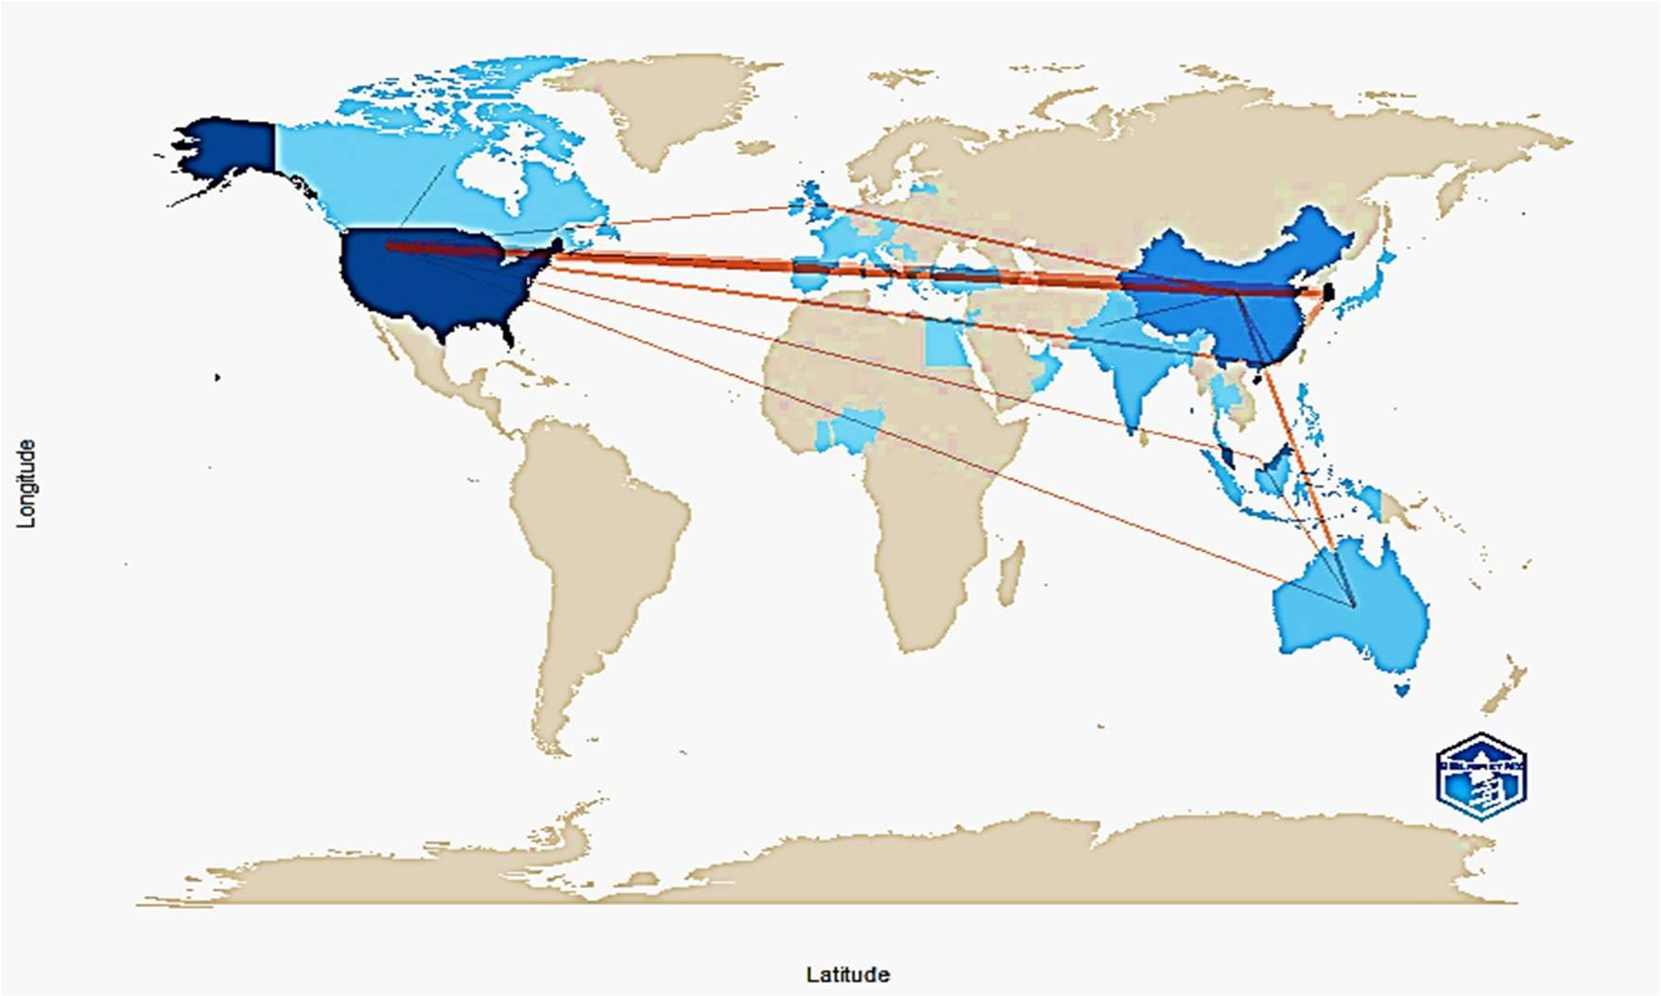
Figure 7 Country collaboration map

Knowledge Cluster

Science mapping is a visual aid that illustrates the interconnectivity of research in a specific topic through a network representation using tools, software and methodologies. The co-occurrence network technique helps extract knowledge clusters based on authors’ keywords in the article within an extracted review corpus. In this study, three knowledge clusters were extracted using a bibliometric package by R. Figure 8 shows the network link between different authors where keywords are shown with the use of nodes, and the node size shows the frequency of occurrence of the keyword in the review corpus. The larger size of the node shows higher. Frequency of occurrence of the keywords and vice versa. The line connecting different nodes shows the occurrence of those two keywords together. The frequency of co-occurrence of the keywords is shown by the thickness of the line, i.e., the thicker the line is, the higher the frequency of the keywords and vice versa. The knowledge clusters are extracted using three centrality criteria: between centrality, close centrality, and page rank centrality. The between centrality shows the dependency of other nodes on any particular node, whereas "Closeness centrality is an assessment of either access effectiveness or autonomy from probable intermediary control. In addition, by determining how many in-links a particular node has about other relevant nodes” (Bansal et al., 2024), the Score of significance of each node is reflected by PageRank centrality.

Cluster 1: Customer Satisfaction and Revisit Intention

Various studies have been conducted to determine the relationship between customer satisfaction and customer revisit intention. Various factors affect customer satisfaction, which further leads to revisiting intentions. (Kim et al., 2008) their study concluded that perceived quality has a powerful impact on perceived value, and the impact of brand loyalty on revisit intention was confirmed. Customer satisfaction, as the mediator between food quality and behavioural intentions, helps enhance customers’ revisit intention in restaurants (Namkung and Jang, 2007). Furthermore, the study found that food quality positively impacts customer satisfaction and behavioural intentions. The positive relationship between Perceived value and customer satisfaction was also confirmed in the study (Konuk, 2019). Furthermore, it concluded that behavioural intentions are influenced by customer satisfaction, which in turn leads to word-of-mouth and revisit intention. The study conducted by (Lu et al., 2021) on service robots in restaurants showed that humanlike voice and language positively impact revisit intention and word-of-mouth intentions.

Cluster 2: Authenticity and Revisit Intention

Revisit intention of customers is based on various factors such as involvement, authenticity, prior experience, etc. (Islam et al., 2019). Similarly, in the study of (Kim and Baker, 2017), it was found that food authenticity has a positive relation with revisit intention and acts as a mediator between item names on the menu, employee ethnicity and revisit intention in ethnic restaurants. A study conducted on authentic ethnic restaurants by (Ryu and Zhong, 2012) showed that when customers are provided with menu options and surpassing their expectations helps customers revisit intention and positive word of mouth. The study by (Liu and Lee, 2018) found that the customers’ perception of food safety in restaurants and the relationship between cleanliness clues and overall satisfaction and its impact on behavioural intention.
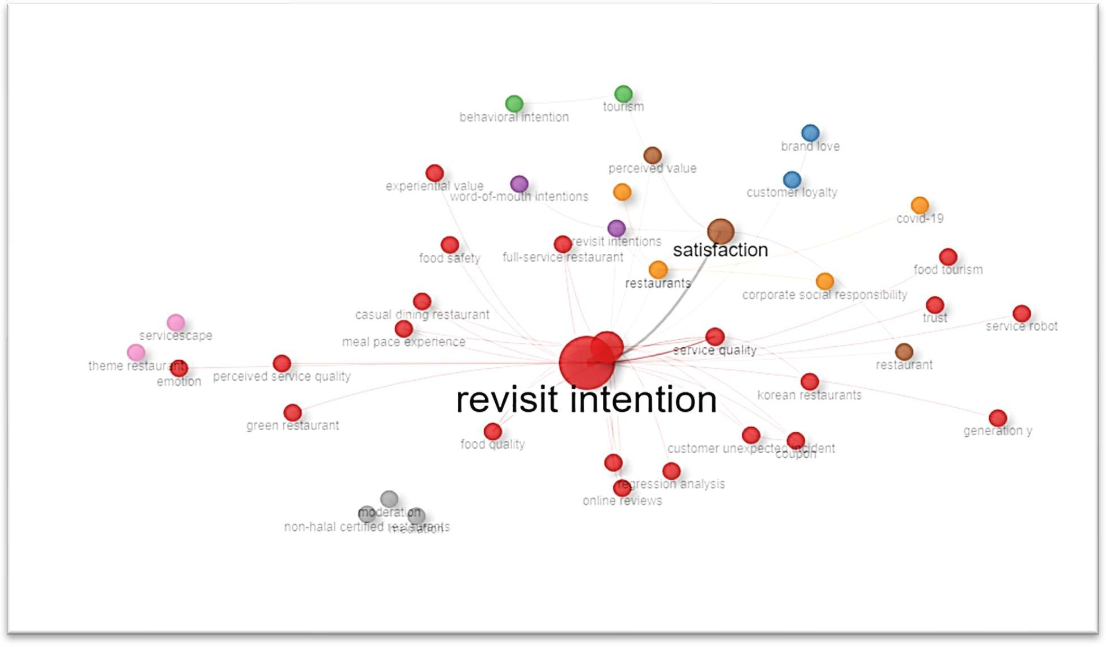
Figure 8 Keyword Co-occurrence network

Cluster 3: Food & Service Quality and Revisit Intention

Theme restaurants promise to provide different novel experiences. The study of (Weiss et al., 2005) found that novelty alone is not the only factor that influences customer satisfaction and their revisit intention; instead, food quality, service quality and atmosphere were found to be significantly related to customer satisfaction and their revisit intention. Based on online reviews, the study by (Yan et al., 2015) concluded that customer satisfaction with food quality, service quality, price and value has a significant positive relation with customer revisit intention. Another study on Korean restaurants by (Nam and Lee, 2011) showed a positive relationship between service quality dimensions, customer satisfaction, and customer revisit intention.

Cluster 4: Customers’ experience in hospitality and Revisit Intention

In a theme restaurant, Servicescape helps form a positive attitude of customers towards the restaurant, resulting in customers’ intention to revisit the restaurant (Meng and Choi, 2018). The study (Kim, 2021) found that nostalgic proneness, i.e., memorable experience, moderates the impact of service authenticity on positive emotions, and positive emotions are further significantly related to customers’ intention to revisit. A study by (Carins et al., 2020) concluded that modification. Servicescape can result in a more enjoyable customer experience, improve customer satisfaction and enhance revisit intention. Theme restaurants were introduced to provide a unique customer experience. It was found that customers' behavioural intentions may originate from attractive physical environments, and servicescape is positively related to customer revisit intention (Kim & Moon, 2009)

Cluster 5: Customer Revisit Intentions' Motivators

The study of (Liu and Jang, 2009) found that the dining atmosphere influences customers’ positive emotions, further impacting behavioural intention and revisit intention at Chinese restaurants. Food was the most impactful factor in customer satisfaction and revisit intention with the Chinese restaurant experience. However, customer satisfaction is not the only factor influencing customer revisit intention (Ma et al., 2011). Revisit intention and word of mouth are also influenced by spatial layout and employee factors (Kement et al., 2021). Another study concluded that Motivation is significantly related to customer satisfaction, revisit intention and intention to recommend (Chang et al., 2021).
Table VI Keyword-based cluster
Keywords | Between Centrality | Closeness Centrality | Pagerank_Centrality
Cluster 1: Customer Satisfaction
Satisfaction | 821.1176161 | 0.004950495 | 0.049882249
Restaurants | 190.1626773 | 0.004464286 | 0.027089493
Revisit Intentions | 350.2536647 | 0.004329004 | 0.025550501
Restaurant | 154.2127116 | 0.004081633 | 0.017504319
Perceived Value | 322.9753654 | 0.00456621 | 0.023093143
Customer Loyalty | 196.6942042 | 0.004032258 | 0.01177426
Covid-19 | 62.05581783 | 0.003984064 | 0.007949749
Trust | 56.40035163 | 0.004016064 | 0.010331019
Behavioral Intentions | 28.2156779 | 0.004149378 | 0.008137379
Loyalty | 76.00299227 | 0.004672897 | 0.009286787
Perceived Price | 11.71971616 | 0.003952569 | 0.008967098
Service Robot | 9.985864727 | 0.003846154 | 0.007235627
Atmosphere | 68.0273037 | 0.004115226 | 0.008922287
Brand Image | 17.37430952 | 0.003861004 | 0.007319457
Brand Love | 0.544678932 | 0.003663004 | 0.005572693
Brand Loyalty | 3.276461039 | 0.003717472 | 0.004592974
Foodservice | 8.333547009 | 0.003690037 | 0.005304606
Word-Of-Mouth Intentions | 2.868109668 | 0.003891051 | 0.007029205
Cluster 2: Authenticity
Authenticity | 114.1630536 | 0.004424779 | 0.011916676
Ethnic Restaurant | 117.7554143 | 0.004672897 | 0.011223812
Food Safety | 96.12303953 | 0.004255319 | 0.01044463
Emotions | 102.0389736 | 0.004524887 | 0.010450743
Food Service | 128.746788 | 0.004608295 | 0.010394034
Behavioural Intentions | 21.41677671 | 0.00390625 | 0.007080596
Food Authenticity | 96 | 0.003436426 | 0.007470925
Hygiene | 6.745403616 | 0.003401361 | 0.006239201
Intention to Revisit | 2.948412698 | 0.003322259 | 0.005264367
Involvement | 36.24047619 | 0.003891051 | 0.005017013
Physical Environment | 20.43746936 | 0.003649635 | 0.006055217
Cluster 3: Food & Service Quality
Revisit Intention | 1722.231416 | 0.005617978 | 0.110460619
Customer Satisfaction | 542.6735844 | 0.004761905 | 0.059126403
Service Quality | 202.3336966 | 0.004347826 | 0.028101625
Food Quality | 183.2816496 | 0.004347826 | 0.022206107
Full-Service Restaurant | 13.03947423 | 0.004132231 | 0.01229296
Perceived Service Quality | 79.66533028 | 0.004065041 | 0.012107254
Casual Dining Restaurant | 6.178113553 | 0.003389831 | 0.007786241
Green Restaurant | 2.293571429 | 0.003571429 | 0.007020229
Online Reviews | 0 | 0.002923977 | 0.007875008
Consumer Satisfaction | 31.97841 | 0.004032258 | 0.005215689
Coupon | 0 | 0.002906977 | 0.006899431
Customer Engagement | 9.4 | 0.003875969 | 0.003435837
Food Tourism | 0 | 0.003584229 | 0.004152676
Korean Restaurants | 9.682558128 | 0.004048583 | 0.006162291
Meal Pace Experience | 0 | 0.002932551 | 0.006835537
Segmentation | 0 | 0.003649635 | 0.002399978
Text Mining | 0 | 0.002923977 | 0.007875008
Theme Restaurants | 6.552002573 | 0.004081633 | 0.004347994
Cluster 4: Customer Experience in Hospitality
Servicescape | 188.3855481 | 0.004464286 | 0.012863877
Memorable Experience | 14.92628068 | 0.004 | 0.004556979
Behavioural Intention | 7.386356699 | 0.003623188 | 0.004579826
Consumer Behavior | 0 | 0.003205128 | 0.005191347
Customer Experience | 59.82874572 | 0.003952569 | 0.009885041
Emotion | 11.76081814 | 0.003424658 | 0.010097712
Hospitality | 10.96550516 | 0.003802281 | 0.007218138
Social Servicescape | 24.05330087 | 0.003367003 | 0.00804105
Theme Restaurant | 24.33183842 | 0.003846154 | 0.007892897
Cluster 5: Customer Revisit Intentions' Motivators
Behavioral Intention | 157.4702461 | 0.004255319 | 0.01375238
Tourism | 20.49258976 | 0.003816794 | 0.008813798
Chinese Restaurant | 40.23741907 | 0.004545455 | 0.007169485
Motivations | 7.491147741 | 0.003731343 | 0.004546875
Positive Emotion | 23.01218645 | 0.004444444 | 0.007310712
Cluster 6: Revisit Intention of Generation Y
Consumer Behaviour | 166.4328182 | 0.004115226 | 0.013239549
Covid‐19 | 49.5322706 | 0.003861004 | 0.00742983
Generation Y | 6.639191454 | 0.003367003 | 0.005449663
Marketing | 0 | 0.003076923 | 0.004128174
Quality | 58.64883151 | 0.0041841 | 0.006339577
Cluster 7: Convenience & Customization
Convenience | 60.25656078 | 0.003571429 | 0.008993905
Customization | 11.52144938 | 0.003278689 | 0.006806783
Intention to Visit | 0 | 0.00304878 | 0.005670793
Word-Of-Mouth | 123.320254 | 0.003861004 | 0.008350602
Cluster 8: Price Fairness
Price Fairness | 204.2906261 | 0.004950495 | 0.013467395
Theory of Planned Behaviour | 47.94762089 | 0.003921569 | 0.0102296
Mediation | 11.70900938 | 0.004132231 | 0.008877619
Moderation | 11.70900938 | 0.004132231 | 0.008877619
Non-Halal Certified Restaurants | 11.70900938 | 0.004132231 | 0.008877619

Cluster 6: Revisit the Intention of Generation Y

Product quality has a significant role and is the first factor that impacts the choice of coffee café in Generation Y (Hashim et al., 2017). The perceived quality of products, services, and experience affects customers’ revisit intention towards trendy coffee café (Ting and Thurasamy, 2016). Another study supported the idea that to enhance the revisit intention, it is important to enhance green perceived quality for Generation Y (Riva et al., 2022). Safety measures adopted by the food sector have become another important factor that influences consumer behaviour and their revisit intention post-Covid-19 (Vandenhaute et al., 2022)

Cluster 7: Role of Convenience & Customization in Intention to Revisit

Reliability, convenience and customisation have a positive relation with customer satisfaction, which further leads to word-of-mouth and customers’ intention of revisiting (C. Y. Kim & Cha, 2023). Food quality, service quality and convenience influence customer satisfaction and intention to revisit quick-service restaurants, as concluded in the article by (Richardson et al., 2019). In the study (Jang, 2021), trust, friendship, and customisation influence perceived value, perceived value beliefs, belief influences personal norms, and personal norms have a positive relationship with customers’ intention to revisit. The impact of customer satisfaction on intention to revisit and word-of-mouth has also been concluded in the study of (Pradana et al., 2021)
Cluster 8: Price Fairness and Revisit Intention:
Service quality offered by a restaurant and its image form the attitude of any consumer, and that attitude plays an important role in customers; revisit intention. Attitude mediates between service quality, image, and revisit intention, whereas food quality is the moderator factor between attitude and revisit intention. (Ngah et al., 2023). The perceived behaviour of consumers is highly influenced by price fairness and food quality; further, customers’ revisit intention was also affected by food quality in non-halal restaurants (Halimi et al., 2022).
Table VII Cluster-wise top articles based on PageRank
Title | Author | Journal |  | PageRank
Cluster 1: Customer Satisfaction
“Does Food Quality Really Matter in Restaurants? Its Impact on Customer Satisfaction and Behavioral Intentions” | (Namkung and Jang, 2007) | “Journal of Hospitality and Tourism Research” |  | 0.09773005
“The Influence of Perceived Food Quality, Price Fairness, Perceived Value and Satisfaction on Customers’ Revisit and Word-Of-Mouth Intentions Towards Organic Food Restaurants” | (Konuk, 2019) | “Journal of Retailing and Consumer Services” |  | 0.12826665
“Multidimensional Customer-Based Brand Equity and Its Consequences in Midpriced Hotels” | (Kim et al., 2008) | “Journal of Hospitality and Tourism Research” |  | 0.02768612
“Leveraging “Human-Likeness” Of Robotic Service at Restaurants” | (Lu et al., 2021) | “International Journal of Hospitality Management” |  | 0.02473995
Cluster 2: Authenticity
“The Impacts of Service Provider Name, Ethnicity, And Menu Information on Perceived Authenticity and Behaviors” | (Kim and Baker, 2017) | “Cornell Hospitality Quarterly” |  | 0.04100545
“An Investigation of Consumers’ Perception of Food Safety in The Restaurants” | (Liu and Lee, 2018) | “International Journal of Hospitality Management” |  | 0.18003165
“Emerging Trend of Coffee Cafe in Pakistan: Factors Affecting Revisit Intention” | (Islam et al., 2019) | “British Food Journal” |  | 0.12739431
“Antecedents and Consequences of Customers' Menu Choice in An Authentic Chinese Restaurant Context” | (Ryu and Zhong, 2012) | “Journal of Hospitality Marketing and Management” |  | 0.06518162
Cluster 3: Food & Service Quality
“Customer Revisit Intention to Restaurants: Evidence from Online Reviews” | (Yan et al., 2015) | “Information Systems Frontiers” |  | 0.19132477
“Customer Satisfaction of Theme Restaurant Attributes and Their Influence on Return Intent” | (Weiss et al., 2005) | “Journal of Foodservice Business Research” |  | 0.0634744
“Foreign Travellers’ Satisfaction with Traditional Korean Restaurants” | (Nam and Lee, 2011) | “International Journal of Hospitality Management” |  | 0.09339032
Cluster 4: Customer Experience in Hospitality
“Customers’ cognitive, emotional, and actionable response to the servicescape: A test of the moderating effect of the restaurant type” | (Kim and Moon, 2009) | “International Journal of Hospitality Management” |  | 0.06370623
“An Investigation on Customer Revisit Intention to Theme Restaurants: The Role of Servicescape And Authentic Perception” | (Meng and Choi, 2018) | “International Journal of Contemporary Hospitality Management” |  | 0.0253366
“Service Authenticity and its Effect on Positive Emotions” | (Kim, 2021) | “Journal of Services Marketing” |  | 0.13766151
“Keep them coming Back: The Role of Variety and Aesthetics in Institutional Food Satisfaction” | (Carins et al., 2020) | “FOOD QUALITY AND PREFERENCE” |  | 0.06274613
Cluster 5: Customer Revisit Intentions' Motivators
“The Effects of Dining Atmospherics: An Extended Mehrabian-Russell Model” | (Liu and Jang, 2009) | “International Journal of Hospitality Management” |  | 0.05132572
“Western and Asian Customers' Perception Towards Chinese Restaurants in The United States” | (Ma et al., 2011) | “Journal of Quality Assurance in Hospitality and Tourism” |  | 0.19561398
“Does A Healthy Diet Travel? Motivations, Satisfaction and Loyalty with Plant-Based Food Dining at Destinations” | (Chang et al., 2021) | “British Food Journal” |  | 0.00454687
“Investigation of The Effect of Restaurant Atmosphere on Behavioral Intention” | (Kement et al., 2021). | “Journal of Tourism and Services” |  | 0.02256618
Cluster 6: Revisit Intention of Generation Y
“Green Consumerism, Green Perceived Value, And Restaurant Revisit Intention: Millennials' Sustainable Consumption with Moderating Effect of Green Perceived Quality” | (Riva et al., 2022) | “Business Strategy and The Environment” |  | 0.1334146
“What Matters to Infrequent Customers: A Pragmatic Approach to Understanding Perceived Value and Intention to Revisit Trendy Coffee Café” | (Ting and Thurasamy, 2016) | “Springer plus” |  | 0.13989334
“Covid‐19 Safety Measures in The Food Service Sector: Consumers’ Attitudes and Transparency Perceptions at Three Different Stages of The Pandemic” | (Vandenhaute et al., 2022) | “Foods” |  | 0.02066938
“Coffee Culture Among Generation Y” | (Hashim et al., 2017) | “Pertanika Journal of Social Sciences and Humanities” |  | 0.12914983
Cluster 7: Convenience & Customization
“Effect of Dining Experience on Future Intention in Quick Service Restaurants” | (Richardson et al., 2019) | “British Food Journal” |  | 0.05930164
“How Important Is Human Service for Sustainable Restaurant Businesses?” | (Jang, 2021) | “Journal of Hospitality and Tourism Management” |  | 0.0171378
“How to Help Restaurants Survive During Covid-19?” | (Pradana et al., 2021) | “Studies of Applied Economics” |  | 0.00567079
“Effect of SNS Characteristics for Dining Out on Customer Satisfaction and Online Word of Mouth” | (C. Y. Kim & Cha, 2023). | “Sage Open” |  | 0.02982208
Cluster 8: Price Fairness
“Modelling Muslims’ Revisit Intention of Non-Halal Certified Restaurants in Malaysia” | (Halimi et al., 2022). | “Journal of Islamic Marketing” |  | 0.07253596
“A Moderation and Mediation Model for Customer Revisit Intention to Non-Halal Certified Restaurants” | (Ngah et al., 2023) | “Electronic Journal of Applied Statistical Analysis” |  | 0.13709348

Mapping of topics:

Figure 9 is the thematic map which is used for analysing the themes of the studied research area and to identify the category of themes on the basis of centrality (i.e. degree of relevance) and density (i.e. development) score. This function allows us to classify the themes by creating four quadrants into “basic theme, motor theme, niche theme and emergent theme. Well established topics shows higher degree of relevance and are categorised into basic and motor themes. In motor themes (quadrant 1 on the top right side of the figure), “there is higher degree of centrality and high impact in the field. The clusters located in this quadrant are motor themes of the speciality, which are closely related to concepts that may come from other conceptually closely related fields of well-established knowledge, and with high implications for the research area analysed” (Batista- Canino et al., 2023) The key motor theme as shown in the figure is: authenticity (in quadrant 1). Basic themes or the general themes i.e. quadrant 2, consist of higher degree of centrality but low degree of density. Consumer behaviour, satisfaction and revisit intention are the basic themes in the studied area. Price fairness, convenience, and servicescape are categories in niche themes (quadrant 3) which shows that there is higher degree of density whereas centrality is low. There is only one emerging/declining theme i.e. behavioural intention. Both degree of density and centrality are low under emerging or declining themes which is shown in quadrant 4 on on the lower left side.
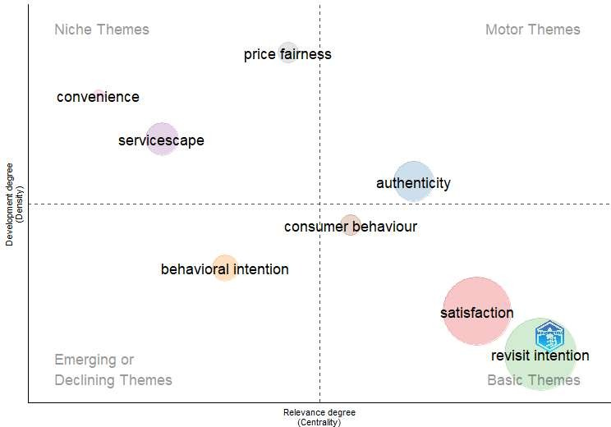
Figure 9 Thematic Map

Implications

This study offers significant academic and practical contributions:

Academic Implications

The findings reveal knowledge clusters that represent the core research areas within the field. These clusters help scholars understand the scope and current boundaries of research in this domain. Social network analysis, including country collaboration maps and co-authorship patterns, uncovers structural networks between authors, institutions, and nations. This information aids researchers in identifying potential academic partners or institutions for collaboration. The thematic network analysis highlights various research themes, showcasing well-established and emerging topics. This perspective allows researchers to understand past developments and pinpoint gaps in the emerging literature, paving the way for future studies. Analyzing publishing trends helps identify anomalies, such as publication spikes, offering a basis for further research to explore the underlying factors driving these changes. Finally, the insights gained from this analysis can inform empirical research that promotes methodological advancements in future investigations.

Practical Implications

This study supports managers in making informed decisions by enhancing their understanding of customer perceptions, ultimately providing a competitive advantage. Performance indicators, such as author, institution, and country contributions, help identify hidden biases or instances of social dominance. For instance, it sheds light on underrepresented or overrepresented populations within specific geographic or demographic groups. These findings are valuable for research funding bodies, enabling them to allocate resources more effectively and promote diversity and inclusivity in academic contributions.

Limitations

This study has certain limitations that future researchers can address to broaden the scope of their investigations:
- Database Scope: The analysis is based solely on articles and documents from the Scopus database. Other databases, such as Web of Science, were not included, which limits the study's comprehensiveness.
- Language Restriction: The study only considered articles published in English. Consequently, significant research published in other languages was excluded, narrowing the global perspective of the findings.
- Methodological Constraint: As the study relies entirely on bibliometric data, it is subject to the inherent limitations of bibliometric analysis, such as potential biases in database indexing and publication trends.
Conclusion

This study utilized the bibliometric tool in R to analyze 162 articles, providing insights into the evolution of academic research in the field. The findings highlighted key contributors, including the most relevant authors, institutions, countries, and journals, as well as trends in publication productivity. A significant rise in annual publication rates in recent years reflects growing interest among researchers in this area.

The International Journal of Hospitality Management emerged as the most influential journal, contributing 15 articles and boasting the highest h-index and total citations. The journal analysis underscores its prominence and serves as a valuable resource for researchers seeking foundational literature and identifying gaps for future studies.

Noteworthy articles include Namkung Y's 2007 study, "Does food quality matter in Restaurants? Its Impact on customer satisfaction and behavioural intentions," which garnered the highest global citations, and Han H's 2009 paper, "Influencing Factors on restaurant customers’ revisit intention: The roles of emotions and switching barriers," which received the most local citations. Han H also stood out as the most prolific author, contributing 15% of the analysed articles.

Sejong University was identified as the leading institution with 19 publications, while the USA and South Korea ranked as the top contributing countries, with 100 and 45 articles, respectively. The science mapping analysis revealed eight significant knowledge clusters categorized into niche, emerging/declining, basic, and motor themes, offering a structured view of research trends.

Overall, this study provides a roadmap for future researchers by highlighting emerging trends and pinpointing critical areas for scientific exploration.

References

Al-Tit, A.A. (2015), “The effect of service and food quality on customer satisfaction and hence customer retention”, Asian Social Science, Canadian Center of Science and Education, Vol. 11 No. 23, pp.
129–139, doi: 10.5539/ass.v11n23p129.
Bansal, R., Martinho, C., Pruthi, N. and Aggarwal, D. (2024), “From virtual observations to business insights: A bibliometric review of netnography in business research”, Heliyon, Elsevier Ltd, 15 January, doi: 10.1016/j.heliyon.2023.e22853.
Batista-Canino, R.M., Santana-Hernández, L. and Medina-Brito, P. (2023), “A scientometric analysis on entrepreneurial intention literature: Delving deeper into local citation”, Heliyon, Vol. 9 No. 2, p. e13046, doi: 10.1016/j.heliyon.2023.e13046.
Carins, J.E., Rundle-Thiele, S.R. and Ong, D.L. (2020), “Keep them coming back: The role of variety and aesthetics in institutional food satisfaction”, Food Quality and Preference, Elsevier Ltd, Vol. 80, doi: 10.1016/j.foodqual.2019.103832.
Chang, J., Morrison, A.M., Chen, Y.-L., Chang, T.-Y. and Chen, D.Z.-Y. (2021), “Does a healthy diet travel?
Motivations, satisfaction and loyalty with plant-based food dining at destinations”, British Food Journal, Vol. 123 No. 12, pp. 4155–4174, doi: 10.1108/BFJ-12-2020-1121.
Chun, S.H. and Nyam-Ochir, A. (2020), “The effects of fast food restaurant attributes on customer satisfaction, revisit intention, and recommendation using DINESERV scale”, Sustainability (Switzerland), MDPI, Vol. 12 No. 18, doi: 10.3390/SU12187435.
Halimi, F.F., Gabarre, S., Rahi, S., Al-Gasawneh, J.A. and Ngah, A.H. (2022), “Modelling Muslims’ revisit intention of non-halal certified restaurants in Malaysia”, Journal of Islamic Marketing, Vol. 13 No. 11, pp. 2437–2461, doi: 10.1108/JIMA-01-2021-0014.
Han, H., Back, K.-J. and Barrett, B. (2009), “Influencing factors on restaurant customers’ revisit intention: The roles of emotions and switching barriers”, International Journal of Hospitality Management, Vol. 28 No. 4, pp. 563–572, doi: 10.1016/j.ijhm.2009.03.005.
Han, H. and Hyun, S.S. (2017), “Impact of hotel-restaurant image and quality of physical-environment, service, and food on satisfaction and intention”, International Journal of Hospitality Management, Elsevier Ltd, Vol. 63, pp. 82–92, doi: 10.1016/j.ijhm.2017.03.006.
Hashim, H., Mamat, A., Nasarudin, N., Anisah, N. and Halim, A. (2017), “SOCIAL SCIENCES & HUMANITIES Coffee Culture among Generation Y”, Pertanika J. Soc. Sci. & Hum, Vol. 25, pp. 39–48.
Islam, T., Ahmed, I., Ali, G. and Ahmer, Z. (2019), “Emerging trend of coffee cafe in Pakistan: factors affecting revisit intention”, British Food Journal, Emerald Group Holdings Ltd., Vol. 121 No. 9, pp. 2132–2147, doi: 10.1108/BFJ-12-2018-0805.
Jang, H.-W. (2021), “How important is human service for sustainable restaurant businesses?”, Journal of Hospitality and Tourism Management, Vol. 48, pp. 406–415, doi: 10.1016/j.jhtm.2021.07.017.
Kement, Ü., Çavuşoğlu, S., Bükey, A., Göral, M. and Uslu, A. (2021), “Investigation of the Effect of Restaurant Atmosphere on Behavioral Intention”, Journal of Tourism and Services, Vol. 12 No. 22,
pp. 222–242, doi: 10.29036/jots.v12i22.245.
Khoo, K.L. (2022), “A study of service quality, corporate image, customer satisfaction, revisit intention and word-of-mouth: evidence from the KTV industry”, PSU Research Review, Emerald Group Holdings Ltd., Vol. 6 No. 2, pp. 105–119, doi: 10.1108/PRR-08-2019-0029.
Kim, C.Y. and Cha, S.S. (2023), “Effect of SNS Characteristics for Dining Out on Customer Satisfaction and Online Word of Mouth”, SAGE Open, SAGE Publications Inc., Vol. 13 No. 3, doi: 10.1177/21582440231199575.
Kim, H.J., Park, J., Kim, M.J. and Ryu, K. (2013), “Does perceived restaurant food healthiness matter? Its influence on value, satisfaction and revisit intentions in restaurant operations in South Korea”, International Journal of Hospitality Management, Vol. 33 No. 1, pp. 397–405, doi: 10.1016/j.ijhm.2012.10.010.
Kim, J.-H. (2021), “Service authenticity and its effect on positive emotions”, Journal of Services Marketing, Emerald Publishing Limited, Vol. 35 No. 5, pp. 572–584, doi: 10.1108/JSM-07-2020- 0261.
Kim, K. and Baker, M.A. (2017), “The Impacts of Service Provider Name, Ethnicity, and Menu Information on Perceived Authenticity and Behaviors”, Cornell Hospitality Quarterly, SAGE Publications Inc., Vol. 58 No. 3, pp. 312–318, doi: 10.1177/1938965516686107.
Kim, W.G., Jin-Sun, B. and Kim, H.J. (2008), “Multidimensional Customer-Based Brand Equity and Its Consequences in Midpriced Hotels”, Journal of Hospitality and Tourism Research, SAGE Publications Inc., Vol. 32 No. 2, pp. 235–254, doi: 10.1177/1096348007313265.
Kim, W.G. and Moon, Y.J. (2009), “Customers’ cognitive, emotional, and actionable response to the servicescape: A test of the moderating effect of the restaurant type”, International Journal of Hospitality Management, Vol. 28 No. 1, pp. 144–156, doi: 10.1016/j.ijhm.2008.06.010.
Konuk, F.A. (2019), “The influence of perceived food quality, price fairness, perceived value and satisfaction on customers’ revisit and word-of-mouth intentions towards organic food restaurants”, Journal of Retailing and Consumer Services, Elsevier Ltd, Vol. 50, pp. 103–110, doi: 10.1016/j.jretconser.2019.05.005.
Liu, P. and Lee, Y.M. (2018), “An investigation of consumers’ perception of food safety in the restaurants”, International Journal of Hospitality Management, Elsevier Ltd, Vol. 73, pp. 29–35, doi: 10.1016/j.ijhm.2018.01.018.
Liu, Y. and Jang, S.C. (Shawn). (2009), “The effects of dining atmospherics: An extended Mehrabian- Russell model”, International Journal of Hospitality Management, Vol. 28 No. 4, pp. 494–503, doi: 10.1016/j.ijhm.2009.01.002.
Lu, L., Zhang, P. and Zhang, T. (Christina). (2021), “Leveraging ‘human-likeness’ of robotic service at restaurants”, International Journal of Hospitality Management, Elsevier Ltd, Vol. 94, doi: 10.1016/j.ijhm.2020.102823.
Ma, J., Qu, H., Njite, D. and Chen, S. (2011), “Western and Asian customers’ perception towards Chinese restaurants in the United States”, Journal of Quality Assurance in Hospitality and Tourism, Vol. 12 No. 2, pp. 121–139, doi: 10.1080/1528008X.2011.541818.
Mannan, M., Chowdhury, N., Sarker, P. and Amir, R. (2019), “Modeling customer satisfaction and revisit intention in Bangladeshi dining restaurants”, Journal of Modelling in Management, Emerald Group Holdings Ltd., Vol. 14 No. 4, pp. 922–947, doi: 10.1108/JM2-12-2017-0135.
Meng, B. and Choi, K. (2018), “An investigation on customer revisit intention to theme restaurants: The role of servicescape and authentic perception”, International Journal of Contemporary Hospitality Management, Emerald Group Publishing Ltd., Vol. 30 No. 3, pp. 1646–1662, doi: 10.1108/IJCHM- 11-2016-0630.
Namin, A. (2017), “Revisiting customers’ perception of service quality in fast food restaurants”, Journal of Retailing and Consumer Services, Vol. 34, pp. 70–81, doi: 10.1016/j.jretconser.2016.09.008.
Nam, J.H. and Lee, T.J. (2011), “Foreign travelers’ satisfaction with traditional Korean restaurants”, International Journal of Hospitality Management, Vol. 30 No. 4, pp. 982–989, doi: 10.1016/j.ijhm.2011.02.006.
Namkung, Y. and Jang, S. (2007), “Does Food Quality Really Matter in Restaurants? Its Impact On Customer Satisfaction and Behavioral Intentions”, Journal of Hospitality & Tourism Research, Vol. 31 No. 3, pp. 387–409, doi: 10.1177/1096348007299924.
Ngah, A., Ramayah, T., Firdaus, M., Mohamad, H. and Din, R. (2023), “A moderation and mediation model for customer revisit intention to non-Halal certified restaurants A moderation and mediation model for customer revisit intention to non-Halal certified restaurants”, Electronic Journal of Applied Statistical Analysis, pp. 122–138, doi: 10.1285/i20705948v16n1p122.
Pradana, B.I., Yuana, P., Ayuni, R.F., Amir, A.M. and Kartika, A.K. (2021), “How To Help Restaurants Survive during COVID-19?”, Studies of Applied Economics, Vol. 39 No. 12, doi: 10.25115/eea.v39i12.5998.
Quintal, V.A. and Polczynski, A. (2010), “Factors influencing tourists’ revisit intentions”, Asia Pacific Journal of Marketing and Logistics, Vol. 22 No. 4, pp. 554–578, doi: 10.1108/13555851011090565.
Richardson, S., Lefrid, M., Jahani, S., Munyon, M.D. and Rasoolimanesh, S.M. (2019), “Effect of dining experience on future intention in quick service restaurants”, British Food Journal, Emerald Group Holdings Ltd., Vol. 121 No. 11, pp. 2620–2636, doi: 10.1108/BFJ-09-2018-0617.
Riva, F., Magrizos, S., Rubel, M.R.B. and Rizomyliotis, I. (2022), “Green consumerism, green perceived value, and restaurant revisit intention: Millennials’ sustainable consumption with moderating effect of green perceived quality”, Business Strategy and the Environment, John Wiley and Sons Ltd, Vol. 31 No. 7, pp. 2807–2819, doi: 10.1002/bse.3048.
Ryu, K. and Zhong, Y. (Grace). (2012), “Antecedents and Consequences of Customers’ Menu Choice in an Authentic Chinese Restaurant Context”, Journal of Hospitality Marketing and Management, Vol. 21 No. 8, pp. 852–871, doi: 10.1080/19368623.2011.615023.
Ting, H. and Thurasamy, R. (2016), “What matters to infrequent customers: a pragmatic approach to understanding perceived value and intention to revisit trendy coffee café”, SpringerPlus, SpringerOpen, Vol. 5 No. 1, pp. 1–11, doi: 10.1186/s40064-016-2259-5.
Um, S., Chon, K. and Ro, Y. (2006), “Antecedents of revisit intention”, Annals of Tourism Research, Vol.
33 No. 4, pp. 1141–1158, doi: 10.1016/j.annals.2006.06.003.
Vandenhaute, H., Gellynck, X. and De Steur, H. (2022), “COVID-19 Safety Measures in the Food Service Sector: Consumers’ Attitudes and Transparency Perceptions at Three Different Stages of the Pandemic”, Foods, MDPI, Vol. 11 No. 6, doi: 10.3390/foods11060810.
Weiss, R., Feinstein, A.H. and Dalbor, M. (2005), “Customer satisfaction of theme restaurant attributes and their influence on return intent”, Journal of Foodservice Business Research, Vol. 7 No. 1, pp. 23–41, doi: 10.1300/J369v07n01_03.
Wijaya, N., Giantari, I., Sukaatmadja, I. and Ekawati, N. (2024), “THE MEDIATING EFFECTS OF BRAND LOVE ON REVISIT INTEREST A META ANALYSIS”, Jurnal Riset Bisnis Dan Manajemen, Vol. 17 No. 1,
pp. 1–10, doi: 10.23969/jrbm.v17i1.10308.
Yan, X., Wang, J. and Chau, M. (2015), “Customer revisit intention to restaurants: Evidence from online reviews”, Information Systems Frontiers, Kluwer Academic Publishers, Vol. 17 No. 3, pp. 645–657, doi: 10.1007/s10796-013-9446-5.
Yuksel, A., Yuksel, F. and Bilim, Y. (2010), “Destination attachment: Effects on customer satisfaction and cognitive, affective and conative loyalty”, Tourism Management, Vol. 31 No. 2, pp. 274–284, doi: 10.1016/j.tourman.2009.03.007.
Zhang, H., Wu, Y. and Buhalis, D. (2018), “A model of perceived image, memorable tourism experiences and revisit intention”, Journal of Destination Marketing & Management, Vol. 8, pp. 326–336, doi: 10.1016/j.jdmm.2017.06.004.

