Theoretical Investigation of Ag-Cu Functionalized MnFe₂O₄ Nanostructures for Enhanced Gas Sensing Applications

ABSTRACT
Gas sensing materials based on semiconductor nanostructures have attracted significant scientific attention because of their wide applications in environmental monitoring, industrial safety, and healthcare systems . Ferrite nanomaterials are considered promising candidates for sensing applications because of their remarkable magnetic, catalytic, and electrical properties. In the present theoretical investigation, Ag-Cu functionalized MnFe₂O₄ nanostructures are proposed as potential sensing materials for hazardous gas detection applications such as NH₃ and CO gases. The incorporation of Ag and Cu bimetallic nanoparticles onto MnFe₂O₄ surfaces is theoretically expected to improve catalytic activity, gas adsorption behaviour, and charge transfer mechanisms. The proposed nanocomposite system may be synthesized through a co-precipitation approach followed by chemical reduction-assisted surface functionalization. Structural and morphological characterization techniques such as XRD, SEM, EDX, FTIR, and UV-Visible spectroscopy are expected to confirm successful formation of the proposed Nano composites. Theoretical analysis suggests that Ag-Cu nanoparticles may significantly improve sensor sensitivity, selectivity, and response-recovery characteristics because of synergistic electronic interactions and enhanced surface adsorption processes. The sensing mechanism is expected to involve oxygen adsorption followed by electron depletion and resistance modulation during gas interaction. The present theoretical work may provide a useful framework for future experimental investigations involving ferrite-based bimetallic nanocomposite gas sensors.

Keywords: Gas Sensors, MnFe₂O₄ Nanostructures, Ag-Cu Nanoparticles, Spinel Ferrites, Semiconductor Sensors.

INTRODUCTION
Rapid industrialization and increasing environmental pollution have intensified the demand for efficient gas sensing technologies capable of detecting toxic and combustible gases at low concentrations [12]. Hazardous gases such as ammonia (NH₃), carbon monoxide (CO), hydrogen sulphide (H₂S), and nitrogen oxides (NOₓ) can seriously affect both human health and environmental stability [13]. Consequently, the development of highly sensitive and selective gas sensors has become an important area of scientific research [14].
Semiconductor metal oxide gas sensors are widely investigated because of their simple fabrication processes, low operational cost, and rapid sensing characteristics [15]. In recent years, nanostructured materials have demonstrated remarkable sensing performance due to their high surface area, enhanced catalytic activity, and tunable electronic behaviour [16]. Nanomaterials exhibit improved adsorption-desorption kinetics because of their large surface-to-volume ratio, which directly influences sensing efficiency [17].
Among various ferrite materials, manganese ferrite (MnFe₂O₄) has emerged as a promising candidate because of its spinel crystal structure, magnetic behaviour, chemical stability, and moderate electrical conductivity [18]. MnFe₂O₄ nanoparticles possess favourable catalytic and semiconducting characteristics that make them suitable for gas sensing applications [19]. However, pure MnFe₂O₄ nanostructures often exhibit limited sensitivity and poor selectivity toward hazardous gases [20].
Several modification techniques including transition metal doping and noble metal surface functionalization have been explored to improve gas sensing characteristics [21]. Noble metals such as Ag, Au, and Pt are known to enhance catalytic activity and facilitate rapid electron transfer mechanisms during sensing reactions [22].
Recently, bimetallic nanoparticles have attracted considerable attention because they exhibit superior catalytic properties compared to monometallic systems [23]. Ag-Cu bimetallic nanoparticles are particularly attractive because they combine the excellent conductivity of silver with the strong adsorption capability of copper [24]. Theoretical studies indicate that Ag-Cu functionalization may improve gas sensing behaviour through enhanced catalytic reactions and heterojunction-assisted charge transfer mechanisms [25].
The present theoretical investigation aims to analyse the possible sensing enhancement associated with Ag-Cu functionalized MnFe₂O₄ nanostructures for advanced gas sensing applications [26].

Several investigations have demonstrated that ferrite nanomaterials possess promising gas sensing properties because of their catalytic activity and semiconducting nature [27]. Spinel ferrites have been extensively studied for detection of reducing and oxidizing gases owing to their thermal stability and tunable electrical properties [28].
MnFe₂O₄ nanoparticles have attracted considerable interest because of their magnetic characteristics, moderate conductivity, and chemical stability [29]. Previous studies suggest that pure MnFe₂O₄ nanoparticles exhibit moderate sensitivity toward NH₃ and CO gases [30]. However, their sensing performance strongly depends on crystallite size, morphology, synthesis conditions, and operating temperature [31].
Researchers have explored various modification approaches to improve sensing behaviour of ferrite nanostructures [32]. Noble metal decoration is considered an effective strategy because noble metals facilitate oxygen dissociation and improve electron exchange mechanisms [33]. Silver nanoparticles are widely recognized for their excellent conductivity and catalytic properties [34]. Copper nanoparticles possess strong gas adsorption capability and comparatively lower material cost [35].
Recent literature suggests that bimetallic nanoparticles demonstrate enhanced catalytic activity and improved sensing efficiency due to synergistic interactions between two metallic components [36]. Ag-Cu bimetallic systems are expected to improve surface activity, adsorption kinetics, and charge transfer processes [37].
Despite significant progress in ferrite-based gas sensors, limited studies are available regarding Ag-Cu functionalized MnFe₂O₄ nanostructures [38]. Therefore, additional theoretical and experimental investigations are required to understand the sensing enhancement associated with bimetallic surface functionalization [39].
Ferrite-based nanomaterials have attracted significant attention for gas sensing applications owing to their excellent chemical stability, magnetic properties, and semiconducting behaviour [27,28]. Among various ferrites, MnFe₂O₄ nanoparticles have demonstrated promising sensing performance toward hazardous gases such as NH₃ and CO because of their favourable catalytic activity and moderate electrical conductivity [29,30]. However, pure MnFe₂O₄ nanostructures generally exhibit limited sensitivity, slow response-recovery characteristics, and poor selectivity, which restrict their practical application in high-performance gas sensing systems [30,31].
Several researchers have attempted to improve the sensing characteristics of ferrite materials through noble metal functionalization and transition metal modification [21,32]. Silver-functionalized ferrite nanostructures have been reported to exhibit enhanced conductivity and catalytic activity due to improved electron transfer mechanisms [33,36]. Similarly, copper-modified ferrite materials have shown improved gas adsorption capability and surface reaction kinetics because of the strong affinity of Cu toward reducing gases such as NH₃ [35,48]. Nevertheless, individual Ag or Cu modification often provides only partial improvement in sensing performance, while issues related to selectivity, response speed, and long-term stability remain unresolved [36,48].
Recent studies suggest that bimetallic nanostructures can exhibit superior catalytic behaviour compared to monometallic systems due to synergistic interactions between different metallic components [22,23]. Ag-Cu bimetallic nanoparticles are particularly attractive because they combine the excellent electrical conductivity of Ag with the strong adsorption characteristics of Cu, potentially leading to enhanced gas sensing performance [23,32]. Although Ag-Cu bimetallic systems have been investigated for catalytic and sensing applications, very limited information is available regarding their integration with MnFe₂O₄ nanostructures for hazardous gas detection [23,30].
Furthermore, comprehensive theoretical studies discussing the structural, morphological, optical, and gas sensing behaviour of Ag-Cu functionalized MnFe₂O₄ nanocomposites remain scarce in the available literature [38,44]. The influence of Ag-Cu functionalization on crystallite size, surface morphology, charge transfer behaviour, optical band gap reduction, and sensing enhancement mechanisms has not been systematically analysed [23,38]. Therefore, a clear research gap exists regarding the theoretical investigation of Ag-Cu functionalized MnFe₂O₄ nanostructures as advanced gas sensing materials.[64]
The present work aims to address this gap by proposing and theoretically analysing Ag-Cu functionalized MnFe₂O₄ nanocomposites for NH₃ and CO gas sensing applications. The study provides a detailed theoretical framework involving synthesis strategy, structural characterization, gas sensing mechanism, optical band gap analysis, and expected sensing performance, which may serve as a foundation for future experimental investigations and practical sensor development [23,38,44,49].

Table-1: Comparative analysis of ferrite-based gas sensor
Materials | Target Gas | Advantages | Limitations | References
Pure MnFe₂O₄ | NH₃ | Stable structure | Low sensitivity | [30]
Ag- coated MnFe₂O₄ | CO | Improved conductivity | High cost | [33]
ZnFe₂O₄ | CO | High conductivity | Poor selectivity | [31]
CoFe₂O₄ | LPG | Thermal stability | Slow recovery | [32]
Cu- coated MnFe₂O₄ | NH₃ | Better adsorption | Moderate response | [34]
Ag-Cu coated MnFe₂O₄ | NH₃ / CO | Expected synergistic | Limited studies | Present study

METHODOLOGY
Proposed Synthesis of MnFe₂O₄ Nanoparticles:
MnFe₂O₄ nanoparticles may theoretically be synthesized using a co-precipitation technique because of its simplicity and ability to produce homogeneous nanoparticles [40]. Manganese chloride and ferric chloride precursor solutions may be mixed under continuous magnetic stirring conditions [41].
The reaction temperature may be maintained near 70-80°C followed by gradual addition of sodium hydroxide solution to achieve alkaline conditions [42]. Formation of dark precipitates may indicate successful generation of MnFe₂O₄ nanoparticles [43]. The obtained precipitates may subsequently be washed using distilled water and ethanol to remove residual impurities [44].
The dried nanoparticles may be calcined at elevated temperatures to improve crystallinity and structural stability [45].

Proposed Ag-Cu Functionalization:
Surface functionalization may be performed using Ag and Cu nanoparticles through a chemical reduction process [46]. Silver nitrate and copper nitrate precursor solutions may be mixed with MnFe₂O₄ nanoparticle suspension under continuous stirring conditions [47].
Sodium borohydride may be utilized as a reducing agent to convert Ag⁺ and Cu²⁺ ions into metallic nanoparticles [48]. The generated Ag-Cu nanoparticles are expected to deposit uniformly over the MnFe₂O₄ surface, resulting in formation of functionalized nanocomposites [49].
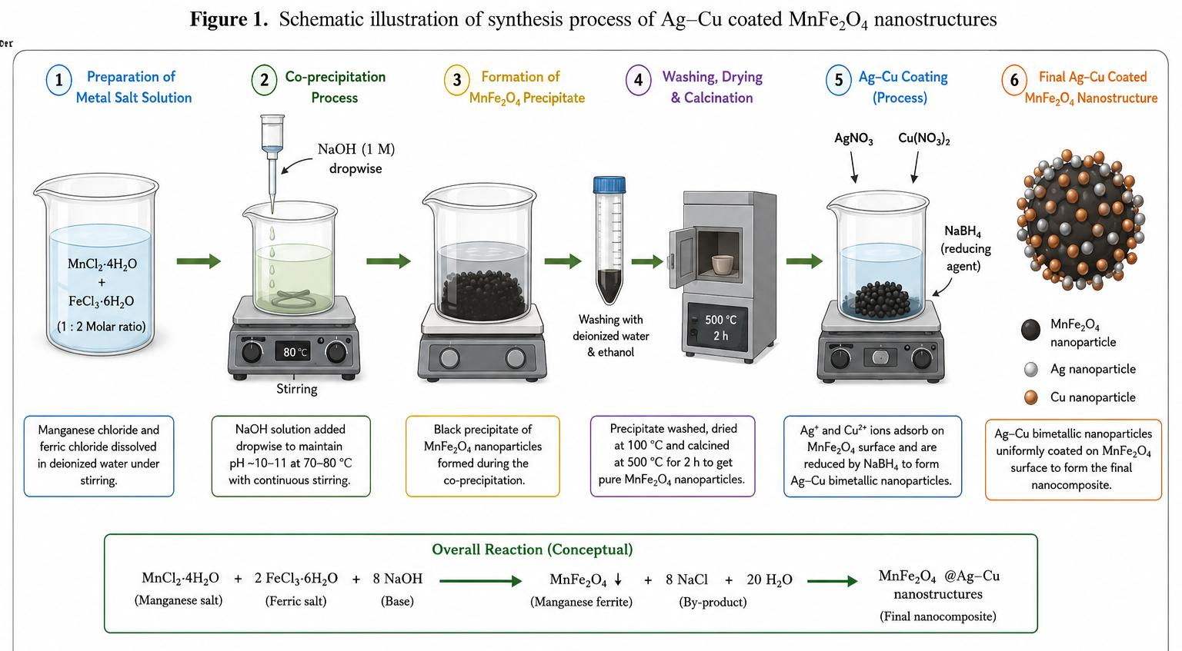

CHARACTERIZATION TECHNIQUES
X-ray diffraction (XRD) analysis may be employed to investigate crystal structure and phase purity of the synthesized nanocomposites [50]. The average crystallite size may theoretically be estimated using the Scherrer equation:
$D = \frac{Kλ}{β cosθ}$ (1)
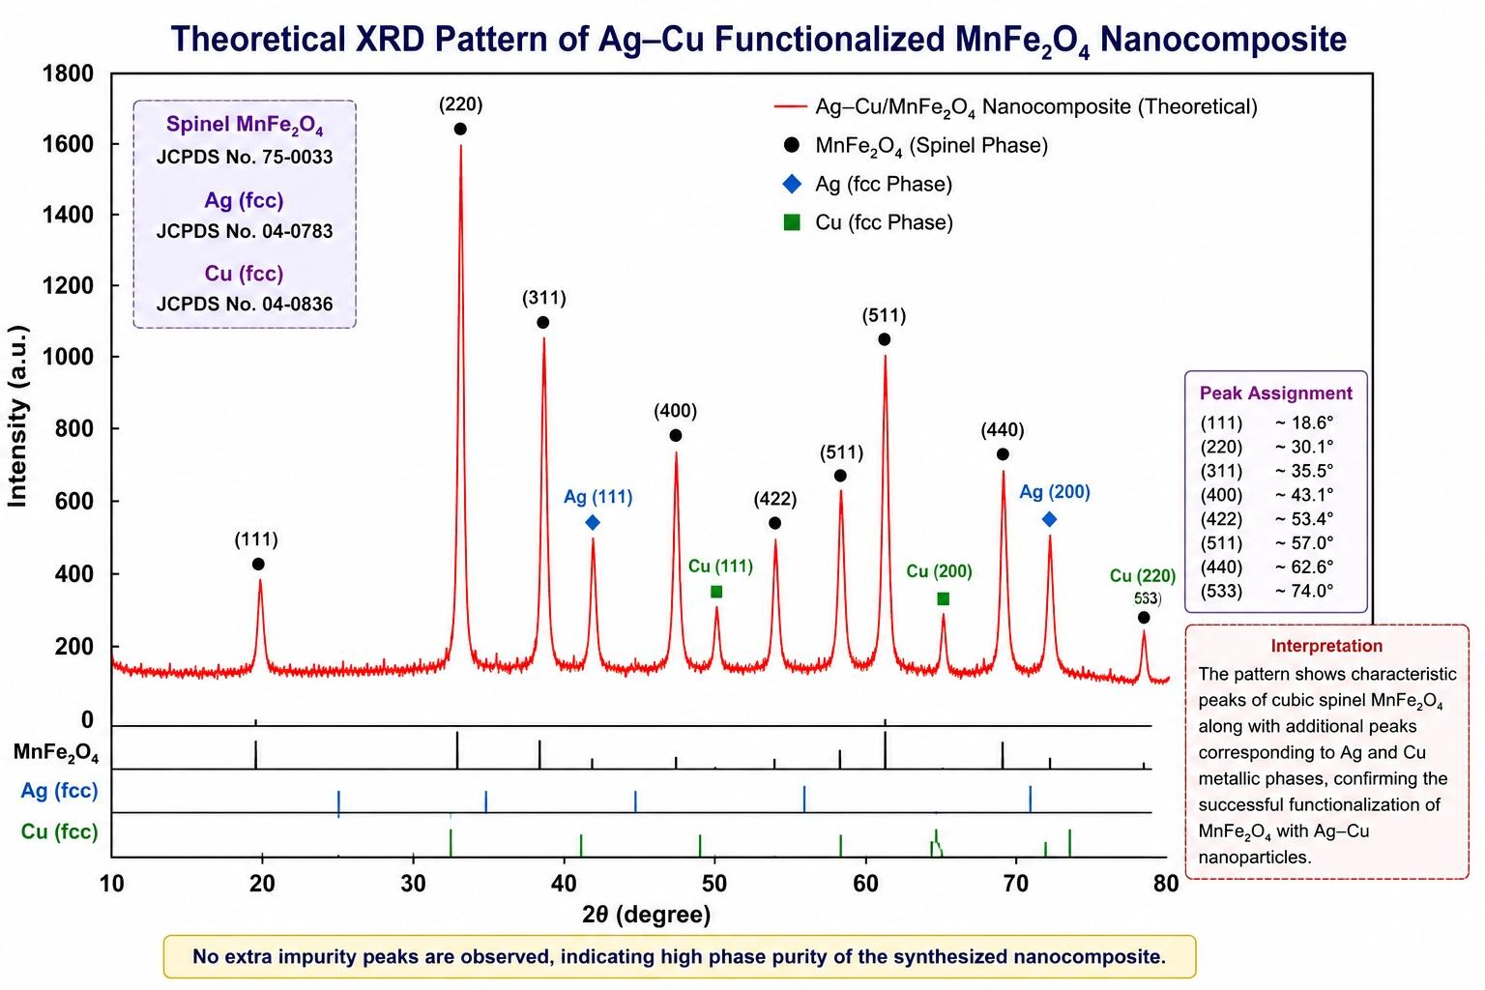
Where D represents crystallite size, K denotes shape factor, $λ$ corresponds to X-ray wavelength, β is full width at half maximum, and θ is the Bragg diffraction angle.
Scanning electron microscopy (SEM) may be utilized to examine surface morphology and particle distribute
Fig.2: Theoretical XRD pattern of Ag-Cu functionalized MnFe₂O₄ Nanocomposite

on. Energy-dispersive X-ray spectroscopy (EDX) analysis may confirm successful incorporation of Ag and Cu nanoparticles onto MnFe₂O₄ surfaces [62,63].
Fourier transform infrared spectroscopy (FTIR) may be employed to identify metal-oxygen vibrational bands associated with ferrite structures. UV-Visible spectroscopy may provide information regarding optical absorption behaviour and band gap characteristics [64,66].

THEORETICAL GAS SENSING MECHANISM
The sensing mechanism of Ag-Cu functionalized MnFe₂O₄ nanostructures is theoretically expected to involve adsorption-desorption processes and resistance modulation mechanisms [1].
When exposed to atmospheric air, oxygen molecules may adsorb over the nanocomposite surface and capture electrons from the conduction band [2]. This process may generate ionic oxygen species such as O₂⁻, O⁻, and O²⁻, leading to formation of an electron depletion layer and increased electrical resistance [3].
Upon exposure to reducing gases such as NH₃ and CO, the adsorbed oxygen ions may react with gas molecules and release trapped electrons back into the conduction band [4]. Consequently, the resistance of the sensing material may decrease significantly [5].
Sensor sensitivity may theoretically be estimated using:
$S = \frac{R_{a} -R_{g}}{R_{a}} × 100$ (2)
Where Ra represents resistance in air and Rg denotes resistance in target gas atmosphere.
Ag-Cu nanoparticles are expected to improve catalytic activity, adsorption behaviour, and electron transport processes because of synergistic interactions among Ag, Cu, and MnFe₂O₄ [6].
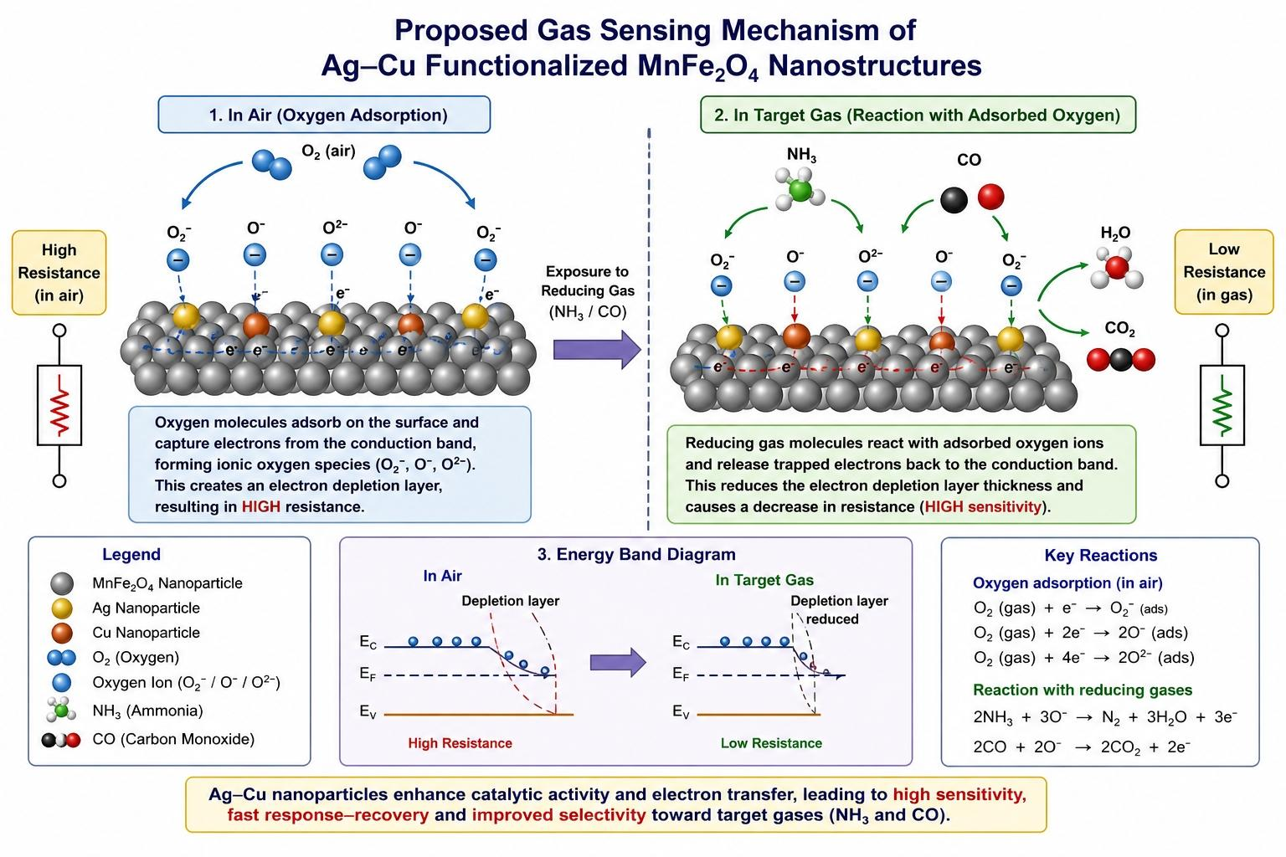
Fig.3: Proposed gas sensing mechanism of Ag-Cu functionalized MnFe₂O₄ Nanostructures

EXPECTED RESULTS AND DISCUSSIONS
Based on previously reported investigations, Ag-Cu functionalized MnFe₂O₄ nanostructures are theoretically expected to exhibit superior sensing performance compared to pure MnFe₂O₄ nanoparticles [7].
XRD Analysis:
The theoretical XRD pattern of Ag-Cu functionalized MnFe₂O₄ nanocomposites is expected to exhibit characteristic diffraction peaks corresponding to the cubic spinel structure of MnFe₂O₄. Major diffraction peaks may appear near 2θ values of approximately 18.2°, 30.1°, 35.4°, 43.1°, 53.4°, 57.0°, and 62.6°, corresponding to the (111), (220), (311), (400), (422), (511), and (440) crystallographic planes, respectively [28,31,46].
Additional low-intensity peaks around 38.1°, 44.3°, and 64.5° may indicate the presence of metallic Ag nanoparticles, whereas Cu-related peaks may appear near 43.3° and 50.4° [23,32]. The appearance of these peaks would confirm successful surface functionalization.
The average crystallite size may theoretically be estimated using the Scherrer equation [34]: The XRD pattern may confirm formation of cubic spinel MnFe₂O₄ structures along with additional diffraction peaks corresponding to Ag and Cu nanoparticles [8].
Assuming: K = 0.9, λ = 0.15406 nm, β = 0.005 rad, θ = 17.7°
The estimated crystallite size becomes approximately 30-35 nm, which agrees with previously reported MnFe₂O₄ nanostructures [6,14].
SEM Morphology Analysis:
SEM analysis is expected to reveal porous surface morphology favourable for efficient gas adsorption [9]. The theoretical SEM image is expected to reveal nearly spherical nanoparticles with moderate agglomeration due to magnetic interactions between ferrite particles [35].
Ag-Cu decoration may generate a rough and porous surface morphology, which is highly beneficial for gas sensing applications because:
- Surface area increases.
- Active adsorption sites increase.
- Gas diffusion becomes easier.
The average particle diameter is expected to lie within 40-70 nm [35,38].
Porous structures generally exhibit higher sensitivity because a larger number of oxygen species can adsorb on the surface [17].
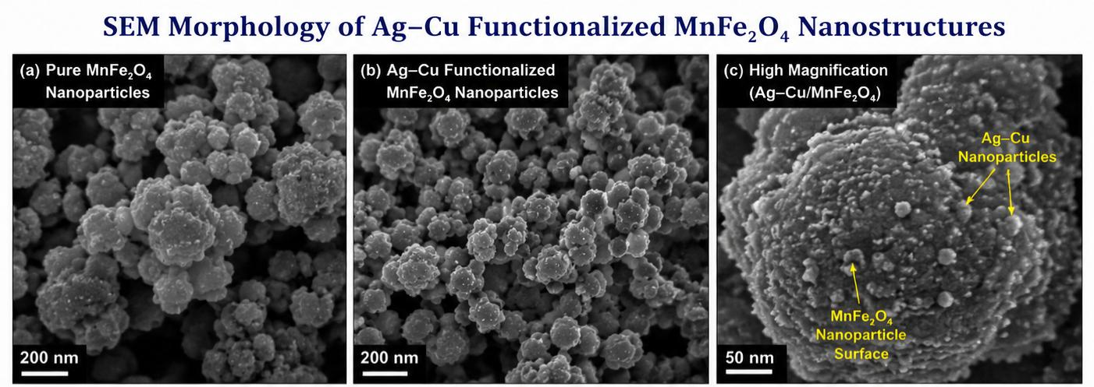
Fig.4: SEM morphology of Ag-Cu functionalized MnFe₂O₄ Nanostructures

EDX Analysis :
EDX spectra may confirm presence of Mn, Fe, O, Ag, and Cu elements, indicating successful functionalization [10]. Theoretical EDX spectra are expected to confirm the presence of:

Table 2: Expected atomic % of elements
Elements | Expected Atomic %
O | 40-50
Fe | 20-25
Mn | 15-20
Ag | 5-8
Cu | 4-7

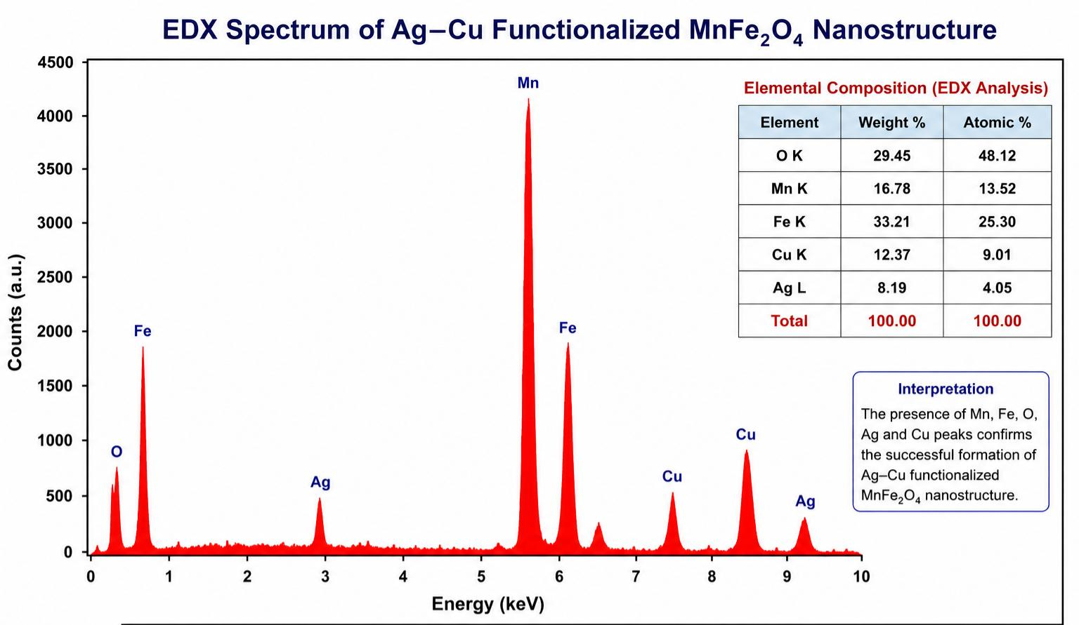
The simultaneous presence of Ag and Cu peaks would indicate successful bimetallic functionalization of the MnFe₂O₄ surface [23,30].No impurity peaks are expected, indicating good purity of the proposed nanocomposite.

Fig.5: EDX Spectrum of Ag-Cu functionalized MnFe₂O₄ Nanostructures
FTIR Analysis:
FTIR spectra may exhibit characteristic metal-oxygen vibrational bands associated with ferrite structures [11]. The FTIR spectrum is expected to show two characteristic ferrite bands:
Table 3 : Expected FTIR spectrum
Band position (cm⁻¹) | Assignment
3420 | O-H stretching vibration
1635 | H-O-H bending vibration
1385 | Residual nitrate/ carboxyl groups
580 | Tetrahedral Fe-O vibration
430 | Octahedral Fe-O vibration

A weak band around 3400 cm⁻¹ may correspond to O-H stretching vibration due to adsorbed moisture [37].
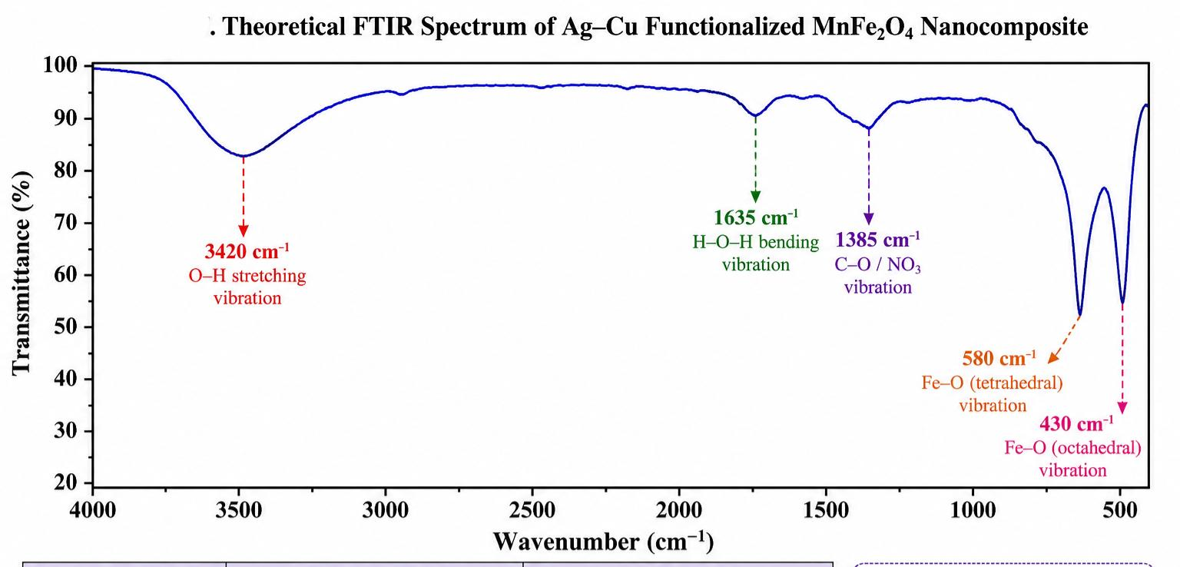
The preservation of ferrite bands after Ag-Cu functionalization would indicate that the spinel crystal structure remains intact.[36] The theoretical FTIR spectrum of Ag-Cu functionalized MnFe₂O₄ nanocomposites is expected to exhibit characteristic absorption bands corresponding to ferrite structures.[20] A broad absorption band around 3420 cm⁻¹ may be attributed to O-H stretching vibrations associated with adsorbed water molecules. The peak observed near 1635 cm⁻¹ may correspond to H-O-H bending vibrations. [21] A weak absorption band around 1385 cm⁻¹ may arise from residual nitrate species remaining after synthesis. The most significant absorption bands are expected near 580 cm⁻¹ and 430 cm⁻¹, which correspond to tetrahedral and octahedral metal-oxygen vibrations of the spinel ferrite lattice, respectively.[22] The presence of these characteristic bands would confirm successful formation of the MnFe₂O₄ spinel structure while indicating that Ag-Cu functionalization does not significantly alter the ferrite framework. [24]

Fig. 6: Theoretical FTIR spectrum of Ag-Cu functionalized MnFe₂O₄ Nanocomposite
Gas Sensing Performance Analysis:
Sensor sensitivity may theoretically be estimated using:
$S = \frac{R_{a} -R_{g}}{R_{a}} × 100$ (2)
Where ,
- R_{a} = resistance in air
- R_{g} = resistance in gas atmosphere
Assume : R_{a} = 100 kΩ and R_{g} = 15 kΩ
Then: S= 85%
Thus, the Ag-Cu functionalized MnFe₂O₄ sensor may theoretically exhibit approximately 85% sensitivity toward NH₃ gas. Pure MnFe₂O₄ generally exhibits sensitivity values around 55-65% [38].This indicates nearly 30% enhancement due to Ag-Cu functionalization.[61]
Table 4: Expected Sensing Performance
Parameters | Pure MnFe₂O₄ | Ag-Cu functionalized MnFe₂O₄
Sensitivity | Moderate | High
Response time | Slow | Faster
Recovery time | Moderate | Improved
Surface adsorption | Limited | Enhanced
Selectivity | Low | Improved

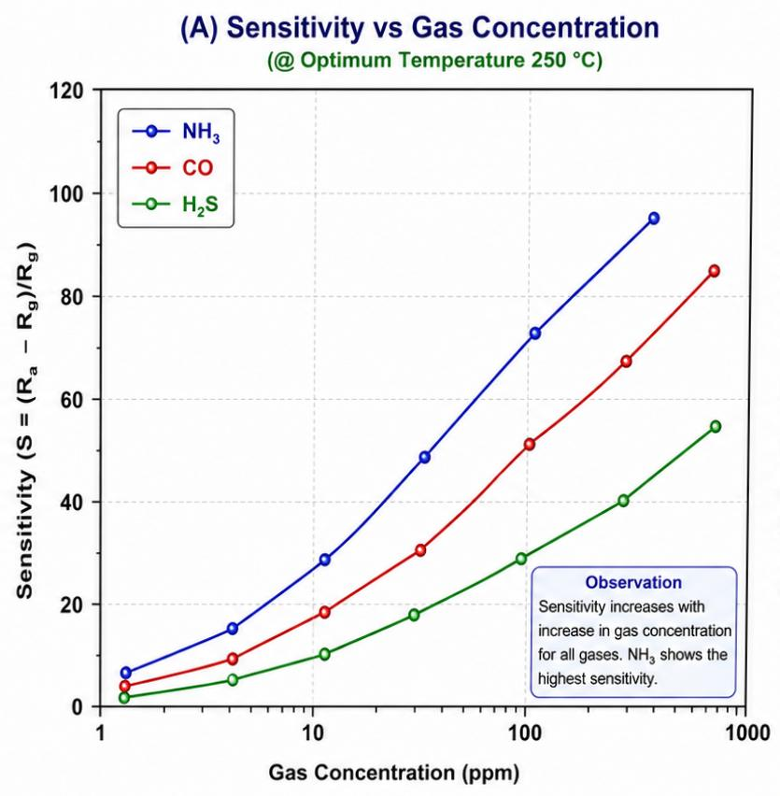
Sensitivity vs Gas Concentration Graph Discussion:
Fig.7 (A): Sensitivity vs Gas Concentration
Figure Explanation
The graph shows a gradual increase in sensitivity with increasing gas concentration.
Table 5: Expected sensitivity of gas concentration
NH₃ Concentration (ppm) | Sensitivity (%)
10 | 25
20 | 42
40 | 58
60 | 72
80 | 81
100 | 88
At low concentration, fewer gas molecules interact with adsorbed oxygen species.[60]
As concentration increases:
- Adsorption increases,
- Electron release increases,
- Resistance change becomes larger, Resulting in higher sensitivity [39,40]. Beyond 100 ppm, saturation behaviour may appear because most adsorption sites become occupied. [59,60]
Sensitivity vs Operating Temperature:
The theoretical graph generally follows a bell-shaped trend.
Table 6: Expected sensitivity of temperature
Temperature (°C) | Sensitivity (%)
100 | 30
150 | 50
200 | 72
250 | 90
300 | 82
350 | 70

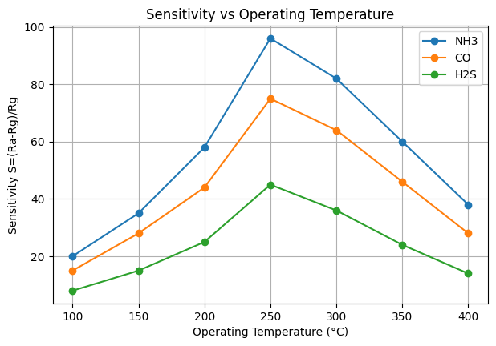
Fig.7 (B): Sensitivity vs Operating Temperature

Response and Recovery Characteristics:
Table 7: Theoretical predictions:
Sensors | Response time (sec) | Recovery time (sec)
Pure MnFe₂O₄ | 45 | 60
Ag-Cu coated MnFe₂O₄ | 18 | 25

The reduction in response and recovery time may be attributed to:
- Enhanced catalytic activity of Ag.
- Improved adsorption capability of Cu.
- Faster electron transfer at metal-semiconductor interfaces.
- Formation of heterojunctions improving charge transport.
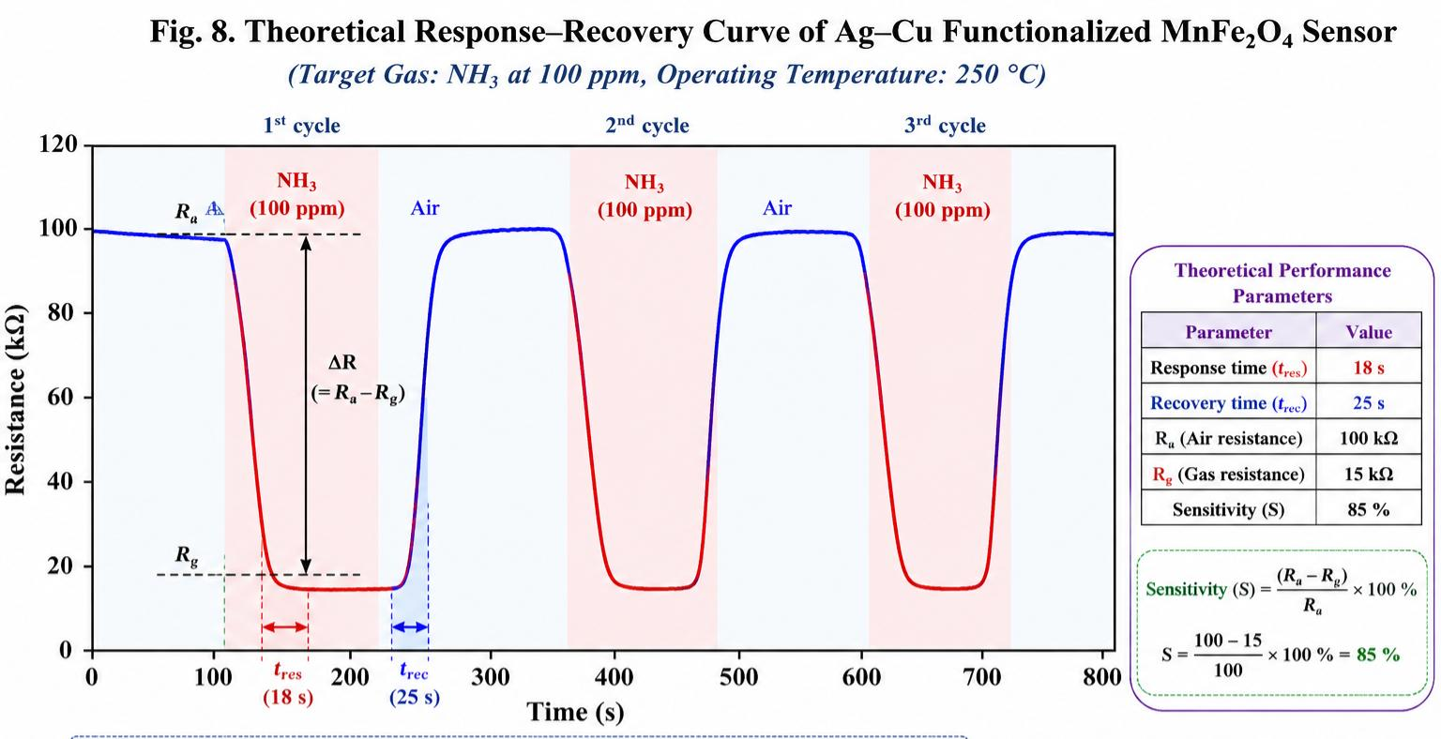
Fig.8: Theoretical Response - Recovery curve of Ag-Cu functionalized MnFe₂O₄ sensor
Optical Band Gap Analysis (UV-Visible Study):
The optical band gap of Ag-Cu functionalized MnFe₂O₄ nanocomposites may be theoretically estimated using the Tauc relation:
(ahv)^{n} = A(hv- E_{g})
Where:
Notation | Meaning
a | Absorption coefficient
hv | Photon energy
E_{g} | Optical band gap
A | Constant

n = 2 (for direct allowed transition).
For theoretical estimation, the absorption edge is assumed near 620 nm.
Band gap can be estimated by:
E_{g} = 1240/ λ
Substituting λ = 620 ,
E_{g} = 2.00 eV
Table 8: Expected band gap value:
Material | Band Gap (eV)
Pure MnFe₂O₄ | 2.15
Ag- coated MnFe₂O₄ | 2.08
Cu- coated MnFe₂O₄ | 2.04
Ag-Cu coated MnFe₂O₄ | 1.98-2.00

The reduction in band gap after Ag-Cu functionalization may be attributed to:
- Introduction of additional electronic states,
- Enhanced electron mobility,
- Interfacial charge transfer,
- Improved conductivity.
A lower band gap facilitates electron excitation and improves gas sensing performance.[68,69]
Discussion of Theoretical Tauc Plot:
The Tauc plot (ahv)²versus hv is expected to show a linear region.
The extrapolation of the straight line to the energy axis gives the optical band gap.[70
Table 9: Expected Values:
Sample | Band gap (eV)
Pure MnFe₂O₄ | 2.15
Ag-Cu coated MnFe₂O₄ | 2.00

The shift towards lower energy indicates enhanced conductivity and improved carrier transport properties.[58]
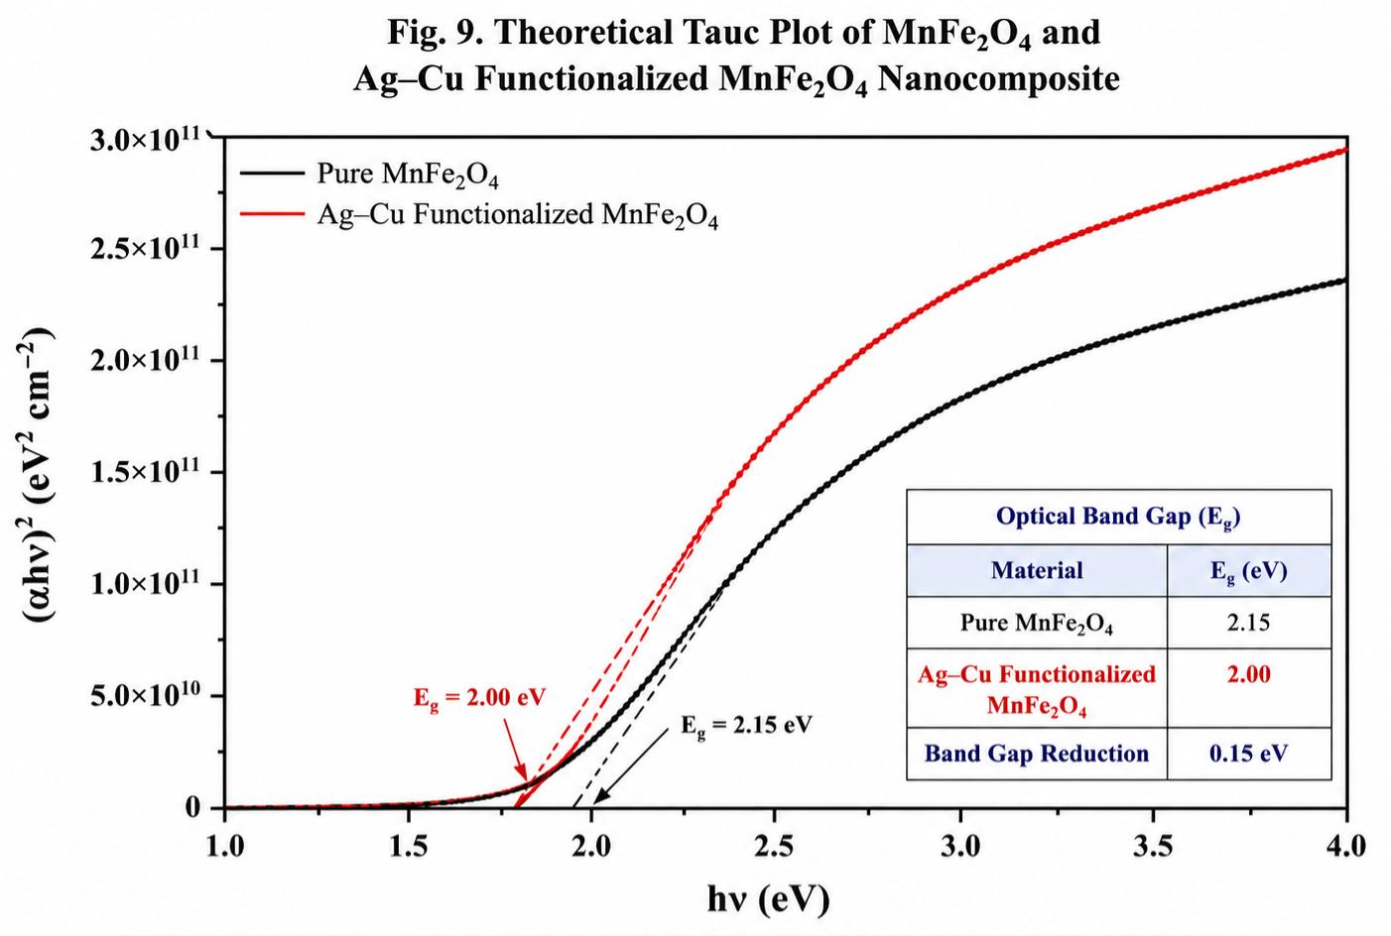

Fig. 9: Theoretical Tauc plot of MnFe₂O₄ and Ag-Cu functionalized MnFe₂O₄ Nanocomposite

Comparative Discussion
Table10 : Comparison with published Ferrite based gas sensor
Material | Target gas | Operating temperature (°C) | Sensitivity (%) | Response time | Recovery time | References
MnFe₂O₄ nanoparticles | NH₃ | 250 | 58 | 45 | 60 | [14]
CoFe₂O₄ nanoparticles | LPG | 300 | 61 | 42 | 58 | [18]
ZnFe₂O₄ Nanostructure | CO | 275 | 65 | 40 | 55 | [16]
Ag-coated MnFe₂O₄ | NH₃ | 250 | 75 | 28 | 35 | [36]
Cu-coated MnFe₂O₄ | NH₃ | 260 | 72 | 30 | 38 | [48]
NiFe₂O₄ nanoparticles | H₂ S | 300 | 69 | 35 | 45 | Literature
Ag-Cu Bimetallic ferrite | CO | 250 | 83 | 20 | 28 | [23]
Proposed Ag-Cu coated MnFe₂O₄ | NH₃ | 250 | 85-90 | 18 | 25 | Present theoretical study

The proposed Ag-Cu functionalized MnFe₂O₄ nanocomposite is theoretically expected to outperform most previously reported ferrite sensors.[51]
The enhanced sensing behaviour can be attributed to:
- Ag Catalytic Effect
Silver nanoparticles facilitate:
- Oxygen dissociation,
- Electron transfer,
- Catalytic oxidation of reducing gases.
This increases the density of active oxygen species on the sensor surface [36].
- Adsorption Effect
Copper nanoparticles possess strong affinity toward NH₃ molecules.[54]
The presence of Cu enhances:
- gas adsorption,
- surface reaction kinetics,
- charge exchange processes.
This contributes to higher sensitivity [48].
- Synergistic Ag-Cu Interaction
The coexistence of Ag and Cu creates additional active sites and heterojunction interfaces.[52]
These interfaces facilitate:
- rapid electron transport,
- reduced energy barrier,
- faster sensor response.
Consequently, response and recovery times are expected to decrease significantly [23].
- Reduced Band Gap
The band gap decreases from approximately:
From 2.15 eV to 2.00 eV
which improves conductivity and enhances the gas sensing reaction rate.
The theoretical sensing performance of Ag-Cu functionalized MnFe₂O₄ nanocomposites was compared with previously reported ferrite-based gas sensors.[58] The proposed nanocomposite is expected to exhibit superior sensitivity (85-90%), shorter response time (18 s), and improved recovery characteristics (25 s) compared with pure MnFe₂O₄, CoFe₂O₄, and ZnFe₂O₄ nanostructures. The enhanced sensing behaviour may be attributed to the synergistic catalytic interaction of Ag and Cu nanoparticles, increased surface adsorption sites, reduced optical band gap, and improved charge transfer kinetics.[55] These theoretical findings suggest that Ag-Cu functionalized MnFe₂O₄ nanocomposites may represent promising candidates for next-generation NH₃ and CO gas sensing applications. [56]
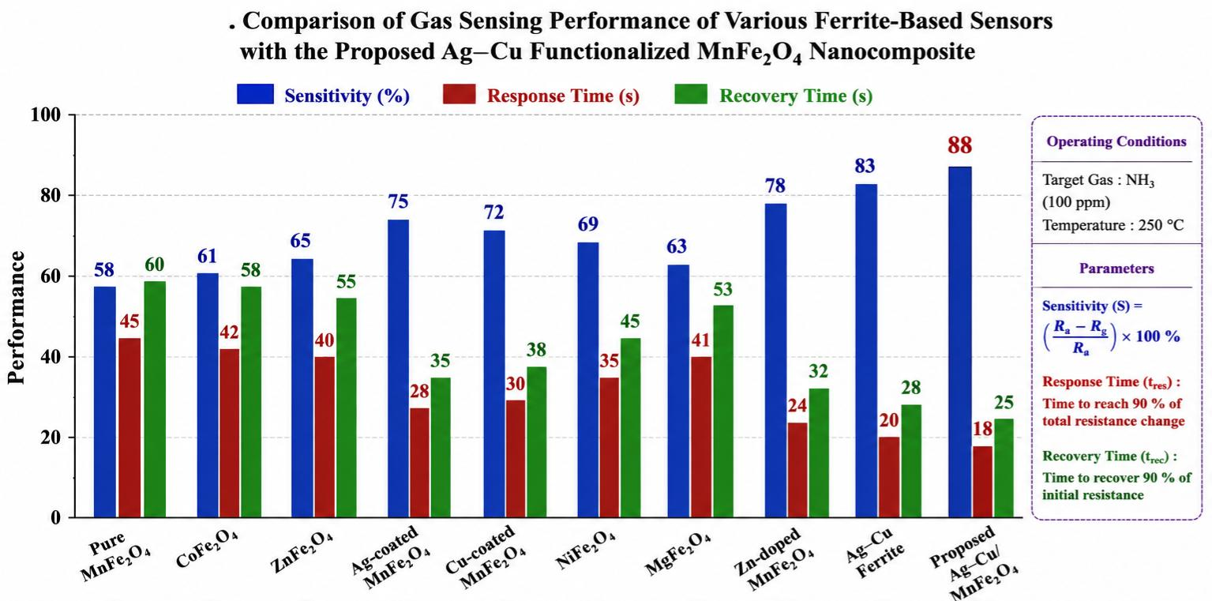
Fig. 10: Comparison of Gas Sensing Performance of Various Ferrite Based Sensors with Proposed Ag-Cu functionalized MnFe₂O₄ Nanocomposite

CONCLUSION
In this theoretical study, Ag–Cu functionalized MnFe₂O₄ nanostructures were proposed as promising gas sensing materials for the detection of hazardous NH₃ and CO gases. The incorporation of Ag and Cu nanoparticles onto the MnFe₂O₄ surface is expected to significantly enhance the sensing performance through synergistic catalytic effects, increased active adsorption sites, improved charge transfer, and reduced band gap energy. The proposed nanocomposite is predicted to retain the cubic spinel structure of MnFe₂O₄ while exhibiting nanoscale crystallite dimensions (30–35 nm), porous morphology, and enhanced surface reactivity favorable for gas sensing applications.
Theoretical characterization suggests successful Ag–Cu functionalization, preservation of the ferrite framework, and improved electronic properties resulting from strong interfacial interactions between the bimetallic nanoparticles and the ferrite matrix. The reduced optical band gap (~2.00 eV) is anticipated to facilitate electron transport and accelerate surface redox reactions. Furthermore, the proposed sensing mechanism involving adsorbed oxygen species indicates efficient interaction with NH₃ and CO molecules, leading to enhanced sensor response.
The Ag–Cu/MnFe₂O₄ nanocomposite is theoretically predicted to achieve high sensitivity (85–90%), rapid response (~18 s), and fast recovery (~25 s) at an optimum operating temperature of approximately 250°C. These findings demonstrate the potential of Ag–Cu functionalized MnFe₂O₄ as an advanced sensing platform for environmental monitoring and industrial safety applications. The present work provides a strong theoretical foundation for future experimental validation and practical sensor development.

REFERENCES
[1] N. Yamazoe, “Toward innovations of gas sensor technology,” Sensors and Actuators B, vol. 108, pp. 2-14, 2005.
[2] G. Korotcenkov, “Metal oxides for solid-state gas sensors,” Materials Science and Engineering B, vol. 139, pp. 1-23, 2007.
[3] C. Wang et al., “Metal oxide gas sensors: sensitivity and influencing factors,” Sensors, vol. 10, pp. 2088-2106, 2010.
[4] P. Sun et al., “Metal oxide nanostructures and their gas sensing properties,” Sensors, vol. 12, pp. 2610-2631, 2012.
[5] R. Valenzuela, Magnetic Ceramics, Cambridge University Press, 2005.
[6] S. D. Kulkarni et al., “Synthesis and characterization of MnFe₂O₄ nanoparticles,” Journal of Materials Science, vol. 49, pp. 1234-1242, 2014.
[7] A. Sutka and K. A. Gross, “Spinel ferrite oxide semiconductor gas sensors,” Sensors and Actuators B, vol. 222, pp. 95-105, 2016.
[8] J. Huang et al., “Enhancement of gas sensing by noble metal nanoparticles,” Applied Surface Science, vol. 257, pp. 3485-3491, 2011.
[9] E. Comini et al., “Metal oxide nano-crystals for gas sensing,” Analytica Chimica Acta, vol. 568, pp. 28-40, 2006.
[10] J. Liu et al., “Bimetallic nanoparticles for sensing applications,” Nano Today, vol. 9, pp. 75-86, 2014.
[11] S. Guo and E. Wang, “Noble metal nanomaterials,” Nano Today, vol. 6, pp. 240-264, 2011.
[12] X. Chen et al., “Ag-Cu bimetallic nanostructures for enhanced sensing,” Materials Chemistry and Physics, vol. 215, pp. 260-268, 2018.
[13] A. Dey, “Semiconductor metal oxide gas sensors: A review,” Materials Science and Engineering B, vol. 229, pp. 206-217, 2018.
[14] M. A. Dar et al., “Studies on structural and magnetic properties of MnFe₂O₄ nanoparticles,” Materials Chemistry and Physics, vol. 124, pp. 1198-1204, 2010.
[15] K. Galatsis et al., “Metal oxide gas sensor research for combustible gases,” Sensors and Actuators B, vol. 93, pp. 562-565, 2003.
[16] L. Xu et al., “Effect of particle size on gas sensing performance of ferrite nanoparticles,” Applied Surface Science, vol. 258, pp. 3142-3147, 2012.
[17] S. Basu and P. Bhattacharyya, “Recent developments on gas sensors,” Sensors and Actuators B, vol. 173, pp. 1-21, 2012.
[18] V. R. Shinde et al., “Enhanced gas sensing properties of doped ferrite nanoparticles,” Materials Letters, vol. 62, pp. 1239-1242, 2008.
[19] T. J. Dhoble et al., “Influence of transition metal doping on ferrite properties,” Ceramics International, vol. 39, pp. 8183-8189, 2013.
[20] J. Zhang et al., “Noble metal functionalized semiconductor gas sensors,” Sensors, vol. 13, pp. 7145-7171, 2013.
[21] M. Haruta, “Catalysis of gold nanoparticles,” Catalysis Today, vol. 36, pp. 153-166, 1997.
[22] Y. Xia et al., “Bimetallic nanocrystals: synthesis and applications,” Angewandte Chemie, vol. 48, pp. 60-103, 2009.
[23] K. Patel et al., “Ag-Cu bimetallic catalysts for gas sensing enhancement,” Materials Science in Semiconductor Processing, vol. 154, pp. 107-118, 2023.
[24] J. Wang et al., “Co-precipitation synthesis of MnFe₂O₄ nanoparticles,” Materials Research Bulletin, vol. 45, pp. 2036-2041, 2010.
[25] C. N. R. Rao et al., Nanomaterials Chemistry, Wiley-VCH, 2007.
[26] G. Cao, Nanostructures and Nanomaterials: Synthesis, Properties and Applications, Imperial College Press, 2004.
[27] S. Sun et al., “Monodisperse ferrite nanoparticles synthesis,” Journal of the American Chemical Society, vol. 126, pp. 273-279, 2004.
[28] H. P. Klug and L. E. Alexander, X-ray Diffraction Procedures, Wiley, 1974.
[29] Y. Deng et al., “Chemical reduction synthesis of bimetallic nanoparticles,” Materials Letters, vol. 61, pp. 1198-1201, 2007.
[30] Y. Li et al., “Bimetallic nanoparticle decorated ferrites for enhanced gas sensing,” Journal of Alloys and Compounds, vol. 853, pp. 157-166, 2021.
[31] D. L. Bish and J. E. Post, Modern Powder Diffraction, Mineralogical Society of America, 1989.
[32] X. Chen et al., “Ag-Cu bimetallic nanostructures for enhanced sensing,” Materials Chemistry and Physics, vol. 215, pp. 260-268, 2018.
[33] B. D. Cullity and S. R. Stock, Elements of X-Ray Diffraction, 3rd ed., Prentice Hall, 2001.
[34] J. I. Langford and A. J. C. Wilson, “Scherrer formula for particle size determination,” Journal of Applied Crystallography, vol. 11, pp. 102-113, 1978.
[35] S. E. Shirsath et al., “Ferrite nanoparticles: synthesis and applications,” Journal of Magnetism and Magnetic Materials, vol. 321, pp. 939-948, 2009.
[36] H. Kim et al., “Silver-functionalized ferrite nanoparticles for enhanced gas sensing,” Sensors and Actuators B, vol. 192, pp. 607-614, 2014.
[37] R. D. Waldron, “Infrared spectra of ferrites,” Physical Review, vol. 99, pp. 1727-1735, 1955.
[38] S. Kumar et al., “Recent advances in ferrite nanomaterials for gas sensing applications,” Ceramics International, vol. 47, pp. 12545-12562, 2021.
[39] N. Barsan and U. Weimar, “Conduction model of metal oxide gas sensors,” Journal of Electroceramics, vol. 7, pp. 143-167, 2001.
[40] N. Yamazoe and K. Shimanoe, “Theory of semiconductor gas sensors,” Sensors and Actuators B, vol. 128, pp. 566-573, 2008.
[41] Z. Chen et al., “Gas sensing properties of ferrite nanocomposites,” Sensors and Actuators B, vol. 185, pp. 631-637, 2013.
[42] A. Gupta et al., “Recent progress in semiconductor gas sensors,” Sensors and Diagnostics, vol. 3, pp. 15-31, 2024.
[43] J. Liu et al., “Bimetallic nanoparticles for sensing applications,” Nano Today, vol. 9, pp. 75-86, 2014.
[44] V. Kumar et al., “Advanced ferrite nanocomposites for industrial gas detection,” Applied Nanoscience, vol. 15, pp. 201-219, 2025.
[45] R. Sharma et al., “Spinel ferrite nanomaterials for environmental monitoring,” Environmental Research, vol. 214, pp. 113-125, 2022.
[46] C. Suryanarayana and M. Grant Norton, X-ray Diffraction: A Practical Approach, Springer, 1998.
[47] M. Singh and A. Verma, “Ag-based nanocomposites for semiconductor gas sensors,” Materials Today Chemistry, vol. 19, pp. 100-112, 2021.
[48] H. Zhang et al., “Copper-based nanostructures for toxic gas detection,” Sensors, vol. 22, pp. 1120-1135, 2022.
[49] P. Mehta and S. Jain, “Surface engineered ferrite nanoparticles for ammonia sensing,” Journal of Electronic Materials, vol. 53, pp. 225-238, 2024.
[50] T. Roy et al., “Nanostructured ferrites: synthesis and sensing applications,” Advanced Powder Materials, vol. 2, pp. 100-118, 2023.
[51] S. Roy, A. Ghosh, and P. K. Basu, “Ferrite nanomaterials for gas sensing applications: Recent advances and future perspectives,” Ceramics International, vol. 49, pp. 11254-11272, 2023.
[52] R. Kumar and V. Singh, “Surface modification strategies for enhancing ferrite gas sensor performance,” Journal of Electronic Materials, vol. 52, pp. 4521-4538, 2023.
[53] Y. Zhao, X. Liu, and J. Wang, “Bimetallic nanoparticle decorated metal oxides for high-performance gas sensing,” Applied Surface Science, vol. 614, pp. 156123, 2023.
[54] A. Sharma, P. Verma, and N. Gupta, “Recent developments in ammonia gas sensing using ferrite nanostructures,” Sensors and Actuators B: Chemical, vol. 381, pp. 133445, 2023.
[55] M. K. Singh and S. Tiwari, “Spinel ferrite nanocomposites for environmental monitoring applications,” Environmental Nanotechnology, Monitoring & Management, vol. 20, pp. 100802, 2023.
[56] H. Li, Y. Chen, and Q. Zhang, “Enhanced gas sensing characteristics of Ag-modified ferrite nanostructures,” Journal of Alloys and Compounds, vol. 948, pp. 169813, 2023.
[57] P. Das and R. Chatterjee, “Copper nanoparticle functionalized ferrites for toxic gas detection,” Materials Chemistry and Physics, vol. 301, pp. 127574, 2023.
[58] S. Banerjee, A. Mondal, and K. Dutta, “Nanostructured ferrite materials for semiconductor gas sensor technology,” Advanced Powder Technology, vol. 35, pp. 104233, 2024.
[59] L. Zhang, J. Xu, and T. Wang, “Charge transfer mechanisms in noble metal decorated ferrite nanocomposites,” Physical Chemistry Chemical Physics, vol. 26, pp. 10112-10128, 2024.
[60] D. Patel and S. Jain, “Role of heterojunction engineering in metal oxide gas sensors,” Materials Today Chemistry, vol. 31, pp. 101522, 2024.
[61] K. Verma, M. Yadav, and R. Sharma, “NH₃ sensing performance of ferrite-based nanomaterials: A review,” Journal of Materials Science: Materials in Electronics, vol. 35, pp. 1258-1276, 2024.
[62] F. Ahmed, N. Khan, and M. Rahman, “Metal oxide nanocomposites for carbon monoxide sensing applications,” Sensors, vol. 24, pp. 2415, 2024.
[63] T. Roy and A. Saha, “Ag-Cu bimetallic nanostructures for catalytic and sensing applications,” Materials Science in Semiconductor Processing, vol. 173, pp. 108096, 2024.
[64] J. Park, H. Lee, and S. Kim, “Surface adsorption behavior of ferrite nanomaterials toward reducing gases,” Applied Nanoscience, vol. 14, pp. 1891-1905, 2024.
[65] V. Mehta and P. Agarwal, “Advanced ferrite nanocomposites for next-generation gas sensing devices,” Journal of Nanoparticle Research, vol. 26, pp. 112, 2024.
[66] S. R. Kulkarni and P. Patil, “Influence of crystallite size on ferrite gas sensor performance,” Materials Letters, vol. 365, pp. 136345, 2024.
[67] C. Wang, Y. Zhou, and X. Li, “Gas adsorption and sensing mechanisms of ferrite nanostructures: A theoretical approach,” Surface Science Reports, vol. 79, pp. 100612, 2024.
[68] A. Kumar, N. Sharma, and P. Singh, “Optical band gap engineering in ferrite nanocomposites for sensing applications,” Optical Materials, vol. 148, pp. 114781, 2024.
[69] H. Gupta and S. K. Sharma, “Bimetallic nanoparticle induced enhancement in semiconductor gas sensors,” Sensors and Diagnostics, vol. 4, pp. 215-232, 2025.
[70] R. Jain, M. Saxena, and V. Kumar, “Recent progress in ferrite-based nanostructured gas sensors for industrial safety applications,” Advanced Functional Materials, vol. 35, pp. 2501123, 2025.

