Soil Test Crop Response Based Phosphorous Calibration Study in Acidic Soil on Grain Yield of Bread Wheat in Jimma Geneti District, Western Oromia.

Negash Teshome Isho1* and Lami G/Kidan Ijigu

Oromia Agricultural Research Institute at Bako Agricultural Research Center, Oromia,Ethiopia
Corresponding Author*: Email: negashteshome5@gmail.com.
Co- Author: lamiGebrekidan@gmail.com

ABSTRACT

Phosphorus calibration study was conducted on twenty (20) sites in the Jimma Geneti District (2020-2021) main cropping seasons. The objective of the study was to determine phosphorus critical level and P-requirement factor for phosphorus recommendation of bread wheat. The treatments were combined in factorial arrangements of five levels of nitrogen (0, 46, 69, 92 and 138 kg/ha) and six levels of P (0, 10, 20, 30, 40 and 50 kg/ha) were used in the first year to determine the optimum N rate. In the second and third year six levels of P (0, 10, 20, 30, 40 and 50 kg/ha) and 138kg/ha N were combined to determine P-critical and P-requirement factor designed in RCBD with three replications. Composite surface soil samples (0-20cm) were collected from all sites before sowing to categorize the degree of soil acidity and lime was applied a month before sowing to buffer the soil pH. After 21 days of planting soil sample was collected from each observation to analyze available phosphorus in the soil. The soil reaction (pH) of experimental site was low (4.78 - 5.48) pH (H2O)); Based on soil pH, the soil under the study area qualify for very strongly acidic to strongly acidic The highest wheat grain yield (4.27 t/ha) was obtained from 138 kg/ha Nitrogen interaction with 40 kg/ha Phosphorous but economically not feasible while the lowest yield (1.87 t/ha) was recorded from the control. The interaction of 92 kg/ha nitrogen and 50 kg/ha P were economically accepted. Eventually, Pcritical (20 ppm) and Pf (4.76) for the district was recommended. So, verification and demonstration of phosphorus critical level and requirement factor together with the application of lime for reclamation of acidic soil is mandatory.

Key words: Bread wheat, Calibration, Nitrogen, Phosphorus critical (Pc) and Phosphorous requirement factor (Pf).
Introduction
Wheat (Triticum species) is the most important staple food crop for more than one-third of the world population and contributes more calories and proteins to the world diet than any other cereal crops (Shewry, 2009). Global wheat production in 2014 was estimated at 729 million tons from 220 million ha area harvested with average yield of 3315.2 kg ha (FAOSTAT, 2014). In Ethiopia, wheat is mainly grown in the highlands, which lie between 6 and 16° N latitude and 35 and 42° E longitude, at altitudes ranging from 1500 to 2800 m above sea level and with mean minimum temperatures of 6 to 11°C (MoA, 2012). There are two types of wheat grown in Ethiopia and both of them are produced under rain fed conditions: durum (pasta and macaroni) wheat, accounting for 40% of production, and bread wheat, accounting for the remaining 60% (Bergh et al., 2012). Durum wheat (Triticum turgidum L. var Durum) is traditionally grown by smallholder farmers on the heavy black clay soils (Vertisols) of the high lands at altitude ranging between 1800 and 2800 m above sea level and rainfall distribution varying from 600 to more than 1200 mm per annum (January to December) in Ethiopia (Hailu,1991). Lack of soil fertility database and absence of area and crop specific fertilizer recommendation was taken as a key obstacle in realizing the first growth and transformation plan (GTP) of doubling agricultural production by the end of the five-year plan period (IFDC, 2015). In order to tackle this problem, the Ministry of Agriculture was conducting soil and plant nutrient survey to determine the key soil nutrient limitations along with importation of different blended fertilizers and micro-nutrients from abroad and test these against Urea (50 kgha) and diammonium phosphate (DAP,100kgha-1) for their impact on crop yield in different areas and crops. The results from both of these initiatives showed deficiency of 3 to 6 nutrients N, P, S, Zn, Mo and B. in most parts of the country and crops responded to the application of additional nutrient. Moreover, the plant analysis data from the same sites indicated that wheat plants were deficient in N, P, Zn and K (Hailu et al., 2015). Due to this, Ethiopia is moving from blanket recommendations for fertilizer application rates to recommendations that are customized based on soil type and crop. This is a move towards diversification and away from DAP and Urea, which have long been the only type of fertilizer imported for grain crops. The farmers in most parts of the country in general and in the study area in particular have limited information on the impact of different types and rates of fertilizers except blanket recommendation of nitrogen 41 kg N ha-1(23 kg N/urea +18 kg N/DAP) and phosphorus (46 kg P2O5 ha-1), that is, 50 kg Urea and 100 kg DAP per ha-1. However, according to the soil fertility map covering over 150 districts, most of the Ethiopian soils lack about seven nutrients (N, P, K, S, Cu, Zn and B) (EthioSIS, 2013). Moreover, Assefa et al. (2015a) reported that grain yield and yield components of wheat (100%) fully responded to applied nitrogen, 72.3% showed response to sulfur, 78% showed response to applied phosphorus on eighteen fields studied in central high lands of Ethiopia and strongly indicated sulfur deficiency along with its importance to include in balanced fertilizer formula. Apart from blanket recommendation of nitrogen and phosphorus, the effect of other fertilizers on yield components and yield of durum and bread wheat are unknown in Ethiopia, even though new blended fertilizers such as NPS (19% N, 38% P2O5 and 7% S) are currently being used by the farmers with blanket recommendation of 100 kg NPS ha in Ethiopia. Deficiencies of P, K, S, B and Zn nutrients were observed in western parts of our country (Tegbaru, 2014). In addition, Lime rate determined based on acid saturation method for different parts of western oromia soils showed 67.8% of soil samples collected from the different district were with pH ≤ 5.5, i.e., requiring liming. Because the applied phosphorous fertilizer to the soil is fixed in acidic soil and not available as plant required. So liming integration with organic and in-organic fertilizer is crucial for for increasing crop productivity. The favorable effects of fertilizer have been demonstrated under different set of climatic and soil conditions. Very recently in an experiment at Holleta an average wheat grain yield of 1447kg ha-1 over unfertilized was obtained by applying 60 kg N and P2O5 per hectare (EARO/HRC, 2000). Currently however, there are negligibly site-specific fertilizer recommendations for the different soil-crop climatic conditions. Therefore, fertilizer application schedules should be based on the requirement of crop response to applied nutrients at different soil fertility levels (Wassie et al., 2011). As in all other areas of the country, a fertilizer recommendation for bread wheat in Jimma Geneti District was not based on soil test crop response based results. Therefore, this study was undertaken with the following objectives

Objectives
- To determine the response of bread wheat to different rates of phosphorus fertilizer.
- To establish soil test crop response based phosphorus recommendation (P critical level and Pf) for bread wheat in the district.
Materials and Methods
Description of the Study Area
The experiment was conducted on farm in Jimma Geneti District, Horro Guduru Wollega Zone of Western Oromia located 290 km to west of Addis Abeba along the main road from Bako to Shambu. The area is located 09 07.047‘E longitudes and having an altitude 2317 m.a.s.l. The soil type of the district is dominantly loamy. Majorly the economy of the area is dominated by crop production and livestock raring agricultural production system. The major crop types were dominated by wheat, teff, faba bean, field pea, maize and barley existence were observed.
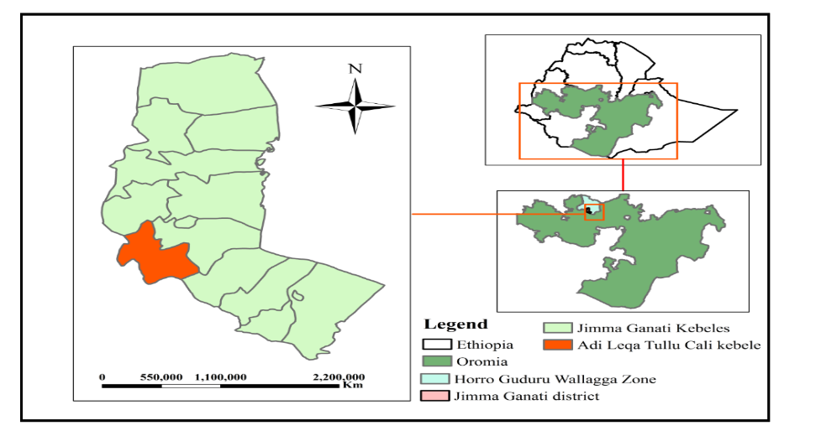
Fig. Location Map of the study area
Soil Sampling and Analysis
For deciding representative experimental locations, six sites/farmers/ fields were selected depending on its accessibility for providing good management system and composite soil samples were collected from the district and optimum nitrogen rate that the crop requires were recommended in the first year (2011) in the case of wheat production. In second and third year (2012–2013) randomly twenty sites were selected for determination of phosphorus critical (Pc) and requirement factors. Composite soil samples were collected from all sites by using Auger from the depth of (0-20cm) air dried, grounded and passed through 2mm sieve and analyzed at Bako Agricultural Research Soil laboratory keeping its standards/procedures.
Treatments, experimental design and procedures
In the case of the first year, the experiment was consisted of six levels of P (0, 10, 20, 30, 40, 50 kg/ha) and five levels of Nitrogen (0, 46, 69, 92 and 138kg/ha) fertilizers were combined as treatments. The treatments were arranged in factorial combination with RCBD replicated three times over six farmers. In second and third years for determination of Pc and Pf treatments consists of six levels of P (0, 10, 20, 30, 40, 50 kg/ha) and 69 kg/ha N were arranged in single factor in RCBD with three replications.
Soil Analysis
Determination of Critical P Concentration
Critical phosphorus concentration is below which there is a response while above phosphorus was not respond. After sowing of 21days soil samples were collected from each plot. At this moment the applied phosphorus during sowing is assumed to be ready to be utilized by the crop. Pc was determined by Cate-Nelson graphical methods where by putting phosphorus soil values on the X-axis (yield x100/maximum yield). Cate-Nelson graphical methods is based on driving the Y-X scatter diagram in to four quadrants and increasing the points in the positive quadrants and reducing the number of points in the negative quadrants.
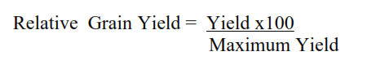
Determination of Phosphorous Requirement Factor
Phosphorus requirement factor (Pf) is the amount of phosphorus in kilogram needed to raise the soil phosphorus by 1ppm. Mean of Olsen P-ppm after 21 days of each applied P-treatment and phosphorus increase over the control were calculated. Eventually, Pf was determined by the following formula.

Statistical Analysis
All the collected yield and soil data from all locations were subjected to analysis of variance (ANOVA) by using Gen stat 18 ^{th} edition software and mean separation was done by using LSD test.
Economic Analysis
To identify economic feasibility of treatments, partial budget analysis was implemented and calculated the marginal rate of return (MRR) (SIMMIT, 1988). Note only MRR was considered but also proper interaction effects of treatments were selected according to its highest net benefit obtained.
Results and Discussion
Soil Reaction (Ph) and Available Phosphorus
The pH (H2O) values of the soil samples collected before sowing were ranged from 4.78-5.48 (Table1) consequently the soils of the study site lies in general from very strongly acidic to strongly acidic soil reaction (Source: Murphy (1968).
Table: 1.Soil pH and initial available phosphorus status in soils before planting in Jimma Geneti District (2012-2013)
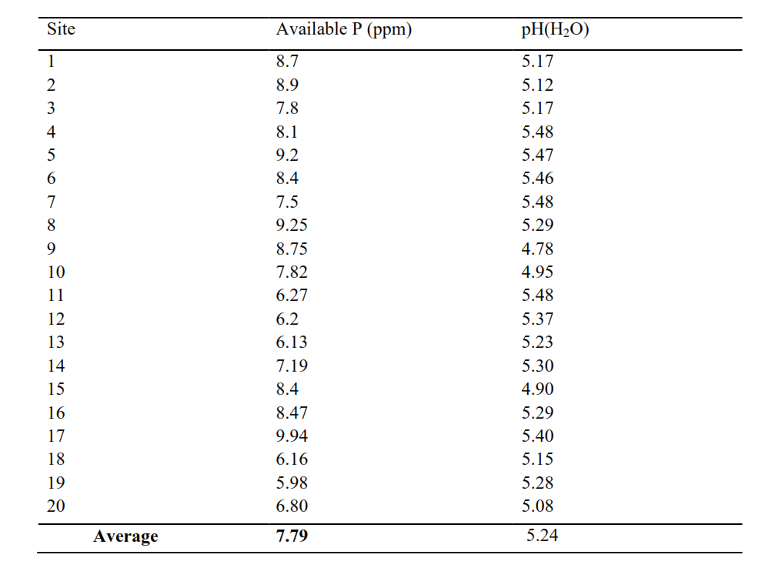
Nitrogen Fertilizer Determination
The interaction effect of phosphorus and nitrogen fertilizer rate was highly significant at (P<0.05) on bread wheat mean grain yield. The highest mean grain yield (4.27 t/ha) was obtained from the interaction of 138 kg/ha N and 40 kg/ha P, whereas the lowest mean grain yield (1.77 t/ha and 1.87 t/ha) were obtained from the interaction of 0 kg/ha N with 20 kg/ha Phosphorous (Table: 2.) but economically feasible rate was 92 kg/ha N interaction with 50 kg/ha P.
Table: 2. Interaction effect of nitrogen and phosphorous (P2O5) fertilizers on bread wheat mean grain yield (t/ha)
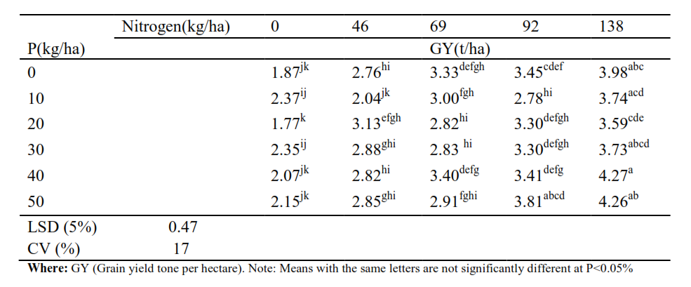
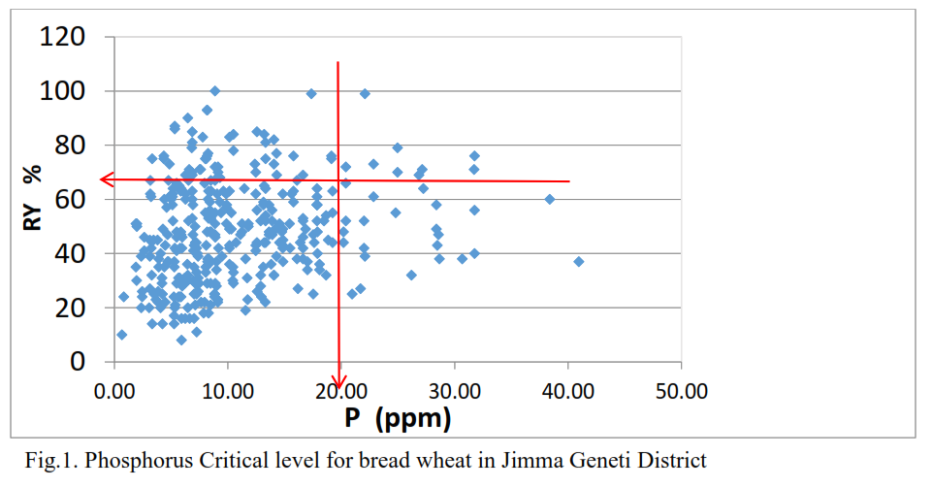
Table: 3. Phosphorus requirement factor for bread wheat
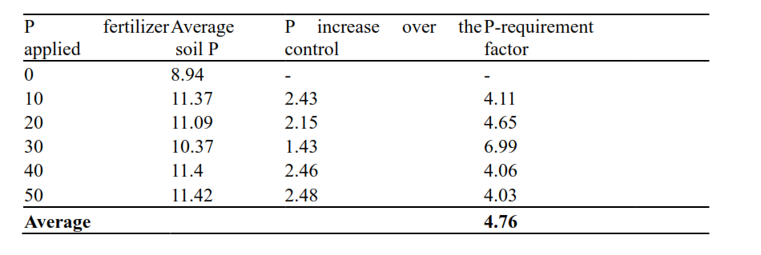
Economic Analysis
Partial budget analysis revealed that 92 kg/ha of N was economically feasible. The highest MRR (1419) and net benefit of (47485) obtained in response to the interaction of 50 kgha-1P with 92 kgha-1 Nitrogen.

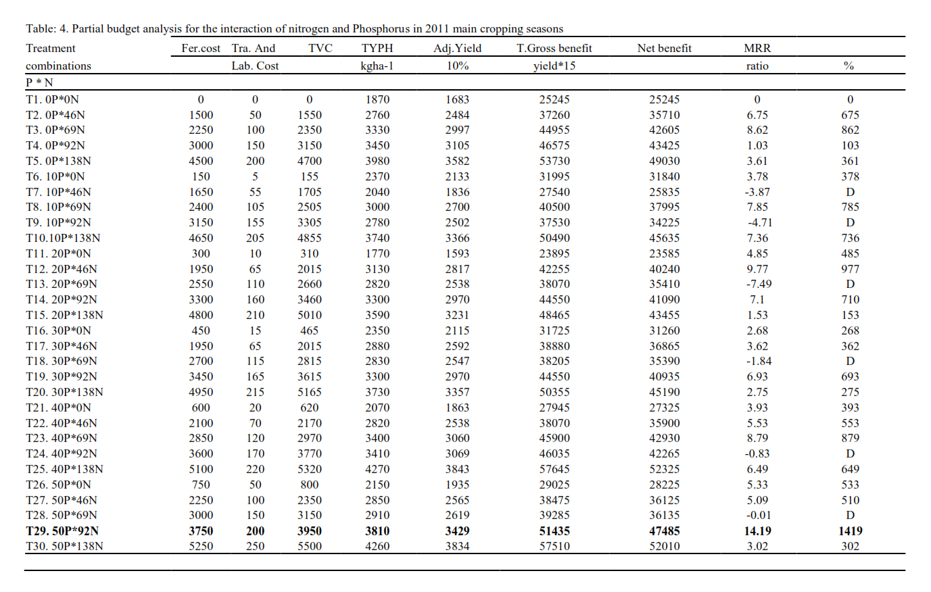
CONCLUSION
Soil test based crop response phosphorous calibration study was conducted at Jimma Geneti District for three years (2011-2013) for determination of optimum nitrogen, P-Critical (Pc) and Prequirement factor (Pf). The soil reaction collected and analyzed before sowing from the district is in general ranged from very strongly acidic to strongly acidic soil pH and low phosphorous availability in the soil which indicated that phosphorous fixation existed i.e. not exist in available forms were plants freely requires the element. Consequently, the experiment was conducted under limed conditions for reclamation of soil acidity of the district. In the first year, optimum nitrogen rate (138kg/ha) was determined for the highest yield obtained but its economic feasibility was not in acceptable range. So, 92 kg/ha nitrogen interaction with 50 kg/ha P was relatively more accepted by considering its highest net benefit and MRR.
RECOMMENDATIONS
Calibration study was conducted in the second and third year, P-Critical (20ppm) and P requirement factor (4.76) was also recommended. Eventually, the farmers/end users/ are advised to use this Pc (phosphorus critical) and Pf (Phosphorus requirement factor) values for phosphorous applications to produce the crop than utilization of blanket recommendations. So, verification and demonstration of phosphorous critical (Pc) and phosphorous requirement factor (Pf) results obtained from the district will be pre-requisite activities before undergoing pre-scaling up of the technology over wider areas to confirm the result.
Acknowledgements
The Author would like to acknowledge Oromia Agricultural Research Institute for financial support and Bako Agricultural Research Center for provision of logistics. Eventually, my great heartfelt thanks go for all devoted researchers, Technical Assistances, Field workers and laboratory technicians of soil fertility improvement research team for their unreserved contribution in all situations.
References
Assefa M, Johnson MRS, Nyambilila A, Tekalign M (2015a). Wheat Response to Applied Nitrogen, Sulfur and Phosphorous in three Representative Areas of the Central Highlands of Ethiopia. International Journal of Plant and Soil science 8(5):1-11.
Ethiopian Soil Information System (EthioSIS) (2013).Soil analysis report. Agricultural Transformation Agency (Unpublished).
Food and Agriculture Organization of the United Nations (2014). FAOSTAT (Online).Available at: http://www.fao.org/faostat.
Hailu GM (1991). Wheat productions and research in Ethiopia. IAR, Addis Ababa. Available at: http://agris.fao.org/agris-search/search.do?recordID=ET9200001
Hailu H, Tekalign M, Riikka K, Erik K, Heluf G, Taye B (2015). Soil fertility status and wheat nutrient content in Vertisol cropping systems of central highlands of Ethiopia.
Agriculture and Food Security4 (19):1-10. International Fertilizer Development Center (IFDC) (2015). Assessment of Fertilizer consumption and use by Crop in Ethiopia. Available at:http://www.africafertilizer.org/wp-content/uploads/2017/05/FUBC-Ethiopia- FinalReport-2016.pdf
Ministry of Agriculture (MoA) (2012). Ministry of Agriculture, Animal and Plant Health Regulatory Directorate. Crop variety register, Issue No.15. Addis Ababa,Ethiopia.
Shewry PR (2009). The Health grain programme opens new opportunities for improving wheat for nutrition and health. Nutrition Bulletin 34(2):225-231.

