ECOTOURISM POTENTIAL AND ITS ROLE IN SUSTAINABLE DEVELOPMENT AND LIVELIHOOD IN TODGARH RAOLI WILDLIFE SANCTUARY, DISTRICT BEAWAR, RAJASTHAN

Abstract
This paper examines the ecotourism potential of the Todgarh Raoli Wildlife Sanctuary, newly situated under the administrative jurisdiction of the Beawar District (formerly spanning Ajmer, Pali, and Rajsamand) in Rajasthan, India. Spanning 495 km² across the central Aravalli hill ranges, the sanctuary serves as a unique ecological ecotone between the hilly forest ecosystems and the semi-arid Thar desert fringes. This study explores how integrating community-based ecotourism can serve as a catalyst for local livelihood generation, reduce human-wildlife conflict, and promote the long-term sustainable development of the 217 villages within its core and eco-sensitive zones.
Keywords: Ecotourism, Sustainable Development, Livelihood, Todgarh Raoli, Beawar, Aravalli Ecosystem.
1. Introduction
Sustainable rural development in ecologically fragile regions requires an approach that aligns biodiversity conservation with local economic upliftment. In Rajasthan, conventional mass tourism heavily favors historical forts, palaces, and desert safaris, leaving pristine wilderness areas like the Todgarh Raoli Wildlife Sanctuary relatively unmapped by mainstream tourism. Established in 1983, this sanctuary features tropical dry deciduous forests, rugged rocky outcrops, and unique historical landmarks.
With the recent administrative restructuring creating Beawar District, localized governance presents a golden opportunity to develop a structured, community-led ecotourism framework. This paper evaluates the site's environmental and cultural assets, details its socioeconomic potential for local communities, and frames a strategic model for sustainable resource management.
2. Study Area
The Todgarh Raoli Wildlife Sanctuary is geographically anchored around the historic village of Todgarh in the central Aravalli range.
- Geographic Coordinates: 25°00' to 25°40' North latitude and 73°02' to 73°30' East longitude as shown in Figure # 01.
- Topography: High undulating terrain, deep valleys, and rocky cliffs ranging from 300 to 1,000 meters above sea level.
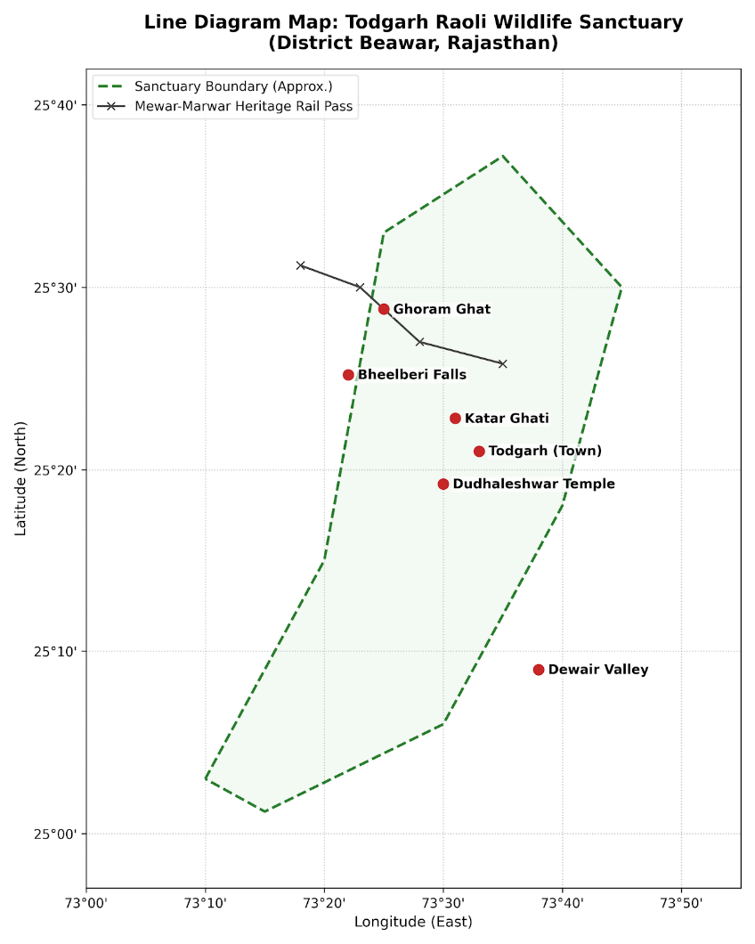
Figure # 01 Geographical Location of The Todgarh Raoli Wildlife Sanctuary District Beawar, Rajasthan
- Climate: Semi-arid, with temperatures peaking at 46°C in summer and dropping to 7°C during winter.
- Flora: Predominantly tropical dry deciduous forests dominated by Dhok (Anogeissus pendula), Salai (Boswellia serrata), Palash (Butea monosperma), and dry scrublands.
- Fauna: Keystone predators and mammals include the Indian Leopard (Panthera pardus), Sloth Bear (Melursus ursinus), Striped Hyena, Indian Wolf, Chinkara (Gazella gazella), and over 140 avian species.
3. Assessing Ecotourism Potential
The sanctuary possesses a diverse mix of natural, historical, and religious points of interest that make it an excellent candidate for low-impact ecotourism:
Destination / Asset | Ecological & Cultural Significance | Potential Ecotourism Activity
Bheelberi Falls | A 55-meter-high seasonal waterfall inside the Bhagora forest block; home to nesting long-billed vultures and massive cliff beehives. | Nature trails, birdwatching, and vulture-conservation education.
Dudhaleshwar Temple | An ancient Shiva temple surrounded by dense patches of Karanj and Banyan trees, featuring a perennial natural spring. | Cultural tourism, sacred grove trekking, and night-time wildlife spotting.
Dewair Valley | The historic site of the 1582 Battle of Dewair, termed the "Marathon of Mewar" by Colonel James Tod where Maharana Pratap defeated Mughal forces. | Historical treks, heritage walks, and battle-site tourism.
Ghoram Ghat | A spectacular mountain railway pass running between Kamlighat and Fulad, winding through old tunnels and deep gorges. | Heritage rail tourism and monsoon landscape photography.
Katar Ghati | A 4 km serpentine road constructed by British engineers demonstrating remarkable masonry layout. | Guided cycling and historical engineering walks.
4. Role in Local Livelihoods and Sustainable Development
The sanctuary encompasses 217 villages within its core and 1 km Eco-Sensitive Zone (ESZ). The local populace relies primarily on rain-fed subsistence agriculture, livestock grazing, and the collection of Non-Timber Forest Products (NTFPs). This heavy dependence often leads to overgrazing, forest degradation, and human-wildlife friction.
Ecotourism acts as an intervention tool to redirect economic activities away from forest depletion:
[Ecotourism Infrastructure Setup]
│
▼
[Alternative Livelihood Generation] ──► (Guides, Homestays, Handicrafts)
│
▼
[Reduced Pressure on Core Forest] ──► (Less Overgrazing & Fuelwood Cutting)
│
▼
[Enhanced Wildlife Habitat Security] ──► (Long-term Ecosystem Stability)

Direct Livelihood Channels:
- Community Homestays: Transforming traditional rural Rajasthani homes into eco-lodges, allowing tourists to experience indigenous culture, local cuisine, and folk arts directly benefiting households.
- Eco-Guides and Trackers: Training local youth as certified nature guides, wildlife spotters, and historians for trekking routes like Bheelberi and Dewair.
- Artisanal and Handicraft Markets: Creating micro-enterprises centered around local products, such as traditional weaving, organic honey collection, and ethnic Aravalli artwork.
5. Challenges to Ecotourism Development
Despite its clear advantages, several bottlenecks hinder sustainable growth in the Beawar district sector of the sanctuary:
- Unregulated Infrastructure: Vulnerability to over-commercialization or unchecked tourist flow around spots like Dudhaleshwar during peak monsoon seasons.
- Ecological Fragility: The central Aravallis suffer from acute soil erosion and water scarcity; excessive foot traffic can disrupt critical leopard and vulture breeding zones.
- Skill Deficit: Local communities often lack formal hospitality, language, and management skills required to interface effectively with domestic and international travelers.
6. Strategic Recommendations
To unlock Todgarh Raoli's potential responsibly, the following procedural roadmap should be implemented by the Beawar District administration and the Rajasthan Forest Department:
1.Carry Capacity Assessment:
Conduct rigorous ecological studies to determine the maximum number of daily visitors permitted at sensitive spots like Bheelberi Falls and Dudhaleshwar to avoid habitat degradation.
2.Zoning and Eco-Sensitive Master Planning:
Implement strict demarcation of Core, Buffer, and Eco-Sensitive Zones in line with the 2017 MoEFCC notification, ensuring commercial hospitality stays confined strictly outside the 1 km boundary.
3.Joint Forest Management & Capacity Building:
Form Village Eco-Development Committees (EDCs) to manage community funds. Launch hospitality, wilderness first-aid, and language training workshops for local youth.
4.Low-Impact Infrastructure Installation:
Construct eco-friendly watchtowers, solar-powered waste management units, and clearly demarcated dirt trails instead of laying down disruptive concrete pathways.
Guidelines should be implemented of Department of Environment, Government of Rajasthan for regulating infrastructure expansion, promoting organic farming, and developing eco-compatible tourist activities without fracturing the delicate Aravalli ecosystem.
Meet out the Challenges for State Eco-Tourism Directives: Establishes the policy architecture for community-based tourism, adventure trails, and equitable revenue-sharing setups between state forest departments and local populations.
7. Conclusion
The Todgarh Raoli Wildlife Sanctuary in Beawar District possesses vast, untapped potential to become a model site for community-driven ecotourism in Rajasthan. By shifting the economic focus from resource exploitation to experiential conservation tourism, the region can achieve a harmonious balance. The revenue generated from guided treks, heritage rail journeys, and authentic homestays offers a sustainable financial lifeline to local communities. Ultimately, protecting this unique slice of the Aravalli ecosystem ensures long-term environmental protection while celebrating the region's rich historical and natural heritage.
8. References
- Brodnig, G., 2006. Biodiversity Conservation and the Millennium Development Goals: Toward Sustainable Development. Regional Development Dialogue, 27(1):1-7.
- Chhangani, A. K. (2014). "Diversity and status of avifauna in Todgarh-Raoli Wildlife Sanctuary, Rajasthan, India." Journal of Asia-Pacific Biodiversity, 7(4), pp. e401–e409.
- Department of Environment and Climate Change, Government of Rajasthan. (2026). Zonal Master Plan of Eco-Sensitive Zone of Todgarh-Raoli Wildlife Sanctuary.
- Department of Environment, Government of Rajasthan. (2017). Notification for Eco-Sensitive Zone (ESZ) of Todgarh-Raoli Wildlife Sanctuary. Ministry of Environment, Forest and Climate Change (MoEFCC), Gazette of India.
- Department of Forest, Government of Rajasthan. (2021). Rajasthan Eco-Tourism Policy, 2021.
- Kanther, R. P., & Gena, C. B. (2014). "Traditional Wound Healing Plants of Todgarh Raoli Wildlife Sanctuary." International Journal of Innovative Research in Science, Engineering and Technology, 3(12).
- Koli, Vijay. (2014). Diversity and status of avifauna in Todgarh-Raoli Wildlife Sanctuary, Rajasthan, India. Journal of Asia-Pacific Biodiversity. 7. 401-407. 10.1016/j.japb.2014.10.005. PY - 2014/11/23
- Purohit, C. S. (2024). "Additions to the avifauna of Todgarh-Raoli Wildlife Sanctuary, Rajasthan." Species, 25(75), e19s1657.
- Sharma, S. (2018). People participation and eco tourism in Todgarh Raoli Wildlife Sanctuary. International Journal of Creative Research Thoughts, 6(1), 832-838.
- Sharma, S., & Tomar, A. (2018). "People participation and eco tourism in Todgarh Raoli Wildlife Sanctuary." International Journal of Creative Research Thoughts (IJCRT), 6(1), pp. 832–838.
- Sutherland, William J., Ian Newton, and Rhys Green. Bird ecology and conservation: a handbook of techniques. No. 1. Oxford university press, 2004.
- Torres, R. and Momsen, J.H. 2004. Challenges and potentials for liking tourism and agriculture to achieve pro-poor tourism objectives. Progress in Development Studies.

ADDRESS OF CORRESPONDING AUTHOR:
Dr. NISHA SIROYA
Associate Professor, Department of Zoology,
S.D. GOVERNMENT COLLEGE BEAWAR (RAJASTHAN)

E MAIL: dr.ashoksiroya@yahoo.com
nishasiroya@ymail.com

