ENHANCING WAYFINDING AND FIRE EGRESS SYSTEMS IN ENTERTAINMENT

ABSTRACT
Entertainment centres are increasingly common features of contemporary urban life, bringing together leisure, retail, dining, and cultural functions within single, high-occupancy facilities. Because these spaces host large and diverse crowds with varying degrees of familiarity, effective wayfinding and fire egress design are essential to both user experience and life safety. This study investigates how these two systems can be architecturally integrated, drawing on a qualitative comparative case study approach that examines one Nigerian facility, Twinwaters Entertainment Centre in Lagos, alongside three internationally recognised precedents: Ferrari World Abu Dhabi, Entertainment City Manila, and Shanghai Disneyland. Evidence was gathered through architectural documentation, observational assessment, and a review of relevant regulatory and design literature. The findings show that facilities characterised by clear spatial hierarchy, strong visual connectivity, and well-integrated circulation networks achieve superior navigation efficiency and evacuation performance. However, the analysis also reveals that the international cases accomplish this integration largely through resource-intensive mechanisms, such as performance-based fire engineering, digital wayfinding infrastructure, and dedicated environmental graphic design, that assume levels of capital investment and regulatory enforcement not consistently available within the Nigerian development context. Twinwaters, by contrast, relies heavily on signage and staff-guided navigation, exposing a wider gap between local practice and global standards. To address this gap, the study proposes a Low-Cost Architectural Integration (LCAI) strategy: an approach that achieves spatial legibility and egress alignment through layout, massing, and material decisions made at the design stage, rather than through added technology or signage. Adopting this strategy is anticipated to reduce dependence on signage and staff intervention, align everyday circulation with emergency egress routes, and improve user orientation and evacuation readiness at minimal additional capital cost, particularly within resource-constrained, emerging urban contexts.
Key Words: Wayfinding, Fire Egress, Entertainment Centres, Spatial Legibility, Low-Cost Architectural Integration (LCAI)

INTRODUCTION
Entertainment centres have become dominant features within contemporary cities, serving as multifunctional spaces that combine leisure, retail, dining, and cultural activities. These facilities often host large and diverse crowds with varying familiarity levels, making effective wayfinding and fire egress essential to life safety and user comfort. In developing contexts such as Nigeria, the rapid emergence of entertainment centres has sometimes exceeded the consistent application of integrated navigation and evacuation strategies, resulting in spatial confusion and potential safety risks (Dickson, 2019).
Wayfinding and fire egress are interdependent architectural systems. While wayfinding facilitates orientation and movement during everyday use, fire egress supports rapid and intuitive evacuation under emergency conditions. When poorly coordinated, these systems may conflict; however, when architecturally integrated, they significantly improve spatial clarity, evacuation efficiency, and overall user safety (NFPA, 2024). Existing literature strongly supports this principle of integration (Umo, 2019; Hölscher et al., 2018; Ronchi & Nilsson, 2020; Kuligowski, 2021), yet the strategies through which integration is typically achieved, digital wayfinding systems, performance-based fire engineering, and dedicated environmental graphic design, are largely resource-intensive and assume levels of capital investment and regulatory enforcement that are not consistently available within developing contexts such as Nigeria. This study examines architectural strategies that integrate wayfinding and fire egress in entertainment centres, drawing evidence from a Nigerian case study, Twinwaters Entertainment Centre, Lagos, and international precedents including Ferrari World Abu Dhabi, Entertainment City Manila, and Shanghai Disneyland, with the specific aim of identifying which integration mechanisms are transferable to the Nigerian context and which are not.
Building on this comparative evidence, the study proposes a Low-Cost Architectural Integration (LCAI) strategy: an approach to achieving wayfinding-egress integration through design-stage layout, circulation, and material decisions, rather than through the costly digital and performance-engineering systems observed internationally. This represents the study's principal contribution to knowledge, extending existing literature beyond the general argument that integration is beneficial toward a specific, practically implementable means of achieving it within resource-constrained settings.

Aim
To examine how wayfinding and fire egress systems can be integrated within the architectural design of entertainment centres to enhance user navigation and safety, and to propose a low-cost, architecturally embedded integration strategy suited to the Nigerian context.

Research Objectives
- To compare wayfinding and fire egress practices in Nigerian and international entertainment centres, to identify design gaps and transferable strategies affecting safety and user experience
- To propose a low-cost, architecturally embedded integration strategy, derived from the comparative findings, that is feasible within the resource and regulatory constraints typical of Nigerian entertainment centre development

Research Questions
- What are the differences between Nigerian and international practices in integrating wayfinding and fire egress, and what design gaps do these differences reveal?
- What low-cost, architecturally embedded strategies could achieve comparable integration benefits within the Nigerian context, and what outcomes might their adoption be expected to produce?

Problem Statement
Entertainment centers in Nigeria are increasingly complex, high-occupancy environments that require efficient systems for both navigation and emergency evacuation. However, many of these facilities rely heavily on signage and basic fire safety provisions, with limited integration of wayfinding and fire egress into the architectural design.

As a result, users often experience spatial confusion, poor orientation, and difficulty identifying exit routes, particularly during peak periods or emergency situations. Inadequate circulation planning, weak spatial hierarchy, and poorly distributed exits further increase the risk of congestion and delayed evacuation.

Although building codes in Nigeria provide guidelines for fire safety, there is often a gap between regulatory requirements and actual design implementation. In contrast, international entertainment centres demonstrate more integrated approaches, where architectural form, spatial organization, and visual cues support both everyday navigation and emergency movement. However, as this study's comparative analysis will show, these international approaches typically depend on levels of capital investment, technological infrastructure, and regulatory enforcement that are not readily available in the Nigerian development context. Consequently, simply recommending that Nigerian entertainment centres adopt international best practice, without addressing this resource gap, offers limited practical guidance.

This study therefore seeks to examine these gaps, identify architectural strategies that can improve wayfinding and fire egress systems in Nigerian entertainment centres, and, on that basis, propose a low-cost architectural integration strategy that offers a practically achievable path toward the safety and legibility outcomes observed internationally.

LITERATURE REVIEW

Entertainment Centres as High-Occupancy Public Buildings
Entertainment centres are complex public facilities designed to accommodate diverse leisure, commercial, and social activities within a unified architectural environment. Their functions commonly include cinemas, gaming facilities, restaurants, event spaces, retail outlets, and recreational attractions. Because these facilities attract large numbers of visitors simultaneously, they are generally classified as assembly occupancies and require careful attention to circulation planning, crowd management, and life-safety provisions (Ching, 2014; NFPA, 2024).
The concentration of multiple activities within a single facility often increases spatial complexity and user movement demands. As occupancy levels rise during weekends, holidays, and special events, challenges associated with congestion, orientation, and emergency evacuation become more pronounced. Consequently, architectural design must balance operational efficiency with occupant safety and comfort (Umo, 2019; Hölscher et al., 2018).

Wayfinding and User Navigation in the Built Environment
Wayfinding refers to the process through which individuals understand their location, determine destinations, and select routes within an environment. Successful navigation depends on both environmental characteristics and human cognitive abilities. Architectural features such as visual accessibility, spatial organization, circulation hierarchy, landmarks, and environmental cues assist users in developing mental representations of spaces and making movement decisions (Ibrahim et al., 2022; Jamshidi et al., 2020).
In large public facilities, users often encounter unfamiliar environments that require rapid interpretation. Buildings that provide clear visual information and logical spatial arrangements tend to reduce confusion and improve user confidence. Conversely, environments characterized by complex layouts and poor visibility can contribute to disorientation and inefficient movement patterns (Hölscher et al., 2018; Ibrahim et al., 2022).
Umo (2019) and Hölscher et al. (2018) argue that effective wayfinding extends beyond signage and should be integrated into the architectural form itself. Environmental cues embedded within the building's design often provide stronger navigational support than graphic information alone. This position is significant for the present study, since it implies that legibility can, in principle, be achieved through design decisions rather than through added signage systems.
Fire Egress and Life-Safety Considerations
Fire egress constitutes one of the most critical aspects of building safety. It involves the provision of continuous and unobstructed routes that allow occupants to move from any point within a building to a place of safety during emergencies. Effective egress design incorporates adequate exit capacity, travel distances, emergency lighting, signage, smoke control measures, and accessible evacuation routes (NFPA, 2024).
The National Building Code of Nigeria similarly emphasizes the provision of adequate means of escape and fire protection systems in public buildings (Federal Republic of Nigeria, 2023). However, studies have identified challenges associated with the implementation and enforcement of these requirements in many developing countries, resulting in deficiencies that may compromise occupant safety during emergencies (Obi, 2015).
Contemporary fire-safety research further emphasizes that compliance with regulations alone does not guarantee effective evacuation. The spatial relationship between exits, circulation routes, and occupant behaviour significantly influences evacuation outcomes (Kuligowski, Peacock, & Hoskins, 2010).
Human Behaviour During Emergency Evacuation
Occupant behaviour during emergencies differs considerably from movement under normal conditions. Studies indicate that individuals often experience stress, uncertainty, and reduced decision-making efficiency during fire incidents. Rather than immediately following emergency signage, occupants frequently attempt to retrace familiar routes or move toward visible exits and recognizable spaces (Proulx, 2001).
Environmental psychology research suggests that familiarity, visibility, and perceived safety strongly influence evacuation behaviour. When users cannot easily interpret their surroundings, delays in decision-making may occur, potentially increasing evacuation times and exposure to danger (Devlin & McKay, 2018).
Neuroscience-based studies further indicate that environments with strong visual connections and clear spatial organization support faster decision-making and reduce anxiety during emergencies (Jeffery, 2019). Taken together, this body of work suggests that the built environment itself, independent of signage or technology, is a primary determinant of evacuation performance, a principle central to the strategy this study later proposes.
Integrating Wayfinding and Fire Egress in Architectural Design
Recent architectural approaches increasingly recognize that wayfinding and fire egress should not be treated as separate design considerations. Instead, both systems should be integrated within the overall spatial structure of a building. When primary circulation routes correspond with emergency escape paths, occupants are more likely to identify exits quickly and evacuate efficiently (Umo, 2019; Hölscher et al., 2018).
Integration can be achieved through spatial hierarchy, visual connectivity, zoning strategies, landmark placement, lighting design, and coordinated environmental graphics. Such approaches reduce dependence on signage alone and create environments that support both everyday navigation and emergency evacuation (Umo, 2019).
Buildings that successfully integrate navigation and evacuation principles demonstrate improved spatial legibility, reduced cognitive load, and enhanced life-safety performance (Kuligowski et al., 2010). What this literature does not address, however, is the resource intensity of the integration mechanisms it describes; landmark placement, digital and coordinated graphics, and performance-based design are generally discussed as design goals rather than as strategies differentiated by cost, technical capacity, or regulatory context.
Core Components of Wayfinding and Fire Egress Systems
The effectiveness of wayfinding and fire egress systems in entertainment centres depends on several architectural and environmental factors that influence user movement, orientation, and emergency evacuation. These components collectively determine how efficiently occupants navigate spaces under normal conditions and respond during emergencies (Ronchi & Nilsson, 2020).
- Spatial Hierarchy
Spatial hierarchy refers to the organization of spaces according to their functional importance and accessibility. Clear differentiation between primary and secondary circulation routes enables users to understand movement patterns within a building and identify key destinations. In emergency situations, a well-defined spatial hierarchy assists occupants in recognizing evacuation routes and locating exits more efficiently (Ibrahim et al., 2022).
- Visual Connectivity
Visual connectivity describes the degree to which occupants can perceive destinations, circulation routes, and exit points from different locations within a building. Open layouts, atria, transparent partitions, and unobstructed sightlines improve orientation and reduce confusion. Strong visual connections have been shown to enhance wayfinding performance and facilitate quicker evacuation decisions during emergencies (Hölscher et al., 2018).
- Circulation Configuration
Circulation configuration refers to the arrangement of horizontal and vertical movement systems, including corridors, staircases, escalators, ramps, and elevators. Effective circulation networks promote intuitive movement and reduce congestion. In entertainment centres with high occupant densities, circulation design directly influences evacuation efficiency and overall safety performance (Shi, Ren, & Chen, 2019).
- Environmental and Architectural Cues
Environmental cues include architectural landmarks, lighting variations, colour differentiation, material changes, and spatial markers that assist users in understanding their location within a building. These cues support cognitive mapping and improve spatial awareness, particularly in unfamiliar environments. During emergencies, recognizable architectural features can guide occupants toward safe exits and assembly areas (Jamshidi et al., 2020). Notably, these cues, unlike digital wayfinding systems or performance-based fire engineering, can generally be produced through ordinary construction materials and finishes, making them a relevant starting point for a resource-conscious integration strategy.
- Exit Accessibility and Visibility
The visibility and accessibility of exits are fundamental components of fire egress design. Occupants are more likely to use exits that are visible, easily identifiable, and connected to familiar circulation routes. Poorly located or concealed exits may increase evacuation time and contribute to confusion during emergencies. Consequently, architectural design should prioritize clear visual access to exits from major occupied spaces (NFPA, 2024).
- Emergency Information Systems
Emergency information systems include exit signage, directional indicators, emergency lighting, public address systems, and digital guidance technologies. While architectural design should facilitate intuitive movement, supplementary information systems remain important for supporting evacuation during fire incidents and other emergencies. Their effectiveness depends on visibility, reliability, and integration with the overall spatial layout (Ronchi & Nilsson, 2020).
- Occupant Behaviour and Familiarity
Human behaviour significantly influences both wayfinding and evacuation performance. Occupants often rely on familiar routes and previously acquired spatial knowledge when making movement decisions. Buildings that support intuitive navigation during normal operation tend to facilitate more effective evacuation during emergencies because users already possess an understanding of the spatial environment (Kuligowski, 2021).
The interaction among these components determines the overall effectiveness of wayfinding and fire egress systems. Their integration within architectural design contributes to improved safety, enhanced user experience, and greater operational efficiency in entertainment centres.
Theoretical Framework
This study is anchored in an architectural understanding of how spatial organization, user perception, and movement behaviour interact within complex-built environments. The theoretical framework integrates Spatial Cognition Theory and Human Behaviour in Fire Theory, interpreted through the lens of architectural design and spatial configuration. Recent research emphasizes that the effectiveness of movement systems in complex buildings is strongly influenced by the arrangement of spatial form, visibility, and circulation networks (Hölscher et al., 2018; Ibrahim et al., 2022).
- Spatial Cognition and Architectural Legibility
Spatial Cognition Theory explains how individuals perceive, interpret, and navigate built environments through the development of cognitive maps. In architectural contexts, this process is shaped by spatial configuration, circulation hierarchy, and visual connectivity. Studies show that users rely heavily on architectural cues such as openness, axial alignment, and spatial hierarchy to interpret space and make navigation decisions (Jamshidi et al., 2020; Hölscher et al., 2018).
In entertainment centres, where spatial complexity is often high, architectural legibility becomes critical. Legibility is achieved through the organization of spaces into recognizable patterns, supported by visual connections and identifiable landmarks. Environments with clear spatial hierarchy and strong visibility have been shown to significantly improve wayfinding performance and reduce cognitive load (Ibrahim et al., 2022).
From an architectural perspective, spatial cognition is not only a psychological process but a design outcome, shaped by decisions related to layout, volumetric relationships, and the articulation of circulation systems. Buildings that incorporate open sightlines, central nodes, and continuous circulation paths allow users to construct accurate mental representations, thereby enhancing navigation efficiency and spatial understanding (Hölscher et al., 2018; Li & Klippel, 2021).
- Human Behaviour in Fire and Spatial Performance of Egress Systems
Human Behaviour in Fire Theory examines how occupants perceive risks and respond to emergency situations. Research indicates that during fire incidents, occupants tend to rely on familiar spatial routes and visually dominant pathways rather than abstract signage (Kuligowski, 2021; Ronchi & Nilsson, 2020).
Within architectural design, this behavioural tendency highlights the importance of embedding fire egress systems within primary circulation networks. When escape routes correspond with everyday movement paths, such as major corridors and circulation spines, occupants are more likely to identify and use them effectively under stress (Shi, Ren, & Chen, 2019).
The spatial performance of egress systems is influenced by several architectural factors, including spatial continuity, exit visibility, circulation width, and the degree of openness or enclosure. Studies show that environments with clear visual access, distributed exits, and well-defined circulation routes significantly improve evacuation efficiency, while poorly organized layouts increase disorientation and evacuation time (Ronchi & Nilsson, 2020).
Consequently, fire egress should not be treated solely as a regulatory requirement but as a fundamental component of architectural design that shapes user movement and safety outcomes.
- Integration of Wayfinding and Fire Egress in Architectural Design
Recent architectural research emphasizes the need to integrate wayfinding and fire egress systems within a unified spatial framework. Rather than treating navigation and safety as separate elements, contemporary design approaches advocate for a holistic organization of circulation, perception, and evacuation systems (Ibrahim et al., 2022; Jamshidi et al., 2020).
This integration is achieved through architectural strategies such as spatial hierarchy, zoning, landmark placement, and visual connectivity. When these elements are cohesively organized, they create a legible and continuous spatial system where every day navigation reinforces emergency evacuation behaviour.
Empirical studies show that buildings designed with integrated movement systems demonstrate improved wayfinding efficiency, reduced congestion, and faster evacuation times (Ronchi & Nilsson, 2020; Kuligowski, 2021). The framework therefore positions architecture as an active agent in shaping human behaviour, where spatial configuration directly influences both navigation and emergency response.
By embedding wayfinding and fire egress within the architectural design of entertainment centres, this approach moves beyond compliance-based solutions toward environments that are intelligible, user-centred, and inherently safe. However, the framework as presented in existing literature is largely context-agnostic: it does not distinguish between integration achieved through high-cost, technologically advanced means and integration achieved through design decisions alone, a distinction that becomes central once the framework is applied to a resource-constrained setting such as Nigeria.
2.8 Research Gap
Recent studies have examined wayfinding performance, spatial cognition, and fire evacuation behaviour in various public buildings. However, much of the existing literature addresses these topics independently, focusing either on navigation efficiency or emergency evacuation performance. Limited attention has been given to the interaction between wayfinding systems and fire egress design within entertainment centres, particularly in developing countries where rapid urbanization and increasing visitor densities present unique safety challenges.
A further, more specific gap concerns the resource dimension of integration itself. Where the literature does address integrated wayfinding-egress design (Umo, 2019; Hölscher et al., 2018; Ronchi & Nilsson, 2020; Kuligowski, 2021), the strategies discussed, digital wayfinding systems, performance-based fire engineering, and dedicated environmental graphic design, are generally presented as universally applicable design goals, without regard to the cost, technical capacity, or regulatory enforcement conditions required to implement them. This is a significant omission for developing contexts such as Nigeria, where construction budgets are constrained and regulatory enforcement of fire safety requirements has been shown to be inconsistent (Dickson, 2019; Obi, 2015). No study identified in this review proposes an integration strategy explicitly designed to achieve the benefits of wayfinding-egress integration through low-cost, architecturally embedded means suited to such constraints.
Furthermore, there is a scarcity of empirical studies examining how architectural design can simultaneously support routine navigation and emergency evacuation in Nigerian entertainment facilities. This gap highlights the need for research that integrates spatial orientation, circulation planning, and life-safety considerations within a unified architectural framework, while also translating that framework into a strategy that is practically implementable given local constraints. The present study seeks to address this deficiency through a comparative assessment of selected Nigerian and international entertainment centres, from which it derives and proposes a Low-Cost Architectural Integration (LCAI) strategy as its contribution to this gap.Want to be notified when Clau

RESEARCH METHODOLOGY
This study adopted a qualitative comparative case study approach to examine the integration of wayfinding and fire egress strategies in urban entertainment centres, and to develop a context-responsive design strategy applicable to the Nigerian setting. The qualitative approach was considered appropriate because it allows for an in-depth understanding of spatial design decisions, user experience, and regulatory application within real-life architectural contexts. Qualitative research methods are particularly effective in architectural studies where spatial relationships, visual legibility, and human behaviour cannot be adequately quantified without contextual interpretation (Creswell, 2014).
A comparative case study method was employed to enable systematic examination of similarities and differences between selected Nigerian and international entertainment centres. Yin (2018) explains that case study research is suitable for investigating contemporary phenomena within their real-world settings, especially where the boundaries between the phenomenon and context are not clearly defined. In this study, entertainment centres were analysed as holistic systems where architectural form, circulation design, and life-safety provisions interact.
Data was obtained from multiple sources to ensure validity through triangulation. These sources included architectural drawings and documentation, direct observational assessment of circulation and exit systems, and a critical review of relevant regulatory frameworks and design literature. Observational assessment focused on spatial configuration, visibility of exits, circulation hierarchy, and the legibility of wayfinding elements during normal operation conditions. Hart and Bethels (2026) emphasise that observation-based spatial analysis is essential in evaluating circulation efficiency and wayfinding performance in multiplex and entertainment facilities.
The Nigerian case study was selected to provide insight into local design practices, regulatory compliance, and contextual challenges associated with fire safety and wayfinding. Previous Nigerian research has shown that public buildings often suffer from weak enforcement of fire safety regulations and limited post-occupancy evaluation, making local case studies critical for understanding practical design shortcomings (Dickson, 2019; Obi, 2015). The international case studies, on the other hand, were selected based on their recognition for best practices in circulation planning and life-safety design, serving as benchmarks for globally accepted standards.
Analytical Procedure and Derivation of the Proposed Strategy
Beyond identifying similarities and differences across cases, the comparative analysis was structured to isolate how each facility achieved (or failed to achieve) integration between wayfinding and fire egress, rather than simply whether it did. For each case, the analysis examined three dimensions: the specific architectural or technological mechanism used to achieve integration (for example, digital signage, colour-coded zoning, performance-based smoke management, or axial planning), the resource and regulatory conditions that made that mechanism feasible, and the corresponding advantages and disadvantages reported in Section 4.
This structured comparison made it possible to distinguish between integration mechanisms that depend on capital investment or advanced regulatory enforcement, such as those observed at Ferrari World Abu Dhabi, Entertainment City Manila, and Shanghai Disneyland, and integration mechanisms that are achievable through architectural layout and design decisions alone, independent of budget or technological capacity. Where the analysis identified a recurring reliance on costly or technically demanding mechanisms across the international cases, and a corresponding gap in the Nigerian case, this was treated as an opportunity to propose an alternative design strategy suited to the Nigerian context. This process of deriving a proposed strategy directly from the comparative findings, rather than importing one from existing literature, forms the basis of the Low-Cost Architectural Integration (LCAI) strategy presented in Sections 4.5, 5.1, 6, and 7.
By comparing findings across contexts and systematically identifying transferable versus non-transferable integration mechanisms, the methodology enables identification of design gaps, the formulation of a context-specific strategy, and a basis for its anticipated outcomes to be articulated and later tested through post-occupancy evaluation or simulation, as recommended in Section 7.8. This comparative qualitative approach therefore provides a robust framework for evaluating how architectural design influences user orientation and emergency evacuation in urban entertainment centres, while also generating a practical, implementable contribution for the Nigerian design context.

COMPARATIVE CASE ANALYSIS

Case Study 1: Twinwater Centre

Overview
Location: Twinwaters Entertainment Centre is located at Okunde Bluewater Zone, off Remi Olowude Street, Lekki Phase 1, Lagos. The site lies within a high-density, mixed-use coastal corridor characterized by leisure, residential, and commercial developments.
Contractor: The construction of the Twinwaters Entertainment Centre was carried out by Telisol Limited, a firm experienced in large-scale commercial and hospitality projects.
Designer: The architectural design was undertaken by Conceptstruck Company Ltd, whose design approach emphasizes contemporary aesthetics, spatial integration, and experiential architecture.
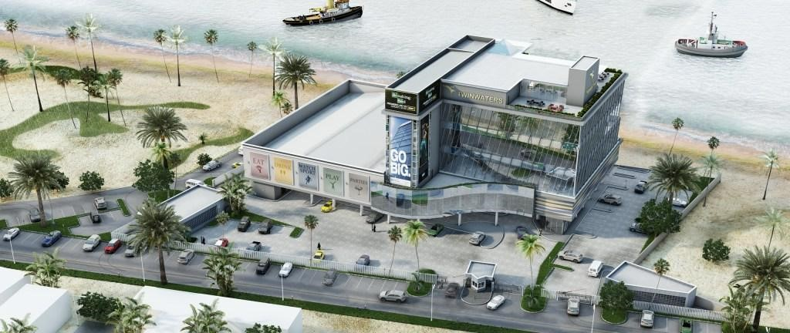
Figure 1: Twinwaters Entertainment Centre, Lagos – Exterior View, Photo credit: Conceptstruck Company Ltd

Architectural Features
Architecturally, Twinwaters Entertainment Centre is a multi-storey leisure complex comprising restaurants, arcades, bowling facilities, event halls, and rooftop entertainment spaces. The building employs a contemporary façade treatment, generous glazing for visual openness, and vertically stacked functional zones. Internal spaces are organized around shared circulation paths linking recreation, dining, and event functions, resulting in a compact yet active spatial configuration.
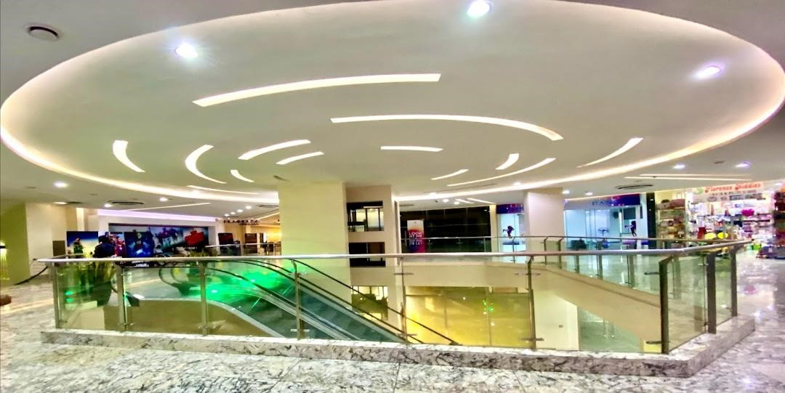 Figure 2: Interior circulation paths at Twinwaters Entertainment Centre, Photo credit: Telisol Limited

Wayfinding Concept

Concept Description
Wayfinding within Twinwaters is achieved primarily through graphic signage, directory boards, staff assistance, and visual branding rather than strong architectural hierarchy. Functional zones are identified using signage and interior design cues, with vertical movement facilitated by staircases and elevators.
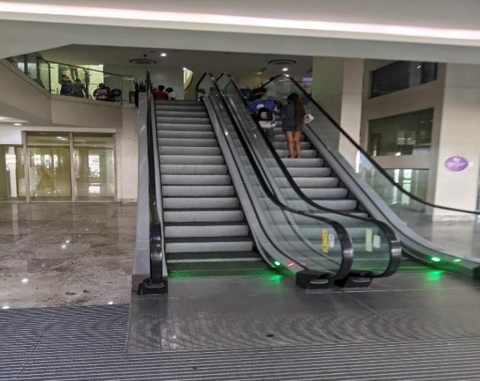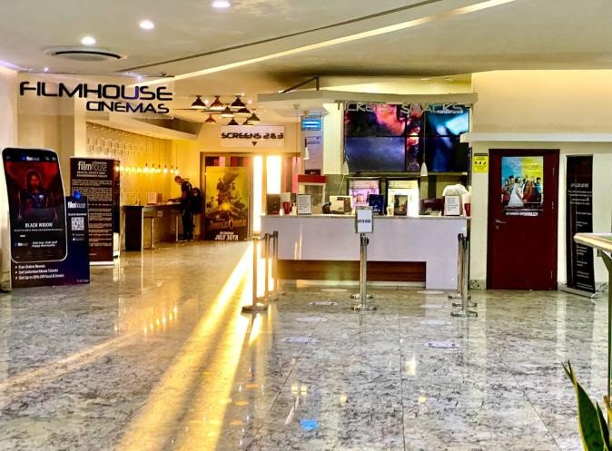
Figure 3: Interior circulation paths at Twinwaters Entertainment Centre, Photo credit: Telisol Limited

Advantages
- Clear signposting assists first-time visitors in navigating between key functions.
- Staff presence supplements navigational clarity during peak periods.
- Branded interiors help users associate activities with specific locations.

Disadvantages
- Limited architectural differentiation between zones reduces intuitive navigation.
- Dependence on signage increases cognitive load, especially during emergencies.
- Visual clutter and crowd density may obscure directional cues at peak times.

Fire Egress Concept

Concept Description
Fire egress in Twinwaters Entertainment Centre is based on a code-compliant approach, incorporating multiple staircases, clearly marked fire exits, fire alarms, extinguishers, and emergency lighting. Escape routes are distributed vertically and horizontally to facilitate evacuation from different functional zones.

Figure 4: Interior circulation paths at Twinwaters Entertainment Centre Roof top, Photo credit: Telisol Limited

Advantages
- Clearly marked exits and alarms enhance occupant awareness during emergencies.
- Multiple staircases provide alternative evacuation paths.
- Integration of emergency lighting supports visibility under power failure conditions. Disadvantages
- Fire exits are not always visually integrated into primary circulation paths.
- Reliance on signage rather than spatial legibility may delay evacuation response.
- Mixed-use activity zones increase the likelihood of congestion during emergency egress.

Mechanism and Transferability
The integration mechanism at Twinwaters is best characterized as operational and graphic rather than architectural: legibility and egress recognition depend on signage, staff, and code-minimum compliance layered onto a spatial layout that does not itself reinforce navigation or evacuation. This mechanism requires ongoing operational investment, in staff training and signage maintenance, rather than upfront design investment, but leaves the facility vulnerable precisely when operational support is most strained, during peak occupancy or emergencies. This case therefore represents the baseline condition that the LCAI strategy is intended to improve upon.

Case Study 2: Ferrari World Abu Dhabi

Overview
Location: Ferrari World Abu Dhabi is located on Yas Island, Abu Dhabi, United Arab Emirates, within a master-planned entertainment and leisure district.
Contractor: The construction of Ferrari World Abu Dhabi involved a consortium of international contractors, coordinated under the authority of the master developer for Yas Island.
Designer: The architectural design was led by Benoy Architects, in collaboration with international engineering and themed entertainment consultants. The design integrates iconic form-making with performance-based safety strategies appropriate for a mega indoor theme park.
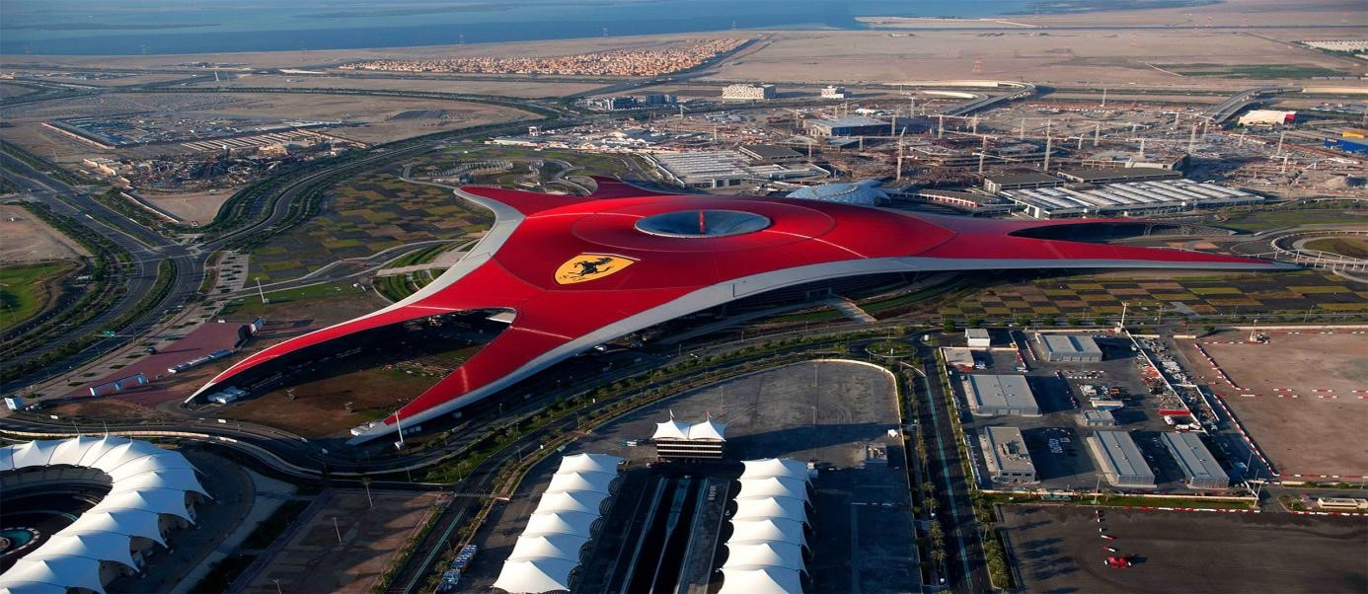
Figure 5: Ferrari World Abu Dhabi – Iconic Red Roof Canopy, Photo credit: Benoy Architects / Yas Island Development
Authority

Architectural Features
Ferrari World is characterized by its vast enclosed structure, iconic red roof canopy, expansive interior spans, and large atrium-like spaces. The building accommodates rides, exhibition areas, retail, dining, and assembly spaces within a single continuous envelope. Spatial organization is structured around major nodes and visual anchors that orient users across the large floor area.

Wayfinding Concept

Concept Description
Wayfinding in Ferrari World is architecturally embedded, combining spatial hierarchy, strong visual axes, color-coded zones, landmarks, and integrated digital and graphic signage. Major circulation paths are intuitive and visibly connected to prominent attractions and nodes. Advantages
- Strong architectural landmarks support intuitive navigation.
- Color coding and zoning reduce cognitive load for visitors.
- Clear sightlines guide movement without over-reliance on signage.
- Digital wayfinding enhances user experience and orientation.

Disadvantages
- Large spatial scale may still overwhelm first-time users.
- High activity density can temporarily obstruct visual cues during peak periods.
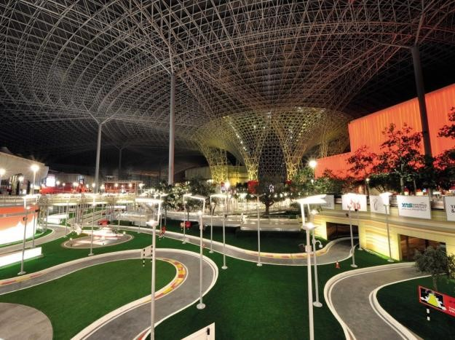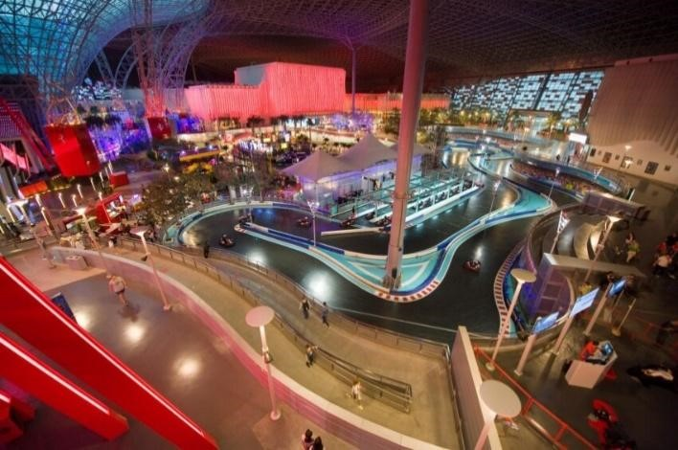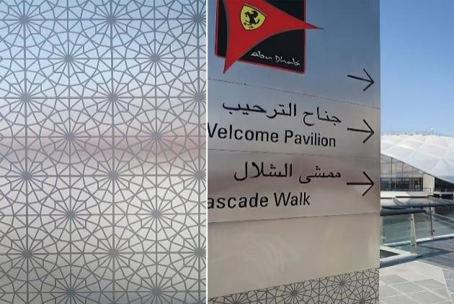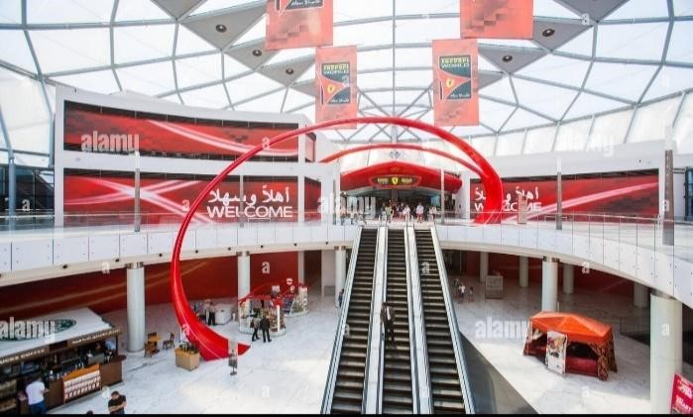
Figure 6: Broad concourses and circulation spines, Photo Credit: Photo credit: Ferrari World Abu Dhabi / Yas Island
Development Authority

Fire Egress Concept

Concept Description
Fire egress at Ferrari World adopts a performance-based fire safety strategy, exceeding minimum prescriptive requirements. The design incorporates multiple wide exits, redundant escape paths, smoke-management systems, photoluminescent markings, and clear exit discharge routes leading directly to safe assembly areas.
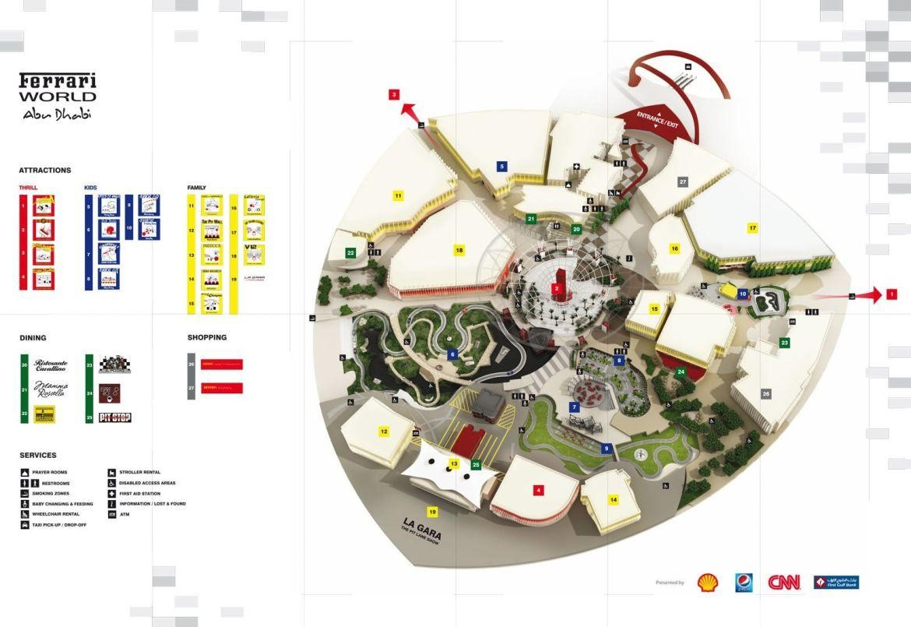
Figure 7: Wayfinding landmarks inside Ferrari World Abu Dhabi, Photo credit: Benoy Architects

Advantages
- Multiple, widely distributed exits ensure rapid evacuation.
- Fire egress routes align with main circulation paths, increasing visibility.
- Advanced smoke control systems enhance tenability during emergencies.

Disadvantages
- Complexity of ride infrastructure requires continuous monitoring and maintenance.
- High reliance on operational systems demands rigorous staff training and drills.

Mechanism and Transferability
The integration mechanism at Ferrari World is primarily architectural and technological: spatial hierarchy and colour-coded zoning are reinforced by digital wayfinding and performance-based smoke-managed egress. While highly effective, this mechanism depends on a scale of engineering consultancy, digital infrastructure, and continuous operational monitoring that is not readily available within the typical Nigerian development budget. The architectural components of this mechanism, landmark placement, colour and material zoning, are transferable at low cost; the technological and performance-engineering components are not.

Case Study 3: Entertainment City Manila

Overview
Location: Entertainment City Manila is located on reclaimed land along Manila Bay, Philippines, forming a large-scale entertainment and tourism corridor. The district comprises integrated resorts, casinos, hotels, and entertainment facilities, planned within a regulated urban framework.
Contractor: Development within Entertainment City Manila involves multiple contractors, each operating under national building and fire regulations enforced by Philippine authorities. Construction emphasizes large-span structures and high-occupancy public buildings.
Designer: Projects within Entertainment City Manila are designed by international and local architectural firms, working collaboratively with planning authorities to meet strict regulatory and safety requirements specific to assembly and mixed-use occupancies.
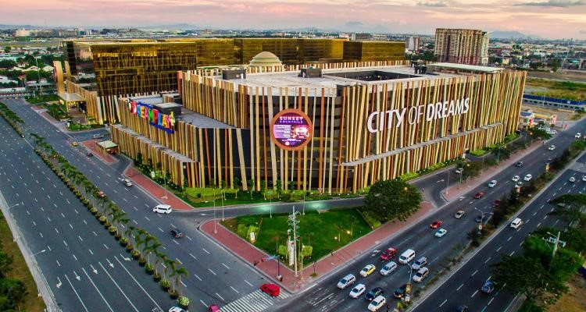
Figure 8: Entertainment City Manila – Broad concourses and circulation spines, Photo credit: Philippine Planning Authority
/ Local Architects

Architectural Features
Architectural features across Entertainment City projects include broad concourses, monumental interior spaces, open courts, and clearly defined circulation spines. Buildings are typically organized horizontally with generous floor plates, enabling direct and legible movement between entertainment functions.

Wayfinding Concept

Concept Description
Wayfinding is achieved through clear spatial zoning, axial planning, architectural hierarchy, and consistent signage systems. Public movement areas are distinct from service zones, reducing spatial confusion and cross-movement conflicts.

Advantages
- Axial planning supports clear directional movement.
- Architectural hierarchy reinforces destination recognition.
- Consistent signage systems enhance navigational clarity.

Disadvantages
- Large horizontal distances may increase walking time.
- Typical resort layouts can disorient users lacking familiarity with the complex.
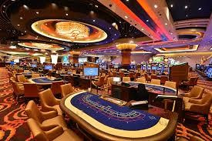
Figure 9: Fire egress routes and open courts in Entertainment City Manila, photo credit: Philippine National Fire Safety
Authority
Fire Egress Concept

Concept Description
Fire egress strategies follow strict national fire and building codes, incorporating multiple exits, generous exit widths, illuminated escape signage, open courts, and setbacks that facilitate firefighter access and occupant evacuation.

Advantages
- Redundant exit systems improve evacuation resilience.
- Open courts enhance smoke dispersal and safe assembly.
- Regulatory enforcement ensures consistent safety performance.

Disadvantages
- Extensive building footprints can prolong travel distance to exits.
- Evacuation coordination across large complexes requires effective management systems.

Mechanism and Transferability
The integration mechanism at Entertainment City Manila is primarily planning-based: axial organization, architectural hierarchy, and generous floor plates achieve legibility through layout rather than digital technology, and open courts achieve egress performance through spatial planning rather than mechanical smoke control. Of the three international cases, this mechanism is the most transferable to the Nigerian context, since it depends less on advanced engineering and more on planning discipline and strict regulatory enforcement, both of which are policy and design-practice matters rather than purely financial ones.

Figure 10: Shanghai Disneyland – Large-scale themed entertainment park layout, Photo credit: CGTN / Disney Imagineering

Overview
Location: Pudong, Shanghai, China
Type: Large-scale themed entertainment park
Shanghai Disneyland is one of the most advanced Disney parks globally, designed with a strong emphasis on user movement, spatial clarity, and crowd management. It accommodates very high visitor volumes while maintaining efficient navigation and safety systems.

Wayfinding Concept

Concept Description
Wayfinding in Shanghai Disneyland is integrated into both spatial planning and user experience. The park uses:
- Themed zones (e.g., Treasure Cove, Tomorrowland)
- Strong visual landmarks (e.g., Enchanted Storybook Castle)
- Radial and looped circulation systems
- Digital support through mobile apps and maps
Key Features
- Central landmark (castle) acts as a primary orientation point
- Clear spatial zoning reduces confusion
- Wide, continuous pathways support smooth pedestrian flow
- Combination of physical and digital wayfinding tool

Advantages
- Visitors can easily navigate using landmarks and spatial cues
- Zoning improves orientation and reduces cognitive load
- Wide pathways reduce congestion and allow efficient movement
- Digital tools enhance navigation for first-time users

Disadvantages
- Large scale may still overwhelm unfamiliar users
- High crowd density can temporarily block visual cues
- Dependence on mobile devices for enhanced navigation

Fire Egress Concept

Concept Description
Fire egress at Shanghai Disneyland is embedded within the overall spatial and circulation system, ensuring safe evacuation without disrupting the user experience.

Key Features
- Multiple widely distributed exits integrated into main routes
- Open spaces and plazas acting as safe assembly points
- Clear and unobstructed evacuation paths
- Strong crowd control and real-time monitoring systems

Advantages
- Evacuation routes align with familiar circulation paths
- Open spaces improve safety and reduce crowd pressure
- Efficient crowd management ensures faster evacuation
- High level of operational control enhances emergency response

Disadvantages
- Requires continuous monitoring and management systems
- Heavy reliance on operational coordination during emergencies

Mechanism and Transferability
The integration mechanism at Shanghai Disneyland combines landmark-driven architectural planning with digital and operational infrastructure: the central landmark and radial circulation are architectural decisions with low marginal cost, while the mobile app support and real-time crowd monitoring represent a significant technological and operational investment. As with Ferrari World, the architectural component of this mechanism, a dominant central landmark organizing radial circulation, is directly transferable to the Nigerian context; the digital and monitoring components are not.

Comparative Synthesis of Findings
The comparative analysis indicates that the effectiveness of wayfinding and fire egress systems increases when navigation and life-safety considerations are integrated into the architectural structure of a facility. Ferrari World and Entertainment City Manila demonstrate stronger performance because spatial organization, circulation planning, and emergency evacuation strategies operate as interconnected systems. In contrast, Twinwaters relies more heavily on signage and operational support, resulting in weaker architectural legibility.
The analysis further reveals that visual connectivity, spatial hierarchy, and alignment between circulation routes and evacuation paths are the most significant factors influencing user orientation and fire egress performance. These findings support the argument that entertainment centres should be designed as legible and safety-oriented environments where everyday movement patterns reinforce emergency evacuation behaviour (Ronchi & Nilsson, 2020; Kuligowski, 2021).
Table 1 consolidates the four cases across the dimensions examined in Sections 4.1–4.4, situated location, dominant wayfinding mechanism, dominant fire-egress mechanism, whether integration is achieved primarily through architecture or through operational/technological layering, the resource intensity of the mechanism, and its transferability to the Nigerian context.
Table 1: Comparative Summary of Wayfinding and Fire Egress Integration Across Case Studies
Case Study | Location | Dominant Wayfinding Mechanism | Dominant Fire Egress Mechanism | Integration Basis | Resource Intensity | Transferability to Nigeria
Twinwaters Entertainment Centre | Lagos, Nigeria | Signage, directory boards, staff assistance, visual branding | Code-compliant staircases, marked exits, alarms, emergency lighting | Operational / graphic (layout does not itself reinforce navigation) | Low upfront, but ongoing operational cost (staff, signage upkeep) | Baseline case represents the condition the LCAI strategy addresses
Ferrari World Abu Dhabi | Yas Island, Abu Dhabi, UAE | Spatial hierarchy, visual axes, colour-coded zones, digital + graphic signage | Performance-based fire engineering, smoke management, photoluminescent marking | Architectural + technological | High (engineering consultancy, digital infrastructure, continuous monitoring) | Partial landmark/colour/material zoning transferable; performance engineering and digital systems not transferable
Entertainment City Manila | Manila Bay, Philippines | Axial planning, architectural hierarchy, consistent signage | Strict code compliance, generous exit widths, open courts, setbacks | Architectural / planning-based | Moderate (depends on planning discipline and regulatory enforcement, not heavy technology) | Highest among the international cases depends on policy and design discipline rather than capital
Shanghai Disneyland | Pudong, Shanghai, China | Central landmark, radial/looped circulation, themed zoning, mobile app support | Distributed exits on main routes, open plazas as assembly points, real-time crowd monitoring | Architectural + digital/operational | High (mobile app infrastructure, real-time monitoring, crowd management staffing) | Partial central-landmark/radial-circulation logic transferable; digital monitoring not transferable
Source: Authors' comparative analysis, derived from Sections 4.1–4.4.
These comparative findings indicate that the international cases achieve integration between wayfinding and fire egress largely through resource-intensive strategies, performance-based fire engineering at Ferrari World, digital and app-based wayfinding at Shanghai Disneyland, and regulator-driven infrastructure investment at Entertainment City Manila, that are not easily transferable to the Nigerian development context given cost constraints and inconsistent regulatory enforcement (Dickson, 2019; Obi, 2015). This gap points to the need for a context-responsive alternative. Accordingly, this study proposes a Low-Cost Architectural Integration (LCAI) strategy: a set of design-stage decisions, rather than post-completion additions, that embed legibility and egress alignment directly into the building's layout. These decisions include
- aligning primary daily circulation spines with escape routes during massing and layout development,
- using material, colour, or ceiling-height changes at key decision points as a substitute for extensive signage or digital wayfinding.
- positioning simple architectural landmarks, such as stair voids, courtyards, or lighting changes, at circulation nodes during design rather than relying on branding or staff intervention afterward.
Unlike the signage-and-staff-dependent approach observed at Twinwaters, this strategy requires no significant additional capital investment, since it is achieved through design decisions rather than added infrastructure.

Comparative Assessment of Egress and Travel-Time Performance
A recurring question raised in review of this study was how the wayfinding and fire-egress enhancements identified above translate into actual movement and evacuation time, since spatial legibility is ultimately only useful in so far as it shortens the time occupants take to recognize and reach a safe exit. As noted in Section 3, this study did not conduct timed evacuation drills, sensor-based occupant tracking, or computational evacuation simulation at any of the four cases; no facility-specific travel-time data of that kind exists in the public domain for Twinwaters, and comparable independent timing data for the three international precedents could not be verified within the scope of this review. Reporting invented minute-and-second figures for any of the four cases would therefore misrepresent the qualitative, document- and observation-based design of the study.
What the comparative evidence in Sections 4.1–4.4 does support is a qualitative, indicator-based assessment of the architectural factors known from the fire-egress literature to drive travel and evacuation time, namely, average travel distance to the nearest identifiable exit, the directness and visibility of exits from major occupied spaces, the degree to which occupants depend on signage or staff rather than the building form itself, and the extent to which everyday circulation is already aligned with escape routes (Kuligowski, Peacock & Hoskins, 2010; Ronchi & Nilsson, 2020). Table 2 rates each case on these indicators and derives an indicative egress-time performance rating; the ratings are relative judgements drawn from the descriptive evidence presented above, not measured or simulated durations.
Table 2: Indicative Comparison of Factors Influencing Egress and Travel Time
Case Study | Travel Distance to Nearest Exit | Exit Visibility / Directness | Dependence on Signage or Staff | Circulation–Egress Alignment | Indicative Egress-Time Performance
Twinwaters Entertainment Centre | Moderate compact footprint, but vertically stacked zones lengthen effective travel path | Low–Moderate exits not consistently visible from primary circulation | High evacuation recognition depends on signage and staff direction | Low everyday routes and escape routes are not designed as one system | Slower / less predictable recognition delay is the main constraint, not physical distance
Ferrari World Abu Dhabi | Low multiple wide, redundant exits shorten path length | High egress routes align with main circulation spines | Low–Moderate digital and graphic wayfinding reduce reliance on staff | High spatial hierarchy and colour zoning reinforce escape routes | Fast architecture and technology jointly minimize recognition and travel time
Entertainment City Manila | Moderate–High large horizontal footprints increase raw distance to exits | High axial planning keeps exits within clear sightlines despite distance | Moderate consistent signage supplements a legible layout | High architectural hierarchy and open courts are built into the plan | Fast, but distance-sensitive legibility offsets longer physical travel distances
Shanghai Disneyland | Low–Moderate radial/looped layout keeps plazas and assembly points within short reach of most zones | High landmark and open-plaza system keeps egress routes visually dominant | Moderate mobile apps support supplements, rather than replaces, architectural cues | High evacuation routes coincide with familiar, everyday circulation | Fast, but crowd-management dependent architecture aids speed; operations manage peak-density risk
Source: Authors' qualitative assessment derived from the descriptive and observational evidence in Sections 4.1–4.4. Ratings are relative and indicative, not measured or simulated evacuation times.

DISCUSSION
While the international cases confirm that integration between wayfinding and fire egress improves both user experience and life-safety outcomes, they also demonstrate that this integration has, to date, been achieved primarily through capital-intensive means, be it performance-based fire engineering, digital wayfinding infrastructure, or dedicated environmental graphic design consultancy. These conditions are not consistently available within the Nigerian development context, where regulatory enforcement is inconsistent and construction budgets are constrained (Dickson, 2019; Obi, 2015). This distinguishes the present study's contribution from prior work: rather than simply confirming that integration is beneficial, as established in Ronchi and Nilsson (2020) and Kuligowski (2021), this study proposes a specific, low-cost design strategy through which that integration can be achieved within the Nigerian context.
The proposed Low-Cost Architectural Integration (LCAI) strategy shifts the burden of legibility and egress alignment from added infrastructure, such as signage, staff, and digital systems, to decisions made at the architectural design stage: circulation-escape alignment during massing, material and colour differentiation at decision points, and landmark placement using existing structural or spatial elements. Because these are layout and design decisions rather than additional systems, they carry minimal marginal cost relative to standard construction, making them more feasible for adoption in the Nigerian entertainment-centre sector than the performance-based approaches observed internationally.
The anticipated outcome of adopting this strategy is threefold. First, it should reduce facilities' dependence on signage and staff-guided navigation, addressing the specific weakness identified in the Twinwaters case. Second, because circulation and egress routes would be aligned from the design stage, everyday movement patterns would already reinforce evacuation behaviour, consistent with the behavioural evidence that occupants favour familiar, visually prominent routes during emergencies (Kuligowski, 2021; Proulx, 2001). Third, it is anticipated to narrow the observed performance gap between Nigerian and international entertainment centres without requiring the scale of investment associated with performance-based fire engineering or digital wayfinding infrastructure. Future post-occupancy evaluation and evacuation simulation studies, as recommended in Section 7.7, would be necessary to empirically test these anticipated outcomes.

Design Implications
The findings of these study carry important implications for the design of entertainment centres, particularly in environments characterized by high visitor densities, complex spatial arrangements, and constrained construction budgets.
- Integration of Wayfinding and Fire Egress Systems
Wayfinding and fire egress systems should be considered as complementary components of architectural design rather than independent elements. The integration of both systems from the conceptual design stage, achieved through layout and massing decisions rather than added infrastructure, can improve user orientation during normal building operation while simultaneously supporting effective emergency evacuation at minimal additional cost.
- Provision of Clear Circulation Networks
Entertainment centres should incorporate circulation systems that are simple, continuous, and easily understood by users. Primary circulation routes should be clearly distinguishable from secondary routes and, in line with the LCAI strategy, should be deliberately aligned with escape routes at the massing stage so that everyday movement patterns double as evacuation guidance.
- Enhancement of Visual Connectivity
Building layouts should maximize visual connections between major activity spaces, circulation routes, and exits. Open sightlines can improve spatial understanding, reduce disorientation, and assist occupants in identifying evacuation routes during emergencies. Where budgets do not permit expansive atria or glazing comparable to Ferrari World Abu Dhabi, more modest sightline strategies, such as strategically placed openings or level changes, can achieve similar orientation benefits.
- Strategic Placement of Exits
Emergency exits should be positioned in locations that are easily visible and accessible from major occupied spaces. Exit routes should be direct, unobstructed, and capable of accommodating anticipated occupant loads during emergency situations. Exit placement decisions made during design, rather than signage added afterward, are central to the LCAI approach and reduce long-term reliance on wayfinding graphics.
- Use of Low-Cost Architectural Landmarks
Distinct architectural features such as atria, focal spaces, lighting elements, and unique forms can improve spatial legibility and assist users in navigating complex environments. Consistent with the LCAI strategy, these features need not be elaborate or costly: a stair void, courtyard, change in ceiling height, or material shift at a circulation node can serve the same orientation function as the branded interiors or digital landmarks used internationally, while remaining feasible within typical Nigerian construction budgets. These features may also contribute to faster recognition of evacuation routes during emergencies.
- User-Centred Safety Design
Architectural design should account for occupant behaviour and decision-making patterns. Spaces should be organized in ways that support intuitive movement and reduce reliance on complex instructions, signage, or staff intervention during emergency situations, addressing the specific dependence on staff assistance identified in the Twinwaters case.
- Continuous Evaluation of Safety Performance
Post-occupancy evaluation should be incorporated into the management of entertainment centres to assess the effectiveness of wayfinding and fire egress systems, including the anticipated performance of the LCAI strategy where adopted. Feedback obtained from building users can support future improvements in design and safety performance.
Additionally, early collaboration between architects, fire engineers, and environmental graphic designers is essential to create coherent wayfinding and fire egress systems aligned with both performance-based safety objectives and user experience requirements (NFPA, 2024). Where such multidisciplinary collaboration is not readily available, as is often the case in the Nigerian development context, the LCAI strategy offers architects a means of achieving comparable integration through design decisions alone.
Finally, Nigerian entertainment centres would benefit from the gradual adoption of performance-based fire design approaches where resources allow, alongside more immediately implementable strategies such as LCAI, allowing flexibility while maintaining high safety standards appropriate for complex, mixed-use occupancies.

RECOMMENDATION
Based on the findings of this study, the following recommendations are proposed to improve the effectiveness of wayfinding and fire egress systems in entertainment centres, particularly within the Nigerian context.
- Integrate Wayfinding and Fire Egress During Design Development
Architects and designers should incorporate wayfinding and fire egress considerations from the earliest stages of planning and design, rather than as additions introduced after design completion. Specifically, primary circulation spines should be aligned with escape routes at the massing and layout stage, as proposed under the LCAI strategy, so that the building's basic form does the work that signage and staff currently do at facilities such as Twinwaters.
- Improve Spatial Legibility Through Low-Cost Design Decisions
Entertainment centres should be designed with clear spatial organization, distinct circulation routes, and recognizable architectural features that assist users in understanding the building layout. Rather than relying on branding, digital signage, or added graphic systems, legibility can be achieved through material change, colour differentiation, and variation in ceiling height at key decision points, achieving comparable navigational clarity to the international cases reviewed without their associated capital cost.
- Enhance Exit Visibility and Accessibility
Emergency exits should be strategically located and clearly visible from major public areas, using architectural means, such as sightlines, level changes, or their placement along primary circulation routes, rather than dependence on signage alone. Exit routes should remain unobstructed and provide direct access to safe assembly points.
- Use Architectural Landmarks in Place of Costly Digital Systems
Where budget or technical capacity limits the adoption of digital wayfinding or performance-based fire engineering, as seen in Ferrari World Abu Dhabi and Shanghai Disneyland, designers should employ simple architectural landmarks, such as stair voids, courtyards, atria, or lighting features, positioned at circulation nodes during design. These landmarks can support orientation and evacuation recognition at minimal additional cost, consistent with the LCAI approach.
- Strengthening Compliance with Fire Safety Standards
Building owners, developers, and regulatory agencies should ensure strict compliance with national and international fire safety requirements. Regular inspections and maintenance of fire protection systems should be conducted to maintain operational effectiveness, alongside verification that circulation-egress alignment principles are applied at the design review stage.
- Adopt User-Centred Design Approaches
Future entertainment-centre developments should prioritize the needs and behaviour of occupants. Design decisions should consider how users perceive space, interpret environmental information, and respond during emergency situations, recognizing that occupants tend to follow familiar and visually prominent routes rather than abstract instructions during emergencies (Kuligowski, 2021).
- Conduct Regular Emergency Preparedness Activities
Management teams should organize periodic evacuation drills, safety awareness programmes, and staff training exercises to improve occupant preparedness and emergency response capabilities, particularly in facilities where architectural integration is still being adopted incrementally.
- Encourage Further Research and Empirical Testing of the LCAI Strategy
Future studies should investigate the application of digital wayfinding technologies, smart evacuation systems, and simulation-based evacuation modelling in entertainment centres and other high-occupancy public buildings. Empirical testing of the Low-Cost Architectural Integration strategy proposed in this study, through post-occupancy evaluation or evacuation simulation, is recommended to validate its anticipated effect on reducing signage dependence and improving evacuation efficiency in Nigerian entertainment centres.

CONCLUSION
This study set out to examine how wayfinding and fire egress can be integrated within the architectural design of entertainment centres, and to translate that understanding into a strategy usable in the Nigerian context. The comparative analysis of Twinwaters, Ferrari World Abu Dhabi, Entertainment City Manila, and Shanghai Disneyland confirm that spatial hierarchy, visual connectivity, circulation configuration, and exit accessibility are the architectural factors that most consistently determine both everyday navigation and evacuation performance.
The cases also expose a gap that the existing literature has largely overlooked: the international examples achieve integration mainly through performance-based fire engineering, digital wayfinding infrastructure, and dedicated graphic design consultancy resources that are rarely available within Nigerian construction budgets and regulatory capacity. Twinwaters illustrates the cost of this gap, relying on signage and staff to compensate for a layout that does not itself support orientation or evacuation.
In response, this study proposed the Low-Cost Architectural Integration (LCAI) strategy, which relocates the burden of legibility and egress alignment from added infrastructure to design-stage decisions: aligning circulation spines with escape routes during massing, using material and colour changes at decision points in place of signage, and placing simple architectural landmarks at circulation nodes. Because these are decisions rather than additions, they carry minimal marginal cost and do not depend on the capital investment or technical capacity that the international precedents require.
Beyond its immediate application, this contribution reframes wayfinding-egress integration as a design-stage problem rather than a compliance or technology problem, offering architects, developers, and regulators a practical route to the safety and legibility outcomes observed internationally, without requiring the resources those outcomes have typically demanded. The anticipated benefits of the LCAI strategy reduced dependence on signage and staff, better alignment between every day and emergency movement, and a narrower performance gap with international best practice should now be tested empirically through post-occupancy evaluation and evacuation simulation.

REFERENCES
- Ching, F. D. K. (2014). Architecture: Form, space, and order (4th ed.). Hoboken, NJ: John Wiley & Sons.
- Creswell, J. W. (2014). Research design: Qualitative, quantitative, and mixed methods approaches (4th ed.). Thousand Oaks, CA: Sage Publications.
- Devlin, A. S., & McKay, K. N. (2018). Designing environments that facilitate wayfinding: Evidence-based approaches for complex buildings. Environment and Behavior, 50(7), 723–748. doi:10.1177/0013916517708140
- Dickson, P. (2019). Building design practice and fire codes for buildings in Nigeria: Issues, effects and solutions. International Journal of Innovative Research and Development, 8(8), 45–50.
- Federal Republic of Nigeria. (2023). National Building Code Review Draft. Abuja, Nigeria: Federal Ministry of Housing and Urban Development.
- Hart, I. I., & Bethels, U. P. (2026). Architectural strategies for wayfinding and circulation in multiplex and entertainment centres: Evidence from a Nigerian case and international precedents. International Journal of Engineering and Modern Technology, 12(1), 123–130.
- Hölscher, C., Büchner, S., Meilinger, T., & Strube, G. (2018). Signs and maps in navigation and wayfinding research. In H. A. Karimi (Ed.), Universal access in human-computer interaction (pp. 117–128). Cham, Switzerland: Springer.
- Ibrahim, N., Abdul Rahman, N., & Ismail, S. (2022). Architectural determinants of wayfinding performance in public facilities. Journal of Building Engineering, 48, 103977.
- Jamshidi, A., Mesbah, M., King, M., & Currie, G. (2020). Wayfinding behaviour and spatial cognition in complex built environments: A review. Sustainability, 12(3), 1124.
- Jeffery, K. J. (2019). Urban architecture: A cognitive neuroscience perspective. Buildings, 9(3), 65. doi:10.3390/buildings9030065
- Kuligowski, E. D. (2021). Human behaviour in fire evacuation: Current research and future directions. Fire Technology, 57(1), 7–34.
- Kuligowski, E. D., Peacock, R. D., & Hoskins, B. L. (2010). A review of building evacuation models (2nd ed.) (NIST Technical Note 1680). Gaithersburg, MD: National Institute of Standards and Technology.
- Li, R., & Klippel, A. (2021). Spatial cognition and navigation in public buildings: Implications for architectural design. Environment and Planning B: Urban Analytics and City Science, 48(7), 1858–1874.
- National Fire Protection Association. (2024). NFPA 101: Life Safety Code (2024 ed.). Quincy, MA: National Fire Protection Association.
- Obi, N. I. (2015). Fire protection measures in buildings: The architect's design role. Civil and Environmental Research, 7(7), 27–30.
- Proulx, G. (2001). Occupant behaviour and evacuation. In Proceedings of the 9th International Fire Protection Symposium (pp. 219–232). Munich: Hughes Associates.
- Ronchi, E., & Nilsson, D. (2020). Fire evacuation in high-occupancy buildings: Human factors and design implications. Fire Safety Journal, 112, 102949.
- Shi, J., Ren, A., & Chen, C. (2019). Effects of building layout on evacuation efficiency and occupant movement behaviour. Safety Science, 117, 231–240.
- Umo, U. U. (2019). Studies towards understanding architectural wayfinding. Rivers State University, Port Harcourt, Nigeria.
- Yin, R. K. (2018). Case study research and applications: Design and methods (6th ed.). Thousand Oaks, CA: Sage Publications.

