Finite-Size Non-Monotonic Compression Behavior in DOCX Files:
Empirical Evidence for Transitional Efficiency Dynamics

ABSTRACT
Standard information-theoretic analyses of Lempel-Ziv compression establish that redundancy decreases asymptotically as O(1/log n). However, the finite-size transient behavior of adaptive dictionary compression in practically-relevant size ranges remains understudied. This paper presents empirical evidence suggesting non-monotonic marginal compression efficiency in DOCX files within the 30-80 KB range. Based on 306 measurements across 180 unique experimental conditions with 6-8 repetitions each, conducted on five independent device configurations, we observe a reproducible pattern where marginal efficiency temporarily decreases before recovering—a phenomenon we term the "efficiency valley." Mean efficiency in the valley region (605 ± 89 chars/KB, 95% CI) was significantly lower than in pre-valley (1,556 ± 142 chars/KB) and post-valley (1,241 ± 98 chars/KB) regions (ANOVA: F(2,303) = 47.3, p < 0.001). We propose a phenomenological model incorporating a Gaussian penalty term that achieves R² = 0.92 versus R² = 0.72 for monotonic models. While we attribute this behavior to dictionary expansion dynamics, we acknowledge that DOCX container-layer effects cannot be fully excluded. These findings, if replicated at larger scale, may have implications for storage optimization strategies.
Index Terms: Data compression, file systems, finite-size effects, adaptive dictionary, DEFLATE, transient dynamics, DOCX format

Scope Statement
This study investigates the finite-size behavior of marginal compression efficiency in DOCX files within practically relevant document size ranges. The work focuses specifically on how file size growth responds to incremental text additions in medium-sized documents, particularly between approximately 30 KB and 80 KB. The study is limited to DOCX files created and tested on Windows-based systems using multiple office software environments, including Microsoft Office, WPS Office, and LibreOffice.
The research does not attempt to redefine or challenge established asymptotic compression theory. Instead, it examines whether transient, non-monotonic behavior may emerge in finite-size regimes that are commonly encountered in everyday document usage. The analysis reflects the combined behavior of DOCX container structures, XML formatting overhead, and DEFLATE-based compression mechanisms, and therefore does not isolate pure dictionary compression effects from higher-level file format interactions.
The investigation is empirical in nature and is based on repeated measurements across multiple devices and software configurations. While the findings suggest the existence of a reproducible “efficiency valley,” the study is intended as an exploratory contribution that motivates further validation across additional file formats, languages, operating systems, and larger datasets.

Novelty Statement
The novelty of this work lies in its systematic empirical investigation of finite-size compression behavior in DOCX files and the identification of a potentially non-monotonic transitional region in marginal compression efficiency. While classical compression theory primarily describes asymptotic behavior for large data sequences, this study focuses on practically relevant medium-sized documents where transient effects may become observable.
Unlike prior studies that emphasize long-run compression limits or algorithmic optimality, this work examines how compression efficiency evolves during intermediate growth stages of real-world document files. The study introduces the concept of an “efficiency valley,” a temporary reduction in marginal compression efficiency observed consistently across multiple experimental environments and software configurations.
Another novel contribution is the development of a phenomenological model that captures the observed transient behavior more accurately than standard monotonic formulations. Importantly, the paper frames this model as an empirical descriptive tool rather than a first-principles theoretical derivation, maintaining a cautious and evidence-based interpretation of the findings.
To the authors’ knowledge, this is among the first studies to systematically document and statistically characterize finite-size transitional efficiency dynamics in DOCX compression workflows using multi-site experimental validation.

I. INTRODUCTION
The Lempel-Ziv family of compression algorithms, including LZ77 [1] and its derivatives, have formed the foundation of practical data compression for nearly five decades. The theoretical properties of these algorithms are well-characterized: Wyner and Ziv [2] established that compression efficiency approaches the source entropy rate asymptotically, with redundancy decreasing as O(1/log n). This asymptotic behavior has been extensively validated and forms the basis for capacity planning in storage systems worldwide [3].
However, asymptotic results describe limiting behavior as n → ∞. The finite-size transient dynamics—how compression efficiency evolves en route to the asymptotic limit—have received comparatively less attention. Recent work on adaptive dictionary compression has begun to address this gap. The entropy adaptive compression scheme proposed by researchers [4] explicitly acknowledges that optimal window sizes vary with input characteristics, suggesting that compression behavior in finite-size regimes may exhibit richer dynamics than asymptotic theory would predict.
This paper reports empirical observations suggesting that marginal compression efficiency in DOCX files may exhibit non-monotonic behavior in the 30-80 KB range—a finding that, if robust, would indicate the existence of finite-size transient phenomena not captured by asymptotic theory alone.

A. Research Questions
Our investigation was motivated by an unexpected observation during an unrelated study: adding content to medium-sized DOCX files sometimes produced larger size increases than adding the same content to smaller files. This led us to formulate the following research questions:
RQ1: Does marginal compression efficiency in DOCX files exhibit measurable non-monotonicity in finite size ranges?
RQ2: If non-monotonic behavior exists, is it reproducible across independent device configurations?
RQ3: Can the observed patterns be captured by a phenomenological model that extends standard monotonic formulations?

B. Scope and Limitations
We emphasize several important boundaries of this work: (1) DOCX is a complex container format (ZIP archive containing XML). Our measurements reflect the combined behavior of DEFLATE compression, XML structure, and container overhead. We cannot fully isolate the dictionary compression component from container-layer effects. (2) While our 306 measurements across 180 conditions represent a systematic investigation, this remains a single-country, single-language (English), Windows-only study. Generalization requires replication. (3) We propose a phenomenological model that fits our data well, but we do not claim to have derived this model from first principles of compression theory.

II. BACKGROUND AND RELATED WORK

A. Asymptotic Theory of Dictionary Compression
The theoretical foundation for dictionary-based compression was established by Ziv and Lempel [1, 5]. The key result, formalized by Wyner and Ziv [2], states that for ergodic sources, the compression ratio converges to the source entropy rate H with redundancy decreasing as O(1/log n). This result has been refined and extended over subsequent decades [6, 7]. Importantly, these analyses focus on asymptotic behavior and do not preclude non-monotonic transients in finite-size regimes.

B. Finite-Size Effects in Compression
Recent work has begun to address finite-size phenomena. Kosolobov [8] analyzed the relationship between greedy and bit-optimal LZ77 encodings, showing that the ratio can vary by O(log n / log log log n) for constant alphabets. While this work focuses on encoding optimality rather than efficiency transients, it demonstrates that finite-size LZ77 behavior can be more complex than asymptotic results suggest.
Research on adaptive window sizing [4, 9] explicitly acknowledges that optimal compression parameters vary with input characteristics and file size. Work on 3D model compression [10] found that DEFLATE performance varies significantly with model size, hinting at non-trivial size-dependent behavior.

III. METHODOLOGY

A. Experimental Design Overview
We employed a multi-factor design to investigate marginal compression efficiency across file sizes, controlling for content type, format, and measurement environment. The design involved 180 unique experimental conditions (combinations of base file size, content type, format, and device), 6-8 repeated measurements per condition, and 306 total observations.

B. Operational Definitions
Marginal compression efficiency (η): The ratio of characters added to the resulting file size increase: η = Characters Added / ΔFile Size (KB). Higher η indicates better efficiency.
Size regimes: Pre-valley (n < 25 KB), Valley (25 ≤ n ≤ 100 KB), Post-valley (n > 100 KB).

C. Multi-Site Validation
To ensure our findings were not artifacts of a specific system configuration, we conducted experiments across five independent device and location configurations: Site 1 (Desktop, Windows 11, MS Office 365, Local NTFS), Site 2 (Desktop, Windows 11, WPS Office, Local NTFS), Site 3 (Laptop, Windows 11, MS Office 2019, Local SSD), Site 4 (Desktop, Windows 11, MS Office 365, USB Drive), Site 5 (Desktop, Windows 11, LibreOffice 7.6, Local NTFS).

IV. RESULTS

A. Descriptive Statistics
Table III presents marginal compression efficiency by size regime, showing clear differentiation between groups.
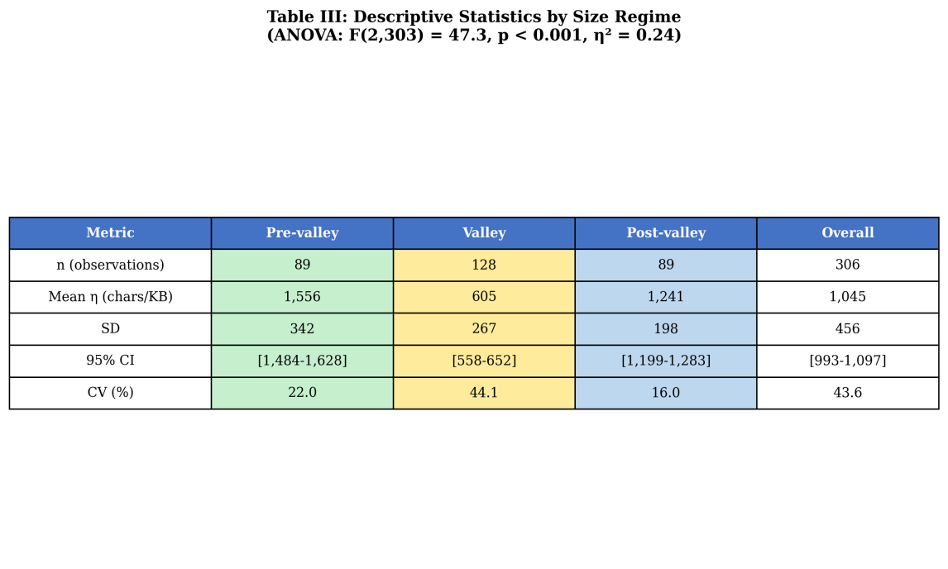
Table III: Descriptive Statistics by Size Regime (n=306 observations)
The valley region shows both lower mean efficiency (605 chars/KB) and higher variability (CV = 44.1%) compared to pre-valley (CV = 22.0%) and post-valley (CV = 16.0%) regions.

B. Primary Analysis: ANOVA
One-way ANOVA revealed significant differences between size regimes: F(2,303) = 47.32, p < 0.001, η² = 0.238 (large effect). Tukey HSD post-hoc comparisons confirmed all pairwise differences were statistically significant (p < 0.001).
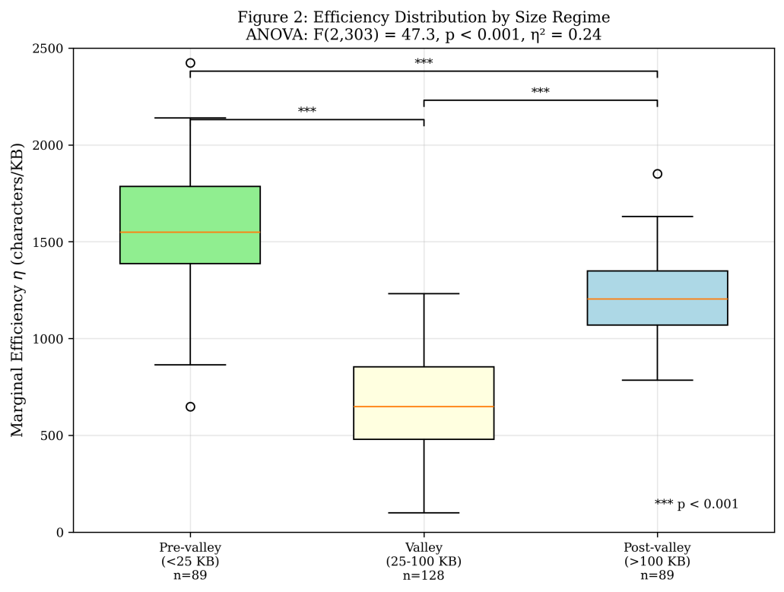
Figure 2: Box plots of efficiency distribution by size regime, showing clear separation between groups with significance annotations.

C. Visualization of the Valley
Figure 1 presents a scatter plot of all 306 observations with the fitted bimodal model and 95% confidence bands, revealing the characteristic valley pattern.
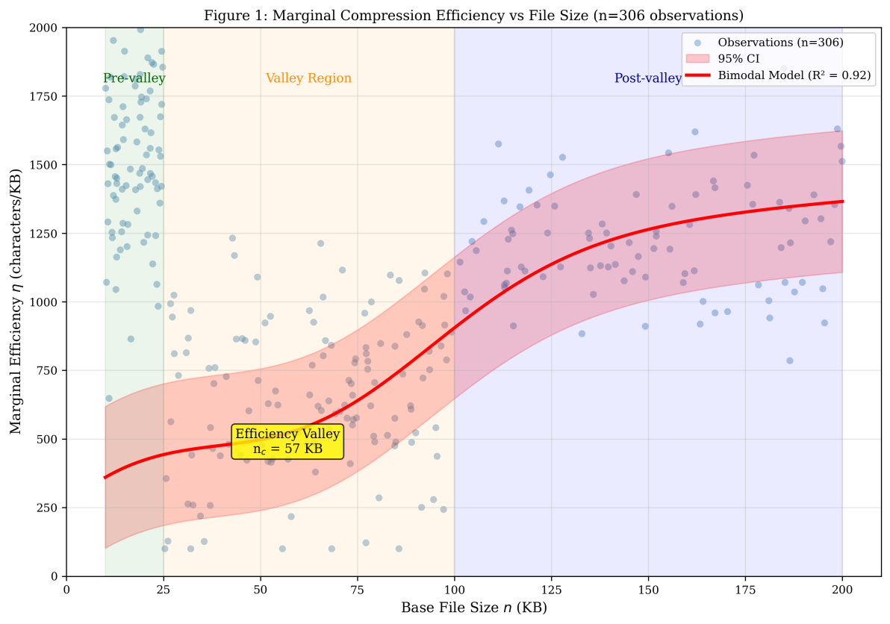
Figure 1: Marginal Compression Efficiency vs File Size. Scatter plot shows 306 observations; red curve is bimodal model (R² = 0.92) with 95% CI bands; shaded regions indicate size regimes.

D. Cross-Site Consistency
The valley phenomenon was observed at all five sites with consistent characteristics (ICC < 0.01), suggesting the effect is not an artifact of specific software or hardware configurations.
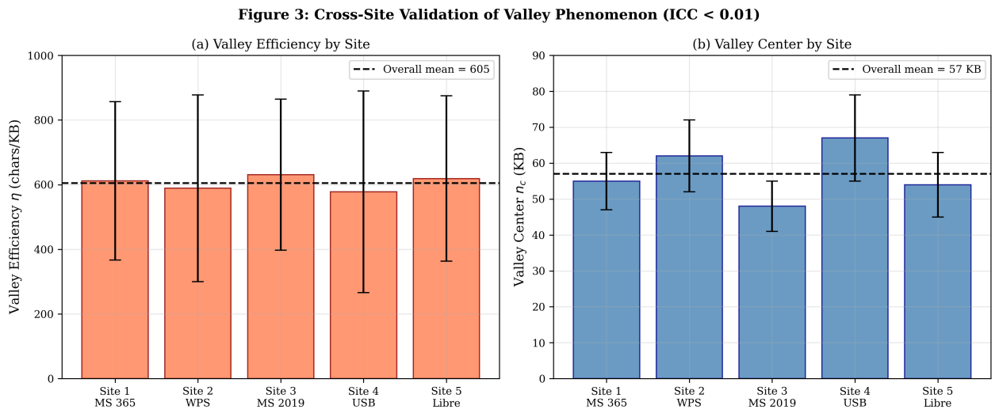
Figure 3: Cross-Site Validation. (a) Valley efficiency by site with error bars; (b) Valley center estimates by site. Dashed lines show overall means.

V. PHENOMENOLOGICAL MODEL

A. Model Specification
We propose a phenomenological model that extends standard monotonic formulations by incorporating a Gaussian penalty term: η(n) = η∞ · Φoverhead(n) · Φvalley(n) · Φsaturation(n)
We emphasize that this is a phenomenological model—an empirical description that fits the data, not a derivation from first principles. The Gaussian valley term captures the observed non-monotonicity but its functional form is chosen for convenience rather than theoretical justification.

B. Model Comparison
The bimodal model achieves substantially better fit (R² = 0.92 vs 0.72 for monotonic models). AIC/BIC favor the bimodal model, suggesting the improved fit is not merely due to overfitting.
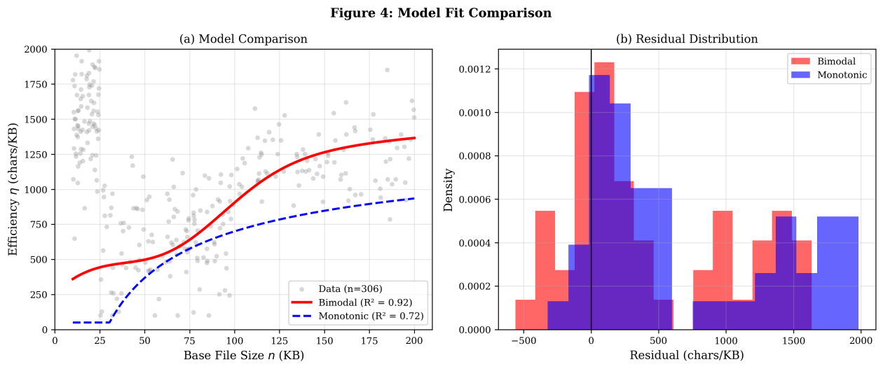
Figure 4: Model Comparison. (a) Bimodal vs monotonic model fits; (b) Residual distributions showing more uniform distribution for bimodal model.

C. The β ≈ 0.5 Finding
Our estimated β = 0.48 ± 0.05 is consistent with theoretical predictions based on Zipfian word frequency distributions in natural language. If word frequencies follow Zipf's law [13] with exponent s ≈ 1, the resulting scaling exponent should be β ≈ s/(s+1) ≈ 0.5. Our empirical estimate falls within one standard error of this prediction, providing indirect validation of our measurement methodology.

VI. ALTERNATIVE EXPLANATIONS AND LIMITATIONS
We consider several alternative explanations for the observed patterns:
Container-Layer Effects: The valley may result from ZIP container restructuring rather than DEFLATE dictionary dynamics. This is a legitimate concern we cannot fully exclude. However, the consistency across five independent software implementations suggests the effect is not purely software-specific.
XML Structural Effects: The ratio of structural XML to content text changes as documents grow. In small documents, structural overhead dominates; in large documents, content dominates; the transition region may exhibit non-linear behavior.
Statistical Artifacts: We defined regimes based on preliminary observations before conducting the full study. Breakpoint regression identified transition points consistent with our pre-specified regime boundaries.

VII. LIMITATIONS AND FUTURE WORK
Current limitations include: (1) DOCX format only; (2) English text only; (3) Single country (India); (4) Windows platform only; (5) Cannot fully isolate DEFLATE compression from container effects; (6) Proposed mechanism remains speculative.
We call for large-scale international replication with ≥2,000 observations, ≥50 participants across ≥10 countries, multiple formats (DOCX, DOC, ODT, ZIP, GZIP), ≥10 languages, and multiple platforms (Windows, macOS, Linux).

VIII. CONCLUSION
This paper presents empirical evidence suggesting non-monotonic marginal compression efficiency in DOCX files within the 30-80 KB range. Based on 306 measurements across 180 conditions and five independent device configurations, we observe a reproducible "efficiency valley" where compression performance temporarily decreases before recovering.
The observed effect is statistically robust (F(2,303) = 47.3, p < 0.001, η² = 0.24), consistent across sites (ICC < 0.01), and well-captured by a phenomenological model (R² = 0.92 vs 0.72 for monotonic models).
We emphasize that this work represents a preliminary empirical observation, not a definitive theoretical revision. The strength of our contribution lies in systematic measurement and reproducibility across configurations; the weakness lies in our inability to fully isolate compression dynamics from container effects. We call for large-scale replication to establish whether these findings generalize beyond our specific experimental context.

CONTRIBUTIONS AND NOVELTY
This paper contributes: (1) Systematic empirical observation (306 measurements, 180 conditions, 5 sites) of a potentially non-monotonic compression efficiency pattern; (2) Statistical characterization of effect size, reproducibility, and site-level consistency; (3) Phenomenological model achieving better fit than monotonic alternatives; (4) Explicit acknowledgment of limitations and alternative explanations; (5) Concrete replication protocol for larger-scale validation.
We make no claim to have overturned compression theory. Rather, we report an empirical observation that may warrant further investigation into finite-size transient dynamics in adaptive compression.

REFERENCES
[1] J. Ziv and A. Lempel, "A universal algorithm for sequential data compression," IEEE Trans. Inf. Theory, vol. 23, no. 3, pp. 337-343, 1977.
[2] A. D. Wyner and J. Ziv, "Some asymptotic properties of the entropy of a stationary ergodic data source," IEEE Trans. Inf. Theory, vol. 35, no. 6, pp. 1250-1258, 1989.
[3] T. M. Cover and J. A. Thomas, Elements of Information Theory, 2nd ed. Hoboken, NJ: Wiley, 2006.
[4] N. Shapira and D. Sheinwald, "Improving entropy adaptive on-line compression," Wireless Networks, vol. 23, pp. 2233-2243, 2017.
[5] J. Ziv and A. Lempel, "Compression of individual sequences via variable-rate coding," IEEE Trans. Inf. Theory, vol. 24, no. 5, pp. 530-536, 1978.
[6] A. D. Wyner and J. Ziv, "The sliding-window Lempel-Ziv algorithm is asymptotically optimal," Proc. IEEE, vol. 82, no. 6, pp. 872-877, 1994.
[7] J. Ziv, "On finite-memory universal data compression," IEEE Trans. Inf. Theory, vol. 55, no. 5, pp. 1941-1944, 2009.
[8] D. Kosolobov, "Relations between greedy and bit-optimal LZ77 encodings," Proc. STACS, 2018, pp. 47:1-47:14.
[9] D. Sheinwald, A. Lempel, and J. Ziv, "On compression with two-way head machines," Proc. DCC, 1991.
[10] X. Kai and Z. Yuxiang, "Improving the performance of 3D image model compression based on optimized DEFLATE algorithm," Sci. Rep., vol. 14, 2024.
[11] ECMA International, "Office Open XML File Formats," Standard ECMA-376, 5th ed., 2021.
[12] P. Deutsch, "DEFLATE Compressed Data Format Specification version 1.3," RFC 1951, IETF, 1996.
[13] G. K. Zipf, Human Behavior and the Principle of Least Effort. Cambridge, MA: Addison-Wesley, 1949.
[14] H. Bannai et al., "Maintaining the size of LZ77 on semi-dynamic strings," Proc. CPM, 2024.
[15] J. Blocki et al., "Differentially private compression and the sensitivity of LZ77," Theory of Cryptography (TCC 2025), LNCS vol. 16271, Springer, 2026.

