Assessing the Impact of Purpose-Driven Strategies on Sustainable Development: A Study of Early Childhood Education Centres

Abstract
This study investigates the impact of purpose-driven strategies—those that prioritize societal well-being and long-term value creation—on sustainable development within early childhood education centers, viewed from a business perspective. As these centres operate in an increasingly dynamic and competitive market, they face the dual challenge of delivering high-quality educational outcomes while addressing broader societal responsibilities. This research explores how fostering sustainable practices, long-term value creation, and community engagement can reshape these centres and their stakeholders.
The study uses quantitative surveys with key stakeholders, including owners and senior administrators. This approach ensures a nuanced understanding of the perceived effectiveness and impact of purpose-driven strategies.
Findings suggest a significant correlation between such initiatives and enhanced business performance. Centres that emphasize long-term developmental goals report higher levels of community engagement and business growth.
The study’s implications indicate that early childhood education centres, as micro-enterprises, play a vital role in promoting sustainable business development and societal well-being in line with the Triple Bottom Line concept as mentioned in Figure 1. By adopting purpose-driven strategies, these centres not only improve educational outcomes and operational efficiency but also contribute to broader sustainable community development goals. This paper adds to the ongoing discourse on the role of small businesses in sustainable development, offering insights for policymakers, educational leaders, and business practitioners seeking a more inclusive and sustainable future.
Keywords : Early Childhood Education; Sustainable Business; Purpose-Driven Strategy; Community Engagement ; Micro-Enterprises

Introduction
Early Childhood Development in India involves a child's status, including nutrition, health, mental alertness, emotional soundness, social competence, and readiness for learning. It involves comprehensive interventions and cross-sectoral care. Despite over 70% of children attending pre-primary education, there are gaps in quality, leaving nearly 20 million marginalized children out of preschool. ( Source : UNICEF-India)
Purpose-driven strategies are increasingly being adopted by organizations to contribute to societal well-being and achieve long-term business success. This study focuses on early childhood education (ECE) centres, particularly micro-enterprises, which face challenges such as limited resources and balancing short-term operational needs with long-term goals. By aligning their business practices with societal values, ECE centres can contribute to sustainable development and create value for their communities. This research explores the impact of purpose-driven strategies on ECE centres’ sustainable development, highlighting the unique challenges and opportunities faced by these centres.

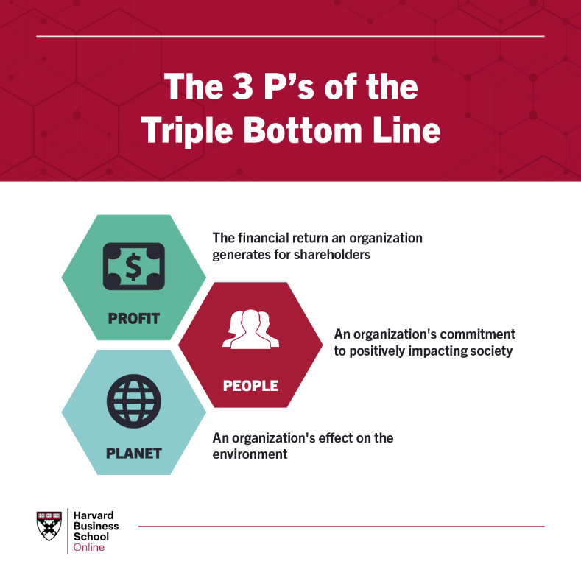
Figure 1 : Triple Bottom Line ; Source : Harvard Business School Online

Research Gap
This research aims to fill a gap in literature on the relationship between business strategies and sustainable development, particularly in early childhood education (ECE) centres. Despite the growing body of literature, studies often focus on large corporations or sectors like manufacturing, retail, or technology, leaving smaller, service-based businesses underrepresented. The study aims to explore the impact of purpose-driven strategies on ECE centres' business performance and contribution to sustainable development.
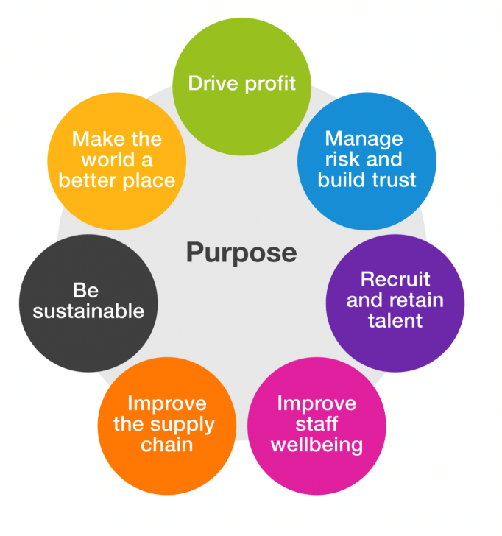
Figure 2 : The seven lenses of Purpose ; Source: Brand Ethos
Objectives
The main objective of this study is to assess the impact of purpose-driven strategies on the sustainable development of early childhood education centres. Specifically, the study seeks to achieve the following objectives:
1: To investigate the relationship between purpose-driven strategies and business performance in early childhood education centres.
Aligned Research Hypothesis: H1 (Purpose-driven strategies in ECE centres are positively associated with improved business performance.)
2: To assess the correlation between purpose-driven strategies and community engagement in early childhood education centres.
Aligned Research Hypothesis: H2 (There is a positive correlation between purpose-driven strategies and community engagement in ECE centres from an owner/administrator point of view)

Literature Review
Purpose-driven strategies prioritize long-term value by aligning organizational goals with societal well-being, ethical principles, and sustainability. These strategies lead to higher customer loyalty, employee engagement, and brand differentiation. (Kramer & Pfitzer, 2016; EY Beacon Institute, 2019). Small businesses can benefit from these strategies, especially in industries requiring trust and community engagement. However, existing literature mainly focuses on larger corporations, leaving a gap in understanding how these strategies can be successfully implemented. Sustainable development, as defined by the Brundtland Commission, aims to meet present needs without compromising future generations' ability to meet their own. Businesses, particularly in manufacturing, energy, and retail, play a significant role. (Porter & Kramer, 2011; Elkington, 1997). Research on the role of small businesses, particularly in the service sector, in promoting sustainable development is limited. This study highlights the importance of education-based businesses in fostering community well-being and social sustainability. (Spence et al., 2018) Early childhood education centres (ECE) are crucial micro-enterprises providing essential services to young children and their families. However, little attention has been given to their business side, such as managing operational challenges, engaging with communities, and adopting sustainability strategies. Despite challenges like financial sustainability, maintaining positive relationships with parents, and navigating regulatory requirements, ECE centres can contribute to community development through purpose-driven strategies. (National Institute for Early Education Research, 2019; OECD, 2018). The literature on the intersection of purpose-driven strategies and sustainable development is still emerging, with most studies focused on larger corporations. Research has demonstrated that businesses that align their purpose with sustainable development goals (SDGs) are better positioned to create long-term value for both shareholders and society (United Nations, 2015; PwC, 2018). These businesses are more likely to adopt sustainable practices, reduce their environmental footprint, and engage in socially responsible activities that benefit their communities (Stubbs & Cocklin, 2008).In the context of small businesses, purpose-driven strategies can help align business goals with broader societal objectives. For ECE centres, this could mean creating an environment that promotes both child development and community well-being, while also contributing to the local economy. By adopting purpose-driven strategies, these centres can enhance their business performance, build stronger relationships with stakeholders, and contribute to the long-term sustainability of their communities. However, empirical research on how these strategies work in the context of ECE centres is limited, which this study aims to address.
Research Methodology
This study analysed the impact of purpose-driven strategies on the sustainable development of early childhood education (ECE) centres in Kerala. A quantitative survey was conducted with administrators and owners of 30 centres. A structured questionnaire was used to gather data on purpose-driven strategies, business performance, adoption of sustainable practices, parent satisfaction, and community engagement. Descriptive and inferential statistics were used to test hypotheses. Participants were informed about the study and their right to withdraw at any time.
Hypotheses
(H1): Purpose-driven strategies in ECE centres are positively associated with improved business performance (e.g., profitability, enrollment rates).
(H2): There is a positive correlation between purpose-driven strategies and community engagement in ECE centres.
Confidentiality: All data was kept confidential and anonymized to protect participants' identities. Data was stored securely and only accessible to the researcher.

Data Analysis and Findings
 |  | Purpose-Driven Strategies Implementation |  | Business Performance Rating |  |  |  |  |  | Community Engagement Rating
N |  | 30 |  | 30 |  |  |  |  |  | 30
Missing |  | 0 |  | 0 |  |  |  |  |  | 0
Mean |  | 4.53 |  | 4.30 |  |  |  |  |  | 4.07
Std. error mean |  | 0.0926 |  | 0.0851 |  |  |  |  |  | 0.126
Median |  | 5.00 |  | 4.00 |  |  |  |  |  | 4.00
Standard deviation |  | 0.507 |  | 0.466 |  |  |  |  |  | 0.691
Table 1 – Descriptive Analysis ; Primary Data, JAMOVI
The study reveals that purpose-driven strategies implementation is high, with over half of businesses scoring near the top. The median score is 4.53, with moderate variability. All variables have means above 4.0, with Community Engagement Rating showing more variability, suggesting differences in community engagement.

Model Fit Measures
Model |  | R |  | R²
1 |  | 0.612 |  | 0.375

Model Coefficients - Business Performance
Predictor |  | Estimate |  | SE |  | t |  | p
Purpose-Driven Strategies Implementation |  | 0.563 |  | 0.137 |  | 4.10 |  | < .001
Table 2 – Inferential Analysis : Purpose – Driven Strategies & Business Performance Primary Data, JAMOVI
The study found a moderate positive correlation between purpose-driven strategies implementation and business performance, with a p-value < 0.001. The linear regression model explains a reasonable portion of the variance in business performance, suggesting that businesses implementing more purpose-driven strategies tend to perform better. This suggests that integrating purpose-driven strategies into operations could potentially improve performance.
Model Fit Measures
Model |  | R |  | R²
1 |  | 0.681 |  | 0.464

Model Coefficients - Community Engagement Rating
Predictor |  | Estimate |  | SE |  | t |  | p
Purpose-Driven Strategies Implementation |  | 0.929 |  | 0.188 |  | 4.926 |  | < .001
Table 3 – Inferential Analysis : Purpose – Driven Strategies & Community Engagement Rating ; Primary Data, JAMOVI
The study found a strong positive correlation between Purpose-Driven Strategies Implementation and Community Engagement Rating, with a p-value < 0.001. The linear regression model explained nearly half of the variation in community engagement among businesses, indicating that businesses adopting more purpose-driven strategies tend to have higher community engagement. This suggests that purpose-driven strategies not only improve internal performance but also enhance external relationships with the community. The study reveals that purpose-driven strategies significantly improve business performance, with a coefficient estimate of 0.563. These strategies also enhance community engagement, with a stronger relationship of 0.929. Businesses that invest in purpose-driven strategies are more likely to align with global sustainability initiatives, such as the UN's Sustainable Development Goals, thereby enhancing outcomes like decent work, economic growth, reduced inequalities, and sustainable cities.
Conclusion
The study reveals that purpose-driven strategies significantly enhance business performance and social sustainability through community engagement. These strategies align business success with broader societal goals, balancing profitability and social responsibility. Adopting these strategies not only benefits financially but also builds resilient, inclusive communities. The study's limitations include a small sample size, potential response bias, and time constraints, which may affect the generalizability of findings. There is potential for future research considering Parental Satisfaction and Sustainable Development as variables of the study, which were not included within the scope of this paper.
References
Elkington, J. (1997). Cannibals with forks: The triple bottom line of 21st century business. Capstone Publishing.
EY Beacon Institute. (2019). The role of purpose in business: Driving long-term value. Retrieved from https://www.ey.com
Kramer, M. R., & Pfitzer, M. (2016). The ecosystem of sustainable development: A new framework for achieving long-term success. Harvard Business Review. Retrieved from https://hbr.org
National Institute for Early Education Research. (2019). The state of early childhood education: A review of research. Retrieved from https://nieer.org
OECD. (2018). Early childhood education and care: Policy brief. Retrieved from https://www.oecd.org
Porter, M. E., & Kramer, M. R. (2011). Creating shared value: How to reinvent capitalism—and unleash a wave of innovation and growth. Harvard Business Review, 89(1), 62-77.
PwC. (2018). Global report on sustainable business practices. Retrieved from https://www.pwc.com
Spence, L. J., Rinaldi, L., & Arosio, V. (2018). Social sustainability and the role of small businesses: An overview. Journal of Business Ethics, 152(3), 549-563.
Stubbs, W., & Cocklin, C. (2008). Conceptualizing a 'sustainable' business: A critique of the literature. Journal of Business Ethics, 82(3), 579-598.
United Nations. (2015). Transforming our world: The 2030 agenda for sustainable development. Retrieved from https://sdgs.un.org/2030agenda
https://www.unicef.org/india/what-we-do/ecd
https://www.brandethos.co.uk/the-purpose-of-purpose/
https://online.hbs.edu/blog/post/what-is-the-triple-bottom-line

