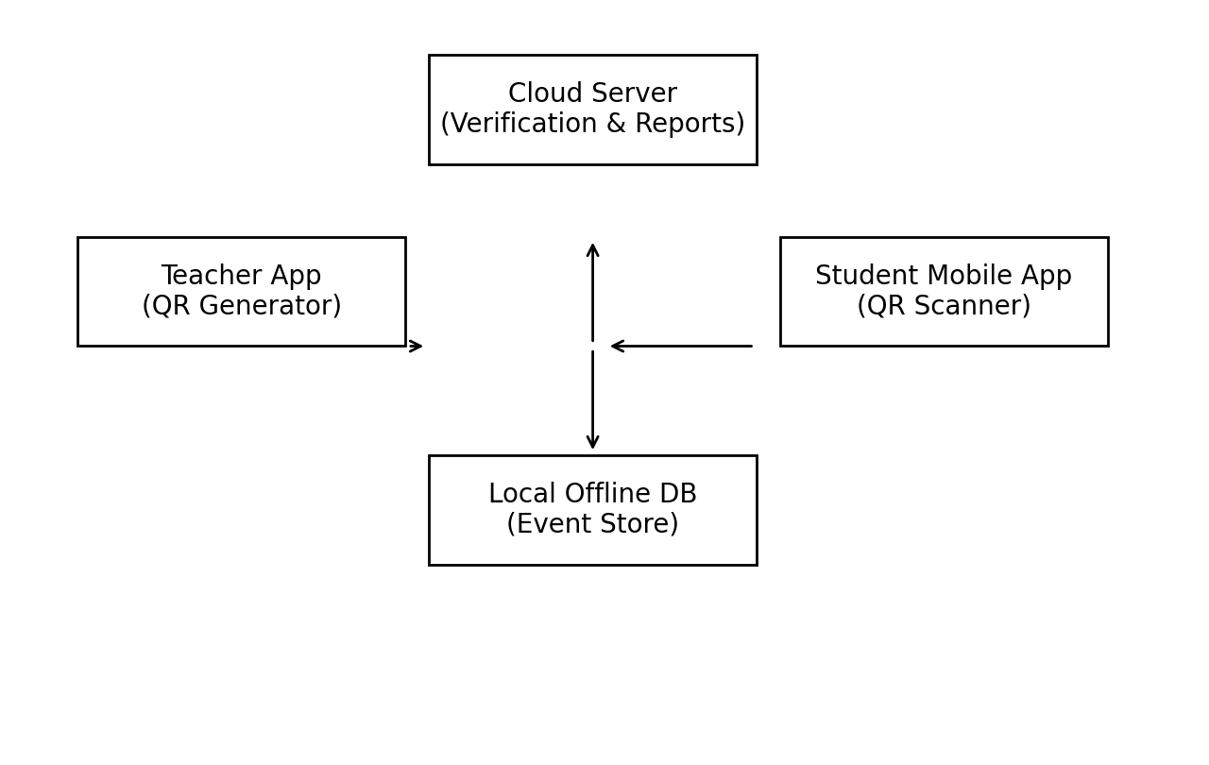
An Offline-First Geolocation-Enabled QR-Based Attendance Management System

for Rural Schools

Aakansha Sharma
Department of Computer Science and Engineering, IIMT Engineering College, Greater Noida, India
Guide: Prof. Ashish Shrivastava aakanshasharma3499@gmail.com
Abstract— Rural schools often rely on manual attendance registers due to intermittent connectivity, limited infrastructure, and low-cost device constraints. Existing QR-, RFID-, and biometric-based attendance systems improve automation but frequently assume always-online operation and provide weak defenses against proxy attendance (e.g., QR screenshots, card swapping). This paper proposes an offline-first, geolocation-enabled QR attendance framework tailored for rural schools. The system combines rotating QR session tokens,
privacy-preserving geo-zones (stored as zone identifiers rather than raw coordinates), append-only event sourcing with integrity checks, and idempotent batch synchronization. We formalize validation as a multi-factor constraint over token validity, geo-zone membership, and session time; provide algorithms for offline queuing and secure synchronization; and map key gaps in prior literature to concrete design improvements. The proposed design targets robustness, auditability, and practical deployment.

Keywords— Offline-first, QR scanning, Geolocation, Rural schools, Event sourcing, Secure synchronization, Proxy prevention.

INTRODUCTION

Attendance is foundational for academic monitoring, scholarship eligibility, mid-day meal reporting, and institutional accountability. Rural schools face distinct operational constraints: unreliable mobile data, inconsistent electricity, shared devices, and limited technical support. Manual registers are time-consuming and error-prone, while proxy attendance remains common. Prior work demonstrates QR, RFID, barcode, and biometric approaches, but many solutions assume continuous connectivity and under-specify security (proxy/replay) and privacy (location storage). This work targets a deployment-ready design that continues functioning offline, limits proxy behavior, and preserves privacy through coarse geolocation zones.
Contributions: (1) Offline-first attendance capture using append-only event sourcing, (2) rotating QR session tokens binding attendance to a short time window, (3) privacy-aware geo-zone validation (zone identifiers instead of raw GPS), (4) idempotent secure synchronization with duplicate suppression, and (5) a gap-to-improvement mapping and evaluation plan suitable for rural deployments.

Fig. 1. High-level architecture: teacher session generation, student scan, and offline event store.

RELATED WORK AND GAP ANALYSIS

Literature broadly clusters into: (a) QR attendance systems emphasizing speed and reduced paperwork [1], (b) RFID-based automation with centralized databases and dashboards [2], (c) combined facial recognition and QR systems improving identity assurance but increasing compute/privacy burden [3], and (d) barcode or hybrid systems that trade accuracy for lower cost [6]. Across these approaches, rural constraints (offline operation, intermittent sync, low-end devices) are often treated as an implementation detail rather than a first-class requirement.

Key gaps observed in prior work
G1—Always-online assumptions: Many systems require immediate server verification, failing during outages. G2—Proxy and replay vulnerabilities: Static QR codes and non-expiring tokens allow screenshot reuse; RFID cards can be shared. G3—Location without privacy: Some designs store raw coordinates, increasing privacy risk and complicating compliance. G4—Weak auditability: Editable records without append-only logs reduce trust in reporting. G5—Limited evaluation in rural conditions: Few studies report sync delay distributions, offline queue behavior, or teacher workload impact.

How our design fixes these gaps
We address G1 via offline-first capture with delayed sync; G2 via rotating tokens and time-bound validation; G3 via zone-based validation and minimal retention; G4 via append-only event sourcing with integrity hashes; and G5 via a deployment evaluation plan that measures availability, sync success rate, and time saved per class.

Work | ID Tech | Offline | Geo | Main limitation | Our improvement hook
[1] | QR | No/partial | Optional | Screenshot proxy, online de | pReontdaetincgytoken + offline qu
[2] | RFID | No | Yes | Card sharing, infra cost | Session binding + anomaly
[3] | Face+QR | No | No | Privacy/compute overhead | Optional biometric; default QR
[4] | Web AMS | No | No | Connectivity required | Event sourcing + delayed s
[5] | Hybrid rural | Discussed | No | No concrete sync protocol | Idempotent batch sync alg
[6] | Barcode | No | No | Scan failures + proxy risk | Fallback policy + append-
[7] | IRJET AMS | No | No | Limited threat model | STRIDE-based mitigations
[8] | SSRN study | Varies | Varies | No deployment metrics | Rural metrics + governanc
[9] | Face monitor | iNngo | No | Ethics not covered | Consent + minimal data p
[10] | Hybrid learni | nNg/Abarriers | N/A | Context: infra constraints | Use to justify offline-first requ

irement

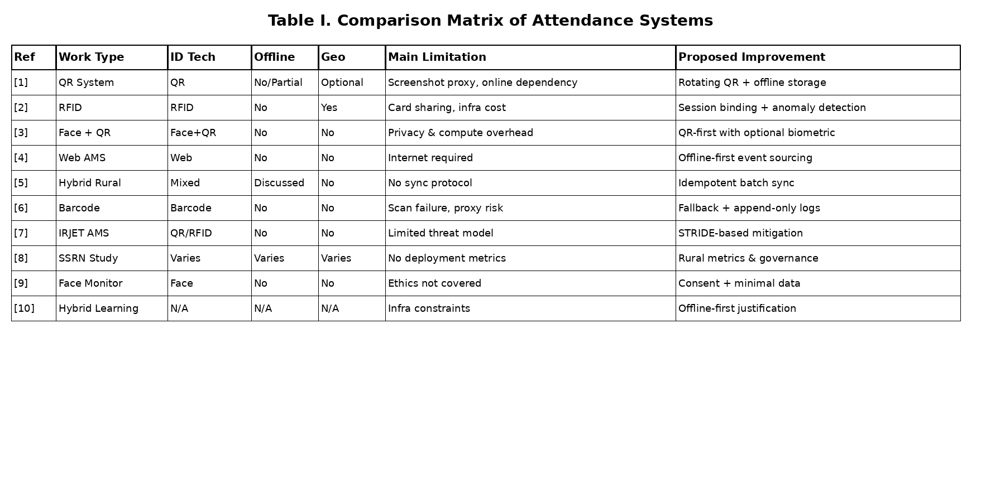
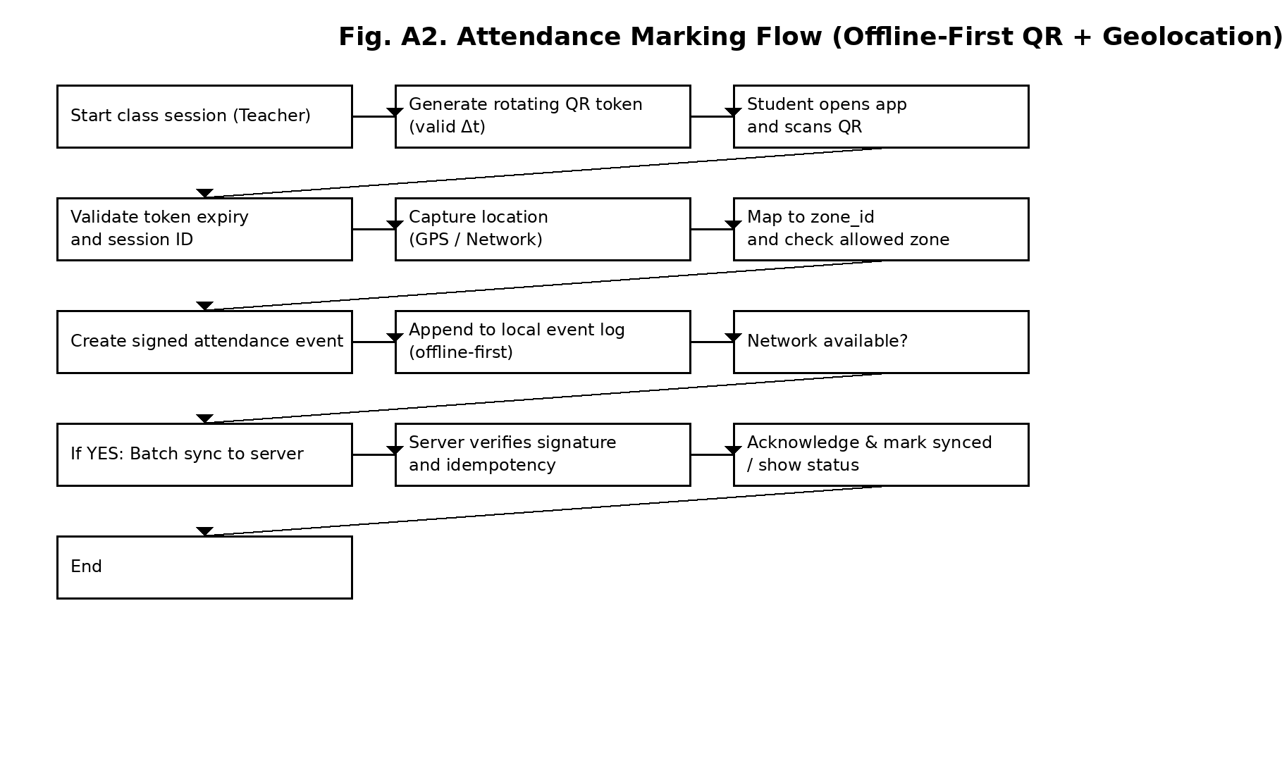
Table I. Comparison matrix (selected uploaded papers) and improvement hooks.
eue + zone check
checks + offline-first
ync
orithm
only audit
e
olicy
+zone

PROBLEM STATEMENT AND OBJECTIVES

Problem statement: Design an attendance system for rural schools that (i) functions reliably with intermittent connectivity, (ii) reduces proxy attendance and replay behavior, (iii) integrates location context without storing sensitive raw coordinates, (iv) preserves auditability of edits, and (v) provides practical deployment and evaluation guidance.

Objectives
O1: Offline-first capture with local persistence; O2: rotating QR session tokens (Δt) and secure validation; O3: geo-zone validation with privacy policy; O4: append-only event log with integrity hashes; O5: idempotent sync protocol and evaluation plan (time saved, sync success, proxy reduction).

PROPOSED SYSTEM DESIGN

Components
The system includes: (1) Teacher Session Controller (creates sessions tied to class/period), (2) QR Token Generator (rotates tokens every Δt seconds), (3) Student Scanner App (captures scan + zone), (4) Local Event Store (SQLite append-only log), (5) Sync Manager (batch upload with cursor), and (6) Web Dashboard (reports, exceptions, audits).

Data flow
Fig. 2. End-to-end attendance flow (scan → geo validation →
local event → sync/queue).
Each scan produces an event containing student_id, session_id, timestamp, zone_id, and an integrity field (hash/signature). Events are appended locally; the server applies idempotent inserts to prevent duplicates.

QR SCANNING AND SESSION TOKEN MODEL

We use rotating session QR to mitigate screenshot reuse. The teacher device generates a token that encodes session metadata and expiry. Students scan the QR; the app checks that the token is within validity window and matches the active session. In contrast to static QR codes used in several QR systems [1], rotation forces real-time presence.

Token structure
Token payload: {session_id, class_id, issued_at, expires_at, nonce}. The payload is signed (or HMACed) to prevent tampering. Only minimal identifiers are embedded; sensitive data is fetched after sync or resolved locally from cached timetables.

Anti-proxy rules
R1: Reject expired tokens; R2: Reject repeated scans from the same device within a short cooldown; R3: If location accuracy is poor, require teacher confirmation or mark as “pending”; R4: Flag anomalies (multiple devices scanning from a far zone).

GEOLOCATION VALIDATION MODEL

Rather than storing raw latitude/longitude, we map observed locations to predefined campus zones (grid/geohash). The stored field is zone_id, enabling privacy and simplifying policy (allowed zones per class). This directly addresses privacy gaps in systems that log detailed coordinates without retention policy.

Mobile (Offline)
Server (Cloud)
Fig. 3. Privacy-preserving geo validation: map location →
zone_id → allow/deny with fallback policy.
Fig. 5. Batch sync (idempotent): local append → queue → verify
→ ack cursor.
Algorithm 1: Offline Attendance Sync (pseudo-code)

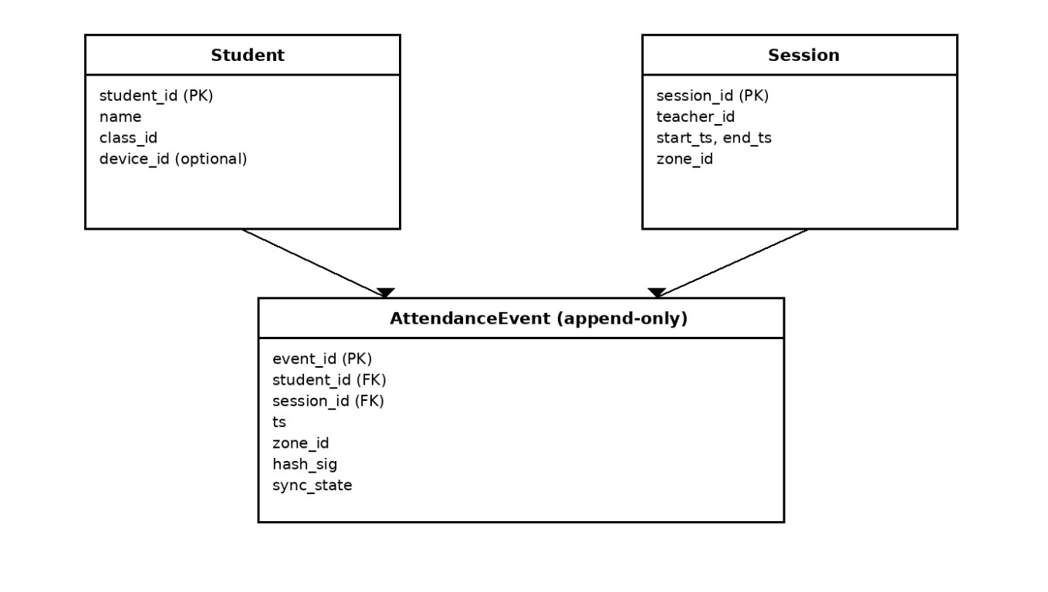
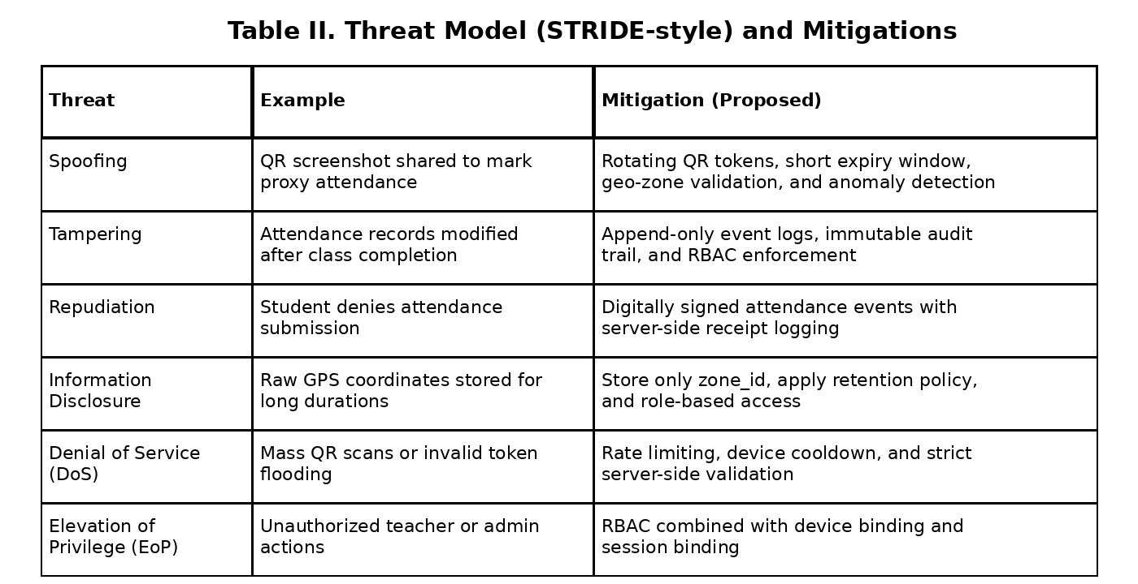
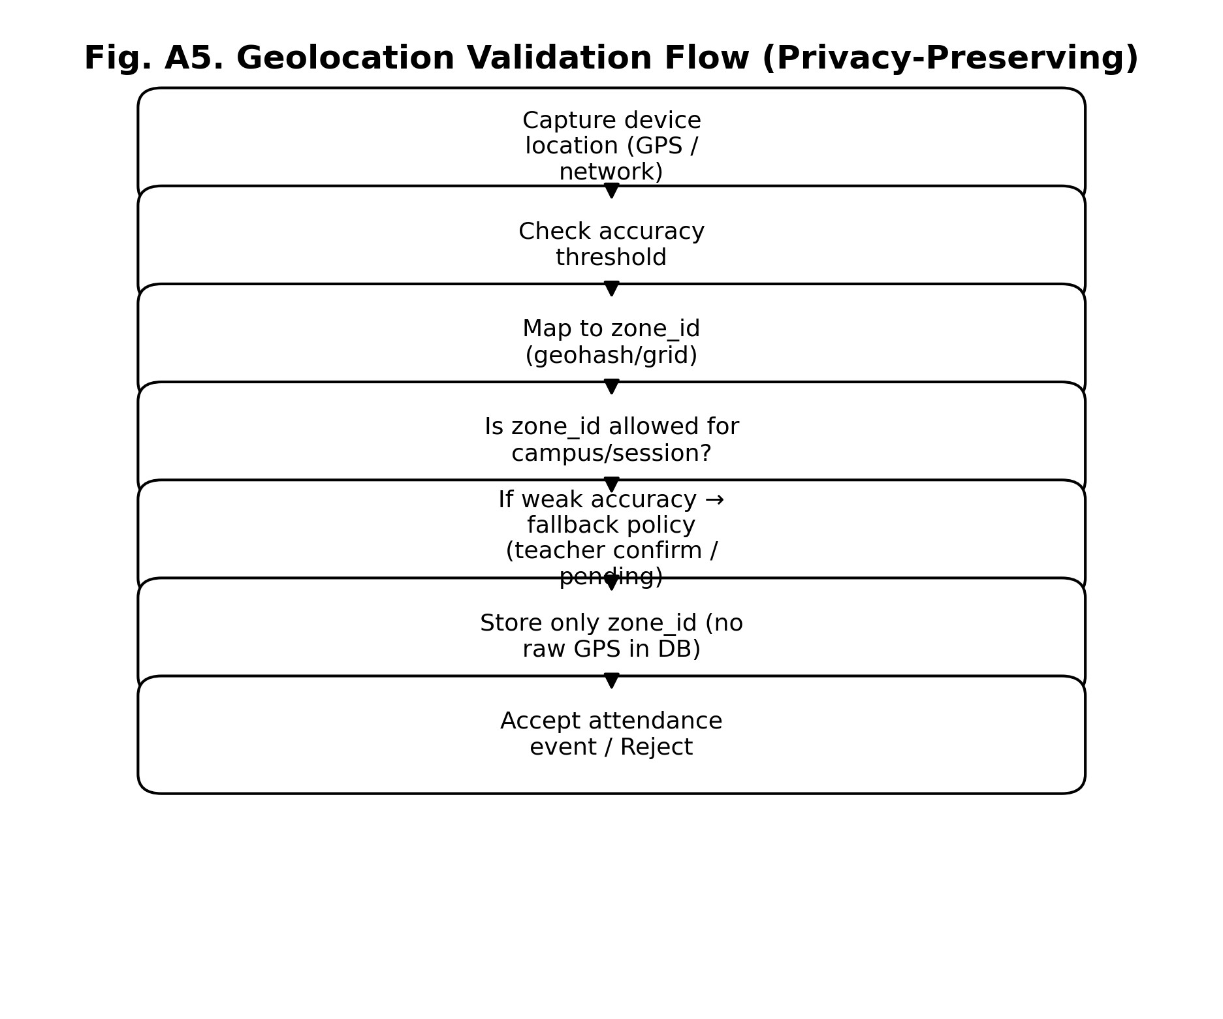
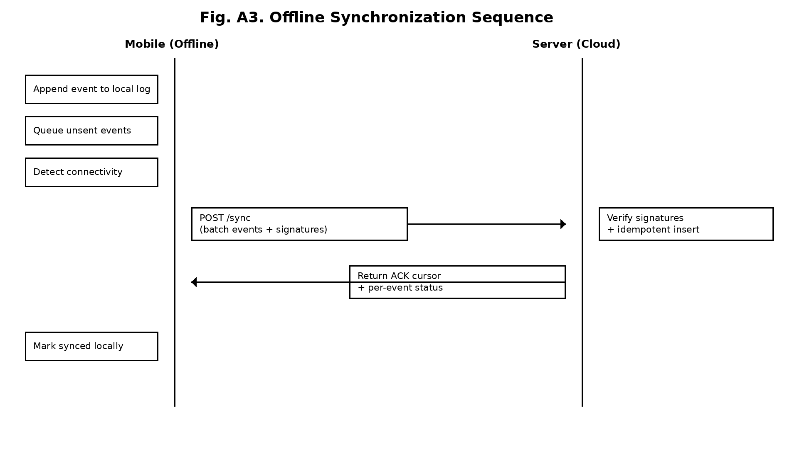
Privacy policy
zone_id
AttendanceEvent (append-only)

zone_id
status
Session
Student
+ anomal

role-based
AC
Table II. Threat model (STRIDE-style) and mitigations.
X. MATHEMATICAL MODEL
Fig. 4.
hash_sig
Database schema (local + conceptual): append-only
Let S be the set of students, and each attendance event e =
P1: Store only zone_id (coarse); P2: Retain raw sensor accuracy only transiently; P3: Apply role-based access to maps; P4: Retention limit for location logs (e.g., delete after report finalization).

OFFLINE-FIRST EVENT SOURCING AND DATABASE SCHEMA
Attendance events are appended to a local log to ensure reliability during outages. Corrections are also appended (never overwrite), preserving audit trails. This event-sourcing approach improves trust compared to editable rows in conventional web-based AMS.

AttendanceEvent with Student and Session references.

Integrity fields
Each event includes a hash signature: h = H(student_id ■ session_id ■ ts ■ zone_id ■ nonce). The server verifies h and enforces idempotence by event_id and hash.

SYNCHRONIZATION ALGORITHM

Synchronization follows store-and-forward. The client maintains a cursor over unsent events. When network is available, it uploads a batch; the server verifies signatures and returns an acknowledgement cursor. Duplicate batches are safe due to idempotent insert.
Input: batch_size B, local_log L, cursor c while true: E ← L.read_unsent(c, B) if E is empty: break if net_available(): payload ← sign(E) resp ← POST /sync(payload) if resp.ack: mark_sent(E); c ← resp.cursor else: backoff() else: schedule_retry(); break

THREAT MODEL AND SECURITY ANALYSIS

We consider STRIDE-like threats: spoofing (proxy), tampering (edit logs), repudiation (deny marking), information disclosure (location privacy), denial-of-service (spam scans), and elevation of privilege (teacher/admin actions).
Threat | Example | Mitigation (proposed)
Spoofing | QR screenshot shared to | aRbsoetantinsgtutdoeknetn + expiry + geo-zone
Tampering | Edits to attendance after | claAspspend-only logs + audit events +
Repudiation | Student denies marking | Signed event_id + server receipt log
Info disclosu | rReaw GPS stored long-term | Store zone_id only + retention + RB
DoS | Mass scans/invalid tokens | Rate-limit + cooldown per device
EoP | Unauthorized teacher acti | oRnsBAC + device/session binding

- sid, sess, t, z, h■. Token validity is: Q_valid = 1 if t ∈ [issued_at, expires_at]. Geo validity is: Z_valid = 1 if z ∈ AllowedZones(sess). Then the acceptance function is: V(e)= Q_valid ∧ Z_valid ∧ SessionOpen(sess). We define a risk score R for anomaly detection: R = w1·I(geo_outlier)+w 2·I(rapid_rescan)+w3·I(device_change)+w4·I(time_skew).

EXPERIMENTAL SETUP AND SIMULATED RESULTS
Because field trials vary by region and infrastructure, we report a simulation-driven evaluation plan and expected behavior. We compare (A) online-only QR, (B) RFID-only, and (C) proposed offline-first QR+geo. Metrics: time per class, offline success rate, sync delay (p50/p95), and proxy risk events.

Table III. Simulated comparison (indicative) for rural deployment conditions.

Deployment considerations
Teacher training and policy are critical: define allowed zones, handle low-accuracy cases, and manage exceptions (late arrivals). Hardware requirements are minimal (Android phone for scanning; teacher device can be a phone or low-cost tablet). The system supports periodic synchronization (e.g., daily) to reduce data cost.

ADVANTAGES AND LIMITATIONS

Advantages
A1: Attendance capture continues during network outages. A2: Rotating tokens reduce screenshot-based proxy. A3: Geo-zones provide context while preserving privacy. A4: Append-only logs improve trust and auditability. A5: Idempotent sync prevents duplicates and supports low-bandwidth batch upload.

Limitations
L1: Indoor GPS accuracy may be weak; fallback policies are needed. L2: Requires at least one scanning device per student or shared device policy. L3: Geolocation spoofing cannot be fully eliminated; anomaly detection and supervision remain necessary.

CONCLUSION AND FUTURE WORK

We presented an offline-first, geolocation-enabled QR attendance system tailored for rural schools, addressing common gaps in prior work by combining rotating session tokens, privacy-preserving geo-zone validation, append-only event sourcing, and idempotent batch synchronization. Future work includes piloting in rural schools, measuring real proxy reduction, and extending dashboards for education department reporting.

REFERENCES

- (IJACSA) International Journal of Advanced Computer Science and Applications, Vol, 2014.
- Southern L eyte St ate Univ ersity 34 PUBLICA TIONS 34 CITATIONS SEE PROFILE All c ontent f ollo wing this p age was uplo aded b y Jose C, 2025.
- However, the applicability of these systems may vary across different educational settings, 2024.
- Selection of appropriate method and the device used for data acquisition reduces chances of errors occurring, 2015.
- This synopsis presents a comprehensive and deeply analytical study on the development of an Automated
fAflitnteen) dance System for rural schools.
- The Pacific Journal of Science and Technology –224– http://www.akamaiuniversity.us/PJST.htm Volume 17,
Metric | Online QR | RFID | Proposed (QR+Geo+O
Avg. marking time / 40 | st3u–d5enmtsin | 2–4 min | 2–3 min
Works during outage | No | Partial | Yes
Proxy risk (qual.) | High | Medium | Low
Sync delay p95 | N/A (fails) | N/A | ≤ 24h (scheduled)
Auditability | Low | Medium | High (append-only)

2016.
- This i s a highly important problem, 2019.
- These inefficiencies directly impact teache r productivity and administrative accuracy, hindering the overall educational ecosystem, 2025.
- It is the most critical part which has various features like eyes, nose, ears, mouth, etc, 2023.
- Kanageswari Suppiah Shanmugam, Arsaythamby Veloo, Soo Boon Ng & Suheysen Revindran To cite this article: S, 2025.

