A Conceptual Framework for Chinese University Students: Active Learning and the Development of Emotional Expression, Self-Esteem, and Self-Regulation

ABSTRACT
Objective: This conceptual study develops a culturally responsive framework for strengthening Chinese university students’ psychological competence through active learning in mental health education. It focuses on the coordinated development of emotional expression, self-esteem, and self-regulation, which are treated as mutually reinforcing dimensions rather than isolated outcomes. Method: Drawing on Experiential Learning Theory and Positive Psychology, the study conducts a conceptual analysis of recent literature on Chinese university students, cultural norms of emotional restraint, lecture-based mental health education, and participatory pedagogical design. The analysis integrates theoretical assumptions with a ten-module active learning structure organized around classroom safety, self-value reconstruction, and regulation internalization. Results: The framework clarifies how active learning can reduce the knowledge-behavior gap by creating psychologically safe interaction, supporting reflective practice, and transforming classroom experience into practical coping strategies. It further proposes three intervention pathways: active interaction for adaptive emotional expression, strengths-based practice for self-esteem reconstruction, and reflective practice for self-regulation strengthening. These pathways show how a single active learning activity can simultaneously promote expression, confidence, and behavioral adjustment while respecting collectivist values of harmony, modesty, and peer support. Conclusion: The proposed framework provides a localized and operational model for Chinese university mental health education. It shifts the pedagogical emphasis from passive knowledge transmission to competence-oriented development and offers theoretical propositions for future empirical testing. The study suggests that culturally sensitive active learning can help universities convert mental health courses into supportive, reflective, and practice-based environments that enhance long-term psychological growth, classroom participation, and sustainable student well-being across diverse campus contexts.
Keywords: Active Learning; Mental Health Education; Emotional Expression; Self-Esteem; Self-Regulation

1. INTRODUCTION
Student mental health has become a global concern in 21st-century higher education. Under the dual pressures of escalating social competition and an achievement-oriented culture, Chinese university students face distinctive psychological adaptation challenges (Shi et al., 2022). Contemporary mental health is no longer defined as the absence of illness, but a comprehensive psychological competence involving emotional awareness, self-evaluation, and behavioral regulation (Gautam et al., 2024), making the exploration of effective educational strategies to enhance psychological literacy both practically urgent and academically valuable (Tick et al., 2023).
Shaped by Confucian values of collectivism and interpersonal harmony, many Chinese students inhibit emotional expression to maintain social stability, with over 60% adopting withdrawal and avoidance to cope with negative emotions (Fogel & Jiang, 2025; Wulijijirigela, 2023). Chronic emotional inhibition restricts authentic self-expression, increases vulnerability to psychological distress, and impairs resilience (Fogel & Jiang, 2025). Despite the widespread implementation of mental health education in Chinese universities, current models are limited by a teacher-centered, lecture-based approach that confines students to passive learning (Islomova et al., 2022). Such methods improve conceptual understanding but rarely drive behavioral change, as emotional expression, self-esteem and self-regulation are practical skills—knowledge of strategies does not guarantee real-world application (Warburton, 2025; Kaur, 2025), resulting in a persistent knowledge-behavior gap.
This study argues that mental health cultivation relies on the synergistic development of emotional expression, self-esteem and self-regulation, which interact dynamically: inadequate emotional expression erodes self-worth and weakens regulation ability; low self-esteem intensifies emotional inhibition and reduces proactive self-management (Cui, 2025; Korzeniowska et al., 2024). Fragmented single-construct interventions yield unsustainable effects, highlighting the need for integrated, participatory educational programs. Despite growing research on student mental health and active learning, four critical gaps remain: first, existing studies examine the three core constructs in isolation, leading to fragmented understandings of psychological functioning (Prokhorov et al., 2023); second, traditional education overemphasizes didactic instruction and neglects experiential learning, reinforcing the knowledge-behavior disconnect (Zhang & Abdullah, 2024; Yap & Mak, 2025); third, few studies clarify how active learning systematically strengthens the three core competencies (Attié et al., 2022; G S & Paul, 2024); fourth, limited research accounts for Chinese cultural particularities in integrating cultural factors, psychological variables and active learning mechanisms (Chen et al., 2025; Lu et al., 2025).
To address these gaps, this study reinterprets active learning within a comprehensive developmental framework that connects interactive experiences with the shared development of the three core competencies. It offers three key theoretical insights: first, framing the three concepts as mutually dependent and examining how they relate to one another within a cohesive system; second, combining two foundational theories to clarify how active learning supports mental health; and third, putting forward a step-by-step teaching structure designed to cultivate emotional openness, stronger self-worth, and internalized self-regulation. The study also puts forth four evidence-based proposals to inform and guide future empirical research.
2. THEORETICAL AND CONCEPTUAL FOUNDATIONS
The pedagogical framework proposed in this paper is grounded in Experiential Learning Theory (ELT) and Positive Psychology, which provide critical theoretical support for explaining how active learning translates into psychological competence development from the perspectives of learning process and developmental value respectively.
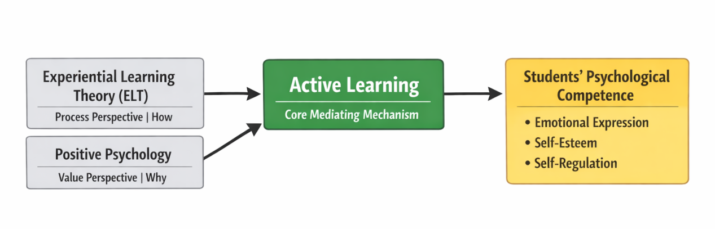
Figure 1. Theoretical Support Framework for Active Learning.

2.1 Experiential Learning Theory (ELT)
Proposed by Kolb (1984), ELT posits that learning is a cyclical process of concrete experience, reflective observation, abstract conceptualization and active experimentation, rather than passive knowledge reception (Jones-Roberts & Bechtold, 2024). Validated in Western individualistic contexts (Burke, 2020; Diyanni & Borst, 2020), ELT lacks adaptation to Chinese collectivist culture—Western applications emphasize individual reflection, while Chinese students favor group-based experience and peer-guided reflection (Chen & Yang, 2023). This paper addresses this cultural mismatch by emphasizing group collaboration and collaborative reflection in active learning design.
2.1.1 Experience and Self-Esteem Development
Concrete experience is the starting point of the ELT cycle. For students with low self-esteem, persuasion or reasoning hardly alters negative self-perception, but active learning creates structured experiences including collaborative tasks, role-playing and situational participation for them to perceive their own worth and capabilities, gaining genuine "I can do it" feedback. Such practice-derived positive feelings lay a stable foundation for self-esteem reconstruction (Diyanni & Borst, 2020).
2.1.2 Reflection and Self-Regulation Development
Reflective observation is the core of both ELT and self-regulation development. Self-regulation involves monitoring and adjusting emotions, impulses, cognition and behaviors, which relies on conscious awareness and reflection of personal experiences. In active learning contexts, students shift from "experiencers" to "self-observers" by reviewing classroom interactions, analyzing emotional changes and identifying response patterns, thus understanding their stress coping styles and forming targeted regulation strategies (Stevanus & Budhayanti, 2024).
2.2 Positive Psychology
Unlike the traditional medical model focusing on problem remediation, Positive Psychology emphasizes fostering positive traits, strengths and healthy development (Zhu, 2020; Seligman & Csikszentmihalyi, 2000). Western applications prioritize individual strength expression (Saksena, 2023), conflicting with Chinese cultural values of modesty and group harmony (Li & Cui, 2022); meanwhile, most Chinese studies apply this theory only to students with psychological distress (Xu et al., 2024), deviating from its universal development goal. This paper resolves these issues by integrating Confucian values of "self-cultivation" and "harmony" into Positive Psychology, designing interventions for all Chinese university students.
2.2.1 From Remediation to Development
Positive Psychology redefines mental health education goals as promoting positive competence and growth potential for all students, rather than only remediating psychological deficiencies (Zhao, 2025). This framework targets the entire student population, framing emotional expression as a positive communication competence, self-esteem as a supportive psychological resource, and self-regulation as a lifelong self-management competence—expanding the task of mental health education from "reducing problems" to "promoting development" (Zhu, 2020).
2.2.2 Students as Active Constructors
Positive Psychology holds that individuals are active developmental subjects with growth potential, rather than passive recipients of psychological intervention. This redefines teachers’ roles from knowledge transmitters to designers and facilitators of supportive learning environments (Saksena, 2023). Through active learning modules, teachers create a classroom context of positive feedback, peer support and psychological safety, enabling students to discover their strengths, accumulate successful experiences, and build confidence in psychological competence—evolving from passive assistance recipients to active constructors of their own psychology (Nagizade, 2024).
2.3 Theoretical Integration
ELT and Positive Psychology form a complementary, context-adaptive foundation for the conceptual framework, each addressing a critical aspect of active learning and psychological competence development:
ELT provides a procedural mechanism for active learning, whose cyclical process explains how students internalize psychological skills through concrete participation (Chae, 2024), bridging the knowledge-behavior gap by emphasizing practice and reflection over memorization (Wu, 2020);
Positive Psychology provides a value orientation for psychological competence development, shifting focus from "reducing problems" to "promoting strengths" (Zhao, 2025) and aligning with the developmental needs of Chinese students under achievement pressure (Shi, 2022), fostering sustainable psychological resources such as resilience and self-acceptance;
Both theories adapt well to Chinese higher education: ELT’s group experience emphasis aligns with collectivist norms (Chen & Yang, 2023), while Positive Psychology’s focus on harmonious interpersonal relationships resonates with Confucian values (Fogel & Jiang, 2025). Their integration avoids cultural mismatches, making active learning both effective and contextually relevant.
3. REVIEW OF CORE CONSTRUCTS
Emotional expression, self-esteem and self-regulation constitute the core of university students’ psychological competence, forming a dynamic interactive system rather than existing in isolation. Clarifying their theoretical connotations and inherent correlations lays the foundation for the pedagogical framework construction.
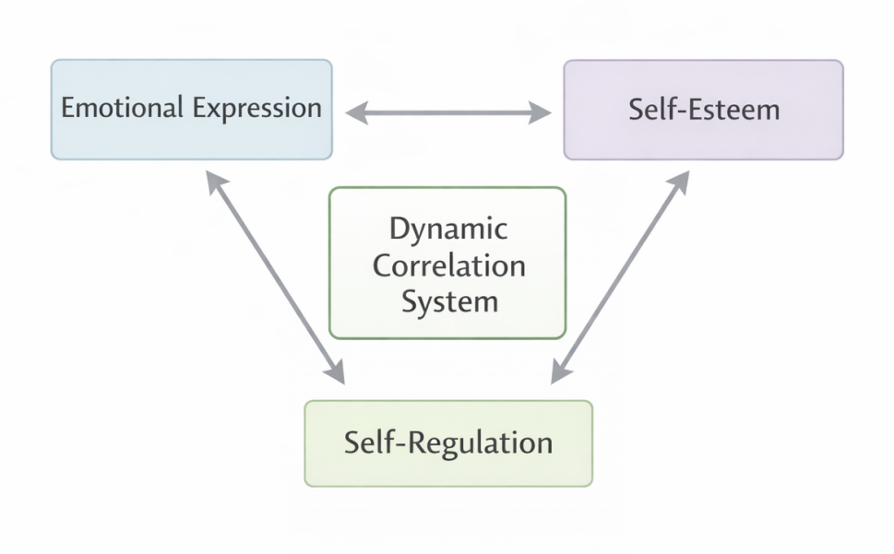
Figure 2. Interactive Logic of the Three Core Psychological Competence Constructs.

3.1 Emotional Expression
Emotional expression refers to the process of conveying internal emotional states via verbal, facial and bodily means (Parapat, 2025), reflecting emotional experiences and the ability to translate internal feelings into external communication. It includes sharing positive emotions and, more importantly, identifying, acknowledging and moderately externalizing negative emotions such as anxiety, frustration and sorrow. Appropriate expression alleviates psychological burdens, reduces cognitive and emotional depletion, and creates conditions for seeking support (SHarafitdinov, 2024).
Raised in a culture emphasizing emotional restraint, many Chinese students view emotional expression as immaturity (Fu et al., 2024). Existing research either frames this suppression as a "cultural defect" (Fogel & Jiang, 2025) or only focuses on its negative consequences, ignoring its adaptive value in maintaining group harmony (Li & Cui, 2022). This paper fills the gap by defining emotional expression as moderate, context-appropriate communication of both positive and negative emotions, balancing personal needs and cultural norms.
3.2 Self-Esteem
Self-esteem is an individual’s overall evaluation and subjective feeling of self-worth (Rosenberg, 1965), reflecting an affirmative attitude toward one’s own value and capabilities. A relatively stable psychological resource for college students, it is also susceptible to academic achievement, interpersonal feedback and social comparison. High self-esteem maintains positive self-identity in the face of challenges, while low self-esteem erodes resilience and leads to withdrawal and helplessness (Yaremko, 2023).
This study regards self-esteem not as a mere outcome variable, but a core supportive psychological resource that influences students’ classroom participation willingness, emotional expression courage and post-failure adjustment ability, forming a close association with emotional expression and self-regulation (Zemskova, 2024).
3.3 Self-Regulation
Self-regulation is the ability to monitor, evaluate and adjust cognition, emotions and behaviors to achieve specific goals (Zimmerman, 2000), encompassing impulse control, goal management and behavioral consequence evaluation. In this paper, it specifically refers to the ability to maintain psychological stability and adopt adaptive behaviors under pressure or emotional fluctuations (Moilanen, 2024), manifesting in emotional identification/management and behavioral strategy adjustment/goal commitment (Lee, 2023).
More executive and transformative than the other two constructs, self-regulation does not directly produce emotions or shape self-perception, but influences the integration of emotional experiences, self-understanding and external pressure into appropriate responses. As a key psychological mechanism, it determines whether internal psychological resources can be translated into effective actions (Romanovska & НОВАК, 2025).
3.4 Interactive Logic of Core Constructs
Emotional expression, self-esteem and self-regulation form an organic interdependent system, with reciprocal relationships supported by theory and empirical evidence:
1. Emotional expression → Self-esteem: Genuine expression strengthens self-acceptance (a core of self-esteem, Rosenberg, 1965). Prolonged suppression leads to the belief that "my true self is unacceptable", eroding self-worth (Fu et al., 2024; Cui, 2025), while adaptive expression fosters coherent self-identity and healthy self-esteem;
2. Self-esteem → Self-regulation: High self-esteem fulfills the "competence" need in Self-Determination Theory (Zemskova, 2024), motivating students to persist in emotional and behavioral regulation despite setbacks. Low self-esteem often leads to abandoning regulation strategies under achievement pressure (Liang, 2024), confirming self-esteem as a prerequisite for effective self-regulation;
3. Self-regulation → Emotional expression/self-esteem: Self-regulation judges the timing and intensity of emotional expression (Bravo Anchundia et al., 2024), avoiding impulsive outbursts that damage relationships. Successful regulation enhances self-efficacy (Martínez Díaz, 2023) and further boosts self-esteem, ensuring the system’s stability and adaptability.
3.5 Core Competence Triad
The three constructs correspond to different dimensions of psychological development: emotional expression is the gateway for externalizing and communicating internal experiences; self-esteem is the core resource for self-worth evaluation; self-regulation is the executive mechanism for translating psychological resources into adaptive actions (Gómez Muzzio & Strasser, 2022). With independent connotations and close mutual support, they form a dynamic psychological competence system. Thus, the subsequent active learning framework focuses on their synergistic development, rather than isolated single-variable interventions (Lin et al., 2025).
3.6 Theoretical Propositions
Based on integrated theories and construct relationships, four theoretically grounded propositions are proposed:
Proposition 1: Active learning is positively associated with adaptive emotional expression among Chinese university students, and psychological safety plays a full mediating role in this relationship.
Theoretical Justification: ELT holds that learning occurs through low-risk concrete experiences (Kolb, 1984). Active learning activities such as anonymous sharing reduce evaluation anxiety and "face" concerns (Mai et al., 2024)—major barriers to Chinese students’ emotional expression (Fogel & Jiang, 2025). Psychological safety fosters open emotional expression by breaking inhibition.
Proposition 2: Adaptive emotional expression is positively associated with self-esteem among Chinese university students, and self-esteem positively reciprocally predicts adaptive emotional expression in this bidirectional relationship.
Theoretical Justification: Open expression enhances self-understanding and acceptance, thus boosting self-esteem; students with higher self-esteem are more confident to express true emotions (Delgado Cobeña & Molina Santana, 2023). Empirical studies have verified this mutual promotion (Fu et al., 2024).
Proposition 3: Self-esteem positively moderates the relationship between active learning and self-regulation ability among Chinese university students— the higher the level of self-esteem, the stronger the positive effect of active learning on self-regulation ability.
Theoretical Justification: Self-esteem provides psychological resources for students to persist in reflective practice, which is a core of active learning. Higher self-esteem motivates the learning and application of self-regulation strategies, while lower self-esteem leads to insufficient motivation for competence development(Kholbotayeva, 2021).
Proposition 4: Adaptive emotional expression, self-esteem and self-regulation each have a positive predictive effect on psychological competence development among Chinese university students, and active learning positively moderates the synergistic effect of the three constructs on psychological competence.
Theoretical Justification: Psychological competence is a multidimensional construct requiring integrated development (Chen et al., 2024). Active learning fosters all three dimensions through experience, reflection and peer support (Dogani et al., 2023), creating a synergistic effect unattainable by isolated interventions.
4. PEDAGOGICAL DESIGN OF THE MODULES
Based on the above theoretical analysis and core construct clarification, this paper proposes a ten-module active learning pedagogical framework for university mental health education, guided by the Analysis, Design, Development, Implementation, and Evaluation, or ADDIE, approach (SANCHEZ-GARCÍA et al., 2023). Centered on the synergistic development of the three core competencies, the framework is divided into three progressive stages—from low to high difficulty, from competence initiation to internalization—aiming to foster students’ psychological competence through participation, interaction, reflection and situational application.
4.1 Module Design Logic
The framework targets key psychological challenges of Chinese university students: reluctance to express vulnerability, poor emotional identification, negative self-evaluation, and lack of practical self-regulation strategies (Guan et al., 2025). The ADDIE model underpins its core logic:
Analysis: Identify students’ difficulties in the three core competencies and their cultural constraints;
Design: Set phased goals from low-risk emotional participation to comprehensive competence integration;
Development: Create operable experiential, interactive and reflective modules with cultural adaptation for collectivist backgrounds;
Implementation: Adopt group collaboration as the main form, enhance participation via teacher facilitation and peer support;
Evaluation: Establish formative evaluation based on student feedback, and adjust module content and implementation methods flexibly (SANCHEZ-GARCÍA et al., 2023).
The ten modules form a coherent system that transforms the abstract conceptual framework into practical teaching logic, making active learning a structured educational process for psychological competence development rather than a random combination of classroom activities.
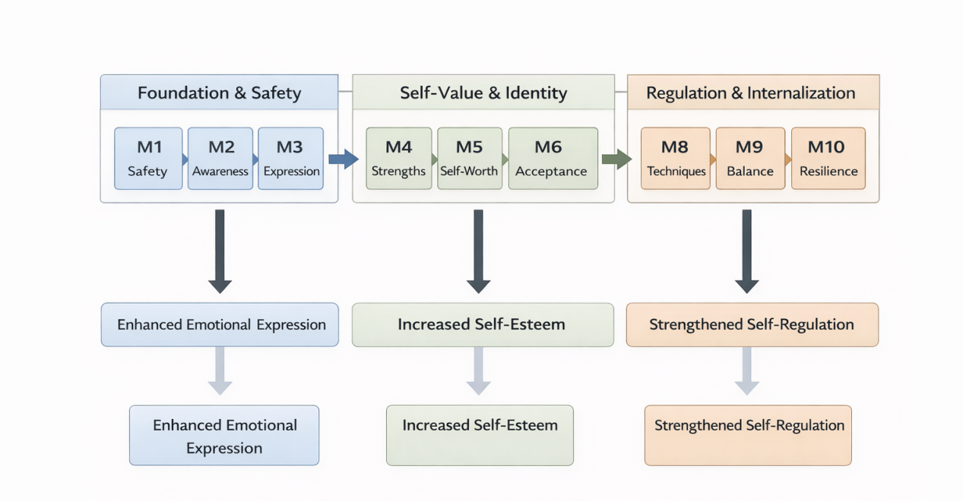
Figure 3. The 10-Module Active Learning Pedagogical Framework.
4.2 Content of the Ten Modules
Divided into three interconnected stages, the modules progress in content and difficulty, closely aligning with the developmental focus of the three core competencies:
Stage 1: Foundation & Safety, or Emotional Expression Initiation, includes 3 modules: establishing inclusive classroom norms, enhancing emotional identification ability, and exploring non-verbal expression channels. Its core goal is to reduce expression anxiety, build a non-judgmental learning environment, and lay a solid foundation for adaptive emotional expression.
Stage 2: Self-Value & Identity, or Self-Esteem Enhancement, includes 4 modules: identifying personal strengths, challenging negative automatic thoughts, cultivating self-compassion and self-acceptance, and practicing social emotional expression in low-risk scenarios. Its core goal is to break negative self-evaluation cycles under achievement pressure, rebuild positive self-cognition, and form stable practice-based self-esteem.
Stage 3: Regulation & Internalization, or Self-Regulation Strengthening, includes 3 modules: acute emotional regulation skill training, interpersonal conflict scenario simulation and practice, and long-term psychological resilience planning. Its core goal is to help students master practical self-regulation strategies, apply them in simulated and real-world scenarios, and internalize these strategies into automatic adaptive responses.
4.3 Progressive Structure and Significance
The modular design follows the interdependent logic of the core competence triad: Stage 1 creates the entry point for psychological participation by building psychological safety and emotional awareness; Stage 2 provides core internal psychological resources through self-esteem reconstruction; Stage 3 realizes the ultimate goal of psychological competence development by promoting the transformation of competencies into stable, automatic behaviors.
This design addresses two major drawbacks of traditional mental health education—passive knowledge instillation and isolated skill training. Through a hierarchical instructional arrangement, it fosters the synergistic development of the three core competencies, framing active learning as a developmentally meaningful educational mechanism rather than a mere collection of fragmented activities. More importantly, it aligns the teaching modules with the core logic of the conceptual framework, rendering active learning an operational pathway for integrated competence development and achieving the organic integration of theory and practice.
5. PROPOSED INTERVENTION PATHWAYS
Three interrelated and mutually reinforcing intervention pathways are proposed to explain how active learning modules foster psychological competence, based on the Pedagogical Input-Psychological Mediating Process-Developmental Outcome framework. These pathways are not linear causal hypotheses, but conceptual generalizations that clarify the specific action mechanisms of active learning on the three core competencies, forming an integrated intervention system with focused goals and mutual reinforcement.
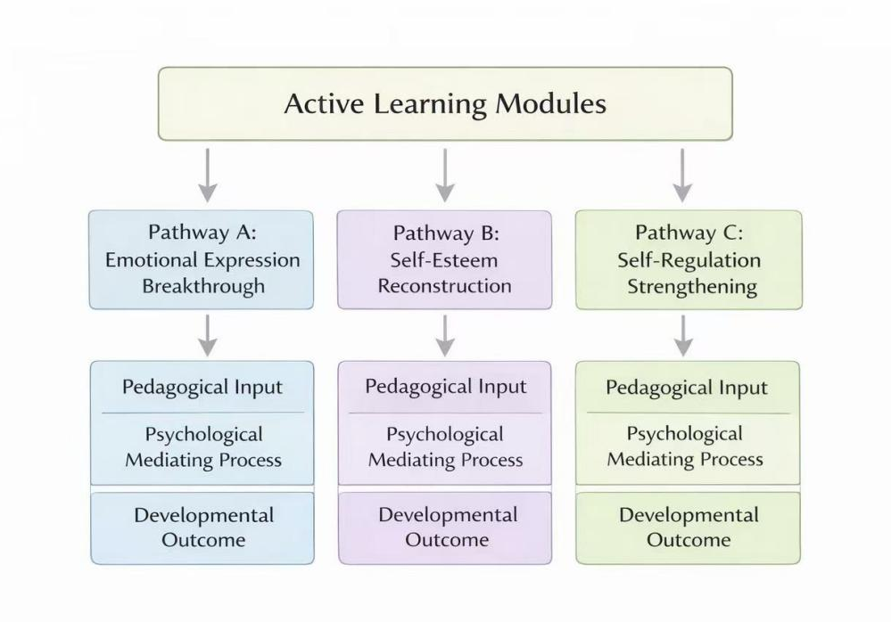
Figure 4. Three Intervention Pathways of Active Learning for Psychological Competence Development.
5.1 Pathway A: Active Interaction and Adaptive Emotional Expression
This pathway targets Chinese students’ emotional inhibition rooted in evaluation anxiety, “face” culture, and insufficient psychological safety (Mai et al., 2024), addressing the lack of effective instructional solutions identified in prior research.
Pedagogical Input: Low-risk interactive activities, including anonymous emotional sharing, small-group guided discussion, and peer emotional agreement-making, are designed to construct a decentralized, non-judgmental classroom atmosphere (Vîșcu, 2024).
Mediating Mechanisms: Peer resonance reduces social defensiveness, alleviating the loneliness and shame associated with emotional suppression (Shah & Galantino, 2019); meanwhile, vocabulary expansion and bodily awareness training enhance students’ capacity to identify and articulate their emotions (Velmurugan et al., 2025).
Developmental Outcome: Students transition from complete emotional suppression to conscious emotional identification, and ultimately to moderate, context-appropriate expression that aligns with Chinese cultural norms—an adaptive capacity that cannot be effectively fostered through traditional lecture-based instruction (De-Damas-González & Gomariz-Vicente, 2020).
5.2 Pathway B: Strengths-Based Practice and Self-Esteem Reconstruction
This pathway links self-esteem development to concrete active learning practices, addressing the limitation of isolated self-esteem research and the short-term effects of traditional verbal encouragement (Yaremko, 2023).
Pedagogical Input: Strength-oriented experiential activities, including peer strength evaluation, collaborative task completion, and social scenario simulation, are designed to help students rediscover their personal capabilities and receive authentic positive feedback (Dunn, 2022).
Mediating Mechanisms: Continuous successful experiences gradually loosen negative self-narratives, while self-compassion and cognitive challenge activities support the positive reinterpretation of failures, reducing the erosion of self-esteem (Jeon & Jo, 2022).
Developmental Outcome: Students develop stable, practice-based self-esteem characterized by enhanced competence and self-acceptance, which acts as the core psychological resource for subsequent emotional expression and self-regulation development, effectively filling the gap of isolated self-esteem interventions in existing research.
5.3 Pathway C: Reflective Practice and Adaptive Self-Regulation Strengthening
This pathway resolves the knowledge-behavior gap in traditional self-regulation teaching (Martínez Díaz, 2023), explaining how active learning facilitates students’ mastery and real-world application of self-regulation strategies.
Pedagogical Input: Reflective and practice-oriented activities, including emotional reflective journals, teacher-guided discussion, regulation skill training, conflict role-playing, and personalized coping plans, are designed to convert classroom experiences into structured opportunities for self-observation and iterative practice (Velmurugan et al., 2025).
Mediating Mechanisms: Through the experience-reflection-adjustment-practice cycle, students develop emotional metacognition—identifying emotional triggers, recognizing response patterns, and evaluating the effectiveness of coping strategies—aligning closely with the reflective observation stage of Kolb’s Experiential Learning Theory (Kolb, 1984).
Developmental Outcome: Students master context-adaptive self-regulation strategies, transforming abstract theoretical knowledge into practical tools for managing academic and interpersonal pressure. Enhanced self-regulation further supports healthy emotional expression and reinforces stable self-esteem, forming a synergistic, positive growth cycle that sustains long-term psychological well-being (Cercado-Acosta et al., 2025).
5.4 Integrative Significance of the Three Pathways
The three pathways form an integrated intervention system, addressing the core limitation of fragmented single-variable interventions in existing research. A single well-designed active learning activity can trigger all three pathways simultaneously: for example, interpersonal conflict role-playing practices emotional expression (Pathway A), boosts self-esteem via task achievement (Pathway B), and enhances self-regulation via reflective discussion (Pathway C).
This confirms the core argument of this paper: active learning is not a series of separate activities targeting individual abilities, but a systematic educational mechanism that fosters the coordinated development of the three core competencies through interaction, positive feedback and reflective practice. It fundamentally changes China’s traditional knowledge-instillation mental health education model, realizing the key shift to practical psychological competence cultivation.
6. EDUCATIONAL AND PRACTICAL IMPLICATIONS AND CONCLUSION
6.1 Educational and Practical Implications
The integrated conceptual framework and phased pedagogical design systematically address the four key research gaps in the introduction, offering context-adapted actionable insights for Chinese university mental health education reform across four dimensions, with distinctiveness from Western-centric fragmented models:
Curriculum Design: Shift from lecture-based knowledge transmission to a student-centered, modular progressive curriculum. Design mental health courses per the three-stage framework, with clear objectives, experiential activities and reflective links to help students internalize psychological skills and close the knowledge-behavior gap (Kakunje, 2023; Zhang & Liu, 2025).
Teaching Practice: Transform teachers’ roles from knowledge transmitters to participation facilitators, reflective practice guides and psychological safety builders. Incorporate non-judgmental emotional response and guided discussion into teacher training, building an interactive education ecosystem of teachers, students and peers (Gunawardena et al., 2024).
Educational Positioning: Shift from remedial intervention for distressed students to universal developmental prevention for all. Align with Positive Psychology’s goal (Zhao, 2025), integrate mental health education into campus life, and proactively cultivate psychological resources to build resilience and prevent problems.
Institutional Development: Abandon blind Western framework transplantation and realize cultural localization. Integrate Chinese collectivism, emotional restraint and academic pressure into active learning design, and establish a tailored system emphasizing group collaboration, low-risk emotional expression and the combination of Confucian values and Positive Psychology (Guo, 2025).
6.2 Conclusion
This paper constructs a culturally adapted conceptual framework linking active learning to the synergistic development of emotional expression, self-esteem and self-regulation for Chinese university students, grounded in ELT and Positive Psychology. The framework has three core strengths: integrating the three constructs into an interdependent system to reveal their reciprocal interaction; translating theory into an operable 10-module design and three intervention pathways; revising Western theories to fit Chinese culture and resolve cultural mismatch in existing frameworks.
The study makes three key contributions: (1) Theoretically, it bridges the gap between active learning and psychological competence development mechanisms, enriching mental health research in collectivist contexts; (2) Pedagogically, it advances active learning as a systematic mechanism instead of fragmented activities; (3) Practically, it provides systematic guidance for Chinese universities to shift from knowledge-based to competence-based mental health education.
As a conceptual study, this paper has limitations: the propositions and intervention pathways lack empirical testing; individual differences (grades, majors) and external moderating factors (family education, campus culture) are not considered. Future research should: (1) Adopt a quasi-experimental pre-test-post-test design to verify the framework and test propositions via SEM; (2) Conduct heterogeneity analysis to optimize the framework for different student groups; (3) Explore multi-level influencing mechanisms by incorporating family and campus culture; (4) Carry out longitudinal research to examine long-term effects on psychological competence.
Overall, active learning in mental health education corely creates a supportive, reflective and experiential environment to foster the integrated development of the three core competencies. This equips Chinese university students with sustainable psychological resources to cope with social competition and academic pressure, laying a foundation for their long-term mental health and holistic growth. The proposed framework offers a valuable localized reference for the transformation of Chinese university mental health education, and provides a cross-cultural perspective for collectivist cultural contexts worldwide.

ETHICAL CONSIDERATIONS
This conceptual article is based on analysis of published literature and does not involve human participants, animals, identifiable personal information, or primary data collection. Therefore, formal ethics approval was not required. Any future empirical implementation of the proposed framework should obtain approval from the relevant institutional ethics committee before data collection.
CONFLICT OF INTEREST
The authors declare that they have no known competing financial interests or personal relationships that could have appeared to influence the work reported in this paper.
DATA AVAILABILITY STATEMENT
No datasets were generated or analyzed during the current conceptual study. The literature sources discussed in this article are available through the cited publications.
COPYRIGHT AND LICENSE
Upon publication, this article will be distributed under the Creative Commons Attribution 4.0 International License (CC BY 4.0), which permits unrestricted use, sharing, adaptation, distribution, and reproduction in any medium or format, provided appropriate credit is given to the original authors and source.
REFERENCES
1. Afasli, B., Firman, F., & Netrawati, N. (2024). Teknik Roleplaying Pada Bimbingan Kelompok Untuk Meningkatkan Komunikasi Interpersonal Siswa: Literatur Review. Guiding World, 7(2), 41–48. https://doi.org/10.33627/gw.v7i2.2159
2. Afyare, D. A. A. A. (2025). The Effects Of Social And Emotional Learning On Student Well-Being Case Study Somalia. International Journal of Environmental Sciences, 4484–4505. https://doi.org/10.64252/512fa902
3. Aptheker, B., Bramberger, A., & Winter, K. (2021). A Dialog about Safer Spaces in Education: Why We Must Understand and Mediate the Energy in an Educational Space. Emerald Publishing Limited. https://doi.org/10.1108/978-1-83982-250-620211019
4. Attié, E., Guibert, J., & Polle, C. (2022). Promoting Student Self-Regulation and Motivation Through Active Learning (pp. 203–226). https://doi.org/10.4018/978-1-7998-9564-0.ch010
5. Bai, X. (n.d.). Psychology-based innovative methods for mental health education of college students. https://doi.org/10.24205/03276716.2020.236
6. Bravo Anchundia, P. I., Ochoa Cochea, N. G., & Tomalá Chavarría, M. D. (2024). Autorregulación emocional y aprendizaje: percepción y experiencia de los estudiantes universitarios. South Florida Journal of Development, 5(5), e3877. https://doi.org/10.46932/sfjdv5n5-004
7. Burke, D. (2020). Experiential Learning Theory (pp. 29–37). Springer, Cham. https://doi.org/10.1007/978-3-030-46279-6_4
8. Cavioni, V., Grazzani, I., & Ornaghi, V. (2020). Mental Health Promotion in Schools: A Comprehensive Theoretical Framework. 12(1), 65–82. https://files.eric.ed.gov/fulltext/EJ1251771.pdf
9. Cercado-Acosta, M. J., Nazareno-Valencia, M. V., & Amable, N. H. (2025). Estrategia de aprendizaje activo en la regulación emocional en los estudiantes de básica media. Deleted Journal, 8(4), 252–259. https://doi.org/10.62452/db4mwj32
10. Chae, S. J. (2024). Understanding and Application of Experiential Learning Theory in Medical Education. Uihak Gyoyuk Nondan, 26(Suppl 1), S40–S45. https://doi.org/10.17496/kmer.23.042
11. Chen, C., Kuay, H. S., Kueh, Y. C., & Liu, C. (2024). Ternary interactive determinism: A narrative review on the problems and innovation paths of college students’ mental health education. Environment & Social Psychology. https://doi.org/10.54517/esp.v9i3.2224
12. Chen, Y., Pan, L., Lu, F., Sun, D., Liao, C., Meng, & Na. (2025). Psychological detachment in Chinese higher education: a multitheoretical model of academic stress, cultural pressure, and coping resources. Frontiers in Psychology, 16, 1647184. https://doi.org/10.3389/fpsyg.2025.1647184
13. Cui, Y. (2025). The Impact of Emotional Expression on Interpersonal Relationship Quality and Mental Health. Journal of Social Science and Cultural Development, 2(3). https://doi.org/10.70767/jsscd.v2i3.606
14. de Neef, M. (2010). Cognitief gedragstherapeutische behandeling van een negatief zelfbeeld. 2(4), 28–31. https://doi.org/10.1007/BF03089034
15. De-Damas-González, M., & Gomariz-Vicente, M.-Á. (2020). La verbalización de las emociones en Educación Infantil. Evaluación de un Programa de Conciencia Emocional. Ese-Estudios Sobre Educacion, 38(38), 279–302. https://doi.org/10.15581/004.38.279-302
16. Diyanni, R., & Borst, A. F. (2020). Experiential Learning. https://doi.org/10.23943/princeton/9780691183800.003.0009
17. Diţa, M. (2022). The development of emotional resilience through psychosocio-educational activities. https://doi.org/10.46728/c.v1.25-03-2022.p164-170
18. Dunn, M. B. (2022). Identifying and Building Strengths: An Experiential Exercise in Developing Classroom Contributions. Management Teaching Review, 237929812211378. https://doi.org/10.1177/23792981221137866
19. Eachempati, P., & Ramnarayan, K. (2020). Ten maxims for creating a safe learning environment. Advances in Physiology Education, 44(4), 550–553. https://doi.org/10.1152/ADVAN.00085.2020
20. Fang, H. (n.d.). A Study of Effective Active Learning under Experiential Learning Theory. https://doi.org/10.3969/j.issn.1672-2345.2010.11.015
21. Fogel, B. S., & Jiang, X. (2025). China: Confucian Harmony and Dissonance (pp. 201–292). https://doi.org/10.1093/med/9780190850074.003.0010
22. Fu, H., Pan, M., & Lai, M. (2024). Sources of negative emotions and tactics of self-emotion regulation among college students during COVID-19 school closure in China. Frontiers in Public Health. https://doi.org/10.3389/fpubh.2024.1265350
23. G S, S., & Paul, I. (2024). Participatory Learning Practices and Life Skills Development among Prospective Teachers. https://doi.org/10.69758/gimrj/2412iv02v12p0004
24. Gautam, S., Jain, A., Chaudhary, J., Gautam, M., Gaur, M., & Grover, S. (2024). Concept of mental health and mental well-being, it’s determinants and coping strategies. Indian Journal of Psychiatry. https://doi.org/10.4103/indianjpsychiatry.indianjpsychiatry_707_23
25. Gledhill, S., & McAuliffe, M. J. (2025). Implementation Strategy for a Mandatory Interprofessional Training Program Using an Instructional Design Model. Nursing Reports, 15(8), 274. https://doi.org/10.3390/nursrep15080274
26. Gong, Z. (2024). Application of Art Curricula in Facilitating Students’ Emotional Expression. Journal of Educational Research and Policies. https://doi.org/10.53469/jerp.2024.06(09).23
27. Graber, R. F. (1988). Progressive muscle relaxation. Patient Care, 22(5), 133–137.
28. Grčić Simeunović, L., & Simeunović, V. (2024). Enhancing emotional vocabulary for psychological literacy. Hum, 19(31), 63–82. https://doi.org/10.47960/2303-7431.19.31.2024.63
29. Guan, D., Gao, S., Li, H., & Sabran, M. K. (2025). The role of cultural contexts in designing video-based mental health intervention for Chinese college students. Environment & Social Psychology, 10(4). https://doi.org/10.59429/esp.v10i4.3614
30. Gunawardena, H., Leontini, R., Nair, S., Cross, S., & Hickie, I. B. (2024). Teacher training and multidimensional systems management for the delivery of mental health care for schools. Advances in Mental Health, 1–14. https://doi.org/10.1080/18387357.2024.2433254
31. Guo, X. (2025). Psychological Safety in Higher Education: Theoretical Foundations and Practical Implications. Lecture Notes in Education Psychology and Public Media, 109(1), 209–215. https://doi.org/10.54254/2753-7048/2025.nd26061
32. Gómez Muzzio, E., & Strasser, K. (2022). An integrative framework of early socio-emotional competencies: cognition, regulation and communication. Interamerican Journal of Psychology, 56(1), e1330. https://doi.org/10.30849/ripijp.v56i1.1330
33. Hargreaves, J., Cooke, B., & McKenna, J. (2025). Integrating Mental Health in Curriculum Design: Reflections from a Case Study in Sport, Exercise, and Health Science. Education Sciences, 15(5), 529. https://doi.org/10.3390/educsci15050529
34. Islomova, D., Khudoykulova, M., & Yugay, E. V. (2022). The importance of teacher-centered approach in educational system. https://doi.org/10.5281/zenodo.7324255
35. Jeon, S. Y., & Jo, H. (2022). The Relationship between Ego-Resilience, Failure Tolerance, Self-Compassion, and Test Anxiety in University Students: Focusing on the Moderated Mediating Effect of Self-Compassion and Failure Tolerance. Korean Journal of Youth Studies, 29(10), 87–112. https://doi.org/10.21509/kjys.2022.10.29.10.87
36. Jones-Roberts, C., & Bechtold, C. (2024). Experiential Learning in Higher Education. Journal of Technology-Integrated Lessons and Teaching, 3(2), 53–63. https://doi.org/10.13001/jtilt.v3i2.8587
37. Kakunje, A. (2023). Mental health education integration into the school curriculum needs to be implemented. Archives of Medicine and Health Sciences, 11(1), 1–2. https://doi.org/10.4103/amhs.amhs_131_23
38. Kaur, H. (2025). Education As A Tool For Managing Stress: An In-Depth Review. Shodh Sari, 04(02), 3–14. https://doi.org/10.59231/sari7804
39. Kholbotayeva, D. U. kizi. (2021). Developing students’ self-development competencies based on a reflexive approach. 9(10), 142–144. https://internationaljournals.co.in/index.php/giirj/article/view/313
40. Kitayama, S., & Markus, H. R. (1994). Emotion and culture: Empirical studies of mutual influence. In S. Kitayama & H. R. Markus (Eds.), Emotion, culture, and behavior (pp. 139–157). Cambridge University Press.
41. Kolb, D. A. (1984). Experiential learning: Experience as the source of learning and development. Prentice-Hall.

42. Korzeniowska, P., Guo, K., & Pollux, P. M. J. (2024). Implicit self-esteem and self-esteem discrepancy predict sensitivity to perceive dynamic facial expressions. The Cognitive Psychology Bulletin, 1(9), 56–58. https://doi.org/10.53841/bpscog.2024.1.9.56
43. Li, Y., & Zhao, X. (2023). Research on Mental Health Problems and Countermeasures of College Students in Chinese Universities. https://doi.org/10.54097/w0vb2d02
44. Liang, S. (2024). Research on Strategies for Promoting the Psychological Health of College Students from the Perspective of Three-All Education. Humanistic and Social Seekers. https://doi.org/10.61206/hass2024020004
45. Lin, W., Lai, X., & Wang, W. (2025). Social-emotional learning competence: conceptual connotation, theoretical framework, and research implications. Journal of Education and Educational Policy Studies, 3(3), 109–116. https://doi.org/10.54254/3049-7248/2025.27295
46. Lu, Y., Zhu, Y., Huang, W., Zhou, C., Shen, Z., Qiu, Y., Yu, K., Zong, X., Guo, Q., Yashengjiang, M., & Man, J. (2025). Institutional Cultural Norms, Cultural Motives for College and Adjustment: Cultural Mismatch Theory in the Chinese Context. Journal of Cross-Cultural Psychology. https://doi.org/10.1177/00220221241305094
47. Luh, J.-H. (2020, March 21). Insights from Tsinghua’s “China College Student Survey” project. Sohu. Retrieved July 22, 2025, from https://www.sohu.com/a/384813513_770697
48. Lundeen, E., & Perkins, C. (2024). Self-compassion in practice. American Nurse Journal, 19(9), 67–71. https://doi.org/10.51256/anj092467
49. Lü, Y. (n.d.). Research on the Curriculum Setting and Teaching Optimization of College Students’ Mental Health. https://doi.org/10.38007/proceedings.0000683
50. Mai, X., Leng, L., & Zhang, L. J. (2024). An idiodynamic study on students’ negative emotions in relation to instructor clarity and non-verbal immediacy in a CLIL classroom. Innovation in Language Learning and Teaching, 1–17. https://doi.org/10.1080/17501229.2024.2431725
51. Martínez Díaz, I. A. (2023). La metacognición y el desarrollo de competencias emocionales en el aula. Alborada de La Ciencia. https://doi.org/10.26490/uncp.alboradaciencia.2023.3.1784
52. Mendoza, M., Quiterio Trujillo, R., & Otero, R. (2023). Salud emocional en el nivel superior. REPSI - Revista Ecuatoriana de Psicología, 6(16), 179–191. https://doi.org/10.33996/repsi.v6i16.98
53. Meng, D., Zhang, X., & Du, L. (2024). A Study of Antidepressant and Anxiety Interviews Based on HDP Topic Modelling of Sichuan University MD and Deputy Chief Physician of Shandong Provincial Hospital (Literature Review and Research Methods). 6(10), 76–80. https://doi.org/10.35629/5252-06107680
54. Moilanen, K. L. (2024). Self-regulation. Elsevier BV. https://doi.org/10.1016/b978-0-323-96023-6.00080-4
55. Mu, Y. (2024). The Dilemma and Outlet of College Students’ Mental Health Education. Frontiers in Educational Psychology. https://doi.org/10.38007/jep.2024.050101
56. Nagizade, P. (2024). Strategies for creating a positive supportive environment at school. Deleted Journal, 91(1), 251–254. https://doi.org/10.69682/azrt.2024.91(1).251-254
57. Ning, X., Liu, Y., & Li, Y. (2025). From Isolation to Inclusion: Building Integrated Mental Health Services through Social Network-based Interventions in Chinese Universities (Preprint). https://doi.org/10.2196/preprints.83279
58. OMOREGIE, I., ANTHONY, H., & Braimoh, J. J. (2025). Comparative Analysis of Instructional Models for Designing Effective Online Courses: ADDIE, SAM, and Dick & Carey Approaches. Journal of Languages & Translation, 5(1), 33–45. https://doi.org/10.70204/jlt.v5i1.221
59. Parapat, N. H. (2025). Simbol komunikasi dan emosi. 7(1), 9–17. https://doi.org/10.37365/insani.v7i1.501
60. Preece, D. A., Ditzer, J., & Gross, J. J. (2025). Emotion Regulation. Oxford Research Encyclopedia of Psychology. https://doi.org/10.1093/acrefore/9780190236557.013.923
61. Prokhorov, A., Chernov, A. V., & Kartasheva, M. I. (2023). Self-System in the Mental Regulation of Mental States. Вестник Российского Фонда Фундаментальных Исследований. Гуманитарные и Общественные Науки. https://doi.org/10.22204/2587-8956-2023-112-01-119-130
62. Rithdaychar, K. (2019). Self-Esteem Building Activity: Personality Development of Thonburi University Students (pp. 407–412). Springer, Singapore. https://doi.org/10.1007/978-981-13-8039-6_38
63. Romanovska, L., & НОВАК, М. (2025). Саморегуляція як ключова психологічна компетентність майбутнього соціального працівника. Psychology Travelogs, 2, 259–266. https://doi.org/10.31891/pt-2025-2-25
64. Rosenberg, M. (1965). Society and the adolescent self-image. Princeton University Press.
65. Saksena, N. K. (2023). School Psychology: A Positive Psychology Approach. Mind & Society, 11(04), 09–17. https://doi.org/10.56011/mind-mri-114-20221
66. SANCHEZ-GARCÍA, J. R., GALEANA-VICTORIA, L. G., FLORES-AZCANIO, N. P., & SÁNCHEZ-VÁZQUEZ, E. (2023). ADDIE model as a methodology for the design of distance courses. Revista de Tecnología Informática. https://doi.org/10.35429/jit.2023.30.10.16.26
67. Seligman, M. E., & Csikszentmihalyi, M. (2000). Positive psychology: An introduction. American Psychologist, 55(1), 5–14.
68. Septiani, D., Madira, J., Utami, D. K., Cahyani, B., & Dewi, R. S. (2025). Efektivitas Teknik Role Playing dalam Layanan Bimbingan Kelompok untuk Pengembangan Sosial dan Emosional Peserta Didik. Jurnal Pendidikan Dan Ilmu Sosial, 3(2), 375–384. https://doi.org/10.54066/jupendis.v3i2.3207
69. Shah, A. P., & Galantino, M. L. (2019). Building Emotional Intelligence for Student Success: A Pilot Study. Perspectives of the ASHA Special Interest Groups, 4(6), 1445–1461. https://doi.org/10.1044/2019_PERSP-19-00101
70. SHarafitdinov, A. (2024). Emotional development and communication. https://doi.org/10.5281/zenodo.14014221
71. Shi, J. (2022). Mental Health Educational Intervention Program and Its Effects on Students’ Well-Being. World Journal of Educational Research, 9(6), 61. https://doi.org/10.22158/wjer.v9n6p61
72. Stevanus, I., & Budhayanti, C. I. S. (2024). Peningkatan regulasi emosi melalui pendekatan experiential learning pada mahasiswa ppg pra jabatan. Vox Education: Jurnal Ilmiah Ilmu Pendidikan. https://doi.org/10.31932/ve.v15i1.3277
73. Tick, N. T., Rijkelijkhuizen, D. N. J., & van der Smagt, M. J. (2023). Making Psychological Literacy an Integral Part of the Psychology Bachelor Curriculum: Exploring Teacher Experiences and Student Views. https://doi.org/10.1177/14757257231216709
74. Velmurugan, R., Jothi, K., Sudarvel, J., & Thirumalaisamy, R. (2025). Strategies for Fostering Emotional Intelligence in the Classroom. 43–70. https://doi.org/10.4018/979-8-3373-0184-6.ch003
75. Vîșcu, I. (2024). Optimizing the educational environment for implementing active learning methodologies. Acta et Commentationes: Științe Ale Educației. https://doi.org/10.36120/2587-3636.v37i3.97-105
76. Warburton, D. M. (2025). Emotional regulation strategies and their long-term impact on psychological well-being and stress adaptation in high-pressure environments. https://doi.org/10.5281/zenodo.14753803
77. Wu, L. (2020). Application of Cognitive Motivation Theory in Mental Health Education. 2(4). https://doi.org/10.25236/IJNDE.2020.020417
78. Wu, Q. (2025). The Relationship Between Parents’ Emotional Expression and Adolescents’ Emotional Intelligence and Self-Regulation. Communications in Humanities Research, 81(1), 31–37. https://doi.org/10.54254/2753-7064/2025.ht26361
79. Wulijijirigela. (2023). Research on the Causes and Countermeasures of the Current Situation of Chinese University Students’ Mental Health. https://doi.org/10.54097/jeer.v6i2.14983
80. Xu, C., Qu, X., Yang, B., & Wang, K. (2024). Exploring the Significance and Implementation Strategies of Mental Health Education for College Students. Journal of Contemporary Educational Research, 8(2), 1–7. https://doi.org/10.26689/jcer.v8i2.5994
81. Yap, J., & Mak, H. K. (2025). Virtual reality for experiential learning: enhancing agitation management skills, confidence, and empathy in healthcare students. https://doi.org/10.25447/sit.29881382
82. Yaremko, R. (2023). Psychological features of self-esteem development among higher education students. 1, 51–57. https://doi.org/10.32782/3041-1297/2023-1-8
83. Zemskova, A. (2024). Self-esteem as a resource for conscious regulation of learning activity of cadet students of the ministry of emergency situations of the russian federation. 1(181), 279–285. https://doi.org/10.25629/hc.2024.01.29
84. Zhang, B., & Abdullah, A. b. (2024). Study on the Effectiveness of Experiential Teaching in Mental Health Education Courses in Higher Education. Technium Social Sciences Journal, 66, 97–103. https://doi.org/10.47577/tssj.v64i1.11955
85. Zhang, M., & Liu, W. (2025). Integrating mental health education to enhance student well-being in co-educational schools. https://doi.org/10.5281/zenodo.15600782
86. Zhao, Z. (2025). Constructing a College Student Mental Health Education Model from the Perspective of Positive Psychology. Scientific Journal of Humanities and Social Sciences, 7(10), 82–88. https://doi.org/10.54691/ce9gwz75
87. Zhu, R. (2020). Research on Mental Health Education of College Students Based on Positive Psychology. https://doi.org/10.23977/IEESASM.2019.519
88. Zimmerman, B. J. (2000). Self-regulated learning and academic achievement: An overview. Educational Psychologist, 35(1), 1–12.

