GLOF Disaster in Sikkim: A Case Study of South Lhonak Lake

Introduction
Climate change is much visible now specially in Himalayan belt. Hilly terrain of Sikkim is vulnerable to different kind of disaster like earthquake, hailstorm, landslides etc. Temperature rise lead to wet future and may increase the extreme events. The construction of hydropower projects have also negative impact of here ecosystem. Teesta is a major source of many hydropower projects in Sikkim which are connected to it. The state has also faces unregulated commercial development and construction of multiple dams which are against the geology of the region. Millions of people provided fresh water by melting of glacier feeding these rivers for all sort of their work. Therefore further any disruption in the area will have huge effect. The risk of Glacial Lake Outburst Flood (GLOF) requires greater care in planning and execution. A recent report has warned that the glaciers are melting at an alarming rate, could lose up to 80% of their ice because of temperatures rise around the world and people living nearby area at high risk from GLOF. The risk of Glacial Lake Outburst Flood (GLOF) requires greater care in planning and execution A recent report has warned that the glaciers are melting at an alarming rate, could lose up to 80% of their ice because of temperatures rise around the world and people living nearby area at high risk from GLOF, (CNN, 6 October, 2023)
About the Study Area
Sikkim transitioned into an Indian protectorate in 1950 and was formally integrated as the 22nd state of the Republic of India in 1975. Geographically positioned in the eastern Himalaya, the state extends between 27°00′46″–28°07′56″ N latitude and 88°00′58″–88°55′25″ E longitude. It shares international boundaries with the Tibet autonomous Region of China to the north and northeast, Bhutan to the southeast, and Nepal to the west, while the Indian state of West Bengal borders it to the south.
Study Area Map
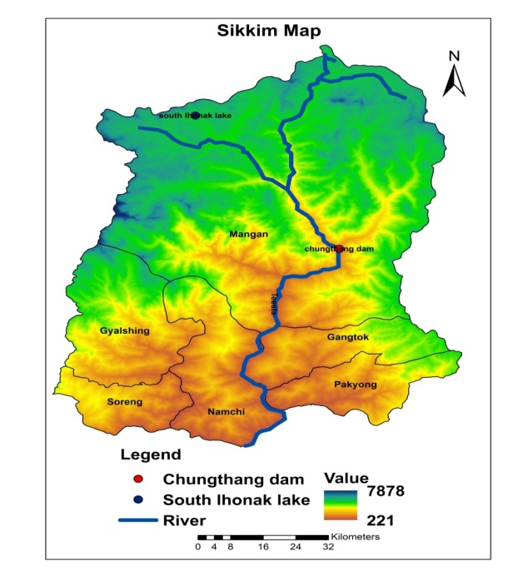
Figure 1 Figure 2
With a total geographical area of approximately 7,096 km² and a projected 2021 population of about 0.68 million, Sikkim is among India’s smallest and least densely populated states (86 persons per km²). Administratively, it comprises six districts: Mangan, Gangtok, Namchi, Gyalshing, Pakyong, and Soreng. Gangtok, located in the southeastern sector, functions as both the political capital and principal urban center.
Physiographically, Sikkim forms part of the Eastern Himalayan orogenic belt, characterized by steep altitudinal gradients ranging from subtropical valleys (300 m) to high alpine zones exceeding 8,500 m. The state hosts Kangchenjunga, India’s highest peak and the world’s third highest mountain, which exerts significant influence on regional microclimates and glaciation patterns. The drainage network is dominated by the Teesta River system, including the Rangeet and numerous glacial and snow-fed tributaries, which collectively regulate hydrological flux, sediment transport, and hydropower generation potential. Approximately 47–48% of the state’s area remains under forest cover, reflecting high ecological integrity, while nearly 35% falls within Khangchendzonga National Park, a UNESCO-recognized biosphere of global biodiversity significance. The region exhibits pronounced climatic heterogeneity, ranging from humid subtropical to alpine tundra conditions, supporting exceptional floral and faunal diversity.
Socio-demographically, Sikkim demonstrates relatively high human development indicators, including a literacy rate exceeding 80% and an urbanization level of roughly one-quarter of the population. The principal ethnic communities—Lepcha, Bhutia, and Nepali—contribute to a distinctive socio-cultural landscape shaped by trans-Himalayan interactions. Infrastructure development has expanded in recent years with the operationalization of Pakyong Airport (Greenfield Airport), ongoing rail connectivity toward Rangpo–Majhitar, and the strengthening of national highway corridors such as NH-10 and NH-717 variants. These transport interventions are strategically significant for regional integration, disaster response logistics, and economic diversification, although their implementation in fragile mountain terrain necessitates rigorous geotechnical assessment and environmental safeguards.
Objectives
- To find out the causes of the GLOF event in the Sikkim
- To assess the damage caused by the GLOF event
Database and Methodology
The work is based on the secondary source of data, which is collected from the various published govt. reports, Sikkim official websites, and news channels reports during and after the phenomena, seismic maps of India, and observed events (e.g., the 2023 Sikkim disaster). The paper employs a descriptive-analytical methodology based on previous and present disasters to explain the types, causes, and impacts of disasters in the Himalayan (specifically Sikkim) region. It describes existing environmental conditions (tectonic activity, geology, slope, and climate change) and analyzes how these contribute to various natural disasters such as earthquakes, landslides, GLOFs, and flash floods. The Sikkim disaster of October 3, 2023 is used as a case study to exemplify the region’s exposure to compound disasters (rainfall, landslide, earthquake leading to GLOF). This case anchors the broader discussion of Himalayan vulnerability and climate-induced risks. The work also emphasizes the use of modern techniques such as Remote Sensing and Geographic Information System for future risk assessment and management. Qualitative Interpretation has been done to show the relationship between climate change, environmental fragility, and socio-economic impacts (like loss of life, property, and infrastructure). It evaluates the implications of disasters on both human and ecological systems.
Literature Review
The South Lhonak Lake outburst flood in October 2023 in Sikkim serves as a wake-up call to the fragile balance between nature and human development in this sensitive ecosystem. Sharma and Gupta (2025), highlights that rising temperatures across the Himalayas up to 0.16°C per year in Nepal have both the rate of melting and size of the glacial lake. Over 45 GLOF events have been recorded in Nepal alone. The South Lhonak event, predicted years in advance by researchers, was triggered by lateral moraine failure, destroying the Chungthang hydroelectric dam and causing extensive loss of life and property. Despite prior hazard assessments (Govindha Raj 2013; Begam, S., et al. 2018 and Sattar et al. 2021), the absence of functional early warning systems and weak policy implementation led to catastrophic outcomes. The study also identifies a critical gap between scientific research and policymaking.
The study by Govindha Raj and Kumar (2012) investigates the formation, expansion, and potential hazards of the Vasundhara Tal supraglacial lake in the Kumaun Himalaya using multi-temporal satellite data. The research highlights the role of twentieth-century climate change in accelerating glacial retreat, leading to the creation and enlargement of supraglacial and moraine-dammed lakes—potential sources of glacial lake outburst floods (GLOFs). These hazards pose significant threats across the Himalayas, particularly in remote regions of India, Bhutan, Tibet, Nepal, and Pakistan, where ground-based monitoring is difficult. Using satellite datasets from Landsat MSS (1976), TM (1990), ETM+ (1999), IRS-1D (2002), and Resourcesat-1 (2005), along with ASTER DEM, the authors mapped the spatio-temporal evolution of Vasundhara Tal. Although Vasundhara Tal currently shows low GLOF potential, the authors warn that future expansion and merging with nearby ponds could form a large moraine-dammed lake, increasing hazard probability. Sharma and Gupta (2025), historical floods such as the 1926 Jammu and Kashmir deluge, the 1981 Kinnaur valley floods in Himachal Pradesh, the 1985 Dig Tsho, 1994 Lugge Tsho, 2013 Kedarnath, and 2021 Chamoli disasters demonstrate the growing intensity of these events due to warming, extreme precipitation, and unstable moraines. Studies show that moraine collapse, glacier surges, and ice avalanches are primary triggers for GLOFs, while anthropogenic factors like unplanned infrastructure and unchecked hydropower development amplify the risks. Glacier collapse in Uttrakhand in 2021, resulted crashing two hydroelectric projects and killing at least 38 people (CNN, 6 October, 2023). This event highlighted the cascading nature of cryosphere-related hazards in the Himalaya, where slope instability, rapid meltwater release, and geomorphic amplification can convert localized failures into large-scale disasters. Such occurrences demonstrate the vulnerability of infrastructure situated along steep, confined river valleys subject to dynamic glacio-fluvial processes.
Within the Indian Himalayan region, Sikkim contains approximately 80 glaciers, representing one of the highest glacier concentrations among Indian states. Many of these glaciers are undergoing accelerated retreat under rising temperature regimes. A notable example is South Lhonak Lake, a large proglacial lake situated at the snout of a receding glacier in North Sikkim. The lake has expanded considerably in recent decades due to enhanced ablation and meltwater accumulation. Satellite observations and field-based glaciological assessments indicate that continued warming has increased both the surface area and volume of several Himalayan glacial lakes. The GLOF situation and hazard potential of South Lhonak lake was assessed by Sattar. A, (2019) and even after the disaster, he has shown his concern with the media that the outburst of 3 October has reduced the water level of the lake temporarily but there is a potential that it could grow in future (ThePrint, 2023 October 11). The local of the area have warned about the unregulated commercial development such as deforestation, dam construction which may increase the risk of disaster. That’s the reason people have been showing their concern and agitation and have been against the concept of building dams in this area because as the disaster occur the locals have to suffer a lot as they are the victims, not the builder. In 2020 as per the scientist from Indian Institute of Technology Guwahati, his study of this region found the increase in the amount of rainfall and temperature in this century. (CNN, 6 October, 2023). As per the words of a senior specialist of the International Centre for Integrated Mountain Development (ICIMOD), Miriam Jackson, we have less time and there are many things to do like installation of early warning system, involvement of locals and monitoring of equipments etc. we have to work carefully before any disaster will take place. The below table 1, shows the types of disaster that actually occurs in the Himalayan region during different period of the years.
Table: 1, Various Types of Disasters in Sikkim
Disasters | Period of Occurrence
Landslide | June to September
Earthquake | Any Time
Flash Flood | June to September
Hailstorm | March to June
Drought | October to April
Forest Fire | March to April
Avalanche | January to March
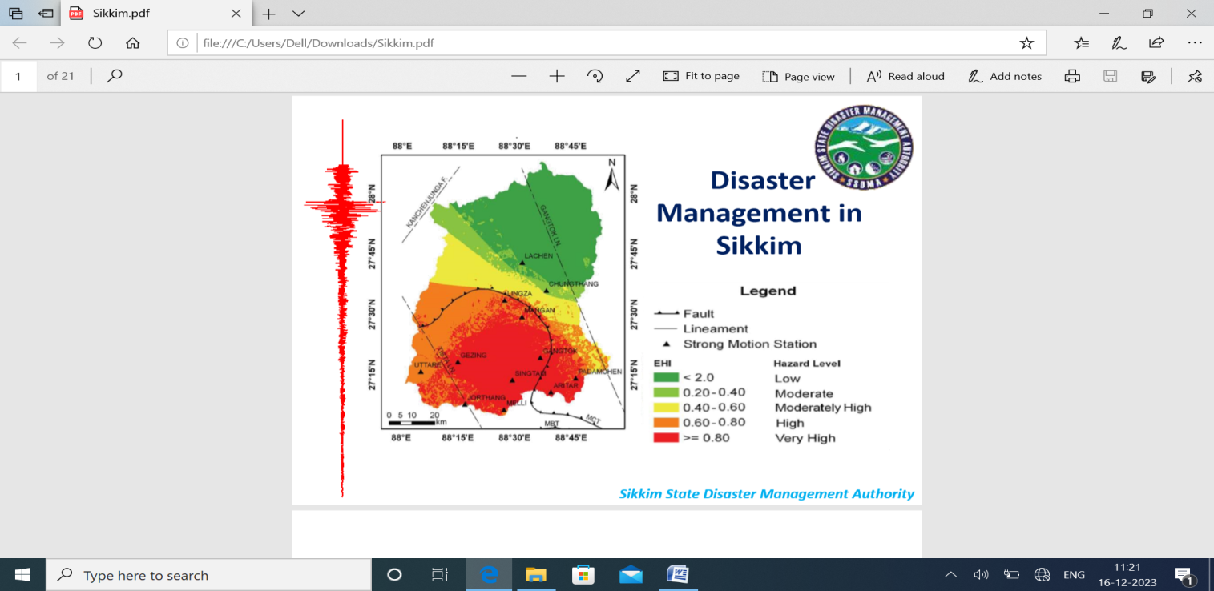
Figure 3
Source: SSDMA PPT, 2023 workshop held at Gangtok, Sikkim on 9 March 2011, CGWB, Eastern Region, Kolkata

GLOF Phenomena
When a glacier melt due to temperature rise, the water collects in deep crevices form a glacial lake which is surrounded by debris and glacier. When water level rises and could not hold extra water it overflow. This may be intensify and triggered by the tectonic movement, land slide and heavy rainfall.
Background of the Lake
Several glacial lake at high altitudes lies under Teesta Basin. As per the study conducted in 2021, among the 12 lakes which are highly likely to be developed an outburst, south Lhonak lake was one of them. Before that in 2013 NRSC Hyderabad has also alerted the authority about the increasing size of the lakes. This moraine dammed glacial fed lake was first seen as a supreglacial lake in 1962 by CORONA satellite fig. 4 and became separated lake by 1977 (Landsat MSS image) with a surface coverage of 17 hectares. It has retreated 1.9 km within four decades. The potential threat of GLOF was felt when it has increased its surface area around 100 hectares by 2008.
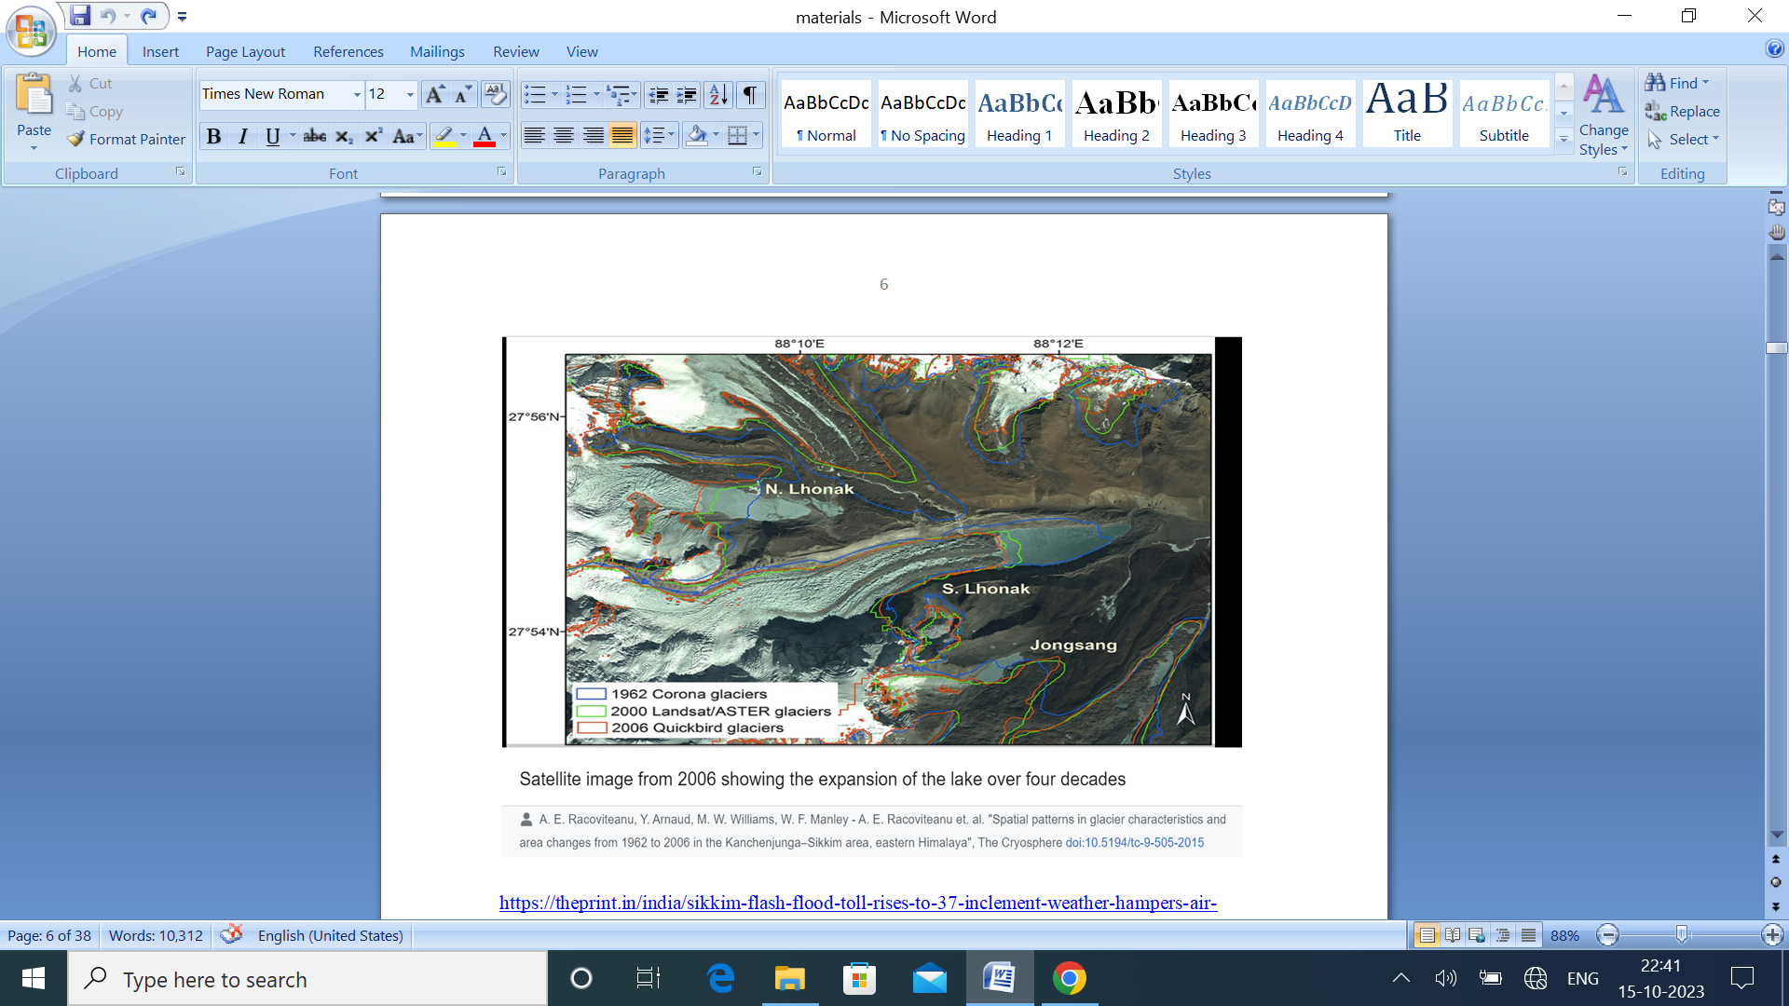
Figure 4
In 2016 the state government team has reported after inspection that the inflow of water is more than outflow. In 2018 the work started to suck the extra water by the process of siphoning to reduce the risk of GLOF. Although the state disaster authority and NDMA were working with Swiss development Corporation to monitor two lake i.e south Lhonak and Shako cho. But due to the delay in installation of early warning system this disaster took place. The delaying of the system may be its strategic location. The shako cho system was working well but other fails and before the swiss team arrive to fix the problem this event could take place. The lake is bullet in shape situated at the height of more than 5000 mtr. In north Sikkim near the border of indo-china, having huge snow cover which has exerted tremendous pressure on the lake snout causing breach in the dam. The series of earthquake in the Nepal region has also triggered it. Moreover the heavy rain which was measure five time more than usual was main factors of the events. Later the gushing water with great force downstream has destroyed the Chungtham Dam in just 10 mints and affected more than 88000 people of adjoining countries.
The figure 5 shows the exact area where there was a breach in the glacial lake indicates that water continued to flow out from the lake even on Friday, three days after it burst its banks. As a result of the decreased level of water in the lake, a large area of the shoreline is now exposed, an area which was under water just three days ago. (CNN, 6 October, 2023)
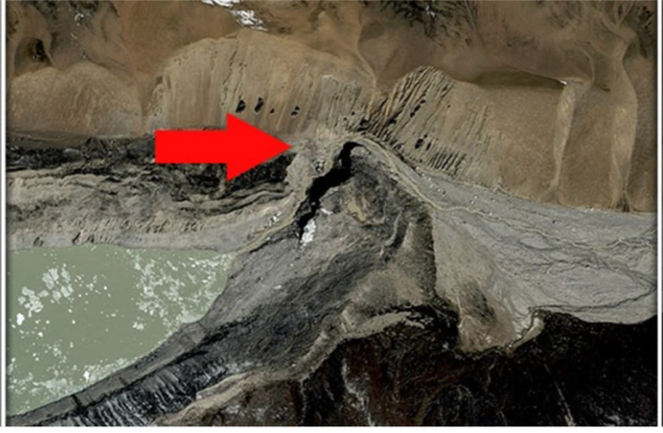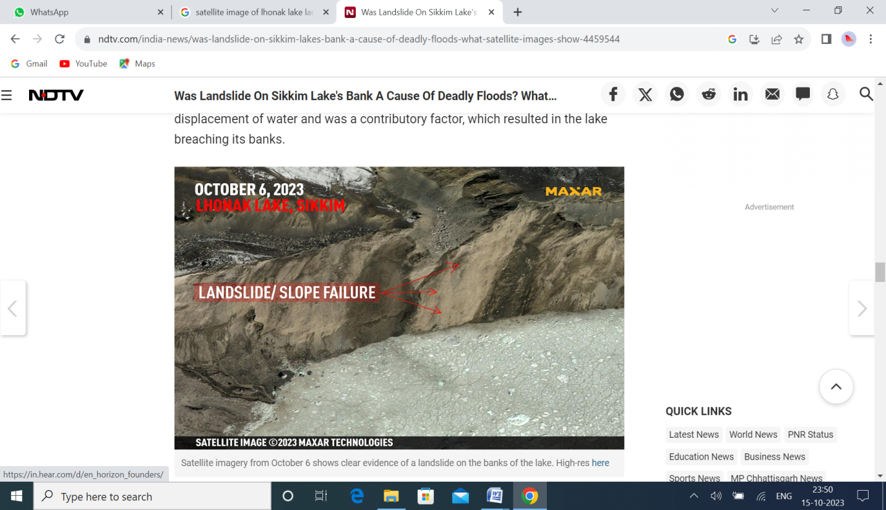
Breaching of moraine
Figure 5 Figure 6
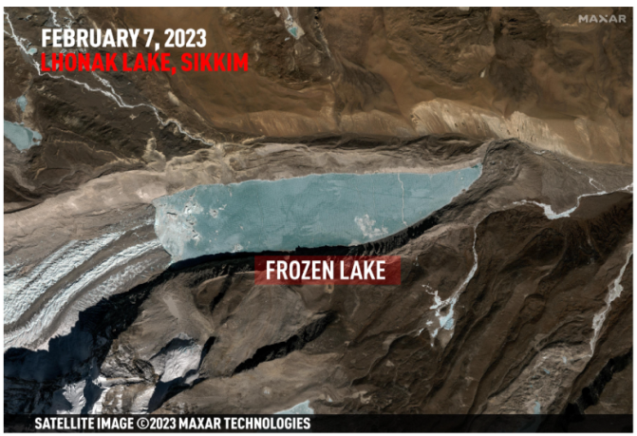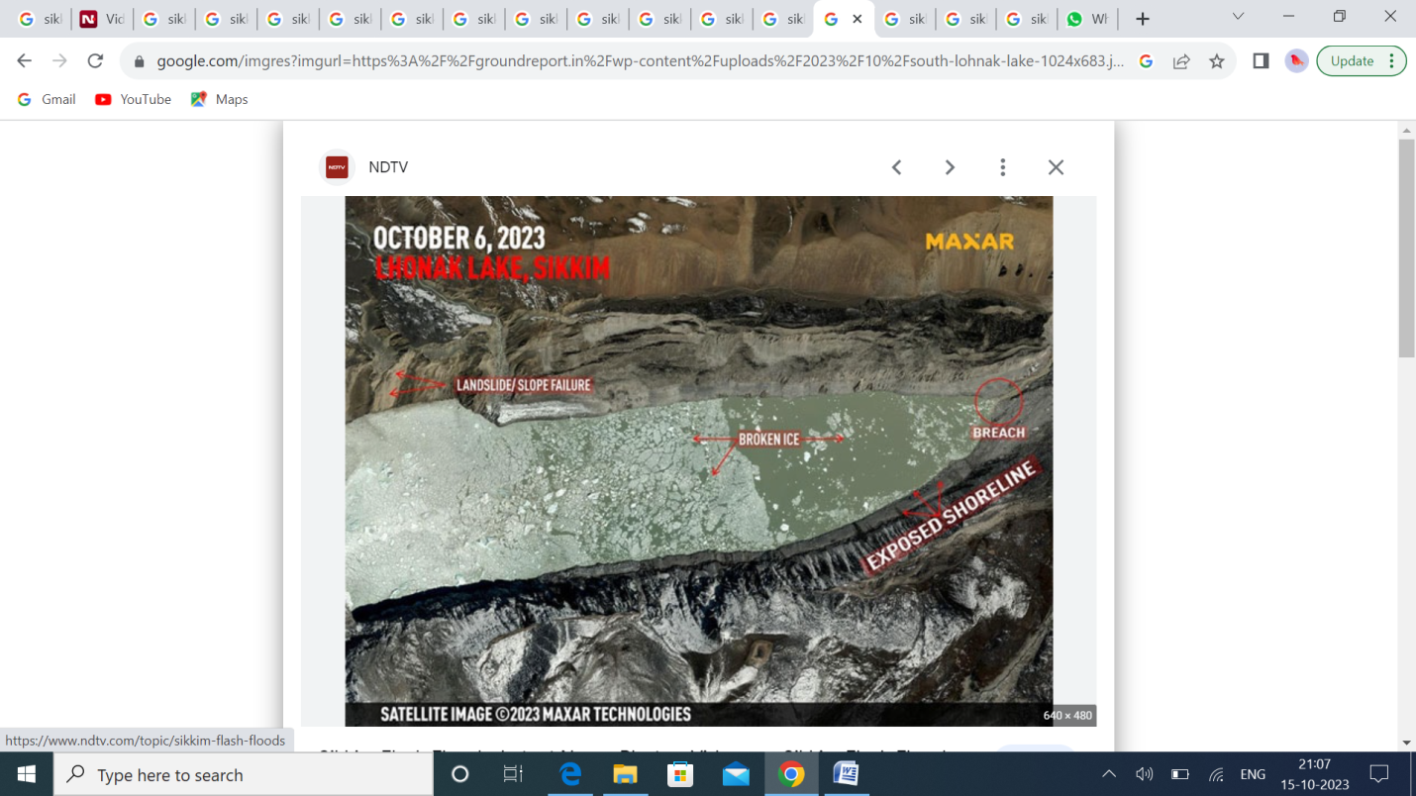
Figure 7 Figure 8
No one knows the exact cause of the lake outburst. In case of Sikkim disaster, most authorities cited a cloudburst in the mountains, which may have triggered the GLOF event (ThePrint, 2023 October 6). No one has better idea about the hydroelectric projects and its impact on mountain region than climatologists as their suspicions are turning in to reality. The images taken on September 28 when the lake spanned in 167 hectares and on the disaster night of 4 octobert it was just 62 ha. almost reduced 60 %. According to Director, DST-Wadia Institute of Himalayan Geology Kalachand Sain, the satellite image does not reveal the depth of the water so it is very difficult to calculate the volume of the water.
This was on comparing images taken on September 28, when the lake spanned 167 ha and on October 4, the night of the disaster, when it shrunk to 62 ha. (reduced around 60%). On September 17, it was 162 ha. According to Director, DST-Wadia Institute of Himalayan Geology Kalachand Sain, as satellite images don’t reveal the depth of the lake, calculating the volume of water in the lake is challenging without physically visiting the place. (The Hindu, 2023, October 8).
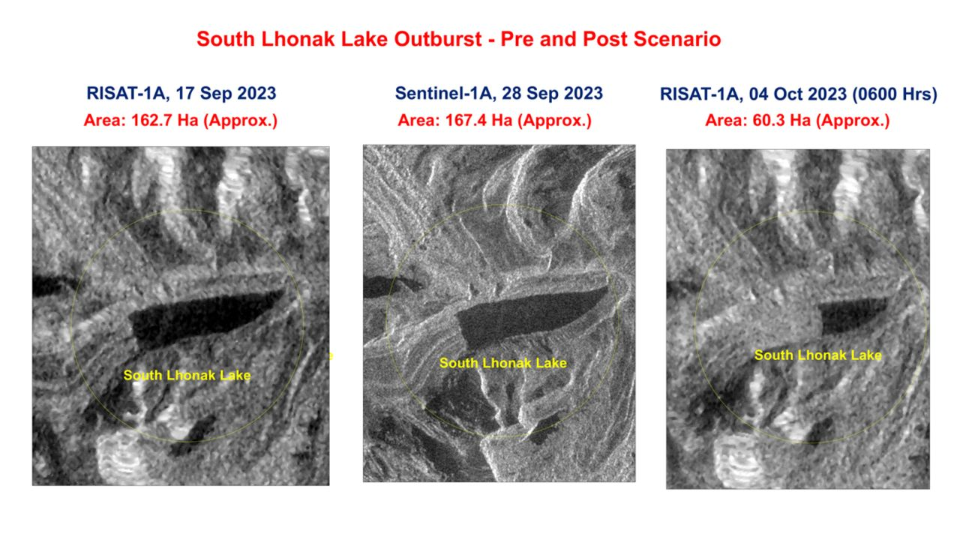
Source : ISRO-Temporal changes in Lhonak Lake area as of September 17; September 28; and October 4.
Figure 9
Damage by Disaster
On that night the town bore maximum brunt of the flood caused by outburst of the South Lhonak glacial lake (ThePrint, 2023 October 10). Though no formal assessment has been done, state government officials said that physical infrastructure worth several thousand crores was damaged (ThePrint, 2023 October 11). The dam was destroyed by the flood water as the level of water rose up 20 feet causing widespread damage downstream Teesta. Flooding damaged four districts i.e. Mangan, Gangtok, Pakyong, and Namchi in Sikkim and in West Bengal the affected areas were Kilipong, Cooch Behar, Japaiguri and Darjeeling district. The flood also affected the hundreds of villages of Bangladesh along the Teesta nd Char area. Before it, in 1968, the state had faced deadiest flood causing death of 1000 people. And now this flood has maximum brunt in the same region. The national gighway no. 10 collasped and most of the northern part of the state was disconnected with country. This flood has affected almost 88400 people where 40 dead were in Sikkim, 60 found dead in Bengol , 26 were greively injured and 76 are still missing. 3,000 tourists were stranded across the state.1831 animal’s death and 29389 poultry death were reported. Total 2002 houses damaged 1423 were fully and 579 were partially damaged till now. Out of 83 army vehicles 31 recovered so far.
Many hydropower projects function were altered by constraining access to electricity and affected people’s livelihood. Total 100 villages/wards affected. 27 villages in across four districts of Sikkim i.e. Mangam, Pakyong, Gangtok and Manchi heavily affected. The flood have fully or partially damaged 2516 houses, washed away 15 bridges and rendered several roads impassable. Additionally the flood water extended to the neighboring state of west Bengal, inundating Darjling, Kalimpong, Cooch Behar and Jalpaiguri district. Damage of Army ammunition depot at Munshithang has also raise concerns of contamination by weapons, ammunition and unexploded ordnances. The destruction of roads and bridges impeded access by response authorities to vulnerable population delaying to provide essential services. The economy of the region has suffered a lot as Sikkim economy relied on three sectors: manufacturing (52%), service sector (32%) and agriculture (10%). The service industry has great impact as it has tourism as a main component of it and the disaster occur tourist season typically October- December. The pharmaceutical is another key sector, and the flood caused substantial damaged the power infrastructure which is expected to disrupt the operation of drug manufacturing companies. Potentially disrupting the supply chains of these firms. It also hinders the access to market for local farmers creating additional challenges. Flood elevated the risk of spreading of many waterborne diseases in affected areas and intensifying the potential of environmental pollution. Damaged Cables of the VSAT Ethernet, BSNL, OFC Line.
Rescue Operation
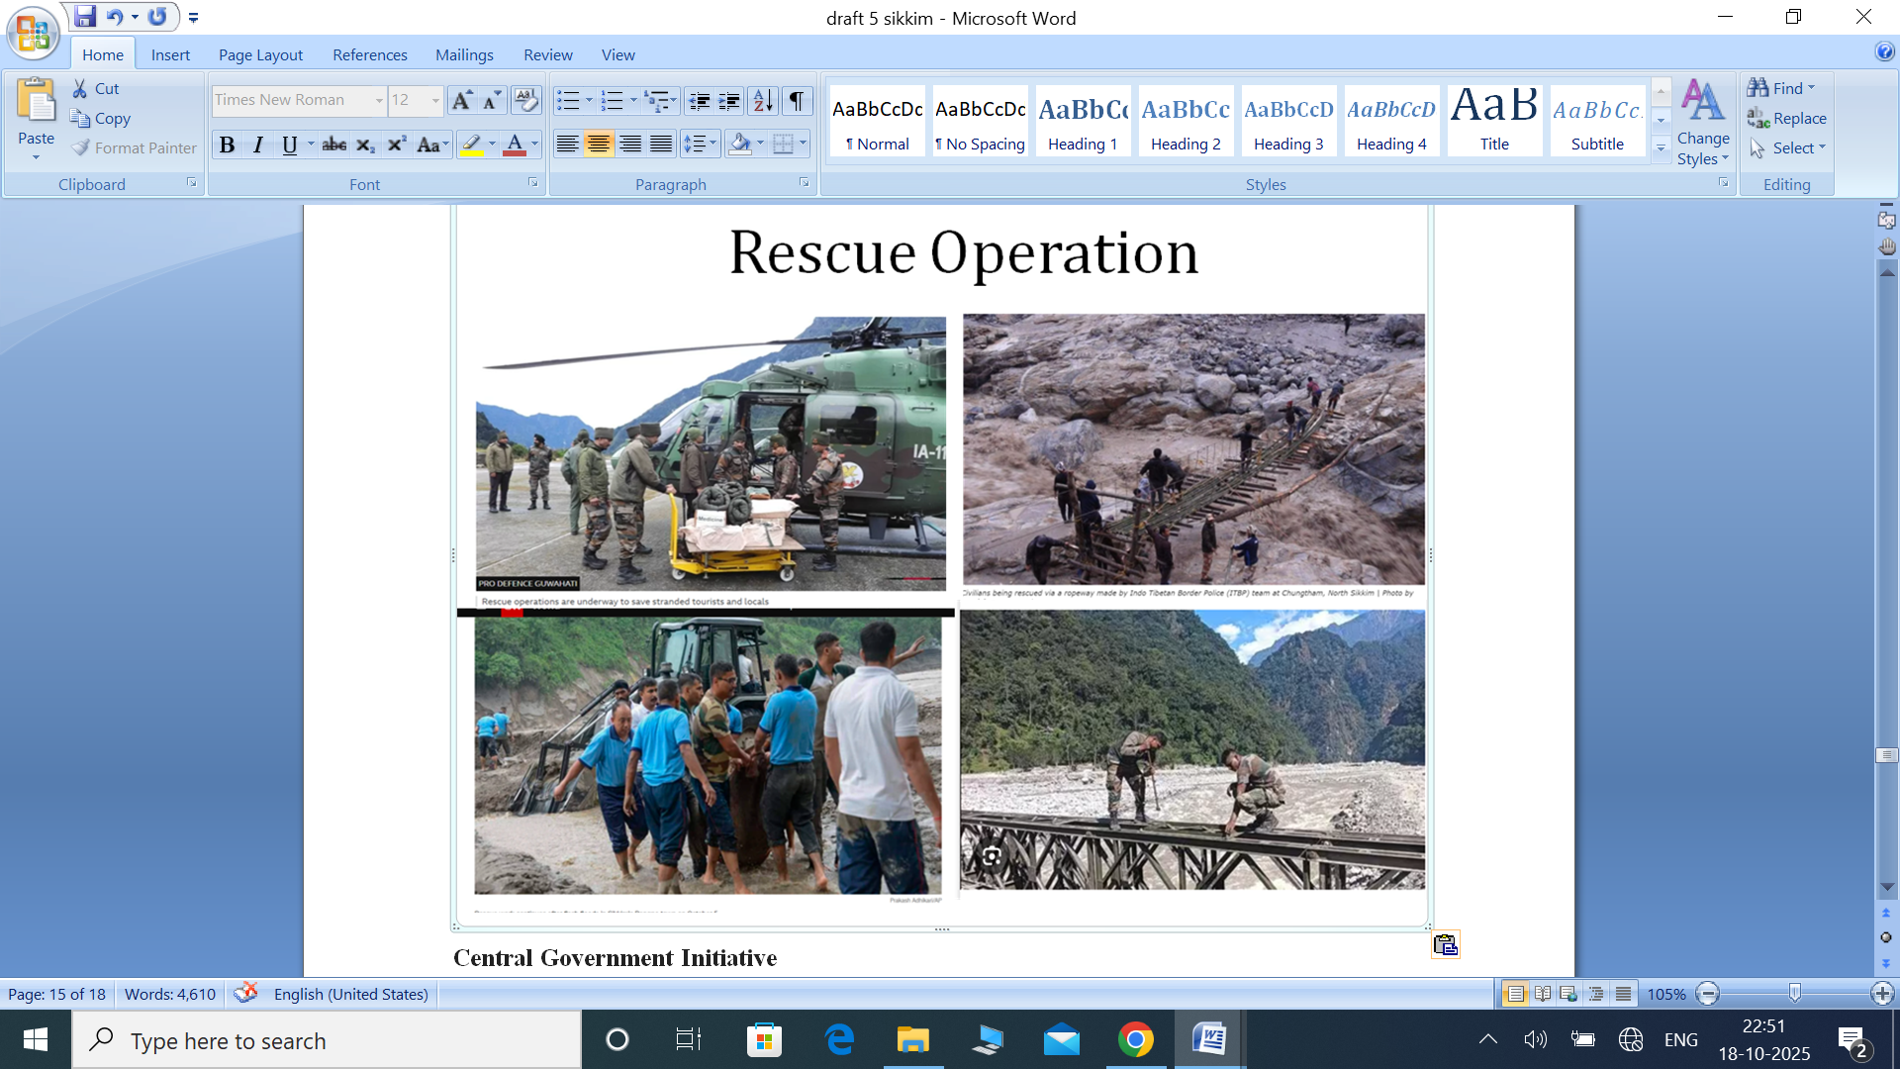
Figure 10
Central Government Initiative
Seeing the situation the Government released Rs 48 crores in disaster relief fund. Rescue team became active like SDRF, civil volunteers, home guard and police in flood affected part. State emergency control room opened for 24X7 monitoring. Helpline numbered issued. Adequate relief camps were opened for affected families. 4 ($4804) lakh rupees were given to those who have lost their families members. 2000 ($24) rupees immediate payment to those in relief camps.
Policy recommendations include:
- Establishing real-time glacier and lake monitoring networks.
- Integrating GLOF risk mapping into regional planning.
- Strengthening infrastructure resilience and local capacity building.
- Enhancing international cooperation in the Himalayan belt for data sharing and response coordination.
Conclusion
Rainfall is a natural phenomenon but when the duration and intensity exceed it become disaster. Being situated at the hilly part this region Sikkim faces many types of disasters. Except earthquake some can manage and their risk can be minimized if managed timely with modern technology. Although the incident took place in the high remote and uninhabited part but their effect were seen in the densely populated and lower area. Could we say it the real development keeping the locals consent aside and ignoring the nature’s parameters? Of course not, a real development should be inclusive one. Due to the lack of early warning system and proper cooperation between the country bureaucrats and people any disaster damage could not be minimize. The flood has damage the property and prosperity of the area and many lives lost. Although since the locals were against the construction of the dams in the areas because of the geology. The so called development had now become a curse for the region as it not only damaged the tourism industry but the rich bio-diversity and ecosystem have also negatively affected. ISRO had been monitoring this two lakes one is South Lhonak Lake and other Shako Chu Lake via satellites for any abnormal changes at the lake to alert the state government, timely to prevent any further Disaster. The four districts of Sikkim namely Pakyong, Mangam, Gangtok, Nanchi have worst affected by the natural disaster. Present day concepts of disaster management coupled with utilization of modern techniques of investigation for example remote sensing and GIS play a greater role in tackling the risks from these hazards. Disaster management is facilitated to a good extent in the mitigation and management by such advanced techniques of inventorying and analyzing the hazards and their zonation. We should learn a lesson from it whether, it was a natural or manmade disaster.
References
Banejei, M. (2023, October 6). What turned Teesta into a killer? Here’s proof Sikkim flash floods are a man-made disaster.
https://theprint.in/opinion/what-turned-teesta-into-a-killer-heres-proof-sikkim-flash-floods-are-a-man-made-disaster/1792214/
Begam, S., Sen, D., & Dey, S. (2018). Moraine dam breach and glacial lake outburst flood generation by physical and numerical models. Journal of Hydrology, 563, 694–710. https://doi.org/10.1016/j.jhydrol.2018.06.038
Chakravarty, A. (2016, August 22). Sikkim High Court issues notice to state government on landslide dam.
https://www.downtoearth.org.in/news/natural-disasters/sikkim-high-court-issues-notice-to-state-government-on-landslide-dam-55354
Govindha Raj, K. B., & Kumar, K. V. (2012). Assessment of supraglacial lake growth from multi-temporal satellite data – A case study of Vasundhara Tal, Kumaun Himalaya, India. Himalayan Geology, 33(1), 53–58.
Govindha Raj, K. B., Remya, S. N., & Vinod Kumar, K. (2013). Remote sensing–based hazard assessment of glacial lakes in Sikkim Himalaya. Current Science, 104(3), 359–364.
Gupta, M. D. (2023, October 10). How an alert ITBP jawan on duty 8 km away from South Lhonak lake raised 1st flood alarm in Sikkim.
https://theprint.in/india/how-an-alert-itbp-jawan-on-duty-8-km-away-from-south-lhonak-lake-raised-1st-flood-alarm-in-sikkim/1797562/
Huber, A. (2019). Hydropower in the Himalayan hazardscape: Strategic ignorance and the production of unequal risk. Water, 11(3), 414. https://doi.org/10.3390/w11030414
Indian Institute of Technology Guwahati (IITG). (2020). Study of climate change impacts in the Teesta River basin: Implications for flood risk and adaptation. Guwahati, India.
Khadka, N. S. (2023, October 10). Sikkim: Deadly Indian glacial lake flash flood exposes lack of warning system.
https://www.bbc.com/news/world-asia-india-67050830
Koshi, J. (2023, October 8). What caused the flood in Sikkim? | Explained.
https://www.thehindu.com/sci-tech/energy-and-environment/what-caused-the-flood-in-sikkim-explained/article67397335.ece
Regan, H., Sharma, A., & Farooqui, S. (2023, October 6). Glacial lake bursts in India leaving 100 missing and 19 dead.
https://edition.cnn.com/2023/10/05/india/india-sikkim-floods-search-damage-climate-intl-hnk/index.html
Sattar, A. (2019). Assessment of glacial lake outburst flood hazard potential of South Lhonak Lake, Sikkim Himalaya. Geomorphology, 350, 106914. https://doi.org/10.1016/j.geomorph.2019.106914
Sattar, A., Goswami, A., & Kulkarni, A. V. (2021). Future glacial lake outburst flood hazard of the South Lhonak Lake, Sikkim Himalaya. Geomorphology, 388, 107783. https://doi.org/10.1016/j.geomorph.2021.107783
Sharma, A., Sharma, N., & Gupta, M. (2025). Critical Perspectives on Climate Change and Glacial Lake Outburst Floods’ Impact in the Himalayas: Policy Inferences from the South Lhonak Flood of 2023. In Water Resources Management in Mountain Regions (pp. 319–333). https://doi.org/10.1002/9781394249619.ch16
Subramanyam, A. (2023, October 10). Sikkim flood was a matter of time despite uncertainties, scientists knew.
https://www.thehindu.com/sci-tech/energy-and-environment/sikkim-flood-anticipated-2021-study-glacier-retreat-lakes/article67399797.ece

