COMPARATIVE ELEMENTAL COMPOSITION OF METALLIC ZINC-CARBON AND CONVENTIONAL ZINC ELECTRODE MATERIALS IN MICROBIAL FUEL CELLS: A STEP TOWARDS ENGINEERING ADVANCEMENTS.

Abstract
Metallic zinc and carbon electrodes are widely used in engineering due to their excellent electron conductivity, electroplating capabilities, gas purification sorption, catalytic properties, and galvanization. Recycling and modifying the used electrodes offers a cost-effective alternative to mining virgin materials, conserving natural resources. Energy-dispersive X-ray spectroscopy (EDX) analysis is essential for understanding the elemental composition and chemical interactions in microbial fuel cells (MFCs). This study analyzed two MFCs with metallic zinc-carbon as the working electrode and conventional metallic zinc as the reference electrode. The anodic chamber electrolyte comprised tryptone soya agar, calcium carbonate, glucose, and domestic wastewater, while the cathodic chamber contained a buffer solution (NaH₂PO₄.H₂O), potassium nitrate, and de-ionized water as the electron acceptor. The MFCs were operated for 25 days. EDX results showed that the working electrode in the anodic chamber initially contained 68.4% Zn, 3.4% C, 12.8% O, 5.2% K, and 10.2% Fe. After digestion, there was a decrease in Zn (45%) and C (5%) and increased presence of O (20.5%), Sn (5%), Cu (10.5%), K (4.1%), Ca (2.3%), S (2.3%), and Na (2.4%). In the cathodic chamber, Zn decreased from 77.2% to 45%, while C, O, Sn, and Cu increased after digestion. For the reference electrodes, anodic chamber composition before digestion showed 75.6% Zn and small amounts of C, Fe, O, and Na, with slight changes after digestion. The cathodic chamber showed a similar trend, with decreases in Zn and increases in Fe and O after digestion. Overall, working electrodes exhibited greater deposition of O, K, Na, Ca, and S in the anodic chamber and higher levels of C, O, K, Cu, Ca, Sn, and S in the cathodic chamber compared to the reference electrodes after digestion. These changes in elemental composition influence electrode strength and durability, critical for maintaining structural integrity in MFC applications.
Keywords: zinc, carbon, wastewater, substrate, elecrodes

1.INTRODUCTION

Metallic zinc electrodes are widely used in engineering and electrochemical industries because of their excellent electrical conductivity, corrosion resistance, catalytic properties, and low cost. Zinc materials are commonly applied in electroplating, galvanization, gas purification, battery technologies, and other electrochemical systems where efficient electron transfer is required (Altaf et al., 2020). Electrodes are important components in engineering applications because they facilitate electrochemical reactions, conductivity measurements, and energy conversion processes. They are also essential in welding operations and electrical grounding systems, where they contribute to safety and operational efficiency (Phillips, 2023). Due to their favorable electrochemical properties, zinc-based electrodes continue to attract significant attention in energy-related applications.

Carbon-based materials have also become increasingly important in modern engineering and environmental technologies because of their high electrical conductivity, large surface area, mechanical strength, and chemical stability. These materials are widely used in carbon composites, water treatment systems, lithium-ion batteries, and supercapacitors (Li, 2019; Ighalo, 2022; Lin, 2021; Dwivedi et al., 2020; Yang, 2025). The modification of metallic electrodes with carbon materials has been reported to improve electrochemical activity, enhance electron transfer, and increase the overall efficiency of electrochemical systems such as microbial fuel cells (MFCs).

Microbial fuel cells are emerging as sustainable technologies for simultaneous wastewater treatment and electricity generation. The performance of MFCs largely depends on the characteristics of the electrode materials used in the anode and cathode chambers. Properties such as conductivity, surface morphology, and chemical composition significantly influence microbial attachment and electron transfer efficiency. As a result, researchers have focused on improving electrode materials through surface modification and composite development.

In addition, recycling and reusing used electrode materials provide an environmentally friendly and cost-effective alternative to the extraction of virgin raw materials (Zanoletti, 2024). The recovery and modification of used electrodes help reduce environmental pollution, conserve natural resources, and support sustainable engineering practices. Coating recycled metallic electrodes with carbon-based materials may further improve their electrochemical performance and durability in microbial fuel cells.

To evaluate the elemental composition and structural properties of electrode materials, Energy-Dispersive X-ray Spectroscopy (EDX) is commonly employed. EDX is a non-destructive analytical technique used to identify and quantify the elemental composition of materials by detecting characteristic X-ray emissions generated when an electron beam interacts with the sample surface (Goldstein et al., 2017). Due to its simplicity, speed, affordability, and accuracy, EDX has become a widely accepted technique in materials science and engineering research.

Previous studies have applied EDX analysis to investigate the elemental composition of various organic and inorganic materials (Guler et al., 2019; Bauer et al., 2020). In microbial fuel cell research, EDX provides valuable information about surface interactions, material degradation, and chemical changes occurring on electrode surfaces during operation. Therefore, the present study aimed to determine and compare the elemental composition of used and unused zinc electrodes in the anode and cathode chambers of microbial fuel cells using Energy-Dispersive X-ray Spectroscopy. The study also evaluated the effects of carbon-based coatings on the structural properties of the electrodes and their potential influence on microbial fuel cell performance.
2. MATERIALS AND METHODS
2.1 Materials
The materials used for this study included domestic wastewater, distilled water, calcium carbonate (CaCO₃), tryptone soya agar, glucose, monosodium phosphate monohydrate (NaH₂PO₄·H₂O), zinc electrodes, activated carbon derived from Terminalia superba (TS), masking tape, temporary markers, copper connecting wires, ceramic membrane, Scanning Electron Microscope (SEM), Energy Dispersive X-ray Spectroscopy (EDX) detector, and specimen holders. All chemicals used were of analytical grade and were utilized without further purification.
2.2 Preparation of Microbial Fuel Cells
Two dual-chamber microbial fuel cells (MFCs), designated as MFC-4 and MFC-5, were constructed and operated under similar conditions. MFC-4 employed modified carbon-zinc composite electrodes, while MFC-5 served as the control system using ordinary zinc electrodes. The modification of zinc electrodes was carried out using activated carbon nanoparticles obtained from Terminalia superba. The activated carbon was incorporated into molten zinc through an ultrasound-assisted powder compaction method to improve the electrochemical and conductive properties of the electrodes.
For MFC-4, the anode electrode consisted of 60 % zinc and 40 % activated carbon powder (3:2 ratio), while the cathode electrode contained 40 % zinc and 60 % activated carbon powder (2:3 ratio). MFC-5 utilized impure zinc electrodes at both the anode and cathode compartments. Each electrode measured 70 mm × 60 mm × 40 mm. The electrodes were connected externally using copper wires to facilitate electron transfer between the chambers.
2.3 Electrochemical Operation of the MFCs
The anodic chamber of each microbial fuel cell contained 250 mL of domestic wastewater supplemented with 7.5 g of tryptone soya agar, 2.5 g of calcium carbonate, and 2.5 g of glucose as substrates for microbial growth and metabolism. The cathodic chamber contained 20 g of potassium nitrate, 100 mL of deionized water, and 0.69 g of NaH₂PO₄·H₂O as the electrolyte and electron acceptor solution. A 3 mm-thick ceramic membrane was used as the proton exchange medium between the anodic and cathodic compartments.
The inoculated anodic chambers were maintained under anaerobic conditions, while the microbial cultures were incubated at 28 °C prior to operation. After inoculation, the systems were allowed to stabilize for five days before electrochemical measurements were conducted. The MFCs were then operated continuously for 25 days to enable microbial digestion and electricity generation. Electrode potentials were monitored using a standard calomel electrode (SCE).
2.4 SEM and EDX Characterization of Electrodes
The elemental composition and surface morphology of both used and unused electrodes were analyzed using Scanning Electron Microscopy coupled with Energy Dispersive X-ray Spectroscopy (SEM–EDX). Prior to analysis, unused electrodes were cleaned to remove contaminants, while used electrodes containing dried electrolyte and biocatalyst deposits were carefully prepared without further alteration.
The electrodes were mounted securely on specimen holders and introduced into the SEM chamber under high vacuum conditions. A focused electron beam was directed onto the electrode surfaces to generate characteristic X-rays emitted from the constituent elements. These X-rays were detected by the EDX detector to produce energy spectra corresponding to the elemental composition of the samples.
The peaks observed in the spectra were identified using the system software, while the peak intensities and areas were used to determine the relative abundance of the elements present. The elemental composition of the electrodes was subsequently expressed in terms of atomic and weight percentages for comparative analysis between the modified carbon-zinc electrodes and the ordinary zinc electrodes.
3. RESULTS AND DISCUSSION
3.1 Energy Dispersive X-Ray Spectroscopy (EDX) Analysis of MFC-4 and MFC-5 Electrodes
Energy Dispersive X-ray Spectroscopy (EDX) analysis was conducted to investigate the elemental composition and surface characteristics of the electrodes used in MFC-4 and MFC-5 before and after microbial digestion. EDX is an important analytical technique for determining the distribution and concentration of elements present in electrode materials and for understanding the electrochemical interactions occurring during microbial fuel cell (MFC) operation. The technique also provides valuable insight into corrosion behavior, biofilm development, material degradation, and elemental deposition on electrode surfaces.
The EDX spectra confirmed the successful synthesis and modification of the zinc-carbon composite electrode used in MFC-4, as well as the elemental composition of the conventional zinc electrode employed in MFC-5. The spectra revealed distinct peaks corresponding to zinc (Zn), carbon (C), oxygen (O), iron (Fe), potassium (K), sodium (Na), calcium (Ca), sulfur (S), copper (Cu), silicon (Si), and tin (Sn). Variations in elemental composition before and after digestion indicated that electrochemical and microbial activities significantly influenced the electrode surfaces during MFC operation.
The anodic chamber of MFC-4 initially contained 68.40 % Zn, 3.40 % C, 12.77 % O, 5.23 % K, and 10.20 % Fe before digestion. After digestion, the composition changed to 45.00 % Zn, 5.00 % C, 20.50 % O, 4.06 % K, 3.00 % Fe, 10.50 % Cu, 5.00 % Sn, 2.30 % Ca, 2.32 % S, and 2.43 % Na. Similarly, the conventional zinc electrode of MFC-5 showed a reduction in zinc concentration from 75.56 % before digestion to 63.34 % after digestion, while oxygen increased from 13.37 % to 20.26 %.
The observed decrease in zinc concentration in both MFC-4 and MFC-5 can be attributed to the corrosion and oxidation of zinc during microbial fuel cell operation. Zinc is an electrochemically active metal with a relatively low reduction potential, making it susceptible to oxidation when used as an anode material. During MFC operation, zinc releases electrons through oxidation reactions, resulting in gradual dissolution and mass loss of the electrode material. This finding agrees with previous studies reporting that zinc-based electrodes undergo sacrificial corrosion during electrochemical processes (El-Shamy, 2020). In addition, microbial activities and biofilm formation may accelerate zinc degradation, particularly in the anodic chamber where electroactive microorganisms metabolize organic substrates and facilitate electron transfer.
The increase in carbon concentration from 3.40 % to 5.00 % in the anodic chamber of MFC-4 indicates the beneficial effect of activated carbon incorporation into the zinc matrix. Carbon materials improve electrode conductivity, increase surface area, and promote microbial attachment, thereby enhancing electrochemical activity. The addition of glucose and microbial metabolites during digestion may also contribute to carbon deposition on the electrode surface. However, excessive carbon concentration may reduce electrode performance because agglomeration of carbon particles can limit electron transfer efficiency and reduce structural stability (Bresser et al., 2018).
A significant increase in oxygen concentration was observed in both MFC-4 and MFC-5 after digestion. In MFC-4, oxygen increased from 12.77 % to 20.50 %, while in MFC-5 it increased from 13.37 % to 20.26 %. The elevated oxygen content may be associated with the formation of zinc oxides and other oxygen-containing compounds during electrochemical reactions. Oxygen accumulation may also result from microbial metabolic activities, electrolyte interactions, and oxygen diffusion within the cathodic chamber. The formation of zinc oxide layers on the electrode surface can influence conductivity and may eventually reduce electrode performance by blocking active sites (Zhou et al., 2024).
The iron concentration decreased considerably after digestion in both systems. In MFC-4, iron decreased from 10.20 % to 3.00 %, while in MFC-5 it decreased from 7.40 % to 5.40 %. Reduced iron concentration may improve electrochemical performance by minimizing undesirable side reactions such as hydrogen evolution and excessive energy consumption (Evans et al., 2003). In addition, certain microorganisms are capable of reducing iron compounds during microbial metabolism, which may contribute to the observed decrease in iron content.
Potassium concentration slightly decreased in MFC-4 from 5.23 % to 4.06 %, whereas MFC-5 showed an increase to 2.20 % after digestion. Potassium ions play an important role in electrochemical reactions and electrolyte conductivity. Variations in potassium concentration may influence ion transport, CO₂ absorption, and the overall efficiency of microbial fuel cells (Tarzan et al., 2019). Similarly, sodium concentration decreased slightly in MFC-5 after digestion, indicating possible electrolyte interactions and stabilization processes occurring at the electrode-electrolyte interface.
Additional elements such as copper, calcium, sulfur, silicon, and tin were detected after digestion. The presence of 10.50 % copper in the anodic chamber of MFC-4 suggests the formation of copper-zinc alloy structures that may enhance electrode conductivity and reduce dendrite formation. Copper has been reported to improve electron diffusion and electrochemical stability in zinc-based systems (Guo et al., 2022). Calcium detected in the electrode may contribute to electrolyte stability and improve electrode cycling behavior.

Sulfur detected in the zinc-carbon composite electrode may also enhance electrical conductivity and electron transport within the electrode matrix (Ogoke et al., 2017). In contrast, sulfur concentration decreased significantly in the cathodic chamber after digestion, indicating possible sulfate reduction reactions occurring during microbial activity. Silicon detected in MFC-5 may have originated from impurities or experimental materials, while its reduction after digestion suggests dissolution or reaction during electrochemical operation.
The cathodic chamber analysis further demonstrated substantial changes in elemental composition after digestion. In MFC-4, zinc concentration decreased from 77.20 % to 45.00 %, while oxygen increased from 10.20 % to 15.00 %. Carbon concentration also increased after digestion, indicating enhanced deposition of carbonaceous materials and microbial metabolites on the electrode surface. The reduction in zinc concentration at the cathode may be associated with corrosion processes, electrolyte interactions, and passivation layer formation during long-term operation (Li et al., 2022).
Overall, the EDX results demonstrated that significant elemental transformations occurred on both zinc-carbon and conventional zinc electrodes during microbial fuel cell operation. The zinc-carbon composite electrode exhibited improved elemental stability and increased deposition of beneficial conductive elements such as carbon, copper, sulfur, and calcium compared to the conventional zinc electrode. The results suggest that the incorporation of activated carbon derived from Terminalia superba enhanced the electrochemical properties of the zinc electrode and promoted favorable electrode surface modifications during microbial digestion.
Therefore, the study confirms that zinc-carbon composite electrodes possess superior electrochemical characteristics compared to conventional zinc electrodes and may provide improved performance for microbial fuel cell applications involving wastewater treatment and bioelectricity generation.
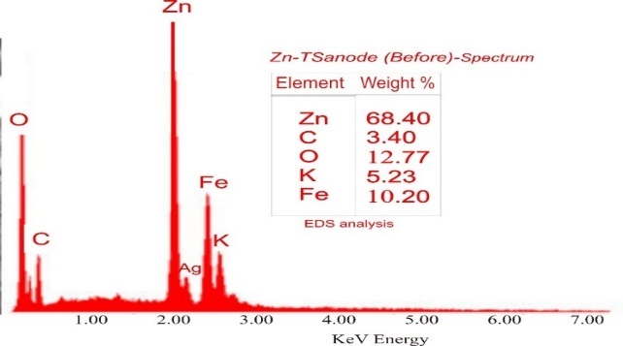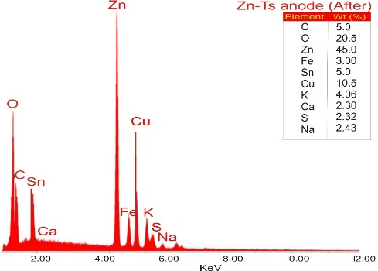
Figure 1: EDX pattern of anodic electrode Figure 2: EDX pattern of anodic electrode (carbon-zinc) as a composite material before as composite material after electrochemical adhesion electrochemical adhesion (spectrum 1) (Spectrum 2)

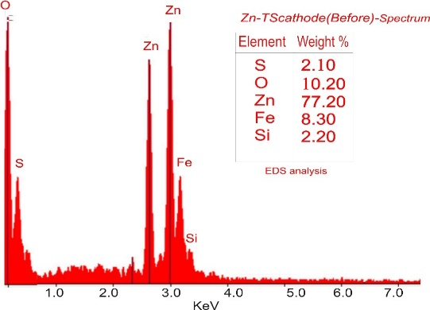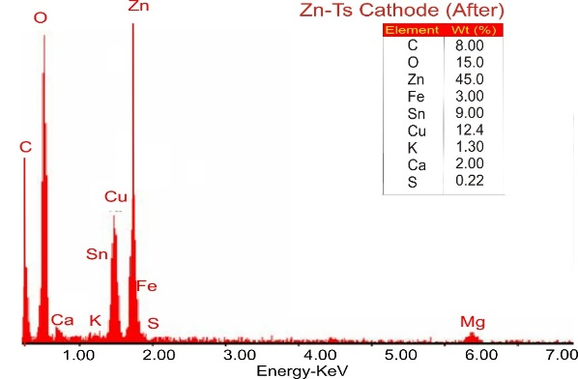
Figure 3: EDX pattern of cathodic electrode Figure 4: EDX pattern of cathodic electrode
(carbon-zinc) as a composite material before (carbon-zinc) as a composite material after
electrochemical adhesion electrochemical adhesion (spectrum
(spectrum 3)

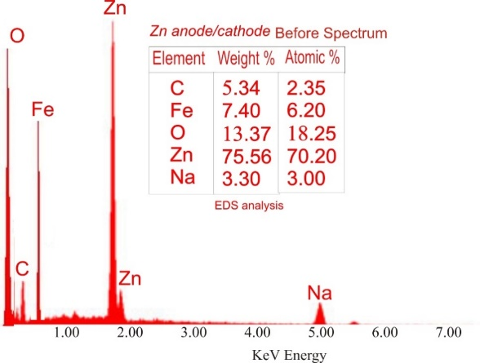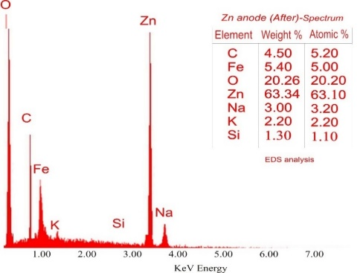
Figure 5: EDX pattern of anodic/cathode electrode Figure 6:Figure 6: EDX pattern of anodic
(zinc) material before electrochemical adhesion electrode (Zinc) material after electrochem-
(spectrum 5) ical adhesion (spectrum 6)

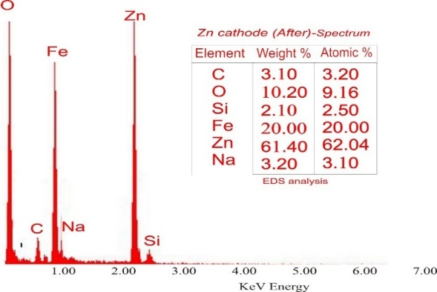
Figure 7: EDX pattern of cathode electrode (Zinc)
material after electrochemical adhesion (spectrum 7)

4. CONCLUSION
This study successfully developed zinc-carbon composite electrodes from recycled materials for application in microbial fuel cells (MFCs). Activated carbon derived from Terminalia superba improved the electrochemical and surface properties of zinc electrodes. Energy Dispersive X-ray Spectroscopy (EDX) analysis revealed significant changes in elemental composition before and after digestion, confirming electrochemical reactions, microbial activity, and surface modification during MFC operation.The results showed that the zinc-carbon electrodes exhibited improved conductivity, enhanced electron transfer, and better elemental stability compared to conventional zinc electrodes. Increased deposition of conductive elements such as carbon, copper, sulfur, and calcium contributed to improved electrochemical performance, while zinc reduction indicated oxidation and corrosion during electricity generation.The findings demonstrate the potential of recycling used electrode materials as a sustainable and cost-effective approach for bioelectrochemical applications. Overall, zinc-carbon composite electrodes showed promising potential for improved electricity generation and wastewater treatment in microbial fuel cell systems.
References
[1] AlRefeai, M.H.; AlHamdan, E.M.; Al-Saleh, S.; Farooq, I.; Abrar, E.; Vohra, F.; Abduljabbar, T. Assessment of bond integrity, durability, and degree of conversion of a calcium fluoride reinforced dentin adhesive. Polymers 2021, 13, 2418.
[2] Altaf, M., Yamin, N., Muhammad, G., Raza, M. A., Shahid, M., & Ashraf, R. S. (2020).
[3] Bauer, L.J.; Mustafa, H.A.; Zaslansky, P.; Mantouvalou, I. Chemical mapping of teeth in 2D and 3D: X-ray fluorescence reveals hidden details in dentine surrounding fillings. Acta Biomater. 2020, 109, 142–152.
[4] Bresser, D., Buchholz, D., Moretti, A., Varzi, A., & Passerini, S. (2018). Alternative binders for sustainable electrochemical energy storage–the transition to aqueous electrode processing and bio-derived polymers. Energy & Environmental Science, 11(11), 3096-3127.
[5] C. De las Casas et al. A review of application of carbon nanotubes for lithium ion battery anode material J Power Sources (2012)

[6] C. Dwivedi et al. recycling of waste tire by pyrolysis to recover carbon black: alternative & environment-friendly reinforcing filler for natural rubber compounds Compos B (2020)
[7] Cierech, M.; Szerszeń, M.; Wojnarowicz, J.; Łojkowski, W.; Kostrzewa-Janicka, J.; Mierzwińska-Nastalska, E. Preparation and Characterisation of Poly(methyl metacrylate)-Titanium Dioxide Nanocomposites for Denture Bases. Polymers 2020, 12, 2655.
[8] de Alcântara Pinto, C.M.S.; Goulart, D.R.; Asprino, L.; Olate, S.; de Moraes, M. Evaluation of Failed Implants by Metallographic and Energy Dispersive X-ray Analysis. Implant Dent. 2018, 27, 69–73.
[9] Deng, Y., Zheng, J., Warren, A., Yin, J., Choudhury, S., Biswal, P., ... & Archer, L. A. (2019). On the reversibility and fragility of sodium metal electrodes. Advanced Energy Materials, 9(39), 1901651.
[10] Ebnesajjad, S. Surface and material characterization techniques. In Surface Treatment of Materials for Adhesive Bonding; Elsevier: Amsterdam, The Netherlands, 2014; pp. 39–75. ISBN 9780323264358
[11] Electroanalytical techniques for the remediation of heavy metals from wastewater. In Water electron microscopy and X-ray microanalysis (pp. 265-287). New York, NY: Springer New
[12] El-Shamy, A. M. (2020). A review on: biocidal activity of some chemical structures and their role in mitigation of microbial corrosion. Egyptian Journal of Chemistry, 63(12), 5251-5267.
[13] Evans, D. E., Harrison, R. M., & Ayres, J. G. (2003). The generation and characterization of metallic and mixed element aerosols for human challenge studies. Aerosol Science & Technology, 37(12), 975-987.
[14] Farzana, R., Hassan, K., & Sahajwalla, V. (2019). Manganese oxide synthesized from spent Zn-C battery for supercapacitor electrode application. scientific reports, 9(1), 8982.
[15] Goldstein, J. I., Newbury, D. E., Michael, J. R., Ritchie, N. W., Scott, J. H. J., & Joy, D. C. (2017).
[16] Guler, B.; Uraz, A.; Çetiner, D. The chemical surface evaluation of black and white porous titanium granules and different commercial dental implants with energy-dispersive x-ray spectroscopy analysis. Clin. Implant Dent. Relat. Res. 2019, 21, 352–359.
[17] Guo, N., Huo, W., Dong, X., Sun, Z., Lu, Y., Wu, X., ... & Zhang, Q. (2022). A review on 3D zinc anodes for zinc ion batteries. Small Methods, 6(9), 2200597.
[18] Imran, M., Prakash, O., Pushkar, P., Mungray, A., Kailasa, S. K., Chongdar, S., & Mungray, A. K. (2019). Performance enhancement of benthic microbial fuel cell by cerium coated electrodes. Electrochimica acta, 295, 58-66.
[19] J.O. Ighalo Recent advances in hydrochar application for the adsorptive removal of wastewater pollutants Chem Eng Res Des (2022)
[20] Jonghe, M. D. (2020). Empowering treatment of metallurgical wastewaters: linking electrochemical cells and sulfur treatment. Ghent University, Belgium.
[21] K. Yang Interfacial enhancement mechanism of carbon fiber composites molded by electrothermal in-situ co-curing with CNT film Compos Sci Technol (2025)

- L. Li Carbon-based materials for fast charging lithium-ion batteries Carbon
(2021)

[23] Li, Q., Han, L., Luo, Q., Liu, X., & Yi, J. (2022). Towards understanding the corrosion behavior of zinc‐metal anode in aqueous systems: from fundamentals to strategies. Batteries & Supercaps, 5(4), e202100417.

[24] Liu, N., Qiu, L., & Qiu, L. (2024). Carbon Steel Corrosion Induced by Sulfate-Reducing Bacteria: A Review of Electrochemical Mechanisms and Pathways in Biofilms. Coatings, 14(9), 1105.

[25] M.P. Garfansa Addition of biochar based-activated carbon into sand filtration columns to improved removal efficiency microplastic from water Bioresour Technol Re(2025)

[26] Ogoke, O., Wu, G., Wang, X., Casimir, A., Ma, L., Wu, T., & Lu, J. (2017). Effective strategies for stabilizing sulfur for advanced lithium–sulfur batteries. Journal of Materials Chemistry A, 5(2), 448-469.
[27] Phillips, D. H. (2023). Welding engineering: an introduction. John Wiley & Sons.Pollution and Remediation: Heavy Metals (pp. 471-511). Cham: Springer International Publishing. Qualitative elemental analysis by energy dispersive X-ray spectrometry. In Scanning
[28] Raja, V., Dutta, S., Murugesan, P., Moses, J. A., & Anandharamakrishnan, C. (2023). Electricity production using food waste: a review. Environmental Chemistry Letters, 21(2), 839-864.

[29] S.R. Karanjikar Utilization of graphene and its derivatives for air & water filtration: a review Mater Today (2022)

[30] Schappo, H.; Gindri, I.M.; Cubillos, P.O.; Maru, M.M.; Salmoria, G.V.; Roesler, C.R.M. Scanning Electron Microscopy and Energy-Dispersive X-Ray Spectroscopy as a Valuable Tool to Investigate the Ultra-High-Molecular-Weight Polyethylene Wear Mechanisms and Debris in Hip Implants. J. Arthroplast. 2018, 33, 258–262.
[31] Shibli, J.A.; Marcantonio, E.; d’Avila, S.; Guastaldi, A.C.; Marcantonio, E. Analysis of failed commercially pure titanium dental implants: A scanning electron microscopy and energy-dispersive spectrometer x-ray study. J. Periodontol. 2005, 76, 1092–1099.
[32] Ucar, D., Zhang, Y., & Angelidaki, I. (2017). An overview of electron acceptors in microbial fuel cells. Frontiers in microbiology, 8, 643.
[33] Weller, J. M., Dopilka, A., and Chan, C. K. (2021). Observation of Elemental Inhomogeneity and Its Impact on Ionic Conductivity in Li‐Conducting Garnets Prepared with Different Synthesis Methods. Advanced Energy and Sustainability Research, 2(5), 2000109.
[34] Y. Li Microwave assisted hydrothermal preparation of rice straw hydrochars for adsorption of organics and heavy metals Bioresour Technol (2019)

- Y.-T. Lin High-performance Li-ion capacitor constructed from biomass-derived porous carbon and high-rate Li4Ti5O12 Appl Surf Sci (2021) York.

[36] Zanoletti, A., Carena, E., Ferrara, C., & Bontempi, E. (2024). A review of lithium-ion battery recycling: technologies, sustainability, and open issues. Batteries, 10(1), 38.
[37] Zhou, T., Wu, X., Liu, S., Wang, A., Liu, Y., Zhou, W. & Jiang, J. (2024). Biomass‐derived catalytically active carbon materials for the air electrode of Zn‐air batteries. ChemSusChem, 17(14), e202301779.

