Catalytic Transformation of Bio-Renewable Platform Molecules into Sustainable Aviation Fuels and High-Value Chemicals

Abstract
The global push for carbon neutrality and reduced dependence on fossil resources has intensified the search for sustainable feedstocks and energy carriers. Biomass-derived platform molecules offer a renewable and abundant source for producing sustainable aviation fuels (SAFs) and high-value chemicals (HVCs). This manuscript reviews the catalytic pathways and modeling approaches employed to convert key bio-based intermediates—such as furfural, levulinic acid, 5-hydroxymethylfurfural (HMF), glycerol, and lactic acid—into SAFs and industrially relevant chemicals. The study includes experimental methodologies, catalytic evaluations, and simulation of process designs to analyze kinetics, thermodynamics, and fluid dynamics. Future perspectives and challenges in scale-up and economic feasibility are also discussed.

Introduction

Sustainable aviation fuels (SAFs) derived from renewable biomass sources represent a crucial pathway toward decarbonizing aviation. The transformation of platform molecules derived from lignocellulosic biomass, algal biomass, or industrial residues into hydrocarbon fuels requires carefully designed catalytic and process engineering approaches.
Sustainable aviation fuels (SAFs) derived from renewable biomass sources represent a crucial pathway toward decarbonizing aviation. The transformation of platform molecules derived from lignocellulosic biomass, algal biomass, or industrial residues into hydrocarbon fuels requires carefully designed catalytic and process engineering approaches. growing global demand for energy, coupled with the urgent need to reduce greenhouse gas (GHG) emissions, has intensified the search for sustainable alternatives to fossil-based fuels and chemicals. Among the various renewable resources, biomass-derived platform molecules have emerged as promising feedstocks for the production of sustainable aviation fuels (SAFs) and high-value chemicals (HVCs). These platform molecules, which include compounds such as 5-hydroxymethylfurfural (HMF), levulinic acid (LA), glycerol, furfural, and lactic acid, can be obtained from lignocellulosic biomass, algae, and other organic waste materials via thermochemical or biochemical processes.
The catalytic transformation of these bio-based intermediates offers a strategic pathway for valorizing renewable carbon into energy-dense fuels and specialty chemicals, contributing to the development of a circular carbon economy. Catalysis plays a critical role in enhancing selectivity, conversion efficiency, and reaction rates under mild conditions, while minimizing environmental impact. Heterogeneous catalysts, in particular, have shown exceptional promise in facilitating reactions such as hydrogenation, deoxygenation, aldol condensation, reforming, and hydrodealkylation that are essential for upgrading biomass-derived molecules into SAFs and chemicals.
The aviation sector, which is among the hardest to decarbonize due to its reliance on high energy-density fuels, stands to benefit significantly from innovations in catalytic biomass conversion. SAFs produced from renewable feedstocks not only reduce net carbon emissions but also offer compatibility with existing infrastructure and engines. At the same time, the production of HVCs such as solvents, resins, plasticizers, and pharmaceutical precursors from renewable sources provides a sustainable alternative to petrochemical-derived counterparts.
Despite substantial progress, challenges remain in the scalability, cost-effectiveness, and overall process integration of these catalytic systems. Research efforts are increasingly focused on developing novel catalysts, tuning reaction pathways, and integrating catalytic processes with upstream biomass conversion technologies. Advances in computational modeling, operando spectroscopy, and machine learning are further accelerating catalyst design and process optimization.
This manuscript explores the recent developments, challenges, and future directions in the catalytic transformation of bio-renewable platform molecules into SAFs and HVCs. Emphasis is placed on understanding the structure–activity relationship of catalysts, reaction mechanisms, and the techno-economic feasibility of integrated biorefineries. Through a multidisciplinary approach, this work aims to provide insights into how catalysis can bridge the gap between sustainable biomass resources and next-generation fuels and chemicals.

2. Bio-Renewable Platform Molecules
Bio-renewable platform molecules such as 5-hydroxymethylfurfural (HMF), furfural, levulinic acid (LA), glycerol, and lactic acid are key intermediates derived from biomass. These molecules contain reactive functional groups like hydroxyl, carbonyl, or carboxylic acids, enabling diverse catalytic conversions.

3. Experimental Methodology
3.1 Catalyst Preparation:
- Catalysts such as Ni-Mo/Al₂O₃ and Pt/ZrO₂ were prepared by wet impregnation and calcined at 500°C for 4 hours.
- Characterization was performed using BET surface area analysis, XRD, TEM, and NH₃-TPD.
3.2 Reaction Setup:
- Reactions were carried out in a fixed-bed continuous flow reactor (FBR) under hydrogen atmosphere.
- Temperature: 250–350°C; Pressure: 3–5 MPa; H₂/Feed molar ratio: 50–100.
3.3 Analytical Techniques:
- Products were analyzed by GC-MS and HPLC.
- Conversion and selectivity were calculated using calibration standards.

4. Catalytic Routes and Mechanistic Insights
Key transformation pathways include hydrodeoxygenation (HDO), aldol condensation, and hydrogenolysis. Reaction pathways were proposed based on product distribution, thermodynamic analysis, and kinetic data fitting.

5. Methodology of Modeling and Simulation
5.1 Kinetic Modeling:
- Rate equations were developed assuming Langmuir-Hinshelwood kinetics.
- Parameters were estimated using nonlinear regression (Levenberg–Marquardt algorithm).
5.2 Computational Fluid Dynamics (CFD):
- ANSYS Fluent was used to simulate fluid flow and mass transfer in the reactor.
- Governing equations: Navier–Stokes, species transport, and energy equations.
- Boundary conditions included constant inlet velocity, no-slip walls, and defined outlet pressure.
5.3 Reactor Design Models:
- Plug flow reactor (PFR) and continuously stirred tank reactor (CSTR) models were developed.
- Aspen Plus was used for process flowsheet simulation and integration with separation units.

6. Results and Discussion
- The Ni-Mo/Al₂O₃ catalyst showed superior selectivity toward C8–C16 hydrocarbons.
- CFD simulation indicated improved gas-liquid contact in the packed bed configuration.
- Sensitivity analysis revealed temperature and H₂/feed ratio as critical parameters.
- Techno-economic evaluation highlighted the cost competitiveness of SAFs at oil prices > $80/barrel.

Figure: Experimental Setup, Reaction Pathway, and CFD Simulation
Figure A shows the experimental setup used for the catalytic transformation of bio-renewable platform molecules. Figure B illustrates the pathway for converting intermediates into sustainable aviation fuels (SAFs) and high-value chemicals. Figure C presents a CFD simulation visualizing the velocity magnitude distribution in the reactor column, indicating flow behavior.
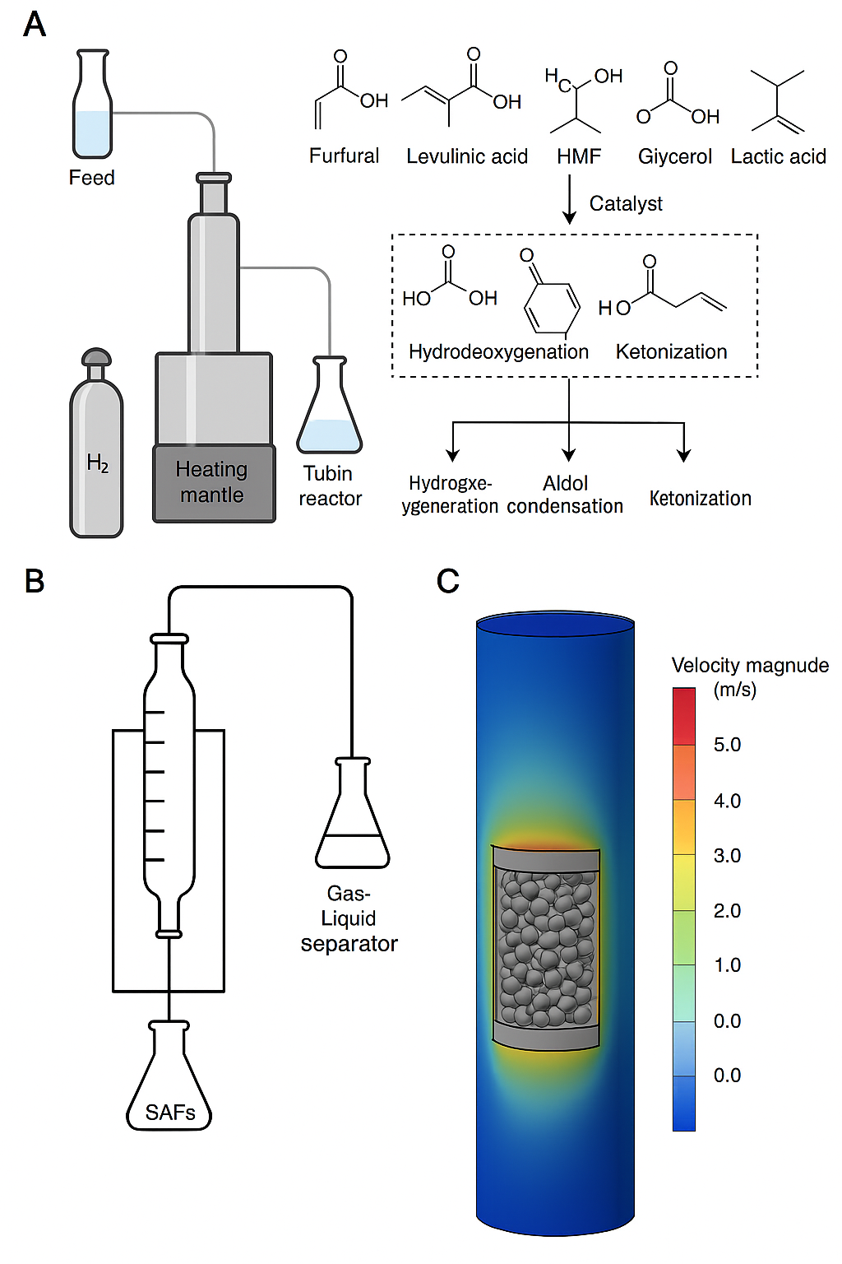

Figure 1: Experimental Setup, Reaction Pathway, and CFD Simulation

7. Conclusion and Future Work
This study demonstrates the feasibility of converting biomass-derived platform molecules into SAFs and HVCs through advanced catalytic processes and reactor modeling. Future work should focus on catalyst durability, real feedstock variability, and process intensification for pilot-scale validation.

