ConsentGuard:

Digital Consent Tracker
Ms. Monali Arjun Kokate, Ms. Sanjeevani Pradeep Khairnar²,
Ms. Snehal Satish Kedar³, Ms. Pinal Dineshbhai Lagdhir⁴, Prof. Smita K. Thakare ⁵ Information Technology, Pune Vidyarthi Griha’s College of Engineering and Shrikrushna S. Dhamankar Institute of Management, Nashik, India¹ ⁻ ⁵

Abstract:- In today’s digital landscape, users frequently provide consent on online platforms without clearly understanding the implications of privacy policies and data-sharing agreements. The Digital Consent Tracker is designed to address this challenge by leveraging Artificial Intelligence (AI) and Natural Language Processing (NLP). The system analyzes lengthy and complex privacy documents, extracts essential information, and generates simplified, user-friendly summaries.
It further classifies consent details into key categories such as data collection, third-party sharing, data retention, and user rights. The solution includes a web-based dashboard and a browser extension that enable users to quickly access and review simplified consent information in real time. This approach enhances transparency, increases user awareness, and promotes responsible data-handling practices.
Overall, the proposed system highlights the potential of AI-driven technologies in enabling informed decision-making, strengthening user trust, and ensuring compliance with global privacy regulations such as GDPR and CCPA.
Keywords: Artificial Intelligence, Natural Language Processing, Privacy Policy, Digital Consent, Data Protection, GDPR, CCPA, Text Summarization, Browser Extension, User Awareness

INTRODUCTION

In today’s digital age, individuals continuously interact with online platforms such as websites, mobile applications, and social media networks. During these interactions, users are required to accept various Terms and Conditions, Privacy Policies, and Cookie Consent Notices. Such consents are legally mandated under global data protection regulations, including the General Data Protection Regulation (GDPR) and the California Consumer Privacy Act (CCPA).
However, most users accept these agreements without reading or fully understanding them. These documents often contain lengthy legal and technical language, making them difficult for non-technical users to comprehend. As a result, users remain unaware of what personal data is being collected, how it is processed, and whether it is shared with third parties. This leads to privacy risks, lack of transparency, and reduced control over personal data.
Furthermore, users frequently provide consent across multiple platforms without having a centralized mechanism to monitor or manage them. Revoking permissions or deleting accounts usually requires navigating through individual platforms, making the process inefficient and confusing.
To address these challenges, the Digital Consent Tracker introduces an AI-powered and user-friendly approach for managing online consents. The system functions as a personal privacy manager that automatically detects, extracts, summarizes, and organizes user consents in real time.
The proposed solution utilizes a browser extension integrated with a secure backend and an AI/NLP-based summarization engine. When a user clicks “Accept” on a cookie banner or terms page, the extension captures the relevant content. This content is then processed by an intelligent summarization module to generate a simplified, plain-language version of the agreement.
Both the original and summarized consent data are securely stored in a MySQL database. Users can access this information through a React-based web dashboard with Google Sign-In authentication. The dashboard provides features such as search, filtering, consent revocation, and exporting records in PDF or CSV format.
In addition to understanding complex consent documents, users often lack visibility into the permissions they have granted across different websites. Modern platforms request multiple permissions, including cookies, notifications, location access, and third-party data sharing, but rarely provide a unified view after consent is given. This absence of centralized tracking limits user awareness and control.
To overcome this limitation, the Digital Consent Tracker maintains a website-wise record of user consents and permissions. Each visited website is logged along with the user’s actions, enabling transparent monitoring of consent decisions. The system also allows users to revoke or modify previously granted permissions directly through a centralized dashboard, eliminating the need to revisit individual platforms.
By integrating real-time consent tracking, secure Google-based authentication, and AI-driven policy analysis, the proposed system offers a comprehensive and user-centric solution for digital consent management. It enhances transparency, strengthens user control, and aligns with privacy regulations such as GDPR, CCPA, and India’s Digital Personal Data Protection (DPDP) Act.
Overall, the system simplifies consent visualization, improves usability for non-technical users, and promotes ethical data-handling practices while strengthening trust between users and digital platforms.

PROBLEM STATEMENT

In the current digital environment, users frequently interact with websites, mobile applications, and online services that collect personal data for purposes such as analytics, advertising, and personalization. However, users are often unaware of how and when their data is collected, processed, stored, or shared with third parties.
Existing consent mechanisms are typically lengthy, inconsistent, and difficult to understand, leading to low user awareness and increased data privacy concerns. Traditional systems rely on static pop-up messages or long privacy policy documents, which users tend to ignore due to repetitive content and complex legal terminology.
Furthermore, organizations face challenges in maintaining compliance with data protection regulations such as GDPR, CCPA, and India’s Digital Personal Data Protection (DPDP) Act, which require explicit user consent, along with clear provisions for consent withdrawal and audit tracking.
Therefore, there is a need for a smart, automated, and user-centric consent management solution. The proposed Digital Consent Tracker provides a centralized platform, along with a browser extension, that enables users to view, track, modify, and revoke their consents across multiple platforms efficiently. This system enhances transparency and provides users with greater control over their personal data.

RESEARCH OBJECTIVES

I. To develop a real-time AI- and NLP-based detection mechanism capable of identifying and extracting digital consent content such as cookie notices, privacy policies, and terms and conditions from websites with high accuracy.
II. To design an intelligent consent analysis system that automatically classifies consent information into categories such as data collection, third-party sharing, data retention, and user rights.
III. To implement AI-driven summarization techniques that convert complex legal consent text into concise, user-friendly, and easily understandable summaries to support informed decision-making.
IV. To develop a secure, centralized, and scalable consent management platform that stores consent records along with metadata such as timestamps, website URLs, and consent status, ensuring compliance with data protection regulations.
V. To provide an intuitive dashboard interface that offers real-time alerts, consent history, and actionable insights, enabling users to review, modify, or withdraw their digital consents efficiently.

RESEARCH BACKGROUND

The research background of ConsentGuard – Digital Consent Tracker is based on the growing concerns related to digital privacy, data misuse, and lack of transparency in online consent mechanisms. In today’s digital ecosystem, users are frequently exposed to lengthy and complex privacy policies, cookie notices, and consent forms that are difficult to understand, leading to uninformed or forced consent.
Traditional consent systems rely heavily on static text and manual interaction, offering limited transparency, control, and accountability over personal data usage. With the rapid growth of data-driven technologies, targeted advertising, and cross-platform tracking, organizations increasingly collect, process, and share user data across multiple third-party services. This makes it difficult for users to track where, when, and how their consent has been provided.
Regulatory frameworks such as GDPR, CCPA, and the DPDP Act emphasize informed consent, data minimization, and user rights. However, existing systems often fail to provide effective tools for monitoring and managing consent histories.
Recent advancements in Artificial Intelligence (AI) and Natural Language Processing (NLP) offer promising solutions by enabling automated detection, analysis, and summarization of legal text. AI-powered consent tracking systems improve user awareness by simplifying complex policies, enhancing transparency, and enabling centralized consent management.
Therefore, the development of intelligent and automated systems like ConsentGuard is essential to empower users, improve regulatory compliance, and build trust in digital platforms.

LITERATURE REVIEW

● 2021 | Browser-Based Tools for Web Consent and Text Handling
Mehta and Gupta (2021) proposed a Google Chrome-based extension framework for secure text authentication. Their work demonstrated the effectiveness of browser extensions in capturing and processing web content in real time, forming the foundation for automated consent detection systems.
● 2021 | NLP Techniques for Simplifying Legal and Policy Texts
Brown and Chen (2021) explored NLP techniques such as tokenization, semantic analysis, and extractive summarization. Their findings showed significant improvements in user understanding of complex legal documents.
● 2022 | AI-Based Privacy Policy Summarization for Transparency
Wilson and Kumar (2022) introduced an AI-powered framework for summarizing privacy policies. Their study demonstrated that automated summarization reduces cognitive load and improves informed consent.
● 2022 | Integrating Consent Management into Intelligent Systems
Sharma and Deshmukh (2022) presented a structured model for integrating consent management into AI-driven systems, emphasizing traceability, governance, and compliance.
● 2022 | AI-Driven Transparency in Data Collection Practices
Smith and Li (2022) proposed AI-based policy summarization methods to improve transparency in data collection, helping users better understand how their data is used.
● 2023 | Cookie-Less and Secure Consent-Oriented Session Management
Shah and Jain (2023) introduced a secure cookie-less session management framework, supporting privacy-focused system designs and reducing unnecessary tracking.

PROPOSED SYSTEM
The proposed Digital Consent Tracker provides a centralized, automated, and intelligent solution for managing user consents across multiple digital platforms. The system is designed to enhance user awareness, simplify decision-making, and improve transparency in digital data handling practices.
It integrates Artificial Intelligence (AI), Natural Language Processing (NLP), and secure web technologies to automatically extract, analyze, and summarize consent data in real time. The system operates through a browser extension connected to a secure backend server, along with a web-based dashboard for user interaction.
When a user interacts with a website displaying consent-related content such as cookie notices or privacy policies, the browser extension automatically detects and captures the consent text along with metadata such as website URL and timestamp.
The captured data is processed using AI/NLP-based summarization techniques to convert complex legal text into simple, understandable sentences. This allows users to quickly grasp key aspects such as data collection practices, third-party sharing, data retention policies, and user rights.
Both the original and summarized consent data are securely stored in a MySQL database. Users can access their consent history through a React-based dashboard integrated with Google Sign-In authentication, ensuring secure and personalized access.
The dashboard provides functionalities such as viewing summarized consents, searching and filtering records, managing permissions, revoking consents, and exporting data in PDF or CSV formats.
Additionally, the system maintains a website-wise record of user consents and permissions. Each visited website is logged along with permissions granted or denied, including cookies, notifications, location access, and third-party data sharing.
This structured tracking enables users to clearly identify which platforms have access to their data and what permissions have been granted, thereby enhancing transparency, accountability, and informed decision-making in digital privacy management.

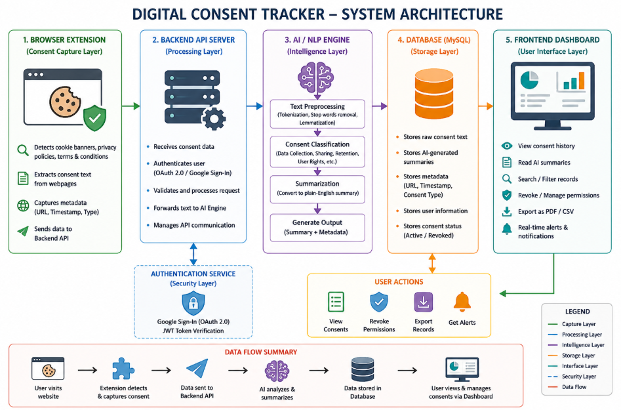

Fig. 1 System architecture.

SYSTEM ARCHITECTURE
The architecture of the Digital Consent Tracker (Consent Guard) is designed as a modular, AI-driven, multi-layered system that enables secure, transparent, and efficient management of user consent data. The system supports real-time consent tracking, intelligent analysis, and centralized user control.

Browser Extension (Consent Capture Layer):
This layer serves as the initial interaction point with the user’s browsing activity. The browser extension continuously monitors websites to detect consent-related elements such as cookie pop-ups, privacy policies, and terms and conditions. Upon detection, it automatically extracts the consent text along with relevant metadata, including the website URL and timestamp. This ensures seamless and real-time consent data capture without requiring manual user intervention.

Backend Web API (Processing and Authentication Layer):
The backend Web API functions as the central processing unit of the system. It receives extracted consent data from the browser extension and authenticates users using secure mechanisms such as JWT and Google Sign-In (OAuth 2.0). The backend manages business logic, handles API communication, and forwards the data to the AI/NLP engine for further processing. It also ensures secure interaction between the frontend, database, and AI components.

AI/NLP Summarization Engine (Intelligence Layer):
This layer acts as the analytical core of the system. It utilizes Artificial Intelligence and Natural Language Processing techniques to analyze complex and lengthy legal text. The engine performs preprocessing, classification, and summarization to generate concise, plain-language summaries. It identifies key aspects such as data collection, third-party sharing, data retention, and user rights, significantly improving user comprehension.

Database (Secure Storage Layer):
The database layer provides secure and structured storage for all consent-related data. It stores raw consent text, AI-generated summaries, user information, permission status, timestamps, and revoke links. A relational database such as MySQL ensures data integrity, scalability, and compliance with data protection regulations. This layer enables efficient retrieval and long-term tracking of consent history.

Frontend Dashboard (Visualization and Control Layer):
The frontend dashboard, developed using React.js, offers an intuitive interface for users to view and manage their consent data. It displays summarized consent information, website-wise permissions, and timestamps in a structured format. Users can search, filter, revoke permissions, and export consent records in PDF or CSV formats, ensuring easy and centralized management.

Consent Revocation and Permission Control (User Control Layer):
This layer provides users with complete control over their consent decisions. Users can withdraw or modify previously granted permissions directly from the dashboard without revisiting individual websites. This functionality supports the “Right to Withdraw Consent” as defined in regulations such as GDPR, CCPA, and India’s DPDP Act.

Feedback and Update Mechanism (Learning Layer):
This layer continuously collects user actions such as consent updates and revocations. The feedback is used to improve system performance, enhance classification accuracy, and refine summarization models. It ensures that the system adapts to changing consent patterns and regulatory requirements over time.

Process Flow:
- The browser extension detects and captures consent-related text from websites.
- The extracted data is securely transmitted to the backend Web API.
- The backend authenticates the user and forwards the data to the AI/NLP engine.
- The AI engine processes the data and generates simplified summaries.
- The processed data is securely stored in the database.
- The frontend dashboard displays consent history and enables user actions such as viewing, revoking, and exporting consent records.

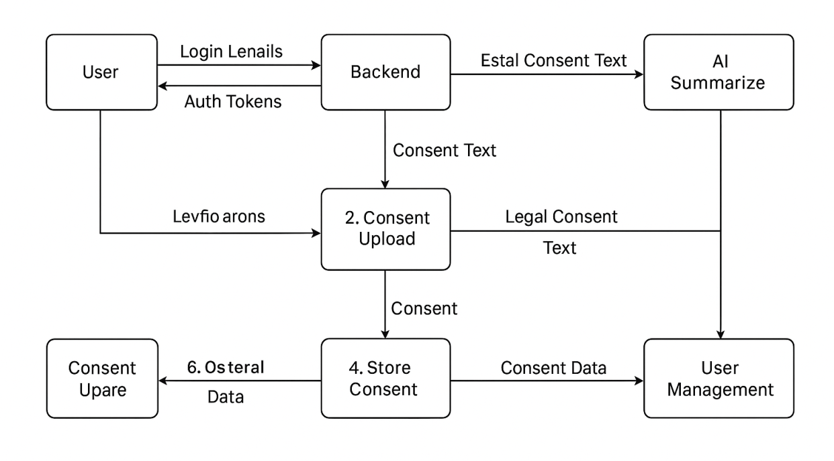
Fig. 2 Overall methodology of Digital
Consent Tracker.

METHODOLOGY
The methodology of the Digital Consent Tracker follows a phased, modular, and AI-driven approach to ensure accuracy, scalability, and user-centric privacy management. The process begins with automated data extraction using a browser extension that continuously monitors user interactions with consent banners, cookie pop-ups, and privacy policy pages across various websites. When the user interacts with such elements, the extension captures the relevant consent text along with associated metadata such as website URL, consent type, and timestamp.
In the next phase, the captured data is securely transmitted to the backend server, where Artificial Intelligence (AI) and Natural Language Processing (NLP) techniques are applied for text analysis and summarization. The summarization module processes lengthy and complex legal documents and converts them into concise, plain-language summaries. These summaries highlight key aspects such as data collection practices, third-party data sharing, data retention policies, and user rights, thereby improving user understanding and decision-making.
The backend system ensures secure data handling through authenticated APIs and structured storage mechanisms. Both the original consent text and AI-generated summaries are stored in a relational database, enabling efficient retrieval and long-term maintenance of consent records. Security mechanisms such as authentication and access control are implemented to protect user data and ensure compliance with privacy regulations.
The processed consent information is then presented through a user-friendly, React-based web dashboard. The dashboard allows users to view, search, and filter their consent history, manage granted permissions, and revoke or withdraw consent when required. This centralized interface ensures real-time consent management, enhanced transparency, and compliance with regulations such as GDPR, CCPA, and India’s Digital Personal Data Protection (DPDP) Act.
Following summarization, the system performs semantic classification and categorization of the consent text. Each clause is structured into predefined categories such as data collection, data usage, third-party sharing, retention period, and user rights. This structured organization enables better analysis, supports filtered searches, and enhances automated consent management.
Overall, the methodology ensures that users can clearly understand how their data is handled and make informed decisions by reviewing and managing their consent effectively.

ALGORITHM USED

The Digital Consent Tracker utilizes a hybrid combination of Natural Language Processing (NLP), Machine Learning (ML), and rule-based techniques to detect, analyze, classify, and summarize consent information in real time.
For consent detection, rule-based DOM analysis and pattern-matching algorithms are implemented within the browser extension. These methods identify consent-related elements such as cookie banners, privacy policy dialogs, and terms and conditions using keyword matching and regular expressions.
After extraction, the consent text undergoes NLP preprocessing steps including tokenization, stop-word removal, lemmatization, and sentence segmentation. These steps normalize the text and enhance the performance of classification and summarization models.
For classification, machine learning algorithms such as Logistic Regression (LR), Support Vector Machines (SVM), Naïve Bayes (NB), and Random Forest (RF) are used. These models categorize consent clauses into predefined classes such as data collection, third-party sharing, data retention, and user rights. Among these, Random Forest and SVM provide higher accuracy due to their ability to handle complex textual patterns.
For summarization, the system employs both extractive and transformer-based techniques. Extractive summarization is performed using TF-IDF-based sentence scoring and ranking, while advanced models generate simplified summaries in plain English.
Score(sentence)=\sum TF(word) \times IDF(word)
In this approach, each sentence is assigned a score based on the importance of its words. Terms that appear frequently in a sentence but are rare across the document receive higher weights, ensuring that important legal information is retained in the summary.
Additionally, rule-based decision logic is implemented to manage consent actions such as grant, deny, and revoke in real time. Secure authentication mechanisms such as OAuth 2.0 (Google Sign-In) and JWT-based authorization ensure that user data remains protected and accessible only to authorized users.
The integration of rule-based detection, NLP preprocessing, machine learning classification, and AI-driven summarization creates a robust and scalable system. This approach reduces information overload, enhances user awareness, and ensures compliance with modern data protection regulations.

IMPLEMENTATION

The implementation of the Digital Consent Tracker is based on a distributed and modular architecture that integrates browser-based monitoring, AI/NLP processing, and secure web technologies.
The browser extension acts as the client-side component and continuously monitors user interactions with websites. It detects consent-related elements such as cookie pop-ups, privacy policies, and terms and conditions in real time. Upon detection, it extracts consent text along with metadata such as website URL, timestamp, and consent type, and sends it securely to the backend.
The backend server processes incoming data, handles authentication and authorization, and coordinates communication between system components. AI/NLP models analyze the extracted text to classify consent clauses and generate summaries. The processed data is stored securely in the database.
To ensure secure and personalized access, the system uses Google Sign-In (OAuth 2.0) along with JWT-based session management. Secure APIs, access control mechanisms, and encrypted storage are implemented to protect sensitive user data and ensure compliance with privacy standards.
The frontend dashboard provides users with an intuitive interface to interact with the system. It enables users to view consent history, analyze summarized content, manage permissions, and export records. This implementation ensures a seamless, secure, and user-centric consent management experience.

I. CLIENT DEPLOYMENT (BROWSER EXTENSION LAYER)
Each user installs a lightweight browser extension that operates locally within the browser environment. The extension continuously monitors:
●Website DOM elements
● Cookie banners and modal dialogs
● Privacy policy and terms and conditions pages
This enables real-time detection and extraction of consent-related content during normal browsing activity without interrupting the user experience.

II. TEXT CAPTURE AND FEATURE EXTRACTION
The browser extension extracts:
● Raw consent text
● Website URL and domain
● Consent type (cookies, tracking, third-party sharing, notifications, etc.)
● Timestamp and user interaction context

III. NLP AND ML-BASED ANALYSIS
The backend integrates an AI/NLP engine that performs:
● Text preprocessing (tokenization, stop-word removal, lemmatization)
● Clause classification using ML algorithms (Logistic Regression, SVM, Random Forest)
● Extractive and transformer-based summarization
These models are trained on legal and consent datasets to accurately identify key clauses related to:
Dat collection
Data usage
Third-party sharing
Retention policies
User rights

IV. SECURE AUTHENTICATION AND ACCESS CONTROL
The system implements Google Sign-In (OAuth 2.0) for secure authentication. JWT-based session management ensures that consent data is:
●User-specific
●Securelyaccessed
● Protected from unauthorized access
Role-based access control supports both user-level and administrative operations.

V. CONSENT MANAGEMENT AND REVOCATION
Processed consent data is stored in a centralized database and accessed through a web-based dashboard. Users can:
● View website-wise consent history
● Read AI-generated summaries
● Revoke or modify permissions in real time
● Export consent records for compliance and auditing
This functionality supports the “Right to Withdraw Consent” under GDPR, CCPA, and India’s DPDP Act.

TOOLS USED
Programming Languages:
●Java (Spring Boot backend)
●JavaScript (Browser Extension)
● JavaScript / TypeScript (React Frontend)
Frontend:
●React.js
●HTML, CSS
● Axios
Backend:
●Spring Boot
●REST APIs
● JWT Authentication
AI / NLP:
● NLP libraries (tokenization, summarization models)
● TF-IDF-based scoring
Database:
● MySQL
Authentication & Security:
●Google OAuth 2.0
● JWT
● HTTPS
Deployment & Testing:
●Docker(optional)
●Postman
● Chrome Developer Tools

HARDWARE / SOFTWARE SETUP

ClientSide:
● OS: Windows / Linux / macOS
● Browser: Google Chrome
● Hardware: 2–4 GB RAM minimum
Server Side:
● OS: Linux (Ubuntu) / Windows Server
● Hardware: 8–16 GB RAM, multi-core processor
● Storage: SSD

EXPERIMENTAL ENVIRONMENT
Training & Validation:
● Use privacy policy datasets
● Evaluate summarization accuracy and classification performance
Testing Phase:
● Deploy extension in controlled environments
● Test across multiple real-world websites
● Measure latency, accuracy, and usability
Evaluation:
● Measure consent capture success rate
● Validate revocation effectiveness
● Assess improvement in user understanding

RESULTS AND ANALYSIS

The Digital Consent Tracker significantly enhances user awareness, transparency, and control over digital privacy. By leveraging AI and NLP techniques, the system simplifies complex privacy policies into concise and understandable summaries. This enables users to clearly understand key aspects such as data collection, usage, third-party sharing, retention policies, and user rights.
The centralized dashboard provides a unified platform for users to view, track, search, and manage their consent history across multiple platforms. Users can revoke or modify permissions at any time, ensuring continuous control over their personal data.
Additionally, the system supports compliance with global and national data protection regulations such as GDPR, CCPA, and India’s DPDP Act. The ability to export consent records in PDF or CSV format allows users to maintain verifiable documentation for auditing and legal purposes.
Overall, the system improves transparency, enhances user trust, and promotes ethical data-handling practices.

CONCLUSION

The Digital Consent Tracker presents an effective and innovative solution to address the challenges of online privacy management and uninformed consent. By integrating Artificial Intelligence and Natural Language Processing, the system transforms complex legal documents into simplified and actionable insights.
The centralized dashboard allows users to manage, track, and revoke their consents efficiently, eliminating the need to navigate individual platforms. This improves transparency and provides greater control over personal data.
The system aligns with global privacy regulations and supports privacy-by-design principles. By enabling informed decision-making and responsible data usage, the Digital Consent Tracker contributes to building a secure, transparent, and user-centric digital ecosystem.

ACKNOWLEDGMENT

We sincerely express our gratitude to Dr. Vijay R. Sonawane for his expert guidance, continuous encouragement, and valuable support throughout this project.
We are also thankful to Prof. S. K. Thakare, Project Coordinator, for her constant support, insightful suggestions, and motivation that contributed significantly to the successful completion of this work.
We extend our heartfelt appreciation to Dr. M. V. Bhalerao, Principal of Pune Vidyarthi Griha’s College of Engineering, Nashik, for providing the necessary support and guidance.
Finally, we thank all the faculty members and staff of the Information Technology Department for their assistance and encouragement throughout the project.

REFERENCES

[1] A. Sharma and K. Deshmukh, “A formal model for integrating consent management into MLOps,” in Proc. Int. Conf. Artificial Intelligence and Privacy Engineering, 2022, pp. 45–52.
[2] L. Mehta and R. S. Gupta, “On the development of a web extension for text authentication on Google Chrome,” in IEEE Int. Workshop on Web Security Technologies, 2021, pp. 34–40.
[3] P. Shah and V. Jain, “Key-based cookie-less session management framework for application layer security,” Int. J. Network Security Engineering, vol. 18, no. 3, pp. 105–113, 2023.
[4] M. H. Wilson and A. Kumar, “AI-powered summarization of privacy policies for user transparency,” IEEE Access, vol. 10, pp. 45123–45135, 2022.
[5] J. Brown and L. Chen, “Natural language processing techniques for simplifying legal texts,” Journal of Artificial Intelligence Research, vol. 74, pp. 115–130, 2021.
[6] T. Nguyen and R. Patel, “Automated consent management system using machine learning and NLP,” in Proc. IEEE Int. Conf. Data Privacy and Ethics, 2023, pp. 101–110.
[7] A. Smith and P. Li, “Improving transparency in data collection through AI-based policy summarization,” ACM Journal on Responsible Computing, vol. 4, no. 2, pp. 65–78, 2022.
[8] R. Kaur and N. Sharma, “Legal document simplification using transformer-based language models,” Int. J. Computer Applications, vol. 185, no. 17, pp. 22–29, 2023.
[9] S. Johnson and Y. Zhang, “HuggingFace transformers for context-aware privacy policy analysis,” IEEE Trans. Computational Linguistics, vol. 9, pp. 211–223, 2023.
[10] A. Banerjee and M. Singh, “AI-driven framework for GDPR and CCPA compliance monitoring,” Journal of Data Protection and Privacy, vol. 5, no. 1, pp. 33–47, 2022.
[11] C. Wang and E. Rober, “Advanced AI-enabled consent governance for secure data handling,” in Proc. Int. Symp. Digital Trust and Cybersecurity, 2023, pp. 88–96.
[12] J. Verma and S. Thomas, “Machine learning approaches for consent compliance and data rights management,” IEEE Trans. Information Forensics and Security, vol. 18, pp. 1321–1335, 2023.
[13] D. I. Rivera and K. Yadav, “Automated legal consent extraction using transformer-based architectures,” in Proc. IEEE Int. Conf. AI and Law (ICAIL), 2022, pp. 76–84.
[14] S. Patel, M. Dutta, and J. Lee, “A user-centric framework for managing digital consent using browser extensions,” Int. J. Web Privacy Engineering, vol. 12, no. 3, pp. 44–53, 2023.
[15] H. Nakamura and E. Diaz, “AI-enabled privacy rights enforcement under GDPR via consent automation,” Springer Journal of Cybersecurity Innovations, vol. 6, no. 1, pp. 21–38, 2024.
[16] S. Zimmeck and S. Bellovin, “Practical privacy policy analysis using machine learning,” in Proc. IEEE Symp. Security and Privacy, 2014, pp. 1–15.
[17] A. M. McDonald and L. F. Cranor, “The cost of reading privacy policies,” I/S: A Journal of Law and Policy for the Information Society, vol. 4, no. 3, pp. 543–568, 2008.
[18] G. Contissa, R. Lagioia, and G. Sartor, “Automated processing of privacy policies under GDPR,” Artificial Intelligence and Law, vol. 26, no. 2, pp. 163–200, 2018.
[19] F. Schaub, R. Balebako, A. L. Durity, and L. F. Cranor, “A design space for effective privacy notices,” in Proc. IEEE Symp. Usable Privacy and Security (SOUPS), 2015, pp. 1–17.
[20] K. Ganesan and S. Meenakshi, “Text summarization techniques for legal documents using NLP,” Int. J. Computer Science and Engineering, vol. 11, no. 4, pp. 210–218, 2022.
[21] N. Kshetri, “The economics of privacy, big data and artificial intelligence,” IEEE IT Professional, vol. 22, no. 2, pp. 5–8, 2020.
[22] A. Gerl et al., “Privacy and data protection by design – from policy to engineering,” IEEE Security & Privacy, vol. 16, no. 3, pp. 25–34, 2018.
[23] T. Hoang et al., “Efficient privacy policy classification using deep learning,” IEEE Access, vol. 9, pp. 98721–98733, 2021.
[24] P. L. Koopman and J. D. Hoven, “Ethical issues in AI-based decision systems,” AI and Society, vol. 35, no. 2, pp. 425–437, 2020.
[25] M. Veale et al., “Algorithms that remember: Model inversion attacks and data protection law,” Philosophical Transactions of the Royal Society A, vol. 376, no. 2133, pp. 1–15, 2018.
[26] A. Cavoukian, “Privacy by design: The seven foundational principles,” IEEE Consumer Electronics Magazine, vol. 4, no. 1, pp. 13–18, 2015.
[27] R. G. Nair and S. Pillai, “User-centric consent management framework for web applications,” Int. J. Web Engineering and Technology, vol. 18, no. 1, pp. 55–72, 2023.
[28] A. T. Smith and H. Jin, “Automated analysis of online privacy policies using deep learning,” IEEE Access, vol. 8, pp. 141184–141195, 2020.
[29] J. Polonetsky et al., “Privacy by design: Principles and implementation,” IEEE Security & Privacy, vol. 12, no. 6, pp. 38–45, 2014.
[30] R. Binns, “Human judgements in algorithmic decision-making,” in Proc. ACM FAccT, 2018, pp. 1–12.
[31] S. Zuboff, “Big other: Surveillance capitalism and the prospects of an information civilization,” Journal of Information Technology, vol. 30, no. 1, pp. 75–89, 2015.
[32] M. Lippi et al., “Legal text classification using machine learning,” Artificial Intelligence and Law, vol. 27, no. 3, pp. 321–347, 2019.
[33] A. Kapoor and S. R. Rao, “Consent management platforms for GDPR compliance: A comparative study,” Int. J. Information Security Science, vol. 11, no. 2, pp. 89–102, 2022.
[34] L. Sweeney, “Privacy risks in data sharing and consent mechanisms,” IEEE Computer, vol. 53, no. 1, pp. 45–52, 2020.
[35] E. Bertino and N. Islam, “Botnets and internet privacy: Challenges and solutions,” IEEE Computer, vol. 50, no. 2, pp. 76–80, 2017.
[36] S. Wachter et al., “Why a right to explanation of automated decision-making does not exist in the GDPR,” International Data Privacy Law, vol. 7, no. 2, pp. 76–99, 2017.
[37] P. Voigt and A. von dem Bussche, The EU General Data Protection Regulation (GDPR): A Practical Guide. Springer, 2017.
[38] F. B. Abdessalem et al., “Consent management and transparency in data-driven systems,” IEEE Internet Computing, vol. 23, no. 6, pp. 72–79, 2019.
[39] A. Degeling et al., “We value your privacy… now take some cookies,” in Proc. NDSS Symposium, 2019, pp. 1–15.
[40] S. K. Sahay et al., “Automated privacy policy analysis and compliance verification,” in Proc. ACM CCS Workshop, 2020, pp. 1–10.
[41] R. Shokri and V. Shmatikov, “Privacy-preserving deep learning,” in Proc. ACM CCS, 2015, pp. 1310–1321.
[42] I. Goodfellow, Y. Bengio, and A. Courville, Deep Learning. MIT Press, 2016.
[43] S. Pearson and A. Benameur, “Privacy, security and trust issues in cloud computing,” IEEE Cloud Computing, vol. 3, no. 2, pp. 14–23, 2016.
[44] J. R. Reidenberg et al., “Privacy interfaces: User-centric privacy design,” IEEE Security & Privacy, vol. 13, no. 1, pp. 68–71, 2015.
[45] P. Ohm, “Broken promises of privacy,” UCLA Law Review, vol. 57, no. 6, pp. 1701–1777, 2010.
[46] M. Hildebrandt, “Law as computation in artificial legal intelligence,” University of Toronto Law Journal, vol. 68, no. 1, pp. 12–35, 2018.
[47] A. Acquisti et al., “Privacy and human behavior in the age of information,” Science, vol. 347, no. 6221, pp. 509–514, 2015.


Prof. Smita K. Thakare is an academician who specializes in big data analytics, data science, and machine learning. She has taught undergraduate and graduate courses in fundamental computing areas like machine learning, social media analysis, computer graphics, digital electronics, and discrete mathematics for more than 8.8 years. Her active participation in academic research is demonstrated by the 11 international research papers she has published and the research she has presented at national and international conferences. She is currently employed at Pune Vidyarthi Griha's College of Engineering in Nashik as an Assistant Professor in the Department of Information Technology, where she teaches, mentors academics, and supports technology-focused education.

Ms. Monali A. Kokate is currently pursuing a B.E. in Information Technology from Savitribai Phule Pune University. She is interested in cloud computing, AI/ML, full stack development, and system architecture. Working on system-level architecture, data-driven decision models, and contemporary security techniques that enable scalable and dependable solutions, she works on creating intelligent and secure software systems.

Ms. Sanjeevani P. Khairnar is currently pursuing a B.E. in Information Technology from Savitribai Phule Pune University and is an alumna of NDMVPS's RSM polytechnic, Nashik. Her areas of interest include data analytics, database management, front-end development, AL/ML, and cloud computing, with a focus on developing efficient and user-centric software solutions. She is enthusiastic about learning emerging technologies and contributing to the development of secure and scalable systems.

Ms. Snehal S. Kedar is currently pursuing a B.E. in Information Technology from Savitribai Phule Pune University. She is particularly interested in full-stack development, cloud computing, AI/ML, and data-driven systems. She has practical expertise with database systems, web technologies, and Internet of Things-based projects. In an effort to support scalable and significant software systems, she actively focuses on system-level thinking, practical problem-solving, and responsible technology design.

Ms. Pinal D. Lagdhir is currently pursuing a B.E. in Information Technology from Savitribai Phule Pune University. She is interested in full-stack web technologies, Java-based apps, and software development. With a strong background in database management systems, object-oriented programming, and data structures, she concentrates on creating dependable and user-friendly software. In order to create reliable and maintainable software systems, she is especially drawn to logical problem-solving, system implementation, and ongoing skill development.

