Empirical Characterization and Modelling of a Typical WCDMA Cellular Network towards Enhancing Soft Handoff Decision
C.S. Okafor¹, T.D. Ekwunife^{2*}, N.C. Maduka³, S.K. Ogbuokebe⁴
^{1,2}Department of Electronic & Computer Engineering, Nnamdi Azikiwe University, Awka, Nigeria
³Department of Physics, Federal University Gusau, Zamfara
⁴National Space Research and Development Agency, Abuja
¹Email: cs.okafor@unizik.edu.ng
²Email: td.ekwunife@unizik.edu.ng
³Email: madukanosike@fugusau.edu.ng
⁴Email: ogbuokebekc@gmail.com
*Corresponding author: cs.okafor@unizik.edu.ng
Abstract
Soft handoff decisions should only be made when necessary in order to improve the Wideband Code Division Multiple Access (WCDMA) cellular network's quality of service (QoS). Constant soft handoffs reduce data speed, raise network signaling overhead, impair communication quality, and lead to ineffective channel management. Based on the parameters for handoff decision, which include; Received Signal Strength (RSS) from current Base Station (BS) and neighboring BS, the distance of the mobile system (MS) to the target BS, and the heading direction, this paper empirically characterizes and models a typical WCDMA network with Base station identifications as (AN0479K), (AN0052H), and (AN0530K), respectively, all located within Onitsha City, Anambra state. It was found that as the MS moves toward any one of the three BSs, the RSS at the MS gets stronger, and as it moves away from any one of the BSs, the RSS gets weaker. When the constructed model is evaluated using an intelligent method, it will help to ensure that there are no needless handoffs in the WCDMA network and that the Ping-Pong effect is suppressed.
Keywords: WCDMA; Soft handoff; QoS; RSS; Ping-Pong.
Introduction
The mobile communication technology's continued development has made it easier for users to communicate with one another anytime, anywhere, and especially while the mobile system (MS) is moving without being constrained by fixed-line connection points, which has significantly accelerated the telecommunications industry's growth rate. Mobility in wireless networks refers to the capability to change the wireless link's connecting point without disrupting the mobile user by requiring little loss of signal strength. In this network, mobility also refers to the movement of communication terminals and ongoing connectivity inside the cell coverage area via the handoff concept.
One of the most crucial quality indicators in the cellular network is call continuation while an active call is in progress. A cellular system can offer such a service thanks to the Handoff process, which involves moving an active call from one cell to another [1]. Supporting handoff, which is the transfer of an active call from the current cell to the next neighboring cell while the mobile moves through the coverage region, enables continuation and sustenance of service [2].
A mechanism of switching the channel (frequency, time slot, spreading code, or a combination of these) in the current network connection while a call is in progress is known as a handoff, sometimes known as a handover [3], [4]. The process of moving an active call or data connexion from one Base Station to another Base Station is known as handoff. The Mobile Switching Center (MSC) changes the call to a new channel that belongs to the new Base Station when a mobile moves into a different cell while the conversation is still active [5]. In order to monitor and detect certain target parameters, collect data, and then wirelessly communicate the data to sink or base station (BS), a wireless sensor network made up of several detection stations known as sensor nodes is placed over a geographical sensing region [6]. Additionally, the trade-off between system throughput and block error rate (BLER) in terms of throughput results in the choice of modulation scheme and code rate in a way that increases system throughput for a given channel quality while still enabling the achievement of a given acceptable block error performance [7].
Handoffs are classified into two categories:
- Hard handoff.
- Soft handoff.

Hard handoff: When switching to a new communication channel that is connected to a nearby cell after the existing channel has been dropped, the hard handoff system is employed. As a result, anytime a hard handoff occurs, there is always a service disruption, which lowers the network's quality of service. The time division multiple access (TDMA) and frequency division multiple access (FDMA)-based systems, including GSM and GPRS, employ hard handoff [8]. When the current or old connection is released before a new connection is established, a hard handoff occurs. A hard handoff's performance is assessed based on a number of initiation criteria [9], [10], and [11]. A hard handoff is essentially a break before make, in which the connection to the source is severed either before or concurrently with the establishment of the connection to the destination. Because of this, a hard handoff is often referred to as a break before make. The MS is only connected to one BS at a time in this situation.
Hard handoff can further be divided into two different types:
- Intra-cell hard handoff
- Inter-cell hard handoff.

Figure 1: Hard handoff between the MS and BSs [3].

Soft handoff: A "Make before break" handoff is a soft handoff [3]. In other words, once the mobile station (MS) switches from one base station (BS) to another, it is up on a call with the new BS before cutting the channel connection while the old BS is still on the call. As MSs move between cells (on cell boundaries), the handoff technique enhances call reception and lowers call drop. Since the MS initiates channel connections and communications with multiple BS simultaneously during soft handoff, the transition from the weaker BS to the stronger BS will be seamless because the MS is already in communication with the stronger BS.
The soft handoff is divided into two main types:
- Multi-way soft handoff
- Softer handoff.

Figure 2: Soft handoff between the MS and BSs [2].
Literature Review
Many researchers have created and presented research works in recent years on how to improve the performance of soft handoffs in Wideband Code Division Multiple Access (WCDMA) cellular networks in order to improve quality of service (QoS).
To assess and study the issue of soft handoffs in cellular radio systems, the authors of [12] created and presented a mathematical model for WCDMA networks. They created and examined a number of performance measures, such as the blocking probability of new calls, the blocking probability of dropped calls, and the blocking probability of handoff calls.
By merging machine learning methodologies and multiple attribute decision making (MADM) mechanisms in handoff choice for picking the best available network for handoff, the authors in [13] suggested and created a robust intelligent framework for soft handoff.
The concept of an overlap region between adjacent cells was presented in [14], and the author also created an analytical model for hard handoff in a WCDMA system. The blocking probability were shown to decrease when the number of channels in a cell or service rate increased. The author also covered the balking and reneging behaviors of calls.
The author of [15] created a mechanism using umbrella cells to lessen the amount of handoffs in the WCDMA system. Small cells (micro cells) are used to serve low-speed users, while large cells (macro cells) are used to serve high-speed users. Two models were simulated, one using umbrella cells and the other not. The study's findings demonstrated that the umbrella cell technique improved the handoff process by significantly reducing the frequency of handoffs and the likelihood of blocked handoffs when compared to the model without the umbrella cell technique.
Methodology

The purpose of this research work is to characterize and model a typical WCDMA network using empirical data such as received signal strength (RSS) from the present base station and nearby base stations, the distance between the mobile system and the target base station, and the heading direction.

Drive Test

Drive Test Drive test measurements were performed in a UMTS network of a Nigerian telecom provider (Airtel) with base stations situated at Ukaegbu, Osumoghu, and Umuaga, with base station Ids (AN0479K), (AN0052H), and (AN0530K), respectively. These base stations were all evenly distributed between Ezeiweka and Oraifite avenue in Awada, Onitsha City, of Anambra state.

Figures 3, 4, and 5 show, accordingly, the Google Earth map and the driving test routes with the Common Pilot Channel (CPICH) footprint at these various places.

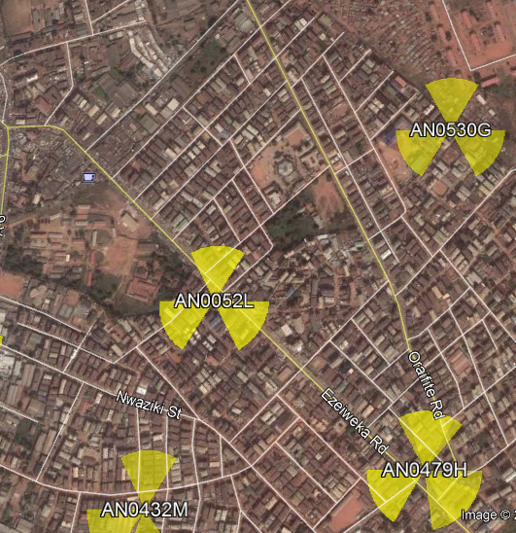

Figure 3: The Google Earth of the area under study

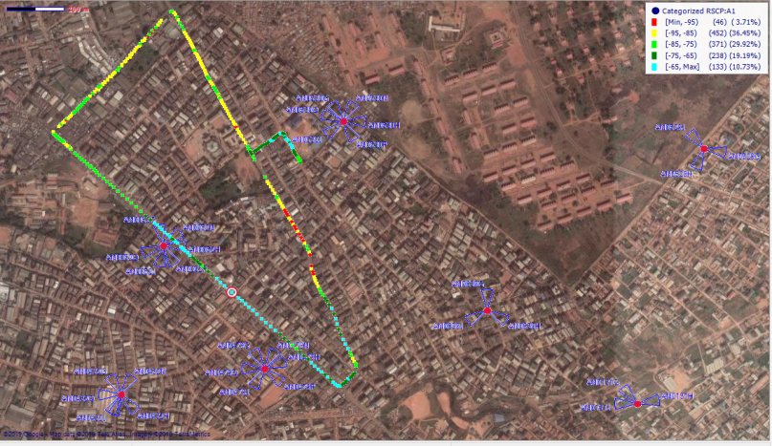

Figure 4: The Google earth of the CPICH footprint along the drive test route

This area covers approximately 514,086 m² with a distance of 3,530 m.

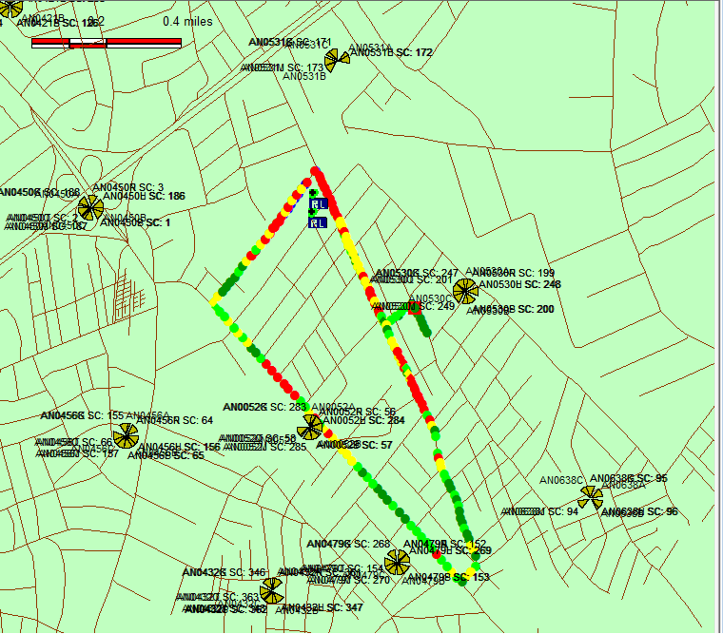

Figure 5: The drive test route with the footprints for the signal coverage

The following measurements were performed and documented from each of the three BSs' specified routes. They include, the MS's GPS coordinates, the power received from BSs in the active set and the monitoring set, the energy per chip to interference ratio (Ec/Io) in dB, and the Received Signal Code Power (RSCP) in dBm.

Measuring Instrument/Equipment

The various equipment used for the collection of data in this research work include the following:
- Personal Computer (Lenovo E-420) – 1no.
- Installed Computer Software (Ericsson TEMS investigation 15.2.2) – 1no.
- Mobile phones (Sony Ericsson W-995) – 2nos.
- Global Positioning System (GPS: G-STAR IV) – 1no.
- An Inverter (1000W) – 1no.

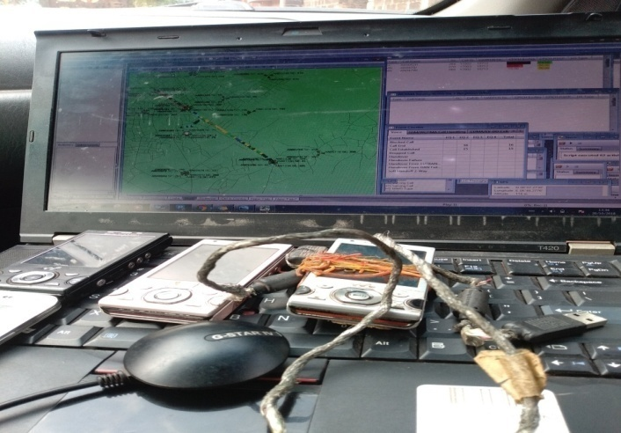

Figure 6: Picture of the used TEMS equipment

Measurement and Data Collection

During the driving test, measurements were made primarily in the channels 1950–1960 of the Nigerian Airtel (WCDMA) network using TEMS investigation 15.2.2 (a Sonny Ericsson W995 with TEMS pocket). The radio resource control (RRC) reports, which were obtained by precise measurement of the Energy per chip to Interference ratio (Ec/Io) of the common pilot channel (CPICH), served as the basis for the judgments on the soft handoff. The measured value of the received signal code power (RSCP) and the available received signal strength from the received signal strength indicator (RSSI) are used to calculate this Ec/Io. The distance of the MS and the power levels received from BSs in the active set and the monitoring set were noted as the measurements were being conducted. Figure 7 displays the results of the drive test study for the CPICH Ec/No and CPICH RSCP values.

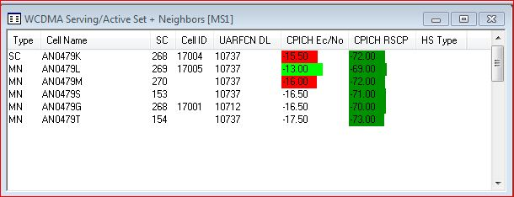

Figure 7: TEMS software interface showing measurements for Common Pilot Channel (CPCH) signals.

The distances between the three base stations are also shown in Table 1:
Table 1: Seperations between the three Base Stations
S/N | Base Stations | Seperation (m)
1 | BS 1 and BS 2 | 707.94
2 | BS 2 and BS 3 | 769.2

Characterization of the Typical WCDMA Network (Testbed)

The propagation path between the transmitter and the receiver may vary from BS to BS and from simple line-of-sight (LOS) to a very complex one due to diffraction, reflecting, and scattering resulting from either natural or constructed obstacles [16]. For Such environments, the propagation path may be modelled as a randomly varying propagation path, and in many instances; there exist more than one propagation path leading to multipath propagation. Such environments are characterized by fading effects such as shadowing, multipath fading, and path loss. These fading effects are best described (on a large scale) by the path loss exponent which defines the rate of change of attenuation that the signals suffer as it propagates from the transmitter to the receiver.

The average large-scale path loss for an arbitrary transmitter to receiver separation is expressed as a function of distance as [17], [18], [19]:

$P_{L}\left(dB\right)= P_{L}\left(d_{0}\right)+ 10ƞLog(\frac{d}{d_{0}})$ (1)

Where: $P_{L}\left(d_{o}\right)$ is the estimated path loss at reference distance$d_{0}$; $ƞ$is the path loss exponent and d is the distance between MS and BS.

It was shown by authors in [20] that for any value of distance (d), the path loss $P_{L}\left(dB\right)$is a random variable with a log-normal distribution about the mean value due to the shadowing effect. To compensate for shadow fading, the path loss beyond the reference distance can be written as:

$P_{L}\left(dB\right)= P_{L}\left(d_{0}\right)+ 10ƞLog\left(\frac{d}{d_{0}}\right)+ ς$ (2)

Where $ς$ is the shadowing factor and also a Gaussian random variable (with values in dB) and modelled as log normal with zero mean and standard deviation $σ$ (also in dB). The standard deviation of the shadowing factor is known as the location variability.

The standard deviation is given as in [20]:

$σ= \sqrt{\sum{\frac{(P_{L}\left(d_{i}\right)- P_{L}\left(d_{0}\right))^{2}}{N}}}$ (3)

Where $P_{L}\left(d_{i}\right)$ is the measured path loss at a distance, $d_{i}$, $P_{L}\left(d_{o}\right)$is the estimated path loss using equation 3.1 and N is the number of measured data points.

The path loss exponent $ƞ,$ is obtained from measured data by applying the method of linear regression analysis in [21] (or method of least squares) such that the sum of squared errors gives:

$e\left(ƞ\right)= \sum_{i=1}^{m}{(P_{L}\left(d_{i}\right)- P_{L}\left(d_{o}\right))^{2}}$ (4)

Making $P_{L}\left(d_{o}\right) in$ (3.1) the subject of formular and substituting into equation 3.4 gives:

$e\left(ƞ\right)= \sum_{i=1}^{m}{(P_{L}\left(d_{i}\right)- P_{L}\left(d_{0}\right)- 10ƞLog(\frac{d}{d_{0}}))^{2}}$ (5)

The value of which minimizes mean square error can be obtained by equating the derivative of $e\left(ƞ\right)$ to zero. Differentiating equation 5 with respect to$ƞ$ and equating to zero gives: $\frac{δe\left(ƞ\right)}{δn}=-20\log\left(\frac{d}{d_{0}}\right)\sum_{i=1}^{m}{\left(P_{L}\left(d_{i}\right)- P_{L}\left(d_{0}\right)- 10ƞLog\left(\frac{d}{d_{0}}\right)\right)=0}$

$$\sum_{i=1}^{m}{(P_{L}\left(d_{i}\right)- P_{L}\left(d_{0}\right)- 10ƞLog\left(\frac{d}{d_{0}}\right))=0}$$

$\sum_{i=1}^{m}{(P_{L}\left(d_{i}\right)- P_{L}\left(d_{o}\right))}$ = $\sum_{i=1}^{m}{(10ƞ\log_{10}{(\frac{d_{i}}{d_{o}}}})$

$\sum_{i=1}^{m}{(P_{L}\left(d_{i}\right)- P_{L}\left(d_{o}\right))}$ = $ƞ\sum_{i=1}^{m}{(10\log_{10}{(\frac{d_{i}}{d_{o}}}})$

Making $ƞ subject of formular gives:$

$ƞ= \frac{\sum_{i=1}^{m}{(P_{L}\left(d_{i}\right)- P_{L}\left(d_{o}\right))}}{\sum_{i=1}^{m}{(10\log_{10}{(\frac{d_{i}}{d_{o}}}}))}$ (6)

Where:

$P_{L}\left(d_{i}\right)$is the average path loss which is the difference between the transmitting power ($P_{t})$ in dB and received power ($P_{r})$ in dB,

$P_{L}\left(d_{o}\right)$= the path loss at close-in reference distance otherwise known as reference path loss,

$d_{o}$is close in reference distance,

$d_{i }$is the distance at intervals from the BS to MS.

Applying equations 3 and 6 to Tables 3 using the MATLAB program, the Path loss exponent and shadowing factor for each site are obtained as shown in Table 2.

Table 2: Path loss exponent and shadowing factor for each site
S/N | Base Station | Pathloss Exponent | Shadowing Factor
1 | AN 0052H | 2.54 | 6.21
2 | AN 0530K | 3.28 | 8.26
3 | AN 0479K | 3.32 | 7.30

To estimate the performance of wireless channels, propagation models are often used [22]. Path loss models represent a set of mathematical equations and algorithms which are applied for radio signal propagation prediction in certain environments. They describe the signal attenuation between a transmitting and a receiving antenna as a function of the propagation distance and other parameters which provide details of the terrain profile required to estimate the attenuating signal [23].

Using base station AN0479K as a reference, the path loss model is determined using the information provided in Table 2.

The empirical path loss model for Onitsha suburban can be obtained from equation 2:

$$P_{L}\left(dB\right)= P_{L}\left(d_{0}\right)+ 10ƞLog\left(\frac{d}{d_{0}}\right)+ ς$$

From Table 3, the average Path loss exponent for AN0479K was found to be 3.32 with an average Shadow factor of 7.30 and $P_{L}\left(d_{o}\right)$ which is the path loss at close-in reference distance otherwise known as reference path loss is 96dB.

Therefore the empirical Path loss for AN0432K is given as:

$$P_{L}\left(dB\right)= P_{L}\left(d_{0}\right)+ 10ƞLog\left(\frac{d}{d_{0}}\right)+ ς$$

Substituting the values above into the equation gives:

$$P_{L}\left(dB\right)= 96+ 10(3.32)Log\left(\frac{d}{d_{0}}\right)+ 7.8$$

$$P_{L}\left(dB\right)= 103.8+ 33.2Log\left(\frac{d}{d_{0}}\right)$$

The empirical path loss model for Onitsha suburban is then obtained as:

$P_{L}\left(dB\right)= 103.8+ 33.2Log\left(\frac{d}{d_{0}}\right)$ (7)

This is the efficient path loss model determined for Onitsha Sub-urban in this work.

The model obtained was also compared with other existing models so as to see the variation and acceptability. Due to the frequency limitation of COST-231 Hata model to 2GHz which is below the frequency of the WCDMA network studied in this work, our comparison will be limited to only free space and the ECC-33 model.

- free space path loss

The free space path loss equation is given as:

$P_{L}\left(dB\right)= 32.4+20Logf+20Logd_{i}$ (8)

Where,

f = frequency in MHz

$d_{i}$ = distance in km

This equation shows the relationship between the path loss, the frequency, and the distance of the transmission medium.

Using the following test parameters: $f = 2112MHz$

$$P_{L}\left(dB\right)= 32.4+20Log2112+20Logd_{i}$$

$$P_{L}\left(dB\right)= 32.4+66.49+20Logd_{i}$$

The free space path loss model for Onitsha suburban is given as:

$P_{L}\left(dB\right)= 98.89+20Logd_{i}$ (9)

- ECC-33 Path loss model

The path loss equation for ECC-33 model (Electronic Communication Committee (ECC), 2003) is:

$P_{L}= A_{fs}+ A_{bm}- G_{b}- G_{r}$ (10)

Where, $A_{fs}, A_{bm}, G_{b}, G_{r}$are the free space attenuation, the basic median path loss, the BS height gain factor and the terminal height gain factor. They are individually defined as

$$A_{fs}= 92.4+20LogF+20Logd_{i}$$

$$A_{bm}= 20.41+7.894Logf+9.83Logd_{i}+ 9.56(Logf)^{2}$$

$$G_{b}= \log\left(\frac{h_{b}}{200}\right)(13.958+5.8Log(d_{i}))^{2}$$

And for sub-urban city environments as shown in [10];

$$G_{r}=\left[42.57+13.7Logf\right]\left[Log\left(h_{m}\right)- 0.585\right]$$

And for large city:

$$G_{r}=0.759h_{m}- 1.862$$

Where f is the frequency in GHz

$h_{b}$is the BS antenna height in meters

$h_{m}$is the mobile antenna height in meters

$h_{m}$ =1.5m, $h_{b}$ = 24m,$f = 2.112 GHz$

$$A_{fs}= 92.4+20Log2.112+20Logd_{i}$$

$$A_{fs}= 92.4+6.53+20Logd_{i}$$

$A_{fs}= 98.89+20Logd_{i}$ (11)

$$A_{bm}= 20.41+7.894Log2.122+9.83Logd_{i}+ 9.56(Logf)^{2}$$

$$A_{bm}= 20.41+2.56+9.83Logd_{i}+ 9.56(Log2.112)^{2}$$

$$A_{bm}= 20.41+2.58+9.83Logd_{i}+ 1.01$$

$A_{bm}=24+9.83Logd_{i}$ (12)

$$G_{b}= \log\left(\frac{h_{b}}{200}\right)(13.958+5.8Log(d_{i}))^{2}$$

$$G_{b}= \log\left(\frac{24}{200}\right)(13.958+5.8Log(d_{i}))^{2}$$

$$G_{b}= -0.92 (13.958+5.8Log(d_{i}))^{2}$$

$$G_{b}= -0.92 (194.83+161.91Log\left(d_{i}\right)+33.64\{Log\left(d_{i}\right)\}^{2})$$

$G_{b}= -179.24-148.96Log\left(d_{i}\right)-30.95\{Log\left(d_{i}\right)\}^{2}$ (13)

$$G_{r}=\left[42.57+13.7LogF\right]\left[Log\left(h_{m}\right)- 0.585\right]$$

$$G_{r}=\left[42.57+13.7Log2.112\right]\left[Log\left(1.5\right)- 0.585\right]$$

$G_{r}=47.02 \left(-0.4089\right)= -19.23$ (14)

Substituting the values of equations (11), (12), (13) and (14) into (10)

$$P_{L}= 98.89+20Logd_{i}+ 24+9.83Logd_{i}- (-179.24-148.96Log\left(d_{i}\right)-30.95\{Log\left(d_{i}\right)\}^{2})-(-19.23)$$

$P_{L}= 321.36+178.79Log\left(d_{i}\right)+30.95\{Log\left(d_{i}\right)\}^{2}$ (15)

Results and Analysis of Text Bed Characterization

Table 3 and Figure 8 show the RSSI measured from the three based stations and the combined plot of the RSSI from the three based stations respectively.

Table 3: Measured Data from the various WCDMA BSs
S/N | Distance (m) | BTS AN0052H |  | BTS AN0530K |  | BTS AN0479K
 |  | RSCP (dBm) | E_{c}/N_{o} (dB) | RSCP (dBm) | E_{c}/N_{o} (dB) | RSCP (dBm) | E_{c}/N_{o} (dB)
1 | 100 | -52.60 | -10.00 | -41.10 | -11.00 | -48.10 | -10.50
2 | 200 | -55.10 | -10.10 | -42.30 | -12.50 | -51.60 | -12.00
3 | 300 | -59.20 | -12.40 | -46.30 | -13.10 | -65.50 | -12.55
4 | 400 | -70.60 | -13.00 | -53.10 | -13.60 | -64.50 | -14.20.
4 | 500 | -66.50 | -13.60 | -57.10 | -14.00 | -70.70 | -14.60
5 | 600 | -68.60 | -14.00 | -63.10 | -14.80 | -72.00 | -16.00
6 | 700 | -72.00 | -15.60 | -71.00 | -15.60 | -75.40 | -16.50
7 | 800 | -72.30 | -15.80 | -74.10 | -15.70 | -78.10 | -16.80
8 | 900 | -78.20 | -16.30 | -78.30 | -16.10 | -82.40 | -17.00
9 | 1000 | -80.00 | -16.40 | -78.10 | -16.50 | -81.30 | -17.30
10 | 1100 | -86.40 | -16.80 | -85.20 | -17.00 | -87.20 | -17.50
11 | 1200 | -90.20 | -16.90 | -88.30 | -17.00 | -88.40 | -17.60

Figure 8: Combined Plot of RSCP for all the base stations

The plot of Figure 8 shows that the signal strength received at the MS becomes stronger as the MS moves closer to a particular BS and becomes weaker as the MS moves farther away from the BS and hence the need for soft handoff. This is true for all the three BSs and it is explained further in the plot of Figure 9.

The values from the various path loss models are computed and tabulated in Table 4 using MATLAB.

Table 4: Comparison of Path loss models
S/N | Distance (Km) | Free Space Model (dB) | Developed model (dB) | ECC-33 Path loss Model (dB)
1 | 0.1 | 138.89 | 103.80 | 802.74
2 | 0.2 | 144.91 | 113.79 | 896.63
3 | 0.3 | 148.43 | 119.64 | 954.16
4 | 0.4 | 150.79 | 123.79 | 996.00
5 | 0.5 | 152.87 | 127.01 | 413.56
6 | 0.6 | 154.45 | 129.63 | 430.16
7 | 0.7 | 155.79 | 131.86 | 447.26
8 | 0.8 | 156.95 | 133.78 | 464.68
9 | 0.9 | 157.97 | 135.48 | 482.34
10 | 1.0 | 158.89 | 137.00 | 500.15
11 | 1.1 | 159.72 | 138.37 | 518.08
12 | 1.2 | 160.47 | 139.63 | 536.10

Table 4 shows the free space pathloss model, the newly developed pathloss model, and the ECC-33 pathloss model for different distances as calculated from MATLAB using equation 15. The graph of Figure 9 plotted with the obtained values shows that the developed pathloss model is closer to the free space pathloss model as compared to the ECC-33 pathloss model.

Figure 9: Graph showing the comparison of various Path Loss Models

The wide variation in the plots of figure 9 shows that the free space is an ideal condition that is free from all the propagation impairments such as pathloss, shadowing, and multipath fading. However, in reality, signal propagation in a normal propagation environment is affected by the above three propagation phenomena, thus, the wide variation in the above-plotted graph.

Conclusion

This research work, which is empirical characterization and modelling of a typical WCDMA cellular network towards enhancing the soft handoff decision developed the fact that the Received Signal Strength (RSS) at the Mobile Station (MS) becomes stronger as the MS moves closer to any of the three Base stations (BSs) and becomes weaker as the MS moves farther away from any of the BSs thus, prompting the need for necessary soft handoffs decisions.

References

[1] Ekiz N., Salih T., Küçüköner S., Fidanboylu, K.: An Overview of Handoff Techniques in Cellular

Networks, World Academy of Science, Engineering and Technology, International Journal of Computer and

Information Engineering, Vol. 1, Iss. 6, pp. 1709 - 1712, (2007).

[2] Paul, L. C.: Handoff / Handover Mechanism for Mobility Improvement in Wireless Communication,

Global Journal of Researches in Engineering Electrical and Electronics Engineering, Vol. 13, Iss. 16, (2013).

[3] Zeng, Q., Agrawal, D.P.: Handoff in Wireless Mobile Networks, Handbook of Wireless Networks and

Mobile Computing, published by John Wiley & Sons, Inc. pp. 4 – 26, (2002).

[4] Khatana, T.: Handoff in Wireless Mobile Networks, IJESC, Vol. 10, Iss. 2, (2020).

[5] Tripathi, N.D., Reed, N.J.H., H. F. VanLandingham, H.F.: Handoff in Cellular Systems, IEEE Personal

Communications, (1998).

[6] Onyeyili T.I, Azubogu A.C.O, Okafor C.S, Oranugo C.O.: Simple Cryptographic Data Security

algorighm for Wireless Sensor Network, International Journal of Innovative Science and Research Technology, Vol. 6, Iss. 5, pp. 834-840, (2021).

[7] Nnebe S.U, Onyeyili T.I, Okafor.C.S, Agubata F.N.: Multicell Environment : Tool For Capacity

Enhancement of LTE Spectrum using Adaptive Modulation, International Journal of Advanced Research in

Computer and Communication Engineering Vol. 11, Iss. 3, pp. 42-51, (2022)

[8] Leu, A.E., Mark, B.L.: Modeling and Analysis of Fast Handoff Algorithms for Microcellular Networks,

Proceedings of the 10th IEEE MASCOTS’2002, pp. 321-328, (2002).

[9] Gudmundson, M.: Analysis of handover algorithms, Proc. IEEE VTC ’91, pp. 537–542, (1991).

[10] Pollini, G.P.: Trends in handover design, IEEE Commun. Magazine, pp. 82–90, (1996).

[11] Wells, J.D.: Cellular system design using the expansion cell layout method”, IEEE Trans. Veh. Technol.,

Vol. 33, Iss. 2, (1984).

[12] Awasthi, B., Bundela, B.: Queuing Model For Soft Handoff Analysis In WCDMA Wireless Cellular

Network, International Journal of Advanced Research in Computer Science, 9 (1), pp. 91-95, (2018).

[13] Ekpenyong, M., Asuquo, D., Robinson, S., Umoren, I., Isong, E.: Soft Handoff Evaluation and Efficient

Access Network Selection in Next Generation Cellular Systems”, Advances in Science, Technology and

Engineering Systems (ASTES) Journal Vol. 2, No. 3, pp. 1616-1625, (2017).

[14] Awasthi, B.: Handoff Analysis in WCDMA Based Wireless Cellular Network using Hard Handoff

Model, Journal of Computer and Mathematical Sciences, Vol.8, No. 12, pp. 739-749, (2017).

[15] Abdulla, L.S.: Improving Handover Process In WCDMA System Using Umbrella Cell Technique,

Quarterly Adjudicated Journal for Natural and Engineering Research and Studies, Vol. 3, No. 5 and 6, pp. 35-

47, (2016).

[16] Doble, J.: Introduction to Radio Propagation for Fixed and Mobile Communications, Artech House Inc,

Norwood, USA, (1996).

[17] Smith, M.S., Dalley, J.E.J.: A new methodology for deriving path loss models from cellular drive test

data, Procedings of AP2000 Conference, Davos, Switzerland, (2000).

[18] Ifeagwu, E.N., Ejiofor, H.C., Obi, P.1., Okafor, C.S., Okoro, K.C.: Bit Error Rate Reduction in Code

Division Multiple Access (CDMA) 20001x Mobile Communication Network Using Antenna Diversity

Technique, International Journal of Engineering and Innovative Technology, Vol. 4, Iss. 11, (2015).

[19] Nnebe, S. U., Oranugo, C.O., Okafor, C.S., Odeh, I. O.: The Impact Of Interference On UMTS/LTE

Network Technology In A Highly Dense Environment, International Journal of Innovative Research and

Advanced Studies, Vol. 8 Iss. 11, (2021).

[20] Erceg, V., Greenstein, L., Tjandra, S., Parkoff, S.R., Gupta, A., Kulic, B., Julius, A., Bianchi, R.: An

Empirically Based Path Loss Model for Wireless Channels in Suburban Environments, IEEE Journal on selected

areas in communications, vol. 17, Iss. 7, (1999).

[21] Azubogu, A.C.O., Onoh, G.N., Idigo, V.E., Ohaneme, C.O.: Empirical-Statistical Propagation Path loss

Model for Suburban Environment of Nigeria at 800MHz Band, International Union of Papers and Journal of

Science and Technology, Hyderabad, India, Vol. 7, No. 2, pp. 56-59, (2011).

[22] Moltechanov, D., Koucheryavy, Y., Harju, J.: A Model for Mobility-Dependent Large Scale Propagation

Characteristics over Wireless Channels, Institute of Communication Engineering, Tampre University of

Finland.http://www.mcs.tut.fi/tlt/npg/icefin/documents/26-large-scale-eunice_11.pdf, (2003).

[23] Ekpenyong, M., Isabona, J., Ekong, E.: Propagation Path Loss Models For 3-G Based Wireless

Networks: A Comparative Analysis, Georgian Electronic Scientific Journal: Computer Science and

Telecommunications, No. 2(25), (2010).

