ASSESSING STUDENTS’ PERCEPTIONS TOWARD EXPLORACE AS AN INNOVATIVE TEACHING METHOD FOR QURANIC LANGUAGE COURSES

ABSTRACT
Students' impressions of the Explorace technique as an inventive, interactive teaching tool in Quranic language classes at the Centre for Foundation Studies, International Islamic University Malaysia (CFS-IIUM Gambang) are examined in this paper because the traditional Quranic language instruction has relied on lecture-based and rote learning, which frequently lacks the interactivity and student-centered engagement required for effective language acquisition. Explorace, however, offers a dynamic learning environment where students collaborate, solve language-related tasks, and apply their knowledge through a series of interactive checkpoints. besides, Explorace, an activity-based learning strategy, aims to increase student engagement through a sequence of tasks that encourage collaboration, problem-solving, and practical application of Quranic Arabic at different learning stations. Seventy students (thirty-eight females and thirty-two males) participated in a quantitative assessment that identified both areas of improvement and positive effects. The results demonstrate that Explorace effectively creates a more engaging environment when compared to traditional methods, with many students reporting increased motivation, better comprehension, and a more pleasurable learning experience. The cooperative exercises, station-based design, and real-world language issues were highly received by the majority of students, who found they were beneficial for both practical application and memory. There is still a need for more hard and diverse question types, as numerous students thought that particular assignments were either too simple or not customized to their skill levels. This research suggests that, while the Explorace method can make learning Quranic Arabic language more engaging and interactive, refining the activities to better align with students’ abilities could enhance learning outcomes. Recommended improvements include incorporating a wider range of question formats, allowing more time per task, and embedding collaborative exercises to deepen comprehension. Therefore. the results point to the potential of Explorace as a student-centered approach to Quranic language instruction, highlighting the value of interactive learning in fostering motivation and language acquisition. By adapting it to the requirements of various students, educators could leverage Explorace's advantages to create a more dynamic, inclusive, and fruitful language-learning environment in Quranic studies.
Keywords: Active learning Explorace, Instructional innovation, Perceptions, Quranic language.

1. INTRODUCTION

Al-Quran Al-Karim studies should be taught in Arabic-medium curricula (Sobri et al., 2021), notably at Islamic schools like the Centre for Foundation Studies on the campus of the International Islamic University of Malaysia (IIUM) in Gambang. These classes aim to equip students with the tools they need to read and comprehend the Al-Quran Al-Karim, which needs a solid mastery of the Arabic language. The majority of traditional Quranic language training involves grammar-based learning, lecture-style instruction, and rote memorization (Baharun et al., 2020). Even if these methods provide basic knowledge, they may lack the interactive and real-world elements essential to keep students interested and enhance language acquisition (Beltrami, 1982; Rosni Samah, 2013).

Innovative teaching methodologies, such as Explorace, have been created to overcome these limitations. Explorace is a dynamic learning environment that combines language issues, teamwork, and physical movement (Rashid et al., 2023). Active participation is encouraged by having students to work in groups (Devare, 2022), solve language-related problems (Devare, 2022), and apply course material in a real-world situation (Безкоровайна & Дищаковська, 2020). Hence, this teaching method has the potential to improve students' enthusiasm, comprehension, and overall language skills.

This study aims to assess the perceptions of students enrolled in Arabic-medium programs at IIUM’s Centre for Foundation Studies regarding the effectiveness of the Explorace method in Quranic language courses. By analyzing their responses, this research aims to assess the impact of Explorace on student engagement, understanding, and the application of Arabic language skills.

To achieve these objectives, the study addresses the following research questions: firstly, to identify the challenges face by students in Quranic Language Courses, secondly, to acquire students’ experience in joining Explorace as an innovative teaching method for Quranic Language Courses and lastly, to evaluate students' perceptions of the perceived outcomes from their participation in Explorace

Thus, the significance of this study lies in its potential to inform educational practices in Quranic language courses and other language-based disciplines within Islamic studies. Positive findings on the effectiveness of Explorace could encourage the adoption of similar activity-based approaches, thereby enriching the learning experiences of students in Arabic-medium programs and enhancing the andragogical landscape of Quranic language education.

2. LITERATURE REVIEW

This research study examines current research on teaching strategies in Quranic and Arabic language education, focusing on creative, activity-based approaches, such as Explorace because it aims to highlight the value of Explorace as a potential tool for enhancing engagement and understanding in Quranic language courses by comparing traditional and modern educational practices (Halim et al., 2024).

Traditional Quranic language training typically includes grammar translation, lecture-based instruction, and systematic memorization (ASEAN Journal of Religion, Education, and Society, n.d.). These teaching methods rarely actively include studetns, despite the fact that they promote the development of crucial abilities. According to research that the rote learning impairs students' capacity to apply language concepts in meaningful ways, limiting their ability to develop critical language skills (Abu Saa et al., 2022).

In fact, active learning strategies, such as group projects, problem-solving tasks, and interactive exercises, have been shown to boost student engagement and comprehension during language training (“Investigating the Effects of Active Learning Strategies on Problem Solving.: A Quasi-Experimental Study in Cycle Two,” 2021; Lugosi & Uribe, 2022). The research showed that the second language learning found that active learners are more likely to remember content and use it in practical circumstances (Bryce et al., 2022).

Meanwhile, teachers who specialize in Arabic language instruction and Islamic studies have recently investigated creative teaching strategies that include active learning components (Bryce et al., 2022; Wafaa Hafize Alowaydhi, Najla Marzuk Almutairi, 2021). Strategies like flipped classrooms and game-based learning have shown potential in improving student engagement (Lamrani & Abdelwahed, 2020; Thongkoo et al., 2019). Yusuf and Latif (2020) showed, for instance, that game-based learning improved students' interest and understanding in Arabic grammar classes (Ghani & Daud, 2023).

Hence, while a growing body of literature highlights the benefits of active learning in language education, research on the application of Explorace in Quranic language instruction remains limited. This study will fill this gap by assessing students’ attitudes toward the Explorace method and exploring its potential to foster engagement and comprehension in an Arabic-medium educational context.

3. RESEARCH METHODOLOGY

3.1 Research Design
This research employs a quantitative approach to evaluate students' perceptions through questionnaire responses (Asad et al., 2021), which capture a range of attitudes toward the Explorace method in Quranic language courses.

3.2 Participants
The study involved 68 students from the Centre for Foundation Studies, IIUM, Gambang Campus, who are enrolled in Arabic-medium programs which is Quranic Language I. LQAF 0813. The sample comprised 37 female and 31 male students. Participants were selected on the basis of their enrollment in Quranic language courses that utilize the Explorace method as a teaching strategy.

3.3 Instrumentation
A structured questionnaire was developed to gather students’ perceptions, incorporating a Likert scale (1 = Strongly Agree to 5 = Strongly Disagree) to evaluate their views on engagement, comprehension, and overall satisfaction with Explorace.

3.4 Procedure
The questionnaire was distributed at the end of the term, allowing students to fully experience the Explorace technique before submitting feedback. The replies were quantitatively analysed to determine overall perceptions.

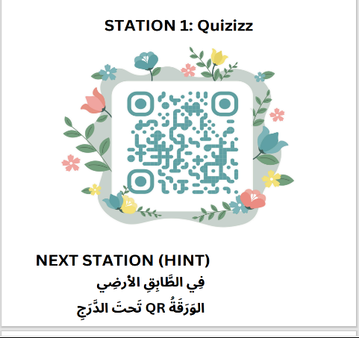
Next, students will acquire the essentials of Arabic vocabulary, sentence structure, and comprehension through a series of interactive projects distributed over multiple stations. Every station has a QR code that can be scanned for answer verification, navigation, and hints. The Explorace consists of four stations, each with its unique theme and activities. Before proceeding to the next station, students will complete tasks at each in pairs or small groups.
Figure 1: Station 1

Students begin their Arabic language journey at Station 1 by completing an interactive Quizizz test. They can access the quiz by scanning the QR code at the station. Participants must interpret and recognise important Arabic words in context in order to pass the quiz, which is designed to evaluate their fundamental vocabulary comprehension. Students can review important vocabulary and terminology in a fun, competitive context by answering a series of gamified questions. After finishing the quiz, players receive an Arabic tip that directs them to the next level. This digital exercise encourages students to utilise their vocabulary and introduces them to a practical application of what they've learned.
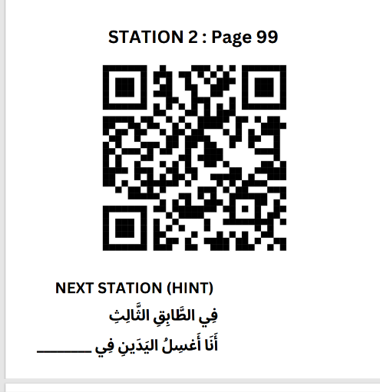
Figure 2: Station 2

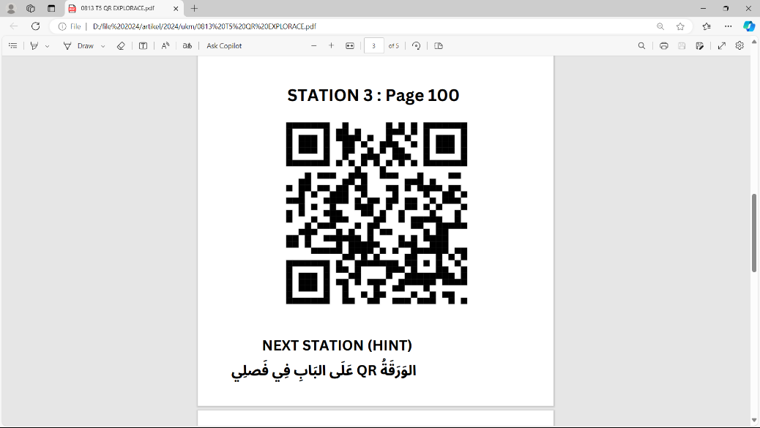
Station 2: Sentence Construction (Page 99). With an emphasis on producing precise and significant Arabic phrases, Station 2 exposes students to the process of developing sentences through hands-on activities. Using the sentence template on Page 99, they practice writing phrases like "This fridge is new" and "The shirt is clean". They execute the job individually, using their vocabulary and syntactical skills rather than internet translation resources. Once they've finished writing their phrases, they photograph them and post them to Padlet, where teachers and peers may track their development. After completion, pupils get another Arabic hint that directs them to Station 3. This station enables students to build confidence in sentence creation and use their terminology in context.
Figure 3: Station 3

Station 3: Descriptive Language (Page 100). Students are introduced to Arabic descriptive language at Station 3. Here, as explained on Page 100, they expand their practice by creating sentences that describe other items. For instance, they might explain the arrangement of objects as "The television is on the shelf" or describe "an old newspaper" using templates. This technique emphasises the importance of specifics, such as single and plural forms, in order to develop precise and meaningful language. After submitting their ideas, students resubmit their work by uploading images to Padlet for evaluation. Students can continue their exploration at Station 4 by scanning the last QR code, which contains hints. This station helps students develop the abilities needed to give clarity and description by emphasising descriptive vocabulary.

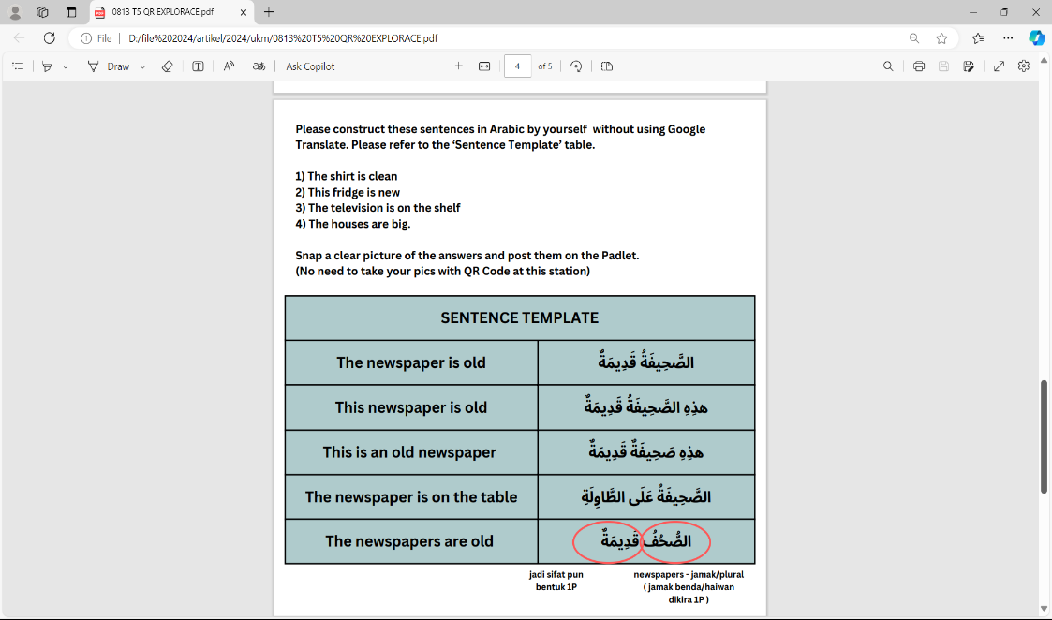
Figure 4: Conversational Phrases and Role-Play

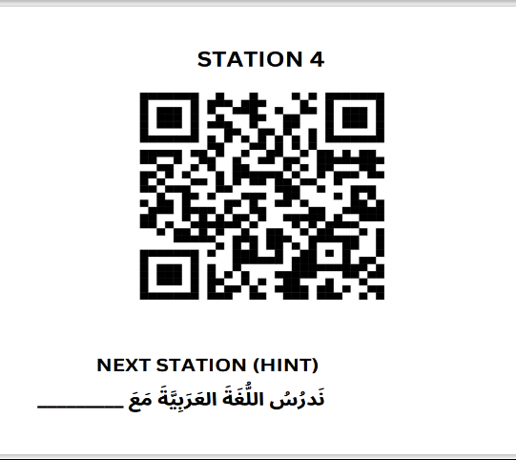
Station 4: Conversational Phrases and Role-Play. At Station 4, students practice conversational phrases in Arabic, focusing on simple exchanges and collaborative phrases. For example, they might role-play a scenario involving a sentence like “The newspaper are old.” Using the structure provided, students work in pairs to practice speaking in Arabic, enhancing their pronunciation and fluency. They capture a short video or audio clip of their role-play and upload it to Padlet as evidence of their completion. The teacher provides feedback on their conversational flow, vocabulary usage, and pronunciation. This station emphasizes practical language skills, preparing students to engage in basic conversations in Arabic with confidence.
Figure 5: Last station
Reflective Closing Activity. Finally, it provides a space for students to reflect and complete their educational experience. In the final exercise, students are invited to reflect on what they learned at each station. Each student composes a brief Arabic sentence to convey any new information gained during the session, such as a vocabulary word or grammatical structure. This statement is both a personal remark and the teacher's appraisal of general comprehension. This station gives students a sense of satisfaction by allowing them to see their development and gain confidence in speaking Arabic.

Using these five stations, the researchers explore and assess students' attitudes towards Explorace as an Innovative Teaching Method for Quranic Language Courses.

3.5 Data Analysis
Data were analyzed using descriptive statistics to assess students' overall responses and perceptions toward Explorace. Based on these objectives: 1) To identify the challenges face by students in Quranic Language Courses. 2) To acquire students’ experience in joining Explorace as an innovative teaching method for Quranic Language Courses and 3) To evaluate students' perceptions of the perceived outcomes from their participation in Explorace

4. RESULTS AND DISCUSSION

4.1 First items are the challenges face by students in Quranic Language Courses

Table 1:
No | Item | Likert Scale
No | Item | Strongly Agree | Agree | Normal | Disagree | Strongly Disagree
1 | I have difficulty to understand Quranic language courses | 31.9% | 26.1% | 32.9% | 5.6% | 4.3%
2 | Current teaching and learning Quranic language courses are only utilizing on traditional or conventional method | 31.9% | 34.8% | 27.5% | 4.3% | 1.4%
3 | Current teaching and learning Quranic language courses are not focusing on student’s centred approach | 53.6% | 27.5% | 13% | 1.4% | 4.3%
4 | I have lack of exposure of variety of engaging activities in my learning of Quranic language courses | 55.1% | 26.1% | 10.1% | 5.8% | 2.9%
5 | I have lack of motivation to learn Quranic language courses without the integration of interesting activities | 36.2% | 17.4% | 18.8% | 18.8% | 8.7%
The challenges face by students in Quranic Language Courses

Difficulty in Understanding Content
A notable portion of students—31.9% strongly agree and 26.1% agree—find it challenging to understand Quranic language courses. With 58% of students facing comprehension issues, this suggests that either the complexity of the language or the instructional methods may not align with students’ learning needs. Only a small minority disagrees, implying that understanding is a major barrier for most students.

Reliance on Traditional Teaching Methods
A significant proportion of pupils (31.9% strongly agree and 26.1% agree) find it difficult to understand Quranic language courses. With 58% of students struggling with comprehension, it appears that either the complexity of the language or the instructional methods do not meet students' learning needs. Only a small percentage disagrees, showing that comprehension is a significant challenge for most students.

Lack of a Student-Centered Approach
More than half of the students (31.9% strongly agree, 34.8% agree) report that their Quranic language classes largely use traditional or normal teaching methods. This trend may add to the aforementioned understanding issues, as traditional methodologies may not fully meet the many learning styles or interactive demands of today's students. The low percentage of students who disagree (5.7%) indicates general agreement on this topic, highlighting a significant gap between teaching techniques and student preferences.
Insufficient Variety in Learning Activities
The vast majority of pupils (55.1% strongly agree, 26.1% agree) that they are not exposed to a variety of stimulating activities in Quranic language education. This finding is especially significant since it demonstrates that the traditional framework not only fails to improve comprehension, but also lacks interactive or diverse characteristics that could excite student interest and involvement. The research emphasises the general monotony of the curriculum, which students say does not provide diverse or compelling learning opportunities.

Low Motivation without Interactive Activities
Finally, students expressed concern about a lack of motivation to study Quranic language without engaging activities, with 36.2% strongly agreeing and 17.4% agreeing with this assertion. This shows that motivational issues may be linked to a lack of interactive aspects in the curriculum, as students clearly prefer learning approaches that incorporate engaging and intriguing activities. Approximately 27.5% of students are neutral or disagree with this assertion, demonstrating that, while some may remain motivated regardless, the majority gain considerably from interactive teaching approaches.

Overall, statistics show that students in Quranic language classes have great problems absorbing content because to a reliance on traditional, non-student-centered methodologies that lack variation and engaging activities. The high response rates to these concerns show a pressing need for curriculum change that involves interactive, student-centered activities to improve comprehension, engagement, and motivation.

4.2 Next items are students’ experience in joining Explorace as an innovative teaching method for Quranic Language Courses

Table 2
No | Item | Likert Scale
No | Item | Strongly Agree | Agree | Normal | Disagree | Strongly Disagree
1 | Explorace method made learning Quranic Arabic more engaging | 68.8% | 10% | 11.4% | 1.4% | 8.6%
2 | The tasks at the different stations during Explorace were challenging | 17.1% | 24.3% | 40% | 10% | 8.6%
3 | The pace of the Explorace activities was appropriate for my level of understanding | 57.1% | 18.6% | 10% | 4.3% | 10%
4 | Learning environment through Explorace was interesting | 67.1% | 14.3% | 8.6% | 1.4% | 8.6%
5 | Explorace method inspired “think outside of the box” | 54.3% | 18.6% | 18.6% | 1.4% | 7.1%
6 | Learning materials through Explorace method were appropriate to my level | 60% | 15.7% | 12.9% | 4.3% | 7.1%
Students’ experience in joining Explorace as an innovative teaching method for Quranic Language Courses

The Likert scale replies provide insight into students' experiences with the Explorace technique, which is a new teaching strategy for Quranic language classes. Overall, the statistics show low levels of agreement with favourable claims about the Explorace technique, implying that this approach did not match students' expectations for interest, challenge, pacing, and appropriateness.

Engagement and Learning Environment
The Explorace method made learning Quranic Arabic more fun, according to an incredible 68.8% of students who strongly agreed. The remaining 10% agreed. Similarly, 14.3% of respondents enjoyed Explorace's learning environment, while 67.1% did. Explorace has created an engaging and exciting learning environment for Quranic Arabic classes, grabbing students' attention and motivating them to participate, as proven by countless positive reviews.

Challenge Level of Tasks
A broadly balanced approach is shown by responses about the activities' degree of difficulty: 41.4% of students (17.1% strongly agree, 24.3% agree) thought the tasks were demanding, while 40% thought the difficulty was "normal." Just 18.6% of respondents said the tasks weren't difficult enough. This harmony implies that the Explorace approach was successful in accommodating a variety of student skill levels by offering stimulating yet manageable tasks.

Appropriateness of Pacing and Materials
Students overwhelmingly agreed that the pace of Explorace activities was suitable, with 57.1% strongly agreeing and 18.6% agreeing. This positive response suggests that the activities were well-paced for the students’ level of understanding, allowing them to engage meaningfully with the content without feeling rushed or overwhelmed.

In addition, 15.7% of students agreed, with 60% strongly agreeing that the course materials were appropriate for their level. This high level of satisfaction with the speed and contents suggests that the Explorace approach was appropriate for the students' comprehension levels, which improved their educational experience.

Encouragement of Critical Thinking
Furthermore, the study found that 18.6% of students agreed, and 54.3% strongly agreed, that the Explorace technique pushed them to "think outside the box." This demonstrates that Explorace was effective in developing critical thinking skills, motivating students to approach challenges creatively, and fostering imaginative application of their knowledge. The majority of students found the method intellectually stimulating and motivating, with only a small minority claiming it did not inspire this level of involvement..

In conclusion, students’ responses suggest that the Explorace method is a highly effective and engaging approach for Quranic Arabic courses. The majority of students found it engaging, appropriately challenging, well-paced, and suited to their level of understanding. The method not only created an enjoyable learning environment but also encouraged critical thinking, suggesting that it could serve as a valuable teaching tool for Quranic language learning. Based on this feedback, the Explorace method appears to be a promising model for future use, with strong potential to enhance student motivation, comprehension, and active participation.

4.3 The last items are students' perceptions of the perceived outcomes from their participation in Explorace.

Table 3
No | Item | Likert Scale
No | Item | 5 | 4 | 3 | 2 | 1
1 | I felt more motivated to participate in class because of the interactive activities in Explorace | 67.1% | 12.9% | 10% | 1.4% | 8.6%
2 | The Explorace method helped me better understand and apply Quranic Arabic grammar | 58.6% | 21.4% | 10% | 2.9% | 7.1%
3 | The use of group collaboration during Explorace activities enhanced my learning experience | 61.4% | 15.7% | 14.3% | 4.3% | 4.3%
4 | Explorace method made learning Quranic Arabic more enjoyable compared to traditional methods | 64.3% | 12.9% | 12.9% | 2.9% | 7.1%
5 | I was able to retain information more effectively after participating in the Explorace activities | 60% | 20% | 10% | 4.3% | 5.7%
6 | The variety of tasks in Explorace (e.g., quizzes, sentence construction) helped me practice different aspects of the language | 70% | 11.4% | 10% | 4.3% | 4.3%
7 | The tasks in Explorace helped reinforcing my learning | 60% | 18.6% | 11.4% | 4.3% | 5.7%
8 | I feel more confident in my ability to use Quranic Arabic after participating in Explorace | 50% | 27.1% | 12.9% | 2.9% | 7.1%
9 | Explorace method should be used in other Quranic language courses to enhance student learning | 67.1% | 12.9% | 11.4% | 4.3% | 4.3%
10 | Explorace method is suitable to be used in future activity for learning Quranic language courses | 65.7% | 15.7% | 8.6% | 2.9% | 7.1%
Students' perceptions of the perceived outcomes from their participation in Explorace.

According to the responses in Table 3, students generally like the Explorace technique and strongly agree that it is useful for fostering participation, boosting comprehension, and bolstering crucial aspects of learning the Quran. These obvious findings demonstrate that a creative teaching technique that considers the benefits of social and cognitive learning was successfully applied.

Motivation and Engagement
The statistics show that Explorace greatly increased student motivation, with 67.1% strongly agreeing that the interactive activities made them more willing to participate in class, followed by 12.9% who concurred. Furthermore, 64.3% strongly agreed that Explorace made learning Quranic Arabic more pleasant than traditional techniques, with 12.9% concurring. These high percentages show that Explorace's participatory aspect favorably improved students' attitudes toward learning, resulting in a more engaging and stimulating atmosphere that may foster long-term engagement.

Understanding and Application of Quranic Arabic
A large number of students said that Explorace improved their grasp of Quranic Arabic, particularly grammar. Specifically, 58.6% strongly agreed, while 21.4% felt that it improved their understanding and application of grammar principles. The strategy also appears to have contributed to improved information retention, with 60% strongly agreeing and 20% agreeing that they retained material more efficiently. Thus, this feedback indicates that Explorace's hands-on, task-based approach facilitates deep learning by enabling students to assimilate and retain information faster than in conventional settings.

Variety and Reinforcement of Learning
Explorace's diversity of tasks, including activities such as quizzes and sentence creation, was well received, with 70% strongly agreeing that it helped them to practice diverse language components and 11.4% agreeing. Furthermore, 60% highly believed that the assignments improved their learning, implying that the variety of exercises aided their comprehension of essential concepts in Quranic Arabic. This planned variety appears to be effective in engaging pupils and providing extensive practice across several areas.

Applicability for Future Classes
Students were generally positive about utilizing Explorace in future Quranic language classes, with 67.1% strongly approving and 12.9% thinking that it should be used more widely. A comparable high percentage (65.7%) strongly agreed that the approach is appropriate for future usage, with 15.7% agreeing. This enthusiasm reflects students' conviction in the method's success and want to see it used as a mainstream strategy in Quranic language teaching.

Students strongly praised the benefits of engaging in Explorace, proving the program's ability to improve retention, motivation, knowledge, and confidence. According to the opinions, Explorace is a comprehensive approach that combines interactive, group, and diverse activities to offer successful and pleasant Quranic language training. Explorace appears to hold a lot of promise as a long-term teaching strategy for increasing student engagement and improving learning outcomes in related courses, based on these promising comments.
4.4 Open-Ended Questions

- In what ways do you think the Explorace method can be improved for future courses?

The students’ responses indicate an overall positive perception of the Explorace method for Quranic language courses, with several key suggestions for improvement focusing on structure, engagement, and interactive learning. One major theme across responses is the desire for a more extensive and engaging experience.

For instance, Student A proposes adding more checkpoints, suggesting that the current structure may feel limited or too brief, while Student B expresses enthusiasm for “more Explorace” sessions, indicating that students find this method enjoyable and would welcome more frequent or extended opportunities to engage with it. This enthusiasm suggests that students perceive the activity’s interactive, game-like approach as not only motivating but also as an engaging alternative to traditional methods.

Furthermore, feedback from Student C highlights the importance of question variety, as they suggest using a “more interesting pattern of questions” to maintain engagement. This insight points to the potential benefit of incorporating diverse question formats that stimulate different thought processes, such as puzzles, open-ended questions, or analytical challenges, which could further enhance engagement and interest.

Student D’s comment, which notes that solving problems at each checkpoint aids memory recall and reinforces learning, underscores the checkpoint system's effectiveness for reviewing course material. This feedback suggests that each checkpoint should remain relevant to core course concepts, as this structure helps students actively apply what they’ve learned, thus enhancing retention and comprehension.

Lastly, Student E’s suggestion to include “more interactive elements” that promote teamwork and critical thinking speaks to the method's potential to encourage collaboration and deeper analysis among students. By incorporating team-based tasks, discussions, or real-world problem-solving scenarios related to Quranic language, Explorace could foster essential skills beyond language acquisition, such as collaboration and analytical thinking.

Together, these responses suggest that with improvements like additional checkpoints, diverse question structures, and interactive tasks that encourage teamwork, the Explorace method could be even more effective in providing an engaging, memorable, and skill-building experience for students in Quranic language courses.

- Any additional comments or suggestions regarding your experience with the Explorace method?

The additional comments provided by students reflect a largely positive reception of the Explorace method, with several expressing a desire for similar interactive, game-like experiences in the future. Student F’s comment, “I want more games like this in the future,” signals that students are enthusiastic about game-based learning approaches and would appreciate the inclusion of similar activities in future courses.

This sentiment is echoed by Student G and Student H, who, while brief, share a clear enjoyment of the method with phrases like “I love it much” and “It was fun,” underscoring that the method effectively makes the learning process enjoyable.

Student I suggests adding "more rewards," indicating that a reward system could enhance motivation and engagement. By incorporating incentives, the Explorace method could potentially heighten student motivation, making the learning experience even more rewarding and competitive, which is often beneficial in game-based learning. Finally, Student J offers a deeper reflection, noting that the Explorace method not only makes learning Quranic language “more fun and enjoyable” but also contributes to a “better understanding” of the material.

This suggests that the method is impactful in facilitating both comprehension and enjoyment, two crucial elements in effective learning experiences. Together, these responses reveal that students find the Explorace method engaging, enjoyable, and beneficial for comprehension, with suggestions for future iterations that include more game-based activities, reward systems, and a continued focus on making learning enjoyable and meaningful.

4. CONCLUSION

The study's findings demonstrate the value of the Explorace technique as an engaging and effective way to instruct Quranic language lessons. The results show that Explorace is more effective than traditional lecture-based methods because it creates an engaging learning environment, increases motivation, and helps students retain and understand Arabic language skills more deeply. Along with greater confidence in applying their knowledge in real-world scenarios, students reported significant increases in engagement and enjoyment—two aspects that are critical to language acquisition.

Key difficulties in learning Quranic Arabic are addressed by Explorace's interactive, station-based framework, which gives students the chance to practice vocabulary, sentence formation, and conversational Arabic. According to the results, Explorace promotes critical thinking and teamwork in addition to improving motivation and understanding. Future implementations, however, might include a wider range of task challenges and more comprehensive interactive components to maximize its efficacy and further match activities to students' specific ability levels.

Overall, the positive response to Explorace advocates for its continued use and potential expansion in Quranic language courses, as it shows promise in creating a dynamic, student-centered learning experience that can be adapted to various educational contexts.

ACKNOWLEDGEMENT

We thank the Centre for Languages and Pre-University Academic Development, Department of Arabic Language and Literature, International Islamic University Malaysia, International Islamic Institute of Islamic Thought and Civilization and Jabatan Pengajian Arab, Universiti Teknologi Mara, for their support and resources throughout this study. Thank you to the financial agencies that funded this initiative, as well as the students who completed the questionnaires and provided critical insights into the explorers' teaching style. We also thank our colleagues' assistance and input, which greatly expanded the depth and scope of this study.

REFERENCES

Abu Saa, N. A. K., Abu Saa, J. W., & Jabsheh, A.-A.-H. M. M. (2022). Strategies of Learning English Vocabulary and Grammar by Freshmen University Students: A Case Study of An-Najah National University and Palestine Technical University-Kadoorie(PTUK)\ Tulkarm. International Journal of Linguistics, Literature and Translation, 5(2). https://doi.org/10.32996/ijllt.2022.5.2.7
Asad, M. M., Khan Soomro, R. B., Shamsy, A., & Churi, P. (2021). Students’ Satisfaction towards E-Assessment for Academic Achievement in ESL at Public Schools and Colleges. Education Research International, 2021. https://doi.org/10.1155/2021/4576750
ASEAN Journal of Religion, Education, and Society. (n.d.). https://ejournal.bumipublikasinusantara.id/index.php/ajores
Baharun, H., Rahman, S. A., Ahmad, H., Saad, N. S. M., & Jamal, I. H. (2020). Quranic Understanding among Non-Native Speaker of Arabic: Malaysian Experts’ Perspectives. GEMA Online Journal of Language Studies, 20(2), 203–223. https://doi.org/10.17576/gema-2020-2002-12
Beltrami, E. (1982). Problem Background. In The High Cost of Clean Water. https://doi.org/10.1007/978-1-4899-5322-3_2
Bryce, J., Thinakaran, R., & Zakaria, Z. A. (2022). KNOWLEDGE MANAGEMENT APPLIED TO LEARNING ENGLISH AS A SECOND LANGUAGE THROUGH ASYNCHRONOUS ONLINE INSTRUCTIONAL VIDEOS. Journal of Information Technology Education: Innovations in Practice, 21. https://doi.org/10.28945/5016
Devare, M. (2022). AMALGAMATION OF INDIRECT GAMIFICATION INTO DEVELOPMENT AND OPERATIONS (DEVOPS) COURSE TEACHING. Information Technologies and Learning Tools, 87(1). https://doi.org/10.33407/itlt.v87i1.4619
Ghani, M. T. A., & Daud, W. a. a. W. (2023, March 31). The Impact of Digital Game-Based Learning Towards Arabic Language Communication. Abdul Ghani | Jurnal Komunikasi: Malaysian Journal of Communication. https://ejournal.ukm.my/mjc/article/view/62613
Halim, S. A., Zbair, A., & Rahman, S. F. A. (2024). Investigating the Impact of ‘Postcard Adventure’ in ESL Classrooms. International Journal of Research and Innovation in Social Science, VIII(IIIS), 1359–1370. https://doi.org/10.47772/ijriss.2024.803094s
Investigating the Effects of Active Learning Strategies on Problem Solving.: A Quasi-Experimental Study in Cycle Two. (2021). Journal of Education and Practice. https://doi.org/10.7176/jep/12-17-05
Lamrani, R., & Abdelwahed, E. H. (2020). Game-based learning and gamification to improve skills in early years education. Computer Science and Information Systems, 17(1). https://doi.org/10.2298/CSIS190511043L
Lugosi, E., & Uribe, G. (2022). Active learning strategies with positive effects on students’ achievements in undergraduate mathematics education. International Journal of Mathematical Education in Science and Technology, 53(2). https://doi.org/10.1080/0020739X.2020.1773555
Rashid, S. N. M., Abdullah, S. Z., Makhtar, N., Jaafar, N. F., & Zuraimi, N. A. (2023). Effectiveness of Virtual Explorace Game Towards Students’ Performance in Physics Subject During Pre-Diploma Programme. International Journal of Academic Research in Progressive Education and Development, 12(1). https://doi.org/10.6007/ijarped/v12-i1/16108
Rosni Samah. (2013). Issues in teaching Arabic Language in the Religious School in Peninsular Malaysia. Wulfenia Journal, 20(12).
Sobri, M., Iryani, E., & Mulyadi. (2021). The Independent Learning (Nature-Based Learning): Outdoor Study Arabic Learning Nature School Jambi City. Studi Arab, 12(1). https://doi.org/10.35891/sa.v12i1.2709
Thongkoo, K., Panjaburee, P., & Daungcharone, K. (2019). Integrating inquiry learning and knowledge management into a flipped classroom to improve students’ web programming performance in higher education. Knowledge Management and E-Learning, 11(3). https://doi.org/10.34105/j.kmel.2019.11.016
Wafaa Hafize Alowaydhi, Najla Marzuk Almutairi. (2021). Attitudes of teachers and supervisors towards teaching prosody (Arūḍ) and rhyme within the Arabic language courses at the secondary level in the Kingdom of Saudi Arabia: اتجاهات المعلمين والمشرفين نحو تدريس العروض والقافية ضمن مقررات اللغة العربية بالمرحلة الثانوية بالمملكة العربية السعودية. مجلة العلوم التربوية و النفسية, 4(41). https://doi.org/10.26389/ajsrp.n140420
Безкоровайна, О., & Дищаковська, О. (2020). INTERACTIVE TEACHING METHODS IN FOREIGN LANGUAGE LEARNING: THEORETICAL ANALYSIS OF THE PROBLEM. Інноватика у Вихованні, 2(11). https://doi.org/10.35619/iiu.v2i

