DREAM-BASED CLASSIFICATION OF DRIVER BEHAVIOURAL PATTERNS IN NIGERIAN ROAD TRAFFIC ACCIDENTS
Aliyu Ahmad^{1*}, Abdullahi Sulaiman¹, Audu Isaac¹, Abubakar Bala Abdullahi¹, Ibrahim Abdulhafeez Bello²
₁Transport Technology Center, Nigerian Institute of Transport Technology, Zaria, Nigeria
²Kano Outreach Learning Center, Nigerian Institute of Transport Technology, Kano, Nigeria
*Corresponding Author: Aliyu Ahmad

ABSTRACT
Road traffic accidents remain a leading cause of mortality and morbidity in Nigeria, yet structured analysis of the behavioral patterns underlying crash causation is largely absent from the literature. This study applies the Driver Reliability and Error Analysis Method (DREAM) to classify driver behavioral patterns from Nigerian road traffic accident records sourced from three national newspaper outlets. A total of 65 accident records were extracted, spanning all geopolitical zones and involving five vehicle categories: trucks (41.5%), buses (38.5%), cars (32.3%), three-wheeled vehicles (12.3%), and two-wheeled vehicles (3.1%). Each record was independently coded by two analysts using the DREAM taxonomy, identifying the observable driver critical events and its underlying causal behavioral and situational contributors. Cumulative DREAM charts were constructed for each critical event by accumulating causal pathways across the dataset. Too High Speed was the most prevalent, accounting for 41.5% of records, followed by Insufficient Force, 20.0%; Wrong Direction, 18.5%; No Action, 15.4% and Too Late Action 4.6%. Across all 65 records, 32 distinct genotype codes were identified. The dominant genotypes were Misjudgment of situation, n = 27; Habitually stretching rules, n = 26; Equipment failure, n = 25; and Inadequate vehicle maintenance, n = 24. 58.5% involved collisions with motorized counterparts and 10 (15.4%) involved non-motorized road users. The findings reveal that Nigerian road crashes are driven by a convergence of deliberate norm violation, cognitive misjudgment, driver skill deficits, and systemic vehicle maintenance failures, providing an evidence base for targeted road safety interventions in Nigeria and comparable low- and middle-income country contexts.
Keywords: driver behavior, road traffic accidents, DREAM methodology, accident phenotypes, Nigeria
INTRODUCTION
Road traffic accidents (RTAs) have emerged as one of the most pressing global public health and socio-economic challenges of the twenty-first century, representing a significant cause of premature mortality and disability (Ahmed et al., 2023; Omooseti & Akinjobi, 2026). Every year, approximately 1.35 million people die on the world’s roads, with nearly 3,700 deaths occurring daily (Ahmed et al., 2023; Berhanu et al., 2023). This burden is disproportionately distributed, as low- and middle-income countries (LMICs) account for about 93% of global road fatalities despite possessing only a fraction of the world’s registered vehicles (Adeleke et al., 2021; Amoadu et al., 2024; Uzondu et al., 2022). Within this global context, Atalay et al. (2025) observed that sub-Saharan Africa remains the most affected region; mortality rates from road traffic injuries in African nations are 40% greater than those in other LMICs and exceed the global average by 50%.
The situation in Nigeria reflects this broader regional crisis, as the country remains one of the worst-hit nations globally. Nigeria’s road traffic fatality rate is estimated at 21.4 deaths per 100,000 population, significantly higher than the world average of 18.2 with an additional annual economic losses estimated at over 80 billion Naira (Adeleke et al., 2021; Onwusoronye et al., 2025; Uzondu et al., 2022). Furthermore, RTAs cost most countries approximately 3% of their gross domestic product (GDP), a figure that can rise to 5% in some developing nations (Amoadu et al., 2024; Taiwo et al., 2024), utilizing scarce financial resources that are vital for nation-building.
Of all the factors contributing to these crashes, human error is the most significant, estimated to account for between 64% and 95% of all road traffic accidents in developing countries like Nigeria (He & Soffker, 2021; Naallah et al., 2024; Onwusoronye et al., 2025). In driver-vehicle systems, the human operator is the key element in ensuring safety, yet behaviors such as speed violation, dangerous driving, and loss of control remain the leading risk factors. Specifically, speed violation alone is reported to contribute to approximately 44% of traffic crashes in Nigeria (Uzondu et al., 2022). Despite the clear dominance of behavioral factors, current accident reporting and management systems in Nigeria face substantial limitations. Data collection is often unstructured, failing to capture the complex cognitive failures leading to a crash. Moreover, significant under-reporting persists, with some estimates suggesting that only 17% of road fatalities are correctly reported in low-income countries (Adeoye et al., 2014; Berhanu et al., 2023).
This highlights a critical research gap: the absence of structured behavioral classification studies in the Nigerian context. While traditional road safety research in Nigeria has extensively examined spatial clustering and descriptive statistics, there is a marked lack of studies analyzing road accidents through the lens of human factors frameworks (Berhanu et al., 2023; Omooseti & Akinjobi, 2026). There is a need to move beyond mere descriptive statistics toward a causes-critical event analysis that explores the interaction between the driver, vehicle, and environment.
The Driving Reliability and Error Analysis Method (DREAM), adapted from the industrial Cognitive Reliability and Error Analysis Method (CREAM), provides a structured Human-Technology-Organisation (HTO) framework to address this need (Fagerlind et al., 2009; Sagberg, 2007; Sandin & Ljung, 2007). DREAM identifies the observable consequences of failures as "phenotypes" and links them to underlying causal factors known as "genotypes". Although this methodology has been successfully applied in Europe to assess driver reliability and error, its application in African road safety research remains extremely limited (Godthelp & Ksentini, 2024; Sagberg, 2007).
In response to these challenges, the present study seeks to apply the DREAM methodology to classify driver behavioral patterns from Nigerian accident reports from newspapers. This involves identifying the dominant accident phenotypes; the critical events and tracing them back to their underlying behavioral genotypes; pattern of causative factors. By analyzing the pattern of occurrence for each phenotype, this research aims to provide a mechanistic understanding of road crashes, offering a data-driven foundation for developing targeted safety interventions and improving the reliability of the transport system in Nigeria.

LITERATURE REVIEW
Road traffic accidents in Nigeria: scale and context
In sub-Saharan Africa, the mortality rate from RTA is particularly high, often exceeding the global average by a considerable margin (Godthelp & Ksentini, 2024). Nigeria remains one of the worst-hit nations in this region, with a fatality rate estimated at 21.4 per 100,000 population. The economic consequences are devastating, costing the nation over 80 billion Naira annually and consuming approximately 3% of the Gross Domestic Product (Taiwo et al., 2024).
Within Nigeria, key corridors such as the Lagos-Ibadan Expressway are frequently cited as accident hotspots due to heavy traffic volumes and high speeds. Causal factors are typically categorized into human, mechanical, and environmental domains (Sagberg, 2007). Environmental factors found to influence accident include inadequate infrastructure, such as the absence of road signs, deep potholes, and poor road design (Adeleke et al., 2021; Naallah et al., 2024; Uzondu et al., 2022). Mechanical factors often involve the use of substandard used tires and brake failures resulting from poor maintenance regimes (Adeleke et al., 2021; Akanbi et al., 2009; Onwusoronye et al., 2025). However, human error is the dominant contributor, estimated to account for between 64% and 95% of all traffic crashes in the country (Naallah et al., 2024; Onwusoronye et al., 2025; Taiwo et al., 2024). Speed violation is the most prominent human factor, contributing to roughly 44% of Nigerian crashes, followed by dangerous driving, fatigue, and the use of mobile phones while driving (Naallah et al., 2024; Uzondu et al., 2022).
Driver behavior and human error frameworks
Accident analysis has shifted from viewing human error as an isolated event to understanding it through Human-Technology-Organization (HTO) frameworks (Fagerlind et al., 2009; Sagberg, 2007). This systemic perspective acknowledges that driving is a control task requiring continuous adaptation to a dynamic environment. Major frameworks such as Reason’s taxonomy distinguish between active failures and latent conditions (Warner & Sandin, 2010). Active failures are the immediate actions or omissions by the driver; such as failing to observe a red light that lead directly to an accident. In contrast, latent conditions are systemic flaws, such as poor organizational safety culture or inadequate vehicle maintenance, that remain dormant until they combine with active failures to trigger a crash.
The Driving Reliability and Error Analysis Method (DREAM) further refines this distinction through the concepts of "phenotypes" and "genotypes". A phenotype is the critical event which capture the observable consequences of the traffic adaptation failure(s) that immediately precede a crash or incident. It is the observable consequence of a system failure, described in physical dimensions of time, space, and energy. Genotypes are the underlying causal factors that lead to these phenotypes, which may include cognitive failures (e.g., missed observation, faulty diagnosis) or external conditions (e.g., inadequate road design, fatigue). This distinction allows researchers to move beyond descriptive statistics to a mechanistic understanding of how and why crashes occur (Fagerlind et al., 2009; Habibovic et al., 2013; Sandin, 2009).
The DREAM methodology
European researchers, particularly those associated with the SafetyNet project, adapted the tool for the road traffic domain to better classify driver reliability and error (Fagerlind et al., 2009; Warner & Sandin, 2010). The structure of DREAM 3.0 includes an accident model based on the HTO triad, a method for investigation, and a classification scheme. The classification scheme utilizes an action taxonomy to categorize phenotypes into five groups: A1 (Timing), A2 (Speed), A3 (Distance), A4 (Direction), and A5 (Object). These are then linked to a set of genotypes categorized under driver cognitive functions (observation, interpretation, planning), driver states (fatigue, distraction), vehicle factors, and organizational/environmental factors.
DREAM has been extensively applied in European road safety research to analyze fatal accidents, single-vehicle crashes, and car-to-pedestrian incidents (Habibovic et al., 2013; Sagberg, 2007; Warner & Sandin, 2010). Studies such as Habibovic et al. (2013) using aggregated DREAM charts have successfully identified common patterns of failure, such as the link between "distraction" (genotype) and "missed observation" (intermediate genotype) leading to "late action" (phenotype). The methodology is highly suitable for LMIC contexts where detailed technical data might be scarce, as its structured taxonomy guides data collection and facilitates the aggregation of qualitative information from varied sources.
Newspaper-based accident data as a research source
The use of media-derived data as a legitimate source for road safety research is supported by a growing body of international literature (Ashutosh & Chand, 2025; Paudel, 2025). In many LMIC settings where official databases may be incomplete, inaccessible, or prone to significant under-reporting, newspapers provide an alternative, geographically broad, and easily accessible archive of crash events. Media reports often capture psychosocial and situational details such as driver fatigue, working conditions for commercial operators, and the specific framing of local infrastructure flaws that may be omitted from standardized police reporting forms.
However, researchers must acknowledge several known limitations of media data, including reporting bias, where dramatic or high-fatality incidents are disproportionately featured compared to their true frequency (Ashutosh & Chand, 2025; Daniels et al., 2010). Journalists often use episodic framing, which treats accidents as isolated incidents of individual blame, rather than thematic framing, which explores systemic root causes. To mitigate these issues, prior studies have employed quantitative content analysis and discourse analysis to identify and adjust for these biases (Ashutosh & Chand, 2025; MacRitchie & Seedat, 2008; Paudel, 2025). By comparing media attributes to available official statistics, researchers can achieve intercoder reliability and ensure the analytical consistency of the data.
Summary and Research Gap
The literature demonstrates that while Nigeria faces a severe road safety crisis dominated by human error, current research often relies on descriptive statistics or spatial clustering without analyzing the underlying cognitive failures of the driver. There is a significant gap in the application of structured behavioral classification methods like DREAM within the African context to explain the mechanistic links between causative factors and accident outcomes. Existing Nigerian studies frequently identify speeding or fatigue (Taiwo et al., 2024) as general causes but fail to map the specific sequence of failures (e.g., from inattention to misjudgment to late braking) that define an accident event.

METHODOLOGY

Research Design
This study adopted a mixed-methods research design, combining systematic content analysis with structured quantitative coding using the Driver Reliability and Error Analysis Method (DREAM). The methodological approach was selected to enable the classification of driver behavioral patterns from narrative accident records into standardized phenotype and genotype categories defined within the DREAM taxonomy. The use of secondary, media-derived data is consistent with established practice in road safety research conducted in low- and middle-income country (LMIC) contexts where official crash investigation databases are either unavailable, incomplete, or inaccessible to independent researchers (Ashutosh & Chand, 2025; Daniels et al., 2010; MacRitchie & Seedat, 2008; Paudel, 2025).

Data Collection

Newspaper Selection Criteria
Newspapers were selected based on three criteria: national circulation or significant regional reach across multiple Nigerian states; a demonstrated record of detailed accident reporting that included descriptions of driver behaviour, vehicle type, and crash circumstances; and availability of archives covering the study period. Applying these criteria, three media sources were identified and included in the study: Arise TV Online, Daily Trust, and Daily Post. These sources collectively provided accident reports spanning multiple geopolitical zones of Nigeria, ensuring reasonable geographic diversity in the dataset.

Accident Record Extraction
Accident records were extracted from the selected media sources through systematic review of published reports. An accident report was included in the dataset if it: (i) described a road traffic crash occurring within Nigeria; (ii) contained sufficient narrative detail to permit the identification of at least one driver action or behavioral failure; and (iii) specified or allowed reasonable inference of the vehicle type involved. Reports that described only crash outcomes (fatalities or injuries) without any description of driver behaviour or pre-crash events were excluded. Out of a total of 1684 candidate records, 65 accident records were extracted across the three sources. Daily Post contributed the largest share of records (n = 28, 43%), followed by Daily Trust (n = 21, 32%) and Arise TV Online (n = 16, 25%). The dataset covered crashes involving five vehicle categories: trucks (n = 27), buses (n = 25), cars (n = 21), three-wheeled vehicles (n = 8), and two-wheeled vehicles (n = 2), reflecting the dominance of heavy and commercial vehicles in Nigerian road traffic accident reports.
Table 1: Distribution of accident records by newspaper source
S/N | Newspaper Source | Records Extracted
1 | Arise TV | 16
2 | Daily Trust | 21
3 | Daily Post | 28
Table 2: Distribution of accidents by vehicle type
S/N | Vehicle Type | Frequency (n)
1 | Two Wheel | 2
2 | Three Wheel | 8
3 | Car | 21
4 | Bus | 25
5 | Truck | 27

The DREAM Methodology
The phenotype taxonomy used in this study is drawn from the DREAM action classification system (Sagberg, 2007). Each phenotype is assigned an alphanumeric code denoting the category of driver action failure. Five phenotype categories were identified across the accident dataset: A1.2 (Too Late Action), A1.3 (No Action), A2.1 (Too High Speed), A4.1 (Wrong Direction), and A5.2 (Insufficient Force). Genotype codes follow a classification covering perceptual failures (B codes), cognitive misjudgements (C codes), decisional errors (D codes), motivational and psychological states (E and F codes), physical and medical impairments (L codes), vehicle-related failures (I and O codes), and road environment factors (Q codes).

Coding Procedure

Phenotype Assignment
Each accident record was independently read by two trained coders. The coding task required each coder to first identify the primary driver action failure described or inferable from the accident narrative, and then assign the corresponding DREAM phenotype code. Phenotype assignment was guided by the DREAM action taxonomy definition for each code. For example, an accident described as resulting from a driver failing to brake in time at a junction was coded A1.2 (Too Late Action), while an accident in which a driver appeared to have made no corrective response whatsoever such as a vehicle continuing at speed into an obstacle was coded A1.3 (No Action). Accidents where excessive speed was the primary observable failure were coded A2.1 (Too High Speed), driving against the right of way was coded A4.1 (Wrong Direction), and cases where braking force was applied but was insufficient to prevent impact were coded A5.2 (Insufficient Force).

Genotype Assignment
Following phenotype assignment, each coder identified one or more genotype codes applicable to each record. Genotype coding required inference from the narrative context of the accident report, drawing on stated or implied driver conditions, behaviors, and circumstances. Where a report explicitly mentioned driver fatigue, substance use, or mechanical failure, the corresponding genotype codes (for example, E4 for substance influence, or I1 for equipment failure preceded by O1 for inadequate maintenance) were assigned directly. Where the causal factor was implied rather than explicitly stated for instance, a report noting that a truck “lost control on a straight road at night” without specifying the cause, coders applied the most parsimonious genotype consistent with the available evidence and recorded the inferential basis for the assignment.

Inter-rater Reliability
Inter-rater reliability was assessed for both phenotype and genotype coding. Following independent coding, disagreements were resolved through structured discussion between coders, with reference to the DREAM taxonomy definitions. Where consensus could not be reached, a third reviewer adjudicated. Cases where genotype attribution was considered highly inferential given the limited narrative detail available in the source report were flagged and subsequently removed from the dataset.

Genotype-Phenotype Linkage and DREAM Chart Construction
Once coding was complete, each accident record was represented as a genotype-to-phenotype pathway, tracing the causal chain from the earliest identifiable behavioral or situational factor through to the observable driver action failure. These pathways were accumulated across all records sharing the same phenotype code, producing a cumulative DREAM chart for each of the five phenotypes. The cumulative DREAM chart displays the frequency with which each genotype and each genotype-to-genotype transition appeared in the accident records associated with a given phenotype. This accumulation method allows the dominant causal pathways for each phenotype to be identified visually and quantitatively, distinguishing high-frequency genotype chains from isolated or incidental factors. Separate charts were produced for phenotypes A1.2, A1.3, A2.1, A4.1, and A5.2 (Figures 1–5).

Pattern of Occurrence Analysis
Beyond genotype-phenotype classification, the dataset was analyzed to characterize the pattern of occurrence of each phenotype. This analysis examined the relative frequency of each phenotype across the full dataset, the distribution of vehicle types associated with each phenotype, and the nature of the collision, specifically whether each accident involved a motorized counterpart vehicle or a non-motorized road user. The collision type variable was coded as either “with other motorized vehicle”; (n = 38) or “with non-motorized road user” (n = 10), capturing the vulnerability dimension of the crash context. Frequency distributions for each phenotype are presented in Table 3.
Table 3: Frequency distribution of identified accident phenotypes
S/N | Phenotype Code | Description | Frequency (n)
1 | A1.2 | Too Late Action | 3
2 | A1.3 | No Action | 10
3 | A2.1 | Too High Speed | 27
4 | A4.1 | Wrong Direction | 12
5 | A5.2 | Insufficient Force | 13

RESULTS

Overview of the Accident Dataset
A total of 65 accident records were selected and extracted from three Nigerian media sources; Arise TV Online, Daily Post, and Daily Post after which they were subjected to DREAM analysis. The records involved five categories of road vehicles. Trucks represented the most frequently involved vehicle type (n = 27, 41.5%), followed by buses (n = 25, 38.5%), cars (n = 21, 32.3%), three-wheeled vehicles (n = 8, 12.3%), and two-wheeled vehicles (n = 2, 3.1%). The predominance of heavy commercial vehicles (trucks and buses) together accounting for 80.0% of records, is consistent with the character of Nigerian intercity road traffic and reflects the high mileage exposure of commercial vehicle operators on federal highway corridors. Across the dataset, 38 accidents (58.5%) involved a collision with another motorized vehicle, while 10 (15.4%) involved a non-motorized road user such as a pedestrian or cyclist, with the remainder involving single-vehicle incidents or infrastructure contacts.

Distribution of Accident Phenotypes
DREAM coding of the 65 accident records yielded five distinct accident phenotypes. The most frequently recorded phenotype was A2.1 (Too High Speed), which accounted for 27 of the 65 records (41.5%). This was followed by A5.2 (Insufficient Force, n = 13, 20.0%), A4.1 (Wrong Direction, n = 12, 18.5%), A1.3 (No Action, n = 10, 15.4%), and A1.2 (Too Late Action, n = 3, 4.6%). The dominance of A2.1 indicates that excessive speed was the most prevalent observable driver action leading to accidents in the dataset, accounting for more than two-fifths of all coded accidents. Together, the two action-timing phenotypes A1.2 and A1.3 accounted for 20.0% of records, suggesting that a significant minority of accidents involved a complete or near-complete failure of driver response. The distribution shows the breadth of behavioral failure modes present in the Nigerian road traffic accident context and the importance of addressing speed regulation, driving against traffic, and braking efficiency as priority intervention targets.

Genotype Distribution
Across all 65 records, 32 distinct genotype codes were identified. The ten most frequently occurring genotypes are presented in Table 4. The most prevalent genotype was C2 (Misjudgment of situation, n = 27), occurring in records spanning multiple phenotype categories and reflecting a pattern of cognitive error in which drivers failed to accurately assess the hazard or traffic situation ahead of them. This was closely followed by F4 (Habitually stretching rules and recommendations, n = 26), which captures patterns of normalized rule-breaking behavior, including sustained speeding, reckless overtaking, and disregard for road markings, suggesting that deliberate norm violation is a major driver of road crash risk in Nigeria. The high frequency of I1 (Equipment failure, n = 25) and O1 (Inadequate vehicle maintenance, n = 24) points to a systemic vehicle-condition dimension to Nigerian road crashes that extends beyond purely behavioral driver error. F6 (Insufficient skills or knowledge, n = 15) and F5 (Overestimation of skills, n = 13) together indicate that driver competence deficits are a recurrent underlying contributor.
Table 4: Top ten genotypes by frequency across all accident records
S/N | Genotype | Description | Frequency (n)
1 | C2 | Misjudgment of situation | 27
2 | F4 | Habitually stretching rules/recommendations | 26
3 | I1 | Equipment failure | 25
4 | O1 | Inadequate vehicle maintenance | 24
5 | F6 | Insufficient skills/knowledge | 15
6 | D1 | Priority error | 13
7 | F5 | Overestimation of skills | 13
8 | B2 | Late observation | 12
9 | C1 | Misjudgment of time gap | 12
10 | E2 | Motivational state (risk acceptance) | 8

Phenotype A1.2: Too Late Action
Phenotype A1.2 was recorded in three accident cases (4.6% of the dataset). The cumulative DREAM chart for this phenotype (Figure 1) reveals that late observation (B2) was the central intermediate node in the causal pathway, arising from motivational state factors (E2) and situational limitations (L5). B2 fed into two downstream cognitive failure nodes: misjudgment of time gap (C1) and misjudgment of situation (C2), both of which converged on the A1.2 outcome. Insufficient skills (F6) and overestimation of skills (F5) appeared as upstream contributors feeding into C1, indicating that driver competence limitations contributed to the delayed perceptual and judgmental response. The occurrence pattern for A1.2 was predominantly associated with car and bus collisions, and all three cases involved interaction with another motorized vehicle. Although A1.2 was the least frequent phenotype numerically, the multi-stage causal chains it exhibits suggest complex, multi-factor accident scenarios in which response latency is the product of converging cognitive and skill-related failures.
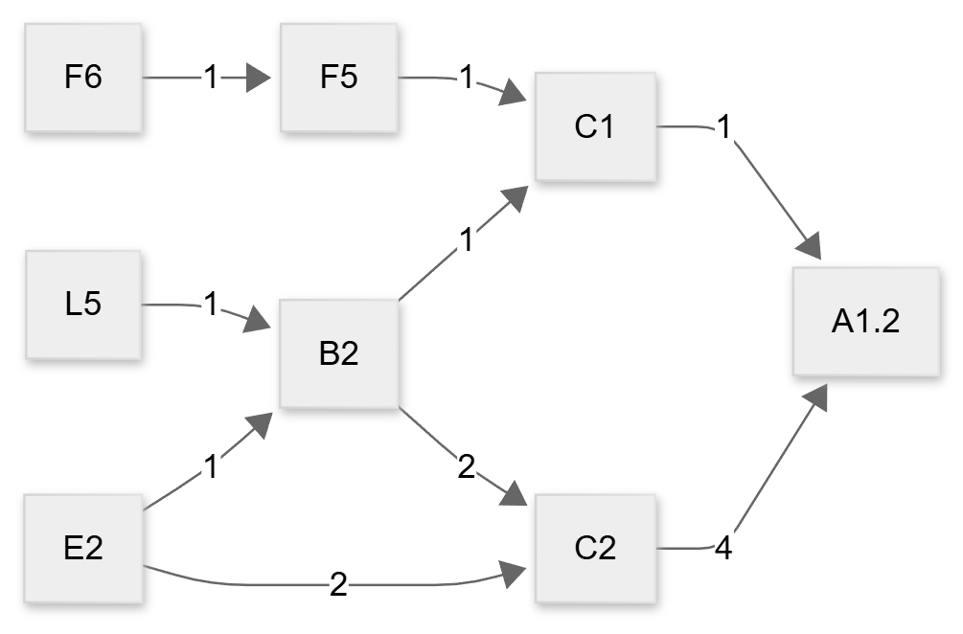
Figure 1: Cumulative DREAM Chart for A1.2: Too Late Action

Phenotype A1.3: No Action
Phenotype A1.3 in which the driver failed to take any corrective action prior to the crash was recorded in 10 cases (15.4%). The cumulative DREAM chart for A1.3 (Figure 2) is the most structurally complex of the five phenotypes, reflecting multiple independent causal routes to the no-action outcome. The primary pathway ran through late observation (B2) feeding into misjudgment of situation (C2), with B2 receiving inputs from a broad set of upstream genotypes including B2.1, F6, F2, M1, E2, and B3 (false observation). A second major pathway involved equipment failure (I1) as a direct contributor to A1.3, preceded by inadequate vehicle maintenance (O1, frequency = 3), indicating that mechanical incapacitation — rather than behavioral failure alone — accounted for a subset of no-action events. Inattention (E3) contributed directly to A1.3 in one case, and substance influence (E4) appeared as a direct contributor in another. Environmental contributors N1 and N2, mediated through E3, indicated that road environment factors contributed to attentional failure in some cases. Collisions associated with A1.3 were split between motorized (n = 6) and non-motorized (n = 4) counterparts, with the non-motorized proportion being higher relative to other phenotypes, consistent with the vulnerability of pedestrians and cyclists to drivers who provide no pre-impact response.
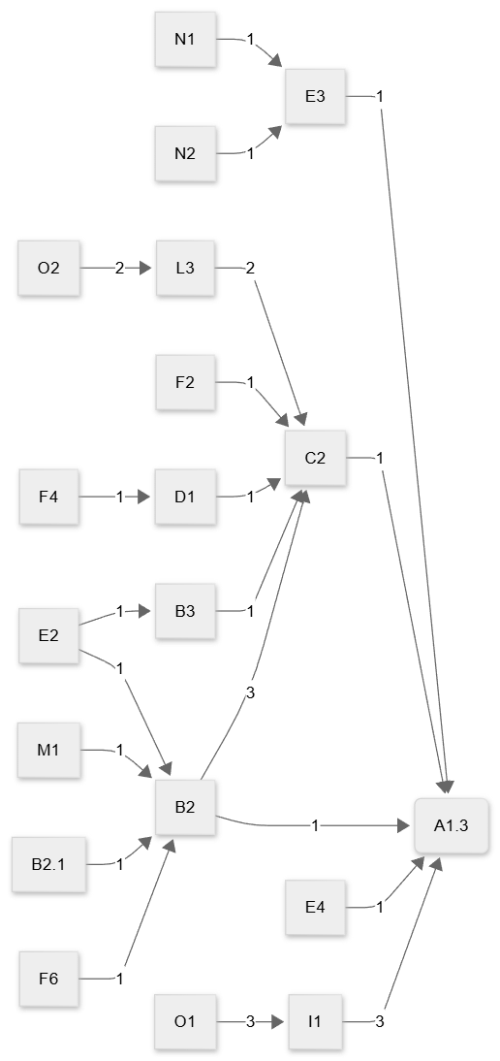
Figure 2: Cumulative DREAM Chart for A1.3; No Action

Phenotype A2.1: Too High Speed
Phenotype A2.1 was the dominant phenotype in the dataset, recorded in 27 cases (41.5%). The cumulative DREAM chart for A2.1 (Figure 3) is the most densely connected of all five charts, reflecting the breadth of causal pathways contributing to speed-related crashes. The most heavily weighted direct route to A2.1 ran through C2 (Misjudgment of situation, frequency = 11) and I1 (Equipment failure, frequency = 9), the latter preceded by O1 (Inadequate vehicle maintenance, frequency = 9). This dual pathway, behavioral misjudgment on one hand and mechanical failure on the other, illustrates that excessive speed outcomes arise both from drivers actively choosing or failing to reduce speed and from drivers losing the physical capacity to do so due to brake or vehicle defects. F4 (Habitually stretching rules, frequency = 4 direct connections to D1 and C2) and F6 (Insufficient skills, frequency = 7 feeding to F5) were the most prominent upstream behavioral genotypes, with D1 (Priority error, frequency = 6) serving as a key intermediate node linking deliberate rule-stretching behavior to situational misjudgment. Inattention (E3) and substance influence (E4, E4.1) appeared as contributing genotypes in isolated cases, while E2 (motivational risk acceptance) showed multiple connections including a direct route to A2.1. The A2.1 phenotype was associated with both motorized (n = 18) and non-motorized (n = 9) collision counterparts, the latter reflecting the severity risk posed by speeding vehicles to pedestrians and cyclists.
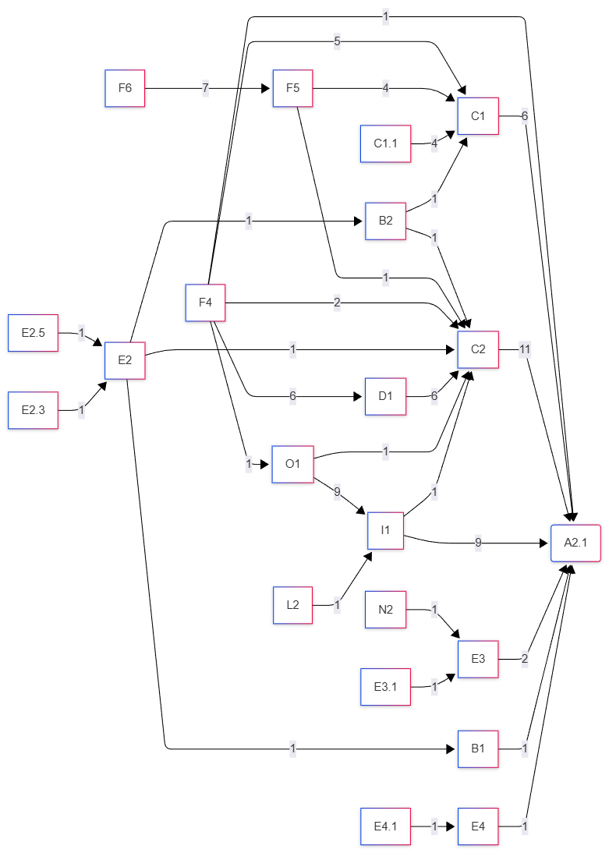
Figure 3: Cumulative DREAM Chart for A2.1: Too High Speed

Phenotype A4.1: Wrong Direction
Phenotype A4.1 was recorded in 12 cases (18.5%). The cumulative DREAM chart for A4.1 (Figure 4) identifies two dominant causal convergence points: C1 (Misjudgment of time gap, frequency = 5 to A4.1) and C2 (Misjudgment of situation, frequency = 8 to A4.1). Both cognitive misjudgment nodes received inputs from the same upstream behavioral genotypes: F4 (Habitually stretching rules) contributed heavily via D1 (Priority error, frequency = 5) to both C1 and C2, while F6 (Insufficient skills, frequency = 4) fed into F5 (Overestimation of skills, frequency = 3) before converging on C1. A further route involved E2 (motivational state) feeding into B2 (Late observation), which then contributed to C2. A minority pathway involved Q2 (Inadequate road design) leading to L5, then to C2, suggesting that road environment deficiencies contributed to directional misjudgment in at least one case. Equipment failure (I1) preceded by O1 appeared once as a direct contributor, and E4 (Substance influence) appeared as a direct contributor in one case. The pattern indicates that wrong-direction accidents are primarily driven by the combination of deliberate norm violation (F4), cognitive overconfidence (F5), and consequent failure to correctly assess the gap or situational dynamics required for safe directional decisions.
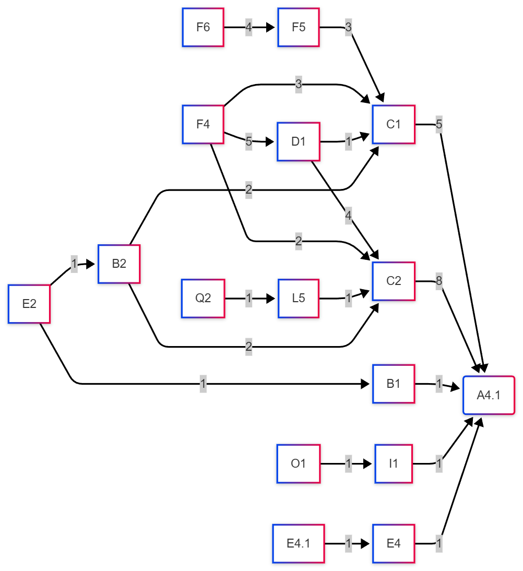
Figure 4: Cumulative DREAM Chart for A4.1: Wrong Direction

Phenotype A5.2: Insufficient Force
Phenotype A5.2 was recorded in 13 cases (20.0%). The cumulative DREAM chart for A5.2 (Figure 5) is notable for the dominance of the vehicle-condition pathway: O1 (Inadequate vehicle maintenance) leading to I1 (Equipment failure) had the highest single-pathway frequency in the entire dataset (frequency = 11), and this chain contributed directly to A5.2, indicating that in the majority of insufficient-force accidents the primary cause was mechanical brake or vehicle failure stemming from poor maintenance rather than a behavioral braking decision error. Secondary pathways included F6 (Insufficient skills) feeding into F5 (Overestimation of skills) and then to C1 (Misjudgment of time gap), which contributed to A5.2 in combination with C2 (Misjudgment of situation). D1 (Priority error) fed into C2 via F4, and B2 (Late observation) contributed once to C2. E2 (Motivational state) contributed via E6 to a minor pathway, and J3 feeding into L3 appeared as a physical/environmental precursor in one case. The strong mechanical failure signal in A5.2 distinguishes this phenotype from the others in the dataset and has direct implications for vehicle roadworthiness enforcement.
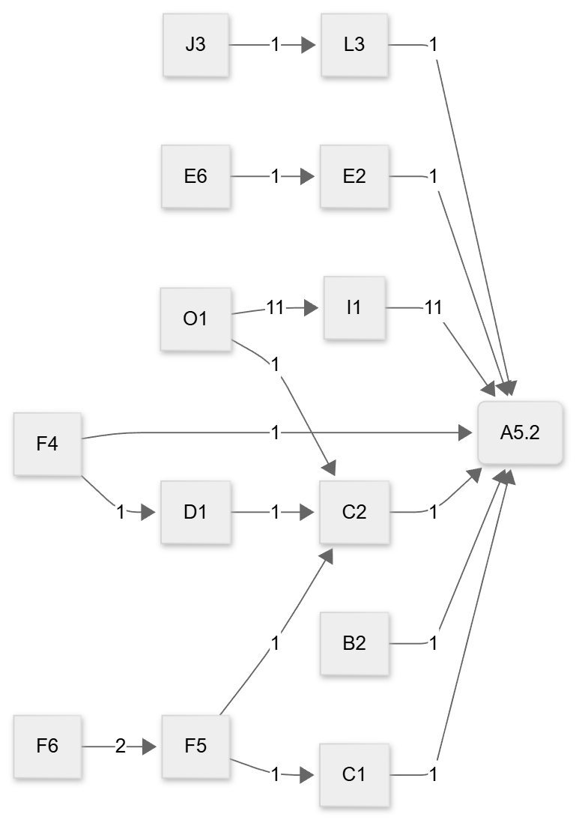
Figure 5: Cumulative DREAM Chart for A5.2:Insufficient Force

Collision Type Distribution across Phenotypes
Table 5 summarizes the distribution of motorized versus non-motorized collision counterparts across the five phenotypes. A2.1 (Too High Speed) accounted for the largest absolute number of non-motorized collisions (n = 9), consistent with the higher kinetic energy of speeding vehicles and their greater likelihood of inflicting fatal or severe injury on pedestrians and cyclists. A1.3 (No Action) showed a disproportionately high non-motorized proportion relative to its overall frequency, suggesting that complete driver response failure is particularly dangerous for vulnerable road users who depend on active avoidance by motorized drivers. A1.2 showed no non-motorized collisions in its three cases.
Table 5: Distribution of collision counterpart type by accident phenotype
S/N | Phenotype | Description | With Motorized (n) | With Non-Motorized (n)
1 | A1.2 | Too Late Action | 2 | 1
2 | A1.3 | No Action | 6 | 4
3 | A2.1 | Too High Speed | 18 | 9
4 | A4.1 | Wrong Direction | 8 | 4
5 | A5.2 | Insufficient Force | 10 | 3
 | Total |  | 38 | 10

DISCUSSION

The Primacy of Speed-Related Behavioral Failure
The finding that A2.1 (Too High Speed) accounts for 41.5% of all coded accidents is consistent with global evidence positioning speed as the single most influential behavioral risk factor in road crash causation (Adeoye et al., 2014; Naallah et al., 2024), but its magnitude in the Nigerian context reflects a set of compounding structural conditions. The DREAM chart for A2.1 reveals that the dominant upstream genotypes are F4 (Habitually stretching rules, n = 26) and C2 (Misjudgment of situation, n = 27), both of which point to normalized patterns of risky driving rather than isolated lapses of judgment. This distinction is analytically important: F4 is a motivational-behavioral genotype indicating that speed violations in the Nigerian accident sample are not primarily accidental but reflect a cultural normalization of rule-bending among drivers. This finding aligns with qualitative research on Nigerian road transport culture documenting pressure on commercial drivers to complete trips rapidly in order to meet revenue targets imposed by vehicle owners and transport unions (Amoadu et al., 2024; Godthelp & Ksentini, 2024). Addressing A2.1 therefore requires interventions that go beyond speed camera enforcement to include structural reform of commercial driver incentive systems and stronger regulatory oversight of transport operators.

Vehicle Condition as a Systemic Co-Factor
A defining characteristic of the Nigerian accident phenotype profile revealed by this study is the persistent co-occurrence of mechanical failure genotypes, particularly I1 (Equipment failure, n = 25) and O1 (Inadequate vehicle maintenance, n = 24) across multiple phenotypes. These genotypes are prominent not only in A5.2, where the O1–I1 chain is the dominant causal pathway with a frequency of 11, but also in A2.1 and A1.3, indicating that brake and vehicle defects contribute to speed-related and no-action crashes as well as to insufficient-force events. This cross-phenotype mechanical failure signal is a distinctive feature of the Nigerian dataset that differentiates it from DREAM-based studies conducted in European contexts, where vehicle maintenance standards are enforced by mandatory periodic inspection regimes. The absence of consistent routine vehicle inspection practice among Nigerian commercial operators, combined with inadequate enforcement of roadworthiness standards, creates a context in which driver behavioral error and mechanical failure interact and amplify each other. These findings provide empirical support for strengthening the traffic law enforcement officers particularly in road worthiness of vehicles and also confirm arguments by Onwusoronye et al. (2025), Adeleke et al. (2020) and Naallah et al. (2024) that poor maintenance is a major cause of accident in Nigeria.

Cognitive Misjudgment and Competence Deficits
Across all five phenotypes, C2 (Misjudgment of situation) emerged as the most frequently occurring intermediate cognitive genotype (n = 27), indicating that a failure to accurately read and respond to the traffic environment is a common thread connecting speed errors, directional errors, timing failures, and insufficient braking force. C2 was in turn consistently preceded by upstream competence genotypes F5 (Overestimation of skills, n = 13) and F6 (Insufficient skills or knowledge, n = 15), suggesting that cognitive misjudgment is often rooted in a driver competence problem rather than a momentary attentional lapse. This profile has direct implications for the quality and rigor of driver licensing and training in Nigeria. The current licensing system has been widely criticized for its susceptibility to corruption and its failure to ensure that licensed drivers possess the practical competencies required for safe operation on high-speed intercity roads (Atubi, 2012). The genotype data from this study provide a specific evidence base for curriculum reform in Nigerian driver training, with particular emphasis on hazard perception, situational awareness, and speed-environment calibration.

Vulnerable Road User Risk
The finding that A2.1 and A1.3 together account for the majority of non-motorized collision outcomes in the dataset has significant public health implications. Pedestrians and cyclists are disproportionately exposed to fatal injury in crashes involving speeding vehicles and in crashes where the driver provides no pre-impact response. This vulnerability pattern has been documented in LMIC road safety literature (Berhanu et al., 2023), but the DREAM phenotype classification adds analytical specificity by identifying which driver behavioral failure modes are most directly implicated. The A1.3 no-action profile in particular, with its combination of inattention, substance influence, and mechanical failure pathways, suggests that interventions targeting driver impairment and distraction on roads with high pedestrian exposure could yield significant reductions in vulnerable road user fatalities.

CONCLUSION
This study presents the first application of the Driver Reliability and Error Analysis Method (DREAM) to a national Nigerian road traffic accident dataset derived from newspaper records, and in doing so provides a structured, evidence-based classification of the dominant driver behavioral failure patterns underlying road crashes in Nigeria. Five accident phenotypes were identified; A1.2 (Too Late Action), A1.3 (No Action), A2.1 (Too High Speed), A4.1 (Wrong Direction), and A5.2 (Insufficient Force), with A2.1 emerging as the most prevalent, accounting for 41.5% of coded accidents. Cumulative DREAM chart analysis revealed that these phenotypes are causally underpinned by a convergent set of genotypes, most notably habitual rule-stretching (F4), cognitive misjudgment of situation (C2), equipment failure (I1), and inadequate vehicle maintenance (O1), which recur across multiple phenotype categories and point to systemic rather than isolated behavioral risk factors.
The genotype-phenotype mapping produced by this study moves Nigerian road safety analysis beyond descriptive crash statistics toward a mechanistic understanding of why crashes occur and through what causal pathways driver failure is realized. The findings have direct implications for road safety policy: interventions targeting speed enforcement, commercial driver incentive reform, mandatory vehicle roadworthiness inspection, and driver competence training are all supported by the genotype evidence and should be prioritized by the Federal Road Safety Corps and relevant state traffic authorities. The identification of A2.1 and A1.3 as the phenotypes most associated with non-motorized collision counterparts further underscores the need for specific protective measures for pedestrians and cyclists on Nigerian roads.

REFERENCES
Adeleke, R., Osayomi, T., & Iyanda, A. E. (2021). Geographical patterns and effects of human and mechanical factors on road traffic crashes in Nigeria. International Journal of Injury Control and Safety Promotion, 28(1), 3–15. https://doi.org/10.1080/17457300.2020.1823996
Adeoye, P. O., Kadri, D. M., Bello, J. O., Pascal, C. K., Abdur-Rahman, L. O., Adekanye, A. O., & Solagberu, B. A. (2014). Host, vehicular and environmental factors responsible for road traffic crashes in a nigerian city: Identifiable issues for road traffic injury control. Pan African Medical Journal, 19. https://doi.org/10.11604/pamj.2014.19.159.5017
Ahmed, S. K., Mohammed, M. G., Abdulqadir, S. O., El‐Kader, R. G. A., El‐Shall, N. A., Chandran, D., Rehman, M. E. U., & Dhama, K. (2023). Road traffic accidental injuries and deaths: A neglected global health issue. Health Science Reports, 6(5), e1240. https://doi.org/10.1002/hsr2.1240
Akanbi, O. G., Charles‐Owaba, O. E., & Oluleye, A. E. (2009). Human factors in traffic accidents in Lagos, Nigeria. Disaster Prevention and Management: An International Journal, 18(4), 397–409. https://doi.org/10.1108/09653560910984456
Amoadu, M., Ansah, E. W., & Sarfo, J. O. (2024). Psychosocial work conditions and traffic safety among minibus and long-bus drivers. Journal of Occupational Health, 66(1), uiad019. https://doi.org/10.1093/joccuh/uiad019
Ashutosh, A., & Chand, S. (2025). Discrepancies in media reporting of fatal road crashes and official data in India. Scientific Reports, 15(1), 34025. https://doi.org/10.1038/s41598-025-14010-2
Atalay, Y. A., Alemie, B. W., Gelaw, B., & Gelaw, K. A. (2025). Epidemiology of road traffic accidents and its associated factors among public transportation in Africa: Systematic review and meta-analysis. Frontiers in Public Health, 13, 1511715. https://doi.org/10.3389/fpubh.2025.1511715
Berhanu, Y., Alemayehu, E., & Schröder, D. (2023). Examining Car Accident Prediction Techniques and Road Traffic Congestion: A Comparative Analysis of Road Safety and Prevention of World Challenges in Low-Income and High-Income Countries. Journal of Advanced Transportation, 2023, 1–18. https://doi.org/10.1155/2023/6643412
Daniels, S., Brijs, T., & Keunen, D. (2010). Official reporting and newspaper coverage of road crashes: A case study. Safety Science, 48(10), 1469–1476. https://doi.org/10.1016/j.ssci.2010.07.007
Fagerlind, H., Bjorkman, K., Warner, H. W., Aust, M. L., Sandin, J., Morris, A., Talbot, R., Danton, R., Giustiniani, G., Usami, D. S., Parkkari, K., Jaensch, M., & Verschragen, E. (2009). Development of an In-depth European Accident Causation Database and the Driving Reliability and Error Analysis Method, DREAM 3.0. Loughborough’s Research Repository. https://repository.lboro.ac.uk/articles/conference_contribution/Development_of_an_In-depth_European_Accident_Causation_Database_and_the_Driving_Reliability_and_Error_Analysis_Method_DREAM_3_0/9339149/1/files/16947809.pdf
Godthelp, H., & Ksentini, A. (2024). Specific road safety issues in low-and middle income countries (LMICs): An overview and some illustrative examples. Traffic Safety Research, 8, e000068–e000068.
Habibovic, A., Tivesten, E., Uchida, N., Bärgman, J., & Ljung Aust, M. (2013). Driver behavior in car-to-pedestrian incidents: An application of the Driving Reliability and Error Analysis Method (DREAM). Accident Analysis & Prevention, 50, 554–565. https://doi.org/10.1016/j.aap.2012.05.034
He, C., & Soffker, D. (2021). Human reliability analysis in situated driving context considering human experience using a fuzzy-based clustering approach. 2021 IEEE 2nd International Conference on Human-Machine Systems (ICHMS). https://doi.org/10.1109/ICHMS53169.2021.9582451
MacRitchie, V., & Seedat, M. (2008). Headlines and discourses in newspaper reports on traffic accidents. South African Journal of Psychology, 38(2), 337–354.
Naallah, A. B., Ibitoye, A. B., & Subair, S. O. (2024). Development of a Predictive Model for Road Traffic Accident Involvement in Southwest Nigeria: A Case Study of Ekiti, Osun, and Oyo State. Journal of Applied Sciences and Environmental Management, 3385–3390. https://doi.org/10.4314/jasem.v28i10.54
Omooseti, T. O., & Akinjobi, S. O. (2026). Modeling the Dynamics and Determinants of Road Traffic Accidents in Southwest Nigeria: A Dual-Level Analytical Approach. In Review. https://doi.org/10.21203/rs.3.rs-8996916/v1
Onwusoronye, O. U., Chukwutoo, I. C., U-Dominic, C. M., & Godspower, E. O. (2025). “‘Trends and Patterns of Road Traffic Crashes, Injuries and Fatalities in Nigeria’” Trends and Patterns of Road Traffic Crashes, Injuries and Fatalities in Nigeria. International Journal of Applied Sciences, 08(09). https://hal.science/hal-05272673v1
Paudel, D. (2025). Road Traffic Accidents in Nepal: A Five-Year Content Analysis of News Media Coverage and Causal Factors. Interdisciplinary International Journal of Advances in Social Sciences, Arts and Humanities, 02(01). https://doi.org/10.62674/iijassah.2025.v2i1.005
Sagberg, F. (2007). A methodological study of the Driving Reliability and Error Analysis Method (DREAM). Institute of Transport Economics. https://www.toi.no/getfile.php/137962-1200992223/Publikasjoner/T%C3%98I%20rapporter/2007/912-2007/912-2007-nett.pdf
Sandin, J. (2009). An analysis of common patterns in aggregated causation charts from intersection crashes. Accident Analysis & Prevention, 41(3), 624–632. https://doi.org/10.1016/j.aap.2009.02.015
Sandin, J., & Ljung, M. (2007). Understanding the causation of single-vehicle crashes: A methodology for in-depth on-scene multidisciplinary case studies. International Journal of Vehicle Safety, 2(3), 316–333.
Taiwo, O. A., Mahmud, N., Hassan, S. A., & Mohsin, R. B. (2024). Influence of commercial drivers’ risky behavior on accident involvement: Moderating effect of positive driving behavior. Journal of Engineering and Applied Science, 71(1), 68. https://doi.org/10.1186/s44147-024-00403-z
Uzondu, C., Jamson, S., & Marsden, G. (2022). Road safety in Nigeria: Unravelling the challenges, measures, and strategies for improvement. International Journal of Injury Control and Safety Promotion, 29(4), 522–532. https://doi.org/10.1080/17457300.2022.2087230
Warner, H. W., & Sandin, J. (2010). The intercoder agreement when using the Driving Reliability and Error Analysis Method in road traffic accident investigations. Safety Science, 48(5), 527–536. https://doi.org/10.1016/j.ssci.2009.12.022

