Construction of a Social Vulnerability Index for Flooding

Tharupama D L R¹, Illeperuma I A K S²
Department of Remote Sensing and GIS, Faculty of Geomatics, Sabaragamuwa University of Sri Lanka, Ratnapura, Sri Lanka

ABSTRACT
Flooding is one of the most devastating natural hazards, causing major economic losses and severe social effects affected on communities. It causes disruptions in livelihoods, infrastructure damage and vulnerable populations. Social vulnerability is very crucial for the identification of risk communities and development of proper risk management and mitigation plans with regard to flood situations. Assessing social vulnerability is important in identifying at risk populations which formulates flood risk management. In this respect, this paper builds up a Social Vulnerability Index for Ratnapura District in Sri Lanka, by combining socio-economic and demographic data with the impact caused due to floods. This methodology applies Hierarchical Segmentation Analysis which systematically partition the data into clusters on similarity to identify the patterns on the spatial scales. Principal Component Analysis systematically categorize vulnerability into three key dimensions: sensitivity, exposure, and resilience. The results show that sensitivity is the highest contributor toward overall social vulnerability, reflecting the importance of socioeconomic conditions emphasizing poverty, educational levels, and demographics. Exposure, reflecting physical and environmental vulnerability, comes second, while resilience, although the least dominant, plays a key role in long-term recovery and adaptation. Spatial analysis showed that Grama Niladhari divisions like Embilipitiya and Ratnapura districts in Sri Lanka are highly vulnerable and indicating the need for targeted and location specific interventions. This study, therefore, calls for the need for refinement of data on a continuous basis and real-time monitoring to ensure the accuracy and practical applicability of vulnerability assessment for policymakers and planners in evidence based decision making in risk reduction and safe community development.
Keywords- Disaster Risk Reduction, Flood Risk Management (FRM), Hierarchical Segmentation Analysis (HSA), Principle Component Analysis (PCA), Social Vulnerability Index (SVI).

INTRODUCTION

The occurring frequency of the natural disasters has been changed in the past years. Flooding is a devasting pervasive natural hazard which affects the communities which causes economic damages, human suffering and infrastructure disruptions among these hazards. Floods often affects the disadvantaged groups which experience losses and distress which was highlighted by the United Nations office for Disaster Risk Reduction (UNDRR, 2022).The rising occurrence of floods is attributed global warming, rainfall patterns and intensities leads to the flowing patterns of rivers and streams. Some anthropogenic factors such as Urbanization, population growth and other unplanned constructions for development activities.
Vulnerability, defined as the susceptibility of a person or group to impact to a natural hazard (Aksha et al., 2019). It is shaped by the exposure to the hazards, sensitivity to the flood impacts and the capacity to adapt or the resilience. It is a measurement of potential risk, as well as the socio-economic ability to tackle the worst situation resulting from disastrous event. The growing of the social injustice and inequalities were affected towards the flood risk reduction in Sri Lanka. The areas which characterized by low-lying terrain along with the dense waterways, poor drainage systems, improper construction make susceptible to floods during the periods of heavy rainfall. When experiencing rapid urbanization and population growth leads the increasing of pressure on land resources. Social Vulnerability indices has been recognized as a powerful decision making tool for both policymakers and researchers (Englund et al., 2023). This may use to prevent injustices of the differentiation of the group with unequal spatial distribution (Englund et al., 2023). Vulnerability depends on exposure and sensitivity of the social system, each parameter increase or decrease the vulnerability (Aroca-Jimenez et al., 2017).
When constructing a Social Vulnerability Index (SVI) to the Grama Niladhari (GN) division level, the smallest administrative unit in Sri Lanka, it ensures a granular and precise analysis of social vulnerability. This study is done to identify disproportionate impacts of floods on disadvantaged groups. It helps in pinpoint communities that are most risk during flooding events, particularly those might lack the resources to prepare for, respond to, and recover from floods.
Vulnerability in Disaster Risk Management
Vulnerability plays a vital role in the disaster risk management and it’s a critical factor in determining the community which are affected to hazards. This is broken into three interrelated components as Exposure, Sensitivity and the Adaptive capacity. Exposure referred to as the degree to which people are harmed, sensitivity is the degree to which community is affected to hazards and adaptive capacity is referred to as the ability to cope with the hazards. Some global frameworks in the disaster management emphasizes on the understanding of the disaster risk which recognizing the role of social, economic and environmental factors, strengthening disaster governance while enhancing the capacity of the government, adding inclusive policies, investing resilience which prioritize investments in infrastructure ,health, education to reduce vulnerability.
Existing Approaches to Social Vulnerability Assessment
Various approaches have been developed to measure the social vulnerability with different methodologies and objectives (Rufat et al., 2015). These approaches are categorize from qualitative to data driven quantitative techniques.
Qualitative assessments enhances the subjective and context specific knowledge. This approach prioritize local knowledge which provide context specific insights that may overlook data driven approaches (Dewi et al., 2023).
Quantitative assessment use statistical and geospatial data which produce measurable indicators to get the social vulnerability. But this type of assessment ignore qualitative factors and data availability more affect the accuracy of the results.
METHODOLOGY
Study Area
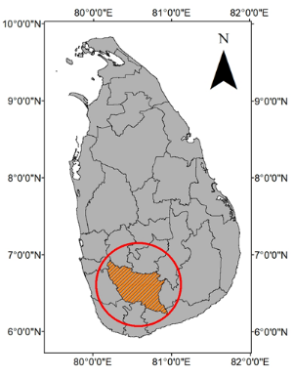
Figure 1: Ratnapura district, Sri Lanka
Ratnapura district, located in the Sabaragamuwa Province, Sri Lanka holds 3,275 km² and consists of 18 DS divisions and 575 GN divisions. The area is frequently affected by floods due to heavy rainfall and the presence of the Kalu Ganga river basin.
Data Collection
Data were sourced from the Department of Census and Statistics, Disaster Management Centre and other government agencies. The study used:
- Socio economic and demographic data (86 variables)
- Flood frequency data (2002 – 2022)
Historical flood events

Flood occurring frequency

Social Vulnerability Index (SVI)

Factor score

Assign weighted score to the observation

Socio-economic variables
&
Demographic variables

Normalize Variables

Group the Variables

Assign loadings to variables

Communality test

Factors
(Resilience, Sensitivity, Exposure)

Explained variance for each factor

Comparison of flood frequency vs. SVI

Figure 2: Methodology Flow Chart

Initially, for the data processing, normalization of all the data using the Min-Max scaling ensures the comparability. Next, the Hierarchical Segmentation analysis was applied to group the variables into 5 meaningful clusters based on their similarities. This is a multivariate statistical technique for automatic data classiﬁcation that divides an initial set of variables into different groups. This division is based on minimizing the distance between variables in the same group and maximizing the distance between variables in different groups. The division of variables into groups followed a hierarchical process in which initially as many groups as variables were considered. Subsequently, successive iterations of hierarchical algorithms enabled variables to converge in larger groups. 86 variables are divided into 5 classes so that checking the communality can be done very easily and accurately.
By using the communality test the latent variables which are not directly observable were identifies. All the variables that are belong to each group was examined. The variables with low communality (values between 0.4) were removed from the variable list.
Next, Principle Component Analysis was used to assign loadings to the variables. Then, a weighted score to the observation was calculated. This identifies the most risk during disasters by giving more importance to factors that contribute the vulnerability. (Frazier et al., 2014)

$S_{i}=D_{ij}×L_{j}$ (1)
Where $S_{i}$ is the weighted score of the observation $i,$
$D_{i}$ is the value of the observation $i$for the variable $j$ and $L_{j}$ is the loading of the variable $j$
By the use of the PCA, identifying the most significant factors which contribute the social vulnerability was done. The correlations between the factors and the variables were represent by the factor loadings. By this the three dimensions are derived such as Sensitivity, Resilience and Exposure. The variables which has the highest loading to each principle component, (variables which have highest loading to principle component 1 is allocated to Sensitivity, variables which have high loadings to principle component 2 is to Exposure and variables which have high loadings to principle component 3 to Resilience).
The explained variance of the 3 factors is calculated by the Principle Component Analysis. Then the factor score is obtained by both indicators weighted component score and the total explained variance. (Frazier et al., 2014)

$B_{if}=S_{i}×F_{f}$ (2)
Where $B_{if}$ is the factor score,$S_{i}$ is the weighted score of the observation $i$ and $F_{f}$ is the amount of variance explained by factor $f$
The Social vulnerability Index for each Grama Niladhari division was calculated under the following equation (Frazier et al., 2014)

$SVI=E+S-R$ (3)
Where $SVI$ is the Social Vulnerability Index, $E$ is the Exposure, $S$ is the Sensitivity and $R$ is the Resilience.

RESULTS AND DISCUSSION
Table 01: Explained Variance
Factor | Explained Variance
Sensitivity | 23.45
Exposure | 4.93
Resilience | 4.14

For the each factor an explained variance was obtained by PCA. Where the Sensitivity factor has obtained the highest variance while Exposure and the Resilience have obtained the least respectively.

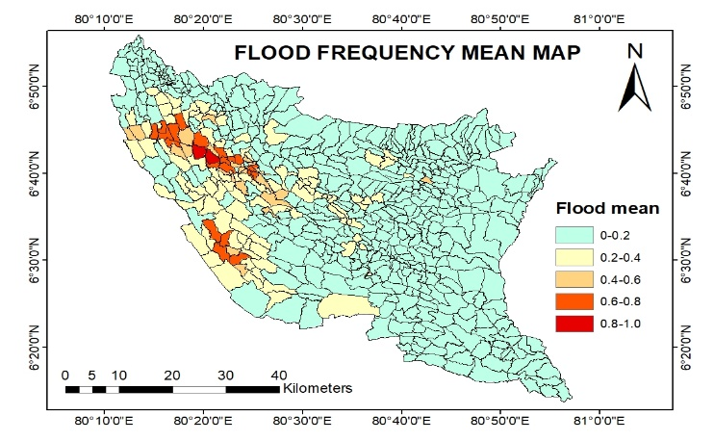
Figure 2: Flood Frequency Mean Map

The flood frequency from 2002 to 2022 of the GN divisions of Ratnapura district is categorized and the mean of the flood frequency is taken and a flood frequency mean map was created. Mean is classified from 0 to 1 where 1 initiates the highest flood frequency mean and 0 represents the lowest flood frequency mean. According to the above map, Ratnapura, Pelmadulla, Kiriella are some DS divisions which conquer the most flood frequency.
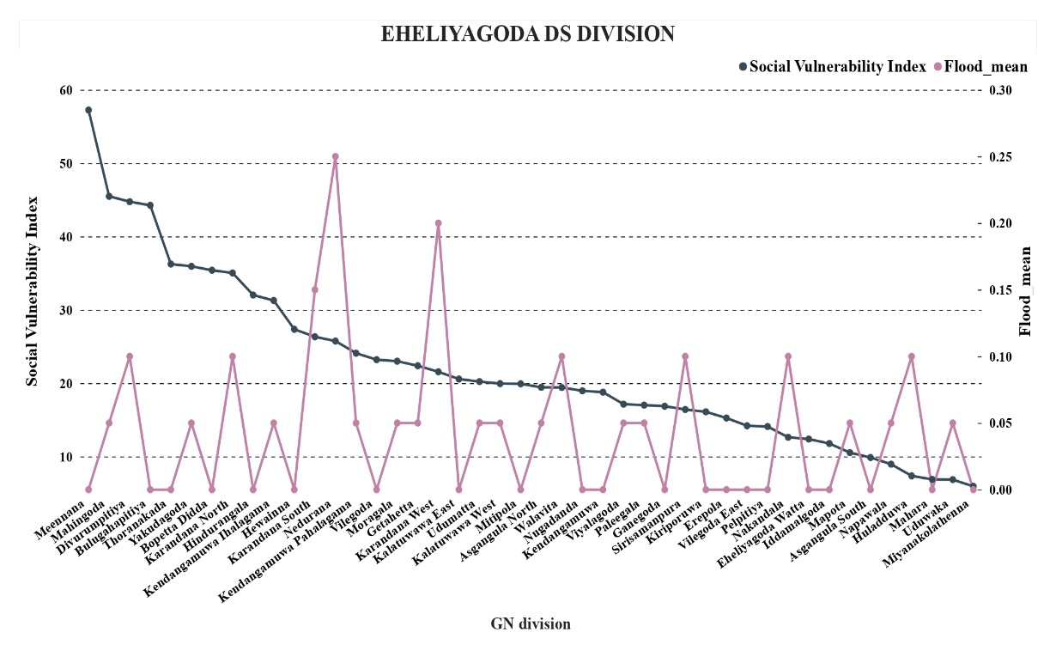
Figure 3: Eheliyagoda DS division

The graph represents Social Vulnerability Index and the mean flood frequency for the Eheliyagoda DS division. The GN divisions on the left side of the graph (e.g.Meemanana, Mahingoda, Divurumpitiya) exhibits the highest SVI values which exceeds 50. These areas are characterized by social vulnerability due to underlying socio economic and demographic factors.
But when some GN divisions, with relatively lower SVI values, have still shown high flood exposure, indicates the factor of social vulnerability may not be solely sufficient to explain the flood risk in the area. While some GN divisions with high SVI indeed have high flood exposure. Others with high SVI have relatively low flood exposure. This evidence that flood risk does not coincide with the social vulnerability.
This results that specific flood risk mitigation strategies are needed, considering social vulnerability and flood exposure. Those GN divisions falling within high SVI but low flood exposure may still require resilience-building measures in terms of improving socio-economic conditions. On the other hand, GN divisions with high flood exposure should be prioritized for flood control interventions regardless of their SVI.
Social Vulnerability Index map was prepared which categorizes the SVI of each GN division of the Ratnapura district. The Index values differ from 0 to 100 where 100 represents the highest SVI while 0 represents the least SVI. According to the map Embilipitiya and Ratnapura DS divisions show a significant SVI which is a very high values compared to the other DS divisions.
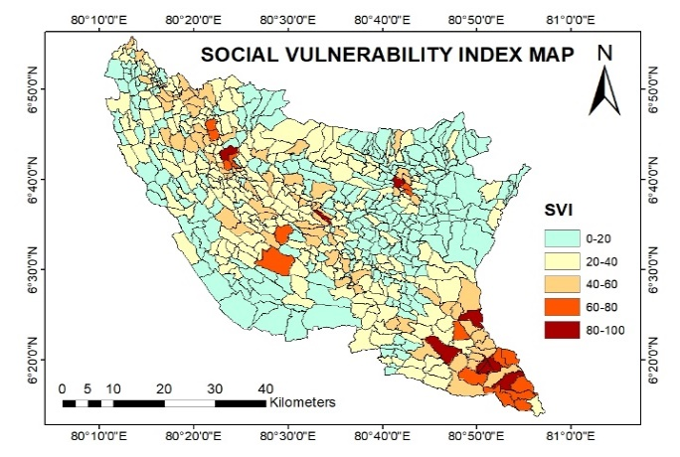
Figure 4: Social Vulnerability Index map
Critical risk prone areas with high sensitivity and exposure but low resilience are evident in the comparative sensitivity, exposure and resilience maps. The risk reduction in these areas should include infrastructure development, early warning systems and enhancement of community resilience programs. These findings also reinforce that a holistic approach to risk management considers all 3 factors
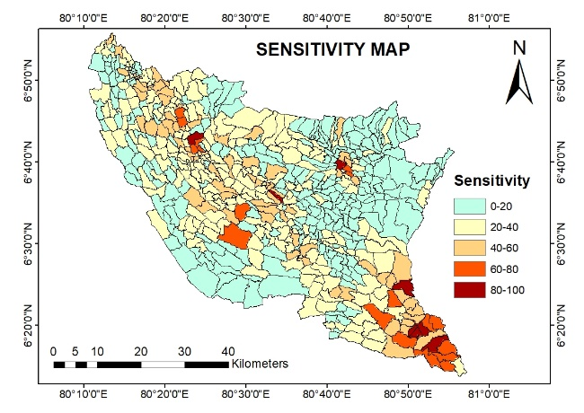
Figure 5: Sensitivity map

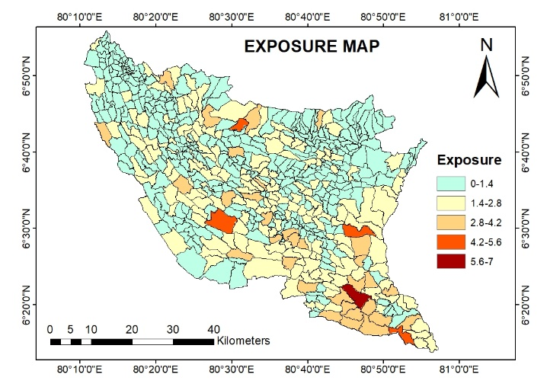
Figure 6: Exposure map

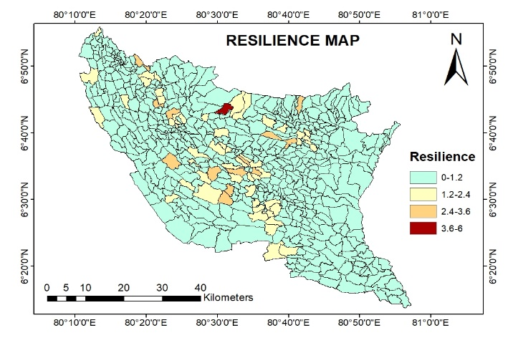
Figure 7: Resilience map

CONCLUSION

This study highlights that this social vulnerability is a multidimensional concept which is influenced by the sensitivity, exposure and the resilience which contribute differently to the overall social vulnerability. According to the results obtained, Sensitivity accounts the highest proportion of the variance in the social vulnerability which basically emphasizes the socio economic conditions such as poverty, education and the population demographics which basically considered as key factors in the social vulnerability index creation. Exposure which gained a less variance than the sensitivity basically focused on the physical infrastructure and the geographic location in the flood risk. Resilience contributes the least variance which uses in understanding the adaptive capacity and the disaster recovery potential.
This SVI can be used as a factor in the disaster management not only for flooding but also other natural disasters that occur in Ratnapura district. The spatial distribution of the SVI revealed a significant disparities among different GN divisions. The areas such as Embilipitiya and Ratnapura were identified as the most vulnerable DS divisions due to the combination of the high sensitivity and the exposure factors. But when studying the flood frequency mean with the SVI it can be identified that the GN divisions which has high flood frequency and a lower SVI basically and vice versa. If two GN divisions which shows the same flood frequency mean but different SVI, the highest SVI occupied GN division should be supported the most.
The SVI maps which are generated in the study provides a valuable insights for the policy makers and the disaster management authorities. It prioritize the highly vulnerable areas and the authorities can allocate the resources effectively and identify the most targeted areas and allocate resources effectively to those areas and enhance the community resilience. The findings also emphasize the necessity of integrating social vulnerability assessments into flood risk management strategies to ensure equitable disaster preparedness and response.
However, there are a few limitations: the used census data is from 2012, and other real-time dynamic factors like climate change or shifts in economic factors have not been considered within this study. This study bridges the gap between geographical assessments of flood risks and considerations about social vulnerability, thus opening avenues for more appropriate and equitable disaster risk reduction strategies in Sri Lanka.

REFERENCES
- Aksha, S.K., Juran, L., Resler, L.M., Zhang, Y., 2019. An Analysis of Social Vulnerability to Natural Hazards in Nepal Using a Modified Social Vulnerability Index. Int. J. Disaster Risk Sci. 10, 103–116. https://doi.org/10.1007/s13753-018-0192-7
- Aroca-Jimenez, E., Bodoque, J.M., Garcia, J.A., Diez-Herrero, A., 2017. Construction of an integrated social vulnerability index in urban areas prone to flash flooding. Nat. Hazards Earth Syst. Sci. 17, 1541–1557. https://doi.org/10.5194/nhess-17-1541-2017
- Chakraborty, J., Tobin, G.A., Montz, B.E., 2005. Population Evacuation: Assessing Spatial Variability in Geophysical Risk and Social Vulnerability to Natural Hazards. Nat. Hazards Rev. 6, 23–33. https://doi.org/10.1061/(ASCE)1527-6988(2005)6:1(23)
- Dewi, R.S., Handayani, W., Pratama, I.P., De Vries, W.T., Rudiarto, I., Artiningsih, A., 2023. Assessing Flood Vulnerability from Rapid Urban Growth: A Case of Central Java — Indonesia. Chin. J. Urban Environ. Stud. 11, 2350020. https://doi.org/10.1142/S2345748123500203
- Englund, M., Vieira Passos, M., André, K., Gerger Swartling, Å., Segnestam, L., Barquet, K., 2023. Constructing a social vulnerability index for flooding: insights from a municipality in Sweden. Front. Clim. 5, 1038883. https://doi.org/10.3389/fclim.2023.1038883
- Frazier, T.G., Thompson, C.M., Dezzani, R.J., 2014. A framework for the development of the SERV model: A Spatially Explicit Resilience-Vulnerability model. Appl. Geogr. 51, 158–172. https://doi.org/10.1016/j.apgeog.2014.04.004
- Morrison, A., Westbrook, C.J., Noble, B.F., 2018. A review of the flood risk management governance and resilience literature. J. Flood Risk Manag. 11, 291–304. https://doi.org/10.1111/jfr3.12315
- Rufat, S., Tate, E., Burton, C.G., Maroof, A.S., 2015. Social vulnerability to floods: Review of case studies and implications for measurement. Int. J. Disaster Risk Reduct. 14, 470–486. https://doi.org/10.1016/j.ijdrr.2015.09.013
- Spielman, S.E., Tuccillo, J., Folch, D.C., Schweikert, A., Davies, R., Wood, N., Tate, E., 2020. Evaluating social vulnerability indicators: criteria and their application to the Social Vulnerability Index. Nat. Hazards 100, 417–436. https://doi.org/10.1007/s11069-019-03820-z
- Tariq, M.A.U.R., Farooq, R., Van De Giesen, N., 2020. A Critical Review of Flood Risk Management and the Selection of Suitable Measures. Appl. Sci. 10, 8752. https://doi.org/10.3390/app10238752

