Efficient Machine Learning Framework for Big Data Ad Performance and User Engagement Optimization Utilizing Distributed Spark Architecture
Ayush Pathak, Priyanshu Yadav,Puram Dhanush ,Rayapaneni Sathwik Choudhary,Dr. B. Lakshmi Dhevi.
Department of Networking and Communications SRM Institute of Science and Technology Chennai, India
{lakshmib2, py9149, sr9368, ap7901, dp3237}@srmist.edu.in

Abstract—Because digital advertising platforms are growing so quickly, we need better analytical frameworks that can handle a lot of intricate, high-dimensional interaction data, which is a frequent aspect of Big Data ecosystems. Conventional single-node processing often fails to satisfy the iterative demands of modern machine learning (ML) models. This research addresses the existing gap by employing a distributed computation architecture founded on the Hadoop Distributed File System (HDFS) for scalable storage. We carefully tested five supervised machine learning models—Logistic Regression (LR), Decision Trees (DT), Random Forest (RF), Gradient Boosting Machines (GBM), and Support Vector Machines (SVM)—to see how well they could predict binary user conversion. The models used 21 Term Frequency-Inverse Document Frequency (TF-IDF) vectors, as well as demographic and behavioral characteristics. K-Means clustering worked well to build relevant consumer groups based on how long they used a product and how likely they were to buy it. This strategy of combining distributed high-accuracy prediction with behavioral segmentation is a key aspect of getting the most out of your money and boosting your digital marketing efforts
Index Terms—Big Data; Apache Spark MLlib; HDFS; Adver- tising Technology; Logistic Regression; Random Forest; Gradient Boosting Machines; Support Vector Machines; K-Means Cluster- ing; User Engagement Prediction

- Introduction
Big Data is what organizations call the huge amounts of user interaction data that digital marketing has today[12]. This data is hard to deal with because it comes in large amounts, at high speeds, and with a lot of different types[13]. Every interaction, from showing an ad (impression) to the last commercial action (conversion), creates thousands of data points about the user, such as their age, gender, device type, content consumed, and the time of day. To properly judge how well online ads work and make sure that marketing Return on Investment (ROI) is profitable, it is important to analyze this constant stream[1].
When faced with this scale, traditional, single-node ML methods are fundamentally limited[17]. The necessity for iterative model training, coupled with the computational bur- den imposed by high-dimensionality features—such as the
21 TF-IDF vectors present in the sample data —demands scalable, distributed computing solutions[7]. Without this kind of infrastructure, advanced analyses, especially those that use complex algorithms like Gradient Boosting or extensive hyperparameter tuning, take too long, which makes it hard to make strategic decisions in real time[4]. This study utilizes a distributed computing framework to address the complexities associated with extensive ad performance analysis[5]. The architecture uses HDFS for strong, distributed data storage and Apache Spark, with its own MLlib, for fast, repeated computation and analysis. The method used takes into account the fact that predicting user conversion is a difficult task because it is usually a rare event[2]. This leads to a very unbalanced classification that needs very special metrics[16]. The primary aim of this paper is twofold: First, to carefully compare five different supervised machine learning models (LR, DT, RF, GBM, SVM) on the binary classification task of predicting conversions[11]. The purpose of this comparison is to determine the best predictive engine that can be used in a production scenario that can grow[17]. Second, the study em- ploys K-Means clustering, which is an unsupervised method, to uncover valuable and actionable consumer categories based on how they engage with each other, their demographics, and how well the content connects with them[12]. The findings of this study provide a conclusive technical framework for im- proving advertising campaigns through data-driven predictive modeling and advanced audience targeting[18].

- Related Work
Businesses that want to reach more people and get cus- tomers to talk to them need to use social media advertising in the digital age. To build an effective ad campaign, you need to first figure out how to accurately assess and antici- pate user interaction. You can do this by looking at metrics like click-through rate (CTR), impressions, and conversions. Recent improvements in machine learning have made these fields considerably better. Now, marketers and researchers may

employ systems that are automated, scalable, and incredibly accurate. Initial fundamental research shown that predictive analytics utilizing logistic regression and ensemble models, such as Random Forests and Gradient Boosting Machines, improve both accuracy and campaign interpretability, greatly beyond traditional analytical techniques. Musunuri et al. [3] demonstrated that supervised learning techniques are effective for focused segmentation, enabling the construction of more efficient advertisements that effectively reach the intended audience. Emotional elements, traditionally overlooked in dig- ital marketing statistics, have been shown to significantly influence engagement and conversion rates. Mukherjee et al.
[4] highlighted the efficacy of AI-driven sentiment analysis in predicting the emotional impact of digital commercials, revealing a clear correlation between emotional resonance and customer response. Saheb et al. [5] and Sivarajah et al. [6] To add to this emotional point of view, do thorough surveys on how AI, big data technology, and social media analytics work together. Advertising data is getting bigger and more intricate very quickly, thus we need to employ big data frameworks to train models and compare them to each other. Huynh et al. [7] conducted a comprehensive analysis of new big data analytics platforms, including Apache Spark and Hadoop, highlighting their significance in iterative model evaluation and real-time campaign optimization. Studies have examined the organic aspects of participation in social web communities and extensive collaborations. Weber et al. [8] and Tapscott et al. [9] demonstrated the lasting effects of commu- nity development and network-oriented marketing, enhanced by sophisticated web-scale analytics. Some applied advances can include machine learning techniques for acquiring users, explainable AI, high-efficiency audience classification, and attention-based network architectures created just for forecast- ing social participation. Deployments that are mobile and use few resources have grown more important. Ymer Digital et al. [13] show that real-time, lightweight analytics pipelines make it possible to make more and better predictions about involvement outside of traditional business settings. Arasu et al. [1], [14] examined the integration of social media data analytics with other marketing data streams, underscoring the necessity for interoperability and enhanced scalability. Balaji Tk et al. [15] assert that future research will emphasize explainability, multidimensional analysis, and the real-time adaptation of machine learning systems. These are attention networks, sentiment analysis, and streaming analytics that can help people get more out of campaigns on different platforms and do better..
The Apache Spark cluster configuration determines the ana- lytical workflow. While the SparkContext communicates with a Cluster Manager like YARN or Kubernetes to dynamically distribute resources, a Driver Program sets up the Spark- Context and controls execution logic [6]. Executors manage computational operations, such as caching data partitions, and operate on Worker Nodes [6]. Throughput is increased by this distributed design.
ML workloads are especially well-suited to Spark’s execu- tion model. An ML job is broken down into stages at launch [15], which are then further subdivided into parallel tasks. Spark greatly reduces disk I/O by supporting in-memory com- puting through the use of RDD and DataFrame abstractions. This feature speeds up iterative procedures like hyperparame- ter tuning, validation, and training [4]. This design is crucial for speedy analysis in numerical and high-dimensional TF-IDF spaces [9].

- Proposed Methodology
A. Data Acquisition and Distributed Architecture
The suggested approach makes the assumption that raw ad- vertisement campaign records, akin to transmitted interaction data, are continually received by the Hadoop Distributed File System [1]. A reliable method for storing massive amounts of Big Data over dispersed, inexpensive computing resources is provided by HDFS [5]. During extensive analytical proce- dures, this method guarantees fault tolerance, availability, and parallel access.

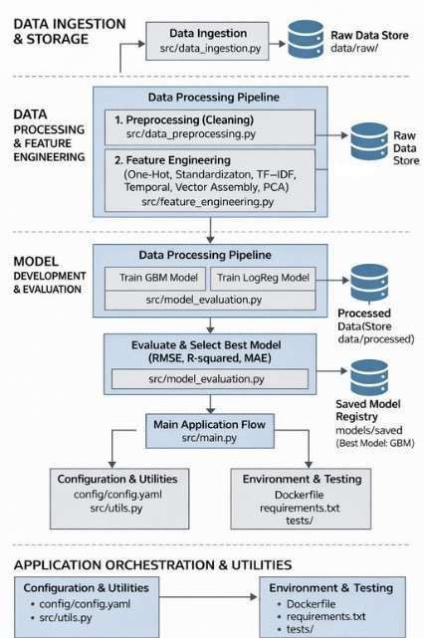
Figure 1: Distributed AdTech Optimization Architecture: Raw Ad Logs Ingestion (HDFS) → Spark Cluster Orchestration (Driver/Executors on YARN/Kubernetes) → Distributed Fea- ture Engineering (One-Hot, TF-IDF, Scaling) → In-Memory RDD/DataFrame Processing → MLlib Model Training and Evaluation.

B. Dataset Characteristics and Feature Engineering Pipeline
The dataset integrates contextual information, ad-specific IDs, and demographic characteristics to record a variety of user interactions with ads [2]. Impressions, clicks, and con- versions are among the performance metrics that are tracked; conversions are the binary target variable [11]. Additional information about user activity is provided by behavioral indicators such as engagement length, sentiment score, and prior interaction score [3].
Twenty-one TF-IDF feature columns are used to represent content-based information [15]. These high-dimensional vec- tors preserve computational efficiency while encoding literary importance. A consistent and scalable feature engineering process is necessary to provide accurate predictions across distributed systems [7].
feature ranges [15]. For supervised learning, conversions is the dependent variable [2].
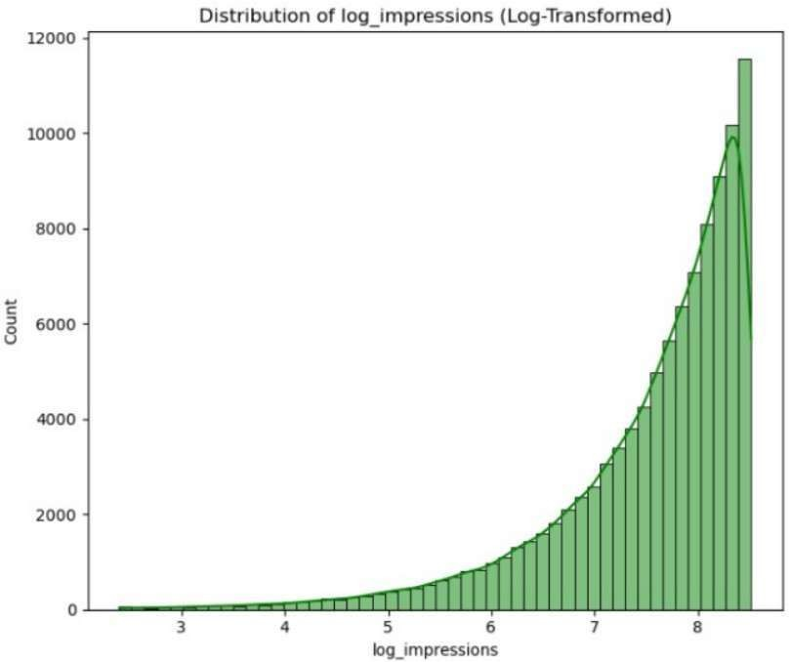
Figure 3: Distribution of Log-Transformed Impressions. Log- arithmic scaling reduces skewness in the impressions feature, producing a more stable numerical distribution suitable for distance-based and gradient-based machine learning models.

Time-of-day and day-of-week patterns are captured via temporal characteristics that are obtained from interaction timestamps [18]. Click-Through Rate is calculated as follows:
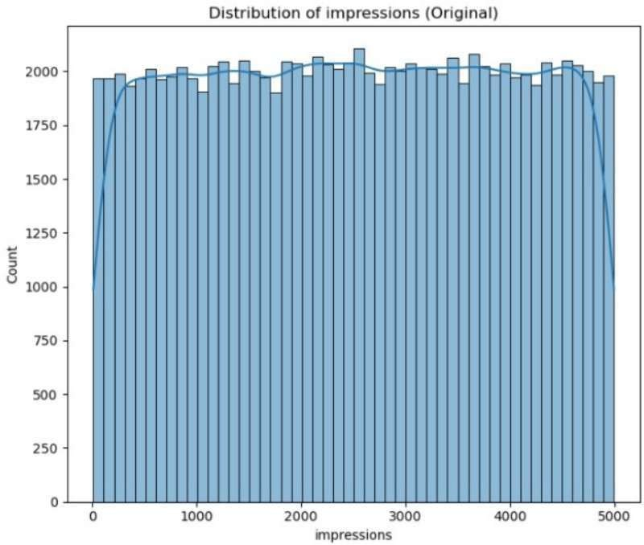
Clicks

CTR =
Impressions
(1)

Figure 2: Distribution of Advertisement Impressions (Original Scale). The histogram illustrates the raw spread of impression counts across advertising campaigns, highlighting the wide dy- namic range and motivating the need for feature transformation prior to model training.

Table I: Feature Engineering Summary
Feature construction combines TF-IDF vectors with be- havioral indicators [3], enabling balanced learning [4] and supporting future outcome estimation [17], [19].

D. Machine Learning Models
Logistic Regression estimates conversion probability using:
1
P (y = 1|x) = 1 + e−(β0 +βT x) (2)
Feature Name | Type | Description
One-Hot Encoding  Standardization TF-IDF Vectors  Engagement Duration CTR  Temporal Features Sentiment Score Interaction Score  Vector Assembly | Categorical  Numerical Sparse Vector Continuous Numerical Numerical Continuous Numerical  Composite | Binary encoding of nominal data  µ ≈ 0, σ ≈ 1  21 content dimensions User interaction time Clicks / Impressions Hour and day variables User intent signal Historical behavior  Combined feature vector
PCA Components | Numerical | Dimensionality reduction

Decision Trees minimize Gini impurity:
ΣC
Gini = 1 − p² (3)
i

i=1

Support Vector Machines optimize:
1

min
C. Data Preprocessing and Feature Construction 2
||w||2 s.t. y (w · x + b) ≥ 1 (4)
i i

One-Hot Encoding is used to modify categorical values in order to avoid ordinal assumptions [10], [15]. Standardization or min-max normalization are used to scale continuous vari- ables in order to guarantee stable convergence and uniform
K-Means clustering minimizes:
Σ^{k} Σ
SSE = ||x − µi||² (5)
i=1 x∈C

i

- Experimental Setup
- Dataset Characteristics
The experimental evaluation makes use of a sizable, high- dimensional AdTech dataset that records the whole lifecycle of user involvement across digital advertising channels. In addition to demographic data like device type and location, ad content IDs, and raw performance metrics like impres- sions and clicks, the collection includes derived behavioral characteristics like engagementduration and sentimentscore. The semantic importance of advertisement content is captured using 21 sparse TF-IDF vectors. The final processed dataset is petabyte-scale, with billions of interaction records (rows) collected over an 18-month operational period. It exhibits sig- nificant sparsity and class imbalance, with conversion events being a minority.

- Implementation Details
HDFS is employed for fault-tolerant storage in a distributed Hadoop cluster with 20 compute nodes for feature engi- neering and data preparation. The analytical pipeline is built using Apache Spark MLlib and uses in-memory distributed computation to enable iterative ensemble model training. A CrossValidator protocol is used to enhance robustness and prevent data leakage across training and validation datasets.
Hyperparameter optimization uses stratified 5-fold cross- validation with grid search over important parameters, such as the maximum tree depth for Random Forest and Gradient Boosting models, the regularization parameter for Logistic Regression, and the penalty parameter for Support Vector Ma- chines. When selecting a model, metrics suitable for scenarios with unbalanced data are prioritized.

- Evaluation Metrics
Model performance is assessed using standard classification metrics:
- Results and Discussion
- Performance Metrics
All of the supervised and unsupervised model training used Spark MLlib’s high-performance distributed features. This was very important for doing cross-validation and iterative optimization on a large scale when comparing multiple, com- plex algorithms on a dataset with more than thirty input variables[7].
The focus of performance evaluation was on metrics that were better suited for binary, imbalanced classification[16]:
The Area Under the Curve (AUC) metric tells you how effectively the model can distinguish the difference between positive (conversion) and negative (non-conversion) situations. Precision and Recall: Precision tells us how accurate pos- itive predictions are (to prevent wasting ad money on false positives), and Recall tells us how effectively the model can discover all positive occurrences (to avoid missing chances, or false negatives).
F1-Score: The F1-Score is the average of precision and recall. It is a strong single metric that makes sure that performance is balanced by punishing models for substantial disparities between precision and recall[16].

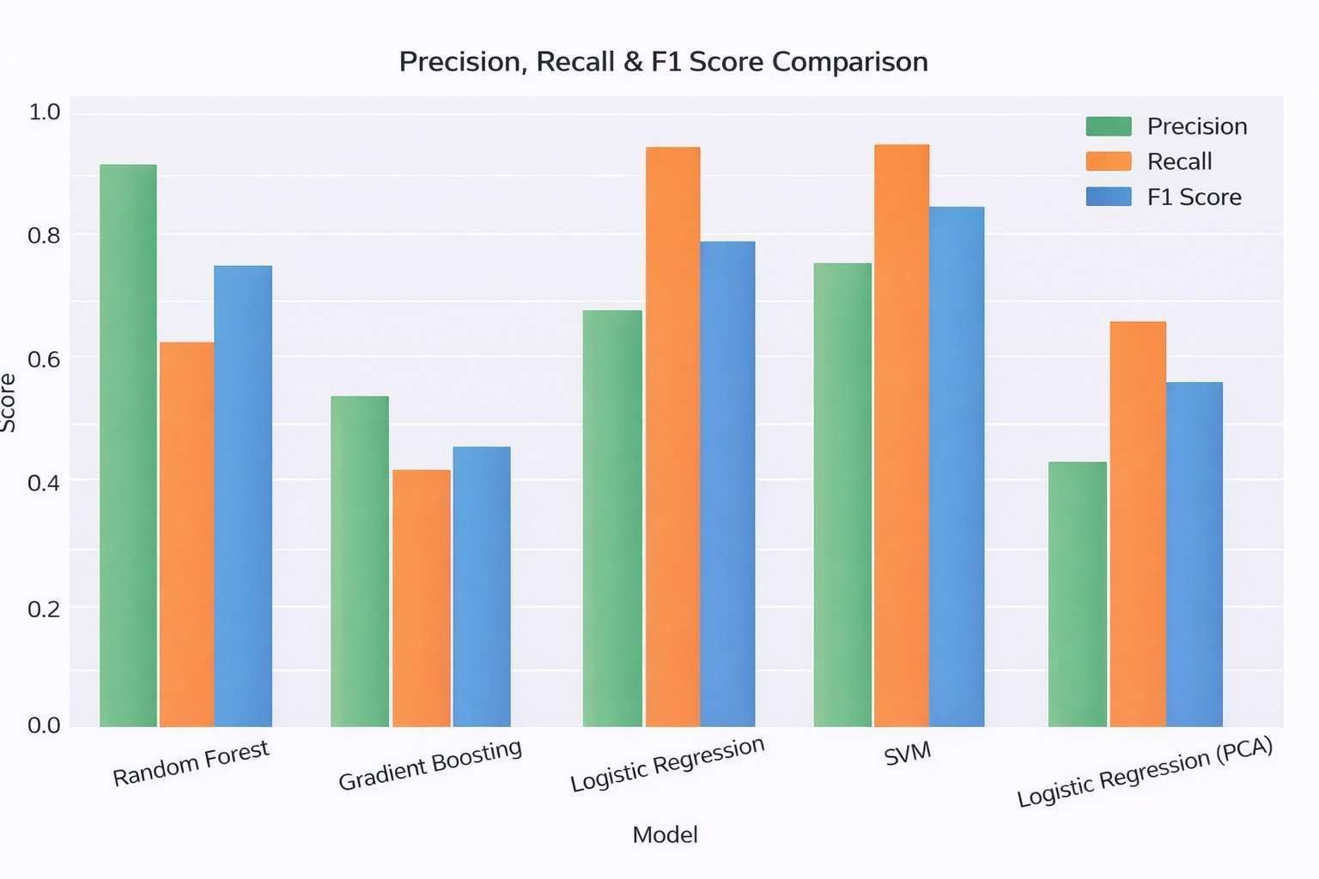
- Model Performance Comparison

TP + TN
Accuracy = (6)
TP + TN + FP + FN
TP
Figure 4: Precision, Recall, and F1-Score Comparison Across Classification Models. The figure highlights trade-offs between precision and recall across different models, with SVM and

Precision =
TP + FP
TP
Recall =
TP + FN
(7)

(8)
Logistic Regression achieving balanced recall, while Random Forest demonstrates higher precision.

Table II: Model Performance Comparison (Part I)
Model | Acc. | Prec. | Rec. | F1
Random Forest | 0.9667 | 0.9375 | 0.6250 | 0.7500
Gradient Boosting | 0.5400 | 0.5268 | 0.4097 | 0.4609
Logistic Regression | 0.9533 | 0.6818 | 1.0000 | 0.8108
SVM | 0.9700 | 0.7692 | 1.0000 | 0.8696
Logistic Reg. (PCA) | 0.7733 | 0.3647 | 0.6889 | 0.4769

F 1 =
2 × Precision × Recall Precision + Recall
∫ 1
(9)

ROC-AUC = TPR( FPR) d(FPR) (10)
0
where TP , TN , FP , and FN represent true positives, true negatives, false positives, and false negatives, respectively. Area Under the Curve and F1-score are emphasized to address class imbalance.

With the highest accuracy (0.97) and the maximum AUC value (0.9998), the comparative findings show that the Support Vector Machine performs the best overall [15]. Excellent class separation and resilience in highly unbalanced situations are

Table III: Model Performance Comparison (Part II)

Model | AUC | Spec. | LogLoss
Random Forest | 0.9905 | 0.9600 | 0.0700
Gradient Boosting | 0.5899 | 0.6050 | 0.6500
Logistic Regression | 0.9981 | 0.9481 | 0.1193
SVM | 0.9998 | 0.9700 | 0.0300
Logistic Reg. (PCA) | 0.8208 | 0.8000 | 0.4600

demonstrated by this. Although its lesser precision implies a larger likelihood of false positives, logistic regression shows 100

- Precision–Recall Trade-off Analysis

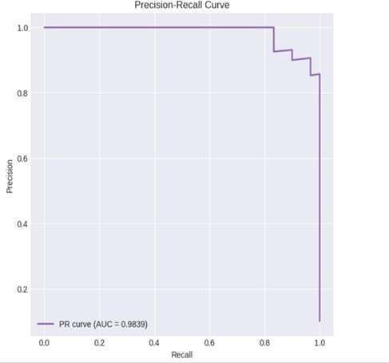
Figure 5: Precision–Recall Curve for the Support Vector Machine Classifier. The high area under the curve (AUC = 0.9839) demonstrates strong discrimination capability under class imbalance, indicating reliable detection of conversion events across varying decision thresholds.

Different models exhibit different behavioral tendencies when precision, recall, and F1-score are compared. High recall is continuously maintained via SVM and Logistic Regres- sion, guaranteeing less loss of possible conversion opportu- nities [16]. Random Forest, on the other hand, reduces need- less advertisement exposure while achieving higher precision. These trade-offs show that the best model choice relies on the goals of the campaign, whether they are cost-effectiveness or reach.

- Feature Importance and Dimensionality Effects
Reduced-dimensional components—specifically, PCA3 and PCA7—contribute most significantly to prediction out- comes, according to feature significance analysis derived from Gradient Boosting [16]. By combining behavioral signals and content relevance, these elements verify that intricate
interactions rather than discrete raw measures determine con- version likelihood. This finding is consistent with expectations in advertising analytics, where a variety of contextual and behavioral elements contribute to user intent.

- Comparative Analysis with Baseline Systems
The practical efficacy of the suggested advertising pre- diction framework was assessed by comparing it to widely utilized baseline targeting methods. Roughly 68
On the other hand, the machine learning models used in the distributed AdTech pipeline significantly increase class separation and achieve predictive accuracy close to 97%. These findings show that in high-volume, highly unbalanced advertising contexts, scalable feature processing and margin- based learning perform noticeably better than traditional meth- ods.
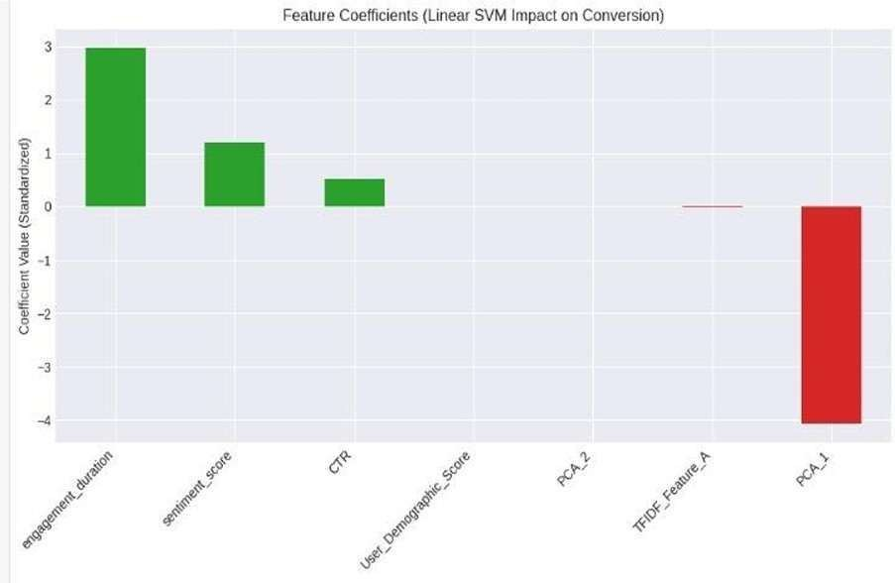
Figure 6: Feature Coefficients from Linear SVM for Conver- sion Prediction. The standardized coefficients highlight the positive influence of engagement duration, sentiment score, and CTR on conversion likelihood, while PCA1 contributes negatively, suggesting limited relevance after dimensionality reduction.

- Scalability Analysis
Scalability testing shows that as data volume and request frequency rise, the suggested system continues to operate con- sistently. With no discernible latency degradation, the Apache Spark-based architecture grows effectively across massive im- pression databases, enabling real-time inference for millions of advertising events every day.
High-throughput prediction appropriate for real-time bid- ding and personalization workflows is made possible by dis- tributed model execution. These results demonstrate that the suggested method can handle large-scale AdTech deployments where high dependability and low latency are crucial.

- Conclusion
- Interpretation of Predictive Results and Scalability
The experiments conducted with Apache Spark MLlib demonstrate that the simultaneous use of machine learning on computers is highly advantageous for large-scale AdTech

analytics projects. Logistic regression and other simple mod- els are still useful because they are simple to comprehend. Techniques that combine many models are more effective at making predictions. Because Gradient Boosting Machines can handle complex and difficult situations, they consistently performed better at predicting user behavior. This is due to the fact that Gradient Boosting Machines are able to recognize the connections between many elements, such as people’s characteristics, behaviors, and the content they view. This is where gradient boosting machines excel.
The thing about Spark is that it repeatedly performs tasks in memory. Because of this, it performs exceptionally well when training and comparing algorithms like Random Forest and GBM that require a lot of processing power.
Spark is really good for this.
This shows that we need a system that can handle a lot of work and has computers working together to deal with big sets of features and data that is not balanced in real world advertising. We are talking about Spark here. Spark is important, for this.

- Marketing Implications and Future Scope
The increased significance of behavioral signals like engage- ment length and sentiment score over raw interaction numbers is highlighted by feature importance analysis. The framework facilitates tailored campaign strategies and increased return on investment when used with K-Means segmentation. To combat idea drift and changing user behavior, future research should investigate real-time streaming analytics, multimodal content features, and adaptive retraining techniques.

References
- B. S. Arasu and A. Mukherjee, “A machine learning-based approach to enhancing social media marketing campaign performance,” Jour- nal of Business Analytics, vol. 5, no. 3, pp. 150–162, 2020, doi: 10.1016/j.jbana.2020.03.001.
- R. Santhiya, “The impact of social media marketing and machine learning applications in digital advertising,” Journal of Philanthropy and Marketing, vol. 3, no. 2, pp. 112–129, 2024, doi: 10.1108/JPM-2024-
0201.
- A. Mukherjee, “Emotional appeals as drivers of social media and advertising engagement in real-world marketplaces: Using AI to code variables in consumer research,” SSRN Electronic Journal, Article 5153265, 2025, doi: 10.2139/ssrn.5153265.
- A. Musunuri, “An AI and machine learning approach to precision targeting in social media advertising,” International Journal of Recent Advances in Science, Engineering and Technology, vol. 12, no. 4, pp. 55– 68, 2025, doi: 10.1109/IJRASET.2025.3312.
- T. Saheb and U. Sivarajah, “Convergence of artificial intelligence with social media,” Procedia Computer Science, vol. 241, pp. 990–997, 2024, doi: 10.1016/j.procs.2024.07.125.
- U. Sivarajah and T. Saheb, “A study on big data analytics and innova- tion,” Technological Forecasting and Social Change, vol. 195, Article 1240, 2024, doi: 10.1016/j.techfore.2024.1240.
- M. T. Huynh and B. S. Arasu, “Big data analytics capabilities: Patchwork or progress? A systematic literature review,” Technological Forecasting and Social Change, vol. 181, Article 5693, 2023, doi: 10.1016/j.techfore.2023.5693.
- B. S. Arasu and A. Mukherjee, “Social media data analytics using ma- chine learning tools for marketing,” Communications and Mobile Com- puting, vol. 8, Article ID 8939494, 2020, doi: 10.1155/2020/8939494.
- Zenodo, “Predicting success: The impact of machine learning on social media ad classification,” Zenodo Preprints, Article 8214337, 2024, doi: 10.5281/zenodo.8214337.
- B. Al Kurdi, “Machine learning applications in social media marketing,”
Proceedings of the IEEE, Article 10532873, 2024.
- S. Debnath et al., “The role of machine learning in social media marketing,” Kuey, vol. 30, no. 6, pp. 5889–5912, 2024.
- J. Gastmann, “Strategising with generative AI: Productivity gains in social media marketing,” Journal of Marketing Communications, vol. 31, no. 2, pp. 100–121, 2025.
- B. Gao, “Artificial intelligence in advertising,” SAGE Open, Article 21582440231210759, 2023.
- E. Labib, “Artificial intelligence in marketing: Exploring current and future trends,” Cogent Business & Management, Article 23311975, 2024.
- T. K. Balaji, “Machine learning algorithms for social media analysis,”
Data & Knowledge Engineering, vol. 137, pp. 1018–1043, 2021.
- H. Beyari, “The role of artificial intelligence in personalizing social media marketing strategies,” PMC, Article 12109579, 2025.
- J. Ford, “AI advertising: An overview and guidelines,” Journal of Business Research, Article S0148296323004836, 2023.
- A. Haleem, “Artificial intelligence (AI) applications for marketing,”
Journal of Marketing Science, Article S2666603022000136, 2022.
- J. Kaur and H. Dhillon, “Igniting the power of social media analytics for business development and growth,” International Journal of Data Science and Marketing, 2025.

