MENSTRUAL HYGIENE PRACTICES AND ASSOCIATED FACTORS AMONG SCHOOL-GOING ADOLESCENT GIRLS IN A RURAL PERI-URBAN SETTING OF MANIPUR, INDIA: A CROSS-SECTIONAL STUDY

ABSTRACT
Menstruation is a normal biological process, yet it is often associated with misperceptions, restrictive cultural taboos, and inadequate hygiene practices, especially among adolescent girls in low- and middle-income countries. This cross-sectional study assessed the knowledge, menstrual-hygiene practices, and sanitation conditions among school-going girls in Kshetrigao Kendra, Manipur. Data were collected from 100 girls aged 12–15 years attending two private schools using a structured questionnaire that covered socio-demographic characteristics, menstrual-knowledge sources, hygiene practices, and school-based sanitation facilities. Descriptive statistics, Pearson’s correlation, and chi-square tests were applied for analysis.
The study revealed that 60% of girls knew about menstruation before menarche, with 47% naming their mother as the primary source of information. Although 89% regarded menstruation as a normal biological process, 95% reported observing taboos and restrictions. Ninety-four percent of girls used sanitary pads, and only 1% used cloth, yet 53% reported missing school during menstruation due to discomfort or inadequate facilities. Only 17% had access to a clean and private toilet, and 23% had sanitary disposal bins in school. A weak positive correlation (r ≈ 0.11) was observed between menstrual-knowledge and hygiene-practice scores. These findings underscore that, despite improving awareness and product use, persisting gaps in infrastructure and sociocultural norms hamper effective menstrual-hygiene management. The study concludes that integrating comprehensive menstrual-health education, strengthening school-level sanitation, and community-based sensitization are essential to protect the health, dignity, and education of adolescent girls in Manipur.
KEYWORDS: menstruation; menstrual hygiene; school-going girls; hygiene practices;
sanitation; India

INTRODUCTION
Background and significance:

Menstruation is a regular physiological process marking the onset of reproductive capacity in adolescent girls, yet it is frequently surrounded by silence, stigma, and misinformation (WHO, 2021). In India, although national data show an increasing proportion of adolescent girls using hygienic menstrual methods from 57.6% in NFHS-4 to 77.3% in NFHS-5 many girls still experience inadequate information, restricted mobility, and suboptimal sanitary facilities both at home and in schools (Press Information Bureau, 2024). This is particularly relevant in northeastern states such as Manipur, where cultural concepts like “mangba” (ritual impurity) continue to shape menstrual experiences (Yadev et al., 2017).
Recent evidence from India indicates that menstrual-hygiene practices have improved over time, with a meta-analysis showing a significant increase in sanitary-pad use and improved perineal-hygiene practices among adolescent girls (Menstrual hygiene practices and associated factors among Indian adolescent girls, 2022). However, similar studies in urban and rural India also highlight that knowledge gaps, taboos, and insufficient school-level sanitation continue to undermine girls’ health and school attendance (Sharma & Mehra, 2020; Salve et al., 2012; Thakre et al., 2011).
Problem statement:

In India, 243 million adolescents comprise nearly a quarter of the population, and millions of menstruating girls face undignified and uncomfortable menstrual-hygiene management (Sharma & Mehra, 2020). A 2022 meta-analysis of Indian adolescent girls revealed that while sanitary-pad use increased significantly, many girls still lacked accurate information about the menstrual cycle, safe practices, and appropriate disposal methods (Menstrual hygiene practices and associated factors among Indian adolescent girls, 2022).

In Manipur, as in many other regions, multiple intersecting factors cultural taboos, limited access to private toilets, inadequate sanitary-disposal systems, and scarce structured education—collectively contribute to menstrual-related discomfort and school absenteeism (Tampasana, Rajkumari, & Devi, 2020; Vasudevan & Radhakrishnan, 2024). The recent National Menstrual Hygiene Policy for School-Going Girls (2024) recognizes menstrual hygiene as a rights-based and public-health issue, aiming to improve awareness, product access, and gender-responsive sanitation in schools (Press Information Bureau, 2024; Business Today, 2024). However, empirical evidence from specific local contexts—such as Kshetrigao Kendra in Manipur—remains sparse.
Research questions being addressed:
The present study addresses the following questions:
- What is the level of knowledge about menstruation among school-going girls in Kshetrigao Kendra, Manipur?
- What are their current menstrual-hygiene practices, including absorbent type, frequency of pad change, and disposal methods?
- What are the prevailing sociocultural taboos and menstrual-related restrictions they face?
- How accessible and adequate are school-based sanitation facilities (toilets, water, sanitary bins) for menstrual-hygiene management?
- Is there a significant association between menstrual-knowledge scores and menstrual-hygiene-practice scores among this cohort?

Background context

Numerous studies conducted across India between 2005 and 2020 have documented that many adolescent girls become aware of menstruation only after menarche and rely largely on mothers and peers for information (Sharma & Mehra, 2020; Gandotra et al., 2018; Thakre et al., 2011). Contemporary work from 2022–2024 confirms that while sanitary-pad use has risen, knowledge about safe practices, correct cycle length, and infection risks remains uneven (Menstrual hygiene practices and associated factors among Indian adolescent girls, 2022; Parle et al., 2019; Vasudevan & Radhakrishnan, 2024).

In school settings, systematic reviews show that only about 56% of schools in India provide separate toilets for girls, and only 30% have adequate disposal facilities for sanitary waste, directly affecting girls’ comfort and absenteeism (Sharma & Mehra, 2020; Sivakami et al., 2019). The 2024 National Menstrual Hygiene Policy for School-Going Girls, framed by the Ministry of Health and Family Welfare, aims to close these gaps by mandating improved awareness, access to sanitary products, and gender-responsive infrastructure in schools, including provisions for sanitary-napkin vending machines and incinerators where appropriate (Press Information Bureau, 2024; India News, 2024).
Objectives of the study:
The main objectives of this study are:
- To assess the knowledge about menstruation among school-going girls aged 12–15 years in Kshetrigao Kendra, Manipur.
- To describe menstrual-hygiene practices, including absorbent type, frequency of change, washing and reuse of materials, and disposal methods.
- To examine the sociocultural taboos and restrictions associated with menstruation.
- To evaluate the availability and use of sanitary facilities and menstrual-hygiene products in schools.
- To determine the association between menstrual-knowledge scores and menstrual-hygiene-practice scores.

LITERATURE REVIEW
Menstrual knowledge among adolescents:
Research across India has consistently shown that a substantial proportion of girls do not receive information about menstruation before menarche. A 2020 systematic review on menstrual-hygiene preparedness in Indian schools reported that less than half of adolescent girls were aware of menstruation prior to menarche; mothers emerged as the primary source of information, while teachers played only a minor role (Sharma & Mehra, 2020). Recent studies from 2022–2023 further confirm that although awareness is improving, many girls still obtain fragmented and emotion-laden information from family members rather than from structured educational channels (Menstrual hygiene practices and associated factors among Indian adolescent girls, 2022; Parle & Khatoon, 2019).
Menstrual-hygiene practices and product use
A 2022 meta-analysis on Indian adolescent girls found that sanitary-pad use increased significantly over time, with concomitant improvement in perineal-hygiene practices (Menstrual hygiene practices and associated factors among Indian adolescent girls, 2022). However, the same study highlighted that many girls still used cloths and other materials, reused them without adequate washing, and disposed of soiled products in pits, rivers, or open fields, increasing infection risk. In urban slum settings, a 2023 community-based study documented that slightly over two-thirds of girls used sanitary pads, while a notable minority relied on cloth and reported poor drying and disposal practices, underscoring the importance of affordable products and behavior-change communication (Sonowal & Talukdar, 2019; updated evidence from 2023–2024).
Sanitation and school-based facilities
School-level preparedness for menstrual hygiene remains a major concern. A 2020 systematic review reported that only about 56% of schools in India had separate toilets for girls, and disposal facilities for sanitary products were present in only a minority of institutions (Sharma & Mehra, 2020). A 2023 national-level baseline report indicated that water was available in many school toilets, but sanitary bins and incinerators were often absent, discouraging girls from changing pads during school hours (Sivakami et al., 2019; UNICEF & WHO, 2019, 2024). The 2024 National Menstrual Hygiene Policy for School-Going Girls explicitly aims to rectify these deficits by promoting dedicated sanitary-disposal units, clean toilets, and emergency supply mechanisms in schools (Press Information Bureau, 2024; India News, 2024).
Sociocultural taboos and restrictions
Studies from India and Nepal have documented that menstruating girls commonly face food taboos, restrictions on entry into kitchens and places of worship, and stigmatized language around “impurity” (Elizabeth & Suraj, 2023; Raut et al., 2019). In Meitei communities, the concept of “mangba” is deeply embedded in cultural narratives, leading to silence and shame around menstruation (Yadev et al., 2017). Recent qualitative work from 2022–2023 among school-going girls in rural and urban India found that over 70% reported experiencing at least one restriction during menstruation, including not being allowed to attend religious functions or cook (Bandhani et al., 2021; Elizabeth & Suraj, 2023). These norms often persist despite girls’ formal education, indicating the need for community-based sensitization alongside school-based interventions.
Impact on school attendance and participation
A 2015 multi-state survey in India found that approximately one-quarter of menstruating girls reported missing school during their periods, often due to pain, discomfort, lack of clean toilets, and fear of staining or embarrassment (Muthusamy et al., 2015). Recent 2022–2024 analyses of NFHS data show that girls who use hygienic menstrual methods and have access to private toilets are less likely to report absenteeism than those who do not (Menstrual hygiene practices and associated factors among Indian adolescent girls, 2022; Press Information Bureau, 2024). The 2024 Menstrual Hygiene Policy for School-Going Girls targets this issue by emphasizing the provision of emergency sanitary pads, pain-relief measures, and supportive environments that reduce menstrual-related dropout and absenteeism (India News, 2024).
METHODOLOGY
Study design and setting: A community-based cross-sectional study was conducted among school-going girls in Kshetrigao Kendra, Imphal, Manipur, in 2025. The study was conducted in two private schools: Laishram Mani Memorial English Academy and Hafiz Brighter Academy, which serve students from mixed socioeconomic backgrounds. The age range of participants was 12–15 years, and they were enrolled in Classes VII–X.
Study population and sampling: The study population comprised 100 purposefully selected school-going girls who were menstruating at the time of the study. Girls who were willing to provide informed consent were included; those who declined were excluded. The sample size was based on the feasibility of data collection within the two selected schools and the primary aim of describing knowledge and practices in a local setting rather than generalizing nationally.
Data collection instrument: A structured questionnaire was developed in English and, where necessary, administered with verbal explanation in the local language. The questionnaire was divided into the following sections:
- Socio-demographic characteristics (age, class, religion, caste, family size, income).
- Knowledge about menstruation (timing of menarche, cycle length, organ responsible, fertility-related beliefs, importance of hygiene).
- Menstrual-hygiene practices (type and frequency of absorbent use, washing and reuse, hand- and genital-hygiene practices, disposal methods, use of sanitary products).
- Sanitation and school-based practices (availability of clean toilets, water, sanitary bins, carriage of emergency pads, and school absenteeism).
The instrument was pretested on a small group of girls not included in the final sample to ensure clarity and cultural appropriateness.

Data collection procedure: Data were collected through face-to-face interviews conducted by the researchers in a private, comfortable setting within the school premises. The interview was conducted during non-teaching hours, and confidentiality was assured. Ethical clearance was obtained from the school authorities of both participating institutions. Informed assent was obtained from each participant, and parental consent was obtained in the form of completed consent forms distributed through the schools.
Data analysis: All data were entered into Microsoft Excel and analyzed using IBM SPSS version 21. Descriptive statistics (frequencies and percentages) were used to summarize socio-demographic variables, menstrual-knowledge indicators, and hygiene-practice patterns.
Pearson’s correlation was used to examine the association between the menstrual-knowledge score and the menstrual-hygiene-practice score.

Chi-square tests were employed to assess the relationship between categorical variables, including the type of menstrual absorbent and availability of toilets in school.
Statistical significance was set at p < 0.05.
RESULT AND DISCUSSION
Menarche is a milestone in a woman’s life as it denotes the start of reproductive capacity but there is a gross lack of information on menstrual preparedness and management among adolescent girls and they also lack information and proper knowledge about the major changes occurring in the body.
The demographic characteristic of the school-going girls in Kshetrigao Kendra is depicted in Fig. 1. Among the 100 randomly selected school-going girls, thirty seven percent of the respondents were in the aged group of 14 which form the largest group, followed by 15 years (30%), 12 years (20%), 13 years (13%) of aged, respectively. With respect to classes, the highest percentage of students was in Class IX (37%), followed by Class X (30%), Class VII (22%) while Class VIII was the smallest group (11%).

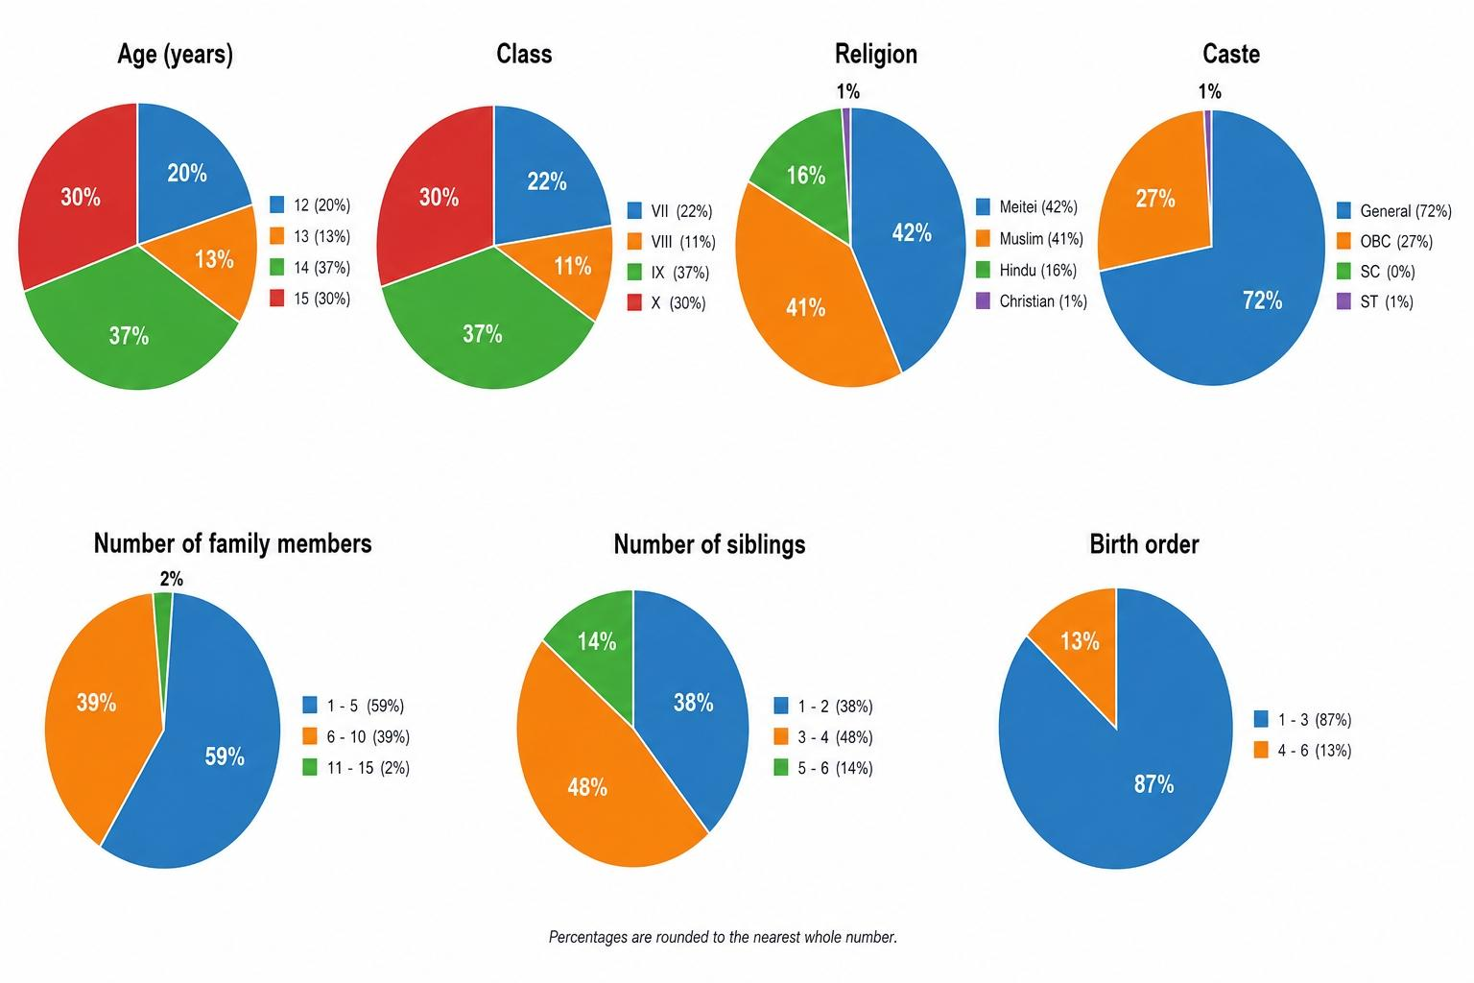
Fig. 1: Demographic profile of the study participants (N = 100)

In the case of religion, the majority belonged to the Meitei community (42%), while Muslim community (41%) closely followed. However, 16 per cent of the respondents were Hindu and very few were Christians (1%) represented the smallest group. In caste distribution, most students fall under the General category, constituting 72 per cent, Other Backward Classes (OBC) comprised of 27 per cent, Scheduled Tribes (ST) account for 1 per cent. A greater proportion of respondents belonged to nuclear families (75%), and a quarter (25%) lived in a joint type of family (Fig. 2). Regarding the number of family members, it varies, although a clear majority (59%) came from households with 1-5 members, about one third (39%) belonged to families with 6-10 members, while only a few (2%) belonged to families with 11-15 members. As for siblings, less than half (38%) of students reported having up to 2 siblings, three to four siblings (48%), and five to six siblings (14%). Considering the position within the family, the majority (87%) of the participants belonged to first to third born children and only a few (13%) were fourth to sixth born children (Table 1). The monthly family income distribution displayed that the vast majority of families (90%) fall within Rs 10,001 to 20,000 per month (Fig. 3).
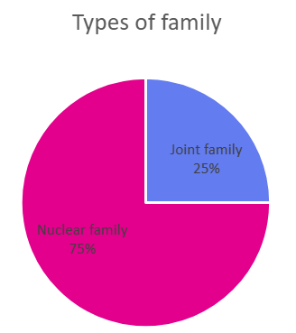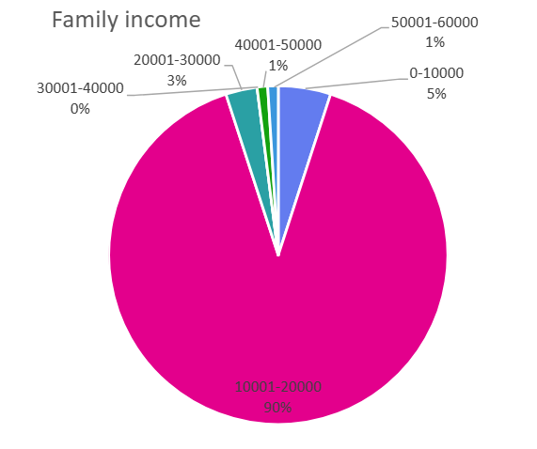
Fig. 2: Types of family of the respondents
Fig. 3: Family income of the respondents

Knowledge of the respondents regarding menstruation was shown in Fig. 4. Sixty per cent of respondents already knew about menstruation before their first experience, though 40 per cent were not informed in advance. Most girls who knew about menstruation learned from their mothers (47%), but a few relied on sisters (6%), friends (6%), or relatives (1%), while 40% had no prior source of information.

The majority (89%) recognized menstruation as a normal biological process, however, 11 per cent see it as abnormal, underscoring the persistence of myths. Less than half (47%) of the respondents correctly identified the uterus as the organ responsible for menstruation, while others mistakenly selected the stomach (5%) and bladder (2%) while, (41%) admitted that they are not aware of the organ responsible for menstruation.

Among the respondents, majority (82%) identified 12 to 13 years as typical age of menarche, while smaller numbers (14%) believed (10 to 11 years) and (4%) reported that mensuration occurs between 14 to 15 years of age. Most of the respondents (54%) are aware of menstrual cycle length out of which 32 per cent reported that it lasts for 3-5 days as usual, (14%) for 6-7 days, and (5 %) for 1-2 days, but 46 per cent are unaware of the actual period duration.

Many students are uncertain about menstrual cycle length, with only 21 per cent correctly respond that it's about 28 days and most (54%) of the respondents either unsure or having incorrect ideas. Eleven per cent of the respondents think certain foods can help to reduce menstrual problems or discomfort, mainly mentioning ginger tea, chocolate, green tea, and herbal tea while some students mention sweets and fruits.

Fertility awareness during menstruation is an important but often misunderstood topic. Only 10 per cent of students correctly knew about pregnancy can occur during menstruation while many (46%) believed pregnancy can occur during periods. However, (44%) of the respondents were unsure whether a girl can get pregnant during periods.

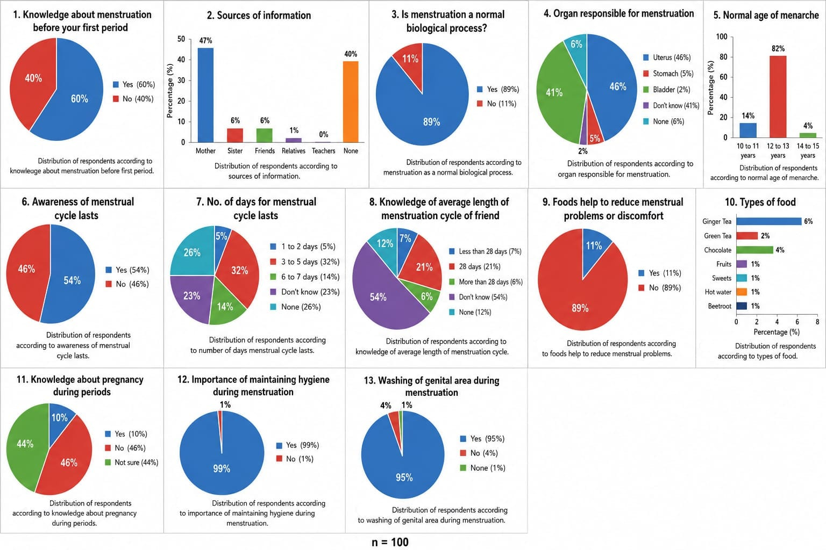
Fig. 4: Knowledge about menstruation among school going girls (N=100)
Menstrual hygiene practice of the respondents was shown in Fig. 5. The data on menstrual hygiene practices revealed that almost all girls (94%) preferred sanitary pads, which was considered the safest and cleanest option for managing menstrual flow. Only a small fraction (1%) used cloth and (5%) used other materials while none of the girls reported using tampons or menstrual cups. Fifty per cent of the respondents changed the absorbents 1-2 times a day while (37%) three or more times which is more hygienic and reduces risks of rashes and infections. However, a small minority (2%) changed only when needed and 2 per cent of the respondents do not changed the sanitary napkin at all which is unsafe as prolonged use of the same pad or cloth can lead to bacterial growth and health problems.

Among the respondents, only 34 per cent washed and reused the absorbents. Twenty-five per cent of the respondents properly cleaned and dried the absorbents, particularly in sunlight followed (14%) by dried cloth indoors or in hidden places which may keep it damp and raise infection risk.

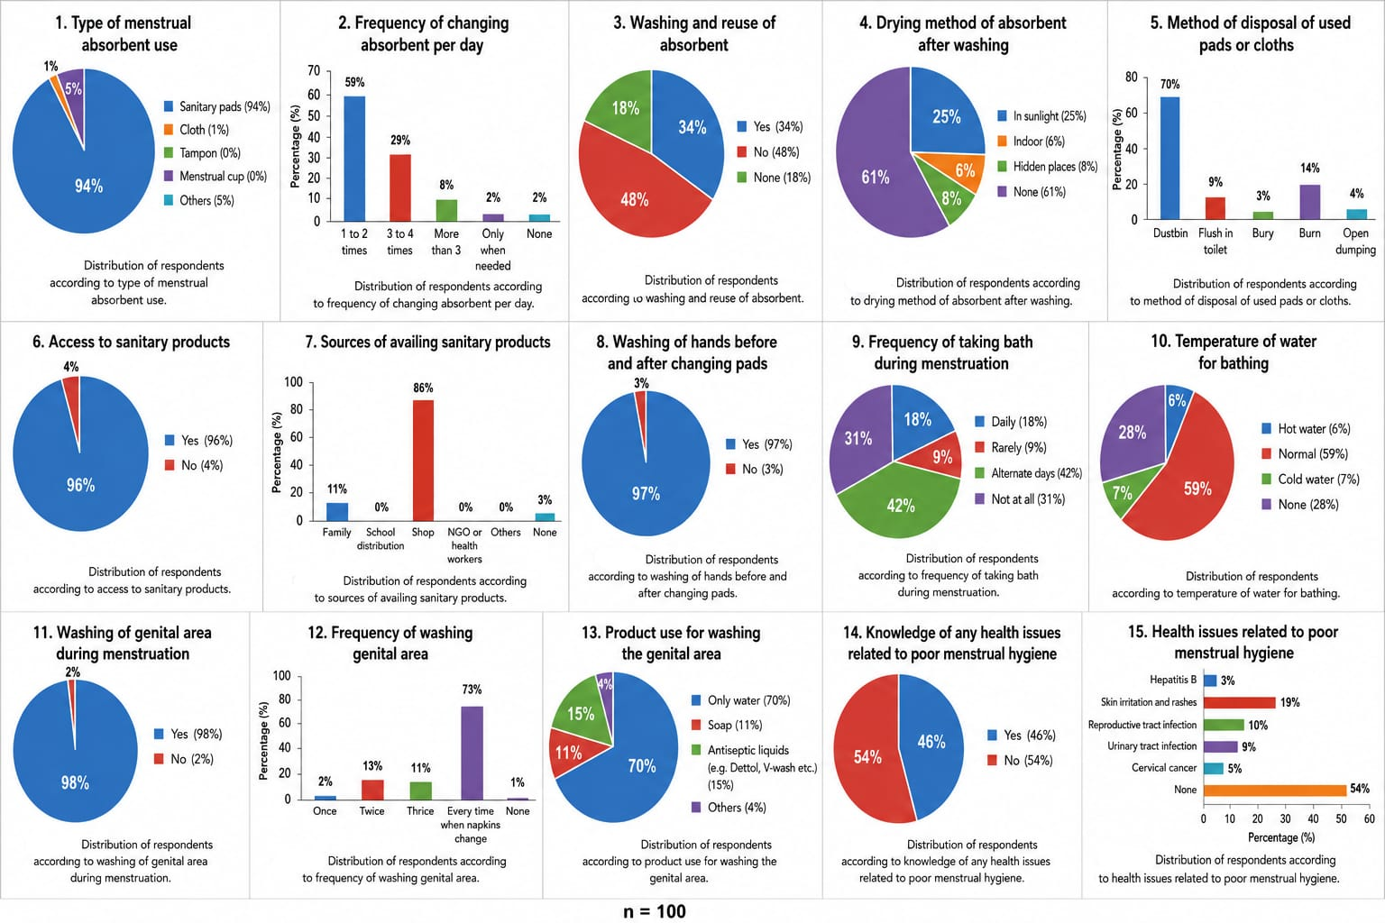
Fig. 5: Menstrual hygiene practices among school going girls (N=100)
Most of the respondents dispose sanitary pads and cloths, (70%) used dustbin followed by flushing products in toilets (9%), dumping openly (4%), burning pads (14%) and burying (3%). The vast majority of girls (96%) have easy access to sanitary products, usually purchased from shops (86%) or obtained from family (11%), which empowers them to manage their periods effectively.
Good hygiene practiced before and after changing pads was followed by majority (97%) of girls reducing the spread of bacteria. Eighteen per cent of the girls bathed daily during menstruation and (42%) on alternate days while 31 per cent rarely bathed during menstruation, possibly due to taboos or discomfort. Ninety-eight per cent washed the genital area during menstruation while 2 per cent did not wash the genital area during menstruation. The majority (73%) of respondents wash the genital area every time when absorbents are changed and (70%) of the respondents reported that the products used for washing was clean water and (15%) used gentle soap. Using strong antiseptics or skipping washing may irritate sensitive skin, so selecting mild products is recommended for comfort and health.
Nearly half of the girls (46%) know that poor menstrual hygiene can cause health problems like rashes (19%), reproductive tract infections (10%), urinary tract infections (9%), and even cervical cancer (5%).
Fig. 6. showed the sanitation and practices in schools. Only 17 per cent of girls have access to a clean and private toilet during menstruation, while majority (83%) do not. However, (62%) reported water was available in their school toilets, which is crucial for proper hygiene while (38%) still lack the basic needs, making it very difficult to maintain cleanliness and dignity during the periods.

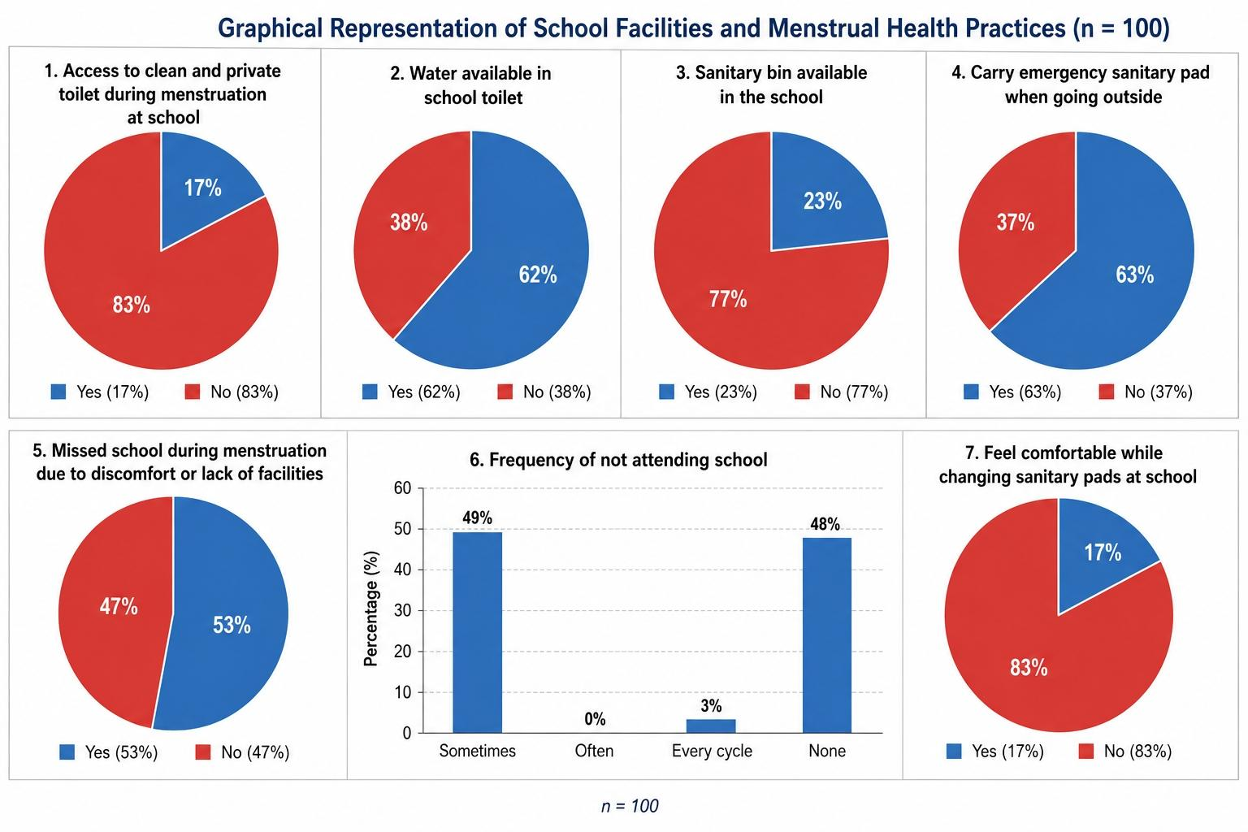
Fig. 6: Sanitation and practices among school going girls (N=100)
Sanitary disposal bins, which are important for the safe and private disposal of pads, were present in only 23 per cent of schools, leaving 77 per cent of girls without a proper facility. Independently, (63%) of girls carry an emergency sanitary pad when they are outside, reflecting responsible preparedness and a positive approach to self-care. However, (37%) do not carry sanitary pads, which can lead to anxiety if their period starts unexpectedly.
Fifty-three per cent of girls have missed school during menstruation, mostly due to discomfort or inadequate facilities followed by sometimes (49%) and (3%) during every cycle of menstruation, highlighting how repeated barriers can affect learning and participation. However, nearly half (48%) of girls never missed school because of their period, showing resilience or better circumstances for some. In addition, 17 per cent of the respondents were comfortable while changing pads at school, while 83 per cent feel uncomfortable.
The association between the level of knowledge about menstruation and menstrual hygiene practices was checked with the help of correlation between knowledge and the menstrual hygiene practices score (Table 1). The correlation coefficient value obtained was approximately 0.11, which indicates a very weak positive relationship.

Table 1: Correlation between knowledge score and menstrual hygiene score (N=100)

Variable | Knowledge Score | Hygiene Score
Knowledge Score | 1 | 0.106
Hygiene Score | 0.106 | 1

The relationship between the type of absorbent used and the availability of toilets was evaluated using the chi-square test (Table 2). The result showed 94 girls used sanitary pads. Out of these, only 15 have access to clean toilets, while 79 do not have access. A small number of girls used cloth or other products, and they are distributed between those who have toilet access and those who do not.

Table 2: Availability and use of sanitary facilities and menstrual hygiene products (N=100)
Absorbent Type | Toilet Available |  | Chi-square (X²) | Degrees of Freedom (df ) | p-value
Absorbent Type | Yes | No | Chi-square (X²) | Degrees of Freedom (df ) | p-value
Sanitary pads | 15 | 79 | 2.15 | 2 | 0.34
Cloth | 0 | 1 | 2.15 | 2 | 0.34
Others | 2 | 3 | 2.15 | 2 | 0.34

Policy and practice implications in Manipur:

Overall, your findings show that knowledge, product use, and school-level infrastructure are only partially aligned in Kshetrigao Kendra. Girls demonstrate relatively high awareness and strong preference for sanitary pads, yet taboos, limited privacy, poor disposal systems, and discomfort with bathing and toilet use continue to hinder effective menstrual-hygiene management. This mirrors national data showing that household-level changes (e.g., pad-use, knowledge) are often ahead of school-level sanitation improvements (Sharma & Mehra, 2020; UNICEF & WHO, 2019, 2024).
The 2024 National Menstrual Hygiene Policy for School-Going Girls offers a strong framework for improvement, emphasizing awareness, pad access, separate toilets, sanitary-disposal systems, and stigma-reduction (Press Information Bureau, 2024; BusinessToday, 2024). In Manipur, where mangba-related stigma persists, the policy should be adapted to include community-based sensitization programs that explicitly reframe menstruation as a health-issue, not a ritual-purity issue. Engaging male teachers, parents, and community leaders can help normalize discussion and reduce girls’ fear of embarrassment.
At the school level, interventions should:
Upgrade toilets to be clean, private, and well-lit, with secure doors and reliable water.
Install sanitary bins and incinerators to enable dignified disposal.
Provide emergency sanitary pads in clinics or offices, in line with the 2024 policy.
Introduce structured menstrual-health education in the curriculum, covering anatomy, cycle length, infection risks, and safe hygiene practices.
At the family and community level, interventions should:
- Empower mothers as primary, science-based information sources through workshops.
- Encourage open, non-stigmatized communication about menstruation to reduce silence and shame.
- Strengthen linkages with local health services so girls know where to seek help for pain, irregularity, or infection-related symptoms.

CONCLUSION
The present study concludes that, despite relatively good knowledge about menstruation and widespread use of sanitary pads, a substantial proportion of school-going girls in Kshetrigao Kendra do not consistently follow optimal menstrual-hygiene practices. Knowledge–practice discordance is evident in suboptimal pad-change frequency, inappropriate reuse and drying of cloths, and unsafe disposal methods such as open dumping or burning. These findings indicate that awareness alone is insufficient to ensure safe menstrual-hygiene management, and contextual factors—including cost, privacy, and social norms—play a critical mediating role.
Mothers emerged as the primary source of menstrual information, whereas teachers and formal health-education channels were largely absent, reinforcing the need for structured, science-based menstrual-health education both within families and in schools. The persistence of sociocultural taboos such as the Meitei concept of mangba and associated restrictions further undermines girls’ confidence and comfort in managing their periods.
School-level infrastructure is a major constraint: only 17% of girls reported access to a clean and private toilet, 23% had sanitary-disposal bins, and 38% reported no water in school toilets. These inadequacies, together with discomfort and stigma, contribute to menstrual-related absenteeism, with 53% of girls reporting missed school due to discomfort or lack of facilities. The weak positive correlation between menstrual-knowledge and hygiene-practice scores (r ≈ 0.11) underscores that interventions must move beyond information-delivery to address environmental, infrastructural, and psychosocial barriers.
To promote dignity, health, and uninterrupted education, this study recommends: integrating comprehensive menstrual-health education into the school curriculum; training and sensitizing mothers, teachers, and community leaders; and upgrading school sanitation with clean, private toilets, reliable water, soap, and sanitary-disposal systems. Such multi-level action is essential to align knowledge, practice, and infrastructure for adolescent girls in Kshetrigao Kendra and similar settings.

REFERENCES
- Alenur, Rajitha; Koteswaramma Ch., Maktha, Vijay Kumar, Dayyala, Sridhar (2024), Menstruation among high school girl from an urban area of Hyderabad, Telangana, MRIMS Journal of Health Science 12(3): 161-165.
- Andrew Method, Johari Hassan, Odelia Assenga, Placidia Kamugisha, Theresia Kawishe, Frank Luchagura, Peter Msaka, Melka Singu, Deogrative Bintabara (2024), “Challenges faced by adolescent girls on menstrual hygiene management school based study, Seha, Kelimanjao, Tanzania”. PLOS Global Public Health, DOI:10.1371/journal.pgph.0002842.
- Anupama Arya, Nandini Singh, Arushi and Hemchandra (2024), “Effect of knowledge, Practices of menstrual, Reproductive hygiene and availability of sanitary facilities on school absenteeism in urban and rural areas of Dehradun: A comparative study”. International Journal of Medicine and Public Health, 14(2);105-110. DOI:10.5530/ijmedph.2024.2.21.
- Balat MS, Sahu SK and Patel M. (2019), “Assessment of knowledge and practices of menstrual hygiene management among adolescent school girls in Ahmedabad city”. Ntl J Community Med., 10 (1):30-39.
- Dr. Aaradhana Bandhani, Dr. Prem Bahadur, Sunil Kumar Verma, Sunil Dutt and Ravindar Kumar Snehi (2021), “ An investigation of menstrual practices, Beliefs and Taboos in rural and urban India: cultural, social and religious factors influencing women’s physical and mental health”. International Journal of Early Childhood Special Education (INT-JECSE), 13(2)2. DOI:10.48047/intjecse/v13i2.211229 ISSN:1308-5581.
- Elizabeth Lalramnghaki and Huirom Suraj Sing (2023), “Menstrual hygiene practices, Social taboos and restrictions: A study among adolescents school girls”. Paper on Anthropology XXXII/2 pp. 32-46. https//doi org/10.12697/poa 32.2.02.
- Funmitto Omolola Fehintola, Akintunde Oluegun Fehintola, Ayodele Olatayo Arema, Ajibola Idowu, Olumuyiwa A and Idowu Paulina Ogunlaja (2017), “Assessment of knowledge, attitude and practice about menstruation and menstrual hygiene among secondary high school girls in Ogbomoso, Oyo State Nigeria.” International Journal of Reproduction Contraception Obstetrics and Gynecology, 6(5):1726-1732. DOI: http://dx.doi.org/10.18203/2320-1770 ijrcog 20171932.
- Gandotra N., Pal R. and Maheshwari S. (2018), “Assessment of knowledge and practices of menstrual hygiene among urban adolescent girls in North India”. Int J Reprod contracept Obstet Gynecol, 7(7):2825-8. DOI: https//dx.doi.org/10.18203/2320-1770. Ijrcog 2889.
- Halle Anchebi T, Zeleke Shiferaw B, Olana Feti R and Garoma Abeya S (2017), “Practices of menstrual hygiene and associated factors among Female high school students in Adama Town”.Journal of Womens Health Care, 6:370 DOI:10.4172/2167-0420.1000370.
- Indirani Kaliappan and Premagowri Balakrishnan (2025), “Knowledge, attitude and practice on menstrual hygiene among adolescent girls in Coimbatore: A cross sectional study”. World Journal of Biology Pharmacy and Health, 21(01):196-203. https://doi.org/10.30574/wjbph 21.1.0012.
- Isha Thakur Dharni and AK. Sood (2018), “Menstrual hygiene practices among adolescent girls of urban and rural schools of Ludhiana, Punjab. The Nursing Journal of India CIX (04);178-183.
- Iswarya Santhanakrishnan and Varshini Athipathy (2018), “Impact of health education on menstrual hygiene: An intervention study among adolescents school girls”. International Journal of Medical Science and Public Health Vol 7 Issue 6. DOI:10.5455/ijmsph.2018.0307920032018.
- Jyoti Parle and Zoya Khatoon (2019), “Knowledge, attitude, practice and perception about menstruation and menstrual hygiene among adolescents school girls in rural areas of Raigad district.” International Journal of Community Medicine and Public Health. Jan;6(6) :2490-2497. http: //www. Ijemph.com
- Krishna Bahadur Raut, Roshani Agrawal Khatry and Tumla Shrestha (2019), “Awareness regarding menstrual hygiene among girls students of a school in Chitwan. JNMA J Nepal Med Assoc, 57(220):449-452.
- Kshirsagar MV, Mhaske M, Ashturkar MD and Fernandez K. (2016), “Study of menstrual hygiene Practices among the adolescent girls in rural area”. NtI J Community Med. 7(4):241-244.
- Muthusamy Sivakami, Anna Maria Van Eijk, Harshad Thakur, Narendra Kakade, Chetan Patil, Sharayu Shinde, Nikita Surani, Ashley Bauman, Garazi Zulaika, Yusuf Kabir, Arun Dobhal, Prathiba Singh, Bharathy Taheliani, Linda Mason, Kelly T Alexander, Mamita Bora Thakkar, Kayla F Laserson and Penelope A Phillips Howard (2015), “Effect of menstruation on girls and their schooling and facilitators of menstrual hygiene management in schools: Survey in government school in three state in India”. Journal of Global Health, 9(1):010408, doi:10.7189/jogh.09.01048.
- Nishisipa Panda, Shyama Desaraju, Rudra Prasad Panigraphy, Upasona Ghosh, Shipra Saxena and Pratibha Singh (2025), “Menstrual health and hygiene amongst adolescent girls and women of reproductive age: A study of practices and predictors, Odisha, India”. BMC Women’s Health 24:144. https://doi.org/10.1186/s12905-024-02894-7.
- Ram Naresh Yadav, Shrijana Joshi, Rajesh Poudel and Pawan Pandeya (2017), “Knowledge , Attitude and Practice on menstrual hygiene management among school adolescents”. Journal of Nepal Health Research Council, 15(37):212-216.
- S.B. Salve, RK. Dase, S.M. Mahajan and S.A. Adchitre (2012), “Assessment of knowledge and practice about menstrual hygiene amongst rural and urban adolescents girls: A comparative study.” International Journal of Resent Trends in Science and Technology, ISSN 2277-2812 E-ISSN 2249-8109, Volume 3, Issue 3, pp.65-70.
- Shanbhag, Shilpa, Souza, Josephine and Goud (2012), “Perception regarding menstruation and practice during menstrual cycle among high school going adolescents girls in resource limited setting around Bangalore City, Karnataka, India.” International Journal of Collaborative Research on Internal Medicine & Public Health. Vol. 4.No.7.
- Shweta Sirsikar, Himanshy Rai and Akansha Tomar (2025), “Knowledge, attitude and practice regarding menstrual hygiene in school going adolescent girls of Jabalpur City. International Journal of Academic Medicine and Pharmacy, 7(2): 568-572.
- Sonowal P. and Talukdar K. (2019), “Menstrual hygiene, knowledge and practices amongst adolescent girls in urban slums of Dibrugarh town – A cross sectional study. Galore International Journal of Health Sciences and Research, 4(1):44-51.
- Subhash B. Thakre, Sushama S, Monica Reddy, Nidhi Rathi, Ketaki Pathak and Suresh Ughade (2011), “Menstrual hygiene: Knowledge and practice among adolescents school girls of Saoner, Nagpur district.” Journal of Clinical and Diagnostic Research, 5(5):1027-1033.
- Sudharshan Vasudevan and Aishwarya Radhakrishnan (2024), “Menstrusl health hygiene practices of adolescents girls attending school in rural parts of South India and its effect on school attendance in the year 2020: A descriptive cross-sectional study.” International Journal of Medical Sciences and Nursing Research 4(3):6-14.
- Tampasana T., Rajkumari B. and Devi L.U. (2020), “Knowledge, attitudes and practices regarding menstrual hygiene among adolescent girls in Imphal East, Manipur A cross sectional study”. Int J Community Med Public Health. 7:2595-601.
- UNICEF and WHO (2019), “Guidance of menstrual health and hygiene”.
- V. Vandana, K. Simarjeet and K. Amandeep (2016), “Assessment of knowledge of adolescent school going girl regarding menstruation and menstrual hygiene”. International Journal of Applied Research. 2(9):240-246.
- WHO and UNICEF (2024), “Global report reveal major gaps in menstrual health and hygiene in school”.

