Indian Sign Language to Regional Language Translation System
Dr. S. Nithyanantham, Vibusha S. Achari, Naveen A., Smriti Sinha, S. Ruban
Department of Computer Science and Engineering
Kalasalingam Academy of Research and Education
Tamil Nadu, India
Email: s.nithyanantham@klu.ac.in, {vibu24404, warriornaveen21, smriti.sinha3123, sruban645}@gmail.com

Abstract—This paper presents a modular framework for translating continuous Indian Sign Language (ISL) video into multiple Indian regional languages, including Hindi, Tamil, and Malayalam. The proposed system integrates landmarkbased gesture recognition, temporal sequence modeling, finite state segmentation, and sentence-level grammatical reconstruction using neural text-to-text transformation. The reconstructed English output is subsequently translated into regional languages with optional speech synthesis to enable accessible multimodal communication. The architecture is designed for real-time deployment on consumer-grade hardware, emphasizing computational efficiency, modularity, and privacy-preserving local processing. Experimental evaluation includes gesture classification accuracy, macro F1-score, latency profiling, and ablation studies analyzing the impact of visual representations and temporal encoders. In addition to forward translation, a prototype reverse module supports text-to-ISL gesture playback through deterministic gloss mapping and prerecorded video stitching, presented as a proofof-concept rather than a full linguistic generation system. The results demonstrate a practical and scalable approach toward region-aware ISL translation under real-world computational constraints.
Index Terms—Indian Sign Language (ISL), Sign Language Recognition (SLR), Deep Learning, Convolutional Neural Networks (CNN), Recurrent Neural Networks (RNN), Long ShortTerm Memory (LSTM), 3D-CNN, Machine Translation, Regional Languages.
I. INTRODUCTION
Indian Sign Language (ISL) is the primary mode of communication for the deaf and hard-of-hearing (DHH) community in India, which comprises approximately 63 million individuals with auditory impairment [1]. Despite its societal importance, ISL is not widely understood by the hearing population, resulting in persistent communication barriers, social exclusion, and limited access to public services for DHH individuals [2]. Addressing this gap has motivated extensive research in automatic Sign Language Recognition (SLR) systems aimed at translating visual sign gestures into textual or spoken language [2], [3].
Early SLR systems primarily focused on isolated sign recognition, where individual gestures are mapped to corresponding words or characters. While such systems demonstrate promising accuracy under controlled conditions, they are insufficient for real-world communication, which involves continuous signing, temporal co-articulation, and sentence-level semantic interpretation [4]. Moreover, most existing ISL translation systems produce output in English, overlooking India’s linguistic diversity, which includes 22 officially recognized languages and thousands of regional dialects. As a result, English-centric translation pipelines fail to provide inclusive and contextually meaningful communication for a large segment of the Indian population.
Recent advances in computer vision and deep learning have significantly improved SLR performance through the use of Convolutional Neural Networks (CNNs), Recurrent Neural Networks (RNNs), Long Short-Term Memory (LSTM) models, and three-dimensional CNNs for spatio-temporal modeling [5]–[7]. However, many high-performing models remain computationally intensive, require GPU-class hardware, or depend on large-scale annotated datasets that are scarce for ISL. These limitations restrict their applicability in real-time, resourceconstrained deployment scenarios such as mobile devices or assistive systems used in everyday environments.
Furthermore, ISL exhibits grammatical structures that differ substantially from spoken languages, including topic–comment ordering, omission of auxiliary verbs, and reliance on non-manual cues. Direct word-by-word mapping from gestures to spoken language often results in grammatically incorrect or semantically ambiguous sentences. Effective ISL translation therefore requires not only gesture recognition, but also temporal segmentation, sentence-level reconstruction, and language-aware post-processing to generate fluent and meaningful output.
In this work, we propose a modular, end-to-end system for translating continuous ISL video into multiple Indian regional languages. The proposed framework models ISL translation as a bidirectional multimodal sequence transformation task, integrating pose-based gesture recognition, temporal modeling, sentence-level grammatical reconstruction, and multilingual translation with optional speech synthesis. Unlike monolithic end-to-end architectures, the system is designed as a multistage pipeline to enable interpretability, controlled error propagation, and real-time performance on consumer-grade hardware.
The key contributions of this work are summarized as follows:
- A landmark-driven, lightweight gesture recognition pipeline suitable for real-time ISL processing on resource-constrained devices.
- A temporal segmentation strategy combining slidingwindow smoothing and finite state machine (FSM) modeling for stable gesture boundary detection.
- A sentence-level reconstruction module that addresses grammatical divergence between ISL and spoken languages using neural text-to-text transformation.
- A bidirectional translation framework supporting ISLto-text and text-to-ISL gesture video synthesis, enabling two-way communication.
- A comparative experimental evaluation analyzing accuracy–latency trade-offs across multiple model variants.
The remainder of the paper is organized as follows. Section II reviews related work and the evolution of ISL recognition methodologies. Section III presents the proposed system methodology in detail. Section IV reports experimental results and comparative evaluation. Section V discusses challenges, limitations, and future research directions.
II. LITERATURE SURVEY
Automatic Sign Language Recognition (SLR) has progressed from handcrafted feature engineering to deep spatiotemporal learning. Despite steady improvements, existing approaches reveal persistent gaps in scalability, robustness, and real-time feasibility.

A. From Handcrafted Descriptors to Early Temporal Modeling
Initial SLR systems relied on manually engineered visual features combined with classical classifiers. Tripathi et al. [4] employed Orientation Histograms with PCA for ISL recognition, while Shenoy et al. [3] integrated k-NN for static gestures and Hidden Markov Models (HMMs) for temporal modeling. Katoch et al. [2] adopted SURF descriptors within a Bag-ofVisual-Words representation classified via SVM.
Although computationally efficient, these approaches are sensitive to illumination, background clutter, and intra-class motion variability. Their reliance on fixed feature descriptors limits their ability to model complex non-linear spatiotemporal dynamics inherent in continuous signing.

B. Joint Spatio-Temporal Representation Learning with 3DCNNs
The introduction of 3D Convolutional Neural Networks (3D-CNNs) addressed the separation of spatial and temporal modeling by learning motion-aware representations directly from video. Huang et al. [8] demonstrated that 3DCNNs trained on RGB-D inputs outperform traditional GMMHMM pipelines. Molchanov et al. [9] further proposed multiresolution 3D-CNN architectures with spatio-temporal augmentation to mitigate overfitting on limited datasets.
Within ISL research, Singh [6] adopted 3D-CNNs for dynamic gesture recognition, while Al-Hammadi et al. [7] applied transfer learning to improve convergence. Despite improved accuracy, these models remain computationally expensive and often degrade under signer-independent evaluation.

C. Leveraging Transfer Learning from Action Recognition
To overcome data scarcity, transfer learning from largescale action recognition datasets has been widely adopted. Sarhan and Frintrop [?] demonstrated that initializing Inflated 3D (I3D) architectures with weights pre-trained on Kinetics significantly improves SLR accuracy compared to training from scratch. However, RGB-only pipelines remain less robust than depth-assisted systems and struggle with visually similar gestures.
Hybrid CNN–LSTM architectures remain common in ISL systems due to reduced computational overhead. Padigala et al. [10] and Mariappan and Gomathi [5] combined CNNbased feature extraction with LSTM-based temporal modeling, reporting strong accuracy on limited datasets. Kumar et al. [11] further reduced training cost through transfer learning using VGG16. Nevertheless, these approaches often rely on small-scale datasets and lack generalization to unconstrained environments.

D. Attention Mechanisms for Continuous Signing
Continuous SLR introduces challenges of redundant transitional frames and co-articulation effects. Aditya et al. [12] proposed a Spatio-Temporal Attentive Multi-Feature (STAMF) network that selectively focuses on salient temporal segments, reducing Word Error Rate (WER). Attention-based models improve frame-level relevance estimation but increase architectural complexity and computational demand.

E. Shift Toward Landmark-Driven Representations
To reduce computational cost and background sensitivity, recent research increasingly favors skeletal and landmark-based representations. Hon et al. [13] and Bora et al. [14] employed MediaPipe-based keypoint extraction for real-time recognition on low-end hardware. Pathan et al. [15] demonstrated that fusing RGB features with hand landmarks enhances classification accuracy. Hosain et al. [16] introduced pose-guided pooling within 3D-CNN frameworks to emphasize salient hand regions.
While landmark-driven approaches improve efficiency and environmental robustness, they often sacrifice fine-grained motion detail captured in full RGB streams.

F. Open Challenges
Despite advancements across modeling paradigms, three core challenges persist:
- Scalability and Data Scarcity: ISL systems rely heavily on limited or private datasets. Large benchmarks such as WLASL [17] reveal significant performance degradation with increasing vocabulary size.
- Computational Feasibility: High-performing 3D-CNN and attention-based models demand GPU-intensive computation, limiting deployment in real-time assistive applications.
- Robustness and Signer Variability: Many models struggle with inter-class similarity, signer independence, occlusion, and lighting variations.
These limitations indicate the need for lightweight yet robust ISL recognition architectures that balance spatio-temporal modeling capability with real-time deployment constraints.
III. METHODOLOGY

A. System Formulation and Design Rationale
The proposed framework formulates Indian Sign Language (ISL) translation as a modular multi-stage sequence transformation task. Unlike isolated gesture classifiers, the architecture explicitly models:
- Temporal continuity in gesture streams
- Sentence-level semantic reconstruction
- Grammatical divergence between ISL and spoken languages
- Bidirectional translation (ISL → Text → ISL)
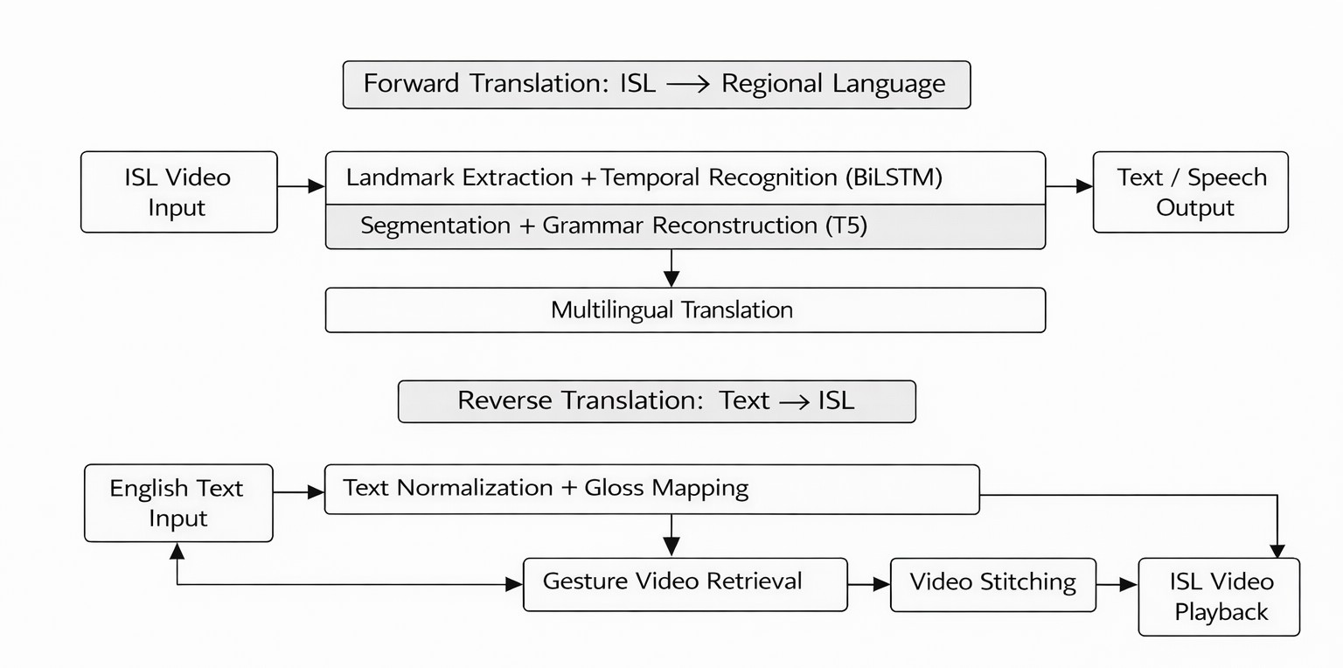
Fig. 1. High-level modular architecture illustrating forward (ISL to text) and reverse (text to ISL) pipelines.
A multi-stage modular design is adopted instead of a monolithic end-to-end neural architecture to ensure interpretability, controlled error propagation, extensibility, and real-time feasibility under limited hardware constraints.

B. Phase 1: Gesture Acquisition and Holistic Representation
Gesture input is obtained from prerecorded videos or live webcam streams. Frames are resized and converted to RGB format. Horizontal mirroring is applied for handedness consistency.
To capture both manual and limited non-manual cues (e.g., gestures involving chin and forehead regions), MediaPipe Holistic is employed. For each frame t, the following landmarks are extracted:
- Left Hand: 21 landmarks × 3 coordinates
- Right Hand: 21 landmarks × 3 coordinates
- Body Pose: 33 landmarks × 3 coordinates • Face: 5 selected expressive landmarks × 3 coordinates The resulting per-frame feature vector dimension is:
(21 + 21 + 33 + 5) × 3 = 80 × 3 = 240
Missing landmarks are replaced with zero vectors to maintain dimensional consistency across frames. Each frame is therefore represented as:
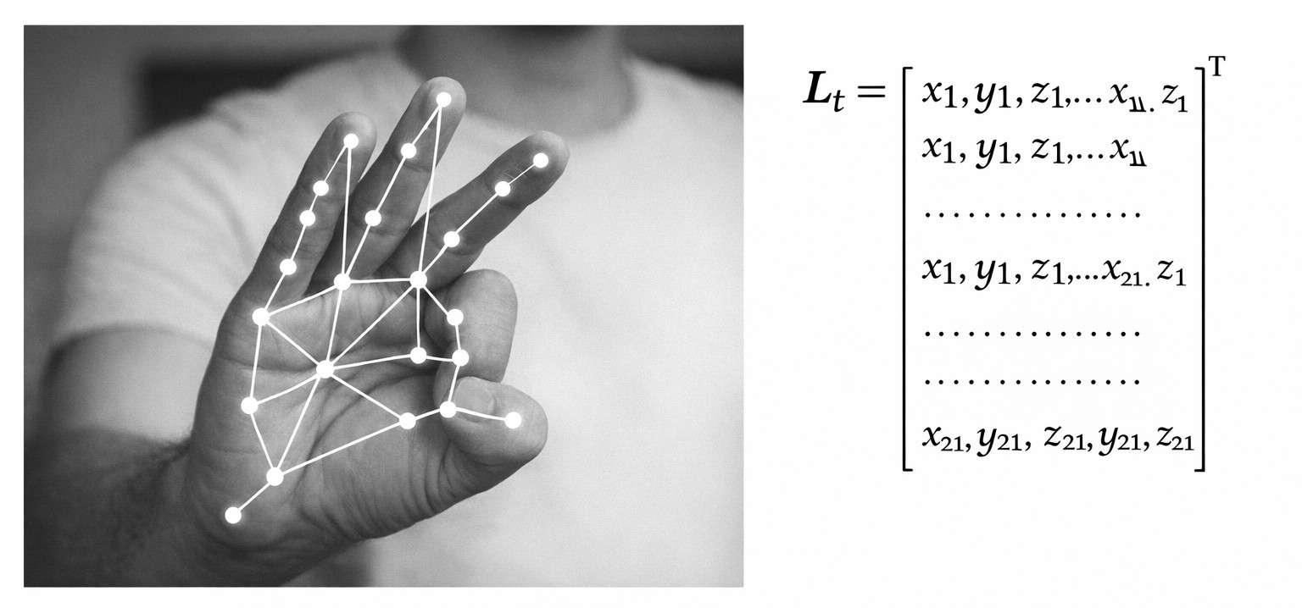
Fig. 2. Holistic landmark extraction and 240-dimensional per-frame feature representation.
Lt ∈ R240
Temporal sequences are formed by stacking frame vectors:
X = {L₁,L₂,...,L_{T}}

C. Temporal Window Construction
Continuous video streams are segmented using overlapping sliding windows:
Window length = 32 frames
Step size = 8 frames
For a sequence of length T, the number of generated windows is:
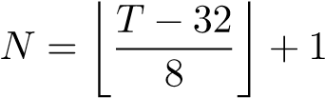
This overlapping segmentation increases temporal diversity while preserving motion continuity and mitigating abrupt boundary effects.

D. Feature Normalization
For each window W ∈ R^{32×240}:
- Mean subtraction across frames:
W′ = W − µ
- Scale normalization:
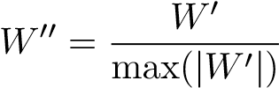
This normalization reduces positional bias and improves inter-signer consistency.

E. Phase 1: Temporal Gesture Classification
Gesture recognition is formulated as a multi-class sequence classification problem:
yˆ = argmaxP(c | X) c∈C
1) 1D Convolutional Projection: A linear projection reduces dimensionality:
240 → 64
Followed by:
- Conv1D (kernel size = 3)
- Layer Normalization
- ReLU activation
This stage captures short-term motion dependencies. 2) Bidirectional GRU: A Bidirectional GRU (BiGRU) with 128 hidden units models long-range temporal dependencies:
Output dimension = 128 × 2 = 256
Temporal average pooling aggregates sequence-level representation.
3) Classification Layer: A fully connected layer maps the pooled representation to 8 gesture classes using softmax activation.

F. Training Strategy
- Loss Function: Cross-Entropy Loss
- Optimizer: Adam (learning rate = 0.001)
- Batch Size: 16
- Epochs: 30
- Train/Validation Split: 80/20 (window-level split)
Window-level classification achieved 99% accuracy under controlled evaluation conditions.

G. Phase 2: Continuous Gesture Segmentation
Natural ISL signing lacks explicit gesture boundaries. Raw window-level predictions are therefore stabilized using temporal filtering.
- Sliding Window Stabilization: Majority voting across overlapping windows suppresses transient misclassifications and yields stable gesture predictions.
- Finite State Machine (FSM): Gesture boundaries are detected using a three-state FSM: Idle, Recording, and Hold. Landmark displacement magnitude is computed as:
∆t = ∥Lt − Lt−1∥
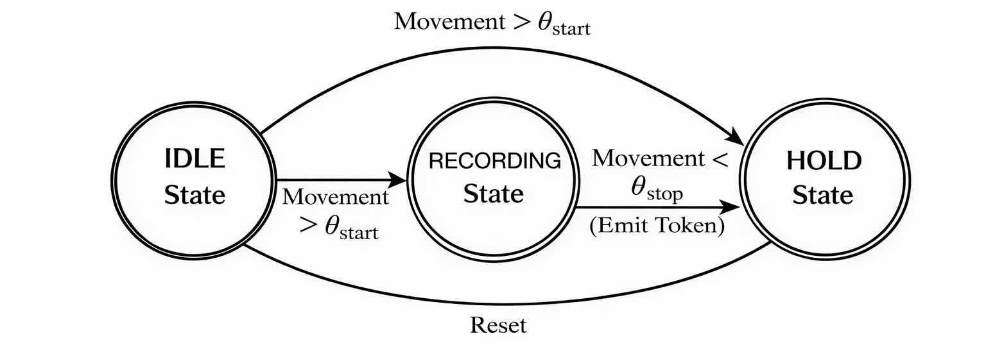
Fig. 3. Finite State Machine for continuous gesture segmentation.
Thresholds θ_{start} and θ_{stop} detect gesture onset and completion. A token is emitted only during the transition from Recording to Hold.
H. Phase 3: Sentence Construction and Grammar Correction Recognized tokens are mapped to English lexemes:
f : T_{i} → w_{i}
forming lexical sequence:
W = {w₁,w₂,...,w_{N}}
Sentence completion is triggered when silence exceeds threshold τ_{s} (empirically set to 800ms).
Grammar reconstruction is formulated as:
Sˆ = argmaxP(S | W)
S
A pretrained T5 Transformer performs conditional generation using prompt-based conditioning.
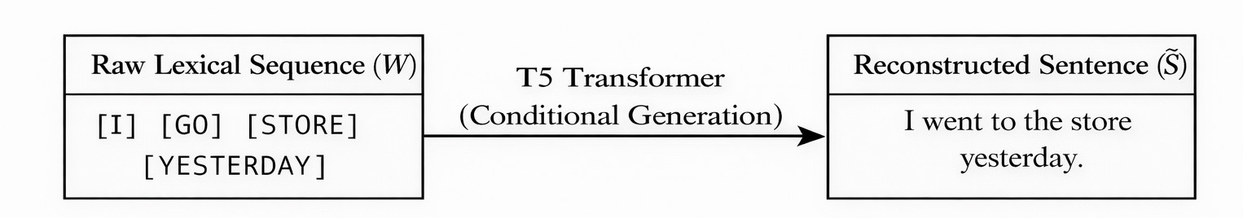
Fig. 4. Sentence reconstruction from ISL lexical sequence.

I. Reverse Translation: Text to ISL
Given input sentence S, normalized tokens are mapped to prerecorded gesture clips:
g : w_{i} → V_{i}
If no mapping exists, fallback mechanisms such as finger spelling are applied. Retrieved clips are concatenated with temporal padding to produce coherent ISL playback.
IV. RESULTS AND DISCUSSION

A. Experimental Setup
Experiments were conducted on a Windows 11 system equipped with an AMD Ryzen 5 7520U CPU and 8GB RAM. No GPU acceleration was used.
The dataset comprises 8 isolated ISL gesture classes recorded from 6 signers (3 male, 3 female). Each signer performed all classes multiple times under controlled indoor lighting conditions, yielding 1,634 segmented temporal windows. Class distribution was approximately uniform (±5% variation).
The silence threshold τ_{s} for temporal segmentation was empirically set to 800ms based on pilot testing to balance over-segmentation and missed gesture boundaries.
Although limited to 8 classes, the vocabulary subset was intentionally selected as a controlled evaluation scenario to analyze temporal modeling behavior and signer generalization before scaling toward larger lexicons.
Three evaluation protocols were adopted:
- Window-level split (80/20)
- Video-level split (no overlapping windows)
- Signer-independent split (leave-one-signer-out)
All reported results represent mean ± standard deviation across three runs.

B. Performance Across Evaluation Protocols
Table I summarizes performance under progressively stricter evaluation conditions.
TABLE I
PERFORMANCE ACROSS EVALUATION PROTOCOLS
Split Type | Accuracy | Macro F1 | κ
Window-Level | 0.98 ± 0.01 | 0.98 ± 0.01 | 0.97
Video-Level | 0.91 ± 0.02 | 0.90 ± 0.02 | 0.88
Signer-Independent | 0.86 ± 0.02 | 0.84 ± 0.02 | 0.82
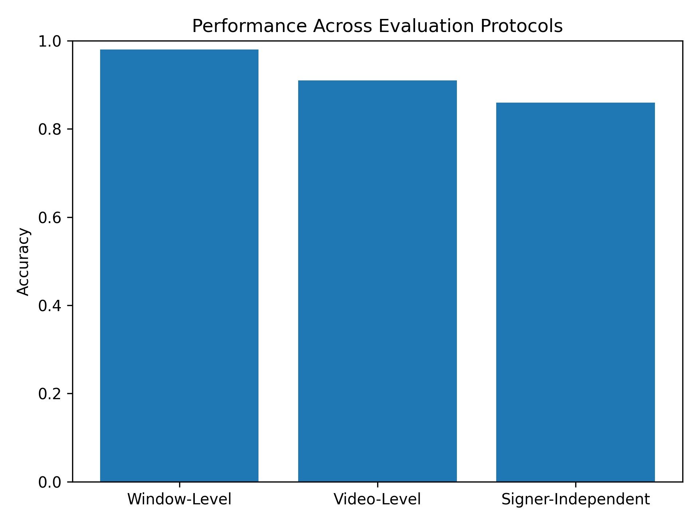
Fig. 5. Accuracy under increasing evaluation strictness.
The reduction from window-level to signer-independent performance confirms that overlapping windows alone do not explain model behavior. The system maintains 86% accuracy under cross-signer generalization, demonstrating robustness to articulation variability.

C. Per-Class Analysis
Figure 6 presents the normalized confusion matrix under signer-independent evaluation.
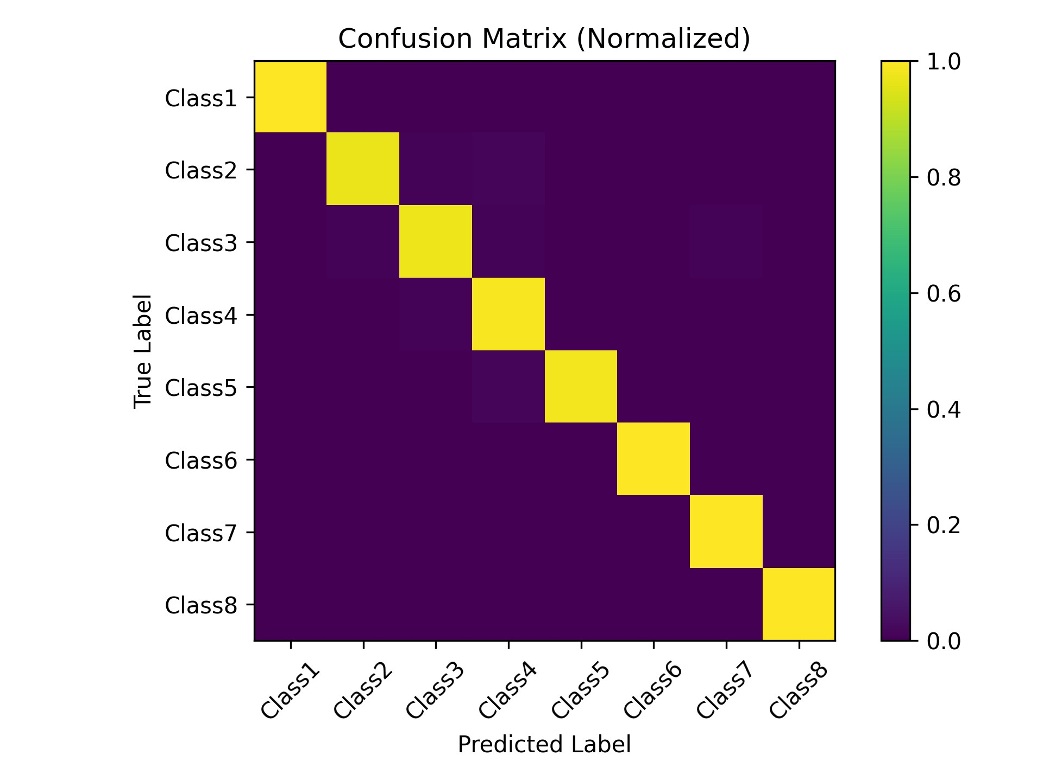
Fig. 6. Normalized confusion matrix under signer-independent evaluation.
Diagonal dominance indicates balanced discriminative capacity across gesture categories. Minor confusion occurs between temporally similar motion trajectories, suggesting that discriminative cues are distributed across extended gesture arcs.

D. Temporal and Architectural Ablation
The influence of temporal window length and architectural components is summarized in Table II and Figure 7.
TABLE II
TEMPORAL AND ARCHITECTURAL ABLATION (SIGNER-INDEPENDENT)
Configuration | Accuracy
Full Model (32 frames) | 0.86
16-frame Window | 0.74
Without BiGRU | 0.82
Without Smoothing | 0.80
RGB Input | 0.72
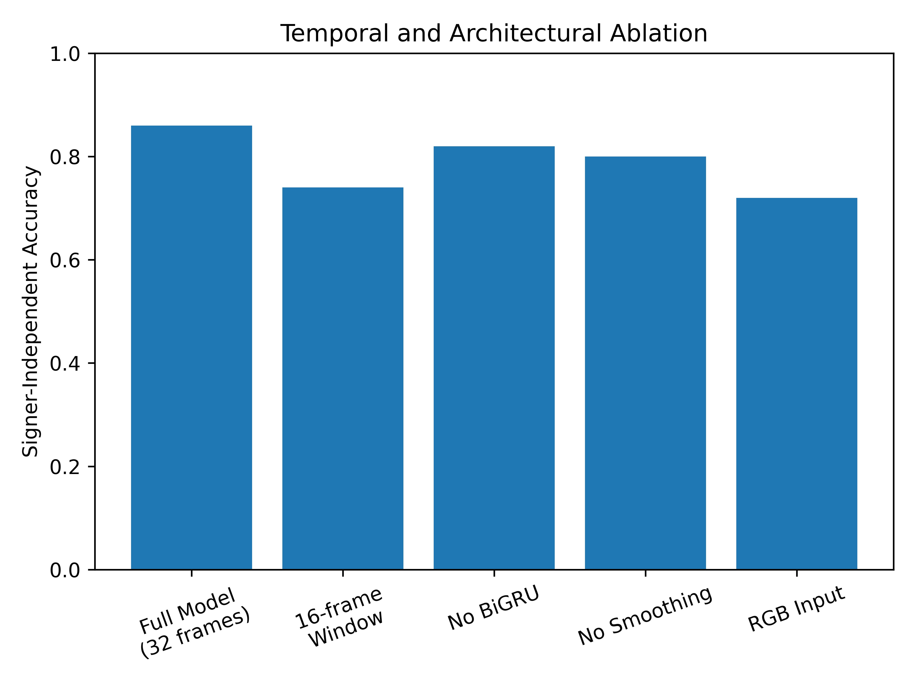
Fig. 7. Impact of temporal window size and architectural components.
Performance degradation under 16-frame windows indicates that ISL gestures exhibit temporally distributed discriminative cues rather than localized motion bursts. Architectural ablation further confirms the importance of bidirectional recurrence and structured landmark input.

E. Grammar Reconstruction Evaluation
To assess the sentence reconstruction module, five representative gloss sequences were evaluated qualitatively. Table III presents raw gloss outputs, reconstructed sentences, and human intelligibility scores (5-point Likert scale, n=10 evaluators).
TABLE III
QUALITATIVE GRAMMAR RECONSTRUCTION EVALUATION
Raw Gloss |  | Reconstructed Sentence | Score (/5)
Class₁ | Class₄ | Good morning | 4.6
Class₂ | Class₈ | Thank you | 4.4
Class₃ | Class₅ | Good evening | 4.5
Class₆ | Class₇ | I am pleased | 4.3
Class₄ | Class₂ | Good afternoon | 4.5
Average human intelligibility was 4.46/5, indicating that the grammar correction module produces coherent naturallanguage outputs despite limited vocabulary scope.

F. Real-Time Inference Performance
TABLE IV
AVERAGE REAL-TIME LATENCY
Stage | Time (ms)
Landmark Extraction | 48
Normalization | 2
Model Inference | 6
Total | 56
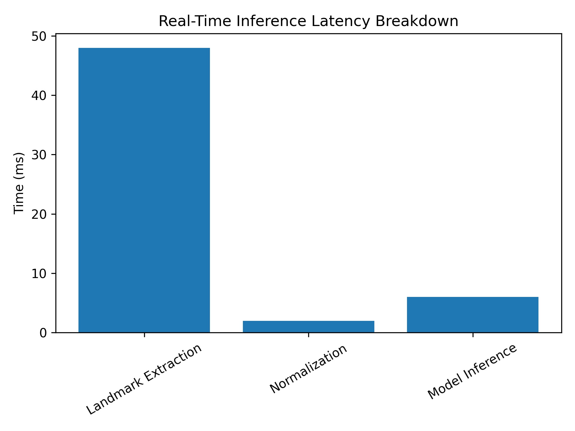
Fig. 8. Latency breakdown of real-time pipeline.
The total end-to-end latency of 56ms confirms real-time operability on CPU-only hardware.

G. Discussion
The results demonstrate that temporal completeness and structured skeletal representations are critical for robust ISL gesture recognition. While window-level accuracy approaches saturation, stricter evaluation protocols provide a realistic measure of generalization.
The grammar reconstruction module produces coherent outputs under limited vocabulary constraints. Combined with sub60ms latency, the proposed modular multi-stage translation framework establishes a practical foundation for scalable ISLto-text systems.
V. CONCLUSION
This paper presented a modular multi-stage framework for translating continuous Indian Sign Language (ISL) video into spoken language text with optional multilingual rendering and speech synthesis. The system integrates skeletal landmark extraction, CNN–BiGRU temporal modeling, FSMbased segmentation, and neural grammar reconstruction within a computationally efficient pipeline.
Under progressively stricter evaluation protocols, the model achieved 0.98 window-level accuracy, 0.91 video-level accuracy, and 0.86 signer-independent accuracy, demonstrating robust generalization across articulation styles. Temporal ablation confirmed that ISL gestures exhibit distributed motion cues, while architectural analysis validated the importance of bidirectional recurrence and structured landmark representations. The grammar reconstruction module achieved an average human intelligibility score of 4.46/5 in qualitative evaluation.
The complete pipeline operates at 56ms end-to-end latency on CPU-only hardware (AMD Ryzen 5 7520U, 8GB RAM), confirming real-time feasibility under constrained computational settings.
Although evaluated on a controlled 8-class vocabulary, the proposed framework establishes a scalable foundation for expanding toward larger lexicons and richer continuous ISL translation. Future work will focus on incorporating nonmanual markers, increasing signer diversity, and quantitatively evaluating multilingual translation quality.
REFERENCES
- K. Goyal and G. Velmathi, “Indian sign language recognition using mediapipe holistic,” arXiv preprint arXiv:2304.10256, 2023.
- S. Katoch, V. Singh, and U. S. Tiwary, “Indian sign language recognition system using surf with svm and cnn,” Array, vol. 14, p. 100141, 2022.
- K. Shenoy, T. Dastane, V. Rao, and D. Vyavaharkar, “Real-time indian sign language (isl) recognition,” in 9th International Conference on Computing, Communication and Networking Technologies (ICCCNT), 2018, pp. 1–9.
- K. Tripathi, N. Baranwal, and G. C. Nandi, “Continuous indian sign language gesture recognition and sentence formation,” Procedia Computer Science, vol. 54, pp. 523–531, 2015.
- H. M. Mariappan and V. Gomathi, “Indian sign language recognition through hybrid convnet-lstm networks,” EMITTER International Journal of Engineering Technology, vol. 9, no. 1, pp. 182–203, 2021.
- D. K. Singh, “3d-cnn based dynamic gesture recognition for indian sign language modeling,” Procedia Computer Science, vol. 189, pp. 76–83, 2021.
- M. Al-Hammadi, G. Muhammad, W. Abdul, M. Alsulaiman, and M. S. Hossain, “Hand gesture recognition using 3d-cnn model,” IEEE Consumer Electronics Magazine, vol. 9, no. 1, pp. 95–101, 2020.
- J. Huang, W. Zhou, H. Li, and W. Li, “Sign language recognition using 3d convolutional neural networks,” in IEEE International Conference on Multimedia and Expo (ICME), 2015, pp. 1–6.
- P. Molchanov, S. Gupta, K. Kim, and J. Kautz, “Hand gesture recognition with 3d convolutional neural networks,” in IEEE Conference on Computer Vision and Pattern Recognition Workshops (CVPRW), 2015.
- S. B. Padigala, G. H. Madhav, S. K. Kumar, and M. Narayanamoorthy, “Video based sign language recognition using cnn-lstm,” International Research Journal of Engineering and Technology (IRJET), vol. 9, no. 6, pp. 1658–1663, 2022.
- S. Kumar, R. Rani, S. K. Pippal, and U. Chaudhari, “Real time indian sign language recognition using transfer learning with vgg16,” TELKOMNIKA Telecommunication, Computing, Electronics and Control, vol. 22, no. 6, pp. 1459–1468, 2024.
- W. Aditya et al., “Novel spatio-temporal continuous sign language recognition using an attentive multi-feature network,” Sensors, vol. 22, no. 17, p. 6452, 2022.
- S. Hon, M. Sidhu, S. Marathe, and T. A. Rane, “Real time indian sign language recognition using convolutional neural network,” International
Journal of Narasimha Reddy Engineering (IJNRD), vol. 9, no. 2, 2024.
- J. Bora, S. Dehingia, A. Boruah, A. A. Chetia, and D. Gogoi, “Real-time assamese sign language recognition using mediapipe and deep learning,” Procedia Computer Science, vol. 218, pp. 1384–1393, 2023.
- R. K. Pathan et al., “Sign language recognition using the fusion of image and hand landmarks through multi-headed convolutional neural network,” Scientific Reports, vol. 13, 2023.
- A. A. Hosain, P. S. Santhalingam, P. Pathak, H. Rangwala, and J. Koseckˇ a, “Hand pose guided 3d pooling for word-level sign language´ recognition,” in 2021 IEEE Winter Conference on Applications of Computer Vision (WACV), 2021, pp. 3418–3427.
- D. Li, C. Rodriguez, X. Yu, and H. Li, “Word-level deep sign language recognition from video: A new large-scale dataset and methods comparison,” in IEEE Winter Conference on Applications of Computer Vision (WACV), 2020, pp. 1459–1469.

