Formulation and Evaluation of Gastro-Retentive Floating Tablets of Verapamil Hydrochloride
Shraddha P. Malpani¹*, Dr. Nishan N. Bobade², Dr. Shrikant D. Pande³

¹Department of Pharmaceutics, Vidyabharati College of Pharmacy, Amravati, Maharashtra, India

Corresponding Author:
Shraddha Malpani
Department of Pharmaceutics
Vidyabharati College of Pharmacy
Amravati, Maharashtra, India
Email: shraddhamalpani2@gmail.com
Phone: +91 9423836796

ABSTRACT
Background: Verapamil Hydrochloride has a short biological half-life and is primarily absorbed in the upper gastrointestinal tract, making it a suitable candidate for a gastro-retentive floating drug delivery system.
Objective: The present study aimed to formulate and evaluate gastro-retentive floating matrix tablets of Verapamil Hydrochloride using HPMC K4M and Xanthan Gum for prolonged gastric retention and sustained drug release.
Methods: Floating matrix tablets were prepared by the direct compression method using HPMC K4M and Xanthan Gum according to a 3² full factorial design. The formulations were evaluated for drug–polymer compatibility (FTIR and DSC), pre- and post-compression parameters, drug content, in vitro buoyancy, swelling index, in vitro drug release, and release kinetics.
Results: FTIR and DSC studies confirmed the compatibility of Verapamil Hydrochloride with HPMC K4M and Xanthan Gum. All formulations showed satisfactory pre- and post-compression characteristics. The floating lag time ranged from 62 ± 0.595 to 128 ± 0.598 s, and all tablets remained buoyant for 12 h. Formulation F3 exhibited the shortest floating lag time (62 ± 0.595 s), the highest swelling index (152.27 ± 0.96%), and the highest cumulative drug release (94.0 ± 0.23%) after 12 h. Drug release kinetic analysis showed that most formulations followed the Korsmeyer–Peppas model, while a few followed Zero-order kinetics.
Conclusion: The developed gastro-retentive floating matrix tablets successfully provided prolonged buoyancy and sustained drug release. Among all formulations, F3 was identified as the optimized formulation and may serve as a promising gastro-retentive drug delivery system for improving gastric residence time and therapeutic efficacy.

Keywords:
Verapamil Hydrochloride, Gastro-retentive drug delivery system, Floating matrix tablets, HPMC K4M, Xanthan Gum, Direct compression, Sustained drug release, Drug release kinetics.

INTRODUCTION

Hypertension is one of the most prevalent chronic cardiovascular disorders worldwide and remains a major risk factor for cardiovascular morbidity and mortality. Long-term pharmacotherapy is essential for effective blood pressure control; however, conventional oral dosage forms often require frequent administration due to their short duration of action, resulting in fluctuations in plasma drug concentration, reduced patient compliance, and suboptimal therapeutic outcomes. These limitations have encouraged the development of novel drug delivery systems capable of providing prolonged drug release and improved therapeutic efficacy.(1,2)

Verapamil Hydrochloride is a calcium channel blocker widely prescribed for the management of hypertension, angina pectoris, and certain cardiac arrhythmias. The drug possesses a relatively short biological half-life of approximately 2.8–7.4 hours and undergoes extensive first-pass hepatic metabolism, leading to reduced oral bioavailability. Consequently, frequent dosing is required to maintain therapeutic plasma concentrations. A sustained-release gastro-retentive formulation may therefore improve drug availability, reduce dosing frequency, and enhance patient compliance.(3,4)

Gastro-retentive drug delivery systems (GRDDS) have emerged as an effective approach for prolonging gastric residence time and enhancing the bioavailability of drugs that are preferentially absorbed in the upper gastrointestinal tract or require prolonged gastric retention. These systems remain in the stomach for an extended period, allowing controlled drug release, improved absorption, reduced plasma concentration fluctuations, and enhanced therapeutic effectiveness.(5,6)

Among the various gastro-retentive approaches, floating drug delivery systems have attracted considerable attention because of their simplicity, safety, and effectiveness. Floating tablets possess a bulk density lower than that of gastric fluid, enabling them to remain buoyant in the stomach without interfering with the normal gastric emptying process. This prolonged gastric residence facilitates sustained drug release and improves therapeutic performance while reducing dosing frequency.(7,8)

Hydrophilic polymers such as Hydroxypropyl Methylcellulose K4M (HPMC K4M) and Xanthan Gum are extensively employed in floating sustained-release formulations because of their excellent swelling, gel-forming, and release-retarding properties. Upon hydration, these polymers form a viscous gel barrier around the tablet that regulates drug diffusion, maintains matrix integrity, and prolongs drug release. Gas-generating agents such as sodium bicarbonate and citric acid react in the acidic gastric environment to produce carbon dioxide, which becomes entrapped within the hydrated polymer matrix, reducing tablet density and enabling buoyancy. The combined use of suitable polymers and gas-generating agents plays a crucial role in achieving desirable floating behavior and sustained drug release.

The present study was undertaken to formulate and evaluate gastro-retentive floating tablets of Verapamil Hydrochloride using HPMC K4M and Xanthan Gum by the direct compression method. The prepared formulations were evaluated for pre-compression and post-compression characteristics, floating behavior, swelling index, in vitro drug release, and drug–excipient compatibility using FTIR and DSC studies. The objective of the study was to develop a stable gastro-retentive floating tablet capable of providing prolonged gastric residence and sustained drug release, thereby improving therapeutic efficacy and reducing the frequency of drug administration.

MATERIALS AND METHODS

2.1 Materials

Verapamil Hydrochloride was obtained from Yarrow Chem Products, Mumbai, India. Hydroxypropyl Methylcellulose K4M (HPMC K4M), Xanthan Gum, Sodium Bicarbonate, and Citric Acid of pharmaceutical grade were procured from S.D. Fine Chem Ltd., Mumbai, India. Microcrystalline Cellulose, Talc, Magnesium Stearate, and Polyvinylpyrrolidone K30 were used as excipients. All chemicals and reagents used in the study were of analytical grade.(9)

2.2 Methods

2.2.1 Experimental Design Using 3² Full Factorial Design

A 3² full factorial design was adopted for the formulation of gastro-retentive floating tablets of Verapamil Hydrochloride. The design consisted of two independent variables at three different levels. The ratio of HPMC K4M to Xanthan Gum (X₁) and the concentration of Citric Acid (X₂) were selected as the independent variables, while Floating Lag Time (Y₁) and Percentage Drug Release (Y₂) were selected as the dependent variables. Based on the selected formulation variables and coded levels, nine formulation batches (F1–F9) were prepared by the direct compression method and evaluated for their floating characteristics and drug release behaviour.

Table 1. Coded Levels of Independent Variables Used in 3² Full Factorial Design.

Independent variables | Symbol | Coded Values
Independent variables | Symbol | -1 | 0 | +1
HPMC K4M: Xanthan gum (Ratio) | X1 | 1:2 | 1:1 | 2:1
Citric acid (mg) | X2 | 10 | 20 | 30

Table 2. Composition of Gastro-retentive Floating Tablets.

Ingredients (mg) | F1 | F2 | F3 | F4 | F5 | F6 | F7 | F8 | F9
X1 | -1 | -1 | -1 | 0 | 0 | 0 | +1 | +1 | +1
X2 | -1 | 0 | +1 | -1 | 0 | +1 | -1 | 0 | +1
Verapamil HCl | 120 | 120 | 120 | 120 | 120 | 120 | 120 | 120 | 120
HPMC K4M | 50 | 50 | 50 | 75 | 75 | 75 | 100 | 100 | 100
Xanthan Gum | 100 | 100 | 100 | 75 | 75 | 75 | 50 | 50 | 50
Citric Acid | 10 | 20 | 30 | 10 | 20 | 30 | 10 | 20 | 30
Sodium Bicarbonate | 50 | 50 | 50 | 50 | 50 | 50 | 50 | 50 | 50
Microcrystalline cellulose | 140 | 130 | 120 | 140 | 130 | 120 | 140 | 130 | 120
Talc | 5 | 5 | 5 | 5 | 5 | 5 | 5 | 5 | 5
Magnesium stearate | 5 | 5 | 5 | 5 | 5 | 5 | 5 | 5 | 5
Polyvinylpyrrolidone K30 | 20 | 20 | 20 | 20 | 20 | 20 | 20 | 20 | 20

2.2.2 Preparation of Gastro-retentive Floating Tablets

Gastro-retentive floating tablets of Verapamil Hydrochloride were prepared by the direct compression method. Verapamil Hydrochloride, HPMC K4M, Xanthan Gum, Sodium Bicarbonate, Citric Acid, and Microcrystalline Cellulose were passed through a 60-mesh sieve to obtain a uniform particle size distribution. The accurately weighed ingredients were blended thoroughly for 10 min to obtain a homogeneous mixture. Magnesium Stearate and Talc were subsequently added and mixed for an additional 5 min. The final powder blend equivalent to 500 mg was compressed into tablets using a rotary tablet compression machine equipped with 12 mm flat-faced punches.(10)

2.3 Evaluation of Formulated Tablets
The prepared gastro-retentive floating tablets were evaluated for drug–excipient compatibility, pre-compression parameters, post-compression characteristics, in vitro buoyancy, swelling index, drug content uniformity, and in vitro drug release using standard pharmacopeial procedures.(11)

A)Compatibility Studies
1)FTIR Spectroscopy
FTIR spectroscopy was performed to investigate the compatibility between Verapamil Hydrochloride and the selected polymers. The spectra of Verapamil Hydrochloride and the drug–polymer physical mixture were recorded using an FTIR spectrophotometer over the range of 4000–400 cm⁻¹ under standard analytical conditions.(12)

2)Differential Scanning Calorimetry (DSC)
Differential Scanning Calorimetry (DSC) was performed to evaluate the thermal behaviour and compatibility of Verapamil Hydrochloride with the selected polymers. The samples were analyzed over a defined temperature range under a nitrogen atmosphere at a controlled heating rate.(13)

B) Evaluation of Powder Blend
The flow properties of the powder blend were assessed prior to compression to ensure uniform die filling and consistent tablet weight. Angle of repose was determined using the fixed funnel method by measuring the height and radius of the powder cone formed after free flow. Bulk and tapped densities were determined using the graduated cylinder method before and after tapping. Compressibility was evaluated by calculating Carr's Index and Hausner Ratio from the density values to assess the flowability and packing characteristics of the powder blend.(14)

C) Evaluation of Tablets
The compressed tablets were evaluated for thickness, hardness, friability, and weight variation using standard pharmacopeial methods. Thickness was measured using a digital vernier caliper. Hardness was determined using a Monsanto hardness tester. Friability was evaluated using a Roche friabilator, while weight variation was determined by individually weighing the tablets and comparing the values with the average tablet weight to ensure dose uniformity. (15,16)

1)Drug Content Uniformity
Drug content uniformity was determined using a validated UV–Visible spectrophotometric method. Twenty tablets were randomly selected, accurately weighed using an electronic balance and finely powdered. A quantity of powder equivalent to 0.1g of Verapamil Hydrochloride was transferred into a conical flask. The drug was extracted using 150 mL of 0.1 N hydrochloric acid with shaking for 10 minutes. The volume was adjusted to 200 mL with 0.1 N HCl, followed by filtration. From the filtrate, 10 mL was diluted to 100 mL with distilled water, and absorbance was measured at λmax 278 nm using a Double Beam UV–Visible Spectrophotometer (UV-2401 PC, Shimadzu Corporation, Japan).

2) In Vitro Buoyancy Study
Floating behavior was evaluated using a USP Type II dissolution apparatus (Model 84005, Shimadzu Asia Pacific Pvt. Ltd., Singapore) at 50 rpm. Tablets were placed in 900 mL of 0.1 N HCl (pH 1.2) maintained at 37 ± 0.5°C.
Floating lag time (FLT) was recorded as the time required for the tablet to rise to the surface of the medium, while total floating time (TFT) was recorded as the duration for which the tablet remained buoyant. Buoyancy was visually observed throughout the study.(17)

3) In Vitro Dissolution Study
The in vitro drug release study of Verapamil Hydrochloride from the prepared floating matrix tablets was carried out using a USP Type II dissolution apparatus (paddle method). The dissolution medium consisted of 900 mL of 0.1 N hydrochloric acid (pH 1.2) maintained at 37 ± 0.5°C, which simulated gastric conditions. The paddle rotation speed was set at 50 rpm.
At predetermined time intervals (30 min, 1, 2, 3, 4, 6, 8, 10, 12, 16, 20, and 24 h), 5 mL aliquots of dissolution medium were withdrawn and immediately replaced with an equal volume of fresh pre-warmed medium to maintain sink conditions. The withdrawn samples were filtered and diluted to 10ml, and the drug content was analyzed using a UV–Visible spectrophotometer (UV-2401 PC, Shimadzu Corporation, Japan) at λmax 278 nm.(18)

4) Swelling Index Study
The swelling behavior of the gastro-retentive tablets was evaluated to study the hydration and gel-forming characteristics of the polymer matrix. Pre-weighed tablets were placed in 900 mL of 0.1 N hydrochloric acid (pH 1.2) maintained at 37 ± 0.5°C using a USP Type II dissolution apparatus. At predetermined time intervals (30 min, 1, 2, 4, 6, 8, 12, and 24 h), the tablets were carefully removed, blotted gently with filter paper to remove excess surface liquid, and weighed immediately.
The swelling index was calculated using the following equation:
Swelling Index (%) = [(Wt − W₀) / W₀] × 100
Where:
W₀ = Initial weight of tablet
Wt = Weight of tablet at time t

5) Kinetic Modeling of Drug Release
The dissolution data were fitted to Zero-order, First-order, Higuchi, Hixson–Crowell, and Korsmeyer–Peppas kinetic models to determine the drug release mechanism(19)

6) Stability Study
Stability studies were conducted on the optimized formulation under accelerated storage conditions (40 ± 2°C and 75 ± 5% RH). Samples were evaluated at predetermined intervals for physical appearance, hardness, friability, swelling index, drug content, floating behavior, and in vitro drug release.(20)

RESULTS AND DISCUSSION

1)Fourier Transform Infrared (FTIR)
FTIR spectroscopy was performed to evaluate the compatibility of Verapamil Hydrochloride with Hydroxypropyl Methylcellulose K4M (HPMC K4M) and Xanthan Gum. The FTIR spectrum of pure Verapamil Hydrochloride exhibited characteristic absorption peaks at 3399 cm⁻¹ (N–H stretching), 2950 cm⁻¹ (C–H stretching), 1593 cm⁻¹ (aromatic C=C stretching), 1465 cm⁻¹ (C–H bending), 1259 cm⁻¹ (C–N stretching), 1151 cm⁻¹ (C–O stretching), 1028 cm⁻¹ (C–O–C stretching), and 829 cm⁻¹ (aromatic C–H bending). The drug–polymer physical mixture showed the characteristic peaks of Verapamil Hydrochloride with only slight shifts and broadening in the O–H/N–H stretching region due to weak intermolecular hydrogen bonding.
No disappearance of characteristic peaks or appearance of new peaks was observed, indicating the absence of significant drug–polymer interaction. These findings confirmed the compatibility of Verapamil Hydrochloride with HPMC K4M and Xanthan Gum, demonstrating their suitability for the development of gastro-retentive floating matrix tablets.

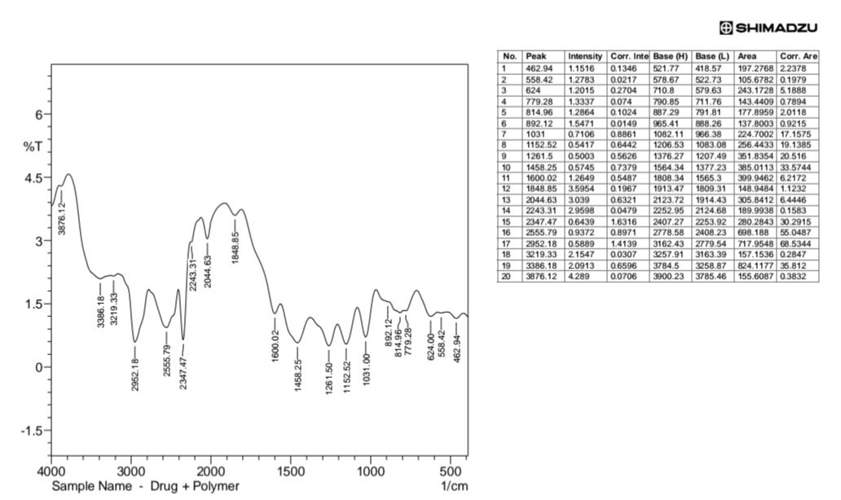
Figure 1. FTIR spectra of pure Verapamil Hydrochloride and the drug–polymer physical mixture.

2) Differential Scanning Calorimetry (DSC)
Differential Scanning Calorimetry (DSC) was performed to evaluate the thermal compatibility of Verapamil Hydrochloride with HPMC K4M and Xanthan Gum. The DSC thermogram of pure Verapamil Hydrochloride exhibited a sharp endothermic melting peak at 144.87°C (onset 137.74°C, endset 153.07°C), confirming its crystalline nature. The drug–polymer physical mixture showed two endothermic peaks at 147.02°C (onset 138.73°C, endset 157.79°C) and 193.97°C (onset 182.91°C, endset 204.15°C). The slight shift in the drug melting peak may be attributed to its uniform dispersion within the polymer matrix and weak physical interactions with the polymers. The retention of the characteristic melting peak without the appearance of any new thermal events indicated the absence of significant drug–polymer interaction. These findings confirmed the thermal compatibility of Verapamil Hydrochloride with HPMC K4M and Xanthan Gum, supporting their suitability for the development of gastro-retentive floating matrix tablets.

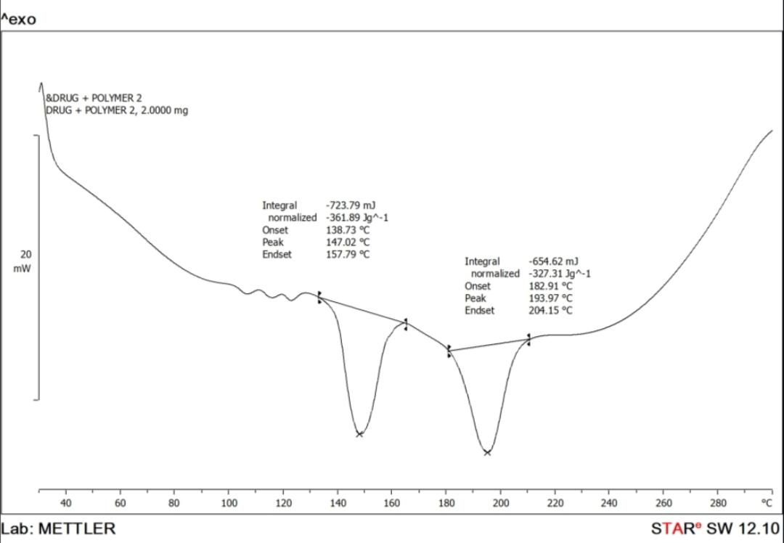
Figure 2. DSC thermograms of pure Verapamil Hydrochloride and the drug–polymer physical mixture.

3) Evaluation of Powder Blend (Pre-compression Studies)

The powder blends of all factorial design formulations (F1–F9) were evaluated for their pre-compression properties. The bulk density and tapped density ranged from 0.566 ± 0.613 to 0.584 ± 0.065 g/cm³ and 0.650 ± 0.008 to 0.663 ± 0.021 g/cm³, respectively, indicating satisfactory packing characteristics. The Carr's Index (11.38 ± 0.72–14.37 ± 0.87%), Hausner's ratio (1.14 ± 0.04–1.16 ± 0.09), and angle of repose (29.2 ± 0.27°–30.4 ± 1.30°) indicated good compressibility and flow properties of all formulations. These results confirmed that the powder blends possessed adequate flowability and were suitable for the preparation of floating matrix tablets by the direct compression method.

Table 3. Pre-compression parameters of factorial design batches (F1–F9).

Batch | Bulk Density (g/cm3±SD) | Tapped Density (g/cm3±SD) | Carr's Index (%±SD) | Hausner’s Ratio (±SD) | Angle of Repose (θ±SD)
F1 | 0.566±0.613 | 0.661±0.014 | 14.37±0.87 | 1.15±0.08 | 29.2±0.27
F2 | 0.574±0.021 | 0.658±0.015 | 12.76±0.45 | 1.14±0.04 | 30.1±1.47
F3 | 0.570±0.009 | 0.663±0.021 | 13.45±0.67 | 1.16±0.09 | 29.6±1.38
F4 | 0.568±0.003 | 0.650±0.008 | 12.61±0.91 | 1.16±0.05 | 29.5±1.19
F5 | 0.584±0.065 | 0.659±0.015 | 11.38±0.72 | 1.15±0.08 | 29.2±1.54
F6 | 0.575±0.012 | 0.658±0.023 | 12.61±0.58 | 1.14±0.09 | 29.6±1.36
F7 | 0.568±0.019 | 0.660±0.009 | 13.93±0.43 | 1.16±0.05 | 29.3±1.26
F8 | 0.571±0.015 | 0.661±0.009 | 13.61±0.46 | 1.15±0.08 | 30.4±1.30
F9 | 0.576±0.075 | 0.660±0.009 | 12.72±0.45 | 1.15±0.08 | 30.1±1.20

4) Evaluation of Tablets (Post-compression Studies)
The prepared Verapamil Hydrochloride floating matrix tablets were evaluated for post-compression parameters, including weight variation, hardness, thickness, diameter, friability, floating lag time (FLT), total floating time (TFT), and drug content. The tablets exhibited uniform weight (500.1 ± 1.3–503.8 ± 1.5 mg), diameter (12.05 ± 0.155–12.09 ± 0.147 mm), and thickness (2.970 ± 0.13–2.985 ± 0.14 mm), indicating consistent die filling and dimensional uniformity. The hardness ranged from 5.2 ± 0.045 to 6.2 ± 0.059 kg/cm², while friability was 0.44 ± 0.025–0.54 ± 0.035%, which was within the pharmacopeial limit (<1%), confirming adequate mechanical strength and tablet integrity. Overall, all formulations exhibited satisfactory post-compression characteristics and were suitable for further evaluation.

5) Drug Content Uniformity
The drug content of the factorial design batches (F1–F9) ranged from 96.46 ± 0.82% to 98.78 ± 0.80%, indicating uniform distribution of Verapamil Hydrochloride within the matrix tablets and compliance with pharmacopeial limits. Formulations F3 and F8 showed the highest drug content (98.78 ± 0.80%), whereas F2 exhibited the lowest (96.46 ± 0.82%). The minimal variation among the formulations confirmed efficient mixing and reproducibility of the direct compression process.

6) In Vitro Buoyancy Study
The in vitro buoyancy study was carried out in 0.1 N HCl (pH 1.2) to evaluate the floating performance of the prepared tablets. The floating lag time (FLT) ranged from 62 ± 0.595 to 128 ± 0.598 s, while all formulations remained buoyant for 12 h, demonstrating excellent floating ability.
The polymer ratio and citric acid concentration significantly influenced the buoyancy behavior. Formulations containing a higher proportion of HPMC K4M exhibited longer floating lag times because of the formation of a more viscous gel barrier, whereas increasing the concentration of citric acid reduced the FLT by enhancing carbon dioxide generation through its reaction with sodium bicarbonate.
Among all formulations, F3 exhibited the shortest floating lag time (62 ± 0.595 s), whereas F7 showed the longest (128 ± 0.598 s). The prolonged floating duration of all formulations indicated good matrix integrity throughout the study. Based on the buoyancy performance, F3 was identified as the optimized formulation.

Table 4. Post-compression parameters of factorial design batches (F1–F9).

Batch | Wt.variation(mg±S D) | Hardness (kg/cm²±SD) | Diameter (mm±S D) | Thickness. (mm±S D) | Friability (±SD) | FLT  (sec±S D) | TFT  (hour± SD) | Drug content (%±SD)
F1 | 503.4±1.5 | 6.2±0.059 | 12.08±0.146 | 2.978±0.15 | 0.46±0.018 | 105±0633 | 12±0.67 | 97.6±0.74
F2 | 501.0±1.4 | 5.2±0.047 | 12.08±0.161 | 2.979±0.14 | 0.44±0.025 | 75±0564 | 12±0.25 | 96.46±0.82
F3 | 502.2±1.5 | 6.1±0.052 | 12.06±0.140 | 2.981±0.17 | 0.47±0.032 | 62±0.595 | 12±0.09 | 98.78±0.80
F4 | 503.8±1.4 | 5.8±0.056 | 12.07±0.150 | 2.980±0.15 | 0.51±0.024 | 125±0.648 | 12±0.08 | 97.04±0.75
F5 | 500.1±1.3 | 5.5±0.056 | 12.05±0.155 | 2.979±0.14 | 0.53±0.025 | 80±0.671 | 12±066 | 96.86±0.88
F6 | 502.0±1.8 | 5.8±0.045 | 12.09±0.147 | 2.978±0.13 | 0.54±0.035 | 70±0.671 | 12±0.87 | 97.64±0.91
F7 | 503.4±1.6 | 5.4±0.057 | 12.08±0.154 | 2.978±0.16 | 0.48±0.031 | 128±0.598 | 12±0.06 | 98.76±0.74
F8 | 503.0±1.5 | 5.4±0.040 | 12.06±0.157 | 2.970±0.13 | 0.50±0.023 | 105±0.561 | 12±0.09 | 98.78±0.80
F9 | 503.8±1.4 | 5.2±0.045 | 12.07±0.147 | 2.985±0.14 | 0.48±0.030 | 70±0.672 | 12±0.87 | 97.64±0.90

7) In Vitro Dissolution Study
The in vitro drug release study was performed in 0.1 N HCl (pH 1.2) for 12 h to evaluate the sustained-release behavior of the floating matrix tablets. The cumulative drug release was significantly influenced by the HPMC K4M:Xanthan Gum ratio and the concentration of citric acid. Formulations containing a higher proportion of Xanthan Gum (F1–F3) exhibited greater drug release than those containing equal proportions (F4–F6) or a higher proportion of HPMC K4M (F7–F9), indicating the release-retarding effect of HPMC K4M.
The cumulative drug release after 12 h for formulations F1, F4, and F7 was 91.0 ± 0.40%, 89.1 ± 0.90%, and 85.1 ± 0.42%, respectively. Within each polymer ratio group, increasing the concentration of citric acid resulted in enhanced drug release, possibly due to increased matrix hydration, pore formation, and improved drug diffusion.
The overall drug release pattern was observed as F3 > F2 > F1, F6 > F5 > F4, and F9 > F8 > F7. Among all formulations, F3 showed the highest cumulative drug release (94.0 ± 0.23%) after 12 h, along with satisfactory floating characteristics. Therefore, F3 was identified as the optimized formulation for the gastro-retentive floating drug delivery system.

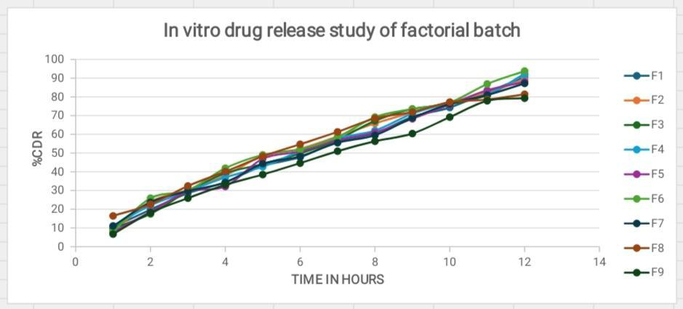
Figure 3. In vitro drug release profiles of factorial design batches (F1–F9).

8) Swelling Index Study

The swelling index of the factorial design batches (F1–F9) was evaluated in 0.1 N HCl (pH 1.2) to study the hydration behavior of the polymeric matrix. All formulations showed a gradual increase in swelling with time, indicating progressive hydration of the polymers. After 12 h, the swelling index ranged from 134.66 ± 0.96% to 152.27 ± 0.96%.
The swelling behavior was influenced by the HPMC K4M:Xanthan Gum ratio and the concentration of citric acid. Formulations containing a higher proportion of HPMC K4M exhibited greater swelling due to its superior hydrophilic and gel-forming properties. Among all formulations, F3 showed the highest swelling index (152.27 ± 0.96%), whereas F7 exhibited the lowest (134.66 ± 0.96%). Increasing the concentration of citric acid also enhanced matrix hydration and swelling. The improved swelling behavior contributed to prolonged tablet buoyancy and sustained drug release by maintaining the integrity of the hydrated polymer matrix throughout the study.

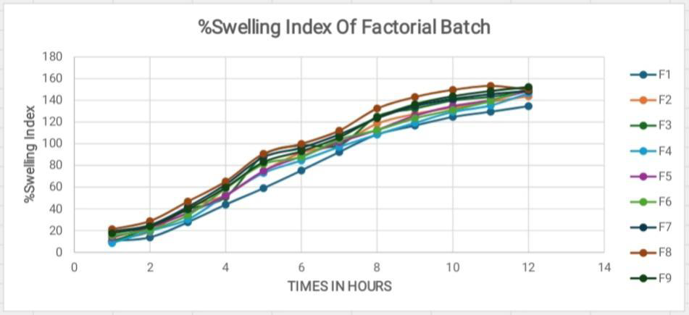
Figure 4. Swelling index profiles of factorial design batches (F1–F9).

9) Drug Release Kinetics

The in vitro drug release data of the factorial design batches were fitted to Zero-order, First-order, Higuchi, and Korsmeyer–Peppas kinetic models to determine the drug release mechanism. Based on the R² values, formulations F1, F2, F3, F4, F7, and F8 showed the best fit to the Korsmeyer–Peppas model, whereas F5, F6, and F9 followed Zero-order kinetics, indicating controlled drug release from the polymeric matrix.
The release exponent (n) values ranged from 0.842 to 0.961, suggesting that drug release occurred predominantly through Case-II transport, while formulation F9 (n = 0.842) exhibited anomalous (non-Fickian) diffusion. Among all formulations, F3 showed the best correlation with the Korsmeyer–Peppas model (R² = 0.9968), indicating a controlled and sustained drug release pattern. Based on the kinetic analysis and overall evaluation, F3 was identified as the optimized formulation for the development of gastro-retentive floating matrix tablets.

Table 5. Kinetic model analysis of factorial design batches (F1–F9).

Parameter | F1 | F2 | F3 | F4 | F5 | F6 | F7 | F8 | F9
Zero Order (R²) | 0.9961 | 0.9874 | 0.9905 | 0.9855 | 0.9944 | 0.9931 | 0.9759 | 0.9841 | 0.9959
1st Order (R²) | 0.9571 | 0.9322 | 0.9543 | 0.8756 | 0.9447 | 0.9632 | 0.9512 | 0.9606 | 0.9218
Higuchi (R²) Model | 0.9874 | 0.9892 | 0.9894 | 0.9894 | 0.9812 | 0.9922 | 0.9898 | 0.9902 | 0.9820
Peppas (R²) Model | 0.9965 | 0.9984 | 0.9968 | 0.9919 | 0.9836 | 0.9781 | 0.9899 | 0.9944 | 0.9891
n value | 0.9610 | 0.953 | 0.938 | 0.944 | 0.936 | 0.922 | 0.9470 | 0.928 | 0.842
k value | 35.16 | 33.47 | 31.23 | 32.21 | 30.56 | 30.22 | 28.88 | 29.45 | 28.87
Best Fitted To | Peppas | Peppas | Peppas | Peppas | Zero order | Zero order | Peppas | Peppas | Zero order

Stability Study
The optimized formulation (F3) was subjected to stability studies under different storage conditions, i.e., 40 ± 2°C / 75 ± 5% RH, 25 ± 2°C / 75 ± 5% RH, and 10 ± 2°C / 75 ± 5% RH for a period of 4 weeks, as per ICH guidelines, to evaluate its physical and chemical stability.
The results of stability studies are shown that drug content remained nearly constant throughout the study period under all storage conditions, ranging from 98.78 ± 0.80% to 98.77 ± 0.80%, indicating excellent chemical stability of the formulation.
No significant variation was observed in floating lag time (168 ± 0.561 sec) and total floating time (12 ± 0.09 h) during the entire study period. The cumulative drug release remained consistent at approximately 84.4 ± 0.3259% under most conditions, as shown in table 9. indicating that the release profile was not affected by storage conditions.
A slight decrease in cumulative drug release (83.4 ± 0.3259%) was observed at the end of the 4th week under 10 ± 2°C / 75 ± 5% RH condition; however, this change was within acceptable limits and not considered significant.
Overall, the formulation showed negligible changes in drug content, floating behavior, and drug release profile across all storage conditions, confirming the stability of the developed gastro-retentive floating tablets under both accelerated and long-term conditions.

Table 6 : Stability study in different temperatures

Stability 40 ± 2°C / 75 ± 5% RH | Drug Content (%) | Lag Time(Sec) | Floating Time (Hr.) | Cumulative Drug Release
0 Day | 98.78±0.80 | 62±0.595 | 12±0.09 | 94±0.23
1 Week | 98.78±0.80 | 62±0.595 | 12±0.09 | 94±0.23
2 Week | 98.78±0.80 | 62±0.595 | 12±0.09 | 94±0.23
3 Week | 97.77±0.80 | 62±0.595 | 12±0.09 | 93±0.23
4 Week | 97.77±0.80 | 62±0.595 | 12±0.09 | 93±0.23

Stability 25 ± 2°C /  75 ± 5% RH | Drug Content (%) | Lag Time in (Sec) | Floating Time (Hr.) | Cumulative Drug Release
0 Day | 98.78±0.80 | 62±0.595 | 12±0.09 | 94±0.23
1 Week | 98.78±0.80 | 62±0.595 | 12±0.09 | 94±0.23
2 Week | 98.78±0.80 | 62±0.595 | 12±0.09 | 94±0.23
3 Week | 98.78±0.80 | 62±0.595 | 12±0.09 | 94±0.23
4 Week | 97.77±0.80 | 62±0.595 | 12±0.09 | 93±0.23

Stability 10± 2°C /  75 ± 5% RH | Drug Content (%) | Lag Time (Sec) | Floating Time (Hr.) | Cumulative Drug Release
0 Day | 98.78±0.80 | 62±0.595 | 12±0.09 | 94±0.23
1 Week | 98.78±0.80 | 62±0.595 | 12±0.09 | 94±0.23
2 Week | 98.78±0.80 | 62±0.595 | 12±0.09 | 94±0.23
3 Week | 98.77±0.80 | 62±0.595 | 12±0.09 | 94±0.23
4 Week | 97.77±0.80 | 62±0.595 | 12±0.09 | 93±0.23

CONCLUSION

The present study successfully developed gastro-retentive floating matrix tablets of Verapamil Hydrochloride using Hydroxypropyl Methylcellulose K4M (HPMC K4M) and Xanthan Gum by the direct compression method. FTIR and DSC studies confirmed the compatibility of Verapamil Hydrochloride with the selected polymers, indicating the absence of any significant drug–polymer interaction.
The pre-compression studies demonstrated satisfactory flowability and compressibility of the powder blends, whereas the post-compression evaluation confirmed that all formulations complied with pharmacopeial specifications for weight variation, hardness, friability, thickness, diameter, and drug content uniformity.
All formulations exhibited excellent floating characteristics with a total floating time of 12 h, indicating their suitability for prolonged gastric retention. The in vitro drug release study demonstrated that both the polymer ratio and citric acid concentration significantly influenced the release profile of Verapamil Hydrochloride. Formulation F3 exhibited the shortest floating lag time (62 ± 0.595 s), the highest cumulative drug release (94.0 ± 0.23%) after 12 h, and the highest swelling index (152.27 ± 0.96%), demonstrating an optimum balance between buoyancy, swelling behavior, and sustained drug release.
Drug release kinetic analysis revealed that most formulations followed the Korsmeyer–Peppas model, while a few formulations exhibited Zero-order release kinetics, indicating controlled drug release from the polymeric matrix. Based on the overall evaluation, formulation F3 was identified as the optimized formulation and may serve as a promising gastro-retentive floating drug delivery system for the sustained release of Verapamil Hydrochloride, with the potential to improve gastric residence time and enhance therapeutic efficacy.

REFERENCES

1. Chien YW. Novel Drug Delivery Systems. 2nd ed. New York: Marcel Dekker; 1992.
2. Jain NK. Controlled and Novel Drug Delivery. 1st ed. New Delhi: CBS Publishers & Distributors; 2002.
3. Singh BN, Kim KH. Floating drug delivery systems: An approach to oral controlled drug delivery via gastric retention. J Control Release. 2000;63(3):235-259.
4. Deshpande AA, Rhodes CT, Shah NH, Malick W. Controlled-release drug delivery systems for prolonged gastric residence: An overview. Drug Dev Ind Pharm. 1996;22(6):531-539.
5. Streubel A, Siepmann J, Bodmeier R. Gastroretentive drug delivery systems. Expert Opin Drug Deliv. 2006;3(2):217-233.
6. Rouge N, Buri P, Doelker E. Drug absorption sites in the gastrointestinal tract and dosage forms for site-specific delivery. Int J Pharm. 1996;136(1-2):117-139.
7. Baumgartner S, Kristl J, Vrecer F, Vodopivec P, Zorko B. Optimization of floating matrix tablets and evaluation of their gastric residence time. Int J Pharm. 2000;195(1-2):125-135.
8. Klausner EA, Lavy E, Friedman M, Hoffman A. Expandable gastroretentive dosage forms. J Control Release. 2003;90(2):143-162.
9. Colombo P, Bettini R, Santi P, Peppas NA. Swellable matrices for controlled drug delivery. Pharm Sci Technolo Today. 2000;3(6):198-204.
10. Rowe RC, Sheskey PJ, Quinn ME. Handbook of Pharmaceutical Excipients. 6th ed. London: Pharmaceutical Press; 2009.
11. Patel VF, Patel NM, Yeole PG. Studies on formulation and evaluation of gastroretentive floating drug delivery system. AAPS PharmSciTech. 2005;6(4):E772-E776.
12. Talukder R, Fassihi R. Gastroretentive delivery systems: A mini review. Drug Dev Ind Pharm. 2004;30(10):1019-1028.
13. Dash S, Murthy PN, Nath L, Chowdhury P. Kinetic modeling on drug release from controlled drug delivery systems. Acta Pol Pharm. 2010;67(3):217-223.
14. Costa P, Sousa Lobo JM. Modeling and comparison of dissolution profiles. Eur J Pharm Sci. 2001;13(2):123-133.
15. Gohel MC, Parikh RK, Nagori SA, Jethwa BA. Fabrication and evaluation of sustained release matrix tablets. AAPS PharmSciTech. 2007;8(1):E1-E8.
16. Shah RB, Tawakkul MA, Khan MA. Comparative evaluation of flow for pharmaceutical powders and granules. AAPS PharmSciTech. 2008;9(1):250–258.
17. Alderborn G. Tablets and compaction. In: Aulton ME, Taylor KMG, editors. Aulton's Pharmaceutics: The Design and Manufacture of Medicines. 6th ed. Elsevier; 2022.
18. Nokhodchi A. An overview of the effect of moisture on compaction and compression of pharmaceutical excipients. Pharm Technol. 2005;29(1):46–66.
19. Banker GS, Anderson NR. Tablets. In: Lachman L, Lieberman HA, Kanig JL, editors. The Theory and Practice of Industrial Pharmacy. 3rd ed. Mumbai: Varghese Publishing House; 2009. p. 293–345.
20. Allen LV Jr, Popovich NG, Ansel HC. Ansel's Pharmaceutical Dosage Forms and Drug Delivery Systems. 10th ed. Philadelphia: Lippincott Williams & Wilkins; 2014.

