Design and Evaluation of Multi-Floor Lorawan System for Indoor Deployment

Dakshayanie Maniaruse., Fakrulradzi Idris*., Norlezah Hashim., Anas Abdul Latiff
Centre for Telecommunication Research & Innovation (CeTRI), Fakulti Teknologi dan Kejuruteraan Elektronik dan Computer (FTKEK), Universiti Teknikal Malaysia Melaka (UTeM), Hang Tuah Jaya, 76100, Durian Tunggal, Melaka, Malaysia
*Corresponding Author

DOI: https://dx.doi.org/10.47772/IJRISS.2025.91100326

Received: 01 December 2025; Accepted: 08 December 2025; Published: 09 December 2025

ABSTRACT
This study explores the impact of gateway placement on the performance of LoRaWAN networks in a multi-floor indoor environment, focusing on signal propagation and packet delivery reliability. Leveraging The Things Network (TTN) as the network server and Ubidots for real-time data visualization, the project involved designing and deploying an indoor LoRaWAN setup to evaluate how gateway elevation influences key metrics such as Received Signal Strength Indicator (RSSI), Signal-to-Noise Ratio (SNR), and Packet Delivery Ratio (PDR). Results indicate that while Level 4 gateway placement offers stronger performance in line- of-sight (LOS) areas, it suffers from sharp degradation in lower floors. Conversely, Level 3 gateway placement provides more consistent coverage, particularly in non-line-of-sight (NLOS) and in the first floor areas. These findings emphasize that optimal gateway placement is not necessarily the highest point, but rather a strategically balanced position suited to the building’s structure. The integration of TTN and Ubidots proved essential for reliable network management, supporting practical recommendations for scalable and energy- efficient LoRaWAN deployments in complex indoor environments.
Keywords: LoRaWAN, Internet of Things, The Things Network, Gateway placement, Spreading Factor

INTRODUCTION
The Internet of Things (IoT) has transformed how devices interact, enabling seamless integration of machines, vehicles, and sensors across various sectors. This technological shift has accelerated digital transformation and innovation, especially in indoor applications like home automation, transportation systems, energy management, safety monitoring and agriculture, Idris et al. (2024). While protocols such as Wi-Fi and Bluetooth have traditionally supported these applications, their limitations in range, scalability, and energy efficiency hinder large-scale, low-power IoT deployments.
To address these challenges, LoRaWAN has emerged as a promising alternative. Its low-power wide-area network (LPWAN) capabilities provide extended range, high energy efficiency, and lower operational costs, making it ideal for connecting numerous battery-powered devices that require modest data throughput and can tolerate some transmission delays. These attributes position LoRaWAN as a leading solution for complex indoor environments where traditional protocols fall short. However, deploying LoRaWAN in multi- floor indoor settings presents unique obstacles. Factors such as building materials, gateway and sensor placement, and signal attenuation from walls and floors can significantly impact network performance. Overcoming these issues requires a thorough investigation to optimize network design and ensure reliable, low-latency data transmission.
This research is motivated by the need to tackle these real-world challenges. It focuses on evaluating LoRaWAN network coverage in a multi-floor indoor environment at the FTKEK campus of UTeM. The study involves designing and deploying a LoRaWAN network, followed by collecting and analysing data on signal strength, signal-to-noise ratio (SNR), and packet losses across different floors. The analysis considers varying base station positions, Spreading factors (SF), and transmission power to provide insights for robust and efficient IoT network design in complex indoor environments.
Neumann et al. (2020) investigated the performance of LoRaWAN in a multi-story academic building, specifically examining how duty cycle regulations and data rates are determined by SF influence network coverage and throughput. Their experiment demonstrated that lower spreading factors, such as SF7 (DR6), significantly reduced transmission delays from 4.5 minutes at SF12 to just 2 seconds at SF7. However, this improvement came with trade-offs in reliability, as lower SFs are more susceptible to packet collisions. One of the study’s major strengths lies in its detailed quantification of how SF selection impacts daily data capacity under duty cycle limits, with capacity ranging from 1 MB/day at SF7 to only 15 KB/day at SF12. The study also highlighted how transmission power remained constant at 47.5 mA across SFs, offering insights into energy efficiency. Nonetheless, its limitation lies in the fixed transmission power settings, as it did not explore how adjusting transmission power might affect network performance across building floors.
Building on this foundation, Bobkov et al. (2020) explored the comparative performance of the 433 MHz and 868 MHz frequency bands in a nine-story concrete building, placing particular emphasis on how SF influences signal stability and packet delivery. Unlike Neumann’s study, which focused on SF-driven data rate effects, Bobkov’s work evaluated both signal strength and reliability across different frequencies and SFs. The study revealed that while the 433 MHz band provided stronger RSSI values, the 868 MHz band combined with SF10 delivered near- perfect packet delivery performance, achieving 99.2% success across all floors. A key strength of this study is its comparative approach, which emphasized the context- dependent nature of SF performance— showing, for instance, that SF7 to SF9 suffered significant packet loss (up to 68%) at 433 MHz. However, the research did not provide data on transmission power configurations or energy consumption, leaving a gap in understanding the energy efficiency trade-offs involved in its findings.
In contrast to the frequency-focused analysis by Bobkov et al., Bertoldo et al. (2019) centered their study on evaluating LoRaWAN propagation within a standard office environment using empirical models. Their objective was to determine which model best describes indoor signal behavior for LoRa communications. Using SF10 as a fixed configuration, they compared measured signal performance against multiple theoretical models and concluded that the Motley- Keenan model provided the most accurate prediction of signal attenuation. A notable strength of the study is its structured comparison of empirical models using real- world measurement data, making it useful for indoor network planning. However, the study did not explore variations in SF or transmission power, limiting its applicability to adaptive or scalable deployments across diverse building structures.
Expanding the focus to a practical, real-world setting, Yasmin et al. (2018) deployed a large- scale LoRaWAN sensor network consisting of 331 nodes across a university’s innovation space. The study aimed to assess LoRaWAN’s performance in a dense, high- traffic indoor environment by monitoring parameters such as temperature, humidity, CO₂ levels, and motion. The network, configured with fixed SF settings and a 15- minute transmission interval, showed that LoRaWAN could achieve acceptable packet error rates averaging 8.56% even in large deployments. The study’s strength lies in its demonstration of LoRaWAN’s scalability and long-term viability, validated over a 51-day period. However, the use of fixed SF and disabled adaptive data rate (ADR) meant that it did not account for varying environmental conditions or dynamic floor-level performance, which might mask localized signal degradation such as that observed in Neumann’s study.
Finally, Muppala et al. (2021) examined indoor LoRaWAN signal behavior in an academic building, focusing on how physical obstacles like walls and doors affect RSSI. Their approach involved collecting signal strength data from 89 indoor locations using a mobile transmitter and fixed gateway. They observed that signal attenuation was influenced not just by distance but also by material type, with brick walls and narrow hallways contributing to notable drops in RSSI. The study’s key contribution lies in its high-resolution spatial mapping of signal behavior in typical Indian infrastructure settings, offering practical insights for deployment in similar environments. However, it did not assess packet delivery rates, transmission power adjustments, or the use of different SFs, thereby limiting its implications for energy efficiency and network reliability under varying indoor conditions.
Taken together, these studies underscore the importance of three interrelated variables SF, frequency band, and transmission power in determining indoor LoRaWAN network performance. While Neumann and Bobkov revealed how SF selection influences throughput, reliability, and duty cycle compliance, Bertoldo and Yasmin validated LoRaWAN’s feasibility under fixed configurations in both model- driven and real-world settings. Muppala’s study added valuable spatial context but lacked dynamic configuration data. A clear research gap remains: there is limited evidence on how the combination of SF and transmission power jointly affects LoRaWAN network coverage, reliability, and energy efficiency in multi- floor indoor environments. Addressing this gap is essential for optimizing adaptive LoRaWAN deployments, where real-time adjustments to SF and Tx power could improve signal reliability, reduce packet loss, and extend device longevity across diverse and challenging indoor scenarios.

METHODOLOGY
In this section the detailed process used to design and evaluate the LoRaWAN indoor network coverage are discussed. It involves the hardware and software configurations, preliminary setup and the floor plan layout. The process begins by setting up the Wisgate Edge Lite 2 as a LoRaWAN gateway and connecting it to an end node using the LoRaWAN RakWireless Module 4631 with a WisBlock Base Board. If the setup is successful, we move on to designing a network deployment plan. Once the basic setup is done, the next step is to test and optimize the network. This involves changing the The Things Network and the distance between devices to see how these changes affect performance. For each floor, we measure the Received Signal Strength (RSSI), signal quality through Signal-to-Noise Ratio (SNR), and packet loss rate from Packet Delivery Ratio (PDR). The collected data is then analyzed to determine which setup gives the best signal and most reliable data delivery. Finally, we can use these insights to decide on the best deployment plan that will provide the widest and most reliable network coverage for the LoRaWAN system.
Hardware and Software Implementation
The end device is programmed using the Arduino IDE software. The RAK 4631 with RAK 190007 Wisboard was used to communicate to SHTC3 module for temperature and humidity sensor along with a 3 axis accelerometer sensor. The primary processes programmed for the end device was to be able to activate an OTAA activation to join the network server. The device transmits at two power levels: 16 dBm (TX0) and 5 dBm (TX5), operating on the AS923-1 frequency band. It uses spreading factors 7, 9, and 10 with a bandwidth of 125 kHz and a coding rate of 4/5. The device runs in Class A mode, sending data every 1 minute with an 11-byte payload. For testing, 60 packets are transmitted to evaluate performance under these settings.
The Wisgate Edge Lite 2 was used as a LoRaWAN gateway. It is configured using a Wi-Fi router and set as basic mode station using its in built WISDM network server. The gateway transmit power was approximately 26dBm with the same operating frequency as the end device, AS 923-1.
For the software two tools are utilized, which are The Things Network (TTN) serving as network server and the Ubidos application as a data visualization, storing and handling application. TTN is required to register both the device and gateway registration in order to monitor live data uplink and downlink messages. The payload formatter was updated for the network server to be able to decode the payload into real time sensor data value.
Preliminary Setup
The preliminary setup was done in level 3 and level 4 of the tested building as shown in Figure 1 and Figure 2 respectively. The end node was set up 3 m away from the gateway to assess the packet behavior for SF 7, SF 9 and SF 10.
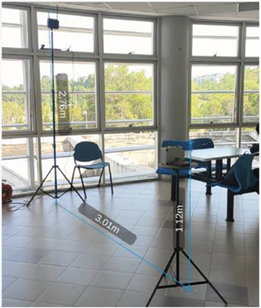
Figure 1. Gateway position at Level 3
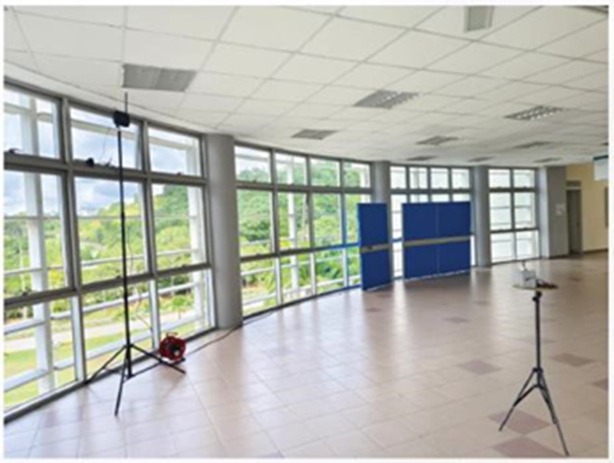
Figure 2. Gateway position at Level 4

Building Floor Plan Layout
Fakulti Teknologi dan Kejuruteraan Elektronik dan Komputer (FTKEK) is a faculty building comprising 2 buildings of administrative and interconnected laboratory buildings as shown in Figure 3. The administrative block has east and west wings spreading around 120 m in total horizontally. The floor-to-floor gap at the mentioned block is 3.3m. It is notable that the building structures are mostly out of cements, steel and glasses. To have increased reliability in the test results NLOS and LOS conditions were considered for the 12 locations of the end device.
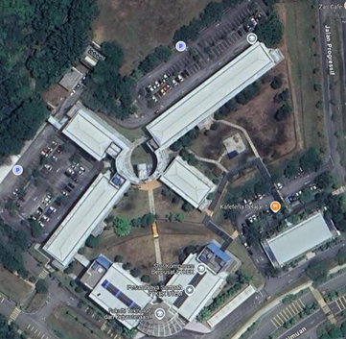
Figure 3. FTKEK building view
Figure 4 to Figure 7 show the floor plan layout with labelling for locations of the sensor node.
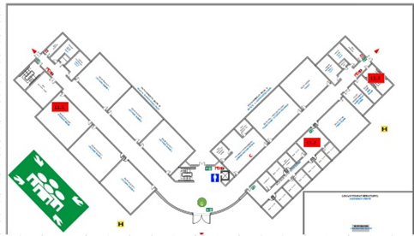
Figure 4. End device placement in Level 1 (first floor)
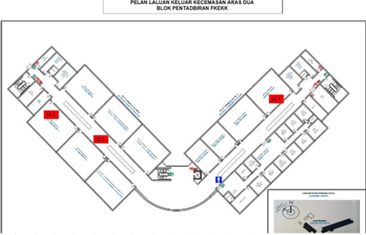
Figure 5. End device placement in Level 2
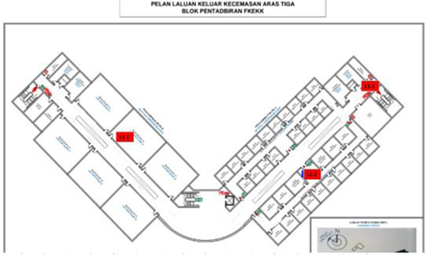
Figure 6. End device placement in Level 3
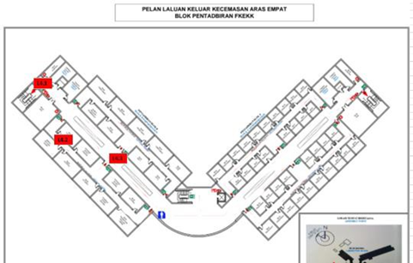
Figure 7. End device placement in Level 4
Another three locations are specially added satisfying the criteria of being the farthest laboratory from the gateway placement situated at the laboratory block in which the farthest and top most location were selected as labelled in Figure 8, location A is Microprocessor laboratory, B is Communication laboratory and C is Texas Instrument Center. All figures provided also summarize the overall strategized indoor network deployment.
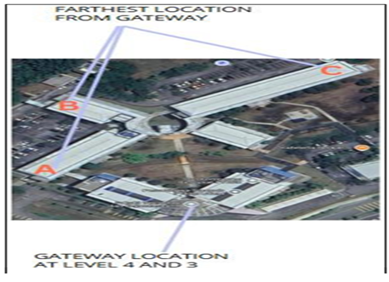
Figure 8. Laboratory locations with respect to the Gateway positions. Microprocessor Lab (A), Communication Lab (B) and Texas Instrument Center (C)

RESULT AND DISCUSSION
In this section the performance analysis of each gateway placement is done critically to provide insights on the best gateway placement for a multi-floor indoor environment. A floor-to-floor analysis is done by manipulating two important parameters which are the SF and the end device transmit power. However, the TX power manipulations were only tested for the laboratory level locations ranging from 80m to 148m. The spreading choice for these experiments were SF 7, SF 9 and SF 10. Meanwhile, the TX power of choice was 16dBm and 5dBm. Therefore, this result reflects the outcome of an efficient LoRaWAN indoor deployment to investigate which gateway placement is the best position. The impact of spreading factors is crucial in leveraging along with the gateway placement. Since different spreading factors have different time on air value, they directly impact the efficiency of packets being sent in NLOS and LOS conditions apart from the distance. Therefore, the shortest time on air spreading factors, moderate time on air spreading factor and the longest time on air spreading factors are chosen as SF 7, SF 9 and SF 10 respectively. Based on this analysis the best gateway placement position and the best practices are aligned.

Analysis of Spreading Factor 7 when gateway placement in level 3 versus level 4
Table 1 and Table 2 show the values of important parameters for SF7 for two different gateway positions and multiple locations of the end node.
Table 1. Spreading Factor 7 (SF7) results when gateway at level 3
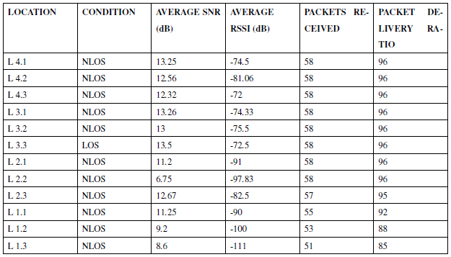
Table 2. Spreading Factor 7 (SF7) results when gateway at level 4
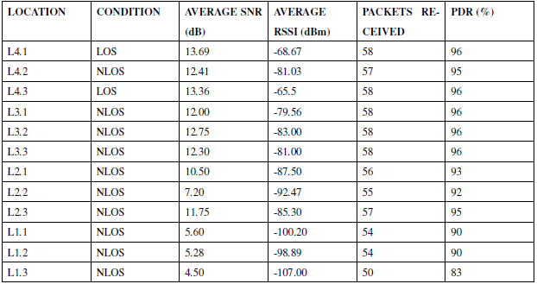
The SNR data reveals several important trends regarding signal quality between the two gateway placements. At Level 4, LOS locations demonstrate excellent SNR performance, with L4.1 (13.69 dB) and L4.3 (13.36 dB) showing nearly identical high values, indicating very stable signal conditions. The NLOS locations at Level 4 maintain relatively strong SNR values between 12.41 dB (L4.2) and 10.5 dB (L2.1), suggesting good signal penetration through moderate obstructions. However, we observe a significant SNR degradation pattern as distance increases and obstructions become more severe, particularly noticeable in the L1.x locations where values drop to 4.5-5.6 dB. Comparatively, Level 3 shows similar peak SNR performance in LOS conditions
(L3.3 at 13.5 dB) but exhibits more variability in NLOS scenarios. The mid-range NLOS locations (L3.1 to L3.3) maintain SNR values between 12.0-12.75 dB, comparable to Level 4’s performance. However, Level 3 demonstrates better SNR resilience in some challenging NLOS conditions, particularly at L2.3 (11.75 dB) compared to Level 4’s equivalent location. This suggests that while Level 4 generally provides superior SNR in optimal conditions, Level 3 may offer more consistent performance in certain obstructed scenarios, possibly due to differences in multipath propagation effects at different elevations. The most dramatic SNR differences appear in the most challenging environments (L1.x locations). Here, Level 4 shows significantly worse performance (4.5-5.6 dB) compared to Level 3 (9.2-11.25 dB). This counterintuitive result may indicate that the higher elevation of Level 4 creates a steeper signal angle to first floor - level locations, resulting in greater signal degradation through multiple floors compared to Level 3’s more direct path. This finding has important implications for deployment planning in multi-story buildings with first floor areas.
The RSSI data shows clear advantages for Level 4 placement in most scenarios, with particularly strong performance in LOS conditions. Level 4’s LOS locations (L4.1 and L4.3) show RSSI values of -68.67 dBm and -65.5 dBm respectively, approximately 4-7 dBm stronger than Level 3’s best LOS performance (L3.3 at -72.5 dBm). This consistent advantage suggests that the higher elevation provides better signal propagation in unobstructed conditions, likely due to reduced first floor-level interference and clearer transmission paths. In NLOS conditions, Level 4 maintains an RSSI advantage of 2-5 dBm across most comparable locations. For example, L4.2 (-81.03 dBm) performs better than L3.2 (-83 dBm), and L4.1 (-68.67 dBm) outperforms L3.1 (-74.33 dBm). However, this advantage diminishes in more obstructed scenarios, with both levels showing similar poor performance in first floor locations (L1.x). The RSSI floor appears to be around -107 dBm to -11 dBm for both placements in worst-case conditions, suggesting a physical limitation in signal penetration that cannot be overcome by elevation alone. An interesting pattern emerges in the mid-range NLOS locations (L2.x and L3.x), where Level 4 shows more consistent RSSI performance across different locations compared to Level 3’s greater variability. This suggests that higher placement may provide more predictable signal strength distribution throughout the coverage area. The standard deviation of RSSI values at Level 4 is approximately 12 dBm across all locations, compared to Level 3’s 15 dBm, indicating more uniform coverage from the elevated position.
PDR results demonstrate that Level 4 provides more reliable communication overall, particularly in the critical 90-96% PDR range that represents practical IoT application requirements. While both levels achieve perfect or near-perfect PDR (96- 97%) in LOS and lightly obstructed NLOS conditions, Level 4 maintains this high reliability across more locations. For instance, Level 4’s L4.2 (95% PDR) and L2.3 (95% PDR) outperform their Level 3 counterparts (92% and 95% respectively). The most significant PDR differences appear in challenging NLOS conditions. Level 4 maintains PDR above 90% for all locations except L1.3 (83%), while Level 3 shows more variability with PDR dropping to 85% at L1.3 and showing inconsistent performance in other obstructed locations. This suggests that Level 4’s placement provides more reliable coverage edge-to-edge, though both placements struggle in extreme conditions. Notably, the PDR data shows a stronger correlation with RSSI than with SNR, particularly in the mid-range values (-80 dBm to -95 dBm RSSI). This indicates that for SF7 in these environments, signal strength may be a more critical factor than signal quality for reliable packet delivery. The PDR/RSSI relationship appears nearly linear in the -70 dBm to -90 dBm range, with approximately 1% PDR improvement per 2 dB of RSSI increase, providing a useful rule-of-thumb for deployment planning.

Analysis of Spreading Factor 9 when gateway placement in level 3 versus level 4
Table 3 and Table 4 show the values of important parameters for SF9 for two different gateway positions and multiple locations of the end node.

Table 3. Spreading Factor 9 (SF9) results when gateway at level 3
Table 4. Spreading Factor 9 (SF9) results when gateway at level 4
The performance of SF 9 shows some clear distinctions when comparing gateway placements at Level 3 and Level 4. When it comes to signal-to-noise ratio (SNR), Level 3 tends to perform more consistently and effectively in non-line-of-sight (NLOS) environments. For example, locations like L4.2 at Level 4 experience a noticeable drop in SNR, while equivalent locations at Level 3 maintain a higher and more stable signal quality. This is particularly evident in lower-level and first floor areas, where Level 3 manages to preserve decent SNR values despite more obstructions. It suggests that a mid-level placement, like Level 3, offers better signal angles for vertical penetration, allowing signals to travel more effectively through floors and physical barriers compared to the steeper angles created from Level 4.
In terms of RSSI, or signal strength, Level 4 does slightly better in open, upper floor environments where line-of-sight is clearer, especially near the top floor. However, once the signal has to travel down through floors or into deeper parts of the building, the advantage quickly fades. Level 3, on the other hand, shows a more gradual and predictable signal loss across all test locations. In many of the NLOS spots, Level 3’s RSSI is consistently stronger by several decibels, making it the more reliable placement when dealing with complex, obstructed layouts. While both placements ultimately converge at lower signal strengths in first floor areas, Level 3 reaches these limits more gradually and with less fluctuation.
When we consider PDR, both placements perform well, often reaching 95 to 99 percent. However, Level 3 shows slightly higher stability across the full range of test locations. PDR at Level 4 remains high in optimal conditions but begins to decline more noticeably as the environment becomes more obstructed. This reflects how Level 3’s balanced position helps maintain a more consistent communication link, especially in indoor deployments with vertical challenges. Overall, for SF9 usage in a multi-floor indoor environment, Level 3 proves to be a more resilient and adaptable gateway placement. It offers stronger SNR in difficult conditions, more stable RSSI across varying distances, and maintains high PDR with less fluctuation compared to the elevated Level 4 placement.
These findings have important implications for network deployment strategies. Level 3’s superior NLOS performance makes it ideal for urban environments with dense obstructions, multi-story buildings, and applications requiring reliable first floor coverage. The lower elevation provides better signal penetration through horizontal obstructions and more consistent performance across varied environments. Level 4 remains preferable for wide-area coverage, rooftop-to-rooftop connections, and scenarios where the gateway can maintain predominantly LOS relationships with endpoints. A hybrid approach combining both placements may offer optimal coverage for complex environments, with Level 4 providing wide-area service and Level 3 ensuring reliable penetration into obstructed areas. The data also suggests SF9 is particularly well-suited for challenging environments, maintaining high reliability even in conditions where lower spreading factors would fail, making it an excellent choice for mission-critical IoT applications requiring consistent connectivity.

Analysis of Spreading Factor 10 when gateway placement in level 3 versus level 4
Table 5 and Table 6 show the values of important parameters for SF10 for two different gateway positions and multiple locations of the end node.
Table 5. Spreading Factor 10 (SF10) results when gateway at level 3
Table 6. Spreading Factor 10 (SF10) results when gateway at level 4
The performance of SF10 under different gateway placements reveals clear differences in signal quality, signal strength, and packet delivery reliability. When it comes to signal quality, placing the gateway at Level 3 consistently delivers better results than Level 4, especially in non-line-of-sight (NLOS) conditions. In line-of-sight (LOS) areas, both placements perform similarly - Level 4 records SNR values between 10.4 and 11.3 dB, while Level 3 edges slightly ahead with values from 12.4 to 12.85 dB. But the real difference emerges in more obstructed spaces. In mid-range NLOS locations, Level 3 reaches SNR readings between 12.67 and 12.85 dB, which is 2 to 3 dB higher than the 10.72 to 10.75 dB observed at Level 4. Even in the first floor where signal conditions are most difficult - Level 3 holds its ground, showing SNR values of 7.52 to 8.6 dB, slightly outperforming Level 4’s 9.23 to 10.78 dB. This suggests that SF10’s longer symbol duration helps preserve signal quality, even without the elevation advantage.
Signal strength follows a similar pattern. In LOS conditions, both Level 3 and Level 4 deliver comparable RSSI values, ranging from -68.5 to -70.9 dBm. But in NLOS environments, Level 3 pulls ahead. At location L3.1, for instance, it registers -68.83 dBm, a notable 15 dB stronger than Level 4’s -83.39 dBm. A similar gap appears at L3.2, with Level 3 showing -68.18 dBm versus -86 dBm at Level 4. At L3.3, the difference is smaller but still in favor of Level 3 (-70.9 dBm compared to -72.3 dBm). Interestingly, this trend flips in the first floor. Here, Level 4 slightly outperforms Level 3, with RSSI values between -92.56 and -97.58 dBm, while Level 3 ranges from -96.62 to -98.33 dBm. This hints that the higher vertical position of Level 4 may offer a modest advantage in penetrating lower floor level.
As for packet delivery, both gateway levels perform reliably with SF10, achieving a packet delivery ratio (PDR) of around 96% in most areas. Level 3 maintains this rate consistently across nearly all test sites, while Level 4 shows minor fluctuations, with PDR dipping to 95% in some NLOS zones. In the first floor areas, both placements experience a slight drop to 93%, but again, Level 3 proves to be more consistent overall Especially in fringe or difficult locations, the Level 3 placement demonstrates greater reliability in maintaining successful data transmissions.

Impact of transmit (TX) power for longer distances at Level 3
Table 7 and Table 8 show the values of important parameters for SF10 for two different gateway positions and multiple locations of the end node.
Table 7. Spreading Factor 7 (SF7) performance analysis
Table 8. Spreading Factor 10 (SF10) performance analysis
When comparing SNR values, higher transmit power (TX0 at 16 dBm) consistently results in better signal-to-noise ratio than lower power (TX5 at 6 dBm) for both SF7 and SF10. At the Microprocessor Lab, SNR with SF7 improves from 6.5 dB (TX5) to 7.5 dB (TX0), while SF10 improves even more significantly from 8.5 dB (TX5) to 9.5 dB (TX0). The same trend appears at the Texas Instrument Centre, where SF7 SNR increases from -2.6 dB (TX5) to 2 dB (TX0), and SF10 rises from 1.6 dB (TX5) to 3.5 dB (TX0). These results show that both spreading factors benefit from higher TX power, but SF10 offers consistently better SNR across all sites, confirming its robustness in weaker signal environments.
RSSI values on the other hand, which reflect raw signal strength, also show improvement when using TX0 (16 dBm) compared to TX5 (6 dBm), though the gains are less dramatic than those seen in SNR. For SF7 at the Microprocessor Lab, RSSI improves from -95 dBm (TX5) to -98 dBm (TX0), while SF10 shows similar improvement from -97 dBm (TX5) to -100 dBm (TX0). At the Communications Lab, both SF7 and SF10 gain about 3 dB with increased TX power. Overall, SF10 records slightly weaker RSSI than SF7, but this doesn’t significantly impact performance. This confirms that while TX power helps improve RSSI, RSSI is less critical than SNR for reliable data transmission, especially when using higher spreading factors like SF10.
PDR is the most practical measure of performance, and the results clearly show that SF10 consistently outperforms SF7, particularly at longer distances or lower TX power. At the Texas Instrument Centre, SF7 PDR drops from 77% (TX0) to 67% (TX5), while SF10 maintains a much higher rate of 92% (TX0) and 80% (TX5). Similarly, at the Microprocessor Lab, SF7 PDR improves from 90% (TX5) to 95% (TX0), whereas SF10 achieves 93% (TX5) and a near-perfect 99% (TX0). These results highlight that higher TX power significantly improves PDR, but SF10 provides better reliability overall, even under weaker signal conditions. This is due to its longer time-on-air, which helps resist interference and reduces packet collision, making it ideal for more demanding indoor environments.

CONCLUSION
In a multi-floor building, placing the gateway on Level 3 is more suitable for vertical signal coverage. Being centrally positioned allows the signal to propagate both upward and downward more evenly, reducing loss as it passes through floor slabs. This placement helps maintain a stable connection across multiple levels without overburdening the signal with excessive elevation. For this kind of vertical communication, Spreading Factor 9 (SF9) is recommended. It offers a good balance between range, reliability, and low latency, especially when combined with TX0 (16 dBm) transmission power. Installing the gateway in an open, central location—away from thick walls or enclosed corners—further helps to minimize reflection and absorption, improving signal flow between floors. For horizontal coverage, such as across long corridors or wide rooms on the same level, Level 4 proves to be the better placement. Being elevated above most obstructions allows the signal to travel across the floor more effectively, especially when there are numerous walls, furniture, or other obstacles that typically weaken lower positioned signals. In this context, Spreading Factor 10 (SF10) is the best choice. Its longer symbol duration helps the signal remain stable even in complex indoor layouts, and it performs well in non-line-of-sight conditions. To ensure robust performance, SF10 should be paired with TX0, which boosts signal strength and improves packet delivery across longer horizontal distances. The gateway should be installed in a clear, elevated spot with as few immediate obstructions as possible to fully take advantage of the Level 4 position. This configuration is especially effective in ensuring reliable horizontal indoor coverage across the same floor.

ACKNOWLEDGEMENT
The authors would like to thank Centre for Research and Innovation Management (CRIM), Universiti Teknikal Malaysia Melaka (UTeM) for sponsoring this work.

REFERENCES
- Shilpa, B., Kumar, P. R., & Kumar Jha, R. (2023). Spreading Factor Optimization for Interference Mitigation in Dense Indoor LoRa Networks. 2023 IEEE IAS Global Conference on Emerging Technologies (GlobConET), 1–5.
- Loh, F., Baur, C., Geißler, S., Hesham ElBakoury, & Hoßfeld, T. (2023). Collision and Energy Efficiency Assessment of LoRaWANs with Cluster-Based Gateway Placement. IEEE International Conference on Communications Workshops (ICC Workshops), 391–396.
- Alkhazmi, E. H., Elkawafi, S. M., Aldarrat, A. A., Abbas, M. A., Hussameldin Abubakr, & Shamatah, H. A. (2023). Analysis of Real-World LoRaWAN Network Performance Across Outdoor and Indoor Scenarios. IEEE 11th International Conference on Systems and Control (ICSC), 329–334.
- Idris, F., Latiff, A. A., Buntat, M. A., Lecthmanan, Y., & Berahim, Z. (2024). IoT-based fertigation system for agriculture. Bulletin of Electrical Engineering and Informatics, 13(3), 1574–1581.
- Pandey, S., Kumari, P., Gupta, H. P., Rai, D., & Rao, S. V. (2024). A Site-Specific LoRaWAN Parameters Selection Approach with Multi-Loss Propagation Model. IFIP Networking Conference (IFIP Networking), 350–358.
- Neumann, P., Montavont, J., & Noël, T. (2016). Indoor deployment of low-power wide area networks (LPWAN): A LoRaWAN case study. IEEE 12th International Conference on Wireless and Mobile Computing, Networking and Communications (WiMob), 1–8.
- Yasmin, R., Juha Petajajarvi, Mikhaylov, K., & Ari Pouttu. (2018). Large and Dense LoRaWAN Deployment to Monitor Real Estate Conditions and Utilization Rate. IEEE 29th Annual International Symposium on Personal, Indoor and Mobile Radio Communications (PIMRC), 1– 6.
- El Chall, R., Lahoud, S., & El Helou, M. (2019). LoRaWAN Network: Radio Propagation Models and Performance Evaluation in Various Environments in Lebanon. IEEE Internet of Things Journal, 6(2), 2366–2378.
- Izzam, M. M., Abidin, H. Z., Afzal, S., & Zaman, K. (2019). Performance Analysis of LoRaWAN for Indoor Application. 2019 IEEE 9th Symposium on Computer Applications & Industrial Electronics (ISCAIE), 156–159.
- Xu, W., Kim, J. Y., Huang, W., Kanhere, S. S., Jha, S. K., & Hu, W. (2020). Measurement, Characterization, and Modeling of LoRa Technology in Multifloor Buildings. IEEE Internet of Things Journal, 7(1), 298–310
- Hanaffi, H., Mohamad, R., Suliman, S. I., Kassim, M., Anas, N. M., & Zaki, A. (2020). Single-Channel LoRaWAN Gateway for Remote Indoor Monitoring System: An Experimental, 8th International Electrical Engineering Congress (iEECON), 1–4.
- Zain, A. R., Oktivasari, P., Agustin, M., Kurniawan, A., Murad, F. A., & Nurrahman, I. (2022). Evaluation of Encryption and Decryption Data Packet Delivery Performance in Smart Home Design using the LoRaWAN Protocol. 5th International Conference of Computer and Informatics Engineering (IC2IE), 241–246.
- Perković, T., Dujić Rodić, L., Šabić, J., & Šolić, P. (2023). Machine Learning Approach towards LoRaWAN Indoor Localization. Electronics, 12(2), 457.
- Sharma, V., & Roy, A. (2023). Localized Indoor / Outdoor Lora Net Work A Review. 1st International Conference on Intelligent Computing and Research Trends (ICRT), 1–11.
- Grübel, J., Thrash, T., Aguilar, L., Gath-Morad, M., Hélal, D. Sumner, R. W., Hölscher. C., & Schinazi, V. R. (2022). Dense Indoor Sensor Networks: Towards passively sensing human presence with LoRaWAN. Pervasive and Mobile Computing, 84, 101640–101640.
- Bertoldo, S., Paredes, M., Carosso, L., Allegretti, M., & Savi, P. (2019). Empirical indoor propagation models for LoRa radio link in an office environment. 13th European Conference on Antennas and Propagation (EuCAP), 1-5.

