advanced rider safety system

INTRODUCTION
Road transportation is one of the most widely used modes of transportation across the world, and motorcycles are among the most popular vehicles due to their affordability, fuel efficiency, and convenience. However, two-wheeler riders are highly vulnerable to road accidents because they lack the protective structure available in cars and other larger vehicles. According to various road safety reports, a significant percentage of road accident fatalities involve motorcycle riders, with many deaths occurring due to the non-use of helmets and riding under the influence of alcohol.
A helmet is one of the most important safety devices for a rider, as it protects the head from severe injuries during accidents. Despite strict traffic regulations and awareness campaigns, many riders fail to wear helmets properly or avoid wearing them altogether. Similarly, drunk riding remains a major cause of road accidents, as alcohol impairs judgment, reduces reaction time, and affects the rider’s ability to control the vehicle safely. Traditional enforcement methods such as traffic police inspections and roadside alcohol testing are limited in their effectiveness because they cannot continuously monitor every rider.
Recent advancements in embedded systems, wireless communication, and Internet of Things (IoT) technologies have enabled the development of intelligent transportation safety solutions. Smart helmets equipped with sensors and communication modules can help enforce safety regulations automatically and improve rider protection. By integrating helmet detection, alcohol sensing, vehicle control, and emergency communication features into a single system, it is possible to reduce accident risks and improve overall road safety.
The Advanced Rider Safety System Helmet is designed as an intelligent safety solution that combines multiple technologies to ensure safe riding practices. The system consists of a helmet-side transmitter unit and a motorcycle-side receiver unit, both built around ESP32 microcontrollers. The helmet unit includes an MQ-3 alcohol sensor for detecting alcohol concentration in the rider’s breath and a helmet detection switch to verify proper helmet usage. The motorcycle unit contains an LCD display, buzzer, relay module, GPS module, and GSM module to provide rider notifications, engine control, location tracking, and emergency communication.
The proposed system allows vehicle ignition only when the rider is wearing the helmet correctly and the alcohol level is below a predefined threshold. If either condition is not satisfied, the system blocks engine ignition and alerts the rider through visual and audible warnings. Furthermore, in the event of an accident, the GPS module obtains the rider’s location coordinates and the GSM module automatically sends emergency SMS alerts to predefined contacts. This helps emergency responders reach the accident location quickly and provide timely medical assistance.
The main objective of this project is to enhance rider safety, reduce accident-related fatalities, and promote responsible riding behavior through automation and intelligent monitoring. By integrating multiple safety features into a single compact and cost-effective system, the Advanced Rider Safety System Helmet offers a practical solution for improving road safety in modern transportation systems.

literature survey

components used

- ESP 32 Microcontrollere (ESP32-WROOM-32)
- MQ-3 Alcohol (Breath) Sensor
- SIM800L GSM Module
- GPS Module (Neo-6M/u-blox)
- 12c LCD Display (16*2 with PCF8574 Backpack)
- Relay Module (5V Single Channel)

The Advanced Rider Safety System Helmet uses ESP32 controllers, MQ-3 alcohol sensor, helmet detection switch, LCD display, buzzer, relay module, GPS module, GSM module, batteries, and voltage regulators to ensure helmet compliance, prevent drunk riding, control vehicle ignition, and provide emergency assistance during accidents.

SOFTWARE INSTALLATION

Installing ARDUINO IDE
To install the Arduino IDE for Windows, follow these instructions:
Download .exe file from website: http://arduino.cc/en/Main/Software/
Once the download is complete, double-click the file, and extract it. (Usually the file is downloaded in .zip format)
The extracted “Arduino” named folder is to be copy and paste it into C-Drive, and Open the folder, if you wish create the shortcut of Arduino.exe file on your desktop.

Installing DRIVERS
The next task is to install the drivers for your Arduino board’s USB interface.
Connect your Arduino to your PC with the USB cable. After a few moments an error message will be displayed, which will say something like “Device driver software not successfully installed.” Just close that dialog or balloon.
Navigate to the Windows Control Panel. Open the Device Manager and scroll down until you see the ports or Arduino,
Right-click Arduino Uno under Other Devices and select Update Driver Software. Then, select browse option and update the drivers.
Taking a look Around the IDE
The IDE is divided into three main areas: the command area, the text area, and the message window area.
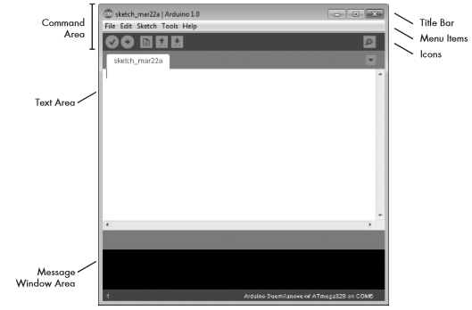
The Command Area
The command area includes the title bar, menu items, and icons. The title bar displays the sketch’s filename. Below this is a series of menu items (File, Edit, Sketch, Tools, and Help) and icons.
The Icons
Below the menu toolbar are six icons. Mouse over each icon to display its name. The icons, from left to right, are as follows:
Verify: Click this to check that the Arduino sketch is valid and doesn’t contain any programming mistakes.
Upload: Click this to verify and then upload your sketch to the Arduino board.
New: Click this to open a new blank sketch in a new window.
Open: Click this to open a saved sketch. Save Click this to save the open sketch.
Serial Monitor: Click this to open a new window for use in sending and receiving data between your Arduino and the IDE.
The Text Area
The actual code is written in this block.

The Message Window Area
The message window area is shown at the bottom side. Messages from the IDE appear in the black area. The messages you see will vary and will include messages about verifying sketches, status updates, and so on.

IV. bLOCK DIAGRAM AND CIRCUIT DIAGRAM
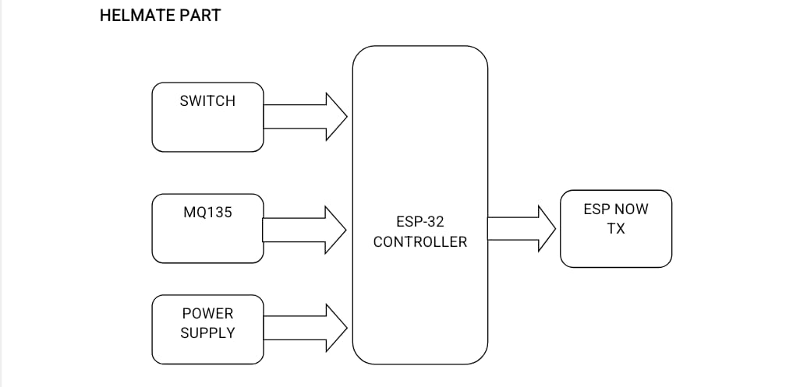

METHODOLOGY
Existing System:
The existing motorcycle safety systems mainly depend on manual monitoring and basic safety measures. In conventional two-wheelers, the vehicle can start even if the rider is not wearing a helmet. Most systems also do not provide real-time alcohol detection or emergency accident notification. Existing helmet safety solutions generally use wired connections or single-controller systems, which reduce reliability and increase response delay.
Current safety systems lack integrated communication between the helmet and the vehicle unit. Many existing designs do not support GPS tracking, GSM emergency alerts, or automatic engine locking features. In addition, some systems only focus on alcohol detection or helmet detection separately, resulting in incomplete rider safety.
• Existing Smart Helmet Systems in India
In India, several academic and prototype-level smart helmet systems have been developed using sensors such as IR sensors, alcohol sensors, and GSM modules. Most projects are based on Arduino UNO or basic microcontroller platforms. However, many of these systems suffer from limitations such as short communication range, wired helmet connections, inaccurate alcohol sensing, and lack of real-time location tracking.
Research institutions and engineering colleges have implemented smart helmet models using RF modules and Bluetooth communication, but these technologies often face interference and connectivity issues. Existing systems are mostly experimental and are not fully optimized for practical road usage. Problems such as delayed emergency response, unstable wireless communication, and improper power management still exist. Therefore, there is a need for a more reliable, wireless, and intelligent smart helmet system.
• Existing Smart Helmet Systems in Other Countries
Several developed countries have introduced advanced motorcycle safety technologies integrated with IoT and intelligent transportation systems. Countries such as the United States, Germany, Japan, and South Korea have tested smart helmets with embedded sensors, accident detection systems, and wireless communication technologies.
Modern systems abroad use technologies like GPS tracking, GSM emergency communication, cloud monitoring, and AI-based accident detection. Some commercial helmets also provide voice assistance and navigation support. However, these systems are expensive and not affordable for common users in developing countries. In addition, many imported systems are designed mainly for high-end motorcycles and may not suit regular commuter vehicles.
Despite these advancements, challenges such as high implementation cost, complex integration, and maintenance requirements still remain. Hence, there is scope for developing a low-cost, efficient, and reliable smart helmet safety system suitable for practical implementation.
4.2 Proposed System:
The proposed Smart Helmet Safety System is designed to improve rider safety by integrating helmet detection, alcohol sensing, wireless communication, GPS tracking, and emergency alert functionalities. The system uses a dual-ESP32 architecture consisting of a transmitter unit inside the helmet and a receiver unit mounted on the motorcycle.
The transmitter section continuously monitors helmet usage and alcohol level using sensors. The collected data is transmitted wirelessly to the receiver section through ESP-NOW communication protocol. If the rider is wearing the helmet properly and no alcohol is detected beyond the threshold limit, the ignition system is enabled. Otherwise, the engine remains OFF.
The receiver unit controls the relay-based ignition mechanism and also manages GPS and GSM modules for accident alerts and emergency messaging. In case of an accident, the system automatically sends the rider’s live location to predefined emergency contacts. The LCD display provides real-time system status messages.
This proposed system improves road safety, minimizes accidents caused by drunk driving, and provides rapid emergency response using IoT-based technologies.

VI. CODE

RESULTS AND DISCUSSION
1. Power-ON Sequence
- Both Transmitter (Helmet Unit) and Receiver (Motorcycle Unit) are powered ON successfully using regulated power supply modules.
- The MQ-3 alcohol sensor requires approximately 20 seconds warm-up time for stable alcohol detection. A firmware delay is implemented to ensure accurate sensor readings.
- The GPS module initializes and acquires satellite signals within 30–60 seconds during cold start conditions. Once connected, real-time location coordinates are updated continuously.
- ESP-NOW wireless communication is established between both ESP32 modules using registered MAC addresses for secure and reliable data transfer.
- LCD display initializes properly and shows system startup messages indicating successful module initialization.
- During testing, stable communication between the transmitter and receiver units was achieved with minimal packet loss.
2. Transmitter Unit (Helmet) Operation Loop
- The ESP32 transmitter continuously reads the MQ-3 alcohol sensor analog value at a sampling rate of approximately 10Hz for real-time alcohol monitoring.
- Helmet wearing status is detected using the helmet switch sensor connected to GPIO pins, where HIGH indicates helmet worn and LOW indicates helmet not worn.
- The collected sensor data packet containing helmet status and alcohol sensor value is broadcast to the receiver unit through ESP-NOW communication every 500ms.
- Experimental results show that the transmitter unit provides fast response and accurate sensor data transmission without noticeable delay.
- The wireless transmission range was found sufficient for normal motorcycle operation and maintained stable connectivity during testing.
3. Receiver Unit (Motorcycle) Operation Loop
- The receiver ESP32 successfully receives the wireless ESP-NOW data packets transmitted from the helmet unit.
- The decision-making algorithm evaluates two major conditions:
  - Whether the rider is wearing the helmet
  - Whether the alcohol level is below the predefined threshold
- If both conditions are satisfied, the relay module activates and allows the DC motor (vehicle ignition) to start. The LCD displays the message “Ride Safe!” and the buzzer remains OFF.
- If the helmet is not worn, the relay remains OFF, the motor stays disabled, the buzzer activates, and the LCD displays “Wear Helmet!”.
- If alcohol is detected above the threshold limit, the system blocks engine ignition, activates the buzzer, and displays “Drunk! Engine Blocked” on the LCD screen.
- Continuous GPS data parsing is performed using TinyGPS++ library, and real-time latitude and longitude coordinates are updated successfully.
- Test results indicate that the ignition control mechanism responds immediately based on rider safety conditions, improving overall vehicle safety.
4. Emergency Alert Sequence (Accident Detection)
- The vibration/tilt sensor continuously monitors sudden impacts or abnormal tilt conditions during vehicle operation.
- When the sensor detects vibration beyond the predefined threshold for more than 500ms, the system identifies it as a possible accident condition.
- The GPS module retrieves accurate latitude and longitude coordinates using the TinyGPS++ library.
- The SIM800L GSM module is controlled through AT commands to send emergency SMS alerts containing accident information and live Google Maps location link.
- Emergency alert messages are successfully transmitted to two pre-programmed emergency contact numbers during testing.
- The buzzer generates an SOS alert pattern consisting of three short beeps, three long beeps, and three short beeps for nearby attention and emergency indication.
- Experimental observations confirm that the emergency alert system responds quickly and improves the chances of immediate rescue assistance after accidents.

VIII. CONCLUSION
The Smart Helmet System presented in this synopsis addresses a
critical gap in two-wheeler road safety by integrating multiple embedded technologies into a unified, automated safety enforcement solution. The system successfully combines helmet detection, breath alcohol analysis, engine ignition control, real-time feedback, GPS tracking, and GSM emergency alerting into a single cohesive platform.
The dual ESP32 architecture provides sufficient processing power, GPIO availability, and wireless capability at a very low cost (approximately Rs.2,460), making this solution viable for mass deployment. Unlike existing systems that address only one aspect of rider safety, the proposed integrated approach ensures that the vehicle physically cannot be started unless safety compliance is verified

REFERENCES

- Sai Prasad R., Kumar A., and Reddy V. (2019). Smart Helmet using Arduino for Alcohol Detection and Engine Control. IEEE International Conference on Computing, Communication and Automation (ICCCA 2019), Greater Noida, India, pp. 1-6.
- [2] Ahmad M., Khan I., and Memon A. (2020). IoT-Based Smart Helmet for Coal Miners Safety Monitoring. IEEE Access, Vol. 8, pp. 33446-33456.
- [3] Nithyashri N., Devi S., and Rajan T. (2021). Alcohol Detection and Helmet Sensing Using Raspberry Pi with OpenCV. International Journal of Engineering Research and Technology (IJERT), Vol. 10, Issue 5.
- Shankar R., Mishra D., and Gupta S. (2023). Comprehensive Review of Smart Helmet Technologies for Road Safety. IEEE Transactions on Intelligent Transportation Systems, Vol. 24, Issue 2, pp. 1587-1604.
- Ministry of Road Transport and Highways, Government of India (2023). Road Accidents in India 2022. MoRTH Annual Statistical Report.
- [13] Espressif Systems (2023). ESP32 Technical Reference Manual v5.1. Espressif Systems, Shanghai.
- Priya S., Kumar M., and Rao B. (2022). I2C Communication for Multi-Device LCD Interfacing in Embedded Systems. International Journal of Computer Applications (IJCA), Vol. 183, Issue 45, pp. 18-24.

